NATIONAL CENTER FOR EDUCATION STATISTICS NATIONAL ASSESSMENT OF EDUCATIONAL PROGRESS

National Assessment of Educational Progress (NAEP)2024

Appendix J2

Teacher Questionnaires

OMB# 1850-0928 v.28

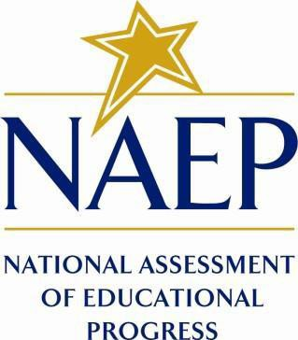

October 2022
No changes since October 2021

Appendix J2 provides the teacher survey questionnaires. This document provides a sample from 2022 (OMB# 1850-0928 v.25). Updates to the teacher survey questionnaires will be available in this document for Amendment #1 by February 2023 and finalized in Amendment #2 (by April 2023).
Table of Contents
Teacher Questionnaires
Sample Teacher Questionnaire Login Screens 3
Sample Teacher Questionnaire Booklet Covers 4
Appendix J2-1: Summary of Changes Operational Grade 4 CORE 5
Appendix J2-2: Operational Grade 4 CORE 12
Appendix J2-3: Summary of Changes Operational Grade 8 CORE 20
Appendix J2-4: Operational Grade 8 CORE 28
Appendix J2-5: Summary of Changes Operational Grade 4 Mathematics 38
Appendix J2-6: Operational Grade 4 Mathematics 43
Appendix J2-7: Summary of Changes Operational Grade 8 Mathematics 50
Appendix J2-8: Operational Grade 8 Mathematics 56
Appendix J2-9: Summary of Changes Operational Grade 4 Reading 64
Appendix J2-10: Operational Grade 4 Reading 68
Appendix J2-11: Summary of Changes Operational Grade 8 Reading 73
Appendix J2-12: Operational Grade 8 Reading 78
Appendix J2-13: Summary of Changes Operational Grade 8 Social Studies 83
Appendix J2-14: Operational Grade 8 Social Studies 92
Appendix J2-15: Summary of Operational Grade 4 COVID-19 101
Appendix J2-16: Operational Grade 4 COVID-19 106
Appendix J2-17: Summary of Operational Grade 8 COVID-19 110
Appendix J2-18: Operational Grade 8 COVID-19 114

Sample Teacher Questionnaire Login Screens

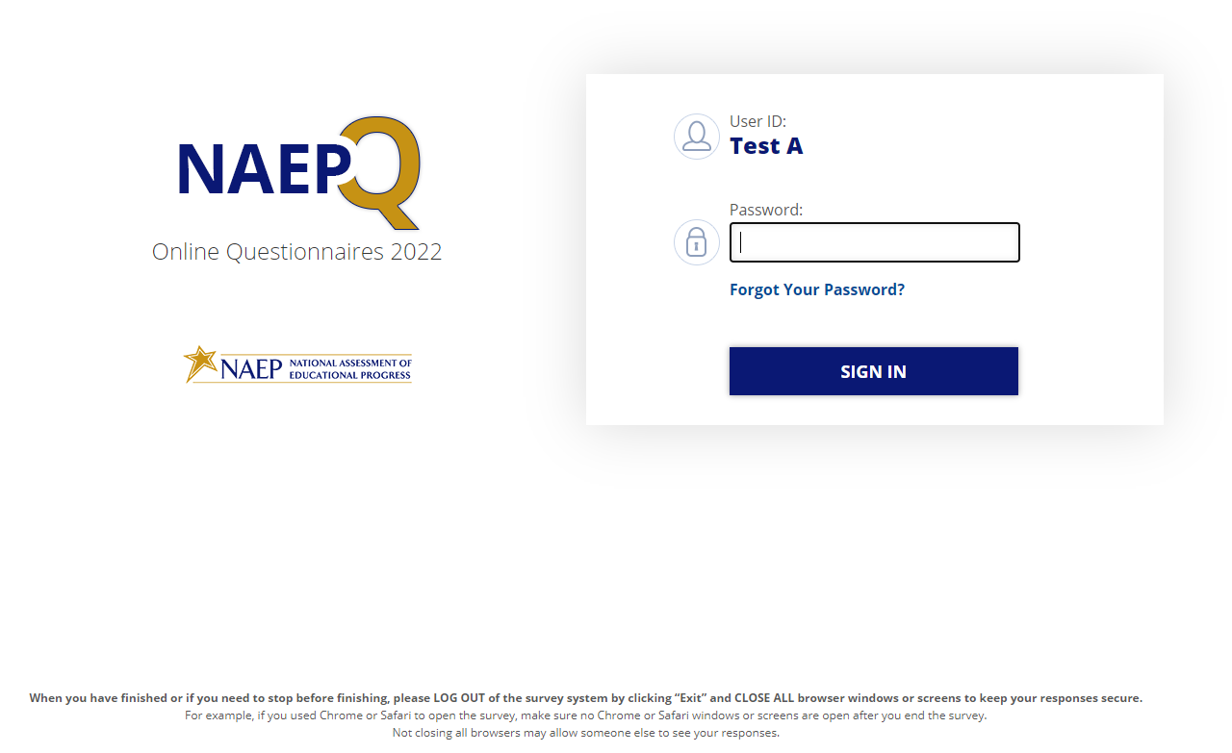
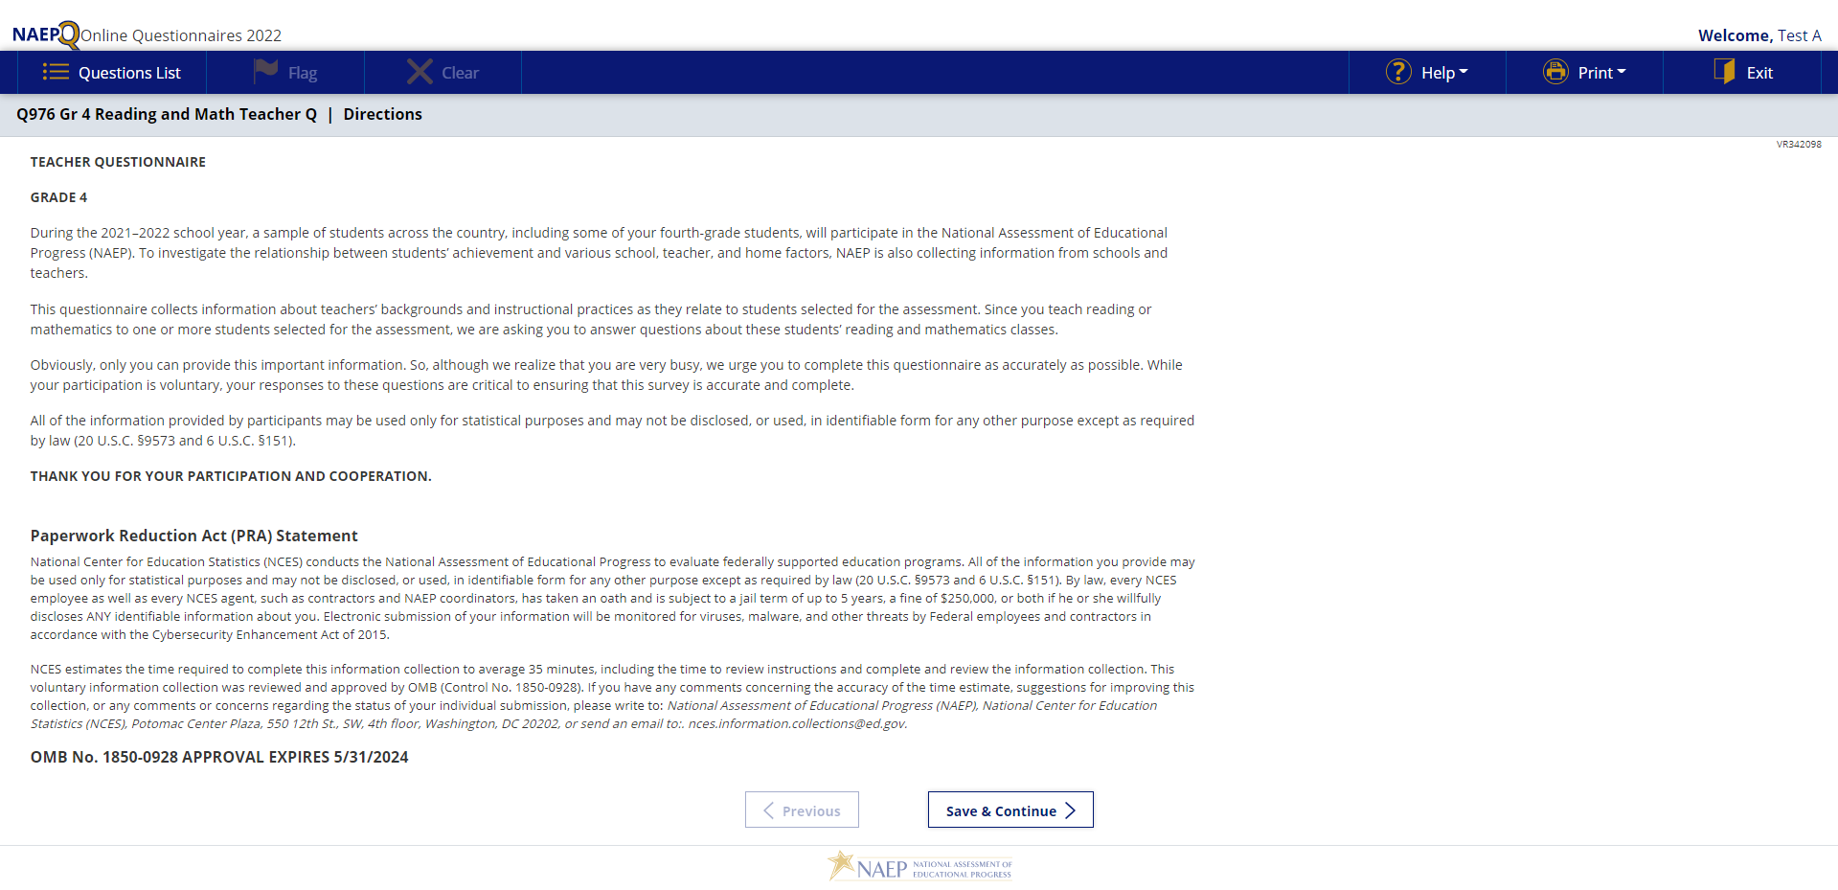

Sample Teacher Questionnaire Booklet Covers
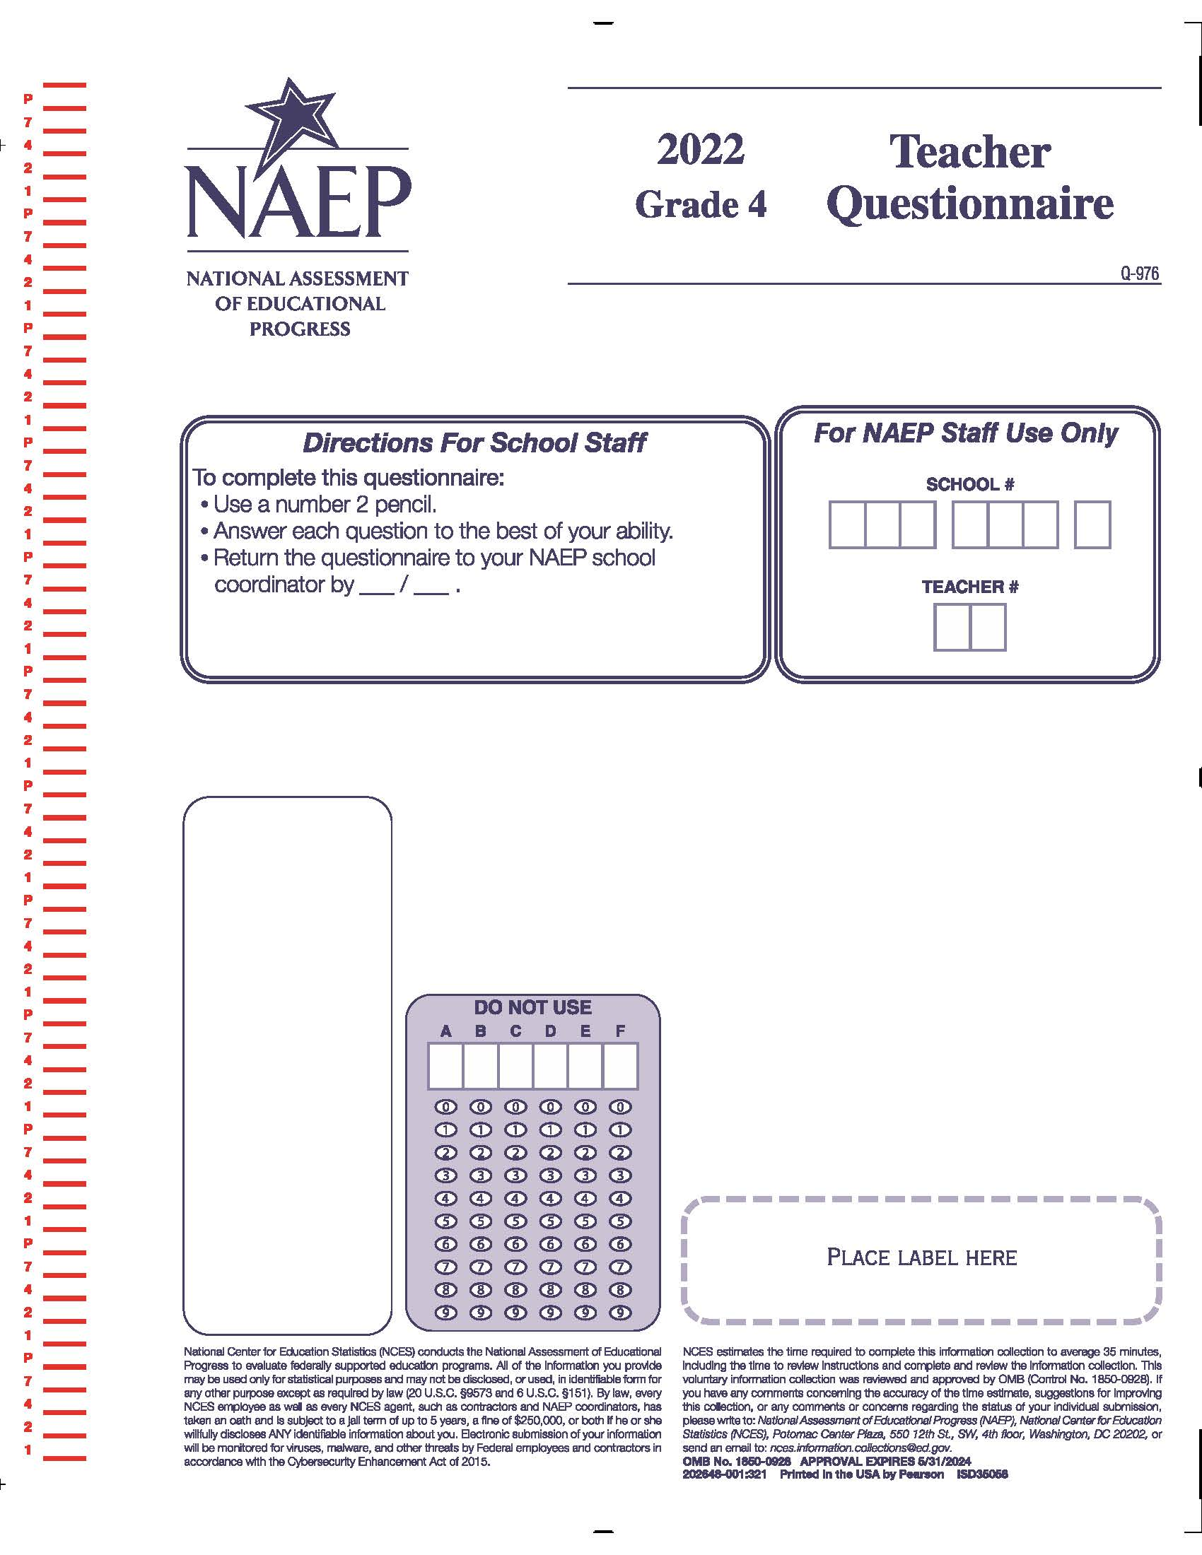

Appendix J2-1: Summary of Changes Operational Grade 4 CORE
2022 Operational Grade 4 Core Teacher

Previous item | 2022 item | D/A/ R/NC+ | Rationale
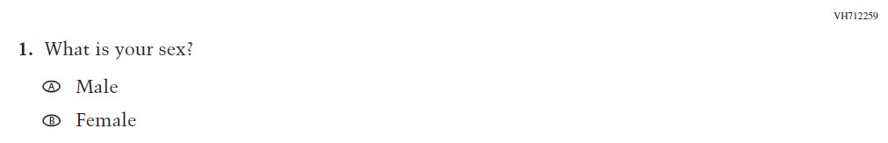  (2021 Grade 4) | 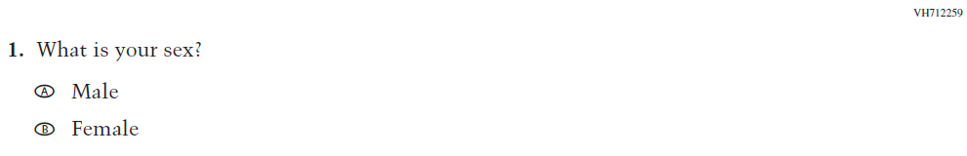  Issue: Gender | NC | N/A
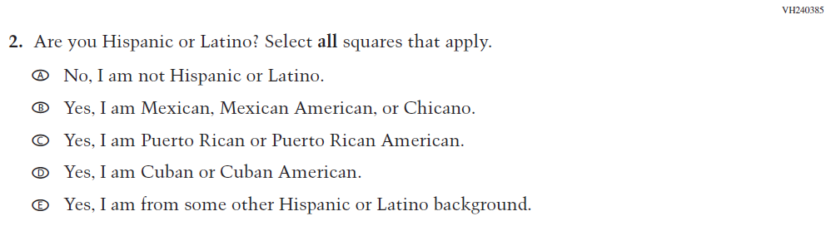  (2021 Grade 4) | 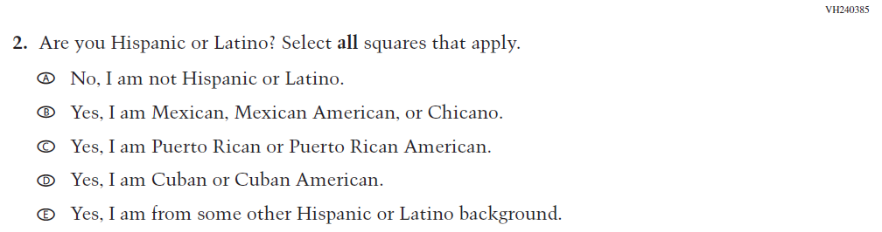  Issue: Race/Ethnicity | NC | N/A
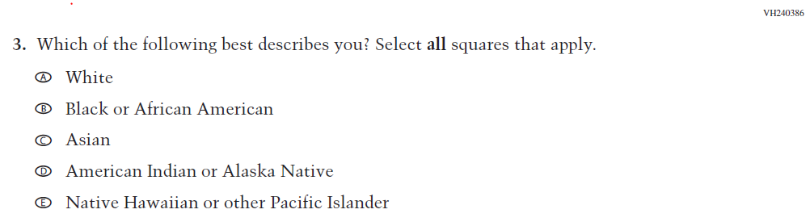  (2021 Grade 4) | 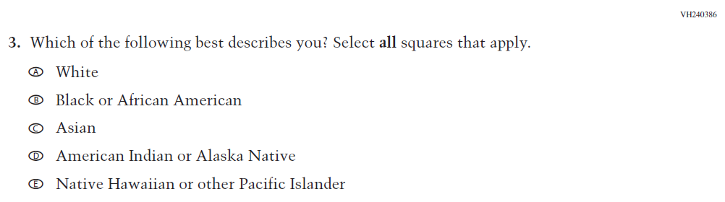  Issue: Race/Ethnicity | NC | N/A
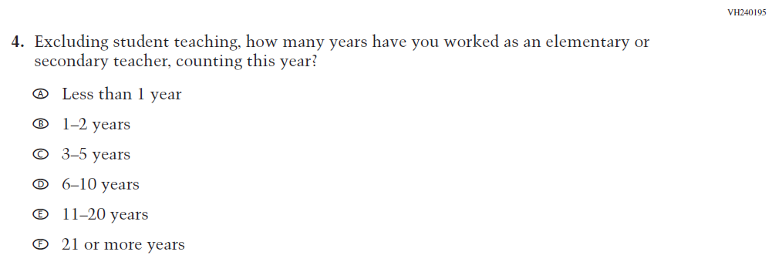  (2021 Grade 4) | 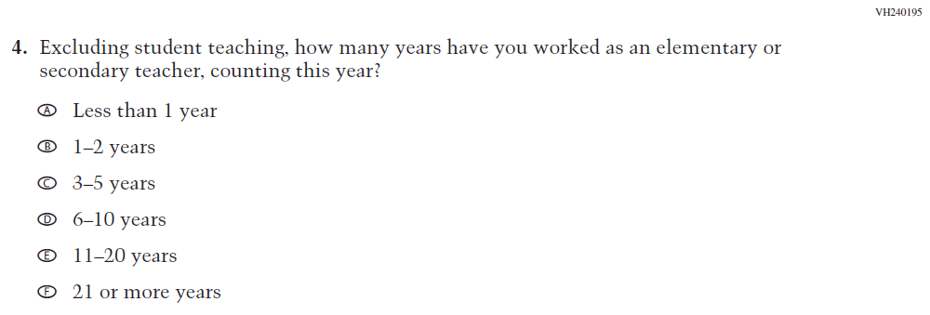  Issue: Teacher Preparation | NC | N/A

2022 Operational Grade 4 Core Teacher

Previous item | 2022 item | D/A/ R/NC+ | Rationale
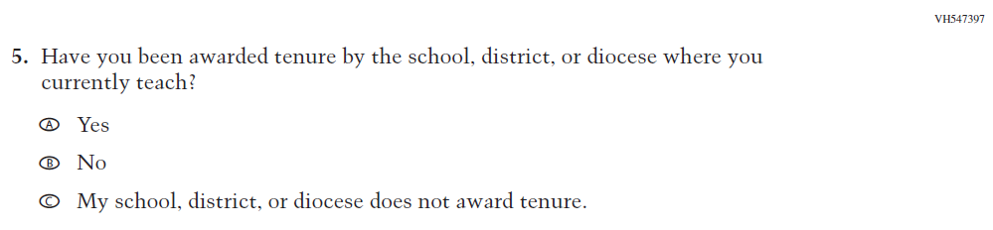  (2021 Grade 4) | 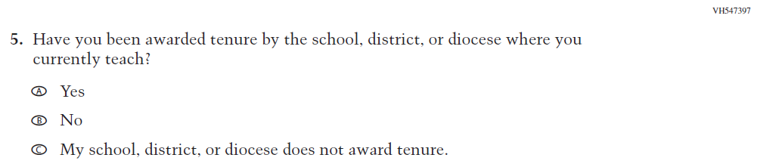  Issue: Teacher Preparation | NC | N/A
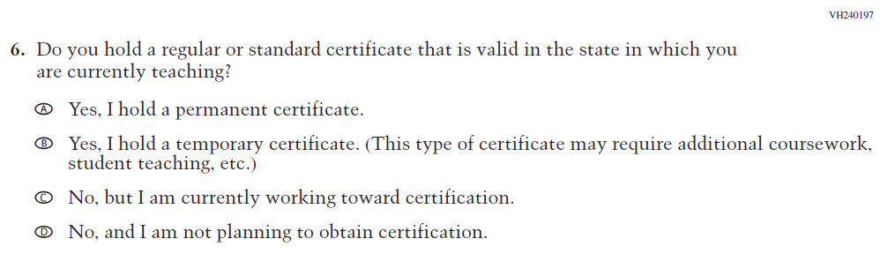  (2021 Grade 4) | 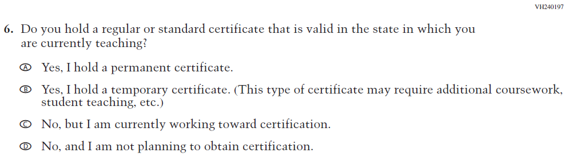  Issue: Teacher Preparation | NC | N/A
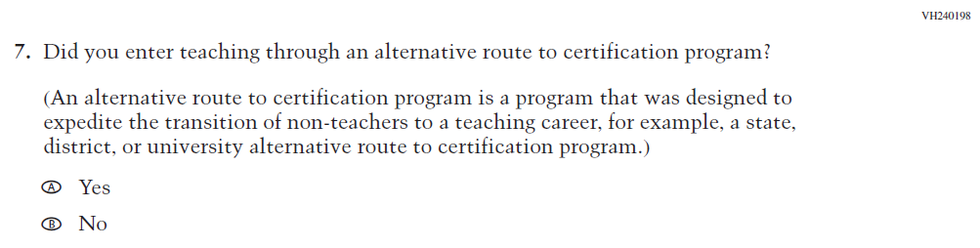  (2021 Grade 4) | 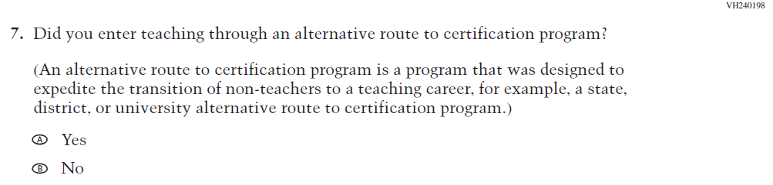  Issue: Teacher Preparation | NC | N/A

2022 Operational Grade 4 Core Teacher

Previous item | 2022 item | D/A/ R/NC+ | Rationale
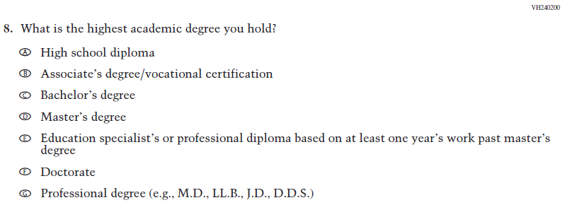  (2021 Grade 4) | Issue: Teacher Preparation | NC | N/A
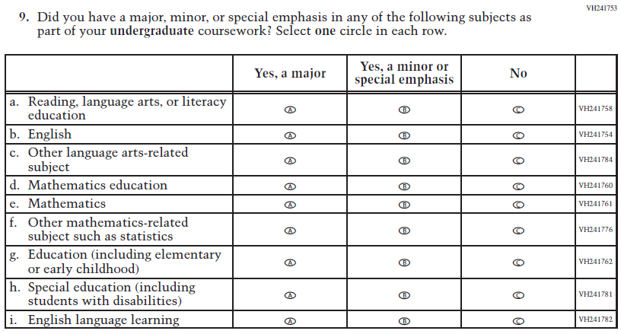  (2021 Grade 4) | Issue: Teacher Preparation | NC | N/A
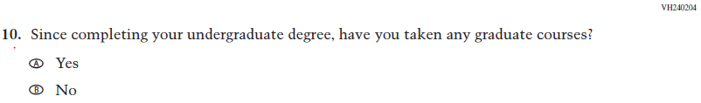  (2021 Grade 4) | Issue: Teacher Preparation | NC | N/A

2022 Operational Grade 4 Core Teacher

Previous item | 2022 item | D/A/ R/NC+ | Rationale
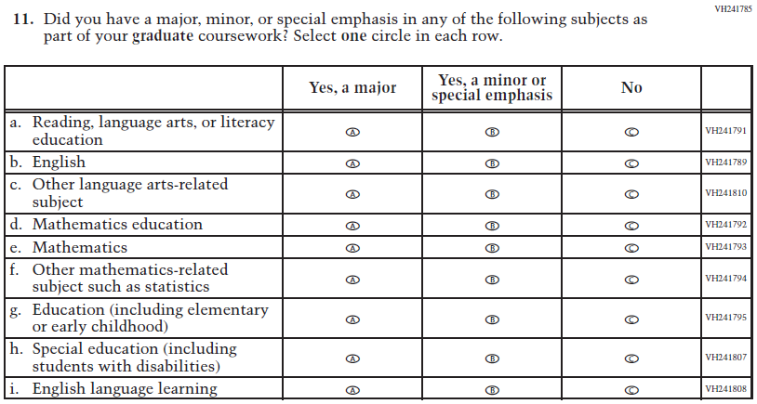  (2021 Grade 4) | Issue: Teacher Preparation | NC | N/A
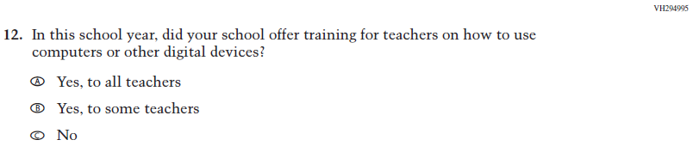  (2021 Grade 4) | 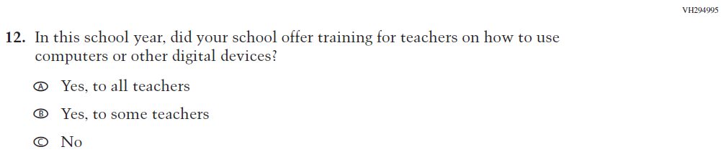  Issue: Technology Use | NC | N/A
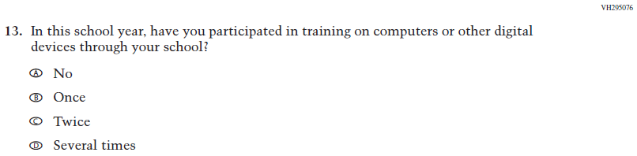  (2021 Grade 4) | Issue: Technology Use | NC | N/A
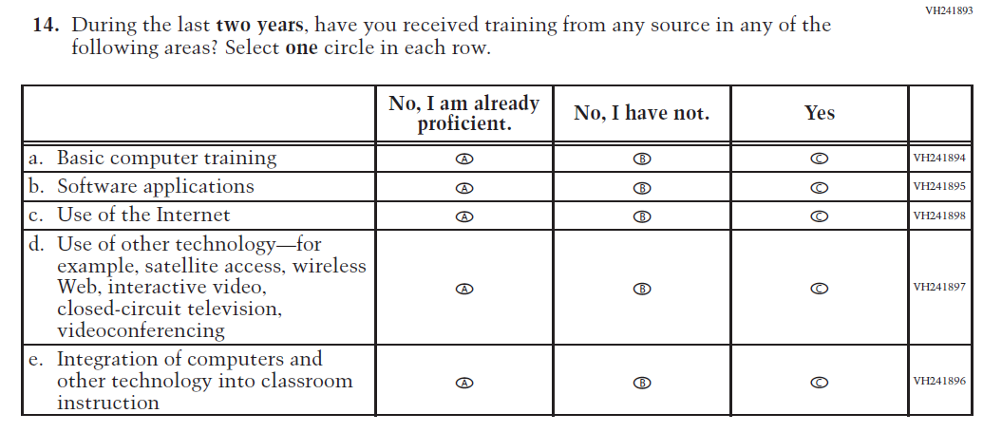  (2021 Grade 4) | 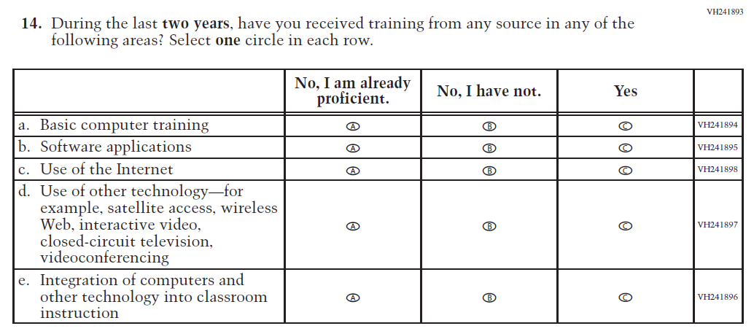  Issue: Teacher Preparation | NC | N/A
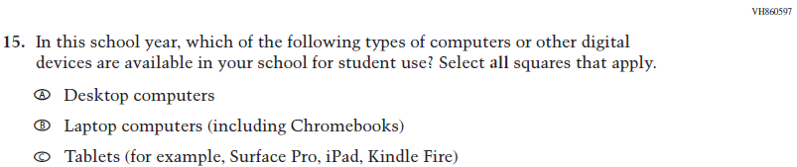  (2021 Grade 4) | Issue: Technology Use | NC | N/A
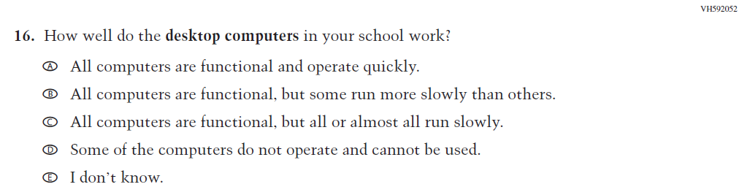  (2021 Grade 4) | Issue: Technology Use | NC | N/A
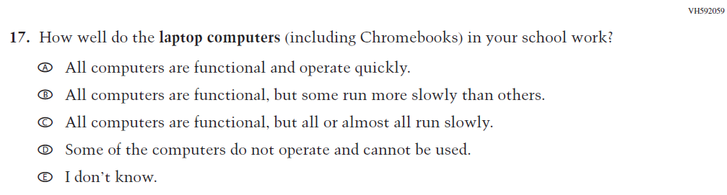  (2021 Grade 4) | Issue: Technology Use | NC | N/A

2022 Operational Grade 4 Core Teacher

Previous item | 2022 item | D/A/ R/NC+ | Rationale
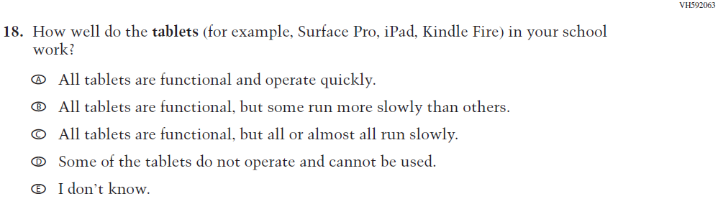  (2021 Grade 4) | Issue: Technology Use | NC | N/A
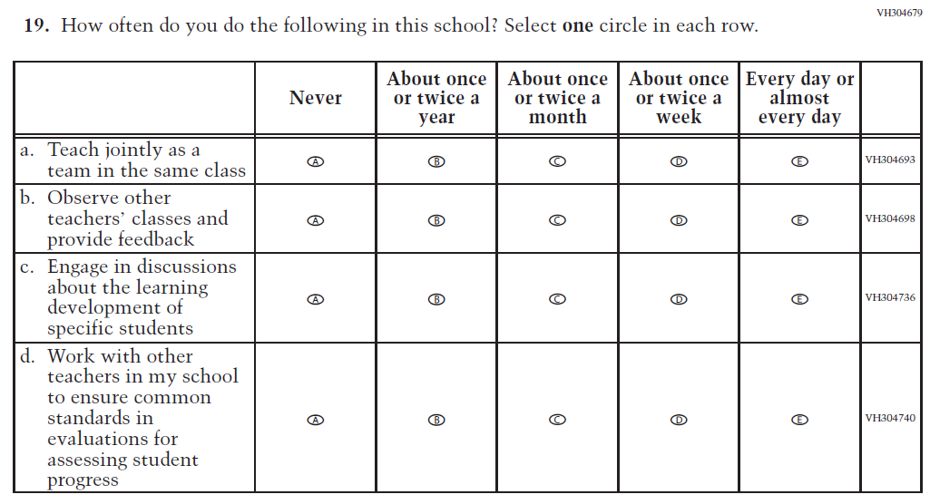  (2021 Grade 4) | Issue: School Climate | NC | N/A
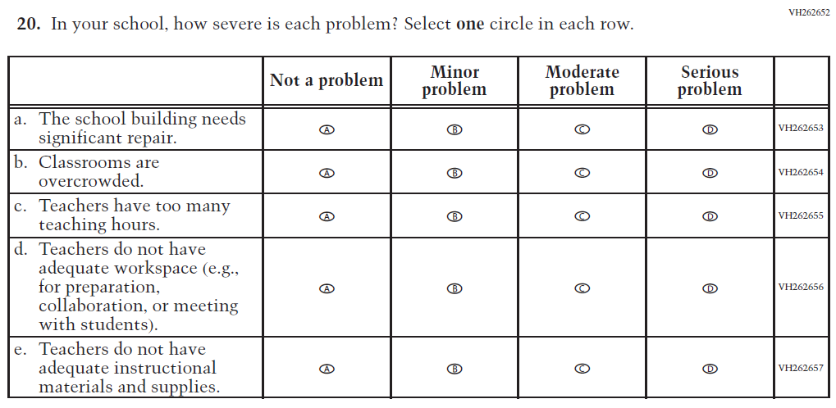  (2021 Grade 4) | Issue: School Climate | NC | N/A

2022 Operational Grade 4 Core Teacher

Previous item | 2022 item | D/A/ R/NC+ | Rationale
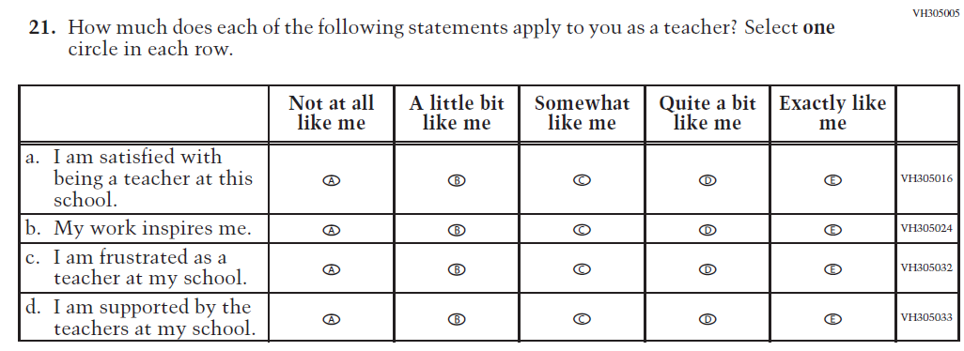  (2021 Grade 4) | Issue: School Climate | NC | N/A
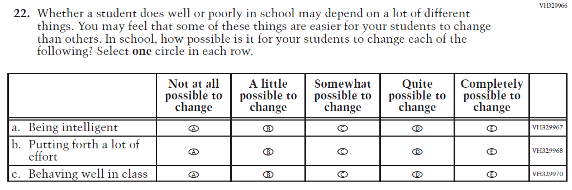  (2021 Grade 4) | Issue: Desire for Learning | NC | N/A

Appendix J2-2: Operational Grade 4 CORE
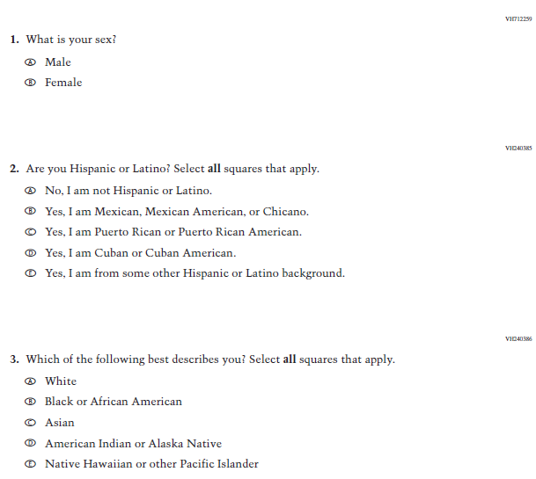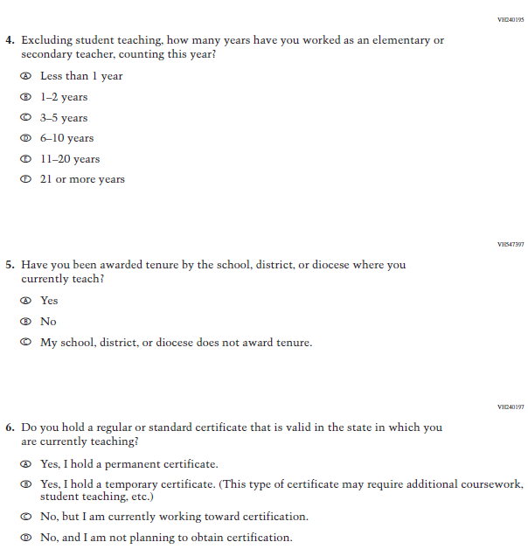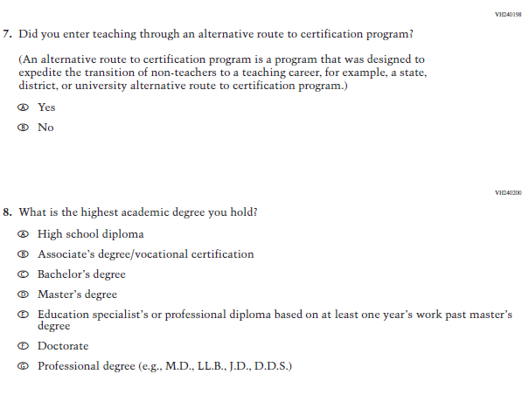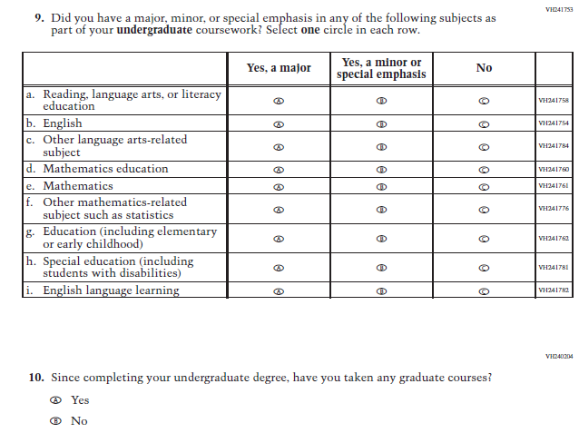
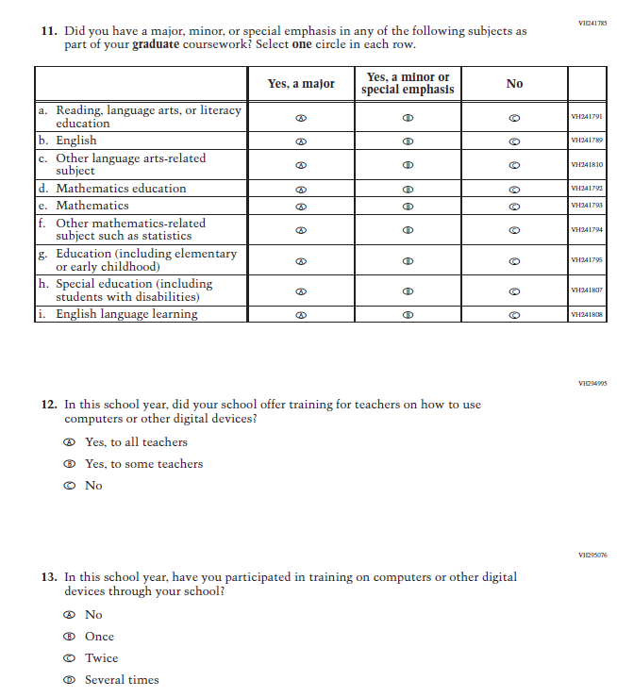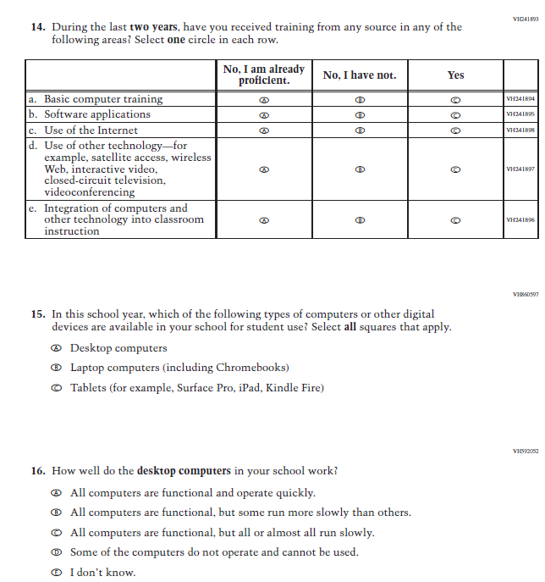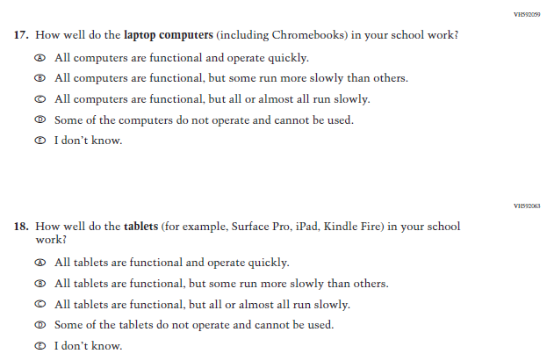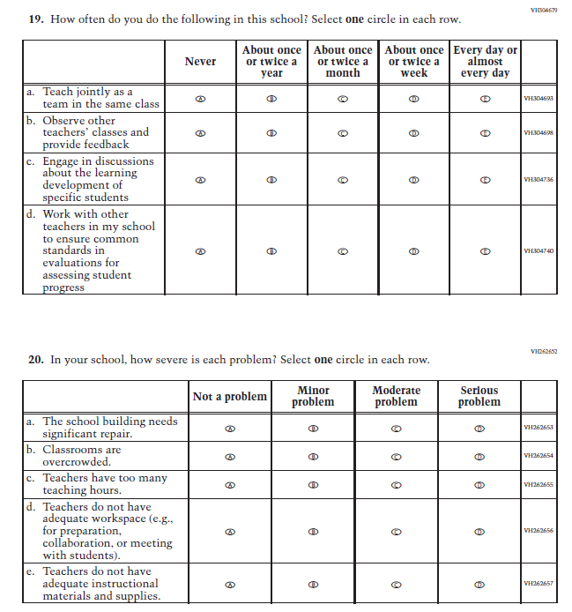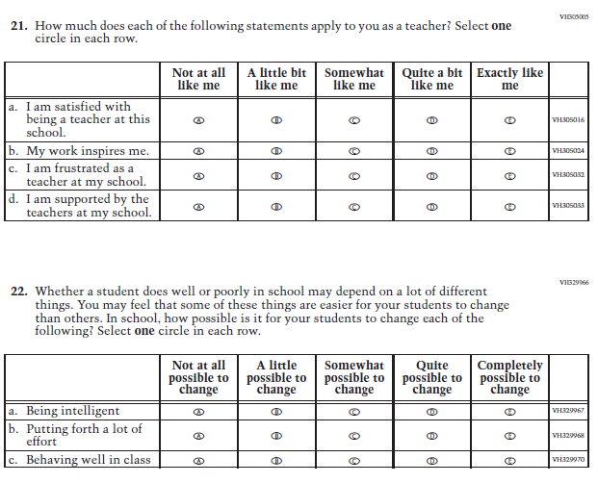

Appendix J2-3: Summary of Changes Operational Grade 8 CORE
2022 Operational Grade 8 Core Teacher

Previous item | 2022 item | D/A/ R/NC+ | Rationale
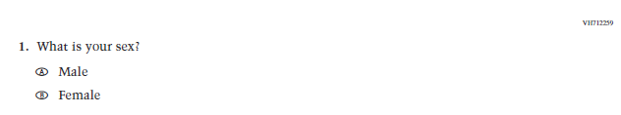  (2021 Grade 8) | Issue: Gender | NC | N/A
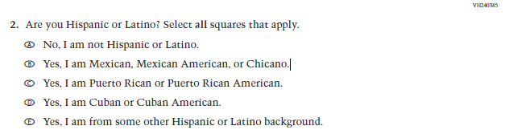  (2021 Grade 8) | Issue: Race/Ethnicity | NC | N/A
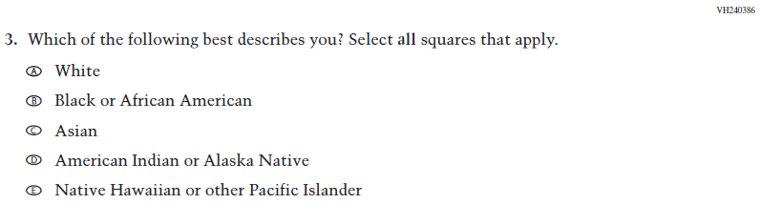  (2021 Grade 8) | Issue: Race/Ethnicity | NC | N/A
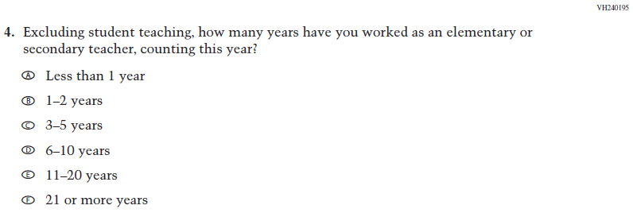  (2021 Grade 8) | Issue: Teacher Preparation | NC | N/A
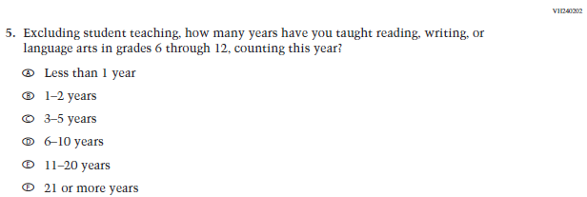  (2021 Grade 8) | Issue: Teacher Preparation | NC | N/A
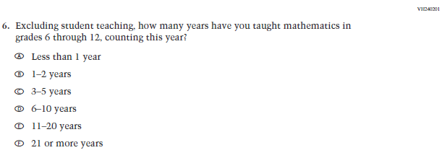  (2021 Grade 8) | Issue: Teacher Preparation | NC | N/A
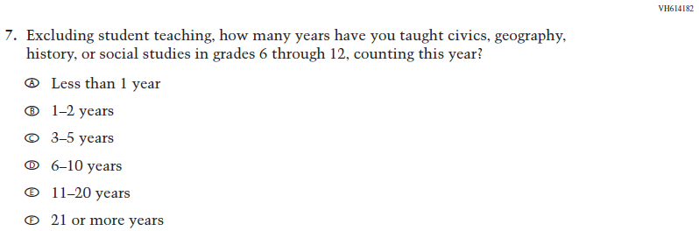  (2021 Grade 8) | Issue: Teacher Preparation | NC | N/A
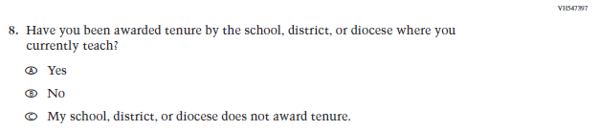  (2021 Grade 8) | Issue: Teacher Preparation | NC | N/A
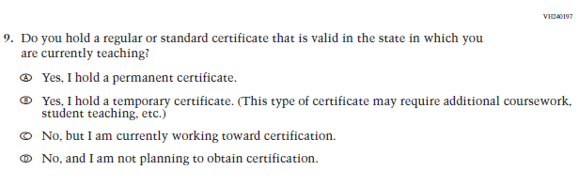  (2021 Grade 8) | Issue: Teacher Preparation | NC | N/A
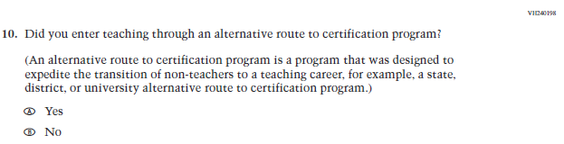  (2021 Grade 8) | Issue: Teacher Preparation | NC | N/A
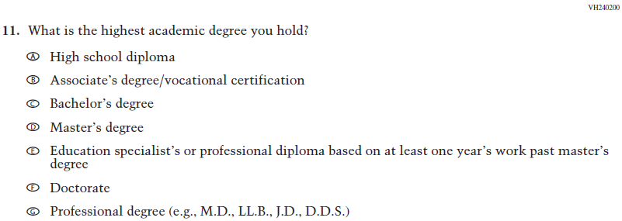  (2021 Grade 8) | Issue: Teacher Preparation | NC | N/A
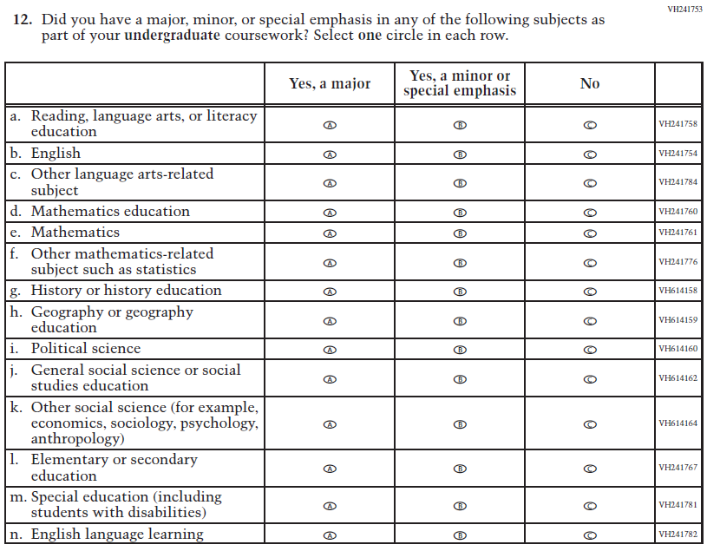  (2021 Grade 8) | Issue: Teacher Preparation | NC | N/A
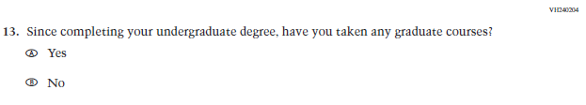  (2021 Grade 8) | Issue: Teacher Preparation | NC | N/A
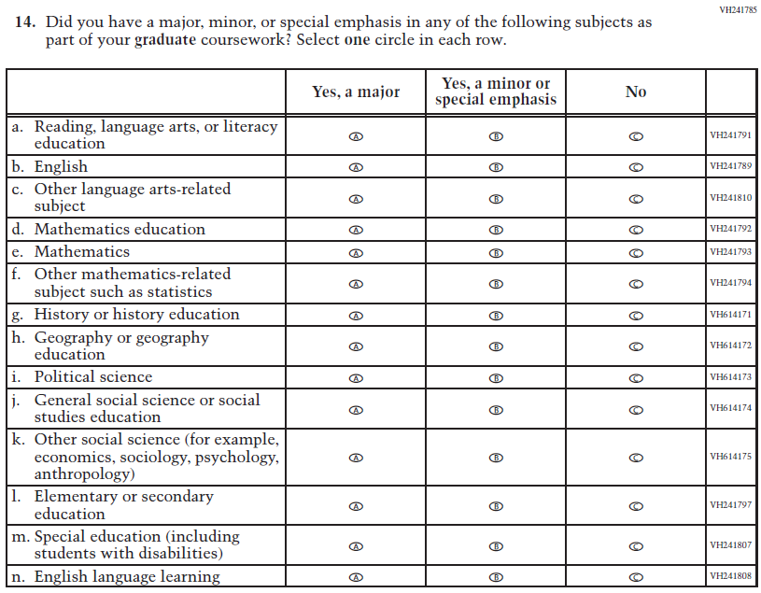  (2021 Grade 8) | Issue: Teacher Preparation | NC | N/A
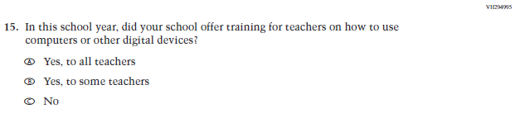  (2021 Grade 8) | Issue: Technology Use | NC | N/A
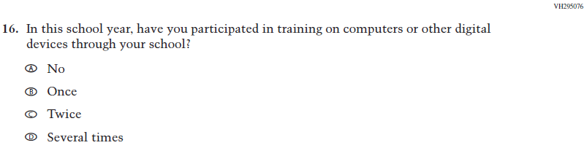  (2021 Grade 8) | Issue: Technology Use | NC | N/A
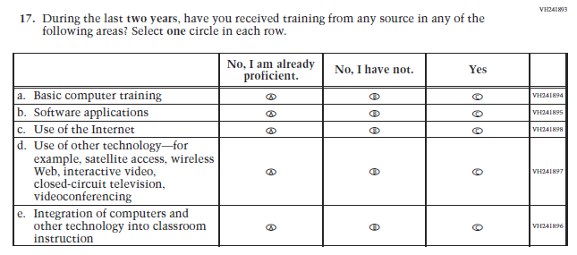  (2021 Grade 8) | Issue: Teacher Preparation | NC | N/A
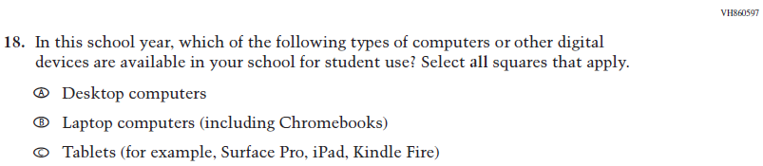  (2021 Grade 8) | Issue: Technology Use | NC | N/A
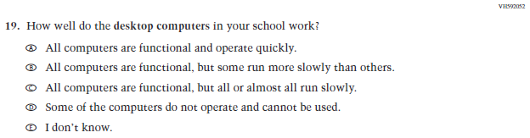  (2021 Grade 8) | Issue: Technology Use | NC | N/A
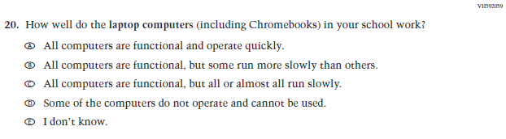  (2021 Grade 8) | Issue: Technology Use | NC | N/A
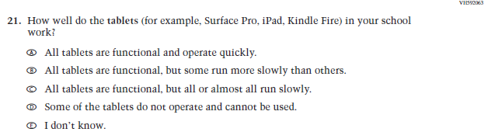  (2021 Grade 8) | Issue: Technology Use | NC | N/A
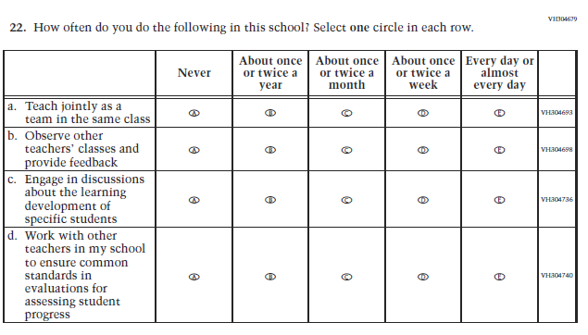  (2021 Grade 8) | Issue: School Climate | NC | N/A
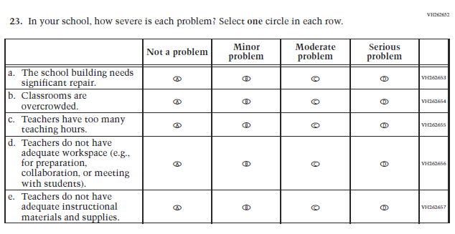  (2021 Grade 8) | Issue: School Climate | NC | N/A
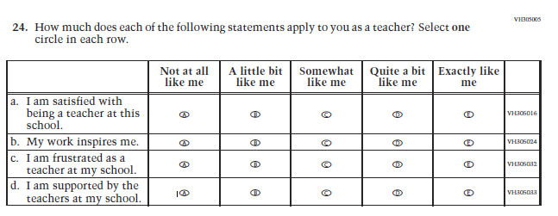  (2021 Grade 8) | Issue: School Climate | NC | N/A
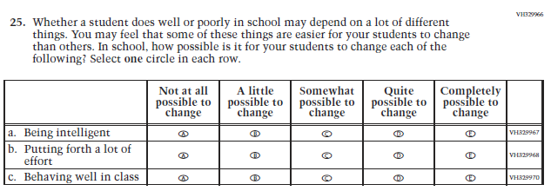  (2021 Grade 8) | Issue: Desire for Learning | NC | N/A

Appendix J2-4: Operational Grade 8 CORE
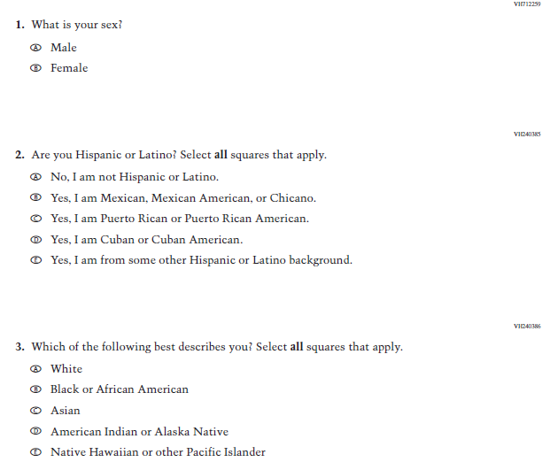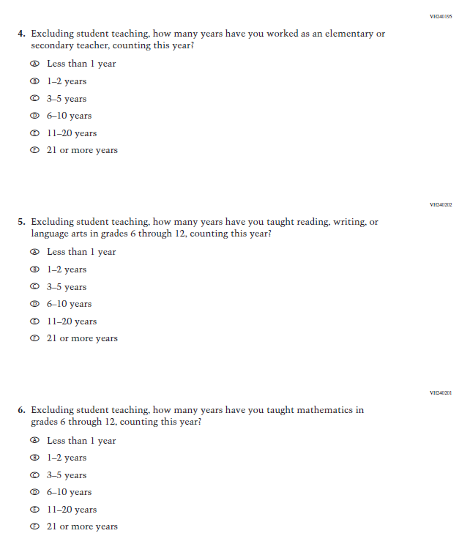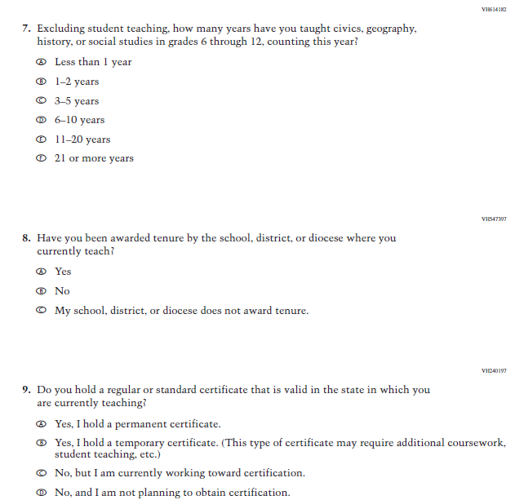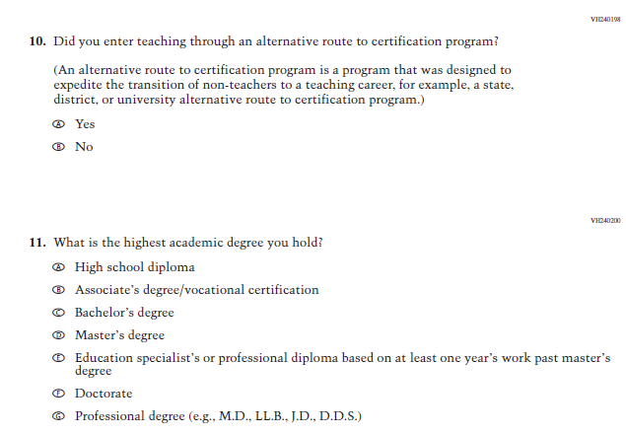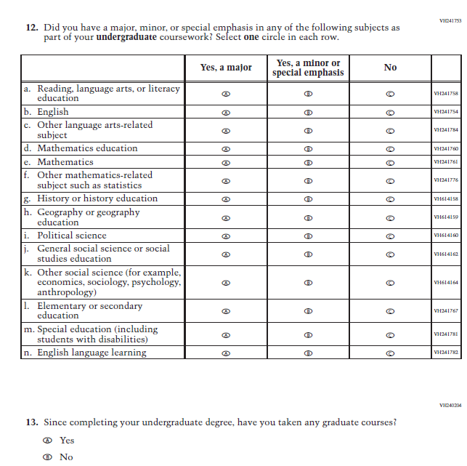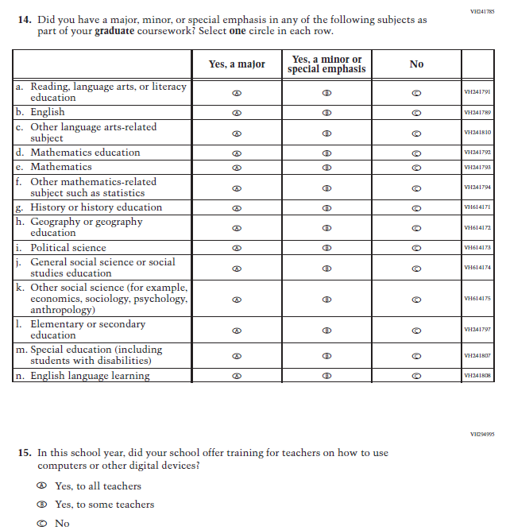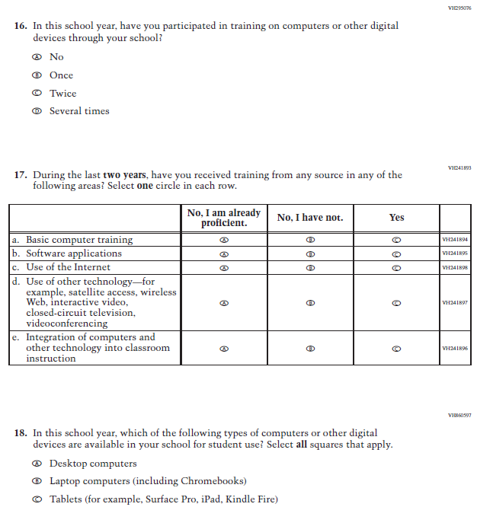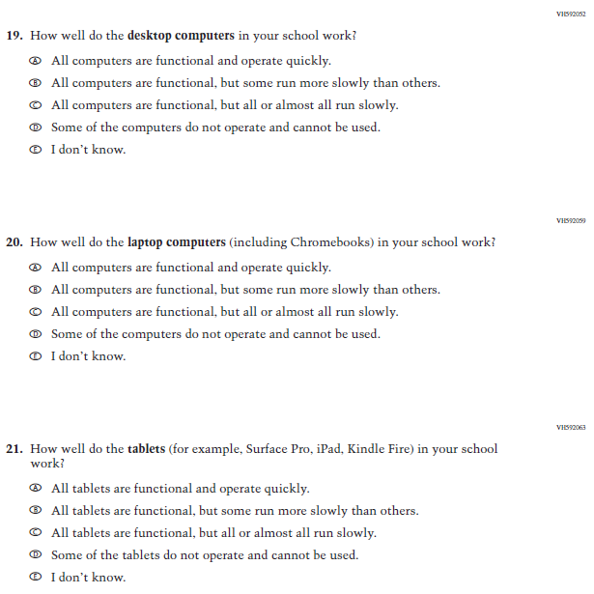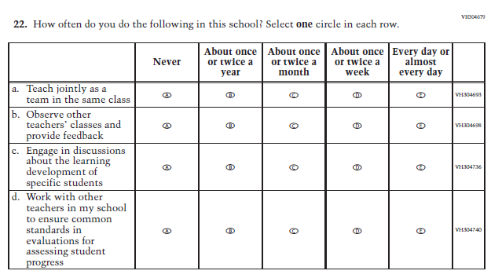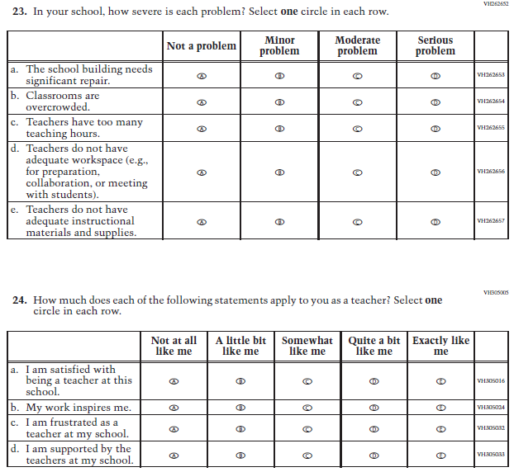
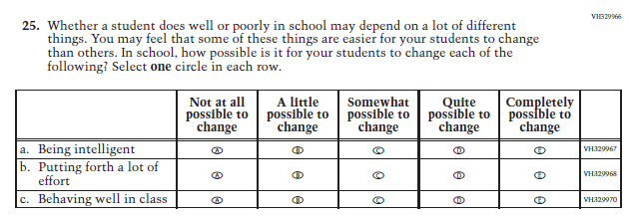

Appendix J2-5: Summary of Changes Operational Grade 4 Mathematics
2022 Operational Grade 4 Mathematics Teacher

Previous item | 2022 item | D/A/ R/NC+ | Rationale
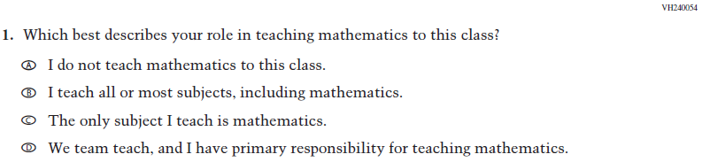  (2021 Grade 4) | Issue: Resources for Learning and Instruction | NC | N/A
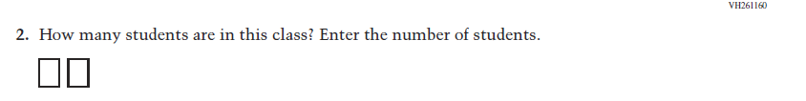  (2021 Grade 4) | Issue: Resources for Learning and Instruction | NC | N/A
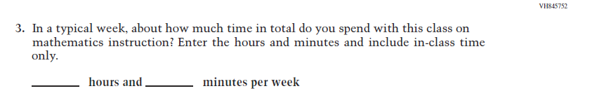  (2021 Grade 4) | Issue: Resources for Learning and Instruction | NC | N/A
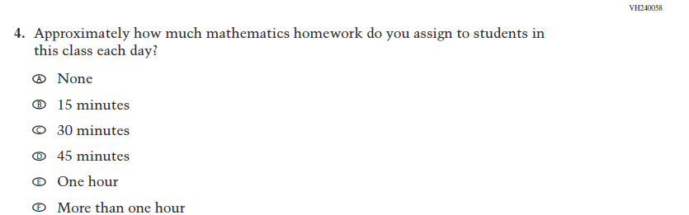  (2021 Grade 4) | Issue: Organization of Instruction | NC | N/A
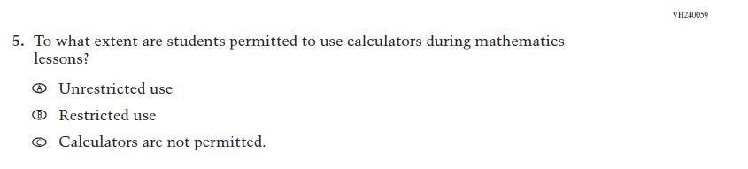  (2021 Grade 4) | Issue: Organization of Instruction | NC | N/A
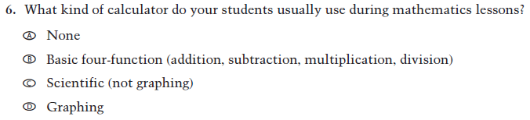  (2021 Grade 4) | Issue: Resources for learning and instruction | NC | N/A
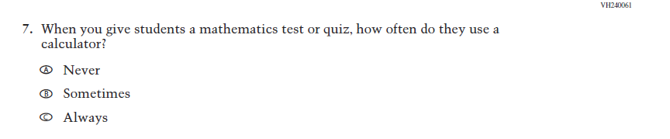  (2021 Grade 4) | Issue: Organization of Instruction | NC | N/A
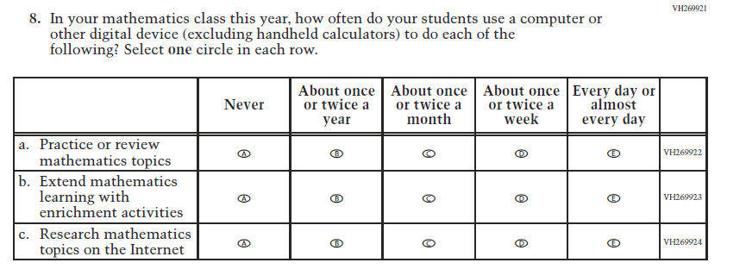  (2021 Grade 4) | Issue: Organization of Instruction | NC | N/A
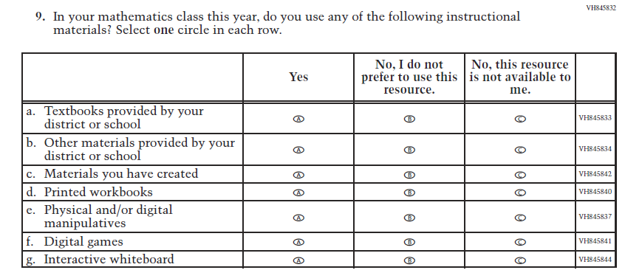  (2021 Grade 4) | Issue: Resources for Learning and Instruction | NC | N/A
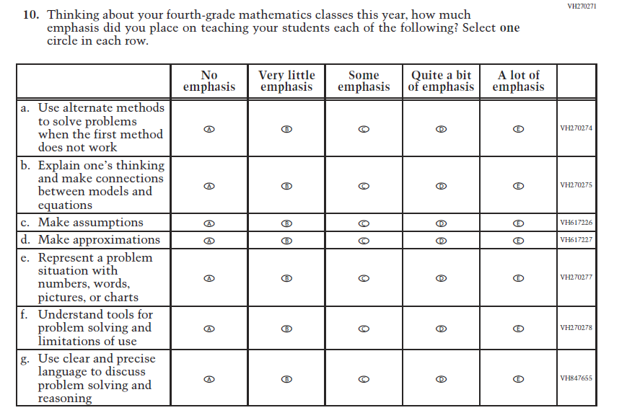  (2021 Grade 4) | Issue: Organization of Instruction | NC | N/A
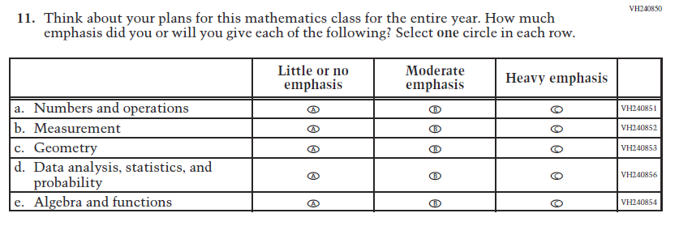  (2021 Grade 4) | Issue: Organization of Instruction | NC | N/A
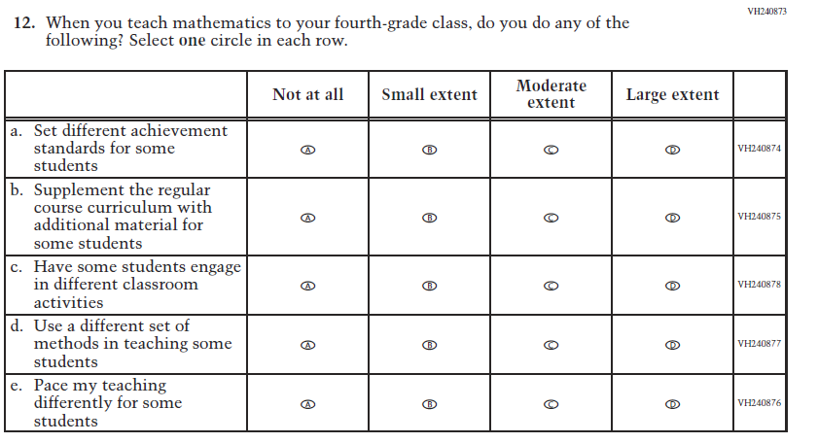  (2021 Grade 4) | Issue: Organization of Instruction | NC | N/A
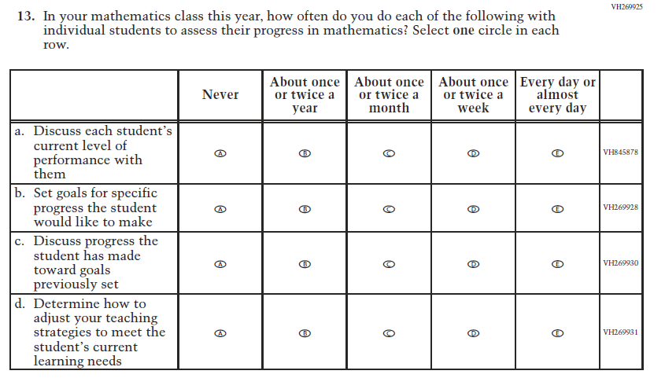  (2021 Grade 4) | Issue: Organization of Instruction | NC | N/A
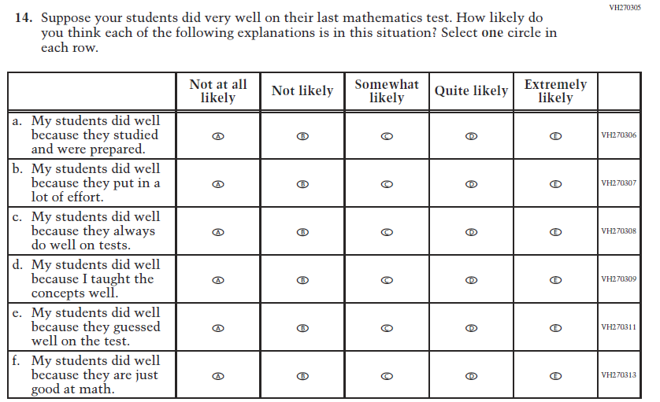  (2021 Grade 4) | Issue: Teacher Preparation | NC | N/A
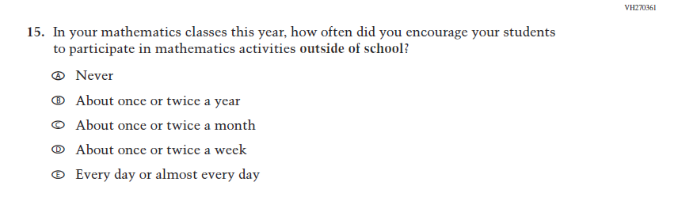  (2021 Grade 4) | Issue: Resources for Learning and Instruction | NC | N/A
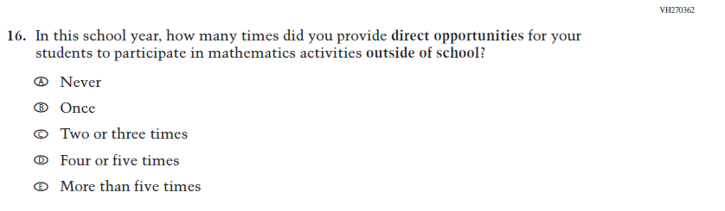  (2021 Grade 4) | Issue: Resources for Learning and Instruction | NC | N/A

Appendix J2-6: Operational Grade 4 Mathematics

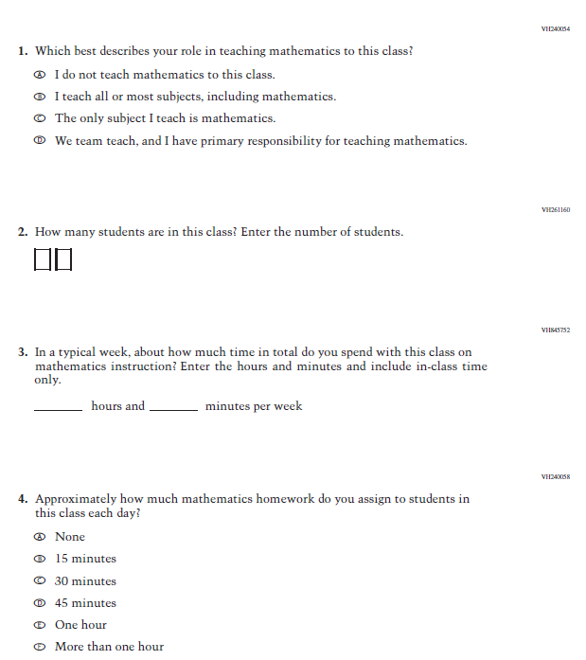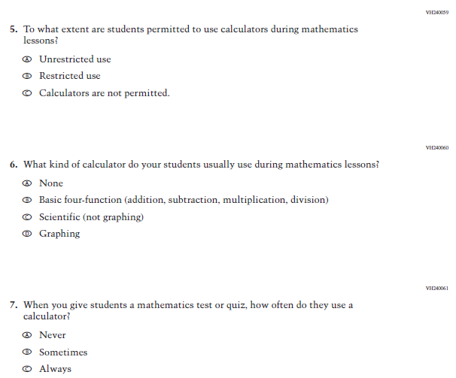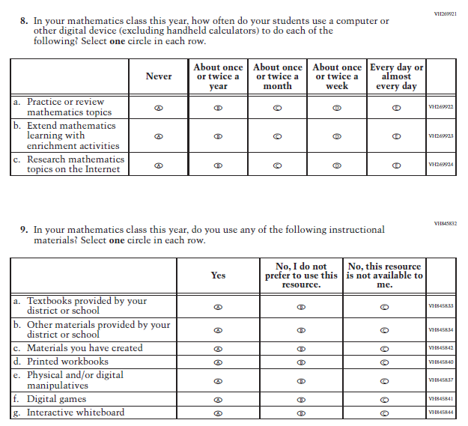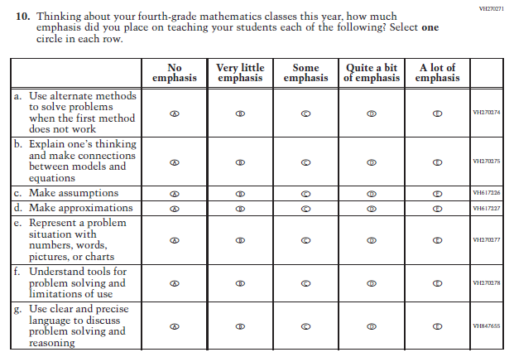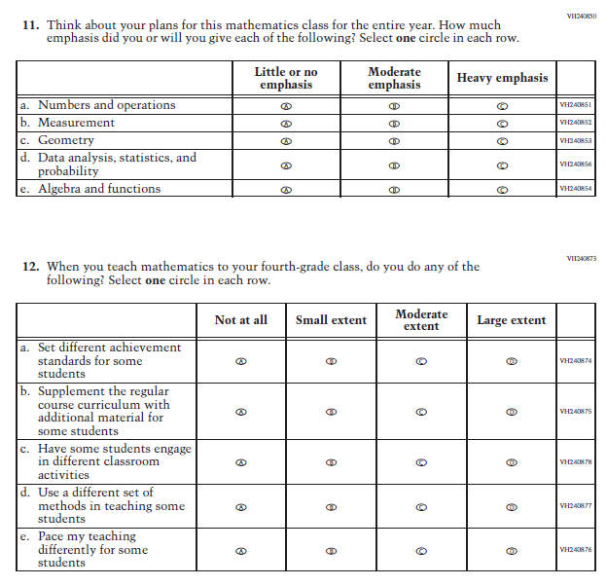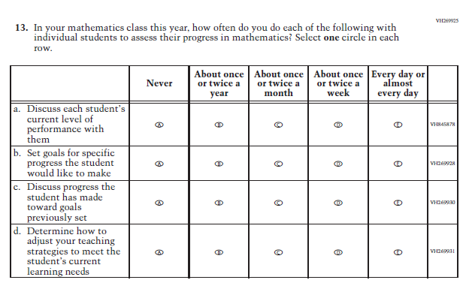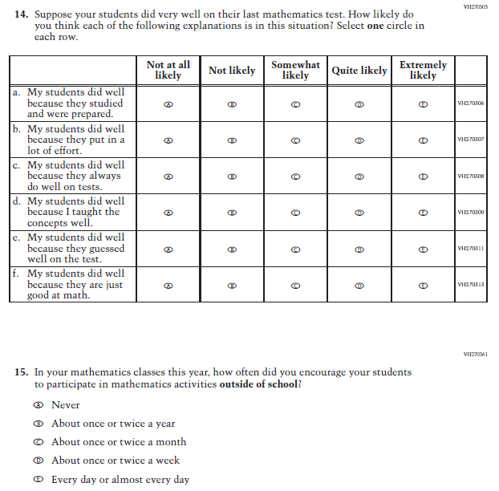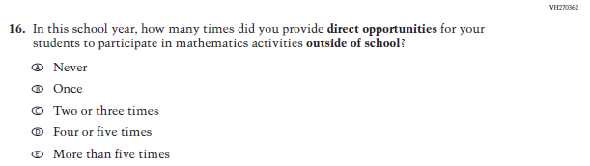

Appendix J2-7: Summary of Changes Operational Grade 8 Mathematics
2022 Operational Grade 8 Mathematics Teacher

Previous item | 2022 item | D/A/ R/NC+ | Rationale
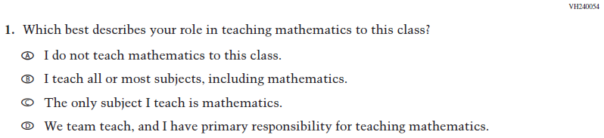  (2021 Grade 8) | Issue: Resources for Learning and Instruction | NC | N/A
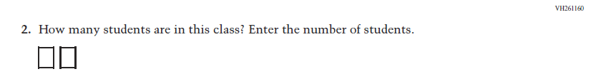  (2021 Grade 8) | 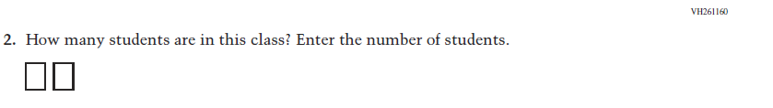  Issue: Resources for Learning and Instruction | NC | N/A
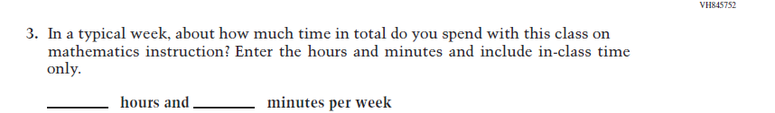  (2021 Grade 8) | Issue: Resources for Learning and Instruction | NC | N/A
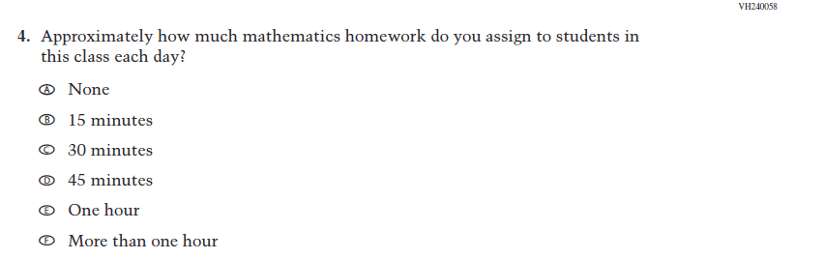  (2021 Grade 8) | Issue: Organization of Instruction | NC | N/A
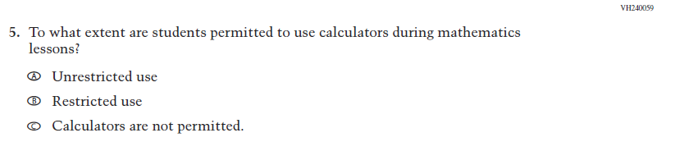  (2021 Grade 8) | Issue: Organization of Instruction | NC | N/A
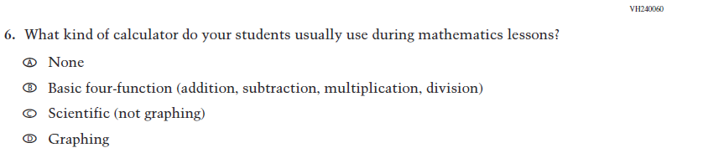  (2021 Grade 8) | Issue: Resources for Learning and Instruction | NC | N/A
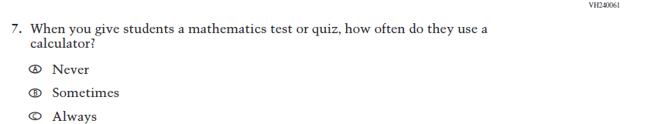  (2021 Grade 8) | Issue: Organization of Instruction | NC | N/A
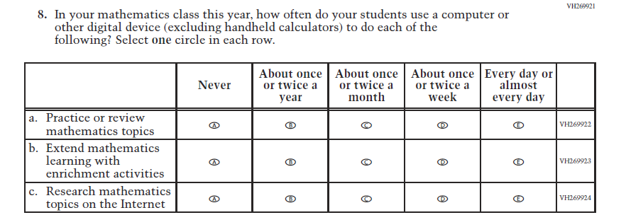  (2021 Grade 8) | Issue: Organization of Instruction | NC | N/A
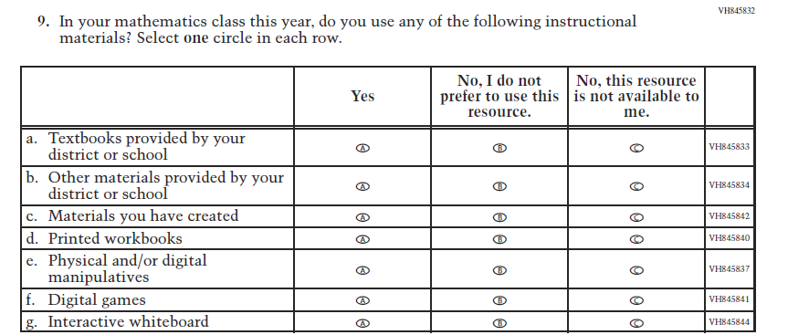  (2021 Grade 8) | Issue: Resources for Learning and Instruction | NC | N/A

2022 Operational Grade 8 Mathematics Teacher

Previous item | 2022 item | D/A/ R/NC+ | Rationale
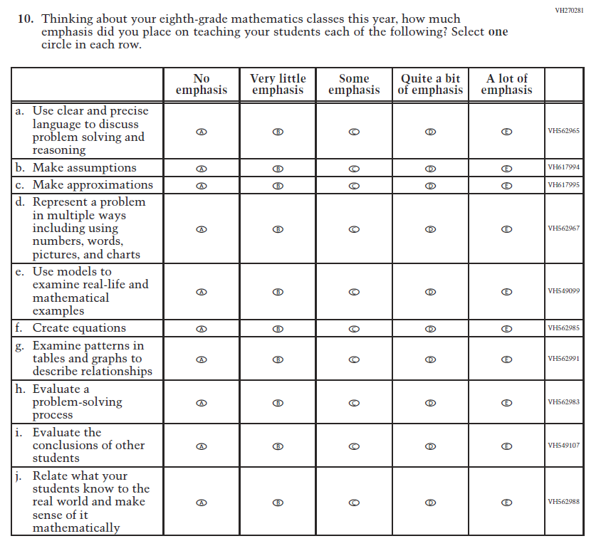  (2021 Grade 8) | Issue: Organization of Instruction | NC | N/A
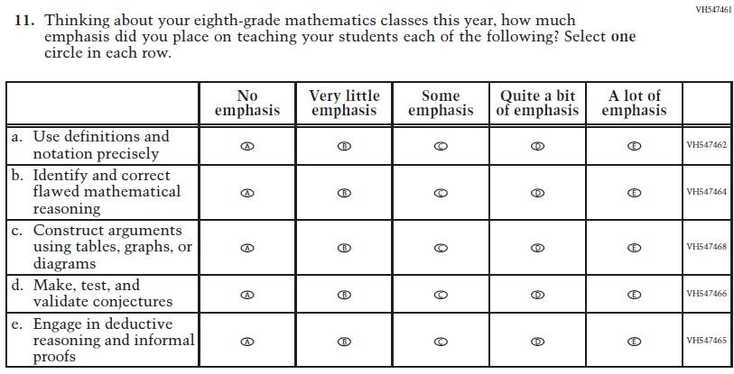  (2021 Grade 8) | Issue: Organization of Instruction | NC | N/A

2022 Operational Grade 8 Mathematics Teacher

Previous item | 2022 item | D/A/ R/NC+ | Rationale
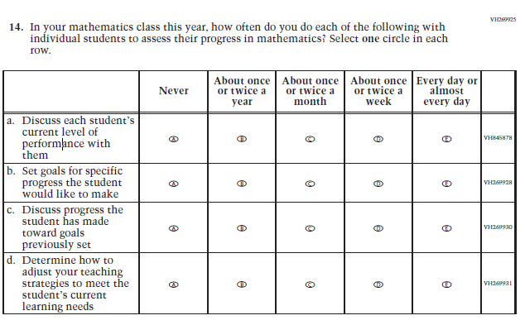  (2021 Grade 8) | Issue: Organization of Instruction | NC | N/A
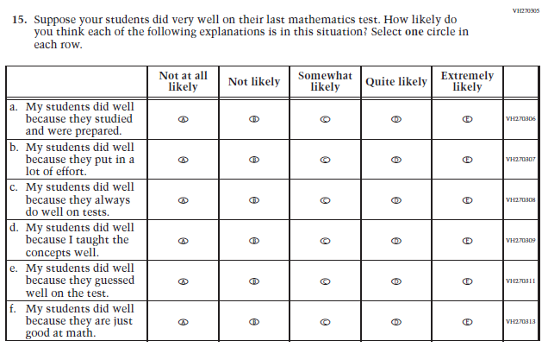  (2021 Grade 8) | Issue: Teacher Preparation | NC | N/A

2022 Operational Grade 8 Mathematics Teacher

Previous item | 2022 item | D/A/ R/NC+ | Rationale
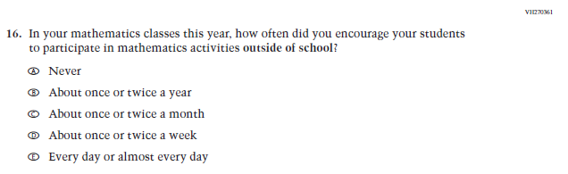  (2021 Grade 8) | Issue: Resources for Learning and Instruction | NC | N/A
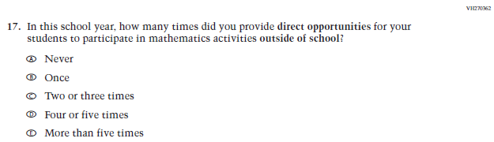  (2021 Grade 8) | Issue: Resources for Learning and Instruction | NC | N/A
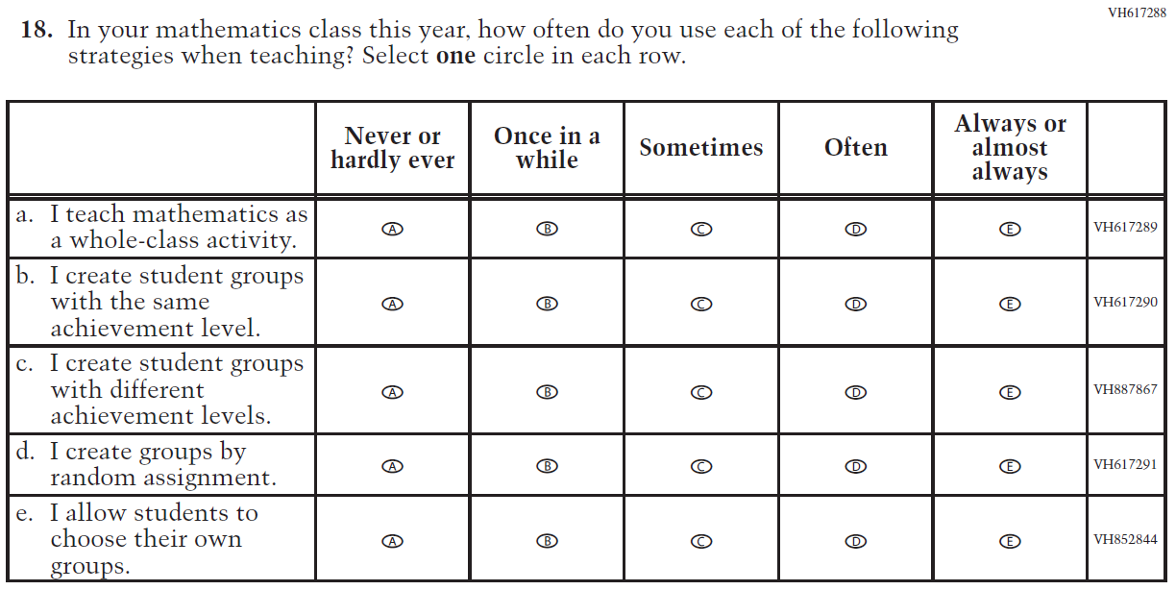  (2021 Grade 8) | Issue: Organization of Instruction | NC | N/A

Appendix J2-8: Operational Grade 8 Mathematics
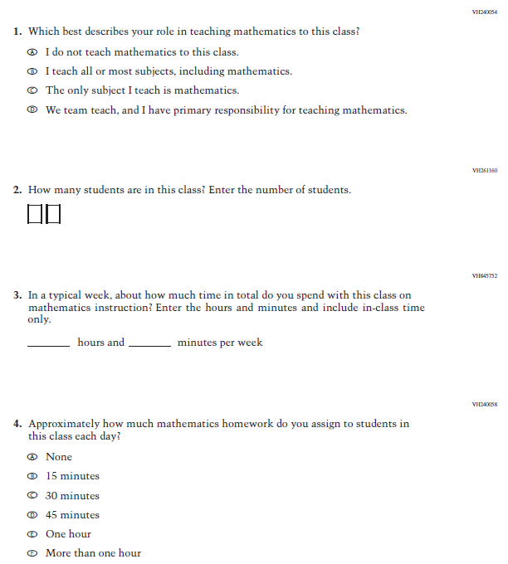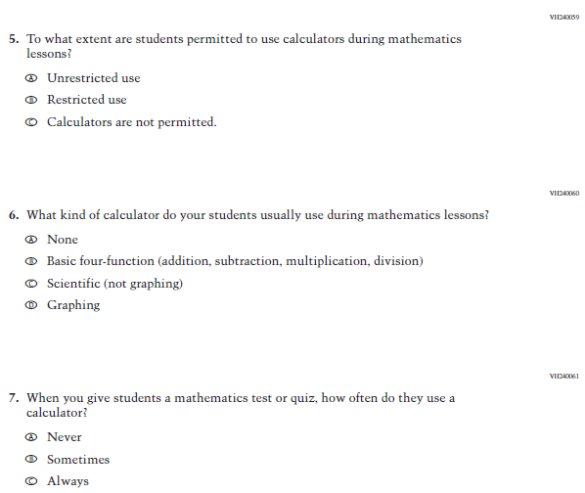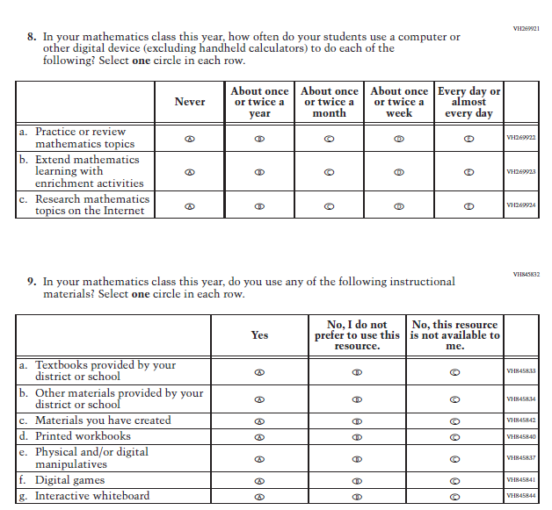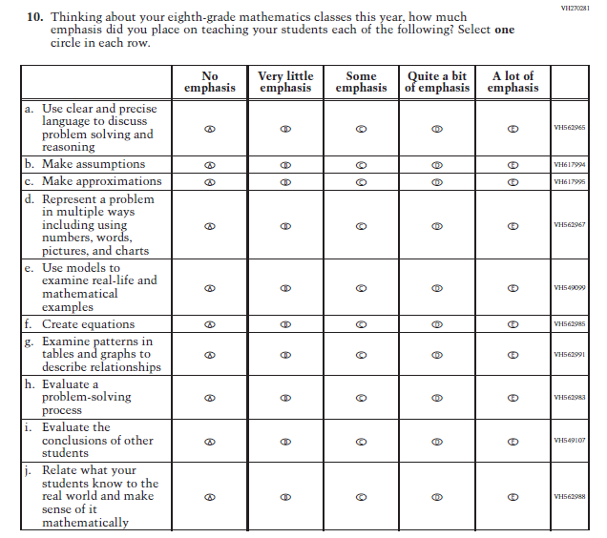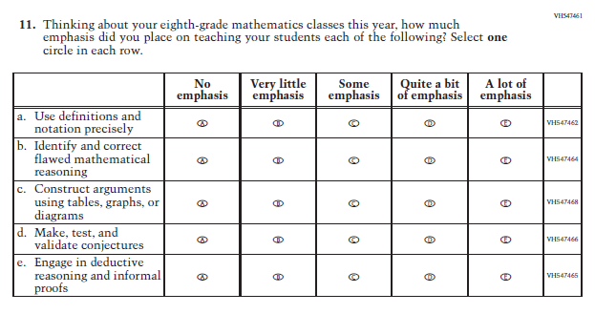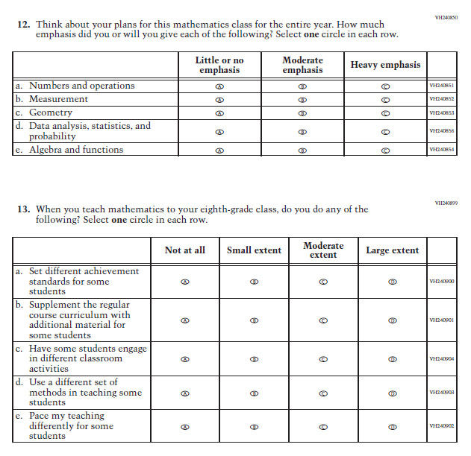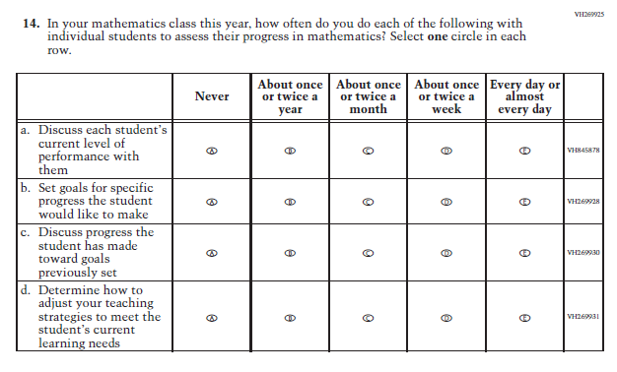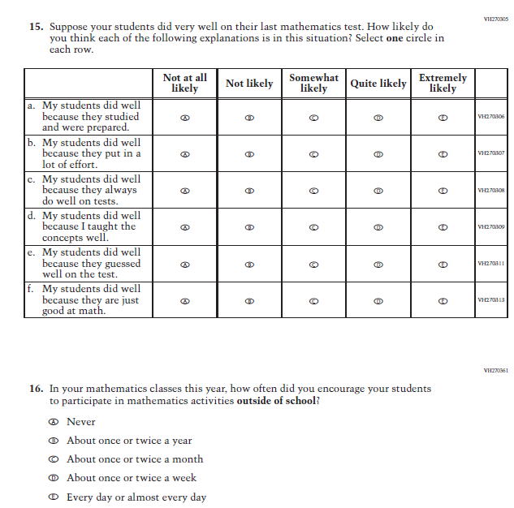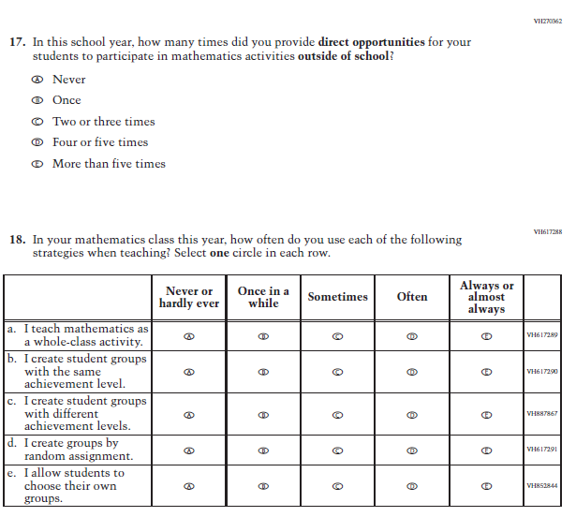

Appendix J2-9: Summary of Changes Operational Grade 4 Reading
2022 Operational Grade 4 Reading Teacher

Previous item | 2022 item | D/A/ R/NC+ | Rationale
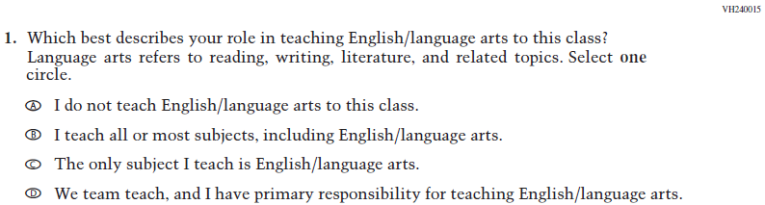  (2021 Grade 4) | Issue: Resources for Learning and Instruction | NC | N/A
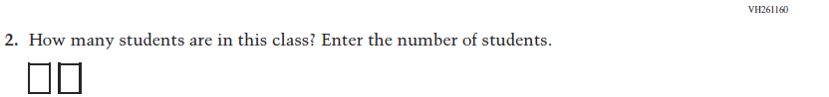  (2021 Grade 4) | Issue: Resources for Learning and Instruction | NC | N/A
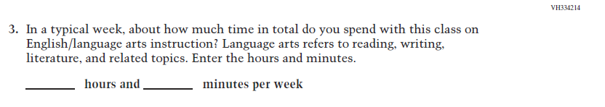  (2021 Grade 4) | Issue: Resources for Learning and Instruction | NC | N/A
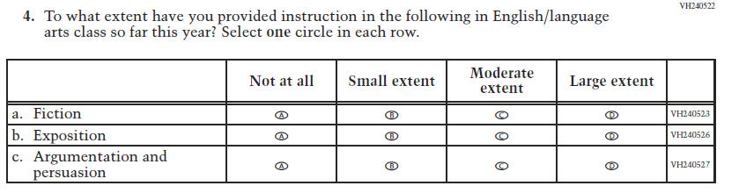  (2021 Grade 4) | Issue: Organization of Instruction | NC | N/A

2022 Operational Grade 4 Reading Teacher

Previous item | 2022 item | D/A/ R/NC+ | Rationale
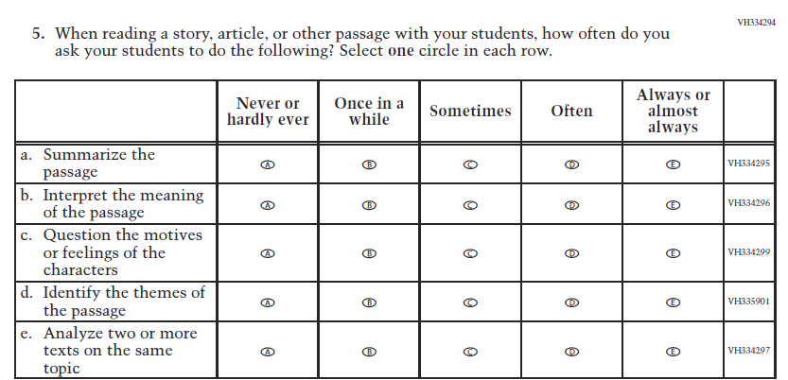  (2021 Grade 4) | Issue: Organization of Instruction | NC | N/A
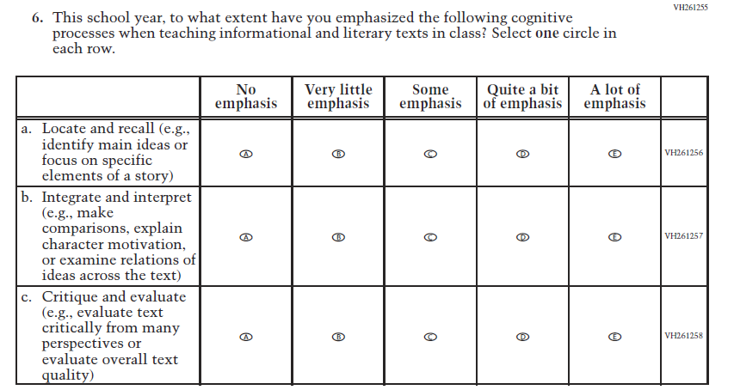  (2021 Grade 4) | Issue: Organization of Instruction | NC | N/A

2022 Operational Grade 4 Reading Teacher

Previous item | 2022 item | D/A/ R/NC+ | Rationale
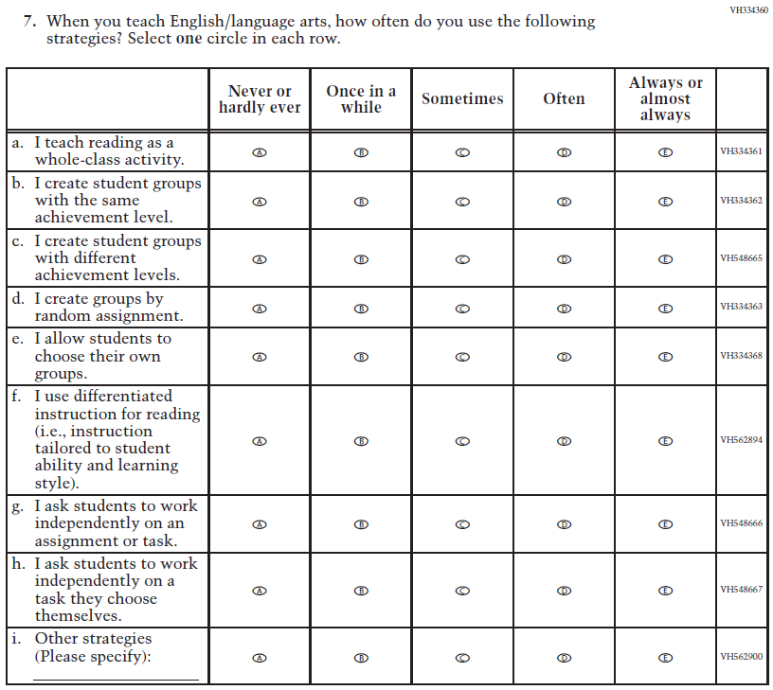  (2021 Grade 4) | Issue: Organization of Instruction | NC | N/A

2022 Operational Grade 4 Reading Teacher

Previous item | 2022 item | D/A/ R/NC+ | Rationale
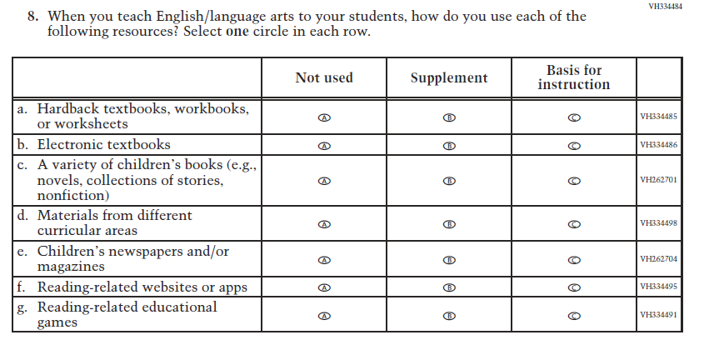  (2021 Grade 4) | Issue: Organization of Instruction | NC | N/A
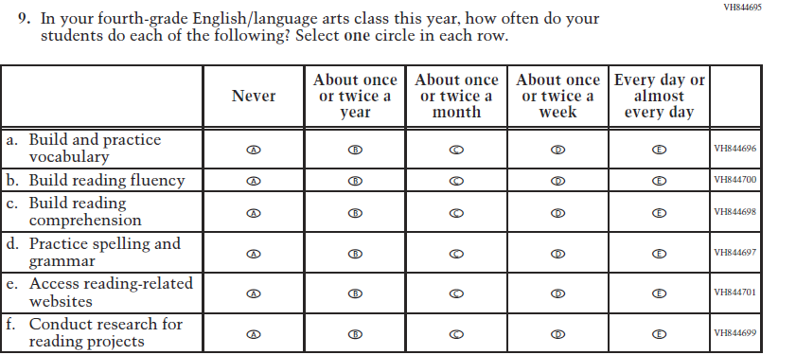  (2021 Grade 4) | Issue: Organization of Instruction | NC | N/A

2022 Operational Grade 4 Reading Teacher

Previous item | 2022 item | D/A/ R/NC+ | Rationale
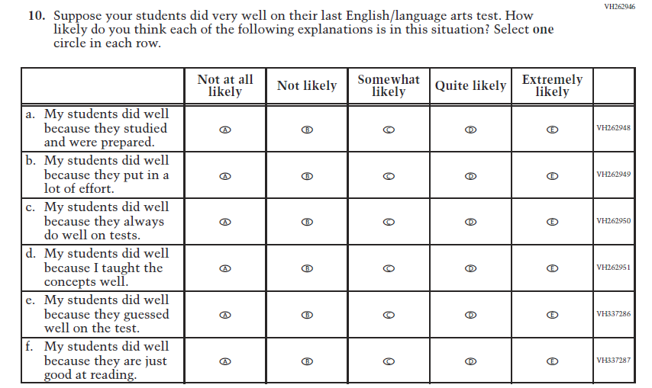  (2021 Grade 4) | Issue: Teacher Preparation | NC | N/A
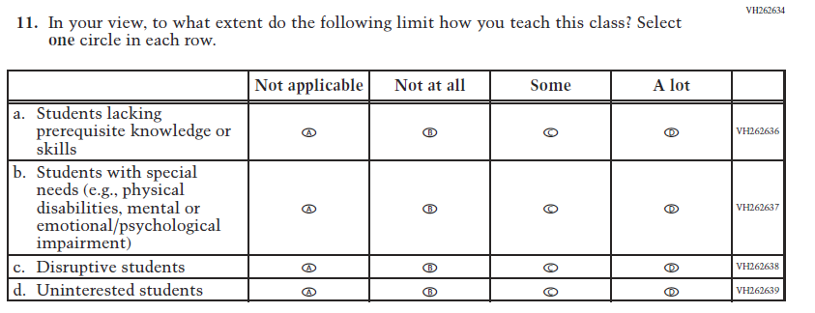  (2021 Grade 4) | Issue: Resources for Learning and Instruction | NC | N/A

Appendix J2-10: Operational Grade 4 Reading
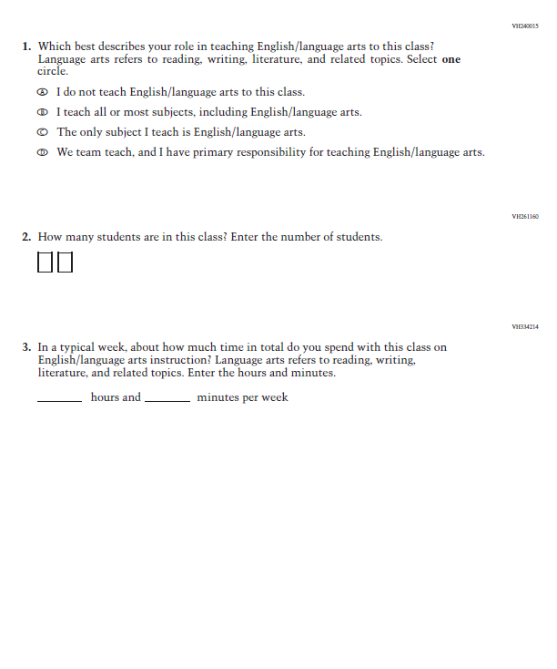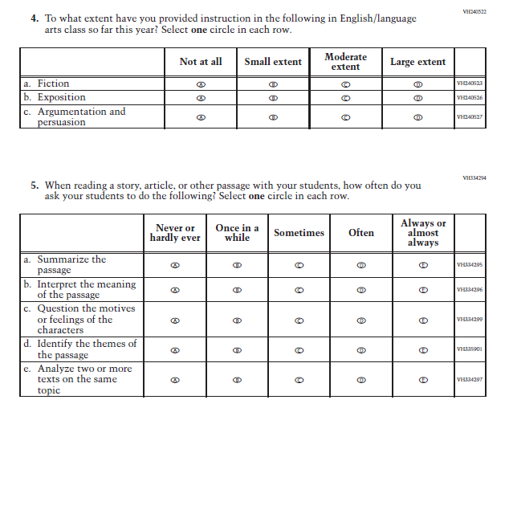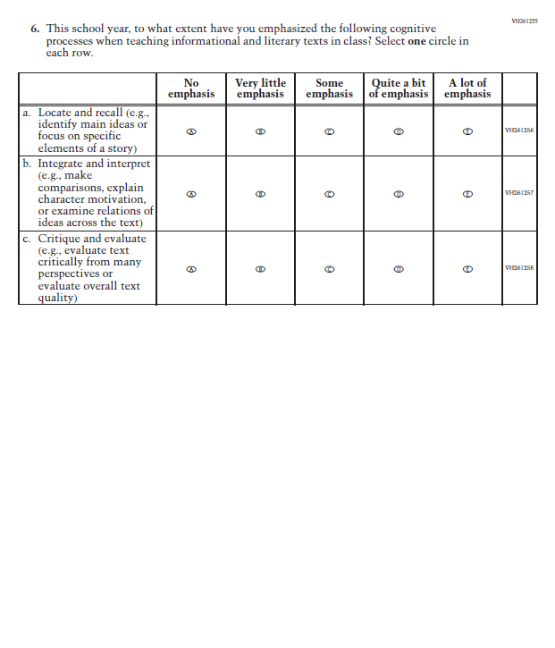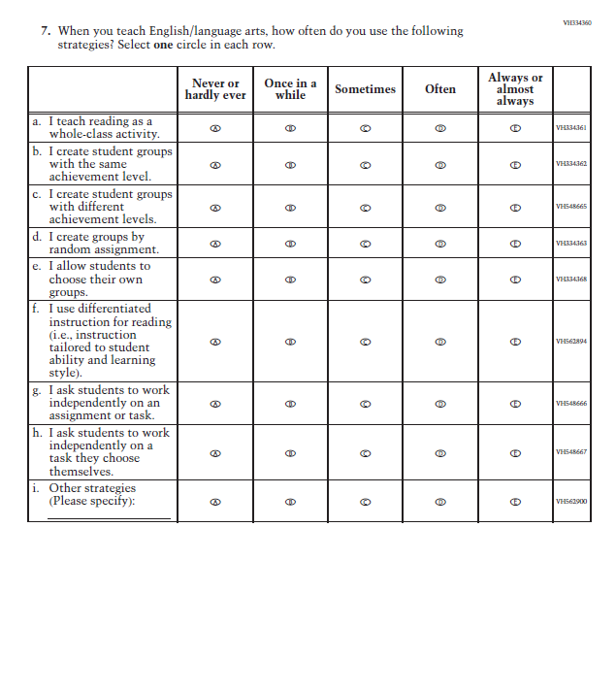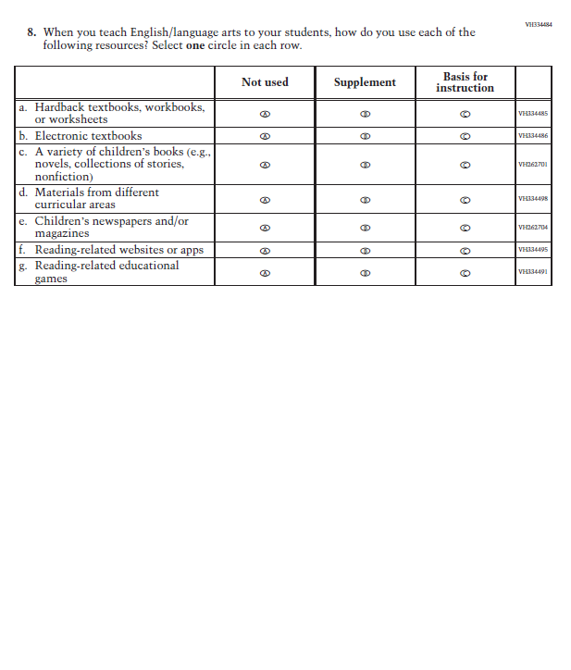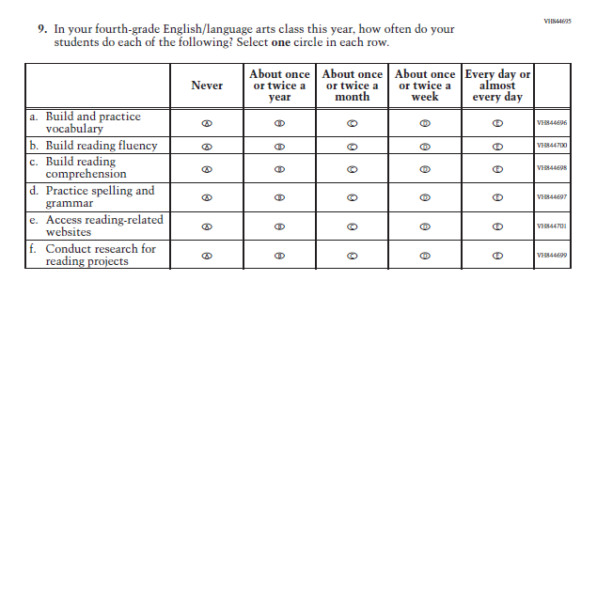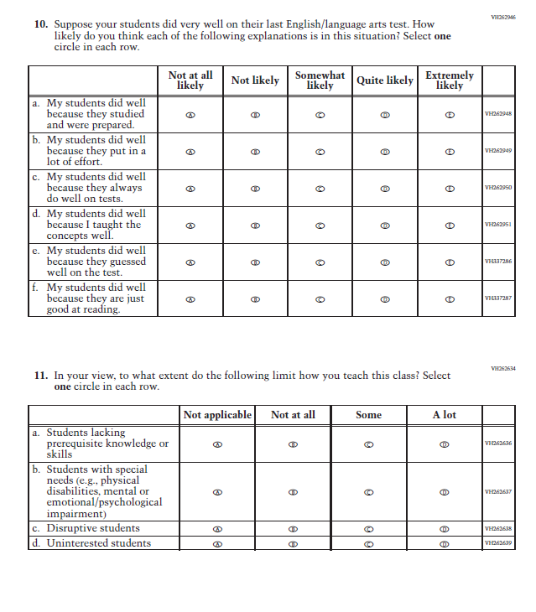

Appendix J2-11: Summary of Changes Operational Grade 8 Reading
2022 Operational Grade 8 Reading Teacher

Previous item | 2022 item | D/A/ R/NC+ | Rationale
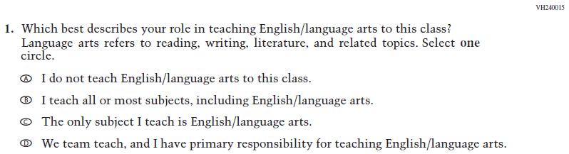  (2021 Grade 8) | Issue: Resources for Learning and Instruction | NC | N/A
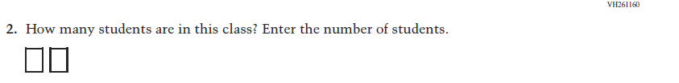  (2021 Grade 8) | Issue: Resources for Learning and Instruction | NC | N/A
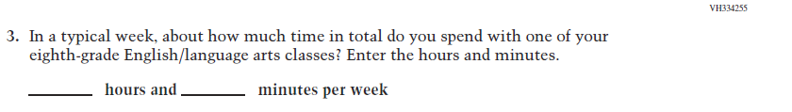  (2021 Grade 8) | Issue: Resources for Learning and Instruction | NC | N/A
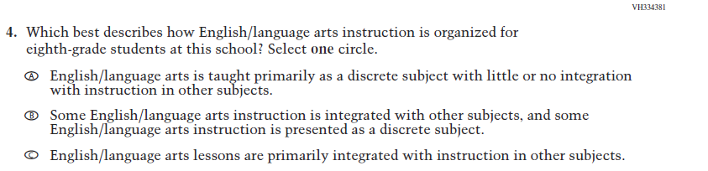  (2021 Grade 8) | Issue: Organization of Instruction | NC | N/A

2022 Operational Grade 8 Reading Teacher

Previous item | 2022 item | D/A/ R/NC+ | Rationale
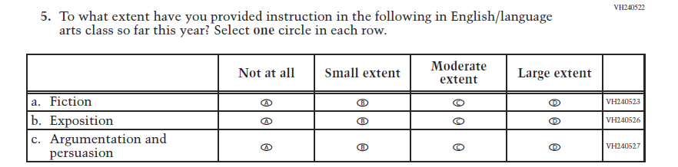  (2021 Grade 8) | Issue: Organization of Instruction | NC | N/A
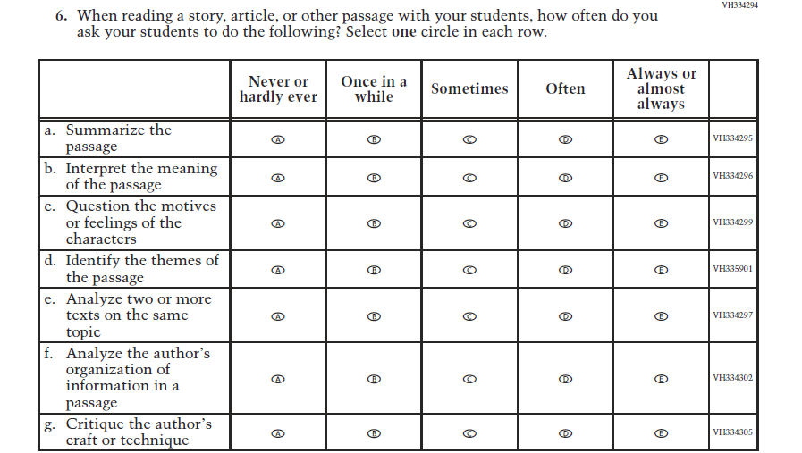  (2021 Grade 8) | Issue: Organization of Instruction | NC | N/A

2022 Operational Grade 8 Reading Teacher

Previous item | 2022 item | D/A/ R/NC+ | Rationale
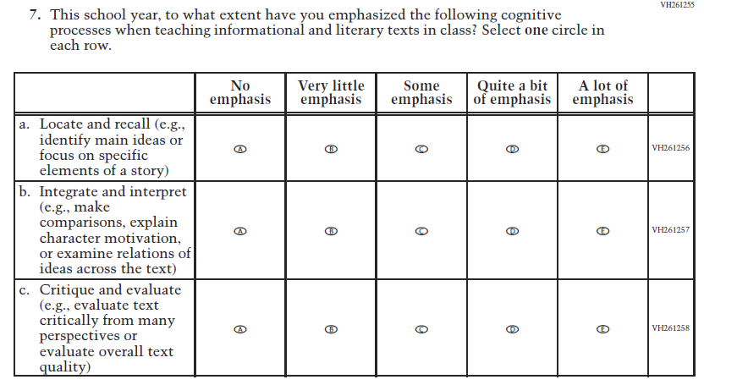  (2021 Grade 8) | Issue: Organization of Instruction | NC | N/A
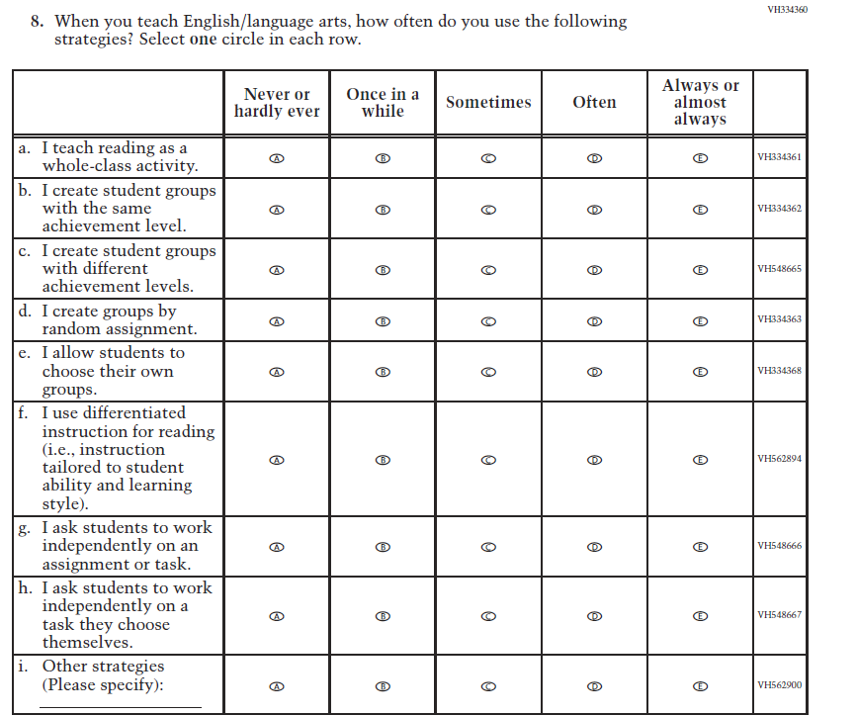  (2021 Grade 8) | Issue: Organization of Instruction | NC | N/A

2022 Operational Grade 8 Reading Teacher

Previous item | 2022 item | D/A/ R/NC+ | Rationale
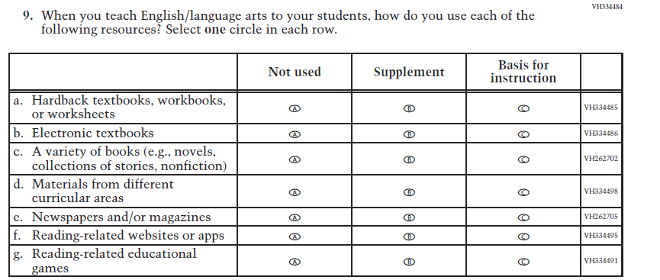  (2021 Grade 8) | Issue: Organization of Instruction | NC | N/A
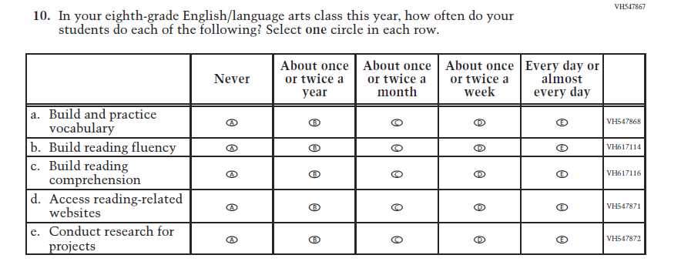  (2021 Grade 8) | Issue: Organization of Instruction | NC | N/A

2022 Operational Grade 8 Reading Teacher

Previous item | 2022 item | D/A/ R/NC+ | Rationale
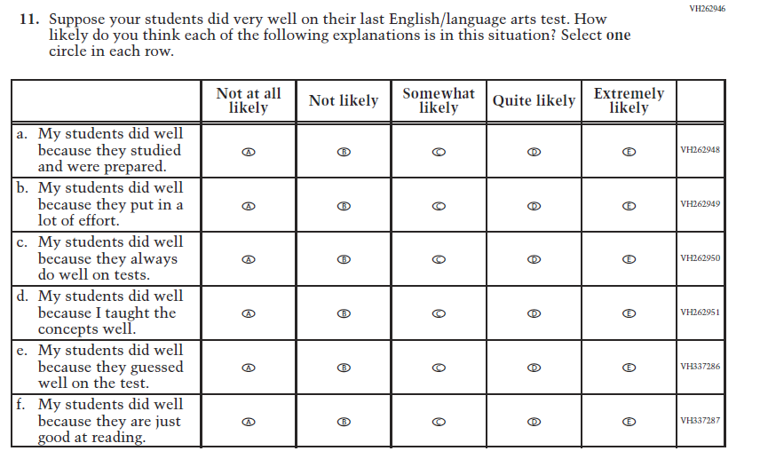  (2021 Grade 8) | Issue: Teacher Preparation | NC | N/A
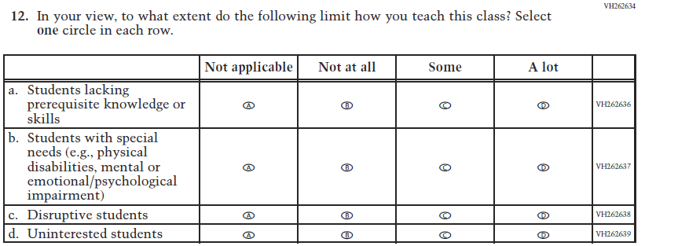  (2021 Grade 8) | Issue: Resources for Learning and Instruction | NC | N/A

Appendix J2-12: Operational Grade 8 Reading
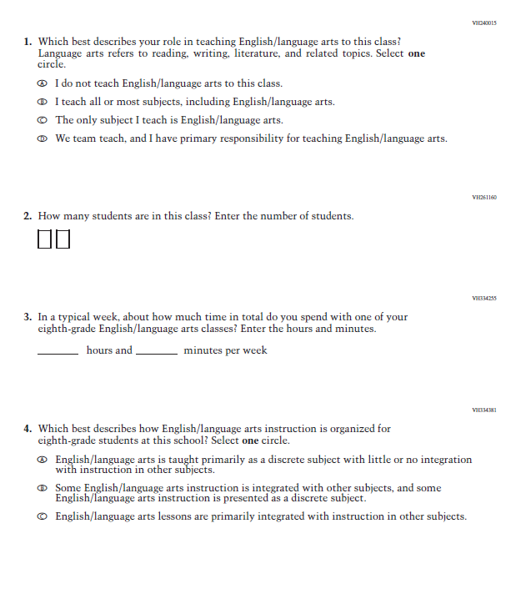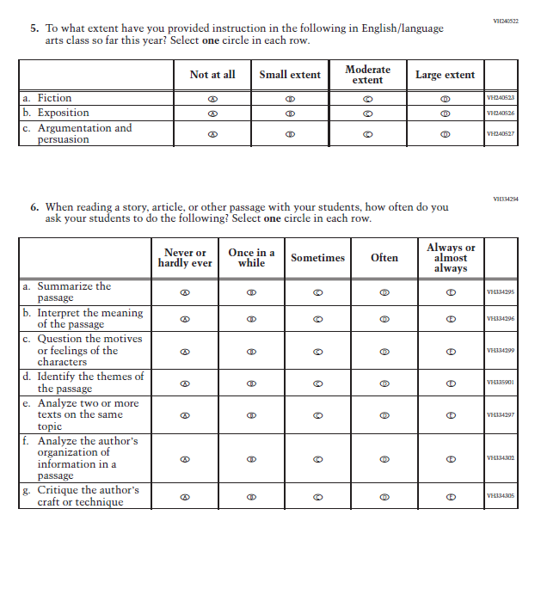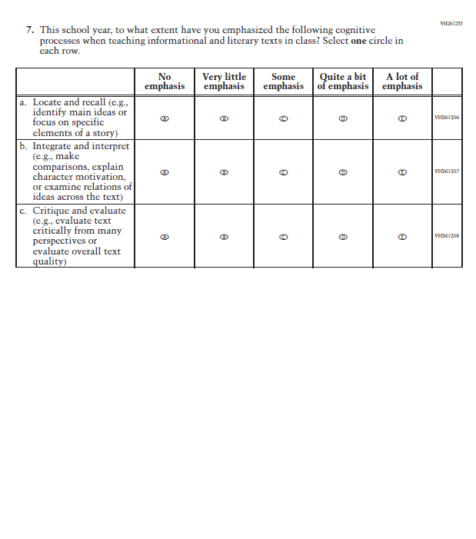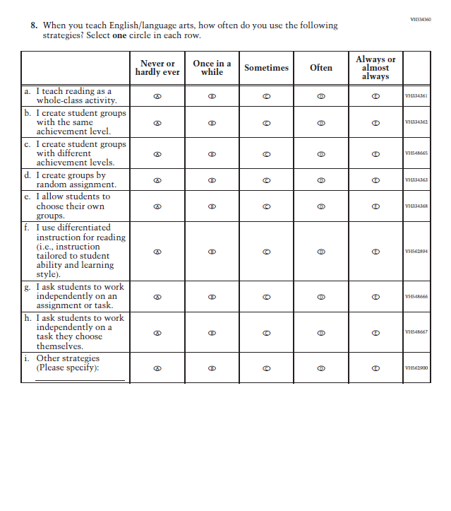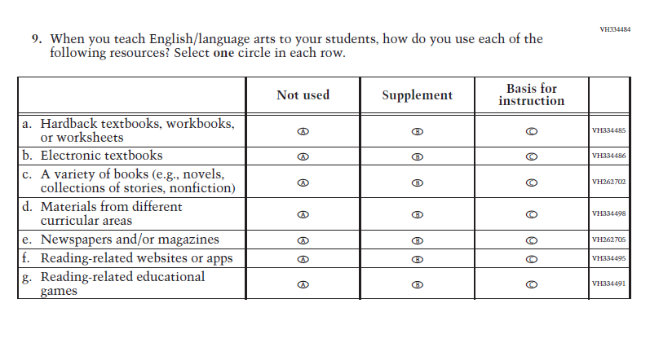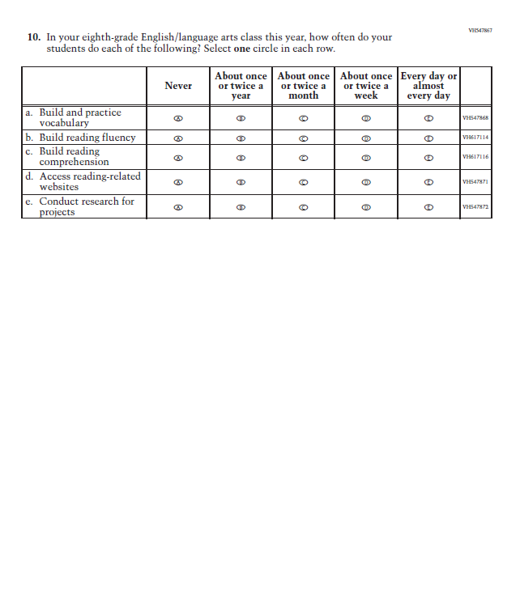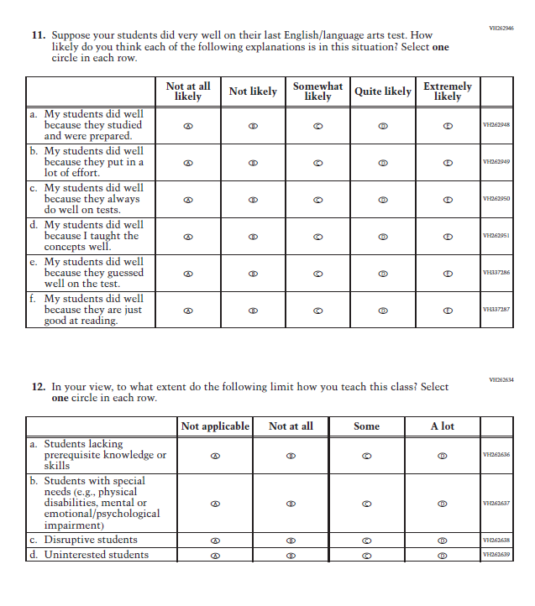

Appendix J2-13: Summary of Changes Operational Grade 8 Social Studies
2022 Operational Grade 8 Social Studies Teacher
Previous item | 2022 item | D/A/ R/NC+ | Rationale
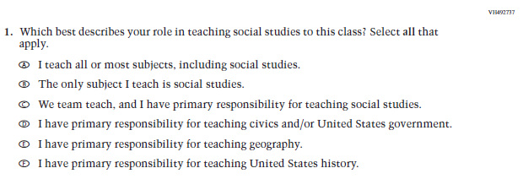  (2018 Grade 8) | Issue: Resources for Learning and Instruction | NC | N/A
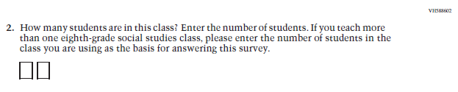  (2018 Grade 8) | Issue: Resources for Learning and Instruction | NC | N/A
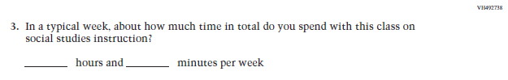  (2018 Grade 8) | Issue: Resources for Learning and Instruction | NC | N/A
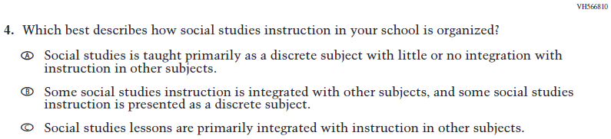  (2018 Grade 8) | Issue: Organization of Instruction | NC | N/A
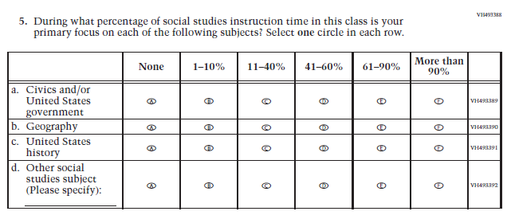  (2018 Grade 8) | Issue: Resources for Learning and Instruction | NC | N/A
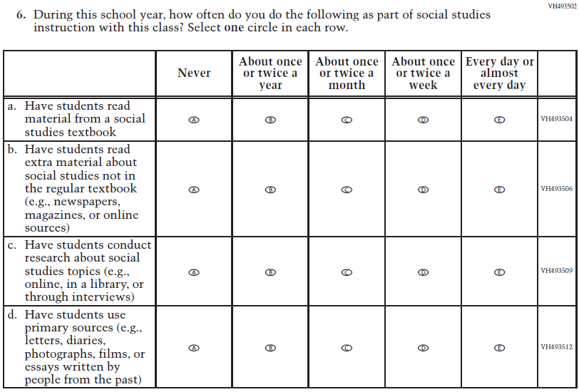  (2018 Grade 8) | Issue: Organization of Instruction | NC | N/A
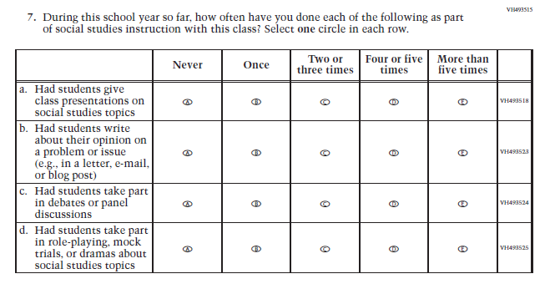  (2018 Grade 8) | Issue: Organization of Instruction | NC | N/A
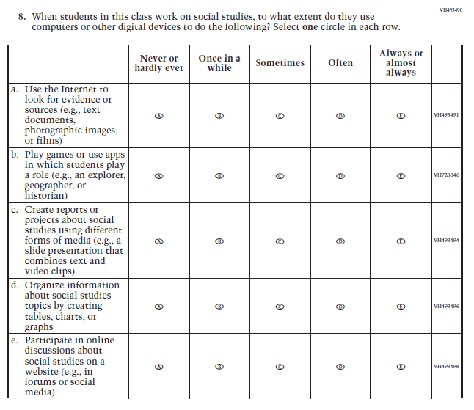  (2018 Grade 8) | Issue: Organization of Instruction | NC | N/A
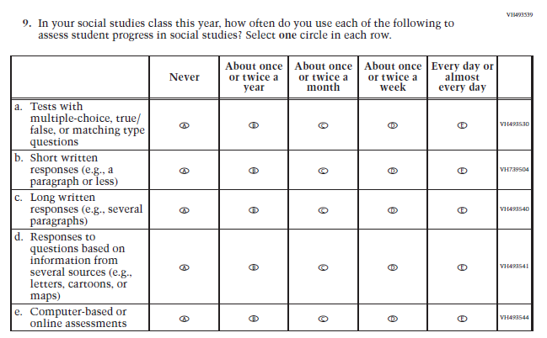  (2018 Grade 8) | Issue: Organization of Instruction | NC | N/A
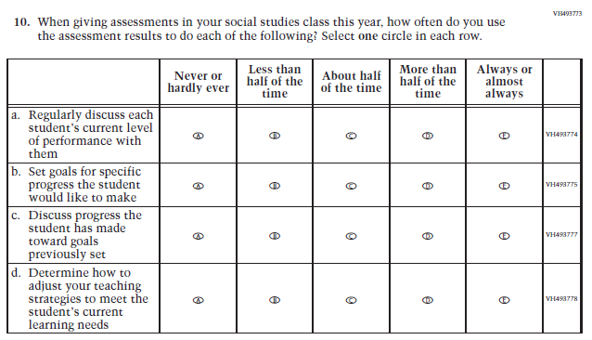  (2018 Grade 8) | Issue: Organization of Instruction | NC | N/A
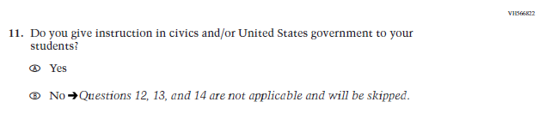  (2018 Grade 8) | 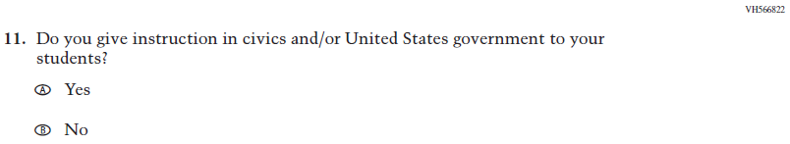  Issue: Organization of Instruction | NC | Please note skip pattern directions have been removed given the transition from PPT to DBA.
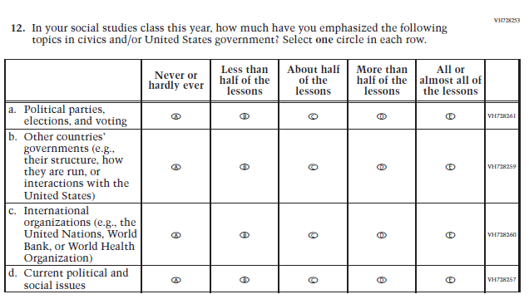  (2018 Grade 8) | Issue: Organization of Instruction | NC | N/A
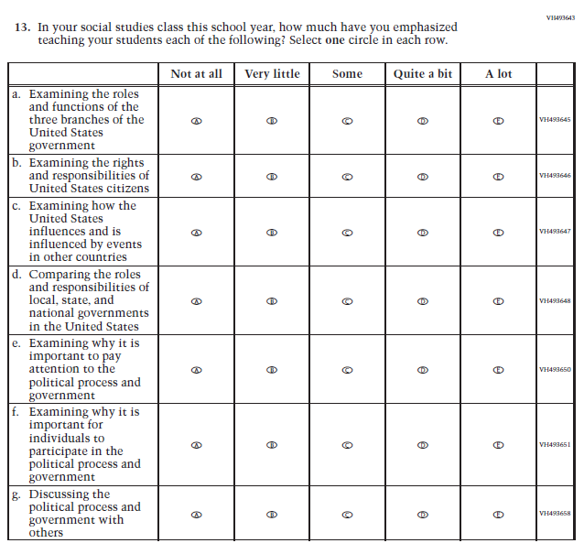  (2018 Grade 8) | Issue: Organization of Instruction | NC | N/A
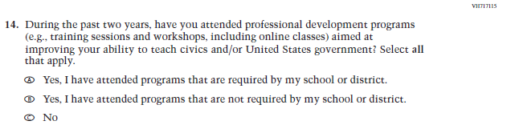  (2018 Grade 8) | Issue: Teacher Preparation | NC | N/A
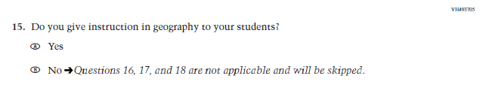  (2018 Grade 8) | N/A | D | The item was dropped because geography will not be administered in 2022.
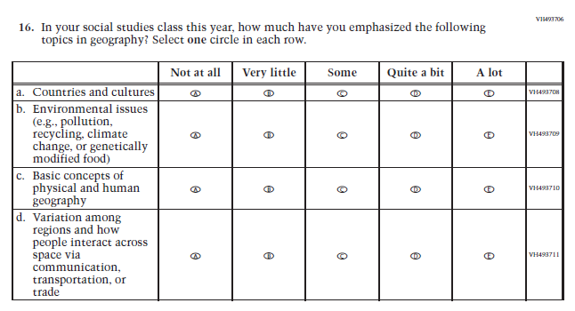  (2018 Grade 8) | N/A | D | The item was dropped because geography will not be administered in 2022.
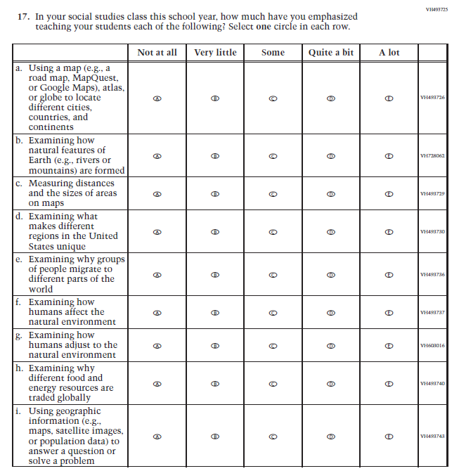  (2018 Grade 8) | N/A | D | The item was dropped because geography will not be administered in 2022.
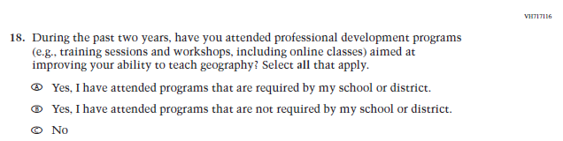  (2018 Grade 8) | N/A | D | The item was dropped because geography will not be administered in 2022.
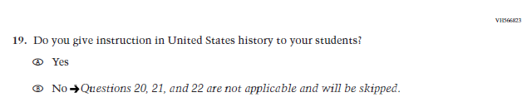  (2018 Grade 8) | 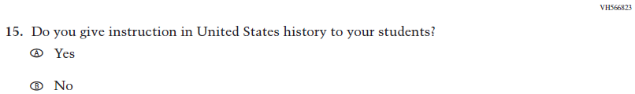  Issue: Organization of Instruction | NC | Please note skip pattern directions have been removed given the transition from PPT to DBA.
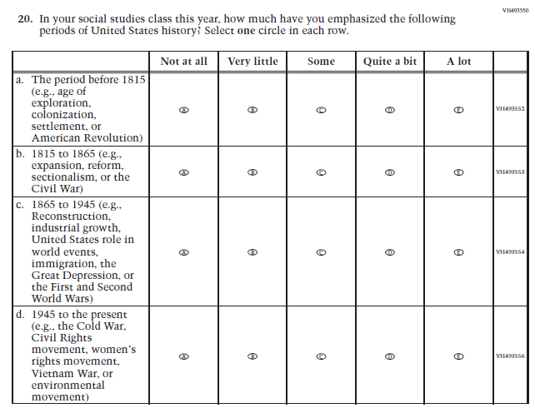  (2018 Grade 8) | 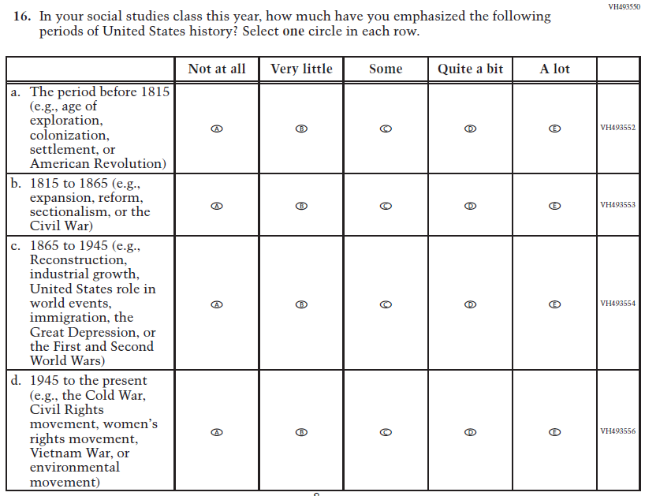  Issue: Organization of Instruction | NC | N/A
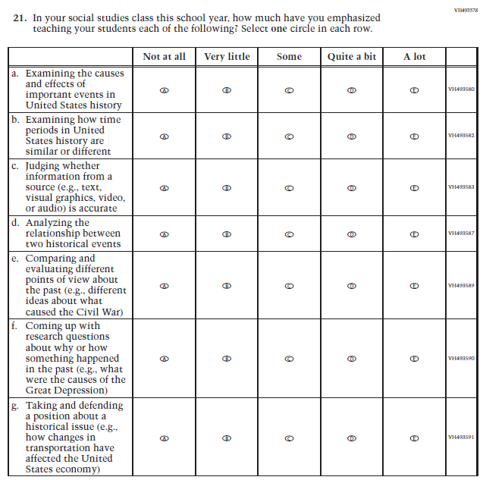  (2018 Grade 8) | 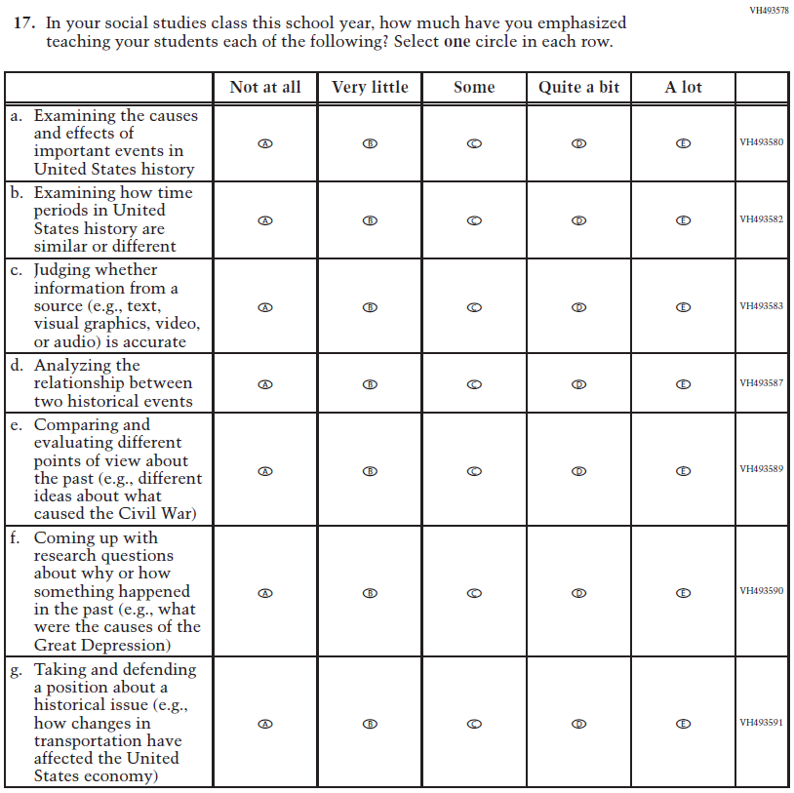  Issue: Organization of Instruction | NC | N/A
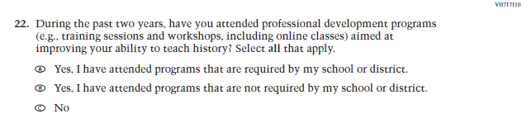  (2018 Grade 8) | 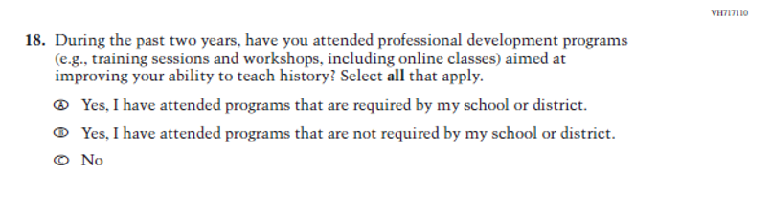Issue: Teacher Preparation | NC | N/A
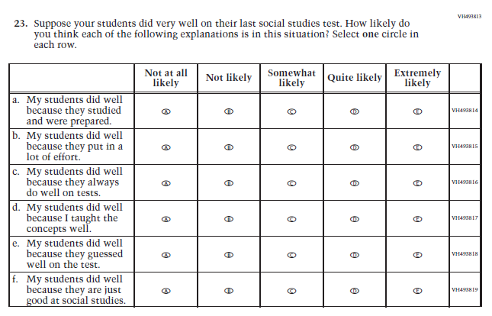  (2018 Grade 8) | 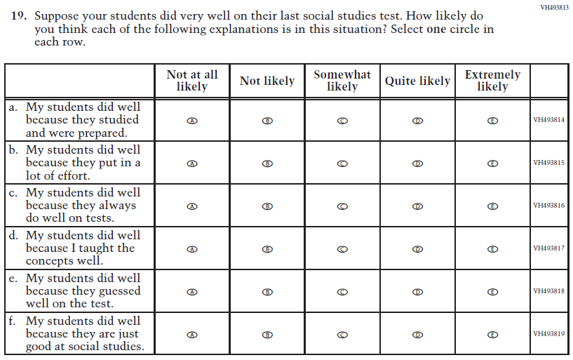  Issue: Teacher Preparation | NC | N/A

Appendix J2-14: Operational Grade 8 Social Studies
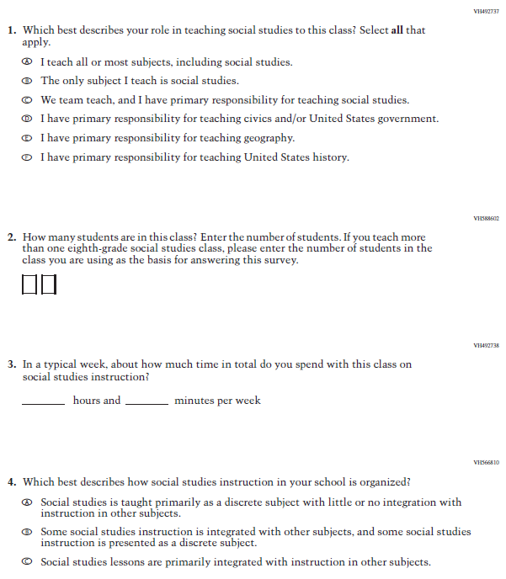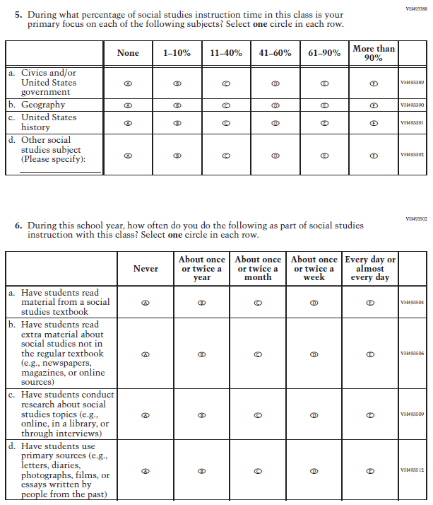
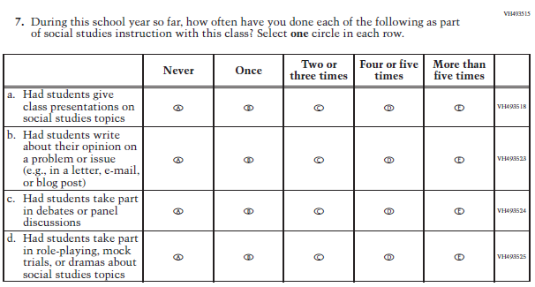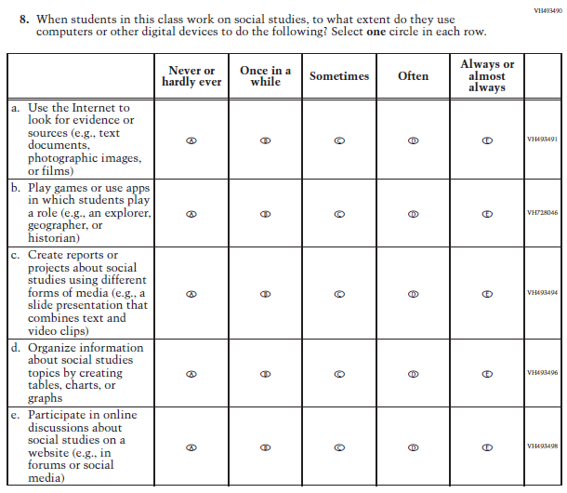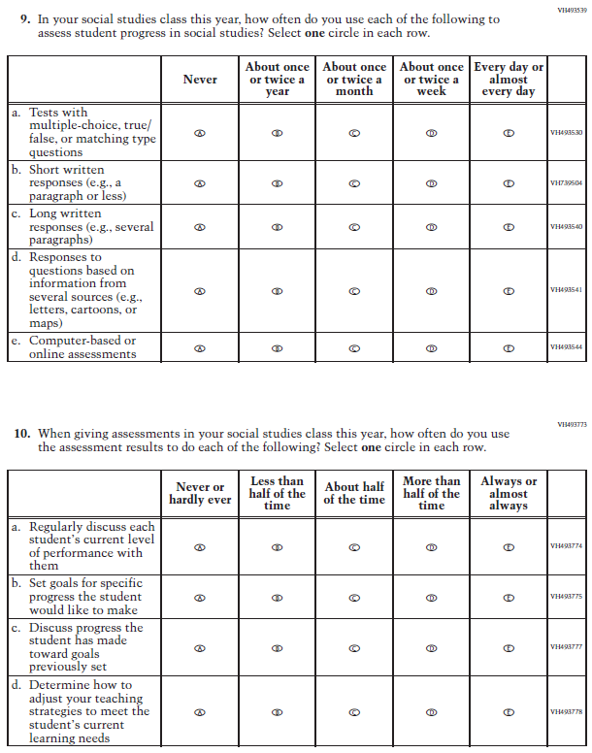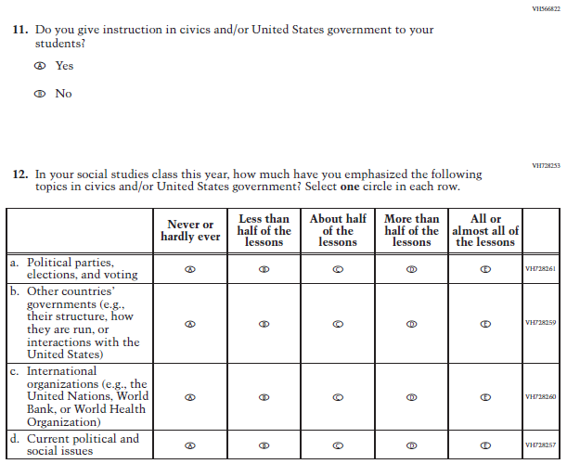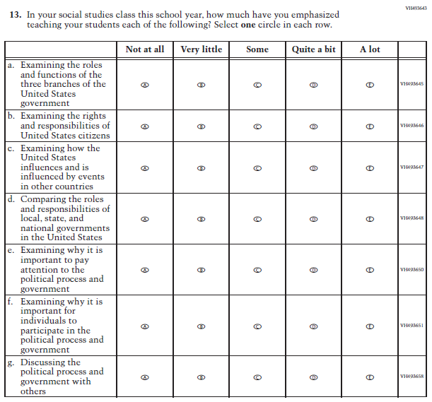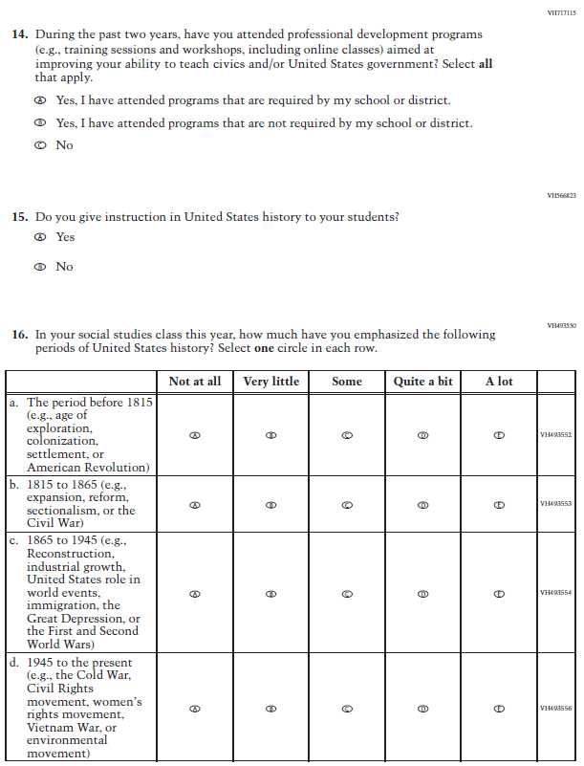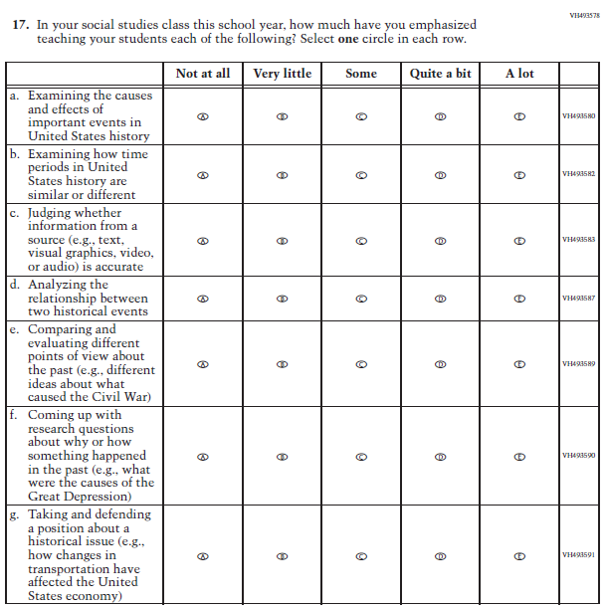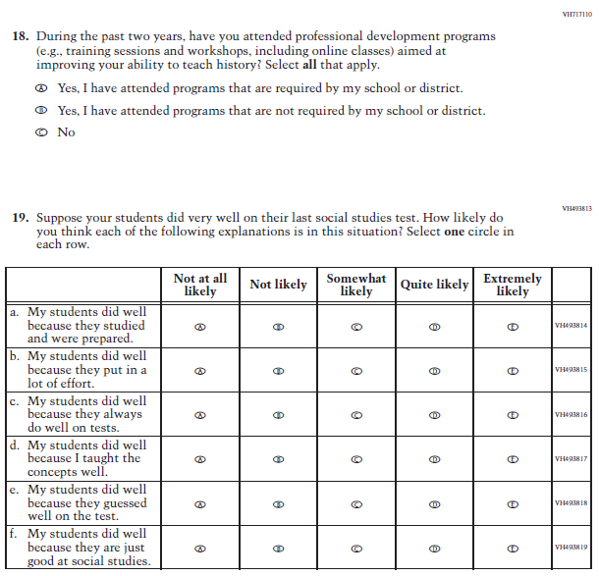

Appendix J2-15: Summary of Operational Grade 4 COVID-19
2022 Operational Grade 4 COVID-19 Teacher Items
Previous item | 2022 item | D/A/R/NC+ | Rationale
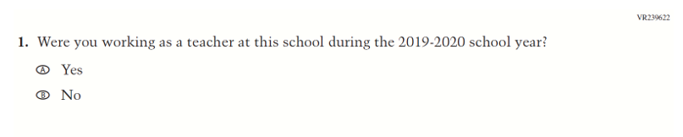  (2021 Grade 4) | 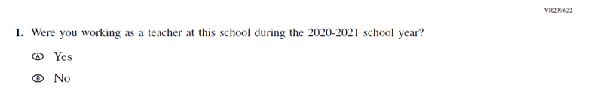  Issue: Organization of Instruction | R | This item has been updated to reference the correct academic year for the 2022 administration.
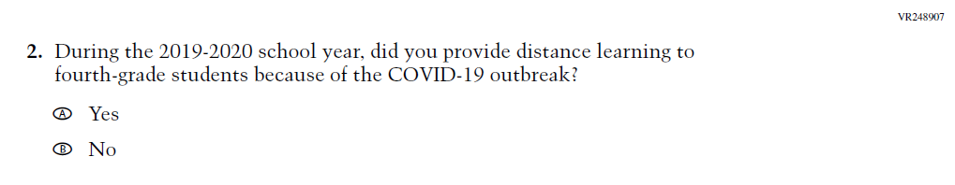  (2021 Grade 4) | 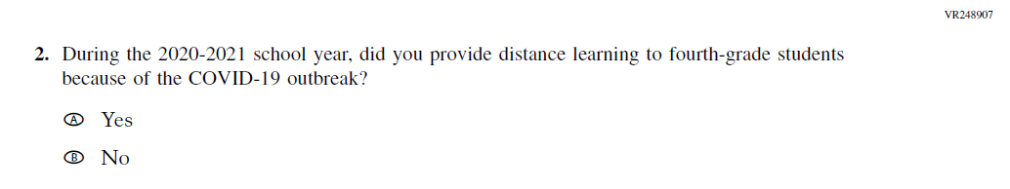  Issue: Organization of Instruction | R | This item has been updated to reference the correct academic year for the 2022 administration.

2022 Operational Grade 4 COVID-19 Teacher Items
Previous item | 2022 item | D/A/R/NC+ | Rationale
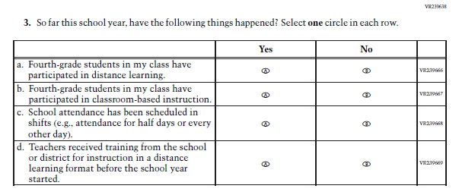  (2021 Grade 4) | Issue: Organization of Instruction | NC | N/A
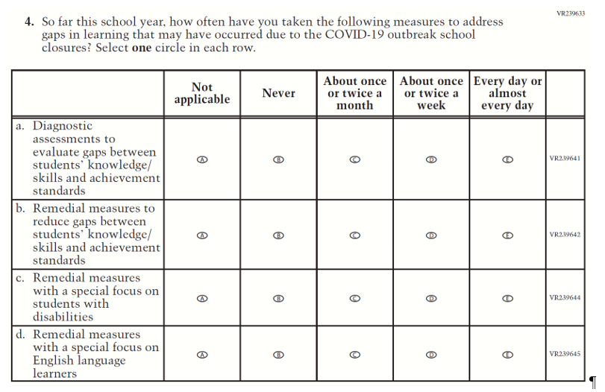  (2021 Grade 4) | Issue: Organization of Instruction | NC | N/A

2022 Operational Grade 4 COVID-19 Teacher Items
Previous item | 2022 item | D/A/R/NC+ | Rationale
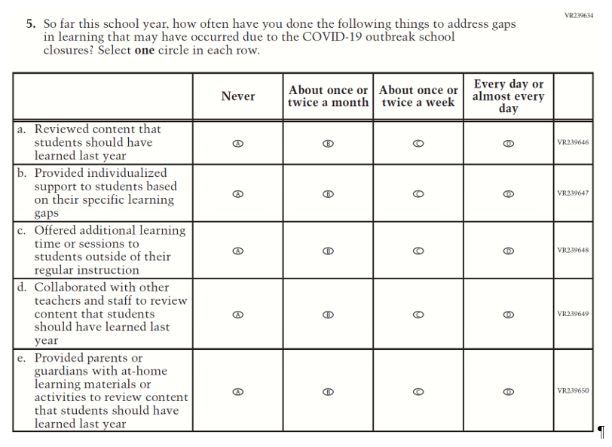  (2021 Grade 4) | Issue: Organization of Instruction | NC | N/A
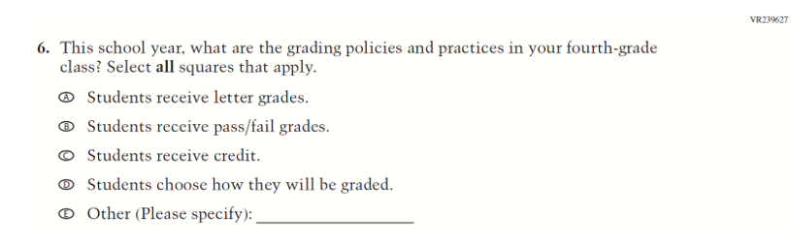  (2021 Grade 4) | Issue: Organization of Instruction | NC | N/A

2022 Operational Grade 4 COVID-19 Teacher Items
Previous item | 2022 item | D/A/R/NC+ | Rationale
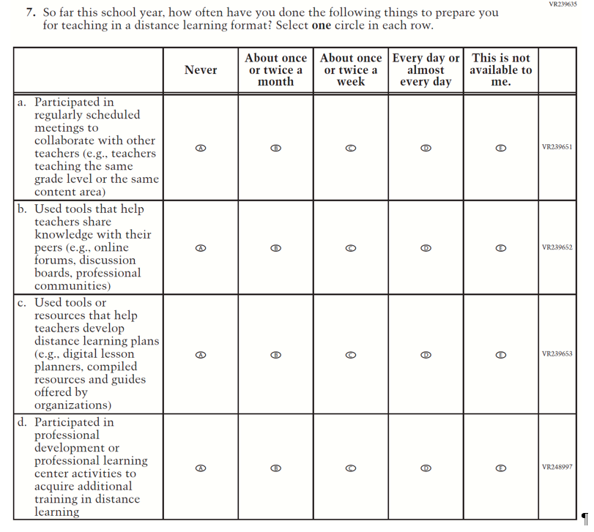  (2021 Grade 4) | Issue: Teacher Preparation | NC | N/A
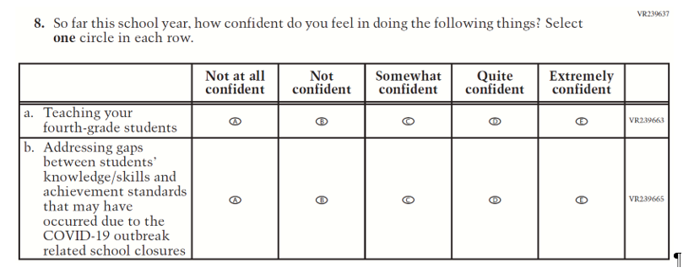  (2021 Grade 4) | Issue: Self-efficacy | NC | N/A

2022 Operational Grade 4 COVID-19 Teacher Items
Previous item | 2022 item | D/A/R/NC+ | Rationale
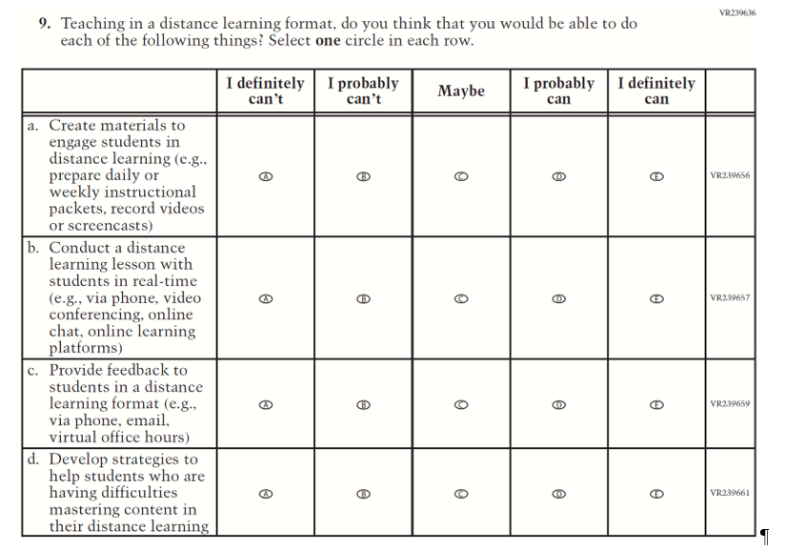  (2021 Grade 4) | Issue: Self-efficacy | NC | N/A

Appendix J2-16: Operational Grade 4 COVID-19
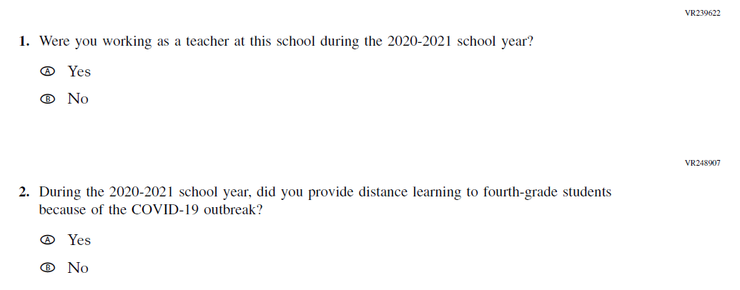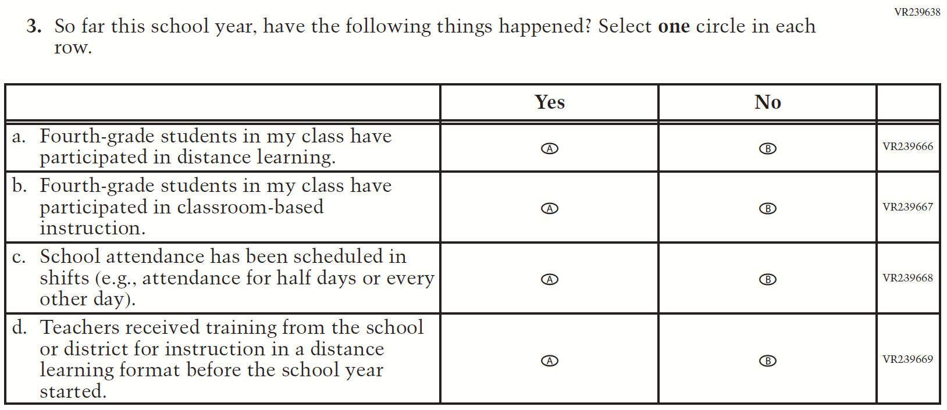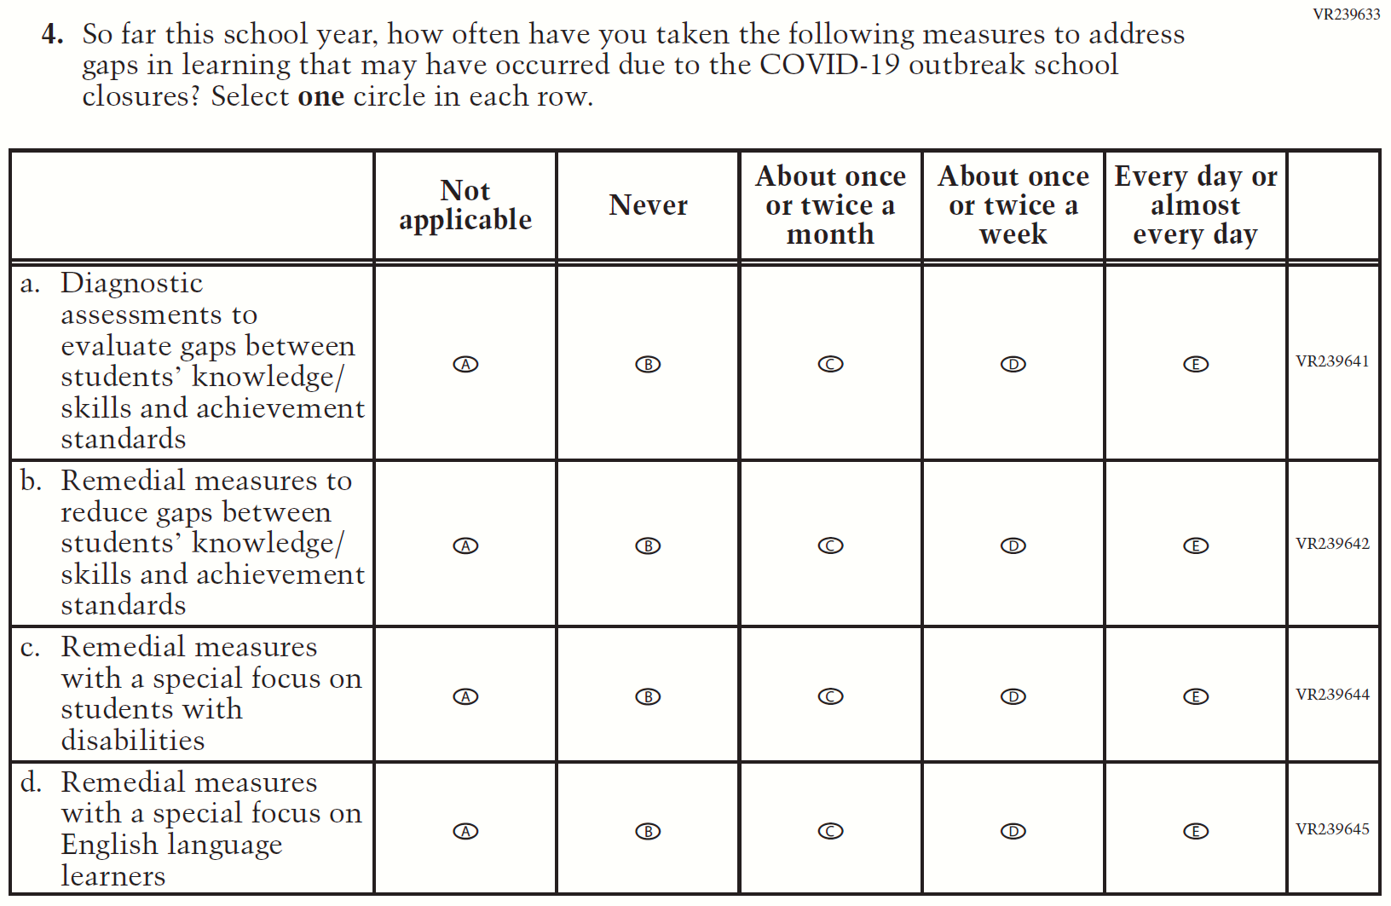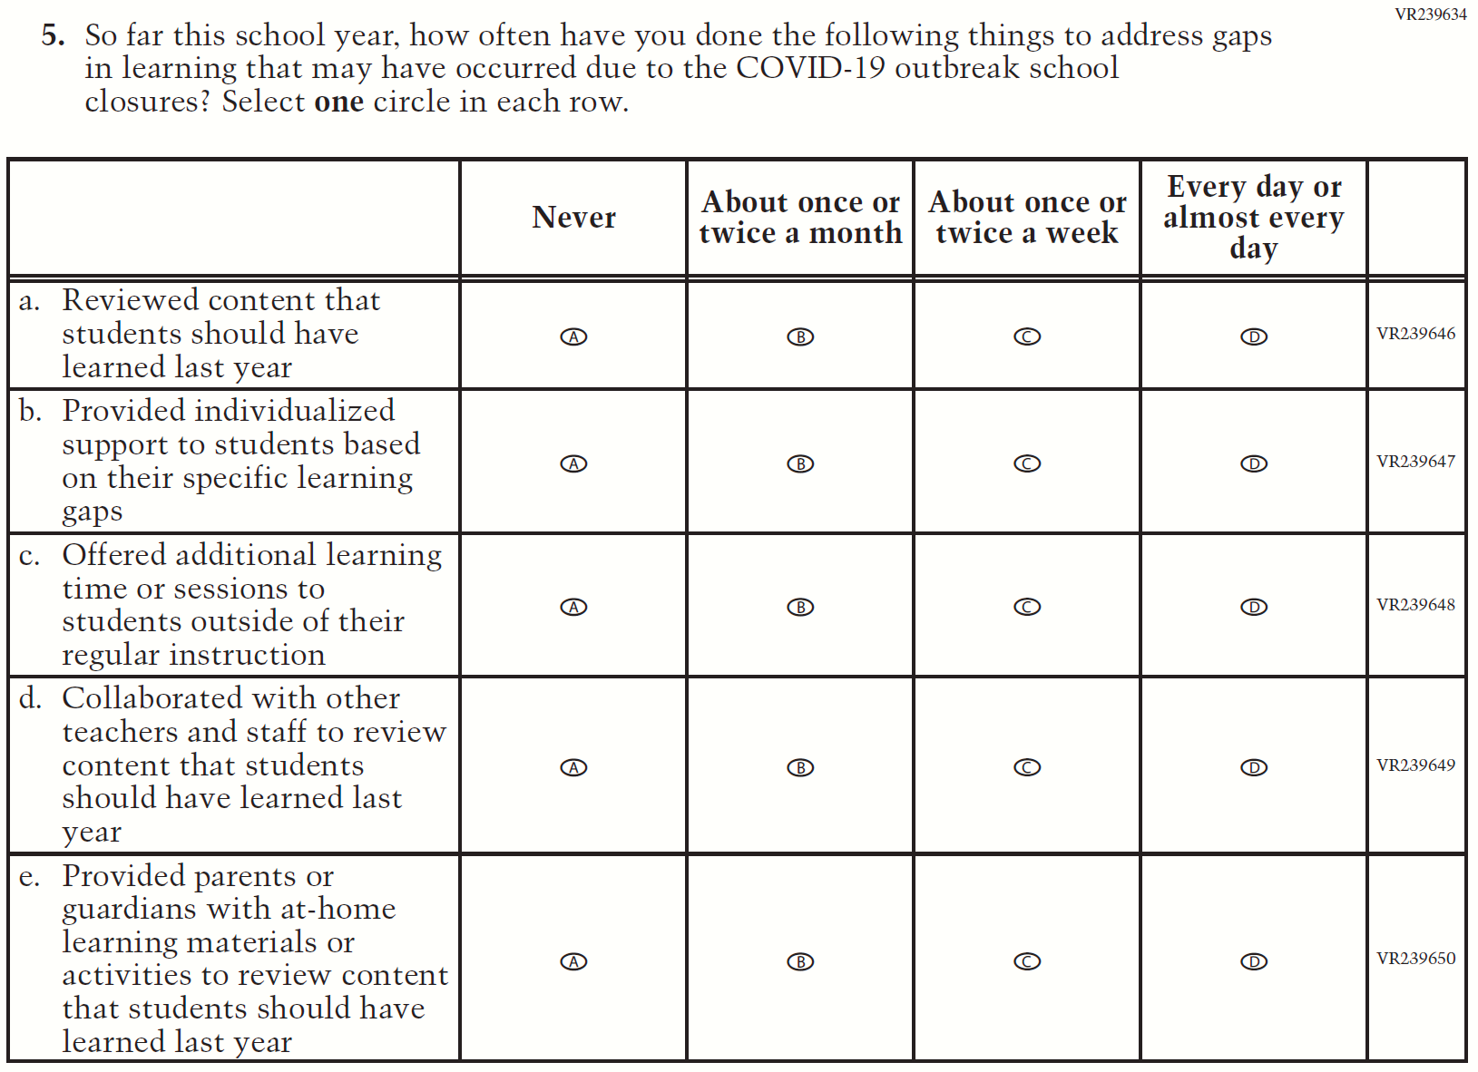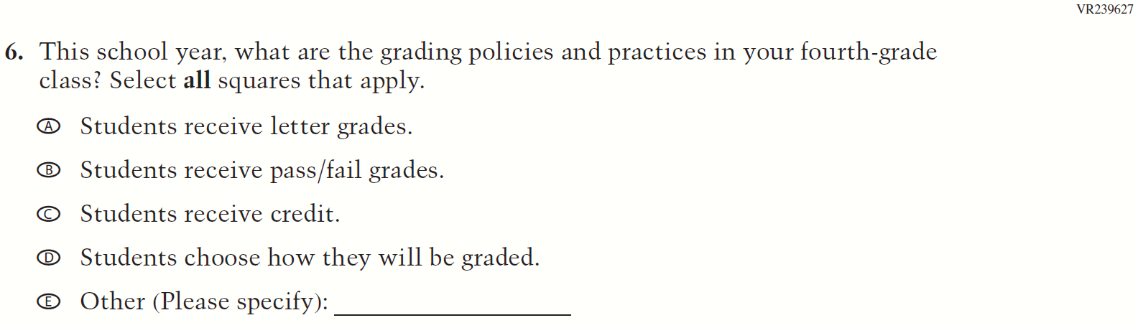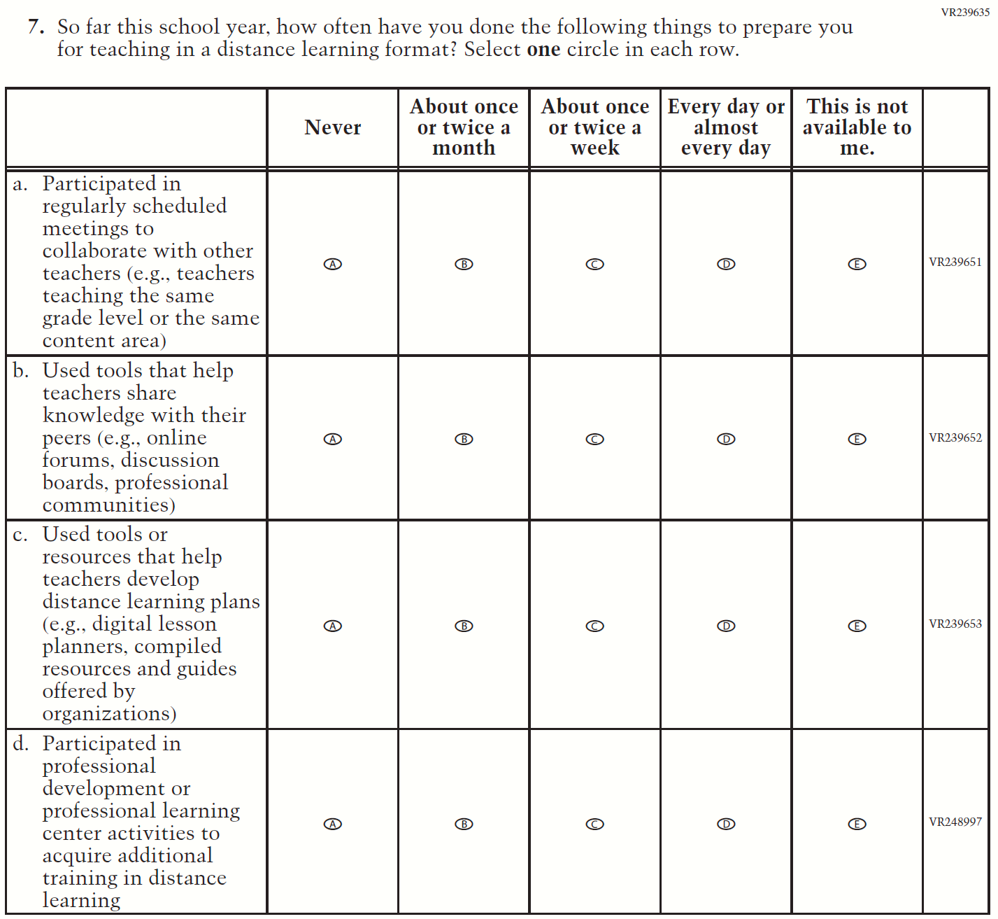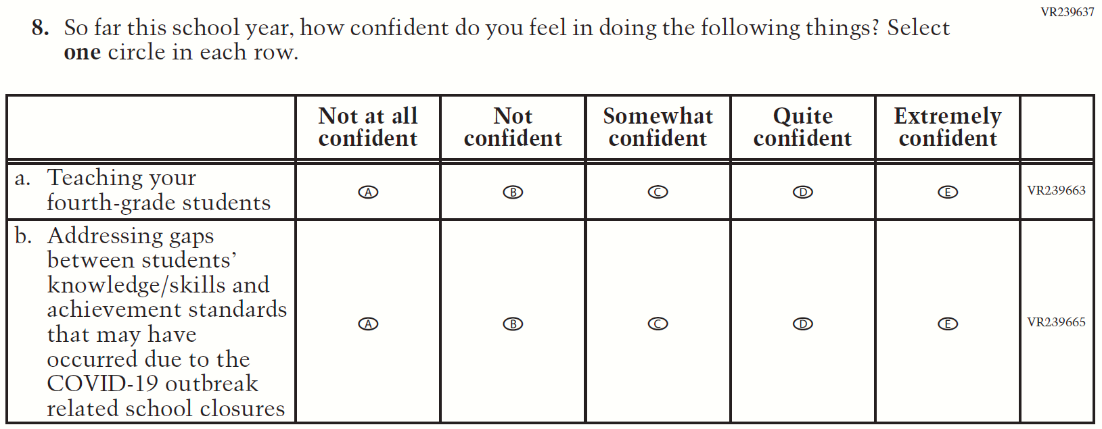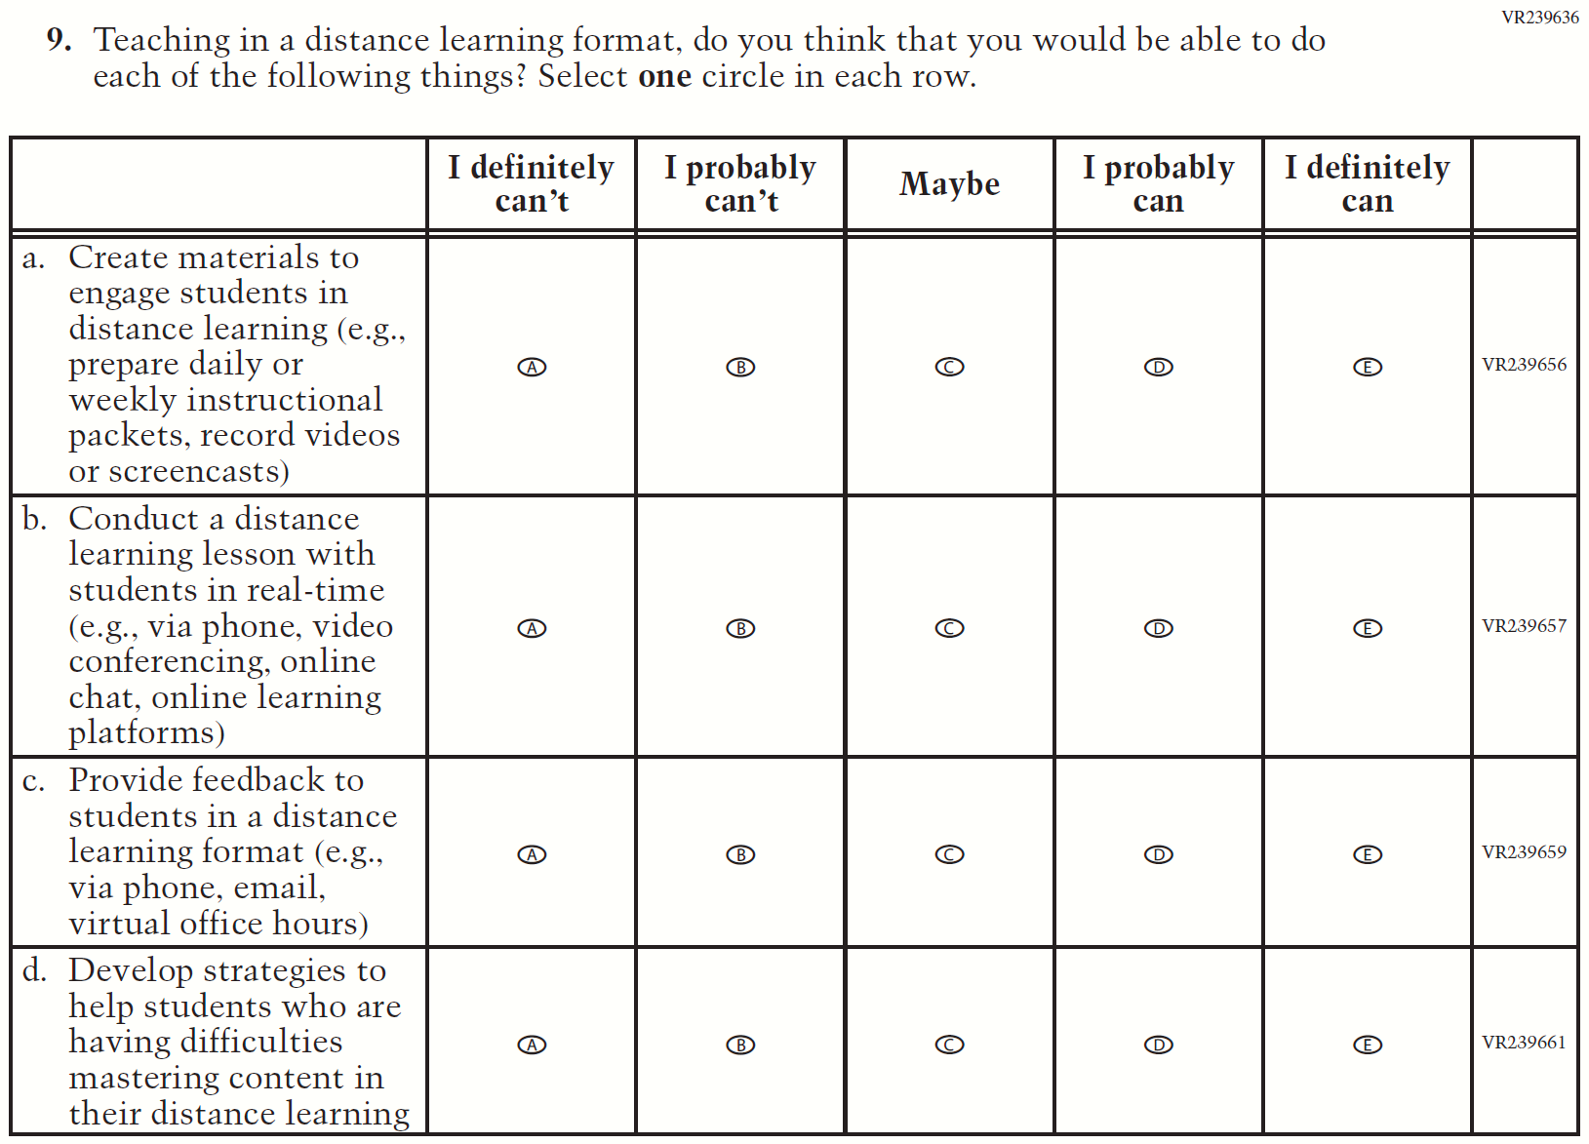

Appendix J2-17: Summary of Operational Grade 8 COVID-19
2022 Operational Grade 8 COVID-19 Teacher Items
Previous item | 2022 item | D/A/R/NC+ | Rationale
(2021 Grade 8) | Issue: Organization of Instruction | R | This item has been updated to reference the correct academic year for the 2022 administration.
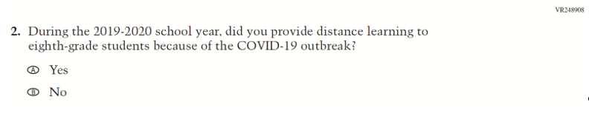  (2021 Grade 8) | 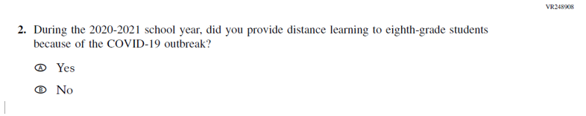  Issue: Organization of Instruction | R | This item has been updated to reference the correct academic year for the 2022 administration.

2022 Operational Grade 8 COVID-19 Teacher Items
Previous item | 2022 item | D/A/R/NC+ | Rationale
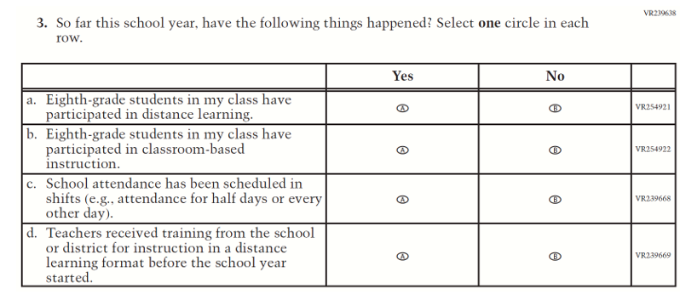  (2021 Grade 8) | Issue: Organization of Instruction | NC | N/A
(2021 Grade 8) | Issue: Organization of Instruction | NC | N/A

2022 Operational Grade 8 COVID-19 Teacher Items
Previous item | 2022 item | D/A/R/NC+ | Rationale
(2021 Grade 8) | Issue: Organization of Instruction | NC | N/A
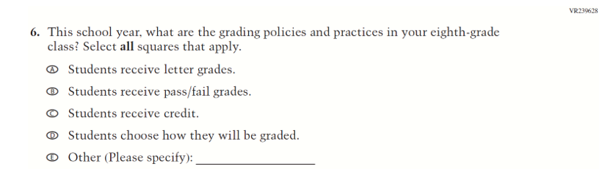  (2021 Grade 8) | Issue: Organization of Instruction | NC | N/A

2022 Operational Grade 8 COVID-19 Teacher Items
Previous item | 2022 item | D/A/R/NC+ | Rationale
(2021 Grade 8) | Issue: Teacher Preparation | NC | N/A
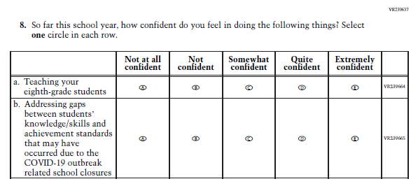  (2021 Grade 8) | Issue: Self-efficacy | NC | N/A

2022 Operational Grade 8 COVID-19 Teacher Items
Previous item | 2022 item | D/A/R/NC+ | Rationale
(2021 Grade 8) | Issue: Self-efficacy | NC | N/A

Appendix J2-18: Operational Grade 8 COVID-19
