Screenshots of RAM Data Collection
Paperwork Reduction Act Burden Statement
A federal agency may not conduct or sponsor, and a person is not required to respond to, nor shall a person be subject to a penalty for failure to comply with a collection of information subject to the requirements of the Paperwork Reduction Act unless that collection of information displays a currently valid OMB Control Number. The OMB Control Number for this information collection is 2120-0015. Public reporting for this collection of information is estimated to be approximately 14,269 hours for all collected data, including the time for reviewing instructions, searching existing data sources, gathering and maintaining the data needed, completing and reviewing the collection of information. All responses to this collection of information are critical to aviation safety and will be published in flight information handbooks and charts for pilot use. The data is also necessary under 49 USC 47130, 49 USC 329(b), 49 USC 47105, 49 USC 44721, 49 USC 40117, 49 USC Subtitle VII Part A, 14 CFR 158, 14 CFR Part 77, and federal grant assurances for to process airport actions, studies, and analyses and for use when considering funding requests. The data is public in nature and is the agency's source for the information used in aeronautical charts and flight information publications. Send comments regarding this burden estimate or any other aspect of this collection of information, including suggestions for reducing this burden to: Information Collection Clearance Officer, Federal Aviation Administration, 10101 Hillwood Parkway, Fort Worth, TX 76177-1524.
OMB CONTROL NUMBER: 2120-0015
EXPIRATION DATE: 4/30/2023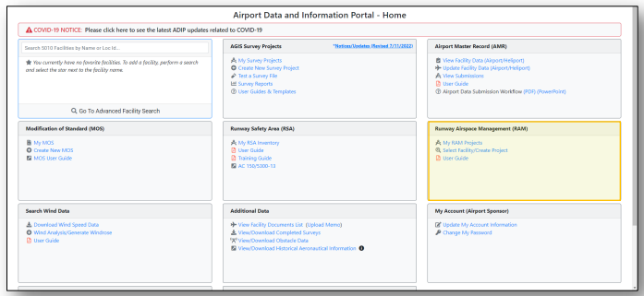

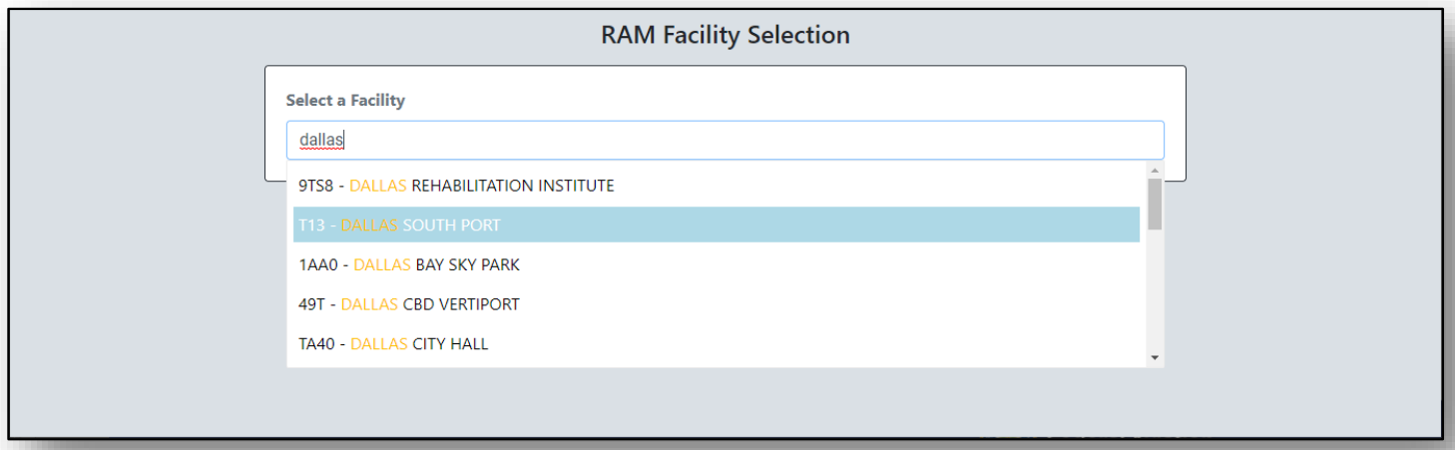
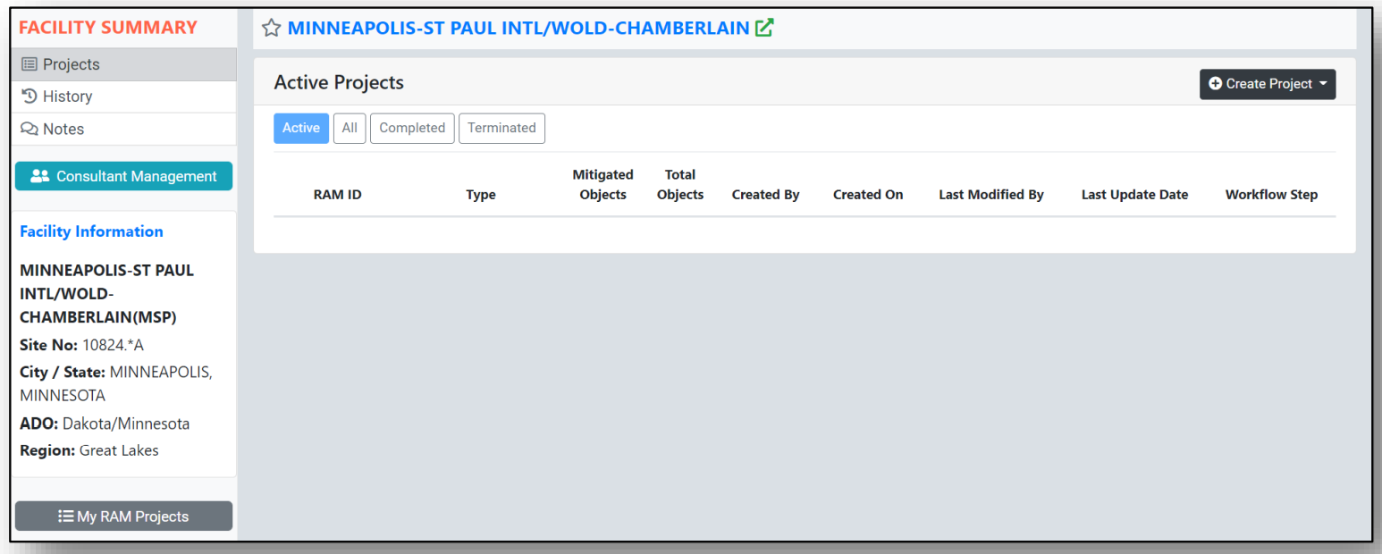
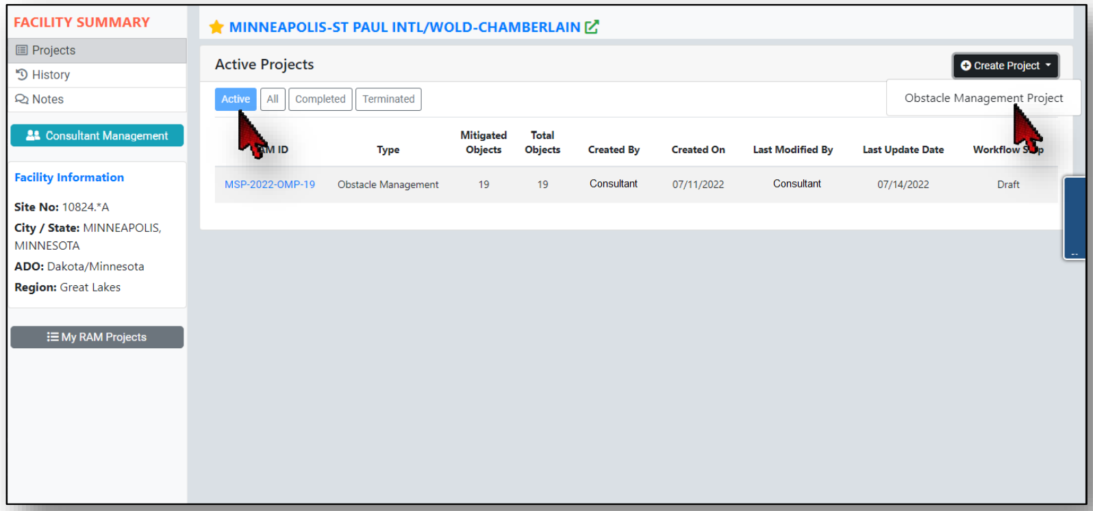
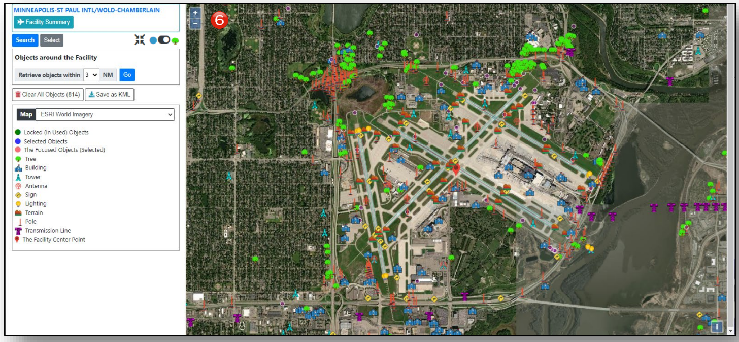
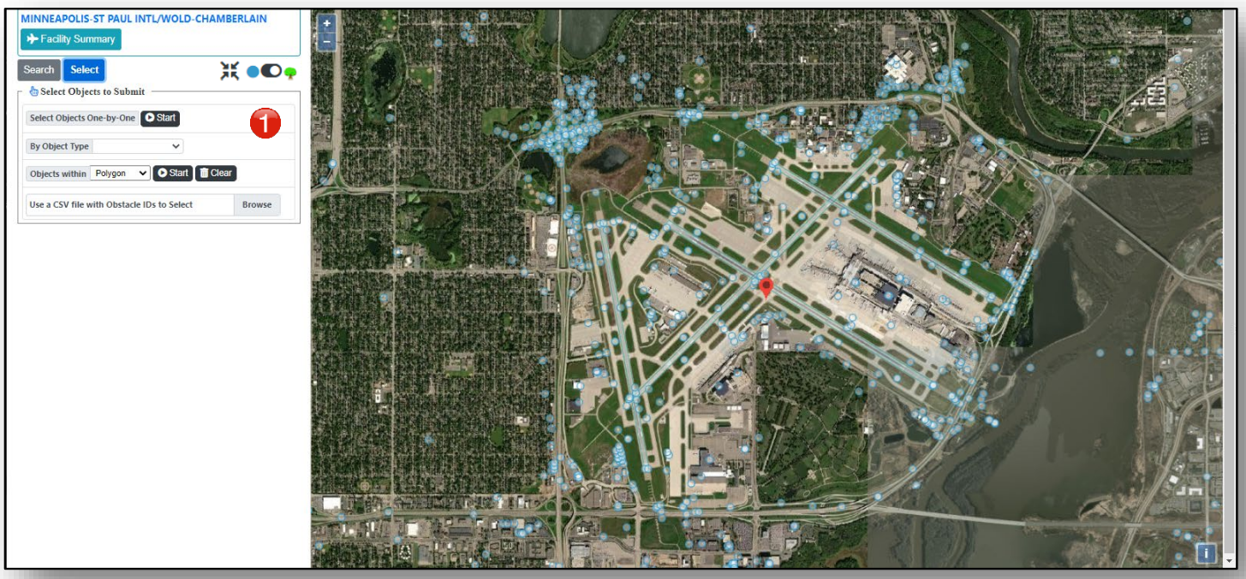
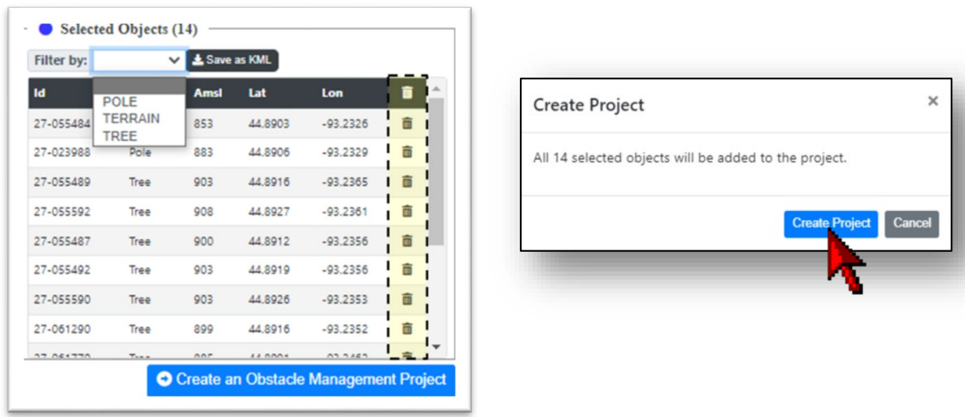
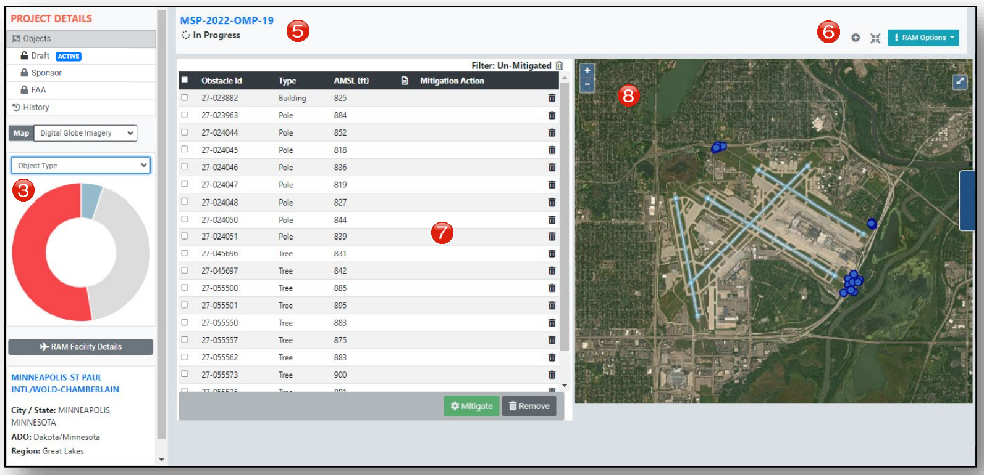
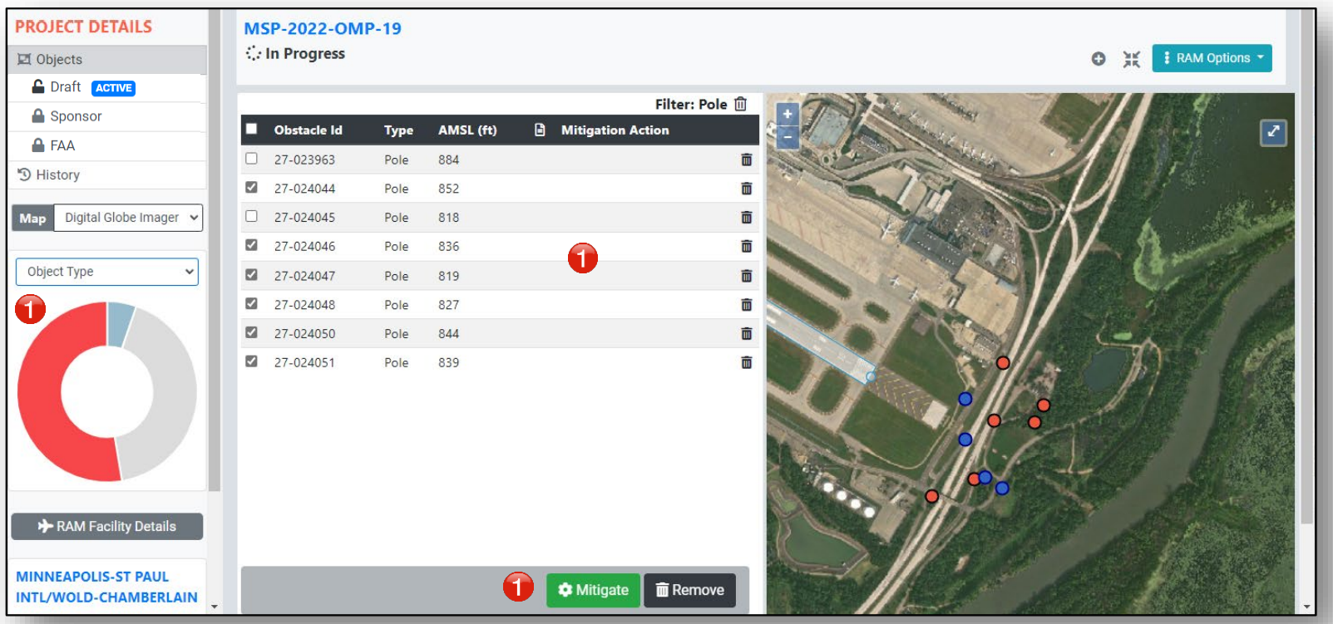
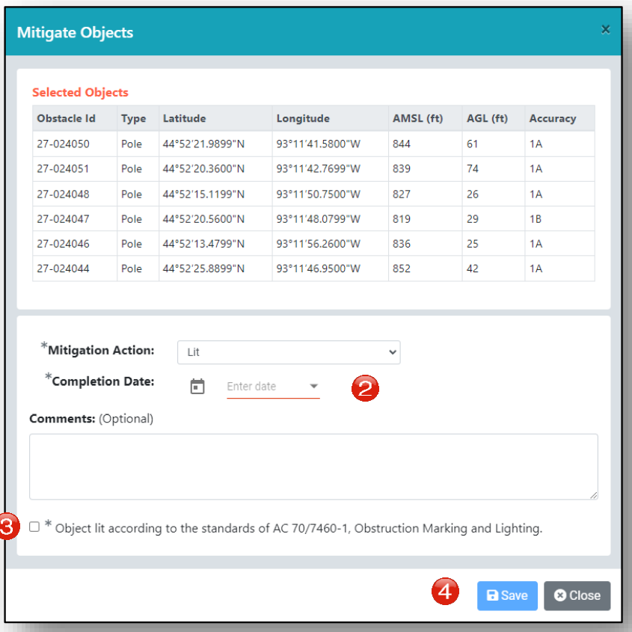
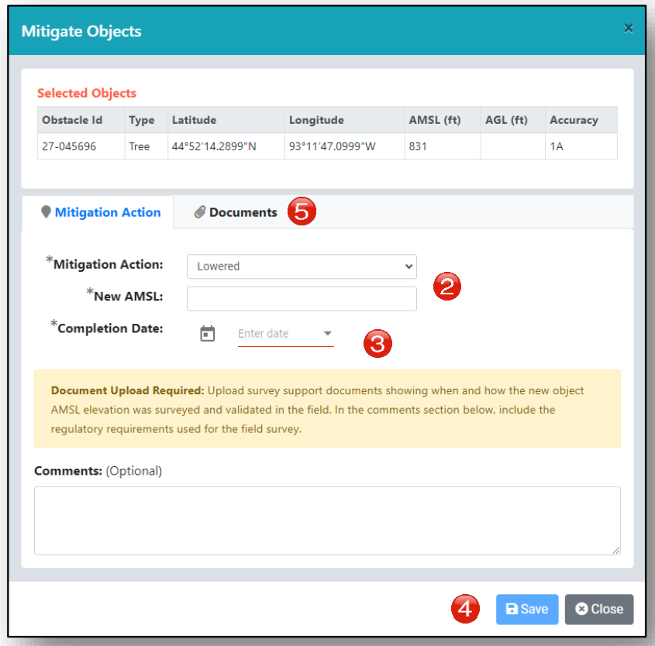
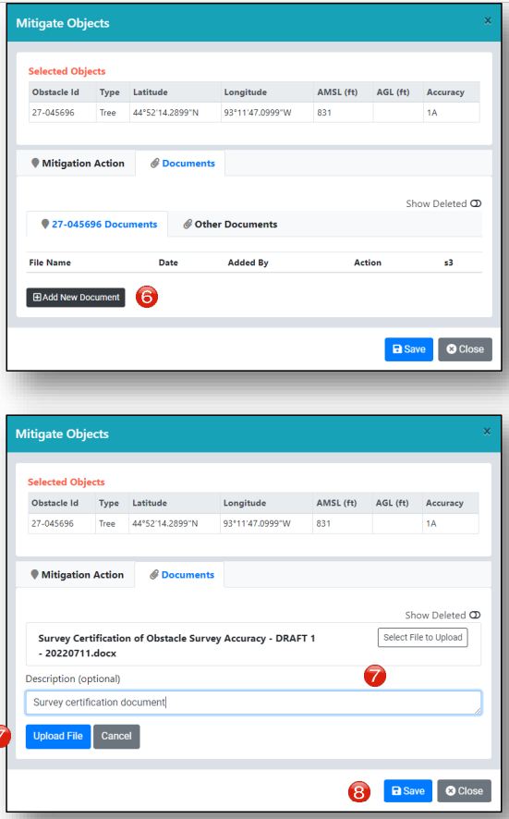
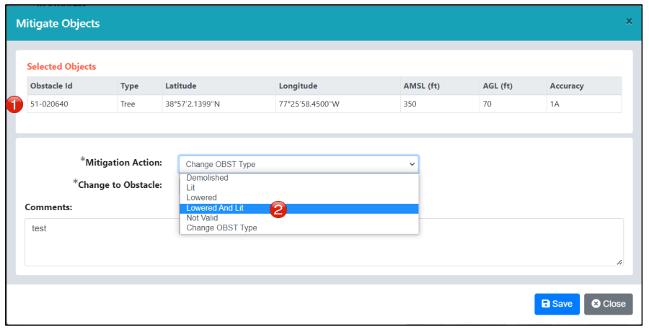
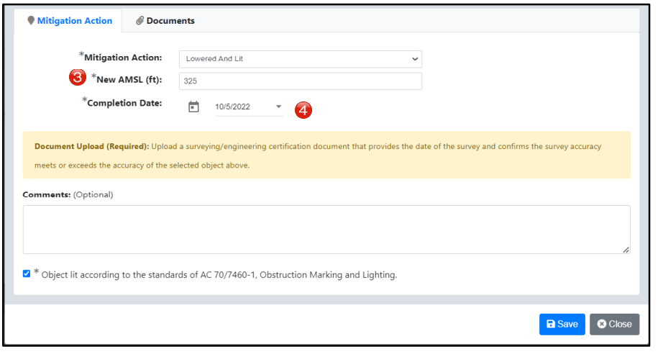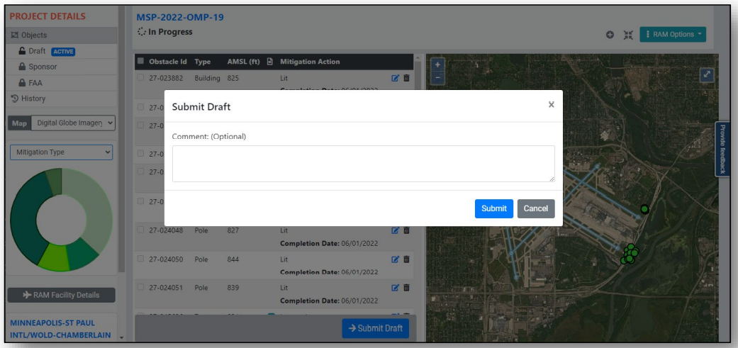
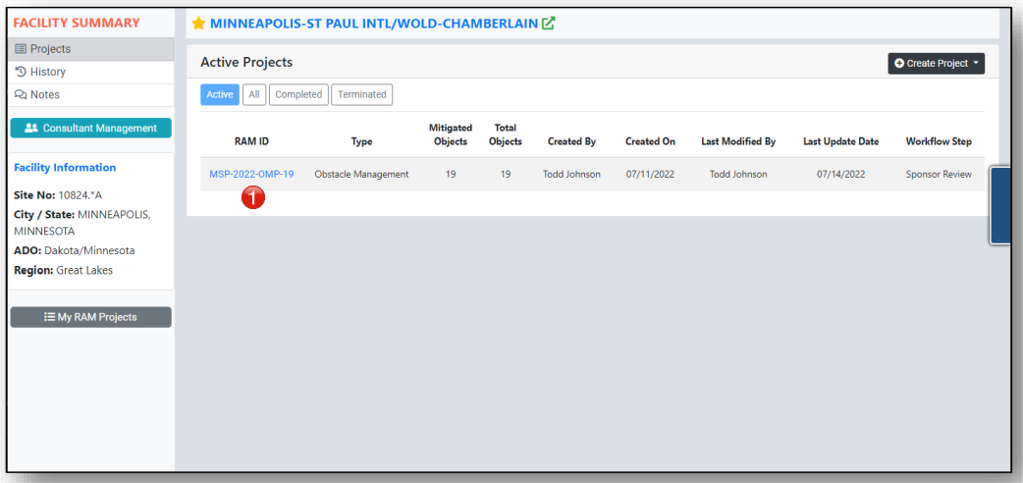
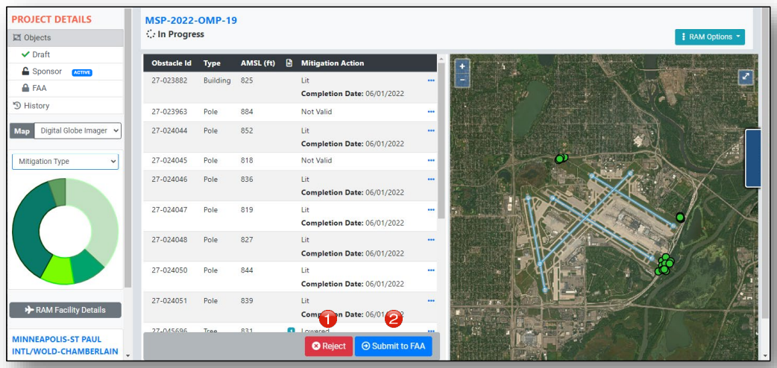
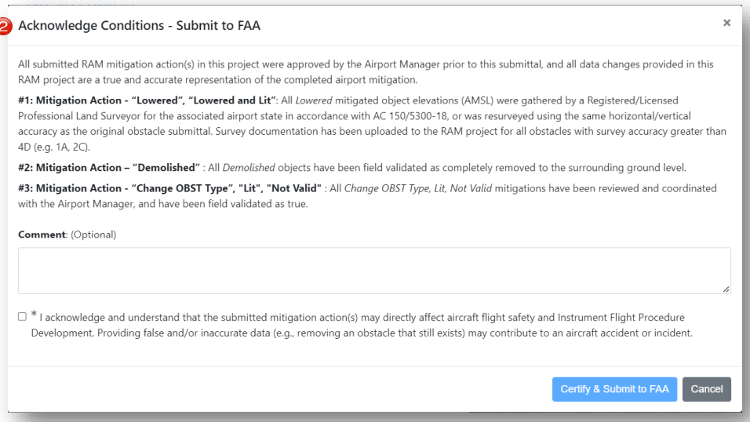
Instructions for this process are available at https://adip.faa.gov/agis/public/data/onlineHelp/pdf/ram/RAM_Users_Guide.pdf.

