Login Screen

Step 1

Step 2

Step 3

Legal Identification Types

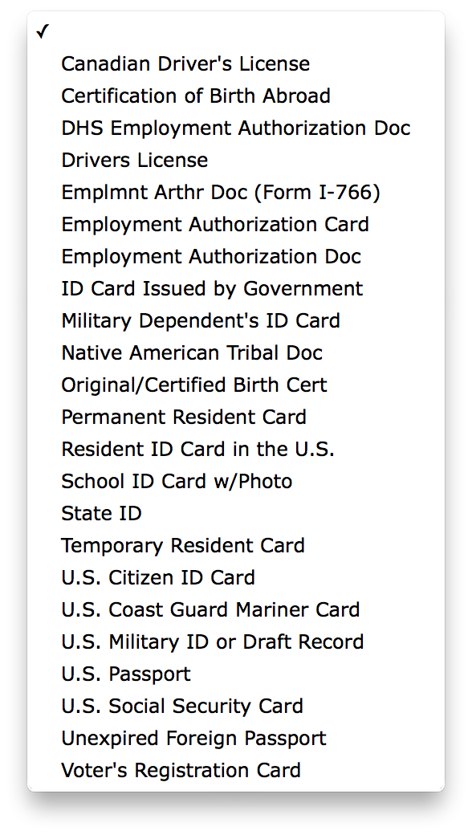

Step 4

Step 5

