TOXIC EXPOSURE SCREEN 01/18/23

View, if reminder is opened by a User that IS NOT a MD/DO/PA/APRN or RN TES Navigator with required scope of practice: 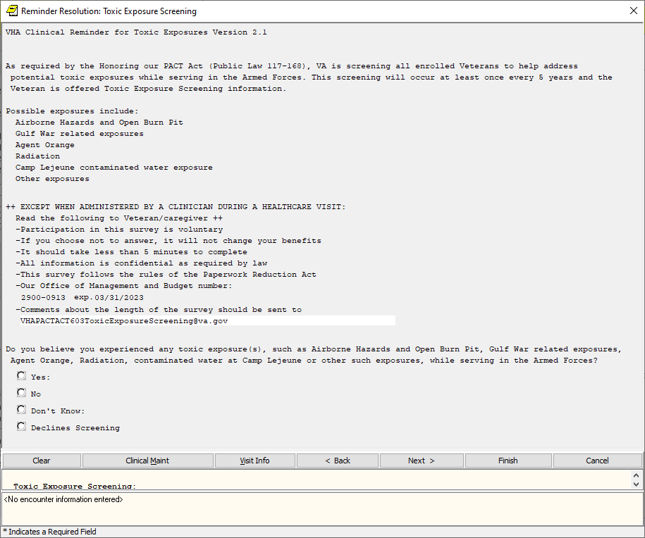

View that will display if opened by a MD/DO/PA/APRN or RN TES Navigator with required scope of practice:

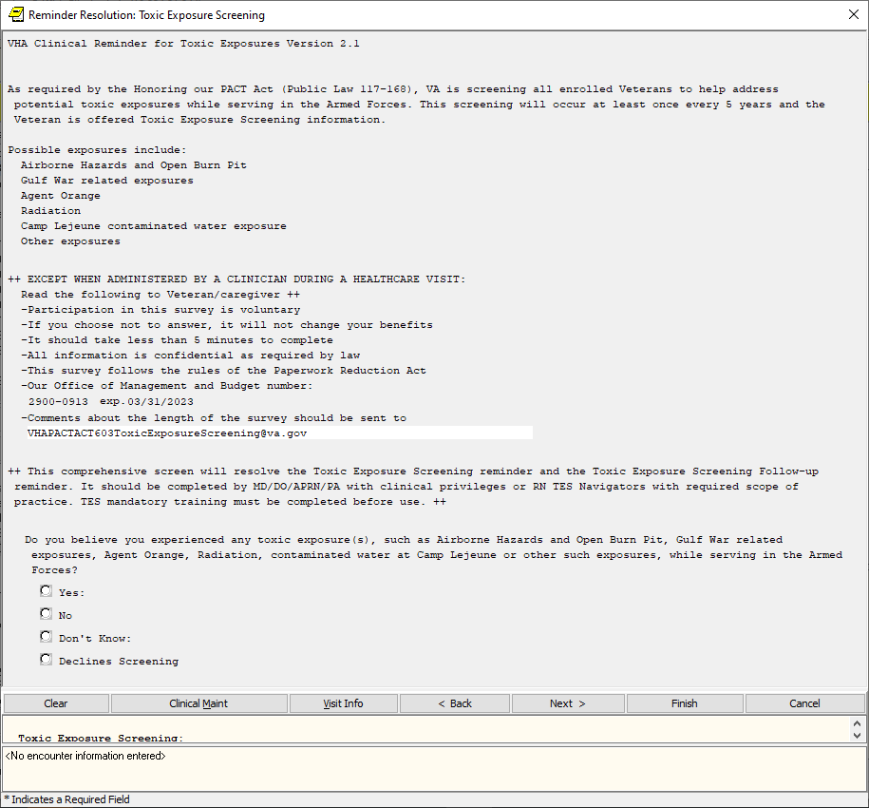

Yes, expanded, if reminder is opened by a User that IS NOT a MD/DO/PA/APRN or RN TES Navigator with required scope of practice: 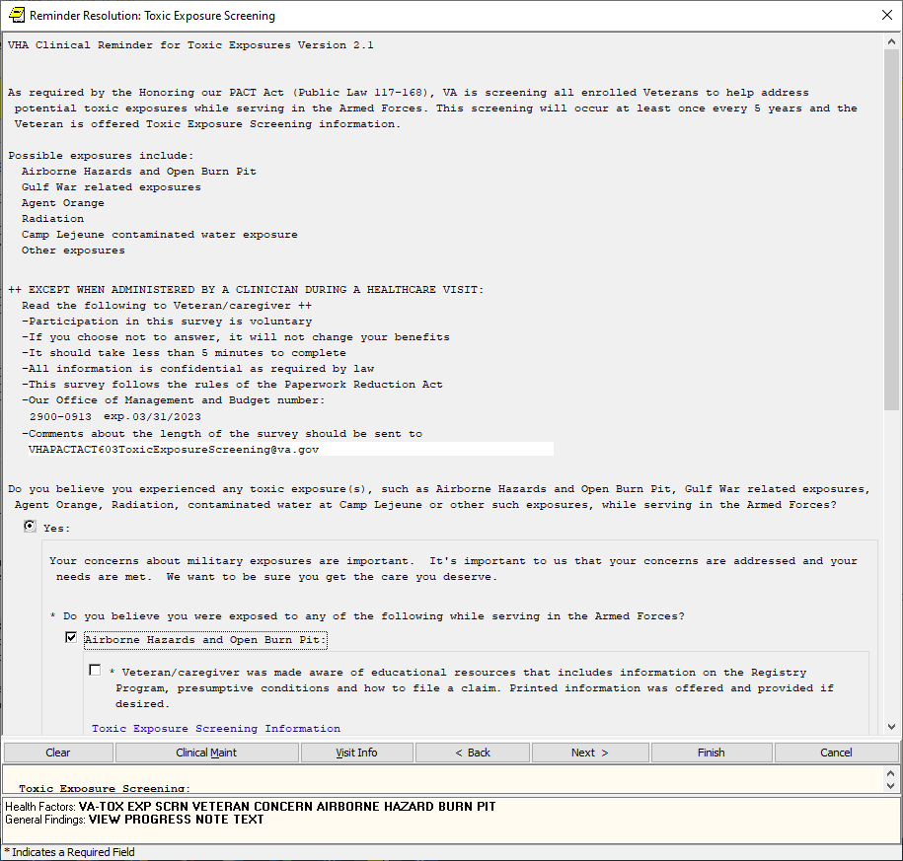

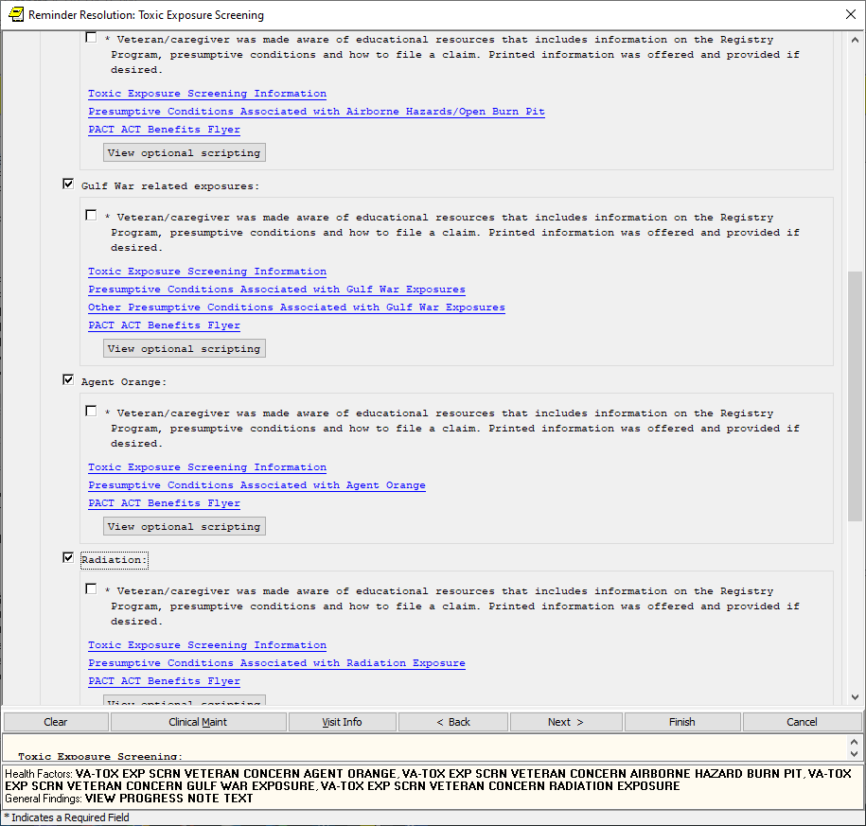

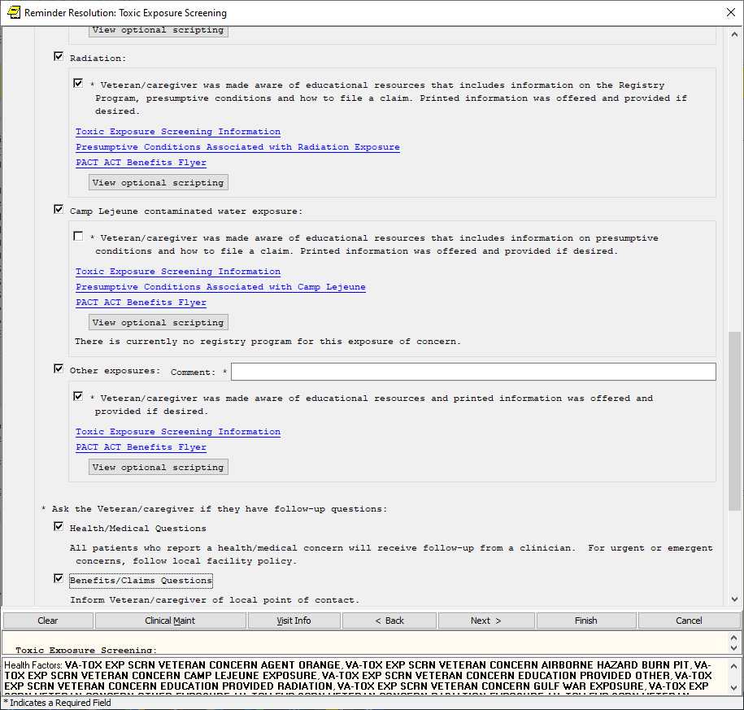

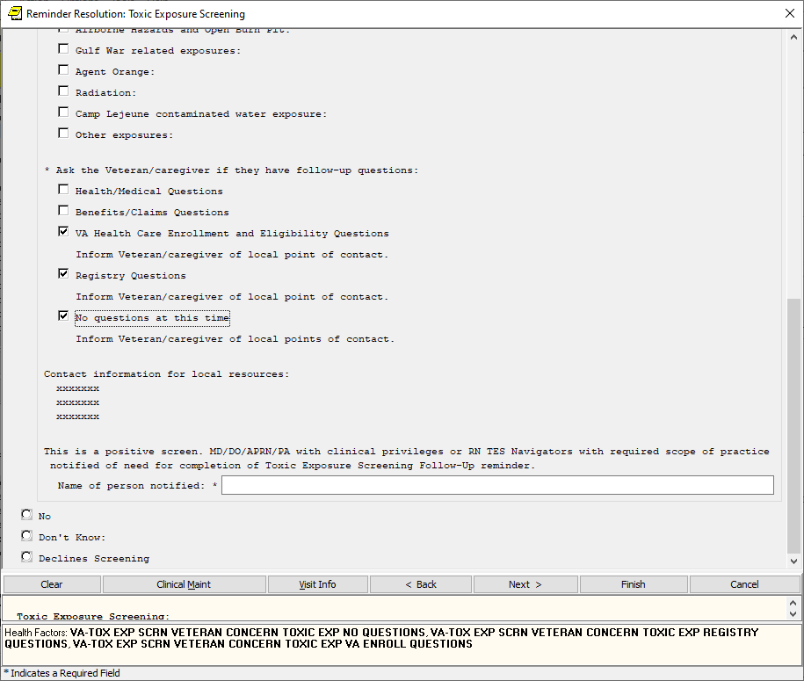

Yes, expanded view that will display if opened by a MD/DO/PA/APRN or RN TES Navigator with required scope of practice:

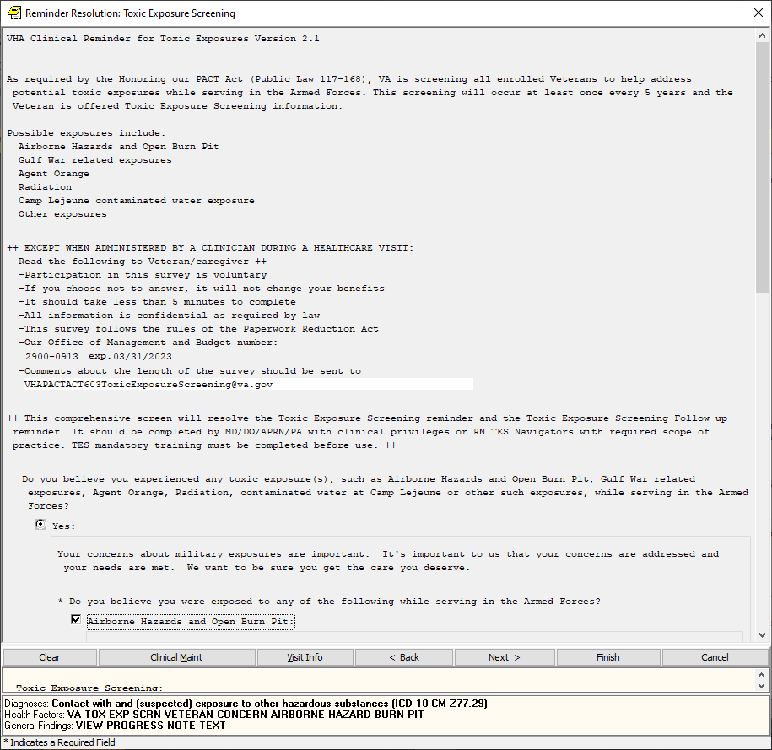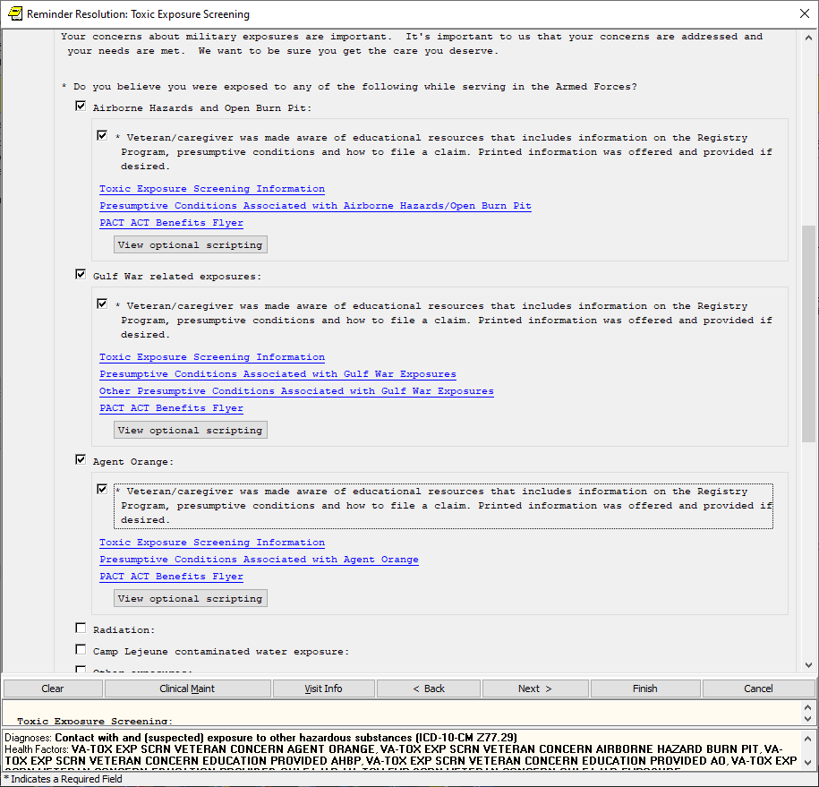

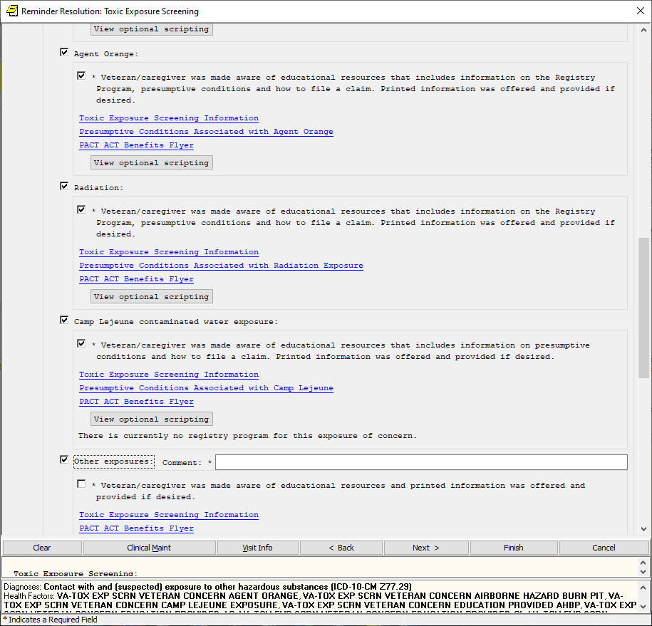

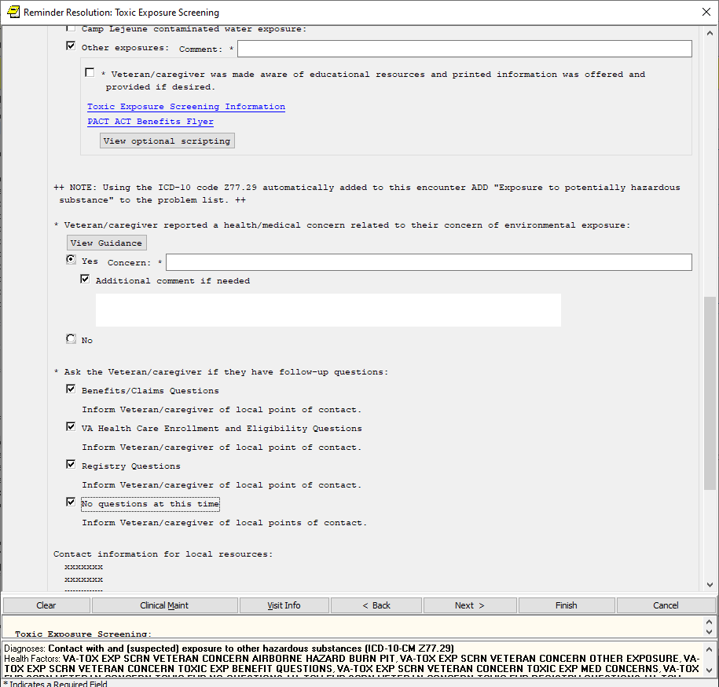

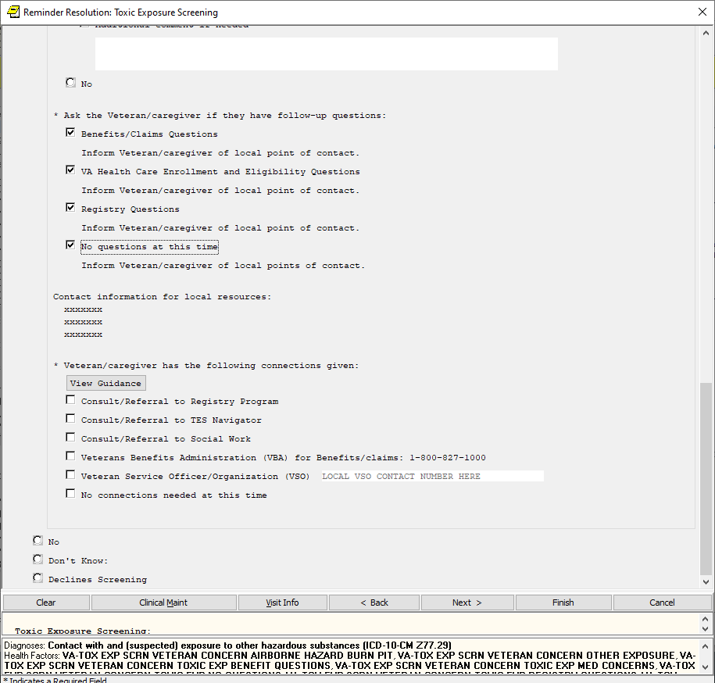

The “view optional scripting” pop ups are all similar as follows:

1. Exposure types are only wording changes between the first 5:

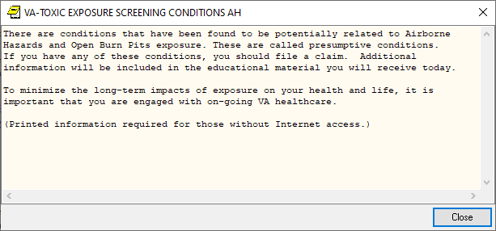

1. The “Other” Option

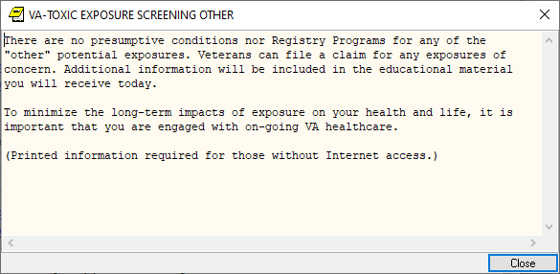

View guidance for health medical concern question:

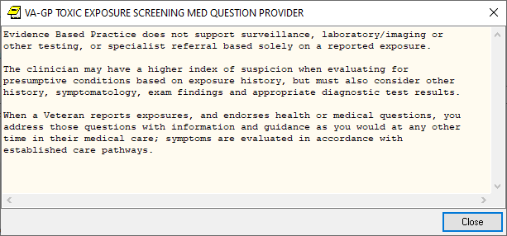

View guidance– connection types

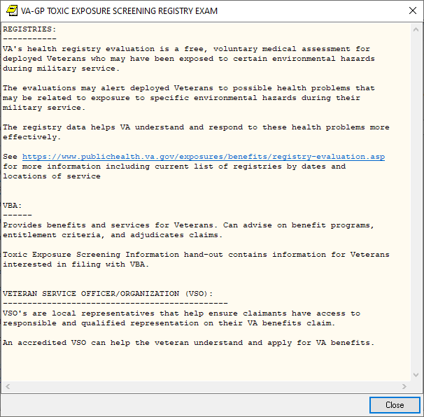

No, expanded, if reminder is opened by a User that IS NOT a MD/DO/PA/APRN or RN TES Navigator with required scope of practice:

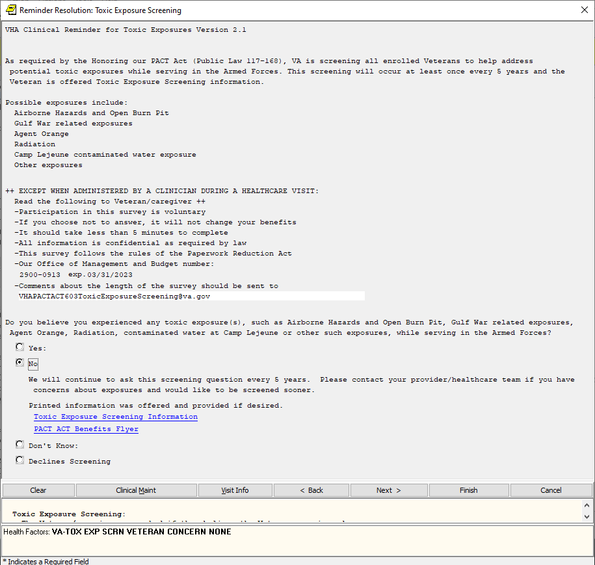

No Expanded that will display if opened by a MD/DO/PA/APRN or RN TES Navigator with required scope of practice:

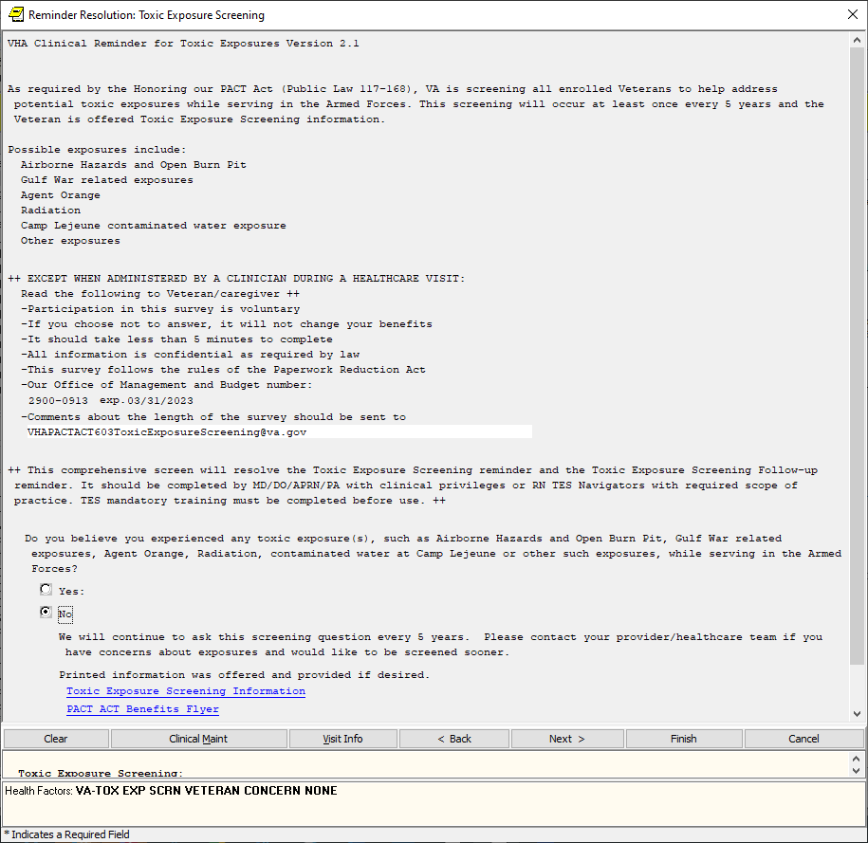

Don’t Know, expanded if reminder is opened by a User that IS NOT a MD/DO/PA/APRN or RN TES Navigator with required scope of practice:

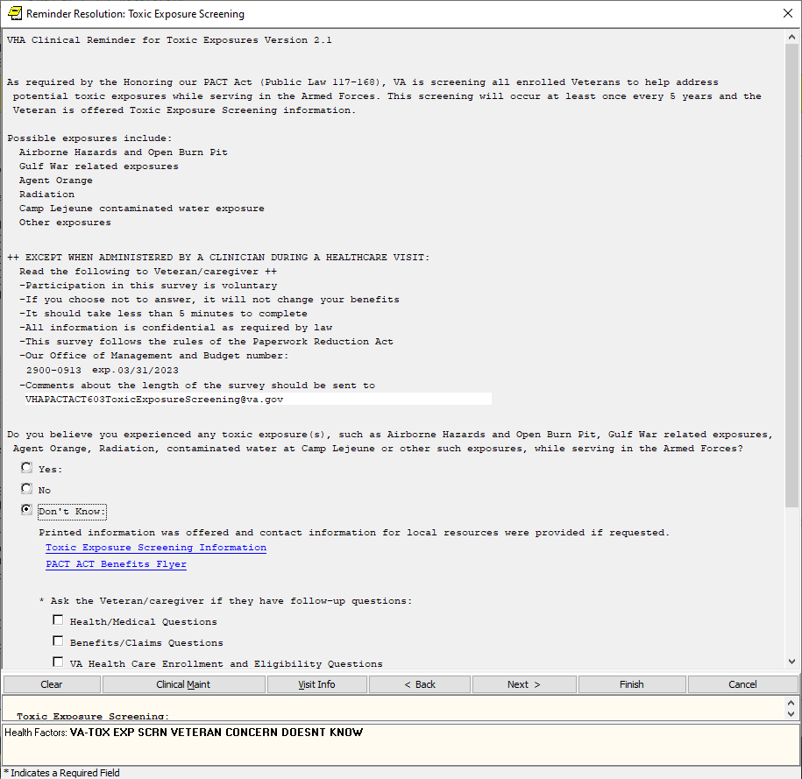

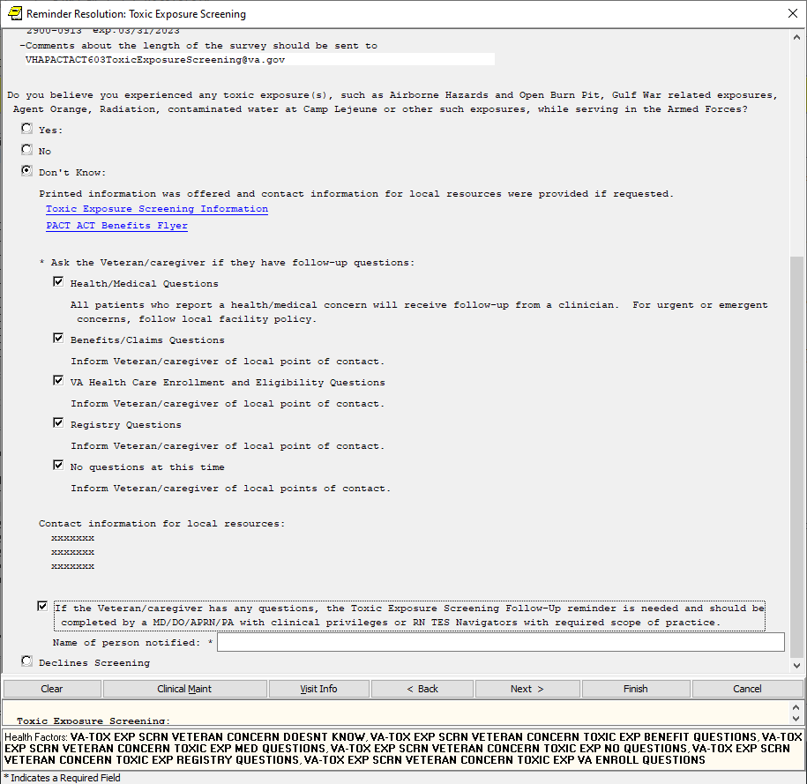

Don’t Know, expanded view that will display if opened by a MD/DO/PA/APRN or RN TES Navigator with required scope of practice:

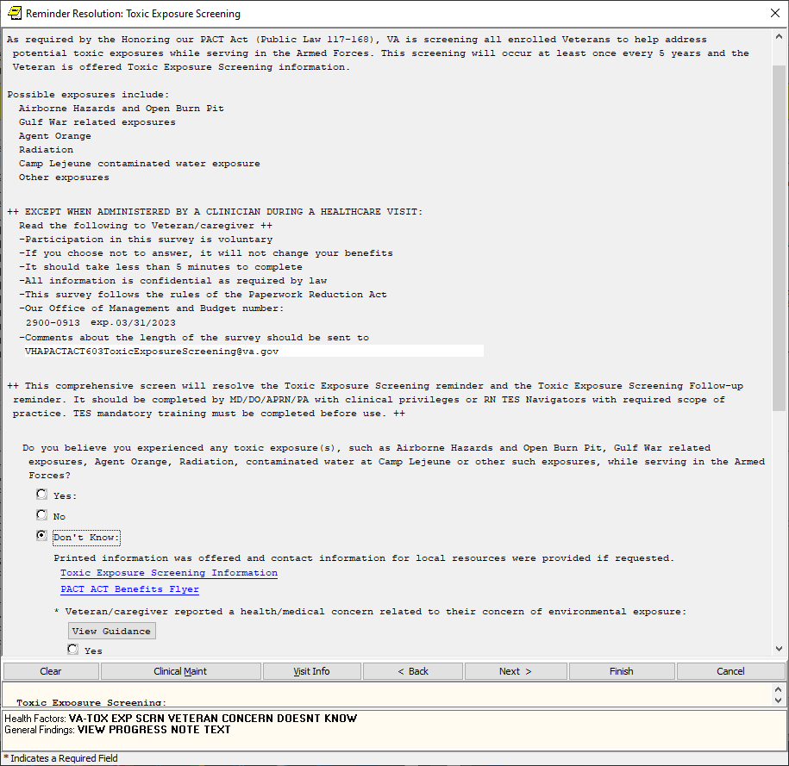

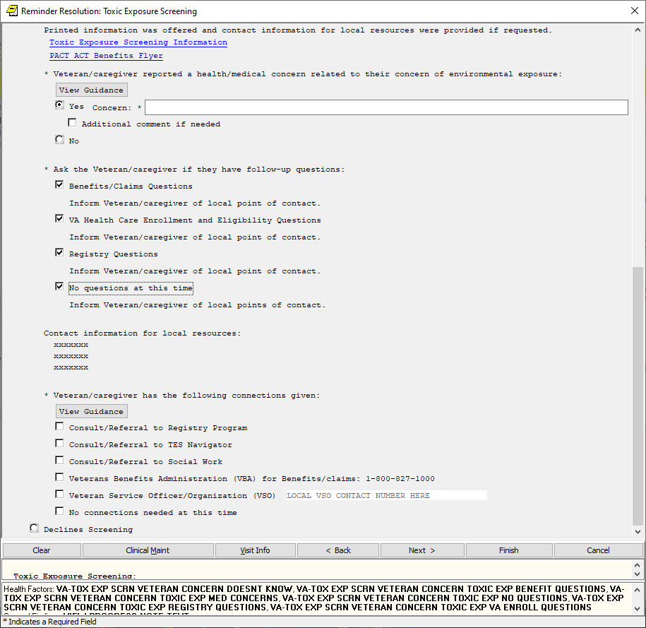



Declines, expanded if opened by a user that IS NOT MD/DO/PA/APRN or RN TES Navigator with required scope of practice:

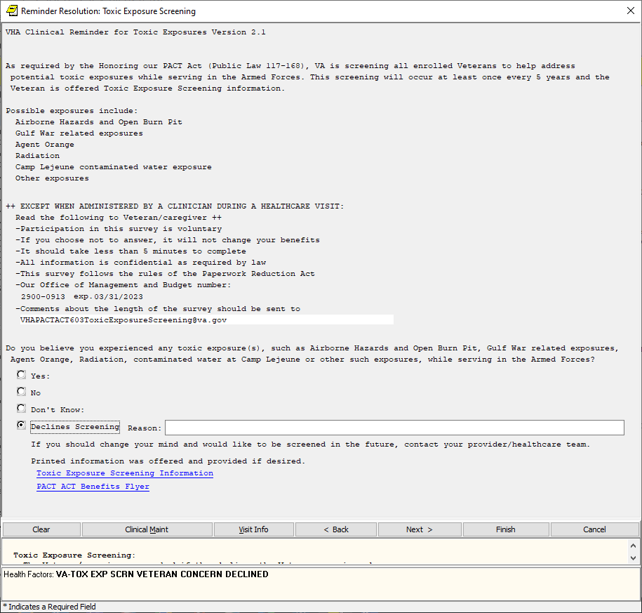

Declines, expanded if opened by MD/DO/PA/APRN or RN TES Navigator with required scope of practice:

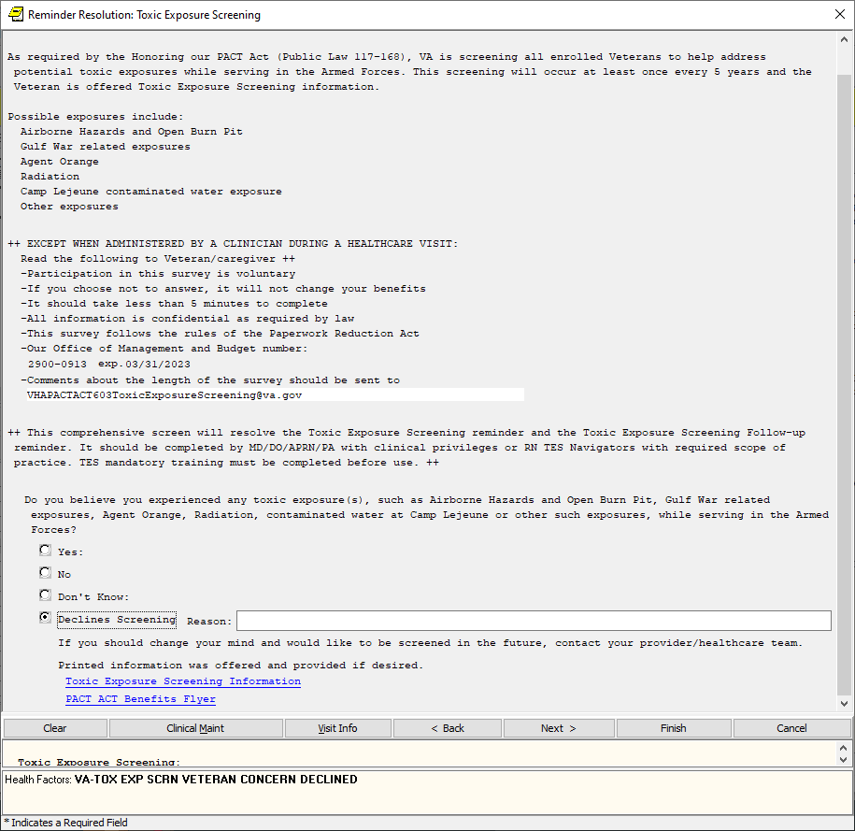

Positive Toxic Exposure Screening Follow-up reminder:

If the screen is completed by a user that is not a PA/APRN/MD/DO and the screen response is YES or if the screen response is DON’T KNOW and the Veteran has any questions, the follow up reminder will come due.

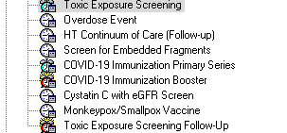

If triggered by an I don’t know on the screen:

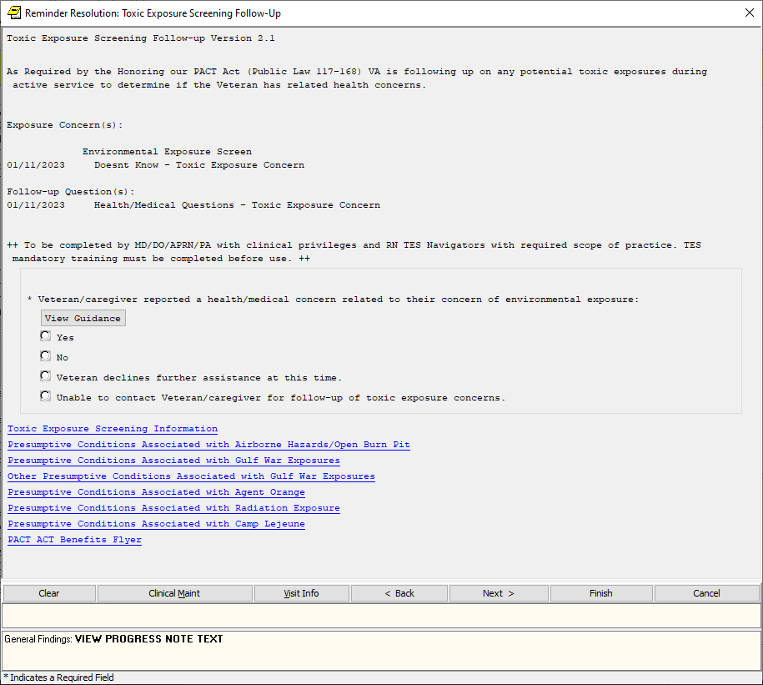

If triggered by an exposure concern on the screen (ICD code is added to encounter and message displays reminding provider to add to problem list):

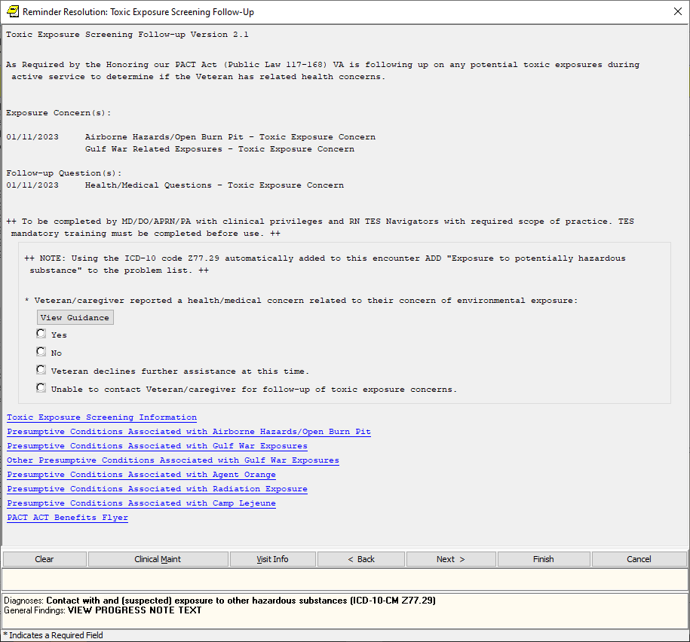

Expanded - yes:

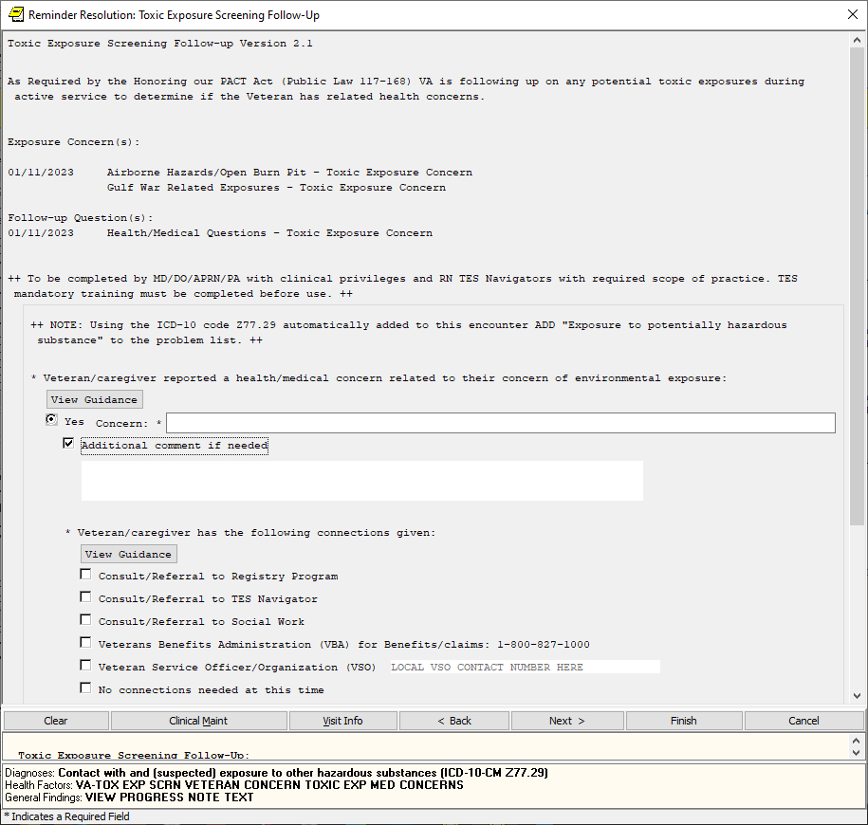

Expanded – no

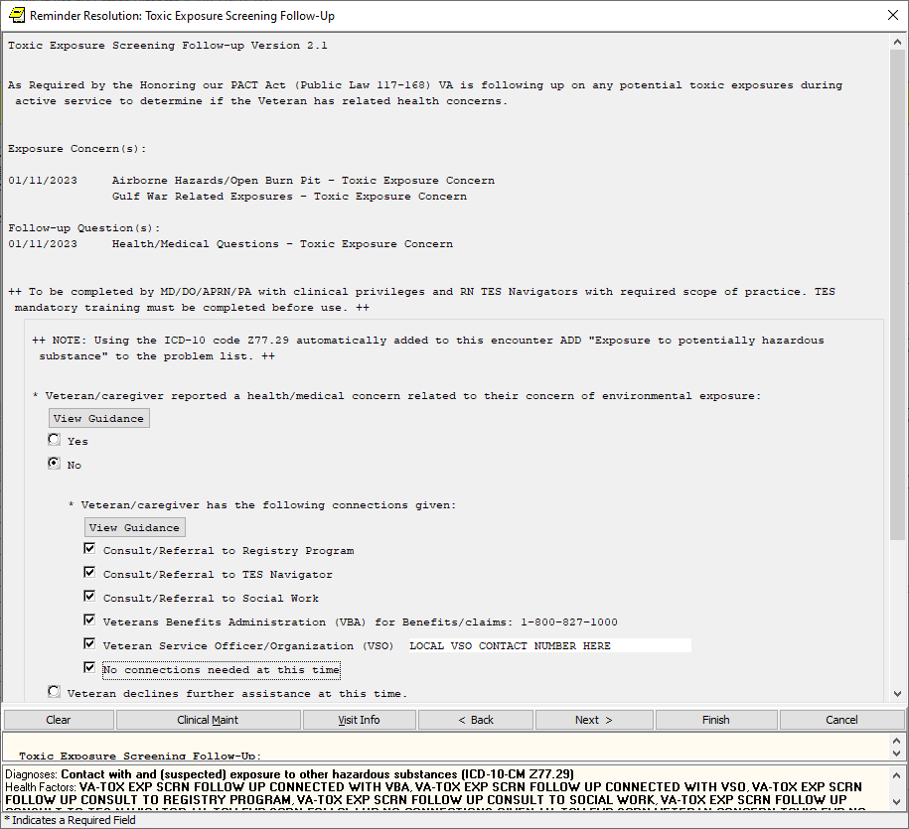

Declines does not expand:

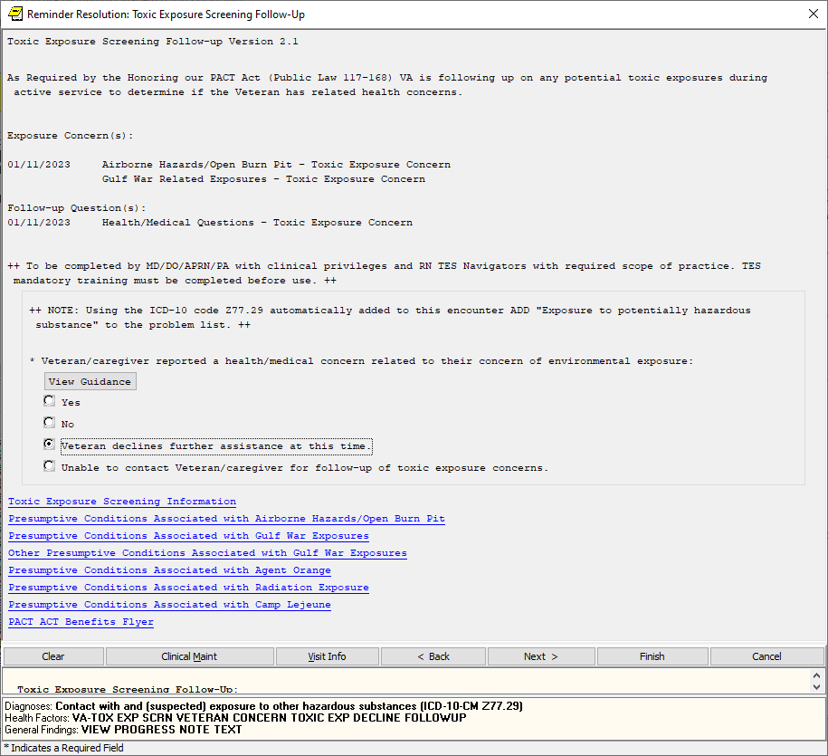

Unable to contact expanded:

