The Carolina Coast: What Does It Mean to You?

To be completed by the adult (age 18 and over) in your household who has the next upcoming birthday. A survey by the National Oceanic and Atmosphere Administration.

Importance of the Carolina Coast
Only households found on the Carolina coast received this survey. Please consider the term “Carolina coast” to mean the land and water area shown within the black boundary on the map below.

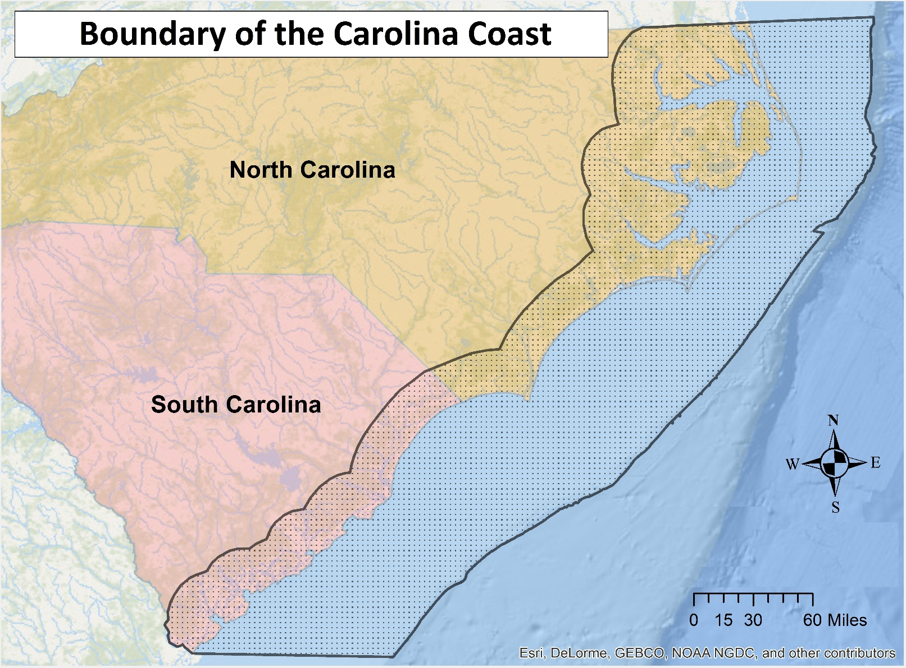

- First, would you describe yourself as a permanent, temporary, or seasonal resident of the Carolina coast?
- Permanent (i.e., you reside here full time, permanently)
- Temporary (i.e., you reside here full time, but for a limited period only)
- Seasonal (i.e., you reside here for one to four months annually or periodically, such as for vacation)

- How long have you resided on the Carolina coast as a permanent, temporary, or seasonal resident?
- Less than 1 year
- 1 to 2 years
- 3 to 5 years
- 6 to 10 years
- 11 to 20 years
- More than 20 years

- To what extent do you agree or disagree with the following statements about the Carolina coast?
 | Strongly  Disagree | Somewhat  Disagree | Neutral | Somewhat  Agree | Strongly  Agree
I feel a strong sense of community on the Carolina coast.
I think the economy is strong on the Carolina coast.
I feel connected to the other people who live on the Carolina coast.
The Carolina coast is a special place for me and/or my family.
I think the natural parts of the Carolina coast are beautiful.
The Carolina coast says a lot about who I am.
The Carolina coast is the best place for what I like to do.
I like the Carolina coast’s mix of plants, animals, and landscapes.

- For only the recreational activities that you engage in along the Carolina coast, please indicate how important each is to you.
 | Not  Important | Somewhat  Important | Very  Important | Extremely  Important | Don’t Engage
Beach going
Nature or scenic photography
Birdwatching
Whale watching or viewing of other marine mammals
Fishing
Hunting
Boating or sailing
SCUBA diving
Other, please specify: ______________

- For the items listed below, please tell us how important each item is to you in terms of your quality of life on the Carolina coast.

 | Not  Important | Somewhat  Important | Very  Important | Extremely  Important | Don’t  Know
Tax revenues

Job opportunities

Affordability of electricity

Image of your community

Shipwrecks and other submerged maritime heritage sites
Local property values

View of ocean from the shore during the day
View of ocean from the shore at night

Recreational fishing

Habitat for birds

Habitat for fish

Habitat for marine mammals and sea turtles

- Please draw a line connecting each pencil to one of your favorite places inside the black boundary on this map. Then mark all the reasons that you value each place. (You may use either a pen or pencil.) Types of reasons for valuing a place are defined below.
Aesthetics: I value this area because I enjoy the beauty, sights, sounds, and smells found here.
Economic: I value this area because it provides fisheries, minerals, and/or tourism opportunities such as outfitting and guiding.
Historic: I value this area because of the historic significance to our culture and communities.
Recreation: I value this area because it provides a place for my favorite outdoor recreation activities.
Relaxation: I value this area because it makes me feel better, physically and/or mentally; it is calming.
Naturalness: I value this area because it is undeveloped with minimal human impact and it provides a variety of fish, wildlife, plant life, etc.
Other: I value this area because of a reason not listed above. Please write in the blank provided a word or two to describe this value.

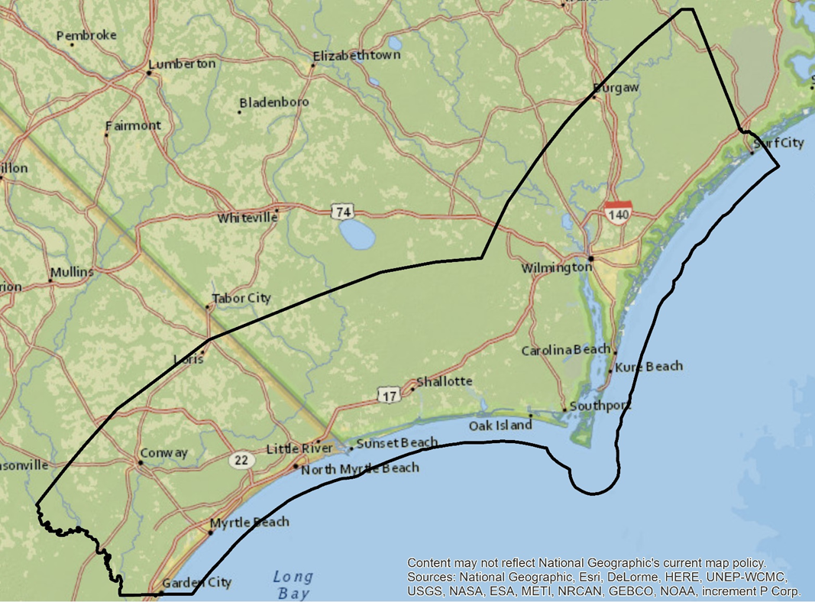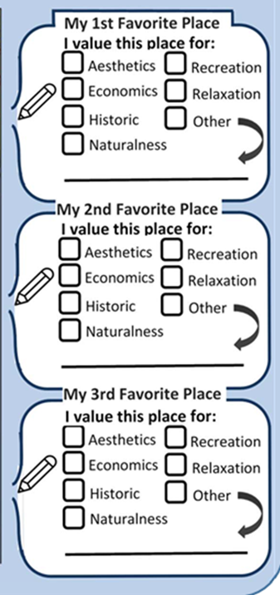
Expressions of Support or Opposition on Issues

The following questions will help us to understand how you express your support for or opposition to issues, including but not limited to offshore wind energy development.

- By selecting “Yes” or “No” for each item below, please indicate whether you have ever done any of the following activities to express your support for or opposition to:

  - any issue in a city, county, or state where you have lived
  - any environmental issue in a city, county, or state where you have lived
  - the potential for offshore wind energy development in a city, county, or state where you have lived

 | a. Any issue | b. Any environmental issue | c. The potential for offshore wind energy development
Signed a petition | Yes No | Yes No | Yes No
Written, emailed or called a public official | Yes No | Yes No | Yes No
Joined a citizen-based advocacy group because of their position | Yes No | Yes No | Yes No
Attended public meetings sponsored by a government agency | Yes No | Yes No | Yes No
Attended public meetings, gatherings or demonstrations sponsored by an advocacy group | Yes No | Yes No | Yes No
Contributed money to an organization or campaign | Yes No | Yes No | Yes No
Other, please specify: ___________________ | Yes No | Yes No | Yes No

- In the next 12 months, do you plan to do any of the activities listed above in Question 7 in response to the potential for offshore wind energy development in your current city, county or state?
  - Yes
  - No

Offshore Wind Energy Development

The following questions will help us to understand your views on offshore wind energy development, generally and in your region.

- How aware are you of efforts to develop offshore wind energy in the following areas?

 | Not at All Aware | Slightly  Aware | Moderately  Aware | Very Aware | Extremely Aware
The United States
North Carolina
South Carolina

- Regardless of how aware you are about efforts to develop offshore wind energy, based on the impressions you have at the present time, what is your level of opposition or support to the development of offshore wind energy in the following areas?

 | Strongly  Oppose | Somewhat  Oppose | Neutral | Somewhat  Support | Strongly  Support
The United States
North Carolina
South Carolina

- Based on the impressions you have at the present time and thinking about the Carolina coast as shown on Page 1, please indicate the type of impact you think development of offshore wind would have for each of the items listed below.

 | Negative  Impact | No  Impact | Positive  Impact | Unsure
Tax revenues
Job opportunities
Affordability of electricity
Image of your community
Shipwrecks and other submerged maritime heritage sites
Local property values
View of ocean from the shore during the day
View of ocean from the shore at night
Recreational fishing
Habitat for birds
Habitat for fish
Habitat for marine mammals and sea turtles

Background
To enable us to compare the responses of people with similar or different characteristics, in this final section we ask a few questions about you and your household. As with all answers, this information will be used for grouped analysis involving responses from all survey participants – your responses will remain completely confidential.

- What is your sex?
  - Male
  - Female

- In what year were you born?

- Which best describes your marital status?
  - Married
  - Widowed
  - Divorced
  - Separated
  - Never married

- Which best describes your ethnicity?
- Hispanic or Latino
- Not Hispanic or Latino

- Which best describes your race? (Select one or more.)
- American Indian or Alaska Native
- Asian
- Black or African American
- Native Hawaiian or Other Pacific Islander
- White

- What is the highest degree or level of school you have completed?
- No schooling completed
- Some high school (no diploma)
- High school diploma or GED
- Some college (no degree)
- Associate’s degree
- Bachelor’s degree
- Master’s degree
- Professional degree (e.g., MD, DVM, JD)
- Doctoral degree (e.g., PhD, EdD)

- Which best describes the ownership status of your residence in this county?
- Owned or being bought by you or someone in your household
- Rented or leased
- Occupied without payment of cash rent

- How many people currently live in your household, including yourself?

- How many people under the age of 18 currently live in your household?

- What was the total income of your household during 2015 before taxes and other deductions?
- Less than $25,000
- $25,000 to $34,999
- $35,000 to $49,999
- $50,000 to $74,999
- $75,000 to $99,999
- $100,000 to $149,999
- $150,000 or more

- Which best describes your current employment status?
- Unemployed
- Employed full-time
- Employed part-time
- Self-employed
- Retired
- Student
- Homemaker
- None of the above

The public reporting burden for this collection of information is estimated to average 20 minutes including the time for reviewing instructions, searching for existing data sources, gathering and maintaining the data needed, and completing and reviewing the collection of information. Send comments regarding this burden estimate or any other suggestions for reducing this burden to: Dr. Theresa L. Goedeke, NOAA National Ocean Service, National Centers for Coastal Ocean Science, 1305 East-West Highway, Silver Spring, MD 20910. Access to raw data collected during the data collection process will be restricted to project managers. In final datasets and products that are released, data provided by individual respondents will be aggregated and not linked to personally identifiable information. Notwithstanding any other provisions of the law, no person is required to respond to, nor shall any person be subjected to a penalty for failure to comply, with a collection of information subject to the requirements of the Paperwork Reduction Act unless that collection of information displays a currently valid OMB Control Number.

