**Information and forms for getting involved and frequently asked questions**

**Interested in volunteering? Find out what is involved.**

**We are looking for new volunteers all across the U.S. to monitor coastal or freshwater environments for potentially harmful phytoplankton.**

***Are you interested in sampling local waters twice a month and identifying the phytoplankton that are found? It’s okay if the last time you used a microscope was back in high school! No Science Experience Required!***

* **Anyone can participate!** Parks, 4-H clubs, Homeschoolers, Master Naturalists, Individuals, etc...
* **PMN provides volunteers with ALL the necessary equipment**, except for the light microscope.
* Volunteers must have access to a basic light microscope with total magnification up to 200x, preferably 400x. The PMN may be able to help you locate a microscope to use in your community.
* Volunteers commit to sampling their site **at least once every two weeks for at least one year**.
* **Sampling sites can be anywhere**, as long as there is easy, safe, and legal access to the site.
* For marine monitoring, sampling sites must have a **salinity of 10-15 ppt or greater** throughout most of the year. (If you're not sure of the salinity, the PMN can loan you a refractometer to determine the salinity.) There is no salinity requirement for freshwater sites.
* Volunteers **must have computer access** for training purposes and to enter data into the PMN online database.

New volunteers interested in getting trained for the first time, please fill out the Schedule Training form below, and we'll get you started!

[Schedule Training](https://docs.google.com/forms/d/1FKJR5l5t1RNUJiXgUBEI0eJOl8nbhrsdb2s8nbAsuhI/edit?ts=5b04328e)

REQUEST TRAINING

Thank you for your interest in becoming a PMN volunteer! Please read the information below, and if you can satisfy all of the requirements, then we will contact you. Our trainings are conducted **once per month**, so please be patient if you do not hear from us immediately! If you have further questions, please email [pmn@noaa.gov](mailto:pmn@noaa.gov)

**joe.terry@noaa.gov** [Switch account](https://accounts.google.com/AccountChooser?continue=https://docs.google.com/forms/d/1FKJR5l5t1RNUJiXgUBEI0eJOl8nbhrsdb2s8nbAsuhI/viewform?ts%3D5b04328e%26edit_requested%3Dtrue&service=wise)

Draft saved

* Required

Email*

Requirements for volunteering

Please read the information below to ensure that you can comply with ALL of the requirements for participating in our citizen science program.

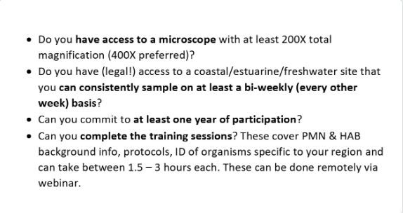

Next

REQUEST TRAINING

**joe.terry@noaa.gov** [Switch account](https://accounts.google.com/AccountChooser?continue=https://docs.google.com/forms/d/e/1FAIpQLSdW8kbqGNeWpsnGgtq5ISOvP5t0DCDFtAu2cC289FvnpYFeKg/formResponse&service=wise)

* Required

FAQ's

What if I don't have a microscope?  
  
We may be able to help with that! We may be able to help you with a loaned microscope if we have one available.  We can also provide some examples of microscopes   
  
How to pick a site?  
  
For the Aquaculture PMN, any salinity range is acceptable.

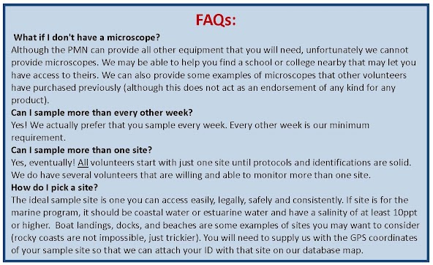

Are you able to fulfill ALL of the requirements listed above?*

Yes

No

Back

Next

REQUEST TRAINING

**joe.terry@noaa.gov** [Switch account](https://accounts.google.com/AccountChooser?continue=https://docs.google.com/forms/d/e/1FAIpQLSdW8kbqGNeWpsnGgtq5ISOvP5t0DCDFtAu2cC289FvnpYFeKg/formResponse&service=wise)

* Required

CONTACT INFORMATION

Your name (first and last)*



Your answer

What state do you live in?*



Your answer

Are you interested in coastal or freshwater monitoring?*

Coastal (salinity must be >10ppt at your sample site)

Aquaculture (hatchery/grow-out/fishery)

Freshwater

Tribal

not sure?

Please provide your complete mailing address below. This would be the address to which your supplies will be mailed following the completion of training. We are unable to ship to PO boxes.*

Your answer



Phone number at which you may be reached



Your answer

Almost done! Just a few more questions to help us better get to know you!

Do you have previous experience with a microscope?*

Yes

No

It's been a while.....

What do you already know about phytoplankton (algae and/or cyanobacteria specifically) and harmful algal blooms (HABs)? This will help us tailor the level of your training.*

Nothing! I'd like to start at the beginning!

I've heard of algae and/or cyanobacteria before but don't know or remember much about them

I am aware of algae/cyanobacteria but not so much HABs

I am aware of HABs but not so much algae/cyanobacteria

I am already familiar with HABs, the organisms that cause them, and some impacts

I am able to identify some algae/cyanobacteria already

Other:



How did you hear about us?*

Through the [noaa.gov](https://www.google.com/url?q=http://noaa.gov&sa=D&source=editors&ust=1672359001931542&usg=AOvVaw0T765F1ryihZYkZvmBB2LN) website

Through another PMN volunteer

Through another group/school/volunteer organization

Other:



Thank you for your responses! We will contact you shortly! If you have any questions, please email [pmn@noaa.gov](mailto:pmn@noaa.gov).

Back

Submit

**Frequently Asked Questions**

**Frequently Asked Questions**

What are the benefits of becoming a PMN volunteer?

PMN volunteers are an asset to the community through the knowledge gained and shared. Volunteers are the primary investigators for the local waters and community public health and directly contribute to a greater understanding of when and where potential harmful algal blooms may be occurring. The program works well as a community group initiative or can be incorporated into the classroom.

What happens when I volunteer with PMN?

Volunteers are given an instructional training course (either in-person or online) by one or more PMN staff members, depending on group size and staff availability. The PMN staff member(s) gives a presentation that explains the program, introduces phytoplankton and explains their ecological importance, and ends with a tutorial on phytoplankton identification. After the initial training, all new volunteers then practice their ID on their own and have at least one “check out” session to ensure that their practice identifications are correct. After that, volunteers sample at least every other week, enter their data, and have their ID’s verified through either submitting photos or by sending their samples in for confirmation.

How much time is required to become an active PMN volunteer?

Initial training takes the most time and varies by volunteer/volunteer group, typically lasting between 2 – 3 hours for marine monitoring and 1.5 hours for freshwater monitoring. Once training is complete, each sample collection takes approximately 5-10 minutes. Sample identification with the microscope can take anywhere from 20 minutes to 2 hours to identify. As volunteers become more comfortable with identification, the time needed to properly identify the sample decreases. Data entry takes only a few moments and can be done online or via the PHYTO app. Additional time factors include travel time to the sampling site and the number of sites monitored. We do ask that you volunteer for at least a year (but hopefully longer) in order for a meaningful data set to be generated for each site.

Once the training sessions are completed, are volunteers left on their own?

Volunteers are never left on their own! Volunteers make weekly/biweekly plankton tows and identify the samples independently after the initial training(s), but PMN staff are available to help with identifications at any time, especially if photos are taken of the sample. Taking photos helps not only in the confirmation of volunteer IDs, but also allows PMN staff to help ID any unknowns or IDs that volunteers are not sure of. The PMN regional coordinator is always available to work with volunteers in any way possible via email or phone.

How does a volunteer get the most out of volunteering for PMN?

A great initial step is to form a phytoplankton monitoring team and establish a consistent sampling schedule. Perhaps have the team leader or project leader get the sample the same day every week and pick a convenient time and location to analyze the sample. Consistent sampling is vital to getting useful information about the phytoplankton we are monitoring!

How do I take pictures through the microscope?

There are several ways to take photos of your samples. The easiest is to use your cell phone camera! The [link here](https://www.youtube.com/watch?v=cfd9ViHBlR4) is a great start to showing you how. There are also adaptors to hold the phone steady over the eyepiece (email PMN@noaa.gov to see if we have any to loan you!).  You may have also get a camera that fits over the eyepiece of your microscope or have a microscope with a built in camera (however, neither of these options are provided by NOAA).

Where can I see my data?

After PMN staff confirm the data entry, it goes to our publically accessible database [here](https://www.ncei.noaa.gov/erddap/tabledap/bedi_PMN.html).  You can go back anytime and see data for just your site or you can explore data from other volunteers across the country.

Additional Information or Questions:

Email us at pmn@noaa.gov or call Steve Morton: (843)762-8857.