Finding Hal

<https://findinghal.org/>

Calling all divers!

We need your help to **find HAL**, endangered white abalone in the genus “*Haliotis*” in and around the Southern California Bight (Point Conception to Ensenada).

White abalone (*Haliotis sorenseni*) are on the brink of extinction, **your** observations could contribute to the conservation of this endangered species.

Use our [ID cards](https://findinghal.org/cards.html) to see different abalone species, and help us positively ID white abalone.

Going diving? Be sure to visit our [Resources](https://findinghal.org/resources.html) page for more SCUBA-related abalone ID and best practices. Want to learn more about these marine snails? Visit our [About](https://findinghal.org/about.html) page for more information, or visit NOAA Fisheries to find out [why you should care about white abalone](https://www.fisheries.noaa.gov/feature-story/white-abalone-why-you-should-care-about-critter).

Identifying HAL

Please enjoy these unique abalone ID cards created by [Oriana Poindexter](http://www.orianapoindexter.com/). Each card has a front and back, and can be downloaded to your device as a PDF.

To aid in the identification of HAL, please see these [shell images](https://findinghal.org/shells.html) provided by the Santa Barbara Museum of Natural History

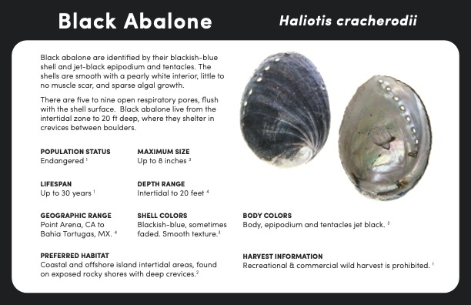

Black Abalone

*Haliotis cracherdoii*

PDF

Download

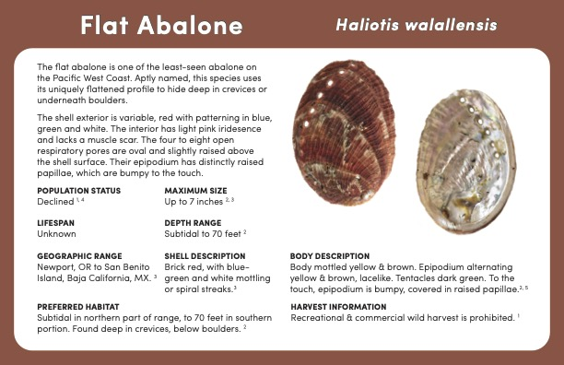

Flat Abalone

*Haliotis walallensis*

PDF

Download

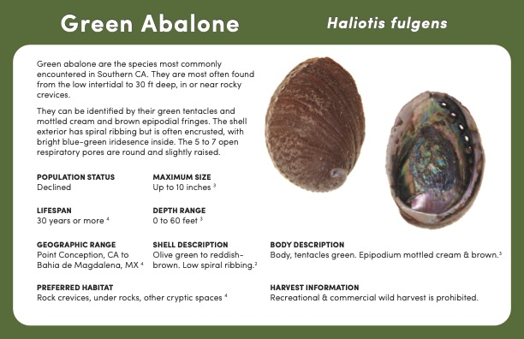

Green Abalone

*Haliotis fulgens*

PDF

Download

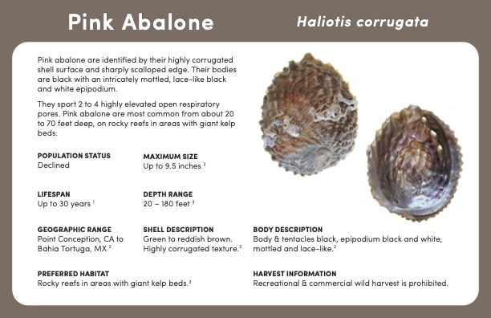

Pink Abalone

*Haliotis corrugata*

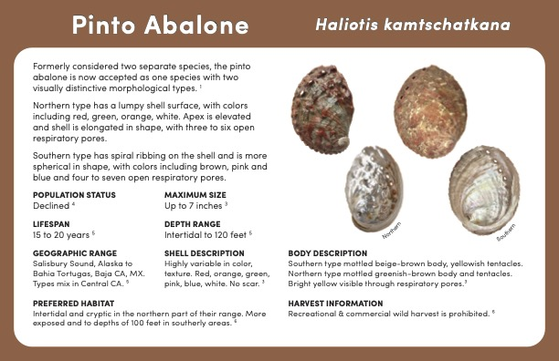

Pinto Abalone

*Haliotis kamtschatkana*

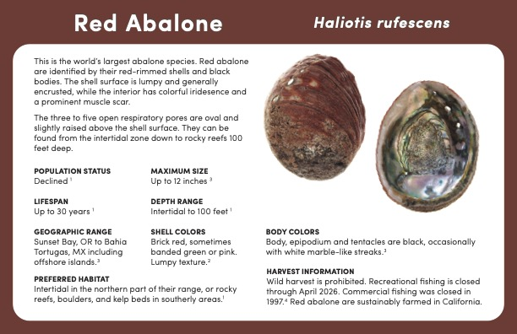

Red Abalone

*Haliotis rufescens*

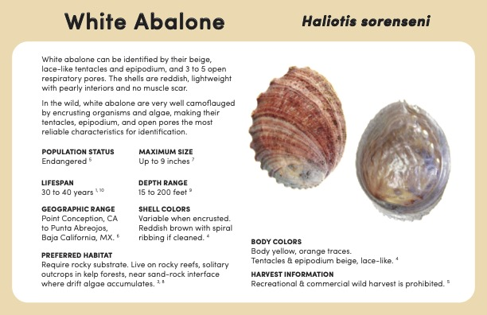

White Abalone

*Haliotis sorenseni*

PDF

Download

[Source: Oriana Poindexter](http://www.orianapoindexter.com/id-guides)

[**Glossary of key terms**](https://findinghal.org/glossary.html)

Already gone diving?

Please submit your abalone field observation here:  [**Submit an observation**](https://forms.gle/7ES7mD9mbVvvCtKX9)

Wanted alive!

Please share information on your recent white abalone sighting. For more information, visit [findinghal.org](http://findinghal.org/)  
  
Information submitted here will *not* be shared publicly

**john.doe@gmail.com** [Switch account](https://accounts.google.com/AccountChooser?continue=https://docs.google.com/forms/d/e/1FAIpQLSdFwtrwflOj5K4cgIzwjj26NlQmFb7XiJcOm56OTcGa5ACAKA/viewform?usp%3Dsend_form&service=wise)

The name and photo associated with your Google account will be recorded when you upload files and submit this form. Your email is not part of your response.

* Required

Name*



Your answer

Affiliation



Your answer

If you would like to be contacted via phone or a different email address, please leave your information here



Your answer

Next

Clear form

Wanted alive!

**john.doe@noaa.gov** [Switch account](https://accounts.google.com/AccountChooser?continue=https://docs.google.com/forms/d/e/1FAIpQLSdFwtrwflOj5K4cgIzwjj26NlQmFb7XiJcOm56OTcGa5ACAKA/formResponse&service=wise)

The name and photo associated with your Google account will be recorded when you upload files and submit this form. Your email is not part of your response.

* Required

Media upload and dive site information

In this section please provide any and all details and related media. Please note that media will only be used to identify white abalone and will *not* be shared publicly.

Please use this form to upload any and all images and video files from the field

Note: Please use this form for single individuals. For multiple sightings on the same dive, please use the duplicate file uploader below.

Add file

A white abalone seen in Southern California. Note the cream colored tentacles and respiratory pores. Easily confused with other abalone, white abalone are found at greater depths with different external features

Did you upload media? If not, please tell us what you saw*

We'd like to send divers to verify your observation. Please describe: mantle color, tentacle color, habitat, etc. to the best of your ability

Your answer



Date of encounter*

Please use the date picker or manually enter the date of your dive or sighting (Month, Day, Year)

Date

Were you the photographer? (Y/N) If not, please provide name and contact information*

E.g. "Yes" or "No; John Smith [j.smith@gmail.com](mailto:j.smith@gmail.com)"



Your answer

A map of the Southern California Bight, with CINMS highlighted in red. Please select the general region that you dove within.

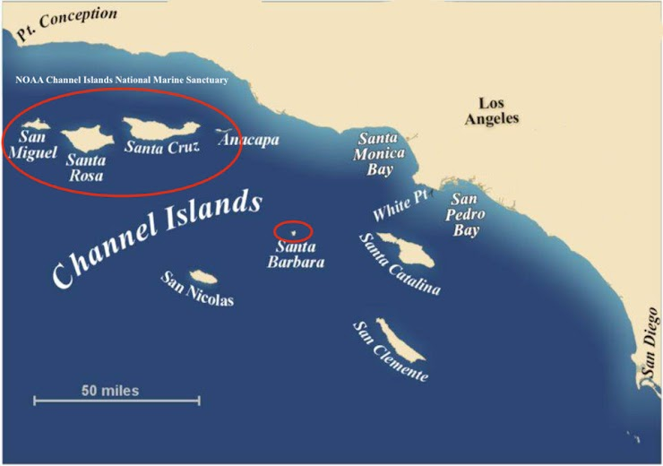

General location of white abalone

Choose

Please provide the name of the dive site (if applicable)



Your answer

If available, please provide GPS coordinates.

Approximate coordinates in (decimal or degrees) are very helpful (e.g.....)

Your answer



Please provide an approximate depth (meters or feet) of sighting*

Choose

Depth*



Your answer

Please provide the name of the vessel or platform you dove off of.*

E.g. "Peace", "Spectre", "Raptor". If you dove off of a private vessel please simply write "Private"



Your answer

*Note: No information will be shared publicly; media will only be used to identify white abalone.*

A wild white abalone (*H. sorenseni*) seen in the field in its preferred habitat. Source: Athena Maguire/CDFW

As part of the *Wanted Alive! White Abalone* campaign, Finding Hal sponsored and funded by the [National Marine Sanctuary Foundation](https://marinesanctuary.org/), implemented through [Ecoquants](https://ecoquants.com/). Partners involved with the campaign (but not hosting this web portal) include the [NOAA Channel Islands National Marine Sanctuary](http://channelislands.noaa.gov/) and [NOAA Fisheries Office of Protected Resources](https://www.fisheries.noaa.gov/about/office-protected-resources).

Resources

* [Wanted Alive Poster](https://findinghal.org/resources.html#wanted-alive-poster)

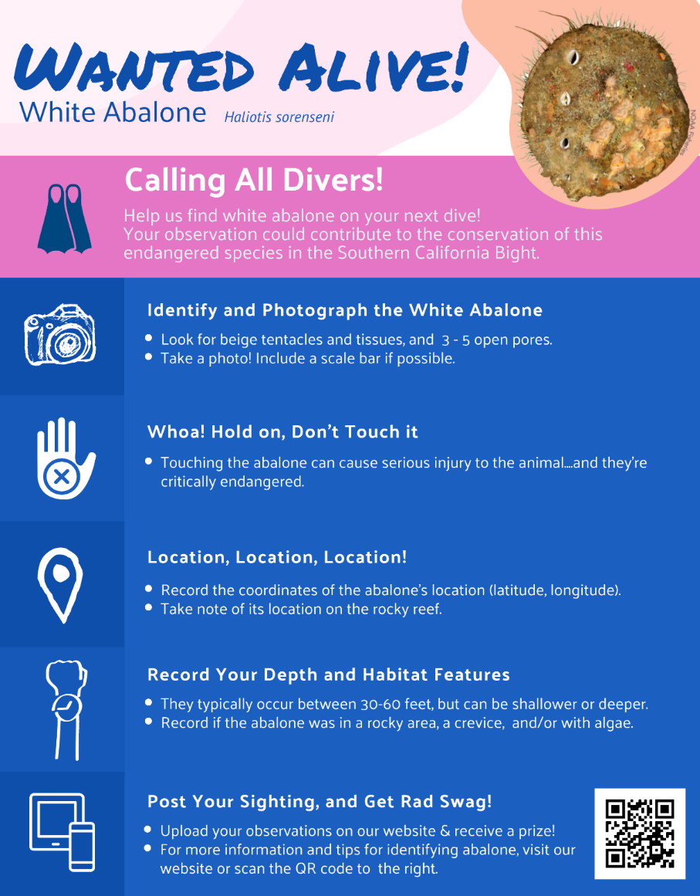

Glossary

Key terminology

**Abalone**: Abalone is a common name for any of a group of small to very large marine gastropod mollusks in the family Haliotidae

**Gastropod**: “gastro” = stomach, “pod” = foot; gastropods (commonly known as snails and slugs) belong to a large taxonomic class of invertebrates within the phylum Molluska called Gastropoda.

Abalone anatomy

**Oral**: relating to the mouth (referring to the “mouth end”)

**Aboral**: relating to/denoting the side or end that is furthest from the mouth

**Tentacle**: a slender, flexible limb or appendage in an animal, especially around the mouth of an invertebrate, used for grasping or moving about, or bearing sense organs.

**Epipodial**: “epi” = around, “podial” = relating to the foot; one of the lateral lobes of the foot of an abalone

**Respiratory pore**: aka “breathing pore”, an opening of the external body anatomy (visible in the shell of an abalone) which draws in water, allowing the organism to breath

Locating Hal

Click on the dropdown below to see a map of known white abalone sightings, and the distribution of abalone species in the North Pacific

* [Known sightings of white abalone](https://findinghal.org/map.html#known-sightings-of-white-abalone)

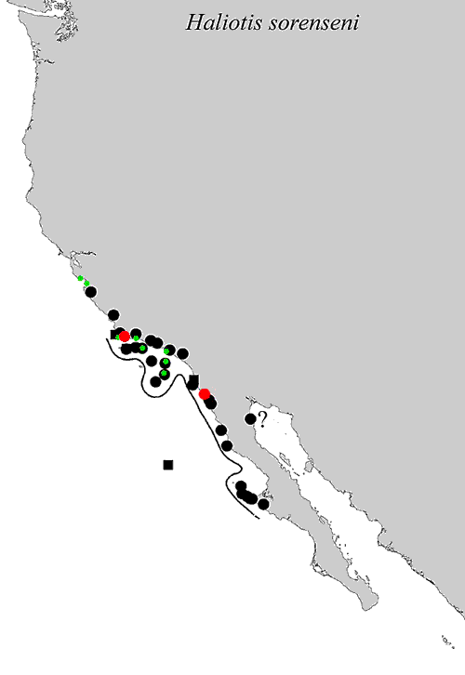

Known sightings of white abalone in California and Baja California. Circles indicate specimen records, squares indicate literature record, questions marks show a dubious record. Dots in red are new records not published in Geiger (2000), dots in green are from the Australian Museum, Sydney. Source: Daniel Geiger

About Hal

White abalone (*Haliotus sorenseni*) belongs to a group of plant-eating marine snails that were once common in California. They once numbered in the millions off the California coast, but now they are endangered. In 2001 white abalone became the first ever marine invertebrate to be Listed as endangered under the [Endangered Species Act](https://www.fisheries.noaa.gov/topic/laws-policies#endangered-species-act). White abalone are one of [NOAA Fisheries’ Species in the Spotlight](https://www.fisheries.noaa.gov/species/white-abalone/spotlight)—an initiative that includes animals considered most at risk for extinction and prioritizes their recovery efforts. Source: [NOAA Fisheries](https://www.fisheries.noaa.gov/species/white-abalone#overview)

As part of the *Wanted Alive! White Abalone* campaign, Finding Hal is sponsored and funded by the [National Marine Sanctuary Foundation](https://marinesanctuary.org/), implemented through [Ecoquants](https://ecoquants.com/). Partners involved with the campaign (but not hosting this web portal) include [NOAA Channel Islands National Marine Sanctuary](http://channelislands.noaa.gov/) and [NOAA Fisheries Office of Protected Resources](https://www.fisheries.noaa.gov/about/office-protected-resources).

Questions or comments about this site? Please reach out to [julie.bursek@noaa.gov](mailto::julie.bursek@noaa.gov) or [pike.spector@noaa.gov](mailto::pike.spector@noaa.gov)

Source: Kat Magaña/CDFW

https://wxcoder.org/login/?next=/home/