**Project Title:** Steller sea lion brand resight and entanglement reports

**Program Office Sponsoring or Conducting this CSC Project:** NMFS/Alaska Region/Protected Resources Division

**Authority for this CSC Project:** CCSA, MMPA and, ESA

**Purpose of this CSC Project:** This project for Steller sea lions (SSLs): helps us determine survival, movement patterns, number of entanglements, entanglement materials, the impacts to SSLs by marine debris or fishing gear, which assists in the conservation and recovery of SSLs. In addition, when the project provides real-time entanglement information, NMFS is sometimes able to respond and save the life of the animal.

**Type(s) of Information Collected and From Whom It Is Collected:** This project collects SSL sightings information including date, location, species, age class, entangling material if entangled, brand number if branded, and photos of SSLs. This information is collected from the individuals who make the sighting, which can include passengers or crew on whale watching vessels, crew on NOAA vessels and others who participate in work or recreational activities in the marine environment.

**Use of the Information:** NMFS principally uses this information in estimating Steller sea lion survival and entanglements and, therefore, in improving the conservation and recovery of SSL.

**Method(s) of Information Collection:** Paper (notes) and photos are sent via email.

**Affected Public:** Individuals, for profit businesses, and state, local, federal, tribal government

**Estimated Average Annual Number of Participants:** 15

**Estimated Average Annual Number of Responses per Participant:** 1

**Estimated Average Minutes per Response:** 5

**Estimated Average Annual Burden Hours:** 1

**Estimated Total Annual Cost to Participants in this CSC Project:** $0

**Estimated Average Annual Costs to the Federal Government:** $1,437

**Estimated Average Annual Number of Federal Government Employees (FTEs)**: 0.01

**Recruitment and Retention Methods for Voluntary Participants (SSA item 1):**

Recruitment: We have annual meetings with several whale watch companies each spring and we ask captains to send us any brand and/or entanglement photos and information. We meet annually with the NOAA Office of Law Enforcement (OLE) and ask them to report sightings.

Retention: When we receive reports, we write the reporter back to thank them, let them know the information about the Steller sea lion they reported (if we have that information available), and ask them to continue to send us reports. We also remind state and federal researchers, OLE, and whale watch captains and crew annually to continue to report.

**Gifts or Payments (SSA Item 9):** We do not plan to provide a gift or payment to the voluntary participants.

**Annual and Multi-Year Schedules (SSA Item 16):** This is an ongoing action, but we collate the data on an annual basis and provide it for the completion of reports. Each year starts with the beginning of the calendar year (Jan. 1) and ends with the last day of the calendar year (Dec. 31).

**Display OMB Control No. and Expiration Date (SSA Item 17):** This information will be provided when individuals sign up to participate in this CSC project**.**

**Statistical Methods:** This CSC project will not employ statistical methods.

**Approval for Pretesting:** This CSC project will not require additional pretesting with more than nine members of the public.

**Supplemental Documents**: There is one supplemental document for this CSC project. It provides promotional/recruitment/educations information, identifies the requested data and explains how to submit the requested information.

**CERTIFICATION:** I certify the following are true.

1. The collection is voluntary.
2. The collection is low-burden for respondents and low-cost for the Federal Government.
3. The collection is non-controversial and does not raise issues of concern to other federal agencies.
4. The collection will not include highly influential scientific information, ,which is information NOAA or OMB determines: (i) could have a potential impact of more than $500 million in any year, or (ii) is novel, controversial, or precedent setting or has significant interagency interest.
5. The collection complies with 5 CFR 1320.9 and the related provisions of 5 CFR 1320.8(b)(3).
6. The collection will provide qualitative and quantitative data that help inform scientific research and monitoring, validate models or tools, support STEM learning, and enhance the quantity and quality of data collected to support NOAA’s mission.

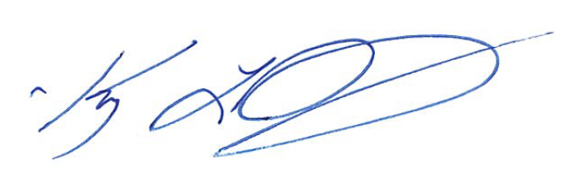

Name: Kim Raum-Suryan