News

There have been a number of articles and stories on false killer whales in the news in recent years – links to some of these are below. An additional PDF option is available for most.

Featured News

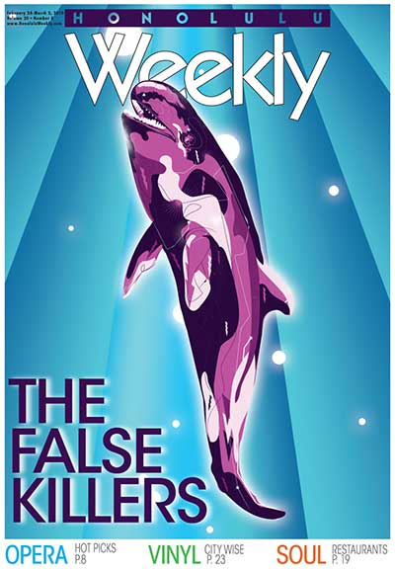

[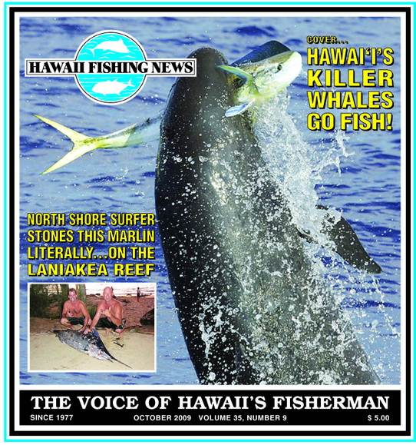](https://falsekillerwhales.org/wp-content/uploads/2016/11/news-hfnfalsekillersoctober2009.pdf)

[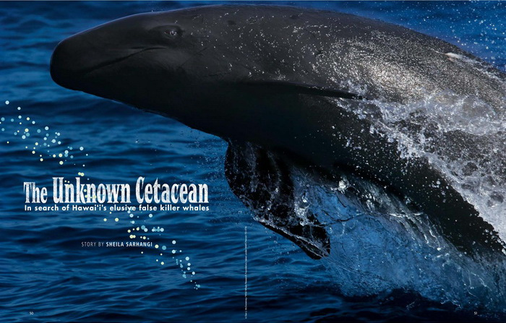](https://falsekillerwhales.org/wp-content/uploads/2019/07/hanahou2011_unknowncetacean.pdf)

Other news

[Hawaii’s false killer whales still face threats to their survival, but a new study offers hope.](https://www.hawaiinewsnow.com/2018/11/20/hawaiis-endangered-false-killer-whales-still-face-threats-their-survival-new-study-offers-hope/) Hawaii News Now, November 2018 [PDF](https://falsekillerwhales.org/wp-content/uploads/2019/07/hawaiinewsnow-hawaiisendangeredfkw-nov2018.pdf)

[Estimating the Number of Endangered False Killer Whales in the Main Hawaiian Islands.](https://www.fisheries.noaa.gov/feature-story/estimating-number-endangered-false-killer-whales-main-hawaiian-islands) NOAA Fisheries, September 2018 [PDF](https://falsekillerwhales.org/wp-content/uploads/2019/07/noaafisheries_estimatingpopulationofifkw.pdf)

[Protecting false killer whales.](https://www.thegardenisland.com/2018/07/27/hawaii-news/protecting-false-killer-whales/) The Garden Island, July 2018 [PDF](https://falsekillerwhales.org/wp-content/uploads/2019/07/thegardenisland-protectingfkw-july2018-1.pdf)

[NOAA moves to protect habitat for Hawaii’s endangered false killer whales. Honolulu Star Advertiser](https://www.staradvertiser.com/2018/07/25/breaking-news/noaa-moves-to-protect-habitat-for-hawaiis-endangered-false-killer-whales/), July 2018 [PDF](https://falsekillerwhales.org/wp-content/uploads/2019/07/staradvertiser-criticalhabitatdesignation.pdf)

[More Than 17,500 Square Miles Protected for Hawaii’s False Killer Whales.](https://www.biologicaldiversity.org/news/press_releases/2018/false-killer-whale-07-23-2018.php) Center for Biological Diversity, July 2018 [PDF](https://falsekillerwhales.org/wp-content/uploads/2019/07/cbd-ifkw_criticalhab.pdf)

[Endangered false killer whales get habitat protection](https://nypost.com/2018/07/27/endangered-false-killer-whales-get-habitat-protection/). New York Post, July 2018 [PDF](https://falsekillerwhales.org/wp-content/uploads/2019/07/nypost-july2018-endangered-false-killer-whales-get-habitat-protection.pdf)

[False Killer Whales: Hawaii’s Local Whale Species.](https://mauioceancenter.com/false-killer-whales-hawaiis-local-whale-species/) The Maui Ocean Center, February 2018 [PDF](https://falsekillerwhales.org/wp-content/uploads/2019/07/moc-hawaiiishometofkw.pdf)

[Hawaii is home to false killer whales.](https://www.mauinews.com/news/community-news/2018/02/hawaii-is-home-to-false-killer-whales/) The Maui News, February 2018 [PDF](https://falsekillerwhales.org/wp-content/uploads/2019/07/themauinews_feb2018_hawaiiishometofkw.pdf)

[False Killer Whales: Sentinels of Ocean Health.](https://www.fisheries.noaa.gov/feature-story/false-killer-whales-sentinels-ocean-health) NOAA Fisheries, June 2017 [PDF](https://falsekillerwhales.org/wp-content/uploads/2019/07/noaafisheries-sentinelsofoceanhealth-june2017.pdf)

[False killer whale’s encounter with longline.](https://www.sciencedaily.com/releases/2016/12/161222191559.htm) Science Daily, December 2016 [PDF](https://falsekillerwhales.org/wp-content/uploads/2019/07/sciencedaily_dec2016_howfkwremovefish.pdf)

False killer whales team up to hunt mahi mahi. Video (c) Seth Conae

[Watch: False killer whales team up to hunt mahi mahi](https://www.earthtouchnews.com/oceans/whales-and-dolphins/watch-false-killer-whales-team-up-to-hunt-mahi-mahi/). Earth Touch News, September 2016

[Grant to fund false killer whale conservation, research.](https://www.hawaiitribune-herald.com/2015/10/05/hawaii-news/grant-to-fund-false-killer-whale-conservation-research/) Hawaii Tribune Herald. October 2015

False killer whales off of Oahu – Video (c) [Wild Side Specialty Tours](https://www.facebook.com/Wild.Side.Specialty.Tours) (WSST)

[Rare footage takes us up close with false killer whales.](https://www.earthtouchnews.com/oceans/whales-and-dolphins/rare-footage-takes-us-up-close-with-false-killer-whales/) Earth Touch News Network, September 2015

[Photographers get rare moment to capture false killer whales on camera](https://www.khon2.com/news/local-news/photographers-get-rare-moment-to-capture-false-killer-whales-on-camera/). KHON 2 News, January 2015

[False killer whales around Kaua‘i and Ni‘ihau.](https://falsekillerwhales.org/wp-content/uploads/2016/11/pub-bairdhfn2013.pdf) *Hawai‘i Fishing News* October 2013

[Hawai’i’s Unique “Blackfish,” False Killer Whales](https://www.huffpost.com/entry/hawaii-blackfish-whales_b_3857134?guccounter=1&guce_referrer=aHR0cHM6Ly93d3cuZ29vZ2xlLmNvbS8&guce_referrer_sig=AQAAADAywo4Lgyl6WuMl8nz6gjYgtetvl63pSFG7myV1UwTODnKAMvMhmXT8-UqZ854DiJJ71ciN1uDKHK29wbdeUzvoeh-fH65NBw5VpGlTTtljHe1IummglwYYVfL27owCyuLVqj_BpoJv0hLS_GztYP5C07E2EVVTflYbeRNx86aj). Huffington Post, September 2013 [PDF](https://falsekillerwhales.org/wp-content/uploads/2019/07/huffpost_hawaiiblackfish_sept2013.pdf)

[Longline hooking of false killer whale could close fishing grounds.](https://www.hawaiinewsnow.com/story/21540531/longline-hooking-of-false-killer-whale-could-close-fishing-grounds/) Hawai‘i News Now, March 2013. [PDF](https://falsekillerwhales.org/wp-content/uploads/2019/07/hawaiinewsnow-longlinehookingfkwclosesez_march2013.pdf)

[Preserving Hawaii’s false killer whales – Action is being taken to preserve a rare Hawaiian creature by Sheila Sarhangi.](http://www.honolulumagazine.com/Honolulu-Magazine/September-2010/Preserving-Hawaii-039s-False-Killer-Whales/) Honolulu Magazine, September 2010 [PDF](https://falsekillerwhales.org/wp-content/uploads/2019/07/honolulumagazine.com-preserving-hawaiis-false-killer-whales.pdf)

[Killers with manners.](https://falsekillerwhales.org/wp-content/uploads/2019/07/killerswithmanners-envhawaii-sept2014.pdf) Environment Hawai‘i, May 2010

[The greenest band on the planet? by Treena Shapiro](http://the.honoluluadvertiser.com/article/2010/Mar/29/il/hawaii3290309.html) in The Honolulu Advertiser, March 29, 2010 [PDF](https://falsekillerwhales.org/wp-content/uploads/2019/07/cakehonoluluadvertiserarticle-march2010.pdf)

[Save the Pseudorca by Rob Parsons](https://mauitime.com/news/save-the-pseudorca/) in MauiTime, November 12, 2009 [PDF](https://falsekillerwhales.org/wp-content/uploads/2019/07/savethepseudorca-robparsons-mauitime-nov2009.pdf)