Brochures

To help raise awareness of *Pseudorca* conservation and management issues within Hawai‘i we have created and printed a brochure for the general public as well as a handout for kids with a word puzzle and map, and coloring pages and fact sheets for kids. These brochures are being distributed through the Hawaiian Islands Humpback Whale National Marine Sanctuary education programs as well as through other venues in Hawai‘i. PDF copies of the brochure and handout (meant for printing double-sided) can be downloaded by clicking on the photos and/or the link above (or below). Left photo (c) Doug Perrine/SeaPics.com – all rights reserved. Center photo (c) Deron Verbeck/iamaquatic.com. If you are interested in printed copies of the brochure or handout for distribution please contact Robin Baird at rwbaird (at) cascadiaresearch.org

[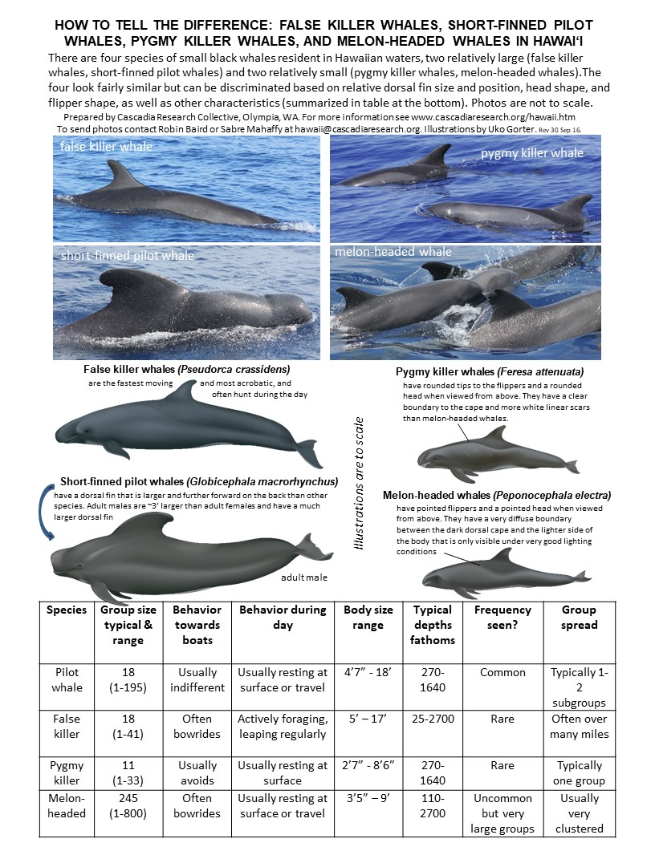](https://falsekillerwhales.org/wp-content/uploads/2019/03/blackfishid.jpg)[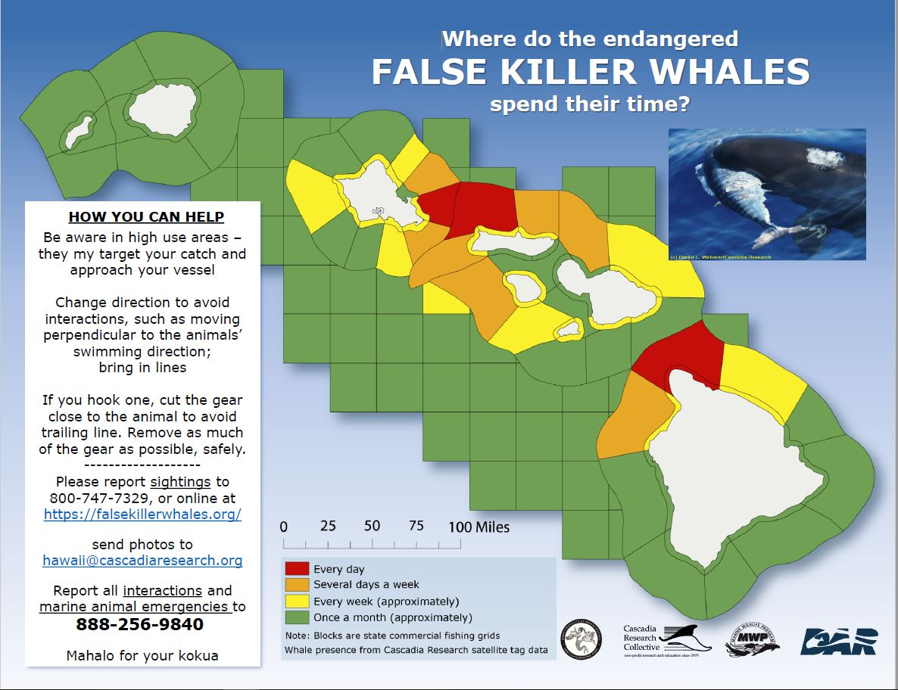](https://falsekillerwhales.org/wp-content/uploads/2019/07/mapid-fishermen-1.pdf)[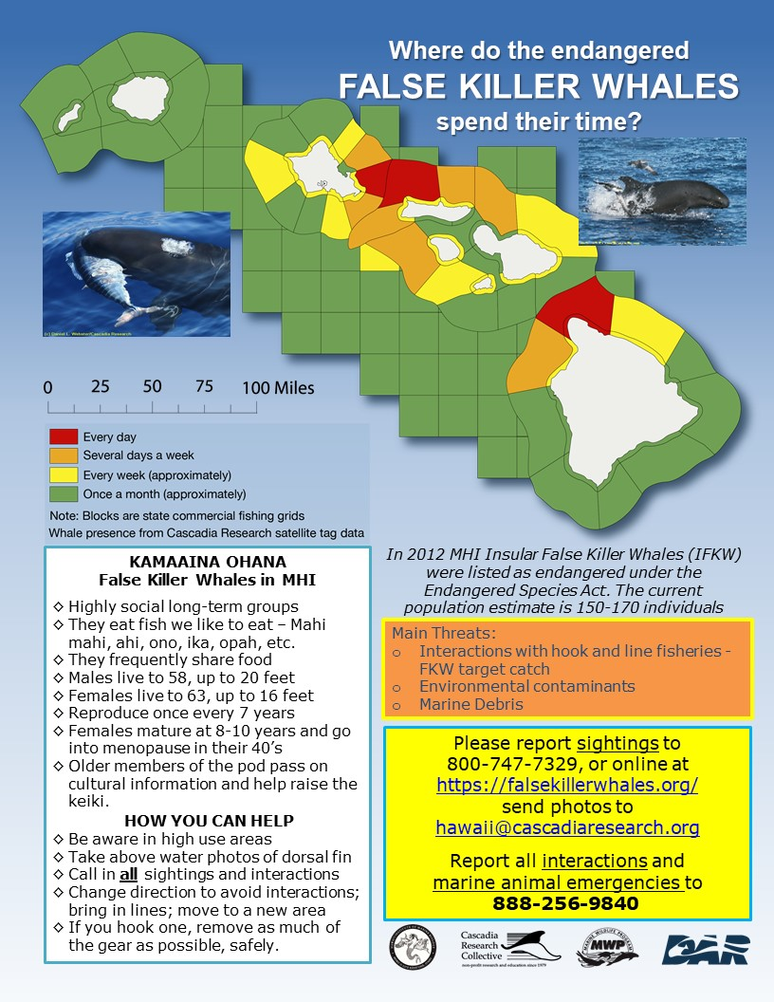](https://falsekillerwhales.org/wp-content/uploads/2019/07/mapid-naturalist-1.pdf)[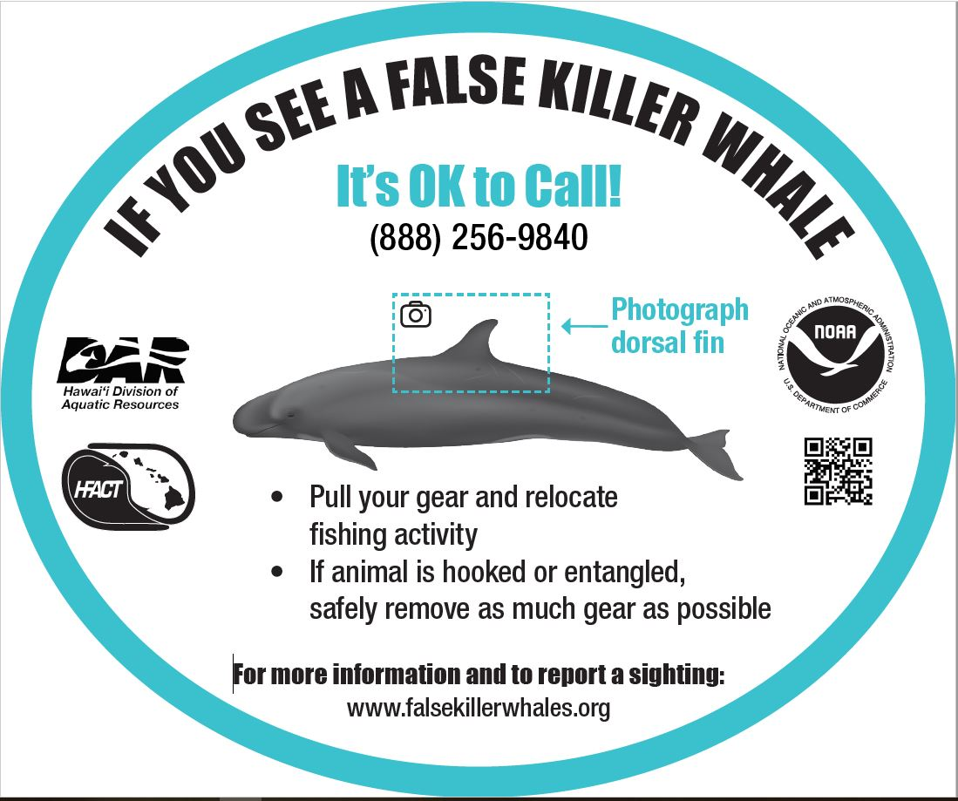](https://falsekillerwhales.org/wp-content/uploads/2019/07/fkw-decal-3-final-1.pdf)Reflective decal developed in partnership with NOAA  
Available from NOAA and DAR[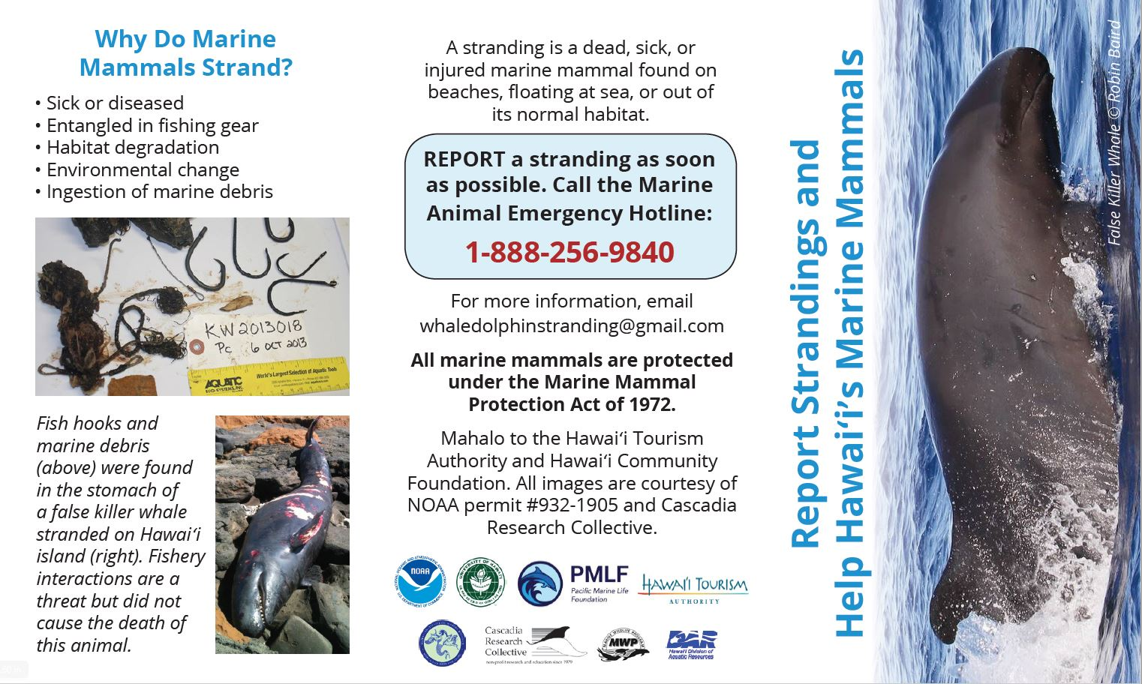](https://falsekillerwhales.org/wp-content/uploads/2019/07/fkw_strandings-mini-brochure-final-1.pdf)Stranding Trifold Brochure – Outside (card-sized)[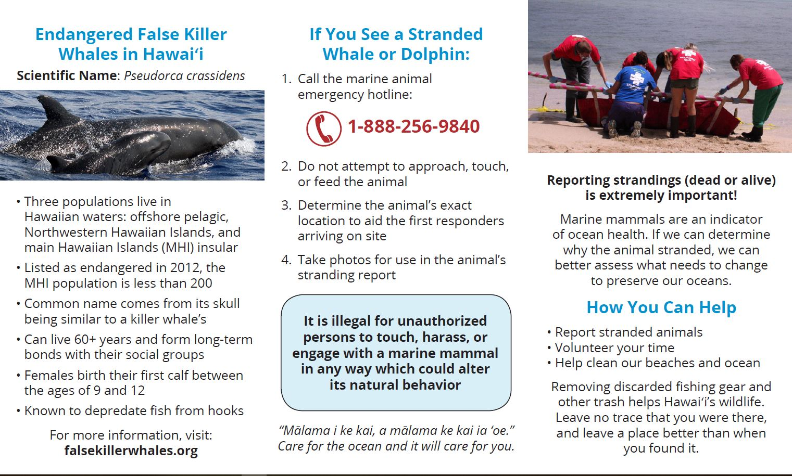](https://falsekillerwhales.org/wp-content/uploads/2019/07/fkw_strandings-mini-brochure-final-1.pdf)Stranding Trifold Brochure – Inside (card-sized)[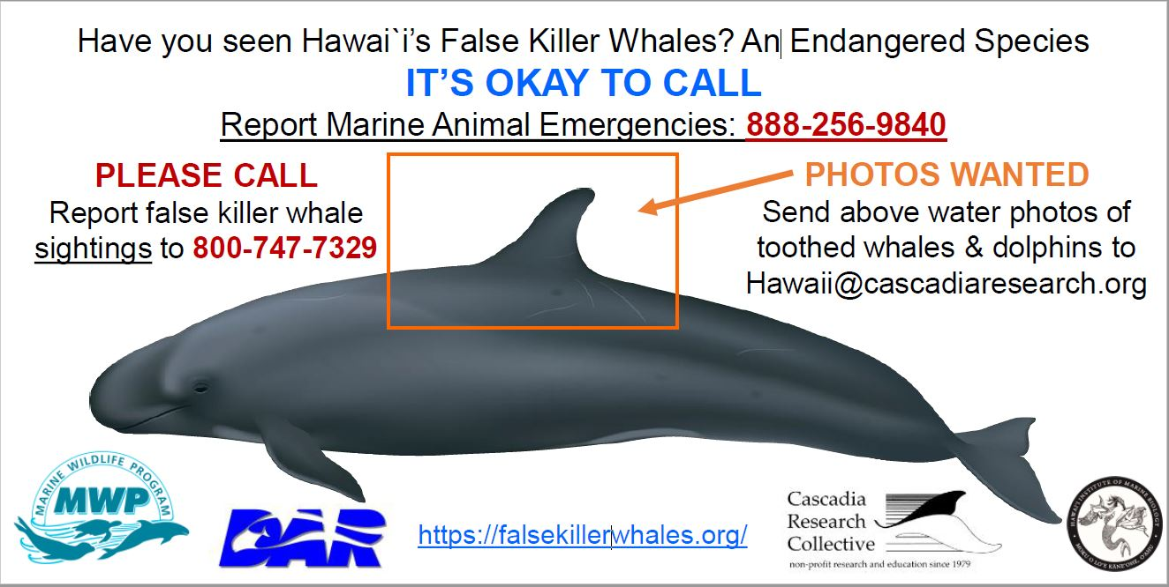](https://falsekillerwhales.org/wp-content/uploads/2019/07/ifkw_sticker_3x6-1.pdf)IFKW Sticker – 3″ x 6″[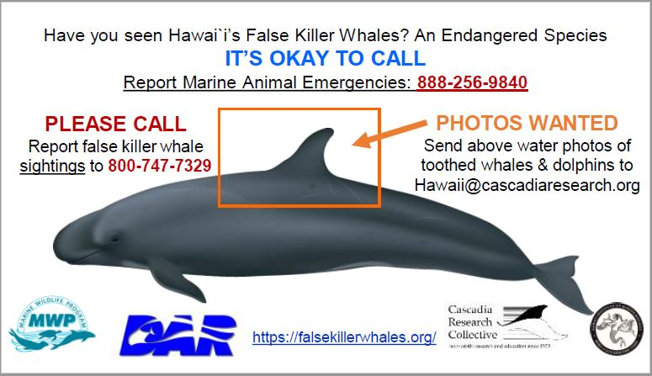](https://falsekillerwhales.org/wp-content/uploads/2019/07/ifkw_sticker_2x3.5-1.pdf)IFKW Sticker/Magnet/Card – 2″ x 3.5″

[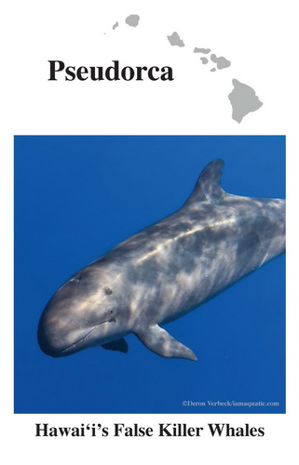](https://falsekillerwhales.org/wp-content/uploads/2016/11/brochure-crc_pseudorca_brochure_jan_2014.pdf)

[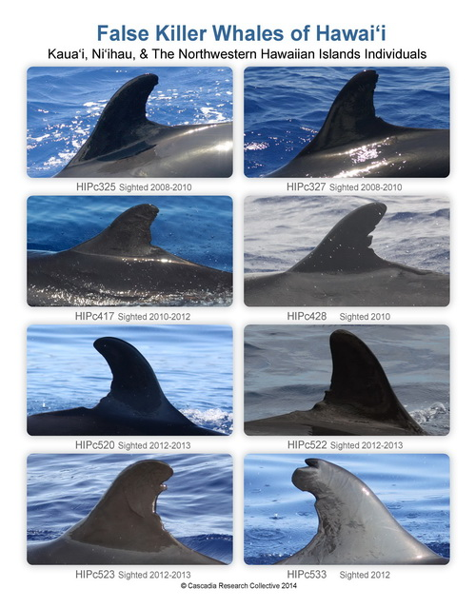](https://falsekillerwhales.org/wp-content/uploads/2016/11/brochure-crc-nwhi-pseudorca-2sided.pdf)

[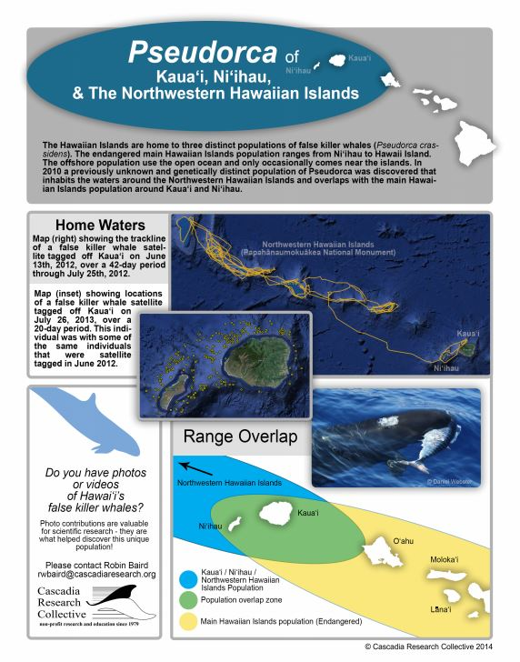](https://falsekillerwhales.org/wp-content/uploads/2016/11/brochure-crc-nwhi-pseudorca-2sided.pdf)

[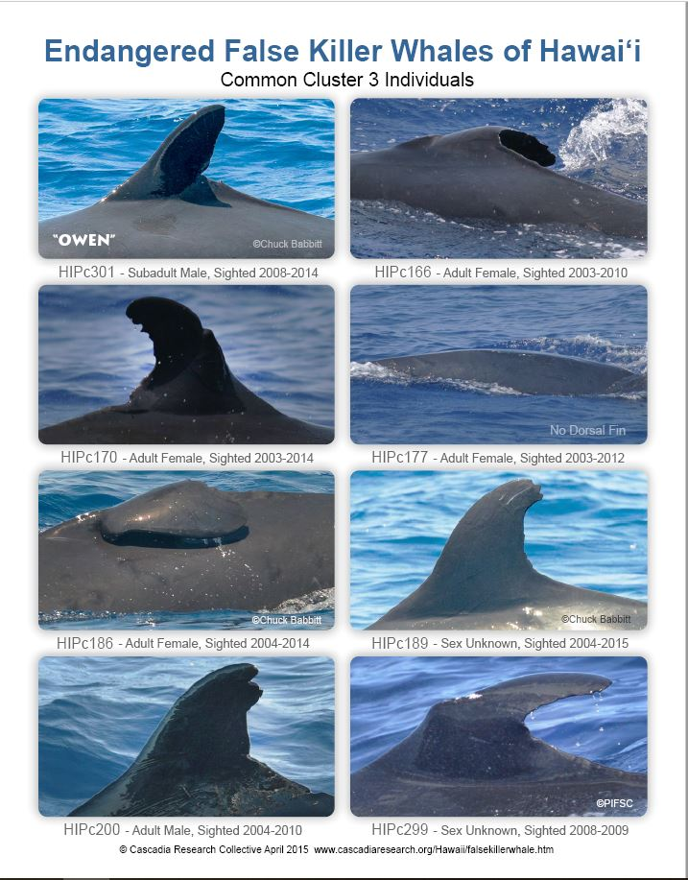](https://falsekillerwhales.org/wp-content/uploads/2019/07/crc_pseudorca_cluster3_2015.pdf)

[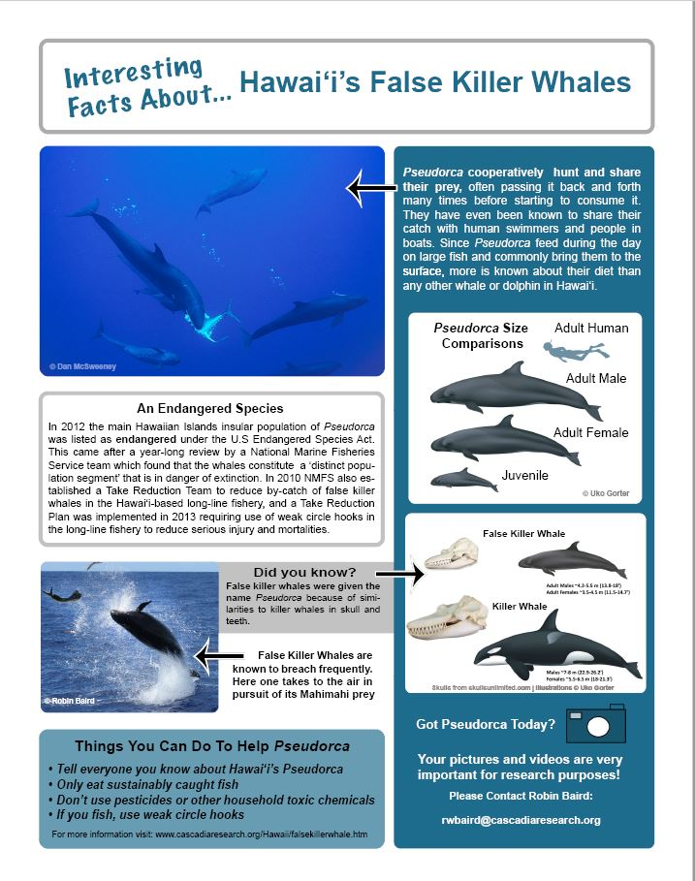](https://falsekillerwhales.org/wp-content/uploads/2019/07/crc_pseudorca_cluster3_2015.pdf)

[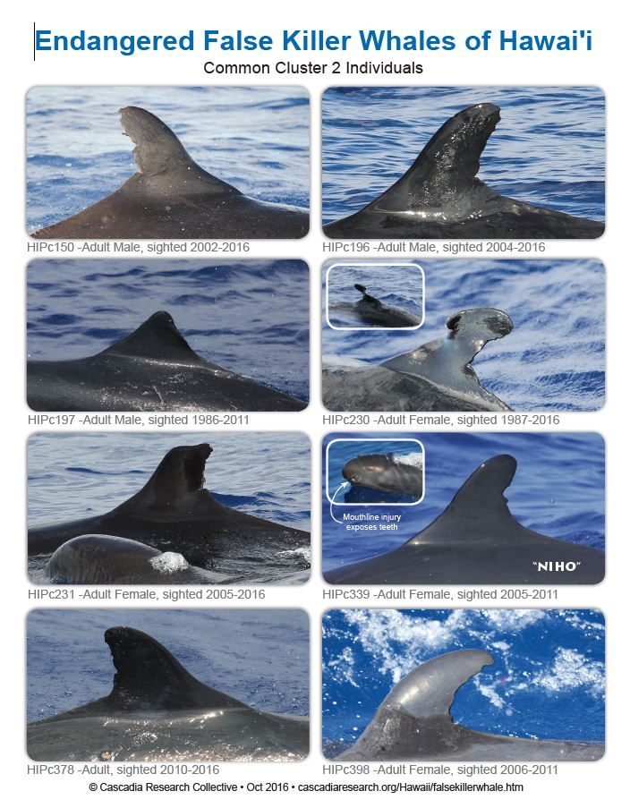](https://falsekillerwhales.org/wp-content/uploads/2019/07/crc_pseudorca_cluster-2_2016.pdf)

[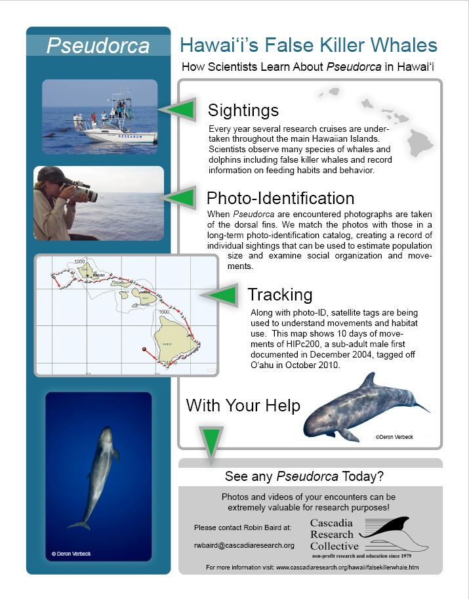](https://falsekillerwhales.org/wp-content/uploads/2019/07/crc_pseudorca_cluster-2_2016.pdf)

[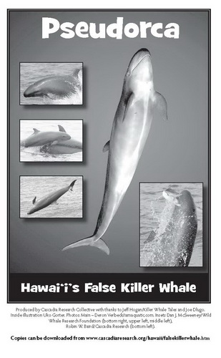](https://falsekillerwhales.org/wp-content/uploads/2019/07/pseudorca_for_kids.pdf)