Activities

Download pdf copies of the coloring pages (with fact sheets on the back) by clicking on the images below. Thanks to Jeff Hogan/Killer Whale Tales and Uko Gorter for producing these coloring pages.

[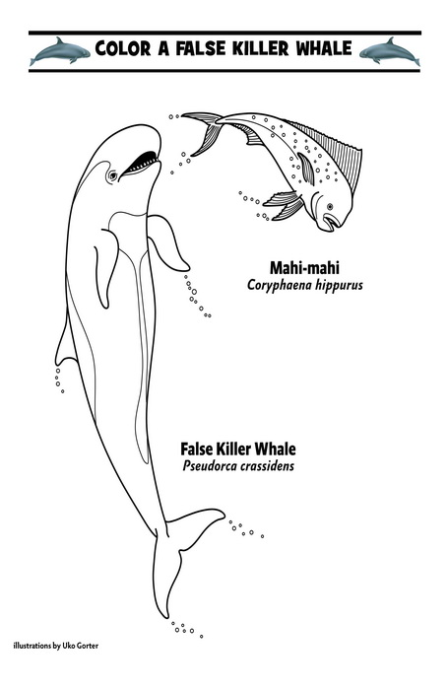](https://falsekillerwhales.org/wp-content/uploads/2016/11/activities-crc_fkw_coloring_page_facts_mahi_handout_press.pdf)

[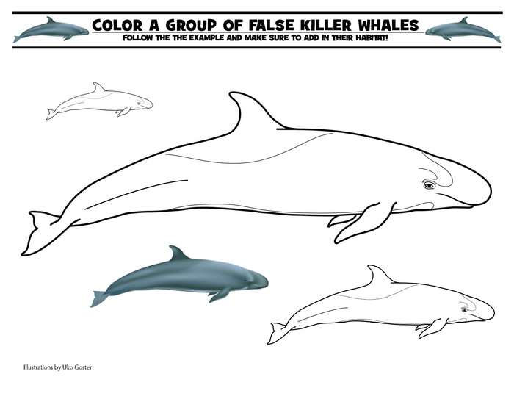](https://falsekillerwhales.org/wp-content/uploads/2016/11/activity-crc_fkw_coloring_page_facts_handout_press.pdf)

[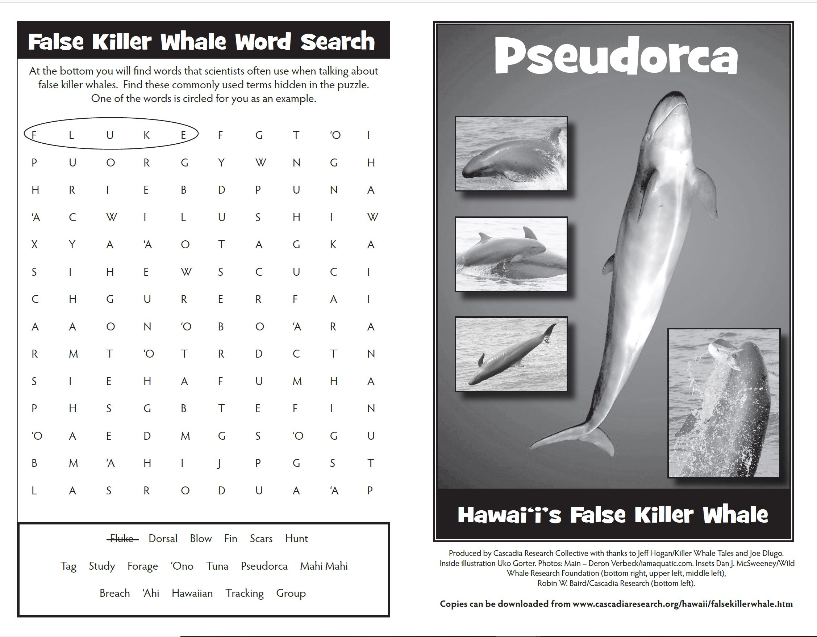](https://falsekillerwhales.org/wp-content/uploads/2019/07/pseudorca_for_kids.pdf)