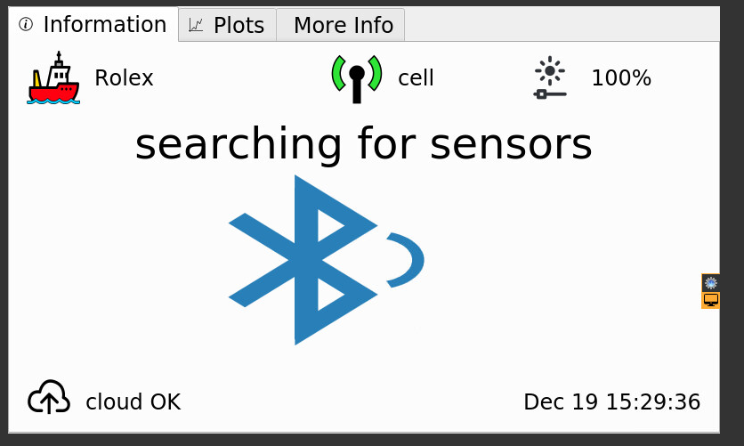

Figure 1 – Screenshot of Lowell Deck Data Hub aboard the F/V Rolex searching for bluetooth enabled sensor to connect to

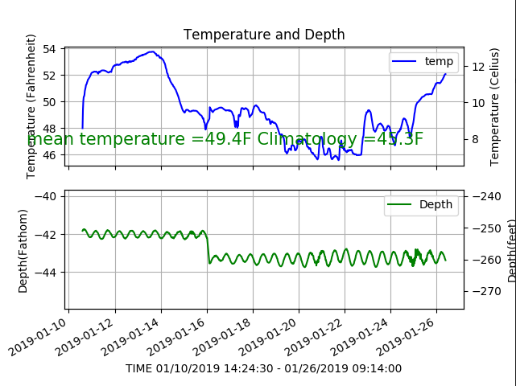

Figure 2 – Screenshot of temperature and depth readouts on a Gulf of Maine Lobster Foundation Deckbox from a successful probe haul on the F/V Lina Rose