Viewing Guidelines

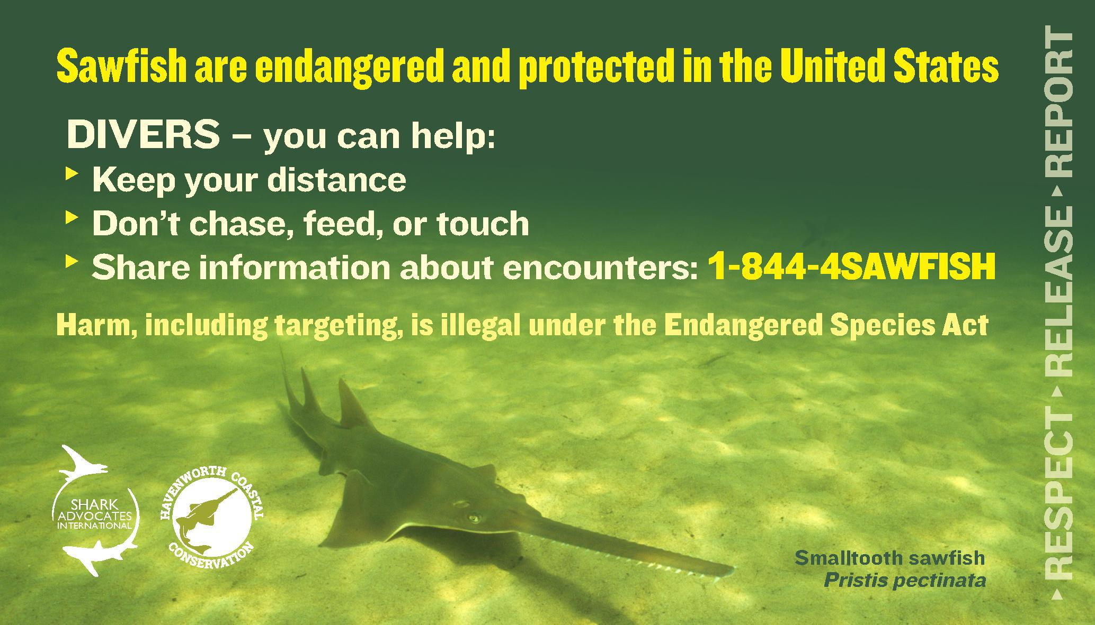

Smalltooth sawfish are listed as endangered under the Endangered Species Act (ESA), which makes it illegal to target, harm, harass, or handle them in any way. The guidelines below were developed to aid divers in safely and legally enjoying their encounter with a sawfish.

The number one rule to remember when viewing a sawfish while diving is to not disturb the sawfish to not disrupt its normal behavior. Use extreme caution if you do approach one as sawfish are large, powerful animals that can whip their saw very quickly. This can cause serious injury to the diver and to the sawfish.

**GENERAL VIEWING GUIDELINES:**

* **Keep your distance**
* **Avoid disturbing sawfish**
* **Never touch, chase, or feed them**

If you see a sawfish, take a quick photograph of the sawfish, estimate its size, note your location, and share the details with scientists. The details of your sightings or catches of sawfish help to monitor the population and track the recovery progress. You can share your information by calling [**844-4-SAWFISH (844-472-9347)**](tel:8444729347) or [**completing the form**](http://www.sawfishrecovery.org/report-a-sawfish).

Your encounter reports will be used to track recovery of the population and steer research efforts, which will ultimately benefit the species and the areas in which you dive and fish.