**Report a Stranded, Injured, or Dead Sturgeon**

Reporting a stranded, injured, or dead sturgeon is the best way to make sure professional responders and scientists know about it and can take appropriate action.

[New England/Mid-Atlantic](https://www.fisheries.noaa.gov/region/mid-atlantic)

[Southeast](https://www.fisheries.noaa.gov/region/southeast)

**Table of Contents**

* [New England/Mid-Atlantic](https://www.fisheries.noaa.gov/new-england-mid-atlantic/endangered-species-conservation/report-stranded-injured-or-dead-sturgeon#new-england/mid-atlantic)
* [Southeast](https://www.fisheries.noaa.gov/new-england-mid-atlantic/endangered-species-conservation/report-stranded-injured-or-dead-sturgeon#southeast)
* [More Information](https://www.fisheries.noaa.gov/new-england-mid-atlantic/endangered-species-conservation/report-stranded-injured-or-dead-sturgeon#more-information)

The Sturgeon Salvage Program is a network run by NOAA Fisheries to help conserve Atlantic and shortnose sturgeon. Information regarding deceased sturgeon that wash up on riverbanks and ocean beaches is sent to NOAA Fisheries through this network. Numerous partners along the Atlantic coast are trained and ready to respond.

You can help us learn more by reporting any sturgeon you may come across. This allows scientists to collect samples and data to better understand sturgeon populations, track recovery efforts, identify threats to the species and fill in gaps in our knowledge.

If you see a stranded, injured or dead sturgeon, immediately contact your local salvage partner (phone numbers provided below).

You can also use our contact NOAA Fisheries at (978) 281-9328 or in the Southeast at (844) STURG-911 or (844) 788-7491, or send us an email at [noaa.sturg911@noaa.gov](mailto:noaa.sturg911@noaa.gov).

New England/Mid-Atlantic region is shown in purple. Southeast region is shown in green.

New England/Mid-Atlantic

**Regional**

**Phone:** (978) 281-9328

**Email:** [noaa.sturg911@noaa.gov](mailto:noaa.sturg911@noaa.gov)

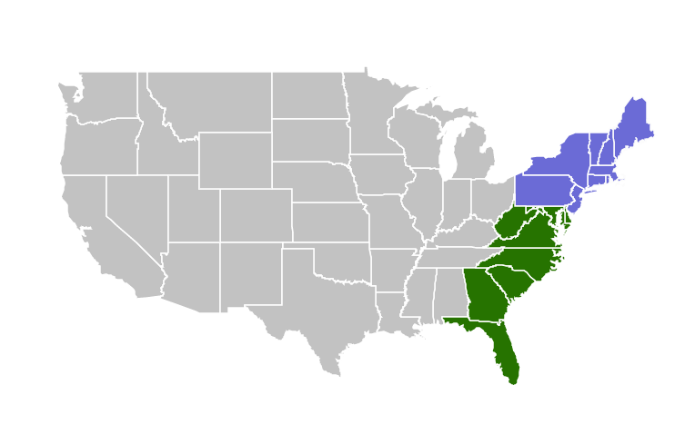

**Note: The reporting app for the Connecticut is shown below. Similar information is collected for the other states listed below the Connecticut example.**

**Connecticut**

**Connecticut Department of Energy and Environmental Protection**

[Report a sturgeon](https://survey123.arcgis.com/share/2baf03a76202462eaad2b7b42e51c6a7)

Report a Sturgeon to CT DEEP

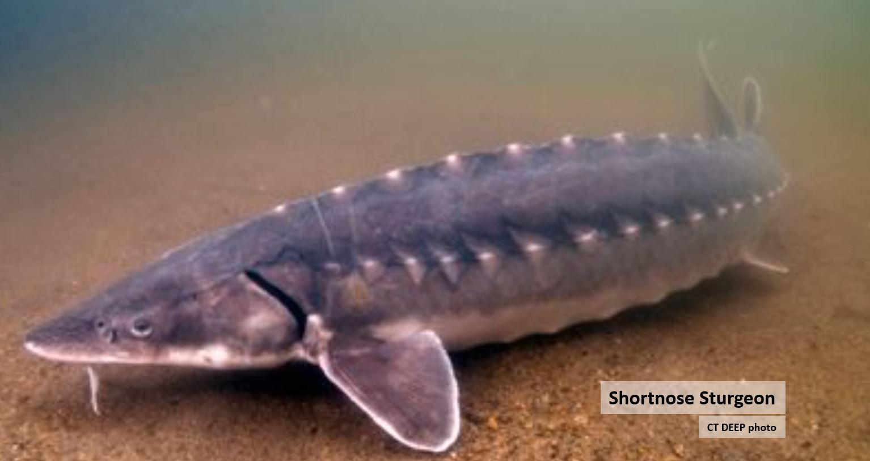

**Welcome to the CT DEEP Sturgeon Sighting Survey.** Report your sturgeon sightings by completing this survey. The data submitted by you and other citizen scientists will assist CT DEEP with tracking sturgeon sightings. Sightings we are interested in hearing about include breaches, strandings, observations of dead sturgeon, or anything unusual involving a sturgeon! Only one type of sturgeon observation can be submitted for each report. Please complete a report for each type of sturgeon encounter you observe. **Thank you for taking the time to help CT DEEP track sturgeon observations!**

Top of Form

**Date and time of sighting**

Please provide the date and time of when you saw the Sturgeon to the best of your ability.







**Nearest Town or Port of sighting**

Please tell us the nearest town or port to where you saw the Sturgeon to the best of your ability.

**Sighting location**

The map will attempt to use your device's location to place the point. **If you are no longer at the location of the sighting, please tap or click the map once to move the dot on the map, and drag the map with a finger or mouse to move the map to where you saw the Sturgeon.**

To place the geopin at specific latitude and longitude coordinates, please follow this format: 41.000000N 72.000000W

**Tip: This question will try to use your location. Press to continue.**

Top of Form



Bottom of Form

Zoom in

Zoom out

Home

Find my location

Esri, GEBCO, DeLorme, NaturalVue | Esri, GEBCO, IHO-IOC GEBCO, DeLorme, NGS

Powered by [Esri](http://www.esri.com/)

Lat: 41.42213  Lon: -72.54822

**Alternative way to enter Sighting Location**

If you prefer, you may type latitude and longitude coordinates here rather than using the map

**Two kinds of Sturgeon are present in CT waters**

Connecticut has two species of sturgeon. The two species look very similar. If the sturgeon is 48" or longer, it is an Atlantic Sturgeon. Shortnose Sturgeon don't get much over 40" long. To tell these two apart at smaller sizes, look at the underside, in particular, look at the mouth. Shortnose Sturgeon have a wider mouth opening (inside the lips) than similarly sized Atlantic Sturgeon.

In this photo, the fish on top with the wider mouth is a Shortnose Sturgeon. The fish on the bottom with the narrower mouth is an Atlantic Sturgeon.

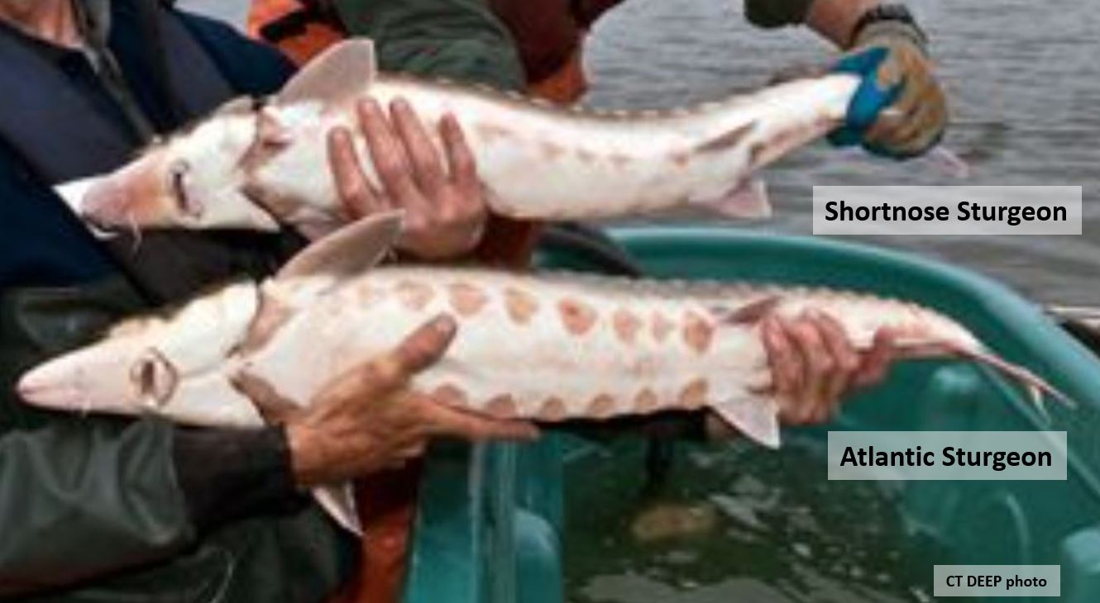

**Sturgeon Sighting Details**

**Please tell us which species of Sturgeon you observed**

(If you can)

Atlantic SturgeonShortnose SturgeonUnsure

**What did you observe?**

Please select one of these options from the drop-down list:



-Please select-

**How many sturgeon did you observe?****What size were the sturgeon?**

If you are able to estimate the size of the fish, please select one of the options below:

< 1 foot1-2 ft long2-3 ft long3-4 ft long4-5 ft long5-6 ft long> 6 feet

**Would you describe the size of the sturgeon some other way?**

(for example, please indicate if there were multiple sizes or if you aren't able to estimate the size)

1000**Photos**

If you have a photo you'd like to share with us, upload here.

**1**

Select image file (maximum number of files allowed: 2)

**Anything else you want to tell us about this Sturgeon Sighting?**500

**Please provide your contact Info**

This will allow staff to contact you if we have questions.

**Name (optional)****Email (optional)****Phone (optional)**

Please submit a 10-digit phone number with no hyphens or parenthesis



Bottom of Form

Submit

[Powered by ArcGIS Survey123](https://www.esri.com/products/survey123)

**Delaware**

**Delaware Division of Fish and Wildlife**

[Report a sturgeon](https://survey123.arcgis.com/share/6ff2fa8d425540cf8b28323c35eb3ecd)

For assistance with the form, please e-mail the DNREC Fisheries Section, [Sturgeon@delaware.gov](mailto:Sturgeon@delaware.gov) , or call (302) 735-8663.

**Maine**

**NOAA Fisheries Greater Atlantic Regional Office**

**Phone:** (978) 281-9328

**Email:** [noaa.sturg911@noaa.gov](mailto:noaa.sturg911@noaa.gov)

**Maryland**

**Maryland Department of Natural Resources**

Phone: (410) 643-6788

**Massachusetts**

**NOAA Fisheries Greater Atlantic Regional Office**

**Phone:** (978) 281-9328

**Email:** [noaa.sturg911@noaa.gov](mailto:noaa.sturg911@noaa.gov)

**New Hampshire**

**NOAA Fisheries Greater Atlantic Regional Office**

**Phone:** (978) 281-9328

**Email:** [noaa.sturg911@noaa.gov](mailto:noaa.sturg911@noaa.gov)

**New Jersey**

**New Jersey Division of Fish and Wildlife**

**Phone:** (609) 748-2020

**Email:** Heather Corbett, [heather.corbett@dep.state.nj.us](mailto:heather.corbett@dep.state.nj.us)

**New York**

**New York Department of Environmental Conservation**

[Report a sturgeon](https://survey123.arcgis.com/share/c4a0ad629d9d464495f81802f2e4b768?)

**Rhode Island**

**Rhode Island Department of Environmental Management, Division of Marine Fisheries**

**Phone:** (401) 423-1923

**Virginia**

**Virginia Commonwealth University**

**Phone:** (804) 827-0236

**Email:** Matthew Balazik, [balazikmt@vcu.edu](mailto:balazikmt@vcu.edu)

Southeast

For sturgeon found in North Carolina through Florida, contact the NOAA Fisheries, Southeast Region at 1-844-STURG 911 (1-844-788-7491) or via email at [noaa.sturg911@noaa.gov](mailto:noaa.sturg911@noaa.gov).

More Information

[Atlantic Sturgeon](https://www.fisheries.noaa.gov/species/atlantic-sturgeon#overview)

[Shortnose Sturgeon](https://www.fisheries.noaa.gov/species/shortnose-sturgeon)

*Last updated by*[*Greater Atlantic Regional Fisheries Office*](https://www.fisheries.noaa.gov/about/greater-atlantic-regional-fisheries-office)*on 06/02/2022*