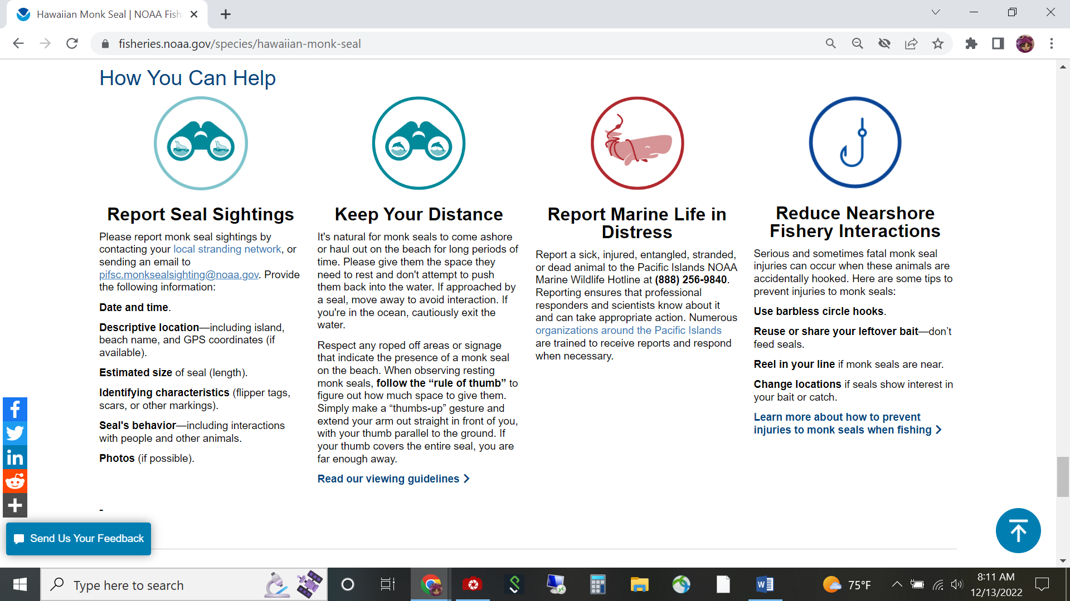Screenshot of NOAA Fisheries website with instructions on how to report information on Hawaiian monk seal sightings and injured or distressed monk seals. CSC Project 20 Hawaiian monk seal reporting project.