Tagged Shark Recapture Form

The most crucial element of all tagging programs is voluntary tag reporting by the fishermen who recapture tagged fish. In many cases it is difficult to determine where a particular tag originated and which program is responsible for its release. The form below will allow the reporting of any tag, regardless of the release program. If you have a tag to report, please fill in the form and submit your information. We will forward your responses to the proper program, request that they contact you directly, and inquire about any reward you may be eligible to receive (not all programs issue rewards for tag recaptures; NOAA Fisheries is not responsible for rewarding recaptures outside of our own tagging programs). Some programs will require tags to be returned. If you keep the fish, be sure to retain the tag until you have spoken with the tagging program's contact.   
  
Tags recovered from our program can be reported by way of the form below, by email at [sharkrecap@noaa.gov](mailto:sharkrecap@noaa.gov), or by calling our toll-free hotline at (877) 826-2612. **Please understand we process reports in order out of fairness.

**john doe@noaa.gov** [Switch account](https://accounts.google.com/AccountChooser?continue=https://docs.google.com/forms/d/1qYVyZHpZBg8HO5omibDFDAmg2f5G7s52DsIAJutK1cM/viewform?edit_requested%3Dtrue&service=wise)

The name and photo associated with your Google account will be recorded when you upload files and submit this form. Only the email you enter is part of your response.

* Required

Email*

Your email

Contact Information

First Name



Your answer

Last Name



Your answer

Phone



Your answer

Mailing Address

Street



Your answer

City



Your answer

State



Your answer

Zipcode



Your answer

Next

Tagged Shark Recapture Form

**John.doe@noaa.gov** [Switch account](https://accounts.google.com/AccountChooser?continue=https://docs.google.com/forms/d/e/1FAIpQLScSnJyPDPferr8G73XdYAzPcpR6HbynhQQYmkCLU2AHl8_K6g/formResponse&service=wise)

The name and photo associated with your Google account will be recorded when you upload files and submit this form. Only the email you enter is part of your response.

Tag Description

If you wish to report multiple tags, please fill out our form for the first tag and we will contact you regarding the others.

Quantity of Tags to Report



Your answer

Tag Number



Your answer

Tag Color



Your answer

Double Tagged? (one fish, two tags)

Yes

No

Tag Type

https://lh4.googleusercontent.com/HdjAPxzJAxHhazeNGm4-fRClPcFdZatu0bPaG5svBeHsMXZs46Bpt1zxs1lkgUzaj0luq4q82TE4ZW5cECnv2TfH-iSOAttEwLLkP0eaoqJ5XbvStfsEwdq1n2JNjqCw=w113

Internal anchor tag | 3 inches | Black sea bass

https://lh5.googleusercontent.com/4j_gJVlkPEoMYBy8-OG3wNrH91vpycAnCO1C3rVGapwfo_Z8bos_hiSrYkGbGiUCHEImWyZgqVoWildkCRbO3_UuBfN_AkEJuIf1MkPFM1rSiV1daVWq5hMb4sYv5xqC=w113

T-Bar tag (clothing tag)| 2 -3 inches | Scup, Cod, Haddock, Monkfish

https://lh4.googleusercontent.com/ENXDTg_vbzoJfsfQAsdbMoLvGxkwKiqNwUT0L92fqUyLZnmEfdX8fTk7KtOFCLe0cKzF0L1a5SsE6KwBqGi_ff22N1vwEcjwjRi8tjt4zakmsaPktwgH-3oak0QfADh8=w113

M-Tag (w/rolled note)| 3- 4 inches | Sharks

https://lh5.googleusercontent.com/OYYpFipNIUl580XtB75F4yO0yXUbDgo_Yfmxm9s8UCE-aa2izXdfpFxO19qghsRRBQKCN7HB7rQ9P4aBsC-lQP-6N8MHb7Lul47h_5VahVuEvwyrblrSxd3YU54YPKfs=w101

Data Storage Tag (archival) | 1 3/4 by 1/2 in diameter | monkfish

https://lh6.googleusercontent.com/ZYbrMaYEQWZxciaOLmfSEAvwq4GEmDi9EOvf8hlB4ODl9zyKZAYeX5eowX3jRnidr-lhgYoLhLfVJUmkjeva9ltGdsQWeFkxAJ0l9eAKGqhsLiS2-VCZgGRivAhgF8gm=w113

Data Stoage tag (archival)| 1 x 3/4 inch| Black Sea Bass, Scup, Yellowtail Flounder, Cod

https://lh6.googleusercontent.com/JzvbcHU1P7o0KoQzMF9jumvqZ9yQcbOgqmbxE2V2S2_aixq1Z5tCfSbiyhQS_Xj0ULsp0AmPVcIcXXI5bO52fuk0uXzie5iWqsTJt2mO5SOOwjyGVXn0GBAW6cY4sMvu=w115

Dorsal Loop Tag | 3-4 inches | Wide variety of species

https://lh5.googleusercontent.com/ZG4Ek2GAQicsdVScSLLPuIsZJNIdABF2WPG4LIrsUPelrMJIWRg9sSiiLRDabSZfPQA3I0xbTmB5cIC_v8hepoGhBBZ0o6kJTUWBC5vA0GwOrhFefXQgQYaNSbJzGyfh=w101

Dart Tag| 2 -4 inches| Sharks

https://lh6.googleusercontent.com/WpsK5YuhI4ak7gw0i57W28gJDvseBpVYuXOtX19x1d9qSwo5ftQzWYQwY6kGEze8s2ObYPQ24UVuyIU3EFjZN0LY-OCH0Sdp20xXpdL3IEdHxUL2eMYgIX_wqS-KzeiV=w63

Peterson Disk | 1 in diameter| Yellowtail flounder, Scallop

https://lh3.googleusercontent.com/eCbk5kp9DtxgzV5yUbCt7UorIsYVORO4puRMEZa9RfSoBthhDk2rsrFNVADctwEUgJA1eKlzgnUmviVvIkppew3sVXeLeXbLep7OKp84Yuhi8TUHJV2cLnl4i6JZf_Lh=w101

Fin Tag | 1 inch | Sharks

Other

Fate of FIsh:

Fish and tag were both kept.

Tag was kept but the fish was was released alive

Tag was kept but the fish was discarded (dead)

Fish was released (alive) with same tag

Fish was released (alive) with new tag

Tag was found without a fish

New Tag Number - See Fate of Fish



Your answer

Release condition

Excellent

Good

Fair

Poor

Unknown

If Fish was kept, did you save a section of the backbone?

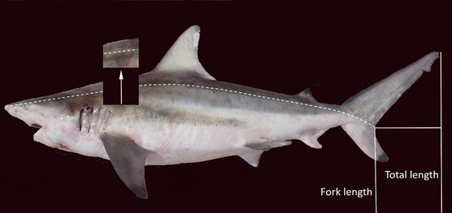

Yes

No

Tagged Shark Recapture Form

**john.doe@noaa.gov** [Switch account](https://accounts.google.com/AccountChooser?continue=https://docs.google.com/forms/d/e/1FAIpQLScSnJyPDPferr8G73XdYAzPcpR6HbynhQQYmkCLU2AHl8_K6g/formResponse&service=wise)

The name and photo associated with your Google account will be recorded when you upload files and submit this form. Only the email you enter is part of your response.

Recapture Details

Fish Species:



Your answer

Sex

Female

Male

Unknown

Date

Date

Date quality

Exact date of recapture

Recapture with a week of the date given

Recapture within a month of the date given

Recapture within a year of the date given

Date of Recapture is unknown

Length



Your answer

Length Unit

Inches

Centimeters

Feet

Length Quality

Estimated

Measured

Length Type

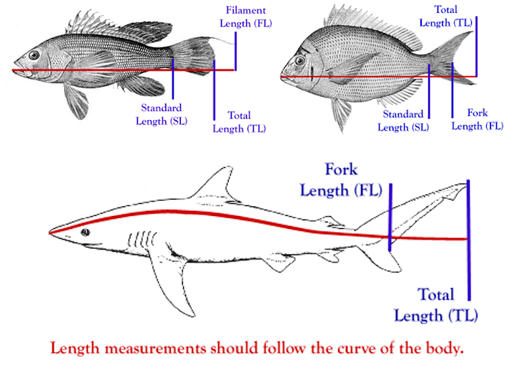

Fork

Total

Filament

Standard

Weight



Your answer

Weight Unit

Pounds

Kilograms

Weight Quality

Estimated

Measured

Location (Lat/Long & Loran C preferred, or submit specific location details)



Your answer

Location Quality

Lat/Lon or Loran Given

Approximate location

Estimated Location

GPS Coordinates

Unknown

Vessel name



Your answer

Vessel Type

Headboat

Charter Boat

Privately owned boat

Commercial vessel

Other

Port



Your answer

State



Your answer

Gear Type

Rod & Reel

Fish Trap/Pot

Trawl

Dredge

Longline

Gillnet

Other

Unknown

Describe gear if Other

Your answer



Depth



Your answer

Depth Unit

Feet

Fathoms

Meters

Comments

Your answer



Would you like to upload a photo?

Add file

A copy of your responses will be emailed to the address you provided.

Back

Submit