Website with web-based app data entry form with instructions and outreach

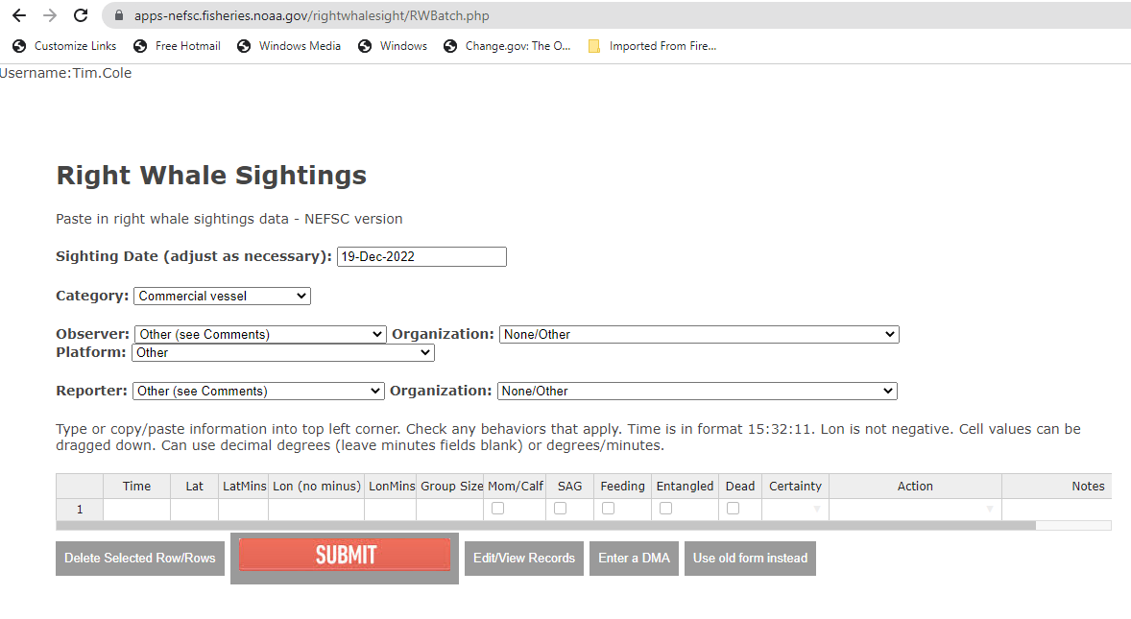

Instructions for our team to fill out the form:

Enter all reported sightings including duplicates if from another reporting source.  Sightings from NARWSS flights are entered automatically during data processing with the Aerial Survey Processing App.

* **Sighting Date** – date of the sighting (not report) in the format 01-May-2022
* **Category** – enter the category of the observer
  1. *Shipboard is used only for dedicated right whale surveys.  If the Shearwater is on a humpback cruise and has a right whale sighting, it would be Opportunistic.*
  2. *Aerial is used only for dedicated right whale surveys (NLPSC or AMAPPS surveys should be Opportunistic, and it’s helpful to write a comment such as “AMAPPS”)*
  3. *Coast Guard use only if they observed the sighting; not if they are passing it along.*
* **Sighting Time** – time format is military HH:MM:SS.  Correct to Eastern Time. If the sighting time is unknown enter 12:00:00 and note time is unknown in comments.
* **Latitude and Longitude** – can be entered as degrees minutes or decimal degrees (by leaving the minutes field blank); do not use a minus sign for longitude values.
* **Behavior** – check appropriate boxes for behavior category (i.e., sag, mom/calf, etc.)
* **Species Certainty** – enter certainty of species identification; unknown sightings will not show on the map

**Definite**

Sightings are considered 'Definite' from experienced sources, such as whale watch naturalists

 and researchers (NMFS, CCS, NEAq, SBNMS, Riverhead, Mass DMF, CCSN, & other stranding networks).  These sources do not require follow-up. For non-experienced sources that require follow-up, ask non-leading questions to determine if the sighting was a right whale.  If a sighting is passed via the Coast Guard, obtain the original reporting source if possible and interview the observer directly. Consider Definite if photos confirm species or if interview confirms they saw at least two distinctive right whale field marks: white bumps on the head, paddle-shaped flippers, absence of dorsal fin (if got a good look at the back), or all dark fluke with smooth edges. *\*Only definite sightings get displayed on WhaleMap\**

**Probable**  
Consider the sighting ‘Probable’ if the observer’s description includes only one distinctive right whale field mark, e.g., white bumps on the head, paddle-shaped flippers, absence of dorsal fin (if got a good look at the back), or all dark fluke with smooth edges.

**Unknown** *(do not display on Google map)*

If there is no indication that the sighting was a right whale, take no management action.  Enter the sighting in the database and make a note that the sighting was unconfirmed.

\***Not Right Whale -** If the sighting is NOT a right whale, enter into the database with Certainty unknown and Action none - unconfirmed/not Egs. Put any details of determination in the comments. (If someone calls to report a non-right whale sighting, then no need to enter it into the database; record only those instances where someone initially thought it was a right whale).

* **Group size** – enter the minimum number of animals (i.e., if reported as “2-3”, enter “2”)
* **Observer/reporter** – enter the name, platform, and organization of the observer (and reporter if applicable – i.e., only if someone other than the person who saw the whale is the one calling the hotline) from the drop down list.  If it is not listed, choose “Other” and write the information in the “Comments” field; try to get accurate spelling.  Make a note in the comments if you need to explain a convoluted chain of reporting. All sightings that come through the Whale Alert App should have “whale alert” selected as the reporter organization.

*Observer = the folks who actually saw the whale*

*Reporter = the folks who relayed the sighting from the observer to the SAS hotline*

* **Action** – select  the management action taken from the drop down list.  If you are not sure, you can always edit your selection later. For example, you may not be sure if a group of whales falls within an existing management zone and initially select “None, within existing protection zone” but then later realize that it triggers a DMA and correct it to “Dynamic Management Area”

|  |  |
| --- | --- |
| 1 | None, only 1 or 2 animals |
| 2 | None, within existing protection zone |
| 3 | None, duplicate |
| 4 | Dynamic Management Area (DMA)  *\*\*\*use for all sightings used in DMA calculation\*\*\** |
| 5 | DMA Extended |
| 6 | None – Canada (*east of -67°00’ W*) |
| 7 | None - unconfirmed/not right whales |
| 8 | USCG BNM local |
| 9 | USCG BNM NEFSC |
| 11 | Dynamic Management Area Not Implemented (if we had 3 whales but did not implement a DMA for any reason such as sighting being reported more than a week late). Add explanation in comments. |

* **Notes –** Include the names and contact information of the observer and/or reporter if not on the drop down list; include any other details.  Do not use any single quotes (‘) in the Comments field. Be sure to click in another table cell besides the Comment field so your notes will be recorded into the database.

Once all information is correctly entered, click the “Submit” button.

This is our website outreach:

