**Supplemental document for the FISHstory project**

Screenshots highlighting data collection in the current FISHstory project in the Zooniverse platform. Multiple screen shots are included to show all current data collection fields.

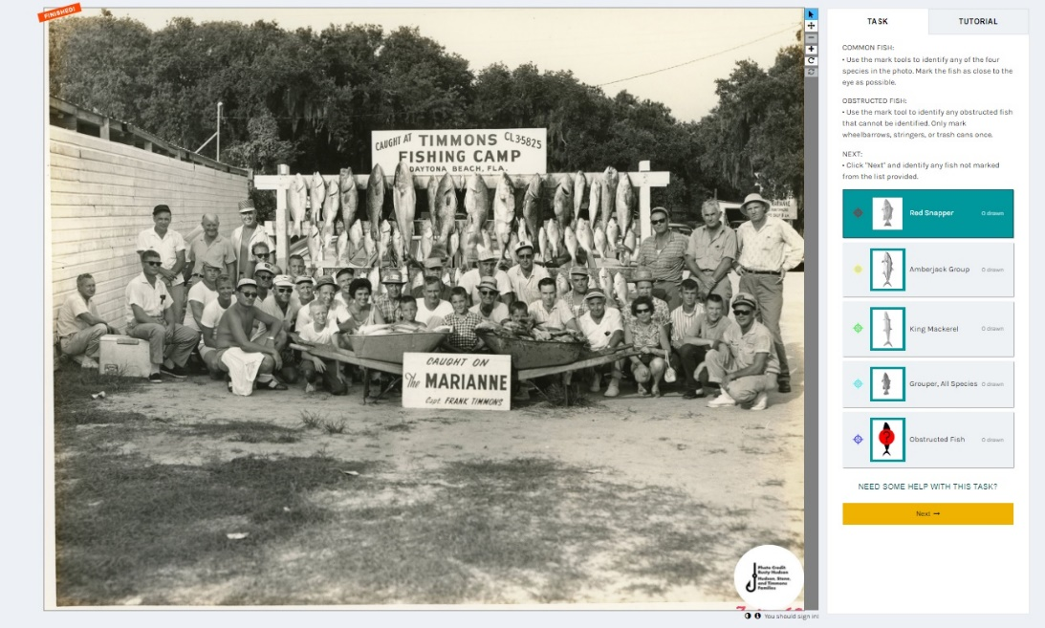

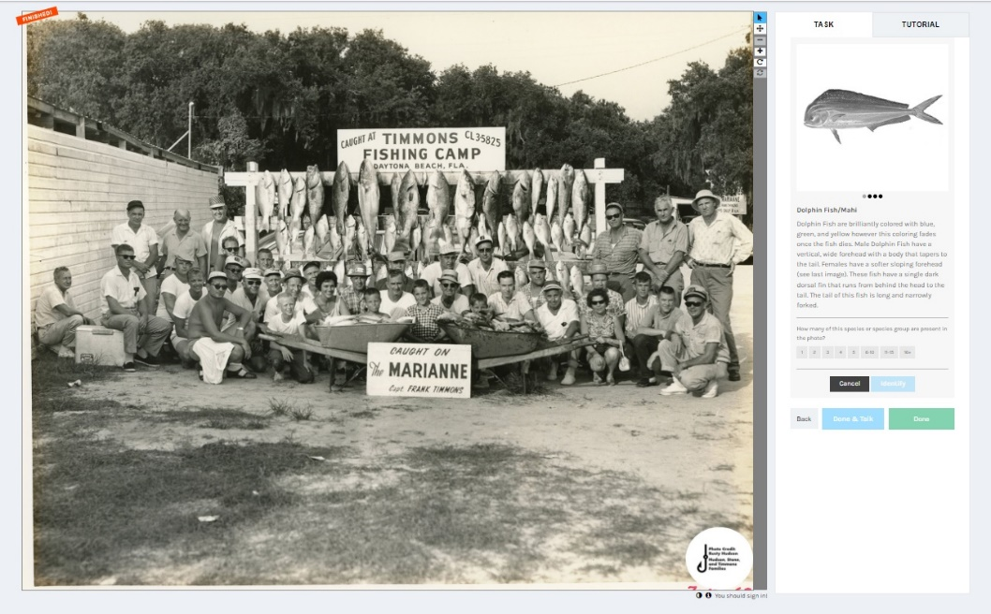

Length component data collection. Gray highlighted fields are autopopulated via the form. Non-highlighted fields are input by project participants.

|  |  |
| --- | --- |
| **FISHstory ImageJ Analysis Metadata** | |
| **Column Name** | **Description** |
| UniqueID | This column is used to determine what type of measurement each row is, this is autopopulated |
| MeasurementNumber | Measurement number pasted from ImageJ, copied from ImageJ |
| PhotoName | Photo file name, copied from ImageJ |
| X | The x coordinate of the center point of the measurement line, copied from ImageJ |
| Y | the y coordinate of the center point of the measurement line, copied from ImageJ |
| Angle | the angle between the primary axis and a line parallel to the x-axis of the image, copied from ImageJ |
| Length | The length of the measurement line drawn in pixels, copied from ImageJ |
| CurvedFishYN | Indicates if fish measured was curved. Annotation: yes (Y) or no (N) |
| FishLevelComments | Any comments pertaining to the fish within that row |
| Analyst | This indicates who analyzed the photo. Annotation: FirstLast |
| Species | Indicates which species was measured in the photo. Annotation: SpecisName (no spaces for multiple word). Will be automated for scalar measurements. |
| TotalHanging | This indicates how many obstructed and unobstructed individuals of the species selected. This is needed for comparison between analysts |
| PrecentFishNotMeasured | approixmate percent of fish that are obsturcted in any way. This accounts for potential bias size distibution. This will be combined with bias to determine how to expand to total catch on the trip. Keep percent categorical |
| BiasYN | Indicate if there is bias in the length of the fish measured compared to non-measured |
| LumberSize | Size of lumber in leaderboard used to scale photo. 2x4 annotation: 4. 2x6 annotation: 6 |
| AngledPhotoYN | Some photos are taken at an angle. Indicate yes or no to the photo being taken at an angle. Annotation: Yes (Y) or No (N) |
| UniqueID | This column is used to determine what type of measurement each row is, this is autopopulated |

|  |  |
| --- | --- |
| **Column Name** | **Description** |
| LabelNo | Unique Measurement number for each photo. Automated field |
| MeasurementTypeSF | indicates measurement type: scalar, fork, or total. Automated field |
| ClosestScalar | indicates the closest scalar to the fish measured. If AngledPhoto is N, then column is automated (AVG). If AngledPhoto is Y enter left (L), middle (M), or right ® |
| ScalarID | The type of measurement, autopopulated based on number |
| ScalarLenPixels | Individual scalar used to set the scale for the photo based on the angle of the photo in pixels, autopopulated |
| ActualLumberSizeIn | The actual size of the lumber used to set the scale in inches. For 2x4 the meausrement is 3.625 inches, 2x6 the measurement is 5.625 inches, autopopulated |
| ScaleRatio | the actual size of the lumber in inches divided by the ScalarLenPixels (scalar used) in pixels, autopopulated |
| LengthInches | The fish length measurement in inches as calculated by the length of fish measurement in pixels multiplied by the ScaleRatio |
| GeneralComment | Additional Comments |