**Example of a social media post advertising the opportunity to participate in this CSC project**

[*facebook*](https://m.facebook.com/login/?privacy_mutation_token=eyJ0eXBlIjowLCJjcmVhdGlvbl90aW1lIjoxNjcxMTEzODk0LCJjYWxsc2l0ZV9pZCI6Mjc4OTkyMDk0NDYyNDI1MX0%3D&refid=13)

**Gulf of Mexico Fishery Management Council is on Facebook.** To connect with Gulf of Mexico Fishery Management Council, join Facebook today.

[Join](https://m.facebook.com/r.php?next=https%3A%2F%2Fm.facebook.com%2Fphoto%2F%3Ffbid%3D349790020520765%26set%3Da.230512419115193%26_rdr&cid=104&rs=17&rid=100064693086377&refid=13)

or

[Log in](https://m.facebook.com/login.php?next=https%3A%2F%2Fm.facebook.com%2Fphoto%2F%3Ffbid%3D349790020520765%26set%3Da.230512419115193%26_rdr&ref=104&rs=17&rid=100064693086377&refsrc=deprecated&refid=13)

**Gulf of Mexico Fishery Management Council is on Facebook.** To connect with Gulf of Mexico Fishery Management Council, join Facebook today.

[Join](https://m.facebook.com/r.php?next=https%3A%2F%2Fm.facebook.com%2Fphoto%2F%3Ffbid%3D349790020520765%26set%3Da.230512419115193%26_rdr&cid=104&rs=17&rid=100064693086377&refid=13)

or

[Log in](https://m.facebook.com/login.php?next=https%3A%2F%2Fm.facebook.com%2Fphoto%2F%3Ffbid%3D349790020520765%26set%3Da.230512419115193%26_rdr&ref=104&rs=17&rid=100064693086377&refsrc=deprecated&refid=13)

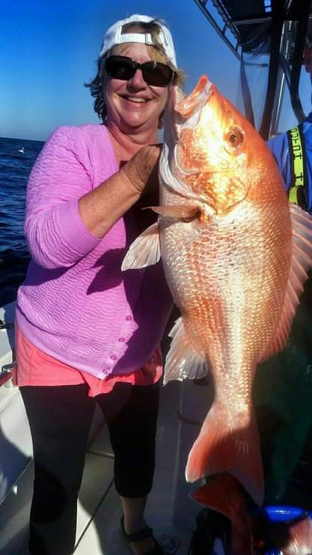

[](https://m.facebook.com/GulfCouncil?refid=13&__tn__=%2Cg)

[**Gulf of Mexico Fishery Management Council**](https://m.facebook.com/GulfCouncil?refid=13&__tn__=%2Cg)

Last chance to fill out our Fisherman Feedback tool on red snapper. Let us know what you've noticed about the fishery so we can share your perspective with the scientists and managers as they conduct a red snapper stock assessment. [https://docs.google.com/forms/d/e/1FAIpQLScmIV4iH4mu3yQ8CqNaTHkbuBWnAyDdSRvgOxmAlg72azsrZQ/viewform?usp=sf_link](https://lm.facebook.com/l.php?u=https%3A%2F%2Fdocs.google.com%2Fforms%2Fd%2Fe%2F1FAIpQLScmIV4iH4mu3yQ8CqNaTHkbuBWnAyDdSRvgOxmAlg72azsrZQ%2Fviewform%3Fusp%3Dsf_link&h=AT1RsbK2xxo4Ih8-t7DGSmjVUugvQL26z27cTtUAg3uPOjNUvSSzZTW4lCp7PTxAH3Q1bmz1T2-dODqW5ho9Us28DqBpoqP65hi5XZwcNySGlRfEYCLlFyMnnSRwgBYjUHR-jpoKv3Dvjdw7gWqit0Tl)

[Timeline photos](https://m.facebook.com/GulfCouncil/albums/230512419115193/?refid=13&__tn__=%2Cg) · 17 Mar ·

[View full size](https://m.facebook.com/photo/view_full_size/?fbid=349790020520765&ref_component=mbasic_photo_permalink&ref_page=%2Fwap%2Fphoto.php&refid=13&__tn__=%2Cg)

Jeremy Gregory and [11 others](https://m.facebook.com/browse/likes/?id=pfbid0345qmGjDzBNpMwhGfaSQsfGTRd9bcyQ1NMxQs59Sj5bU8JaeUE5ZVnBR6q8MhwCCUl&refid=13) like this.

[5 shares](https://m.facebook.com/browse/shares?id=pfbid0345qmGjDzBNpMwhGfaSQsfGTRd9bcyQ1NMxQs59Sj5bU8JaeUE5ZVnBR6q8MhwCCUl&refid=13)



Chris Hamm

Know one wants to help y’all because y’all use what information that suit your agenda. So figure it out on your own if your capable Brandon

9 mthsReport

[1 reply](https://m.facebook.com/comment/replies/?ctoken=349790040520763_349943343838766&count=1&curr&pc=1&isinline&initcomp&ft_ent_identifier=pfbid0345qmGjDzBNpMwhGfaSQsfGTRd9bcyQ1NMxQs59Sj5bU8JaeUE5ZVnBR6q8MhwCCUl&eav=AfZFV58NteHWjeG7TL9hXkMr5FxXyVl--ri_FDBheSqIEnFujpbT9hJfeu4H32DGgsI&av=0&gfid=AQBfpvjR3Rw4vDsINlI&refid=13&__tn__=R)



Jaysen Dautriel

They are over populated

9 mthsReport



Lance McCall

It's not the first chance... go look at any comment section when yall ask for input... just the input in the comments doesn't support yall agenda so yall choose to ignore it

9 mthsReport



Joey Rodriguez

We have been telling you all for years that Snapper have demolished fishing spots and have taken over rigs and wrecks. They are aggressive and invasive. We can’t even target other fish that we used to target. Even in 500’ of water. There needs to be a 5 fish per person limit all year long for several years. Even the private party study showed your assessments were off by over 100 million.

9 mthsReport



Dennis Menard

[Thomas Hilton](https://m.facebook.com/thomas.hilton.3576?refid=13&__tn__=R).. your thoughts??!! 😎🔥

9 mthsReport



Dave Thomas

Here’s your assessment. There are too many. There, I saved you $1,000,000.00

9 mthsReport

[View more comments…](https://m.facebook.com/story.php?story_fbid=pfbid0345qmGjDzBNpMwhGfaSQsfGTRd9bcyQ1NMxQs59Sj5bU8JaeUE5ZVnBR6q8MhwCCUl&id=100064693086377&p=6&refid=13)