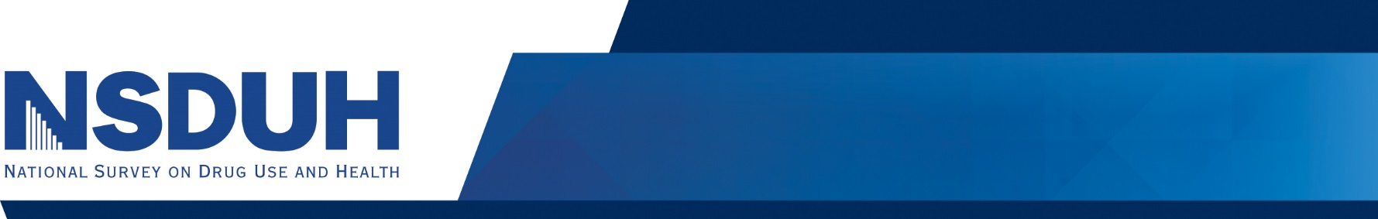
Tobacco Use
Selected Highlights from the 2019 National Survey on Drug Use and Health

Past Month Cigarette Use among People Aged 12 or Older: 2002 - 2019
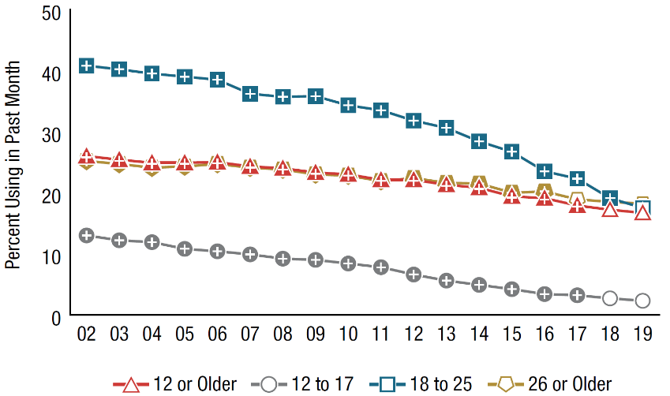
An estimated 45.9 million Americans reported current use (during the past month) of cigarettes in 2019, which is approximately 1 in 6 people aged 12 and older. Of these, 26.8 million were daily cigarette smokers.
As shown in the graph to the right, cigarette use generally declined between 2002 and 2019 across all age groups.

+ Difference between this estimate and the 2019 estimate is statistically significant at the .05 level.

Alcohol Use
Past Month Alcohol Use among People Aged 12 or Older: 2002 - 2019

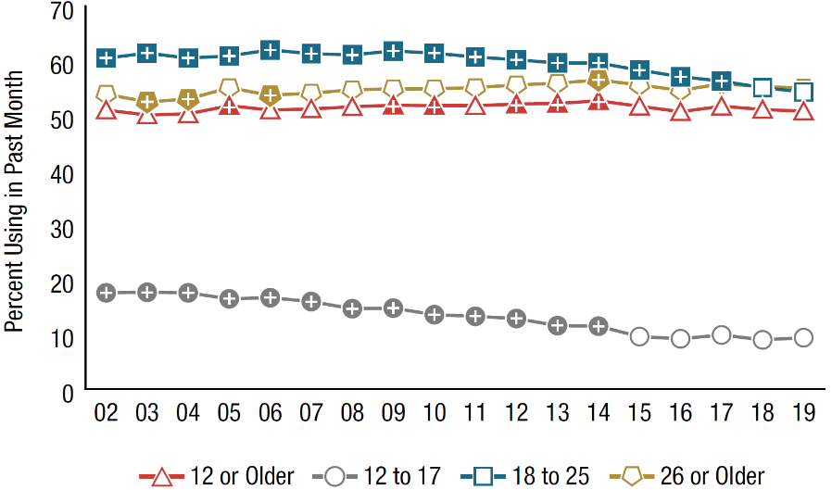
Slightly more than half of all Americans aged 12 or older (50.8% or an estimated 139.7 million persons) were current drinkers in 2019, which is similar to the 139.8 million persons (51.1%) reported in 2018.
The graph on the left shows past month alcohol use by age group.

+ Difference between this estimate and the 2019 estimate is statistically significant at the .05 level.

Illicit Drug Use
An estimated 57.2 million Americans were past year users of illicit drugs in 2019, meaning they used an illicit drug at least once during the year prior to the interview.
Past Year Illicit Drug Use among People Aged 12 or Older: 2019

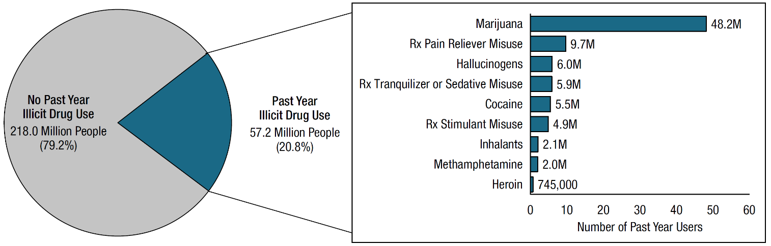

Note: The estimated numbers of past year users of different illicit drugs are not mutually exclusive because people could have used more than one type of illicit drug in the past year.
Adult Mental Health
Major Depressive Episode in the Past Year among Adults Aged 18 or Older: 2005 -2019

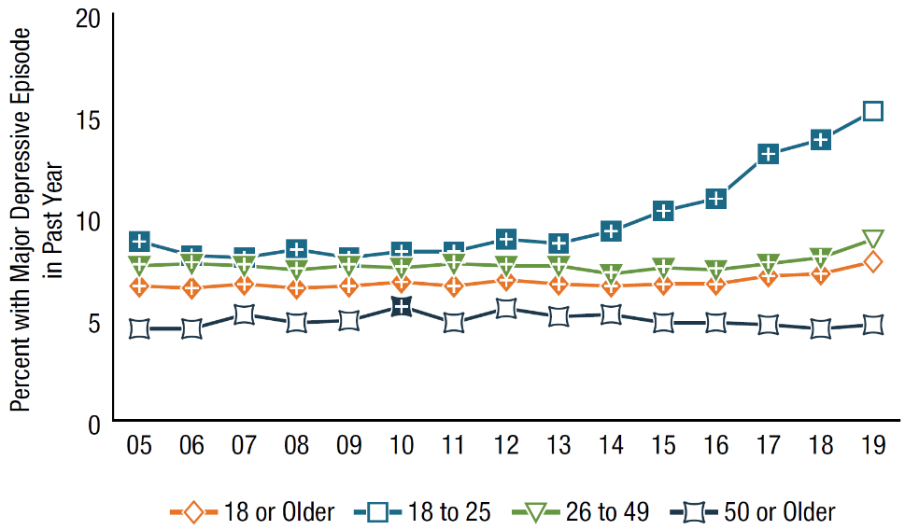
In 2019, an estimated 19.4 million adults, or 7.8% of the population aged 18 or older, had at least one major depressive episode (MDE) in the past 12 months.
Among adults, the percentage having MDE in the past year varied by age, as shown in the graph to the right.

+ Difference between this estimate and the 2019 estimate is statistically significant at the .05 level.
Youth Mental Health
Adolescents aged 12 to 17 with past year MDE were more likely than those without MDE to be substance users, as shown in the graph below. Youths with past year MDE were more likely to have used an illicit drug in the past year (31.9 vs. 14.4%).
Substance Use among Youths Aged 12 to 17, by Past Year Major Depressive Episode (MDE) Status: 2019

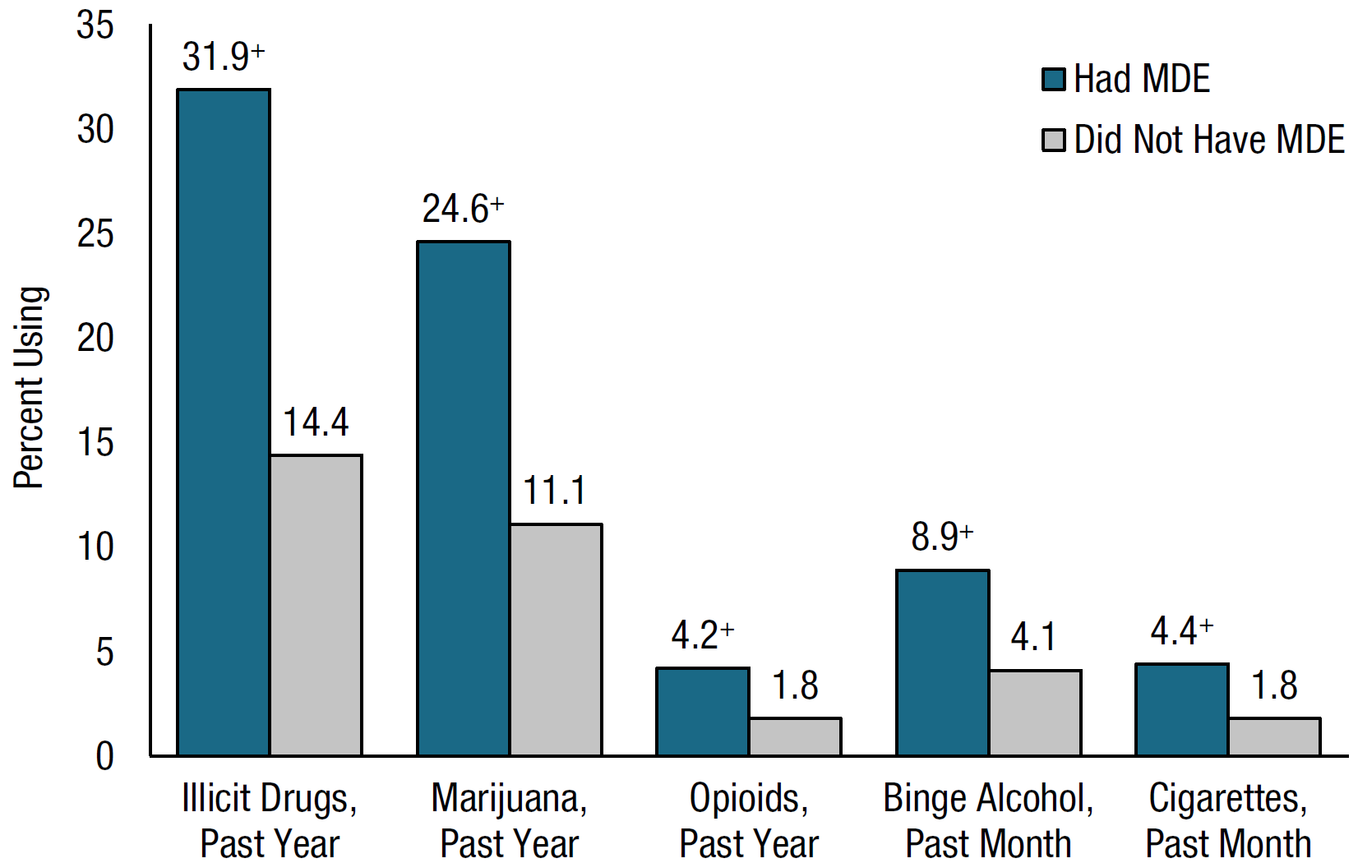

+ Difference between this estimate and the estimate for youths without MDE is statistically significant at the .05 level.
Note: Youth respondents with unknown MDE data were excluded.

Substance Abuse and Mental Health Services Administration. (2020). Key substance use and mental health indicators in the United States: Results from the 2019 National Survey on Drug Use and Health (HHS Publication No. PEP20-07-01-001, NSDUH Series H-55). Rockville, MD: Center for Behavioral Health Statistics and Quality, Substance Abuse and Mental Health Services Administration. Retrieved from https://www.samhsa.gov/data/
