WEB SCREENING FOLLOW-UP 1 (POSTCARD)
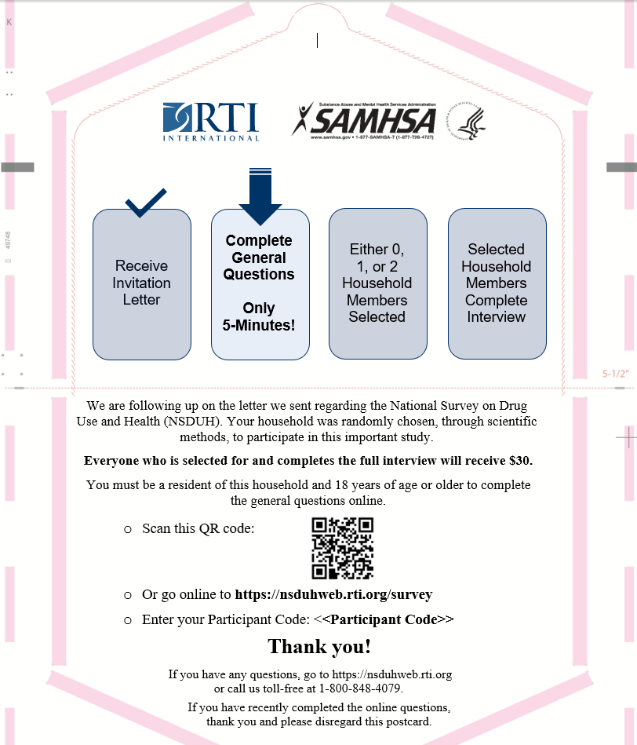

WEB SCREENING FOLLOW-UP 2 (LETTER)

Resident
[STREET ADDRESS]
[CITY], [STATE] [ZIP]

Dear Resident:
We are following up on a letter we sent regarding a study, the National Survey on Drug Use and Health* (NSDUH), sponsored by the U.S. Department of Health and Human Services. If you have recently completed the online questions, thank you and please disregard this letter.
Your address was randomly chosen, through scientific methods, along with almost 200,000 others across the country. RTI International, a nonprofit organization, was selected to conduct this study. Since 1971, this study has been a trusted source of data used by local, state, and national agencies for planning and support for education, treatment and prevention programs related to substance use and mental health. We want you to have a chance to be included in the study. We cannot substitute your address with another address.
Please take a few minutes today to answer a few general questions online. These general questions will determine whether zero, one, or two household members aged 12 or older will be selected to complete the full interview. Everyone who is selected for and completes the full interview will receive $30.
If you choose to participate, please follow the steps below. Please share this information with any others in your household.
You must be a resident of this household and 18 years of age or older to participate
To answer the questions online, go to https://nsduhweb.rti.org/survey (or scan the QR code below), enter your Participant Code, and follow the on-screen instructions. | Participant Code: <CODE>

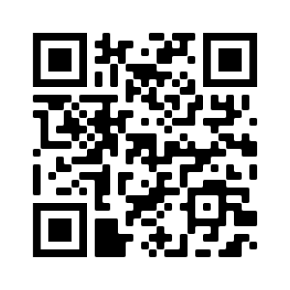
If you have questions, go to https://nsduhweb.rti.org or call us toll-free at 1-800-848-4079. We sincerely thank you in advance for your cooperation.
Sincerely,
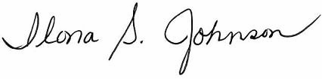

Ilona S. Johnson
National Field Director, RTI
__________________________
*The National Survey on Drug Use and Health is conducted by RTI International for the Substance Abuse and Mental Health Services Administration, an agency in the U.S. Department of Health and Human Services. [http://www.samhsa.gov] [http://www.rti.org]
WEB SCREENING FOLLOW-UP 3 (POSTCARD)
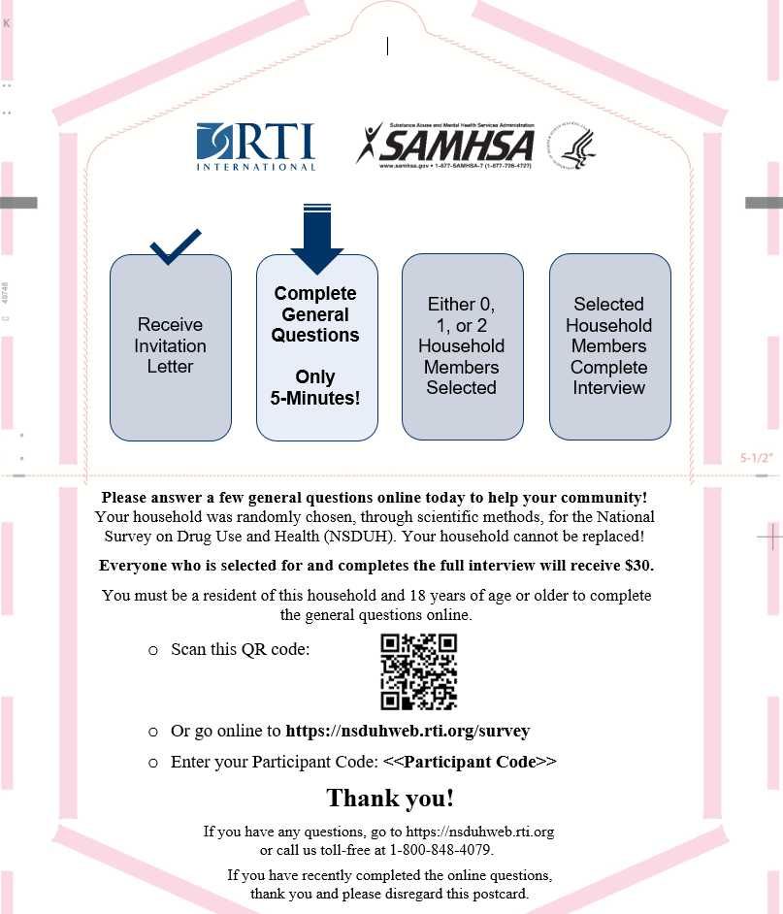

WEB SCREENING FOLLOW-UP 4 (LETTER)

Resident
[STREET ADDRESS]
[CITY], [STATE] [ZIP]

Dear Resident:
We have been trying to contact you regarding an important study, the National Survey on Drug Use and Health* (NSDUH), sponsored by the U.S. Department of Health and Human Services and conducted by RTI International - a nonprofit organization in North Carolina.
Your participation is important, and your household cannot be replaced – therefore we are reaching out to you again. This study will help researchers better understand the use or non-use of alcohol, tobacco and other substances, mental health, and other health issues in the United States. If you have recently completed the online questions, thank you and please disregard this letter.
Please take a few minutes today to answer a few general questions online. These general questions will determine whether zero, one, or two household members aged 12 or older will be selected to complete the full interview. Everyone who is selected for and completes the full interview will receive $30. Please share this information with any others in your household.
You must be a resident of this household and 18 years of age or older to participate
To answer the questions online, go to https://nsduhweb.rti.org/survey (or scan the QR code below), enter your Participant Code, and follow the on-screen instructions. | Participant Code: <CODE>

In some areas where COVID-19 numbers are lower, a professional interviewer from RTI may attempt to contact you in-person to complete these questions.
If you have any questions, go to https://nsduhweb.rti.org or call us toll-free at 1-800-848-4079.
Sincerely,


Ilona S. Johnson
National Field Director, RTI
__________________________
*The National Survey on Drug Use and Health is conducted by RTI International for the Substance Abuse and Mental Health Services Administration, an agency in the U.S. Department of Health and Human Services. [http://www.samhsa.gov] [http://www.rti.org]

WEB SCREENING FOLLOW-UP 5 (POSTCARD)
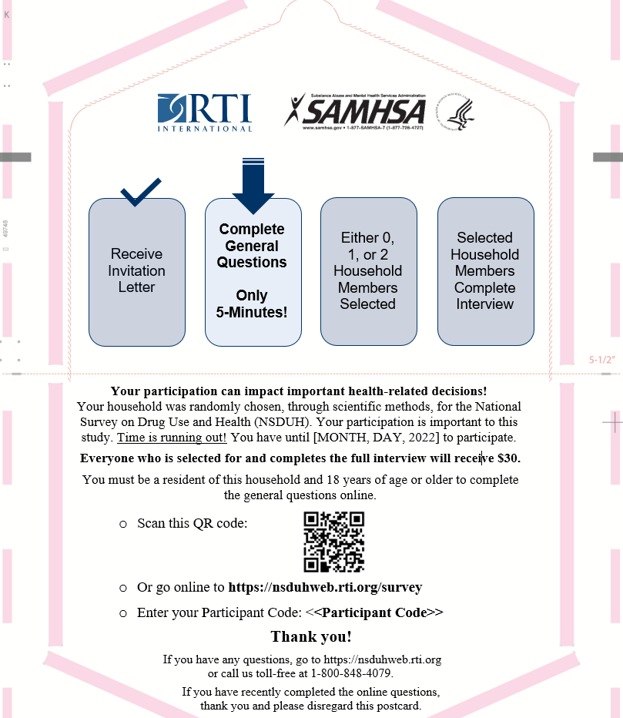

ADULT WEB INTERVIEW FOLLOW-UP 1 (LETTER)

Resident Attention: [age] year old [gender] resident
[STREET ADDRESS]
[CITY], [STATE] [ZIP]

Dear Resident:
Recently, someone at your address answered a few general questions online for the National Survey on Drug Use and Health* (NSDUH) and you were randomly selected to complete the full interview online. If you have recently completed the interview online, thank you and please disregard this letter.
Your participation in this study is important and you cannot be replaced! Here is some additional information about the study:
- A limited number of individuals—including you—were randomly chosen to take part.
- As a token of our appreciation, you will receive a $30 gift card upon completion of the full interview online.
- The interview will take about an hour to complete and can be completed from any device with internet access (computer, tablet, phone, etc.). Use of a desktop or laptop computer is recommended. Any information you provide will be kept completely confidential. Your answers are combined with the answers of thousands of other people and reported only as overall statistics.
If you choose to complete the interview online, please follow the steps below.
You must be a selected individual to participate in this interview.
To complete the interview, go to https://nsduhweb.rti.org/survey, enter your Participant Code, and follow the on-screen instructions. | Participant Code: <CODE>
In some areas where COVID-19 numbers are lower, a professional interviewer from RTI may attempt to contact you in-person to complete the interview in your home, on a laptop computer.
If you have any questions about the study or prefer not to be visited in-person, please visit https://nsduhweb.rti.org or contact us toll-free at 1-800-848-4079. We sincerely thank you in advance for your cooperation.
Sincerely,

Ilona S. Johnson
National Field Director, RTI
__________________________
*The National Survey on Drug Use and Health is conducted by RTI International for the Substance Abuse and Mental Health Services Administration, an agency in the U.S. Department of Health and Human Services. [http://www.samhsa.gov] [http://www.rti.org]

ADULT WEB INTERVIEW FOLLOW-UP 2 (POSTCARD)
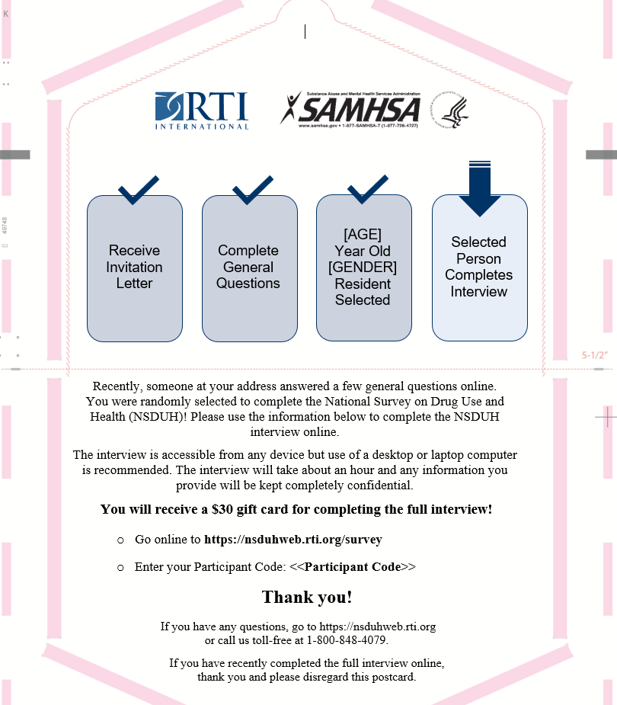

ADULT WEB INTERVIEW FOLLOW-UP 3 (LETTER)

Resident Attention: [age] year old [gender] resident
[STREET ADDRESS]
[CITY], [STATE] [ZIP]

Dear Resident:
We have been trying to contact you regarding an important study called the National Survey on Drug Use and Health* (NSDUH). You were randomly selected to complete the full interview online. If you have recently completed the interview online, thank you and please disregard this letter.
Your participation will make the study a success! You have until [MONTH, DAY, 2022] to participate. Here is some additional information about the study:
- A limited number of individuals—including you—were randomly chosen to take part.
- As a token of our appreciation, you will receive a $30 gift card upon completion of the full interview online.
- The interview will take about an hour to complete and can be completed from any device with internet access (computer, tablet, phone, etc.). Use of a desktop or laptop computer is recommended. Any information you provide will be kept completely confidential. Your answers are combined with the answers of thousands of other people and reported only as overall statistics.
If you choose to complete the interview online, please follow the steps below.
You must be a selected individual to participate in this interview.
To complete the interview, go to https://nsduhweb.rti.org/survey, enter your Participant Code, and follow the on-screen instructions. | Participant Code: <CODE>
In some areas where COVID-19 numbers are lower, a professional interviewer from RTI may attempt to contact you in-person to complete the interview in your home, on a laptop computer.
If you have any questions about the study or prefer not to be visited in-person, please visit https://nsduhweb.rti.org or contact us toll-free at 1-800-848-4079. We sincerely thank you in advance for your cooperation.
Sincerely,

Ilona S. Johnson
National Field Director, RTI
__________________________
*The National Survey on Drug Use and Health is conducted by RTI International for the Substance Abuse and Mental Health Services Administration, an agency in the U.S. Department of Health and Human Services. [http://www.samhsa.gov] [http://www.rti.org]
YOUTH WEB INTERVIEW FOLLOW-UP 1 (LETTER)
Resident Attention: Parent of [age] year old [gender] resident
[STREET ADDRESS]
[CITY], [STATE] [ZIP]

Dear Resident:
Recently, someone at your address answered a few general questions online for the National Survey on Drug Use and Health* (NSDUH) and your child was randomly selected to complete the full interview online. If your child has recently completed the interview online, thank you and please disregard this letter.
The interview will take about an hour to complete and can be completed from any device with internet access. Use of a desktop or laptop computer is recommended. Any information your child provides will be kept completely confidential. Your child’s answers are combined with the answers of thousands of other people and reported only as overall statistics. As a token of our appreciation, your child will receive a $30 gift card upon completion of the full interview online.
If your child is interested in completing the interview online, please follow the steps below.
- Choose a time when you and your child are at home and in a private location.
- Call a project representative at 1-800-848-4079 to receive further instructions about beginning the interview.
Only a selected individual may participate in this interview.
Parent or guardian of selected child: Call 1-800-848-4079 to receive more details and provide parental consent.
Selected child: To complete the interview, go to https://nsduhweb.rti.org/survey, enter your Participant Code, and follow the on-screen instructions. | Participant Code: <CODE>
In some areas where COVID-19 numbers are lower, a professional interviewer from RTI may attempt to contact you in-person to complete the interview in your home, on a laptop computer.
If you have any questions about the study or prefer not to be visited in-person, please visit https://nsduhweb.rti.org or contact us toll-free at 1-800-848-4079. We sincerely thank you in advance for your cooperation.
Sincerely,

Ilona S. Johnson
National Field Director, RTI
__________________________
*The National Survey on Drug Use and Health is conducted by RTI International for the Substance Abuse and Mental Health Services Administration, an agency in the U.S. Department of Health and Human Services. [http://www.samhsa.gov] [http://www.rti.org]

YOUTH WEB INTERVIEW FOLLOW-UP 2 (POSTCARD)

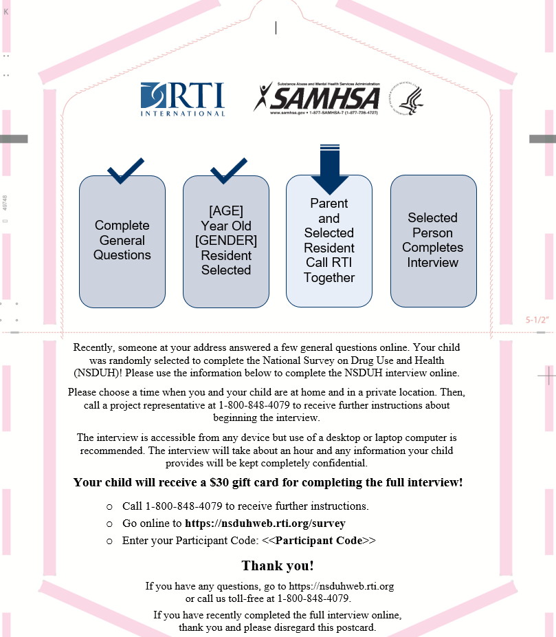

YOUTH WEB INTERVIEW FOLLOW-UP 3 (LETTER)
Resident Attention: Parent of [age] year old [gender] resident
[STREET ADDRESS]
[CITY], [STATE] [ZIP]

Dear Resident:
We have been trying to contact you regarding an important study called the National Survey on Drug Use and Health* (NSDUH). Your child was randomly selected to complete the full interview online. If your child has recently completed the interview online, thank you and please disregard this letter.
The interview will take about an hour to complete and can be completed from any device with internet access. Use of a desktop or laptop computer is recommended. Any information your child provides will be kept completely confidential. Your child’s answers are combined with the answers of thousands of other people and reported only as overall statistics. As a token of our appreciation, your child will receive a $30 gift card upon completion of the full interview online. Your child has until [MONTH, DAY, 2022] to participate.
If your child is interested in completing the interview online, please follow the steps below.
- Choose a time when you and your child are at home and in a private location.
- Call a project representative at 1-800-848-4079 to receive further instructions about beginning the interview.
Only a selected individual may participate in this interview.
Parent or guardian of selected child: Call 1-800-848-4079 to receive more details and provide parental consent.
Selected child: To complete the interview, go to https://nsduhweb.rti.org/survey, enter your Participant Code, and follow the on-screen instructions. | Participant Code: <CODE>
In some areas where COVID-19 numbers are lower, a professional interviewer from RTI may attempt to contact you in-person to complete the interview in your home, on a laptop computer.
If you have any questions about the study or prefer not to be visited in-person, please visit https://nsduhweb.rti.org or contact us toll-free at 1-800-848-4079. We sincerely thank you in advance for your cooperation.
Sincerely,

Ilona S. Johnson
National Field Director, RTI
__________________________
*The National Survey on Drug Use and Health is conducted by RTI International for the Substance Abuse and Mental Health Services Administration, an agency in the U.S. Department of Health and Human Services. [http://www.samhsa.gov] [http://www.rti.org]

ADULT WEB INTERVIEW FOLLOW-UP 1 (LETTER) – COVID REFUSAL FOR IN-PERSON

Resident Attention: [age] year old [gender] resident
[STREET ADDRESS]
[CITY], [STATE] [ZIP]

Dear Resident:
Recently, someone at your address answered a few general questions online for the National Survey on Drug Use and Health* (NSDUH) and you were randomly selected to complete the full interview online. If you have recently completed the interview online, thank you and please disregard this letter.
Your participation in this study is important and you cannot be replaced! Here is some additional information about the study:
- A limited number of individuals—including you—were randomly chosen to take part.
- As a token of our appreciation, you will receive a $30 gift card upon completion of the full interview online.
- The interview will take about an hour to complete and can be completed from any device with internet access (computer, tablet, phone, etc.). Use of a desktop or laptop computer is recommended. Any information you provide will be kept completely confidential. Your answers are combined with the answers of thousands of other people and reported only as overall statistics.

If you choose to complete the interview online, please follow the steps below.
You must be a selected individual to participate in this interview.
To complete the interview, go to https://nsduhweb.rti.org/survey, enter your Participant Code, and follow the on-screen instructions. | Participant Code: <CODE>

If you have any questions about the study, please visit https://nsduhweb.rti.org or contact us toll-free at 1-800-848-4079. We sincerely thank you in advance for your cooperation.
Sincerely,

Ilona S. Johnson
National Field Director, RTI
__________________________
*The National Survey on Drug Use and Heath is conducted by RTI International for the Substance Abuse and Mental Health Services Administration, an agency in the U.S. Department of Health and Human Services. [http://www.samhsa.gov] [http://www.rti.org]

ADULT WEB INTERVIEW FOLLOW-UP 2 (LETTER) – COVID REFUSAL FOR IN-PERSON

Resident Attention: [age] year old [gender] resident
[STREET ADDRESS]
[CITY], [STATE] [ZIP]

Dear Resident:
We have been trying to contact you regarding an important study called the National Survey on Drug Use and Health* (NSDUH). You were randomly selected to complete the full interview online. If you have recently completed the interview online, thank you and please disregard this letter.
Your participation will make the study a success! Here is some additional information about the study:
- A limited number of individuals—including you—were randomly chosen to take part.
- As a token of our appreciation, you will receive a $30 gift card upon completion of the full interview online.
- The interview will take about an hour to complete and can be completed from any device with internet access (computer, tablet, phone, etc.). Use of a desktop or laptop computer is recommended. Any information you provide will be kept completely confidential. Your answers are combined with the answers of thousands of other people and reported only as overall statistics.

If you choose to complete the interview online, please follow the steps below.
You must be a selected individual to participate in this interview.
To complete the interview, go to https://nsduhweb.rti.org/survey, enter your Participant Code, and follow the on-screen instructions. | Participant Code: <CODE>

If you have any questions about the study, please visit https://nsduhweb.rti.org or contact us toll-free at 1-800-848-4079. We sincerely thank you in advance for your cooperation.
Sincerely,

Ilona S. Johnson
National Field Director, RTI
__________________________
*The National Survey on Drug Use and Heath is conducted by RTI International for the Substance Abuse and Mental Health Services Administration, an agency in the U.S. Department of Health and Human Services. [http://www.samhsa.gov] [http://www.rti.org]

YOUTH WEB INTERVIEW FOLLOW-UP 1 (LETTER) – COVID REFUSAL FOR IN-PERSON

Resident Attention: Parent of [age] year old [gender] resident
[STREET ADDRESS]
[CITY], [STATE] [ZIP]

Dear Resident:
Recently, someone at your address answered a few general questions online for the National Survey on Drug Use and Health* (NSDUH) and your child was randomly selected to complete the full interview online. If your child has recently completed the interview online, thank you and please disregard this letter.
The interview will take about an hour to complete and can be completed from any device with internet access. Use of a desktop or laptop computer is recommended. Any information your child provides will be kept completely confidential. Your child’s answers are combined with the answers of thousands of other people and reported only as overall statistics. As a token of our appreciation, your child will receive a $30 gift card upon completion of the full interview online.
If your child is interested in completing the interview online, please follow the steps below.
- Choose a time when you and your child are at home and in a private location.
- Call a project representative at 1-800-848-4079 to receive further instructions about beginning the interview.
Only a selected individual may participate in this interview.
Parent or guardian of selected child: Call 1-800-848-4079 to receive more details and provide parental consent.
Selected child: To complete the interview, go to https://nsduhweb.rti.org/survey, enter your Participant Code, and follow the on-screen instructions. | Participant Code: <CODE>

.
If you have any questions about the study, please visit https://nsduhweb.rti.org or contact us toll-free at 1-800-848-4079. We sincerely thank you in advance for your cooperation.
Sincerely,

Ilona S. Johnson
National Field Director, RTI
__________________________
*The National Survey on Drug Use and Heath is conducted by RTI International for the Substance Abuse and Mental Health Services Administration, an agency in the U.S. Department of Health and Human Services. [http://www.samhsa.gov] [http://www.rti.org]

YOUTH WEB INTERVIEW FOLLOW-UP 2 (LETTER) – COVID REFUSAL FOR IN-PERSON

Resident Attention: Parent of [age] year old [gender] resident
[STREET ADDRESS]
[CITY], [STATE] [ZIP]

Dear Resident:
We have been trying to contact you regarding an important study called the National Survey on Drug Use and Health* (NSDUH). Your child was randomly selected to complete the full interview online. If your child has recently completed the interview online, thank you and please disregard this letter.
The interview will take about an hour to complete and can be completed from any device with internet access. Use of a desktop or laptop computer is recommended. Any information your child provides will be kept completely confidential. Your child’s answers are combined with the answers of thousands of other people and reported only as overall statistics. As a token of our appreciation, your child will receive a $30 gift card upon completion of the full interview online.
If your child is interested in completing the interview online, please follow the steps below.
- Choose a time when you and your child are at home and in a private location.
- Call a project representative at 1-800-848-4079 to receive further instructions about beginning the interview.
Only a selected individual may participate in this interview.
Parent or guardian of selected child: Call 1-800-848-4079 to receive more details and provide parental consent.
Selected child: To complete the interview, go to https://nsduhweb.rti.org/survey, enter your Participant Code, and follow the on-screen instructions. | Participant Code: <CODE>

If you have any questions about the study, please visit https://nsduhweb.rti.org or contact us toll-free at 1-800-848-4079. We sincerely thank you in advance for your cooperation.
Sincerely,

Ilona S. Johnson
National Field Director, RTI
__________________________
*The National Survey on Drug Use and Heath is conducted by RTI International for the Substance Abuse and Mental Health Services Administration, an agency in the U.S. Department of Health and Human Services. [http://www.samhsa.gov] [http://www.rti.org]

