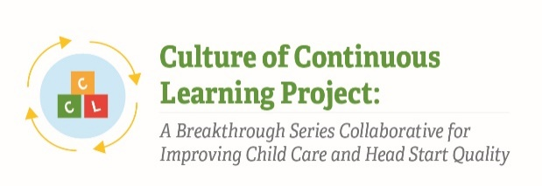

Instrument 10: Key Informant Interviews with BSC Faculty Members Affiliated with the States/Regions Discussion Guide

Culture of Continuous Learning Project: A Breakthrough Series Collaborative for Improving Child Care and Head Start Quality

Respondents | Time of Data Collection
BSC Implementation Faculty and Staff Affiliated with Case Study States/Regions | Post-test (T3)

Note: Respondents are implementation faculty and staff members who are affiliated with a certain state/region.

Questions will be selected based on relevance at time of data collection such that the length of the interviews is no more than 60 minutes.

Thank you very much for agreeing to participate in this discussion. Your participation is very important to our research.

- We are conducting a research study for the Office of Planning, Research, and Evaluation at the Administration for Children and Families within the U.S. Department of Health and Human Services. The purpose of this study is to learn about the options for integrating a Breakthrough Series Collaborative (BSC) into early care and education quality improvement systems. The BSC is a specific training approach designed to support learning and improvement among practitioners at all levels of an organization, from directors to teachers who work in a classroom with children. This BSC aims to support children's social and emotional learning practices among staff who work in child care and Head Start settings. The intended use of the information collected is to study whether a BSC can enhance existing Head Start and child care training and technical assistance activities to support social and emotional learning practices.
- Our conversation will last approximately one hour. We will ask you about the process of implementing a BSC and facilitators and barriers to BSC implementation.
- There is a chance that you may feel uncomfortable answering some of our questions. Being part of this discussion is completely voluntary. You can choose to skip any question or stop the conversation at any time. Additionally, there is no direct benefit to participating in this interview. We hope the information you provide will benefit the early child care and education field.
- We would like to record this conversation for note-taking purposes only. We will delete the recordings after the notes have been cleaned. We will separate your name and personal information from our notes and transcripts. Your identity and the information you share will be kept private by the research team. Our report will describe the experiences and viewpoints expressed, but comments will not be attributed to specific individuals. No individuals will be quoted by name. Information shared during this conversation may be made available to other researchers for future study. However, your identity will be kept private and no comments will be able to be attributed to you.
- [For questions:] If you would like a copy of this information or have questions, please email us at ktout@childtrends.org or the IRB at irbparticipant@childtrends.org or by phone at 1-855-288-3506.
- [Send comments:] Send comments regarding this burden estimate or any other aspect of this collection of information, including suggestions for reducing this burden to Kathryn Tout, ktout@childtrends.org or Child Trends, 708 N 1st Suite #333 Minneapolis, MN 55401 Attention: Kathryn Tout
- [PRA statement:] A Federal agency may not conduct or sponsor, and no individual or entity is required to respond to, nor shall an individual or entity be subject to a penalty for failure to comply with a collection of information subject to the requirements of the Paperwork Reduction Act of 1995, unless that collection of information displays a currently valid OMB Control Number. The OMB number for this collection of information is 0970-0XXX and the expiration date is XX/XX/XXXX.

Are you willing to participate in this discussion and be recorded? [Yes/No]
Topic | Subtopic | Type of Respondent
Background on faculty member | - Current position within state system  - Current employer  - How you came to be involved as BSC implementation faculty  - Perceptions of training for your role as BSC implementation faculty  - Feelings of support (or lack thereof) from supervisor or employer for work as BSC implementation faculty  - Additional supports that would have been helpful for your role as BSC implementation faculty | Only State/Region BSC Implementation Faculty
How the BSC compares to other experiences of QI | - How the BSC compares to other quadrant 2, 3, and 4 QI initiatives in the state  - Overall opinions of elements of the BSC | Only State/Region BSC Implementation Faculty

