nFORM 2.0 Screens to Collect Information

on Services Provided to Participants

**Note:** Screen shots include fictional names for illustrative purposes. OMB Control Number and Expiration Date appear on entry to nFORM system and individual surveys. The NonSubstantive Change Request only applies to the Paperwork Reduction Act statement that appears on the nFORM 2.0 Home page.

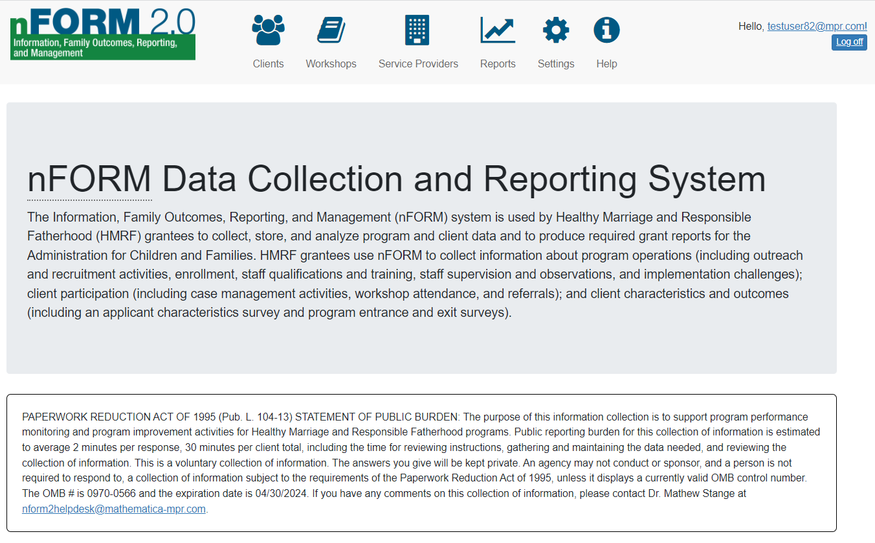

Will replace with [Current Point of Contact Name]

**C1-C6. Client Level Data on Service Contacts, Referrals, Incentives, and Workshops**

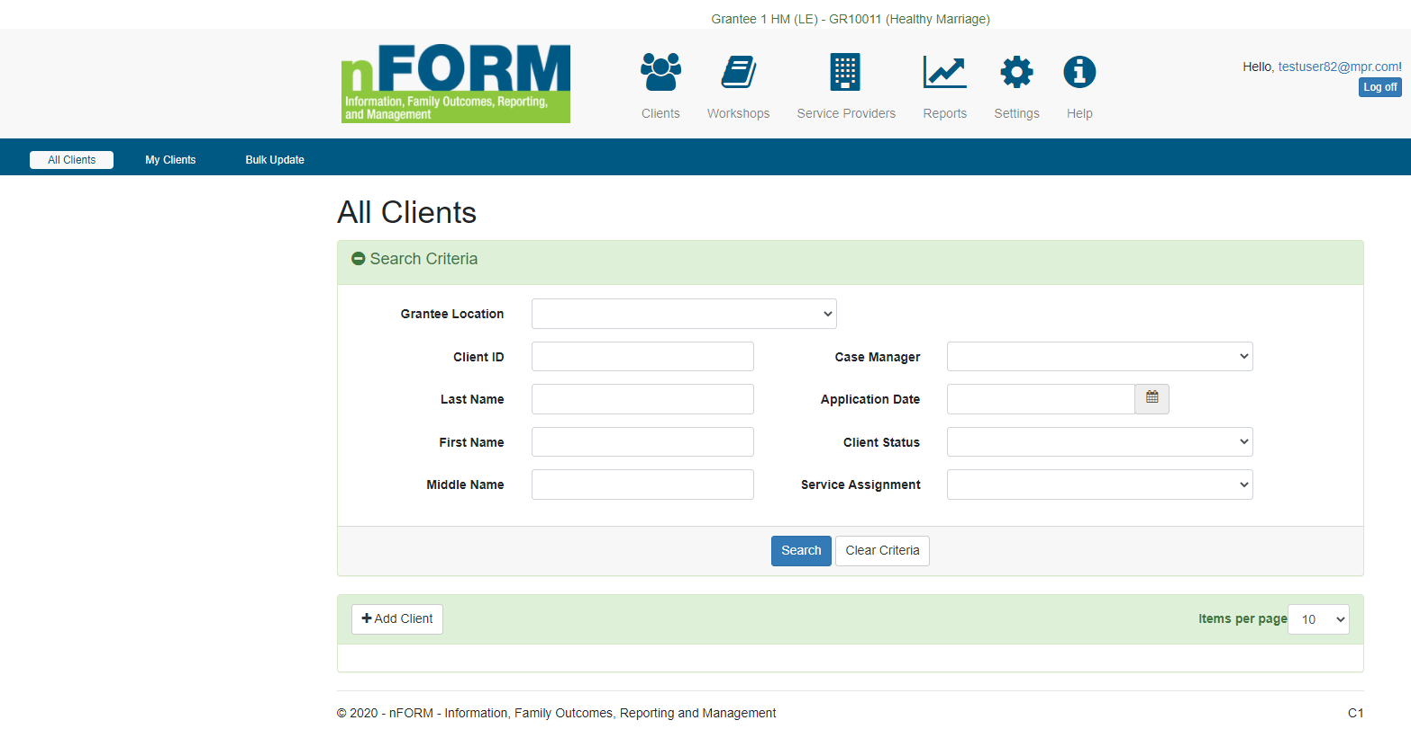

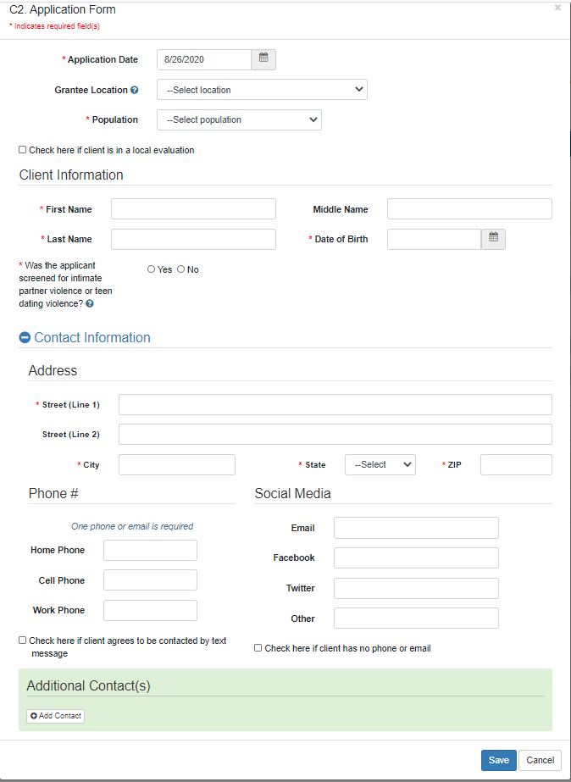

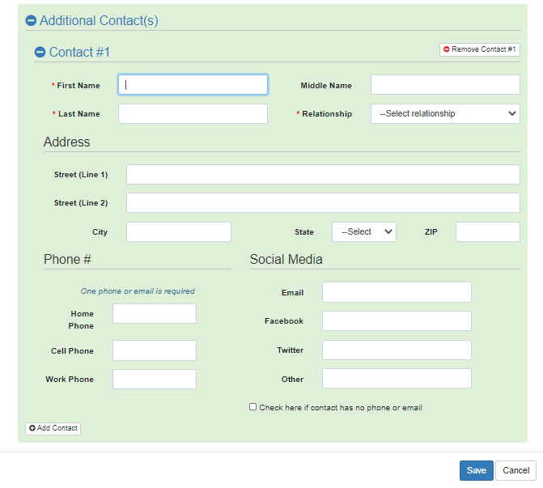

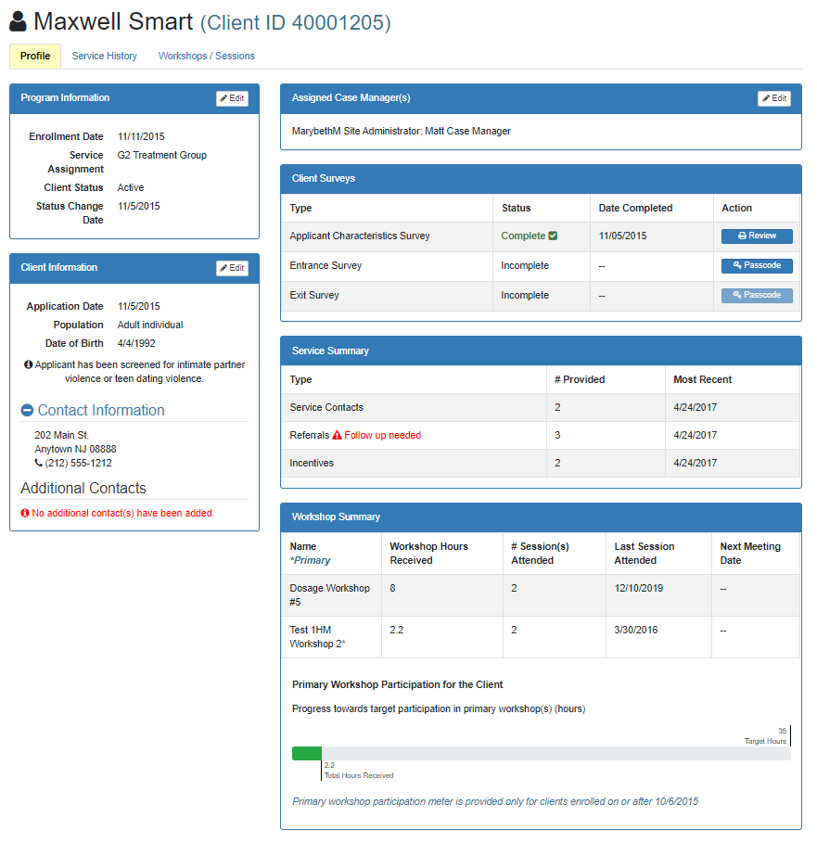

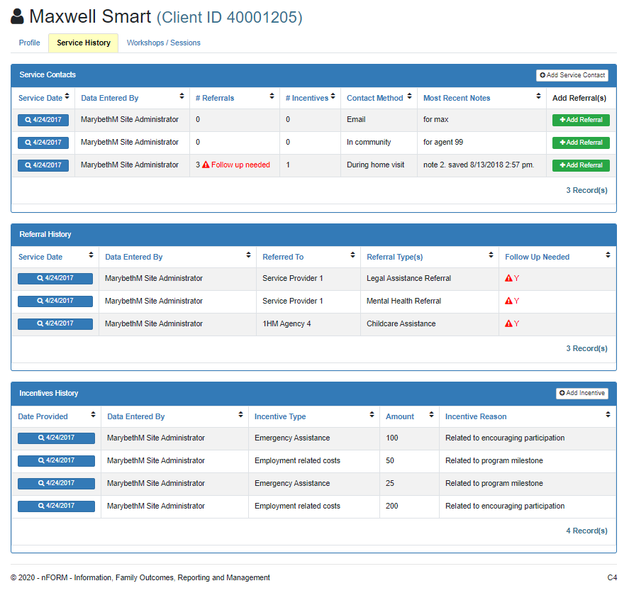

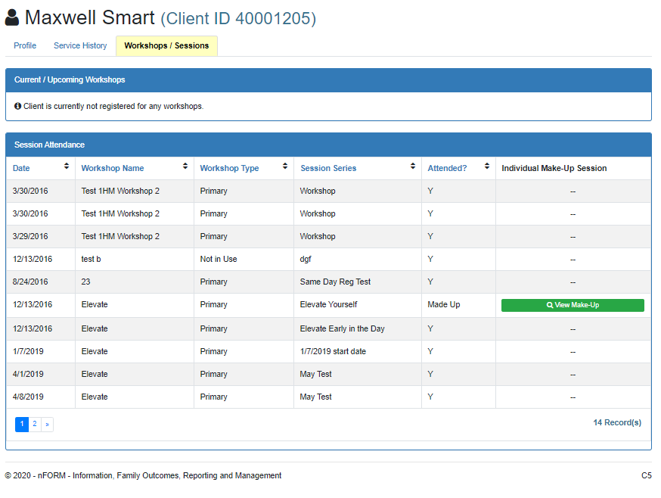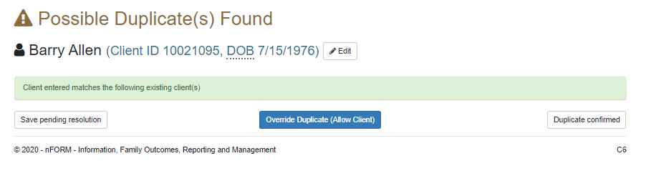

**C7/C12/C13. Add/Edit Client Service Contacts, Referrals, and Incentives**

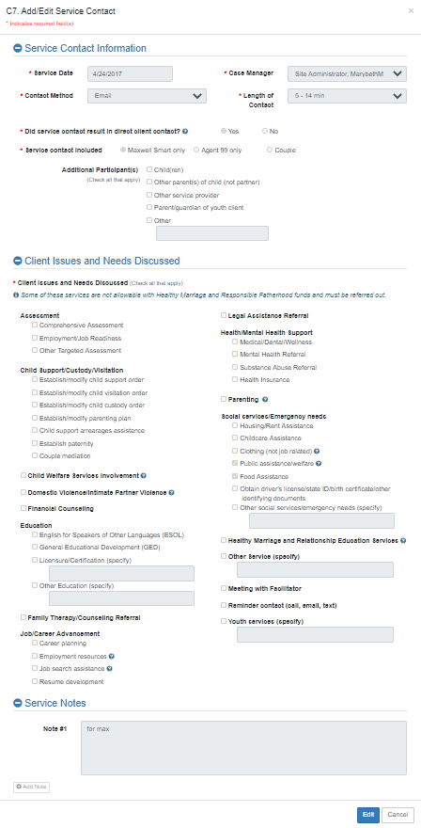

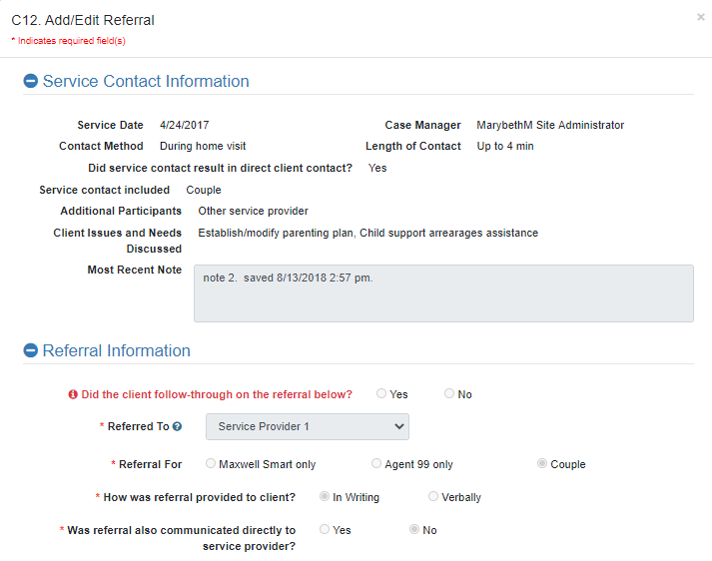

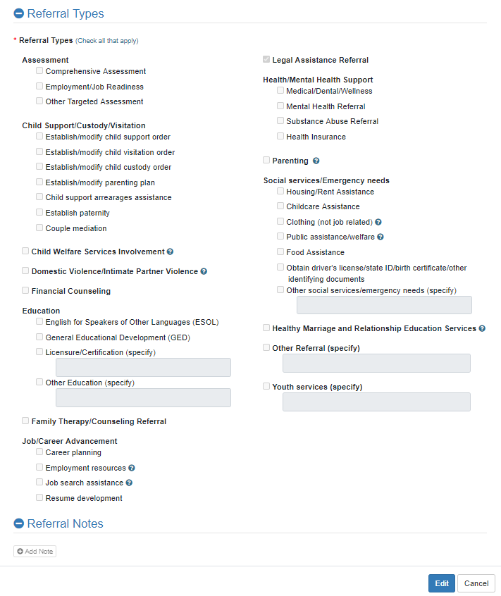

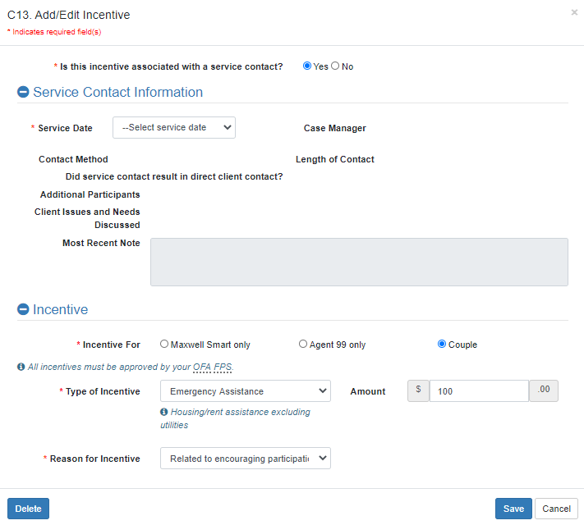

**W1. Workshop List**

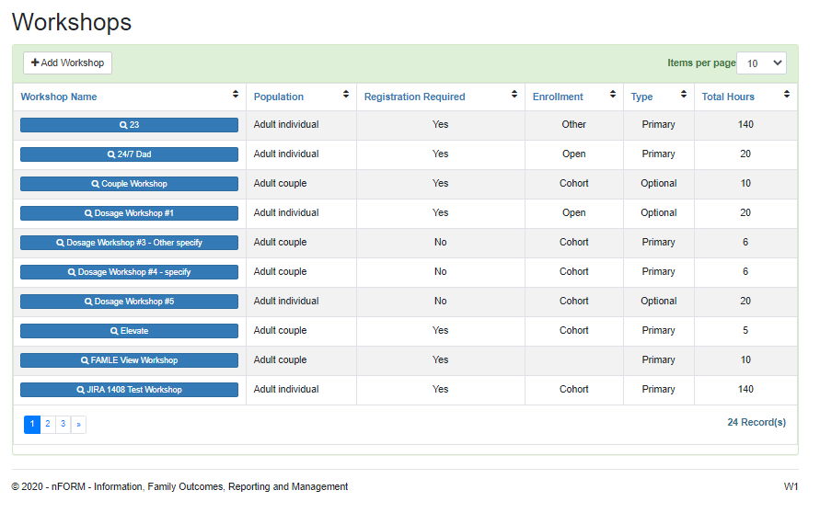

**W2. Add/Edit Workshop**

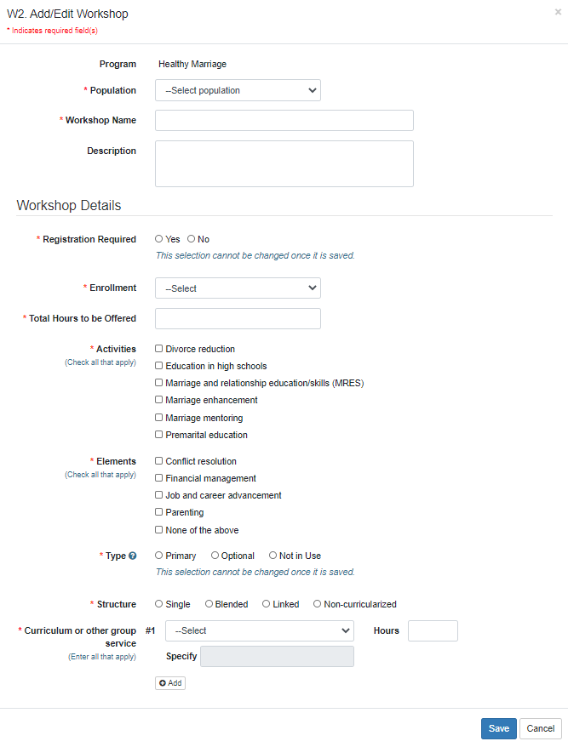

**W5. Add/Edit Workshop Session Series**

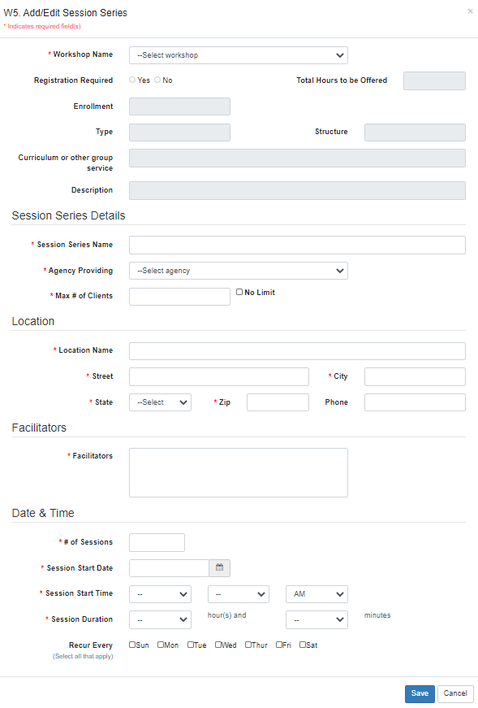

**W4/W8. Manage Session Series and Client Registration**

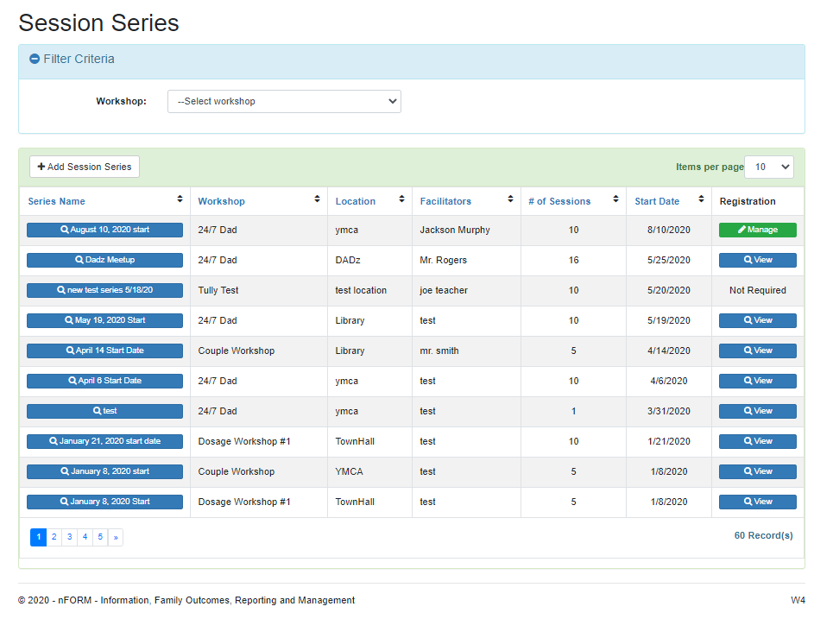

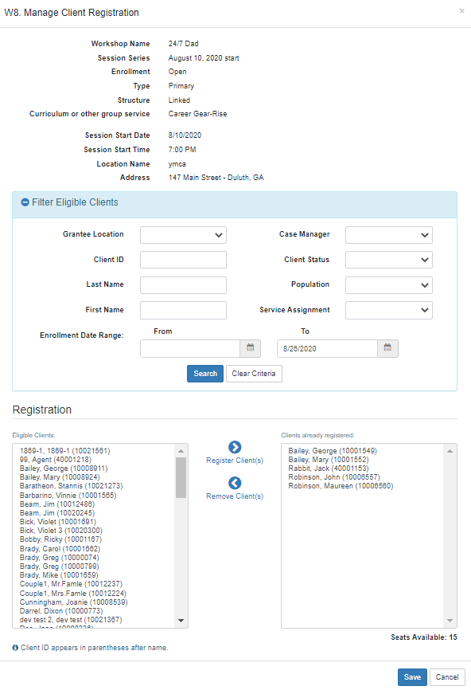

**W7/W9/C11. Manage Session Occurrences and Attendance**

