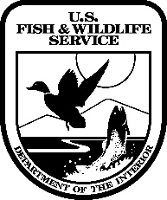
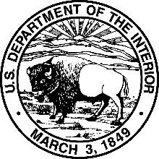
United States Department of the Interior

FISH AND WILDLIFE SERVICE
Region 5 Regional Office
300 Westgate Center Drive
Hadley, MA 01035

USFWS Release and Waiver of Liability

Please read the following carefully. By registering for a program or activity, I acknowledge acceptance of this waiver. I am aware that the courses of activities that I am participating in include certain risks including but not limited to bodily injury, death, illness, loss or damage to personal property and other safety-related dangers. I understand that the unique character of the program includes certain risks that cannot be eliminated. I assume responsibility for my own safety and loss or damage to personal property. I understand that I am responsible for providing my own personal health and accident insurance. The U.S. Fish and Wildlife Service (FWS) has provided me with information pertaining to the risks involved and I am voluntarily participating in these activities. I acknowledge other dangers not mentioned may exist. I release and hold harmless the FWS, its employees, staff, board of directors, members, instructors, volunteers, and their representatives from any and all claims as a result of circumstances and I give permission for instructors, staff and emergency personnel to make necessary first aid decisions in the event of accident, injury or illness. I understand activities may involve remote locations where communication and transportation or evacuation procedures performed by the FWS or other personnel and equipment. I agree to reimburse the FWS for any damage to their equipment if I fail to take reasonable care of the equipment placed in my care. I understand the registration cancellation policy and that I will not be reimbursed if I fail to complete a course or activity. I understand FWS reserves the right to cancel or change activities without prior notice and reserves the right to cancel the registration of any participant it determines fails to meet the requirements for these activities. My participation in this program or activity is purely voluntary. I agree to allow FWS the use of my name and likeness from photograph, digital image, or video taken during these activities to promote FWS activities or to create sales items. I agree to allow FWS to use any written materials, testimonials, artwork, video, or photographs I produce as part of this activity/program that I submit to FWS to promote FWS activities or to create sales items and I consent to and authorize such use without restrictions.

I understand the physical requirements of participation in these activities and affirm I meet these requirements.

Name___________________________________________

Signature________________________________________Date__________________________

A parent or guardian must also sign if the participant is a minor. As the parent or guardian of the minor participating in this activity I acknowledge I have read and understood the release and liability waiver and accept full responsibility for the participation by the minor.

_________________________________________ ___________________________________
Guardian’s Name Signature

Emergency Contact Name____________________________________

Phone Number Day/Evening/Cell______________________________

