Top of the page wording
DS-4317-Family Reunification Assistance for Afghan Parolees Immediate Family Members outside the US
The U.S. Government may be able to offer departure assistance for your spouse and your unmarried children under the age of 21 who are outside the United States if you were admitted into the United States under humanitarian parole and:
- You currently remain a parolee; OR
- You were paroled into the United States and subsequently granted Temporary Protected Status (TPS).
With this assistance, your lawful spouse and your unmarried children under the age of 21 may be eligible for admission to the United States as refugees. You may apply for your children who are unmarried and were under the age of 21 on August 14, 2021.
"Generally, only the lawful marriage of a polygamous marriage will be considered valid for immigration purposes unless a divorce/death certificate can be provided as evidence that a marriage has ended, along with a marriage certificate for any subsequent marriages. Polygamy is the religious practice or historical custom of having more than one spouse at the same time. Polygamous marriages are legal under Afghan law, but they are illegal in all states in the United States. U.S. law does not recognize polygamous marriages.
If you continue a polygamous marriage you were in before you came to the United States or begin a new polygamous marriage in the United States, your immigration application or petition may be denied. If you have questions about polygamous marriage and U.S. immigration law, contact your local resettlement agency. If you need to find legal services, please visit the USCIS Find Legal Services webpage.
To request departure assistance for your family, complete the DS-4317 through this website. The Department of State will contact you with departure options for your family members after your DS-4317 has been received. If the U.S. Government can help your family members depart Afghanistan, your family members will travel to a country where they can be referred for refugee status through the U.S. Refugee Admissions Program. Each family member will require a valid passport. Assistance from the U.S. Government to depart Afghanistan is not a guarantee of admission into the United States by U.S. immigration officials. Each individual must pass security vetting before receiving approval to relocate to the United States.
To complete this form, please have the following documents available:
- Employment Authorization Document (EAD); or
- If an EAD is not available, other U.S. Citizenship and Immigration Services (USCIS) documents such as your I-94. For more information on locating a Form I-94, see the Customs and Border Protection (CBP) Form I-94 webpage for parolees; or see Temporary Protected Status (TPS) Webinar Questions and Answers (uscis.gov) for TPS recipients.
Please have the following documents available on behalf of your lawful spouse and unmarried children under 21 who are outside of the United States:
- Marriage Certificate – for your lawful spouse*
- Birth Certificate – for your children under the age of 21
- Tazkera – for each family member
- Passport (if available) – for each family member

Wording below ‘Information About You”
You can use your Employment Authorization Documents (EAD) to verify your entry on parole when you complete this form. An EAD is an identity document that USCIS issues to individuals with temporary authorization to work in the United States. You may have applied for an EAD at a safe haven and later received it from your resettlement agency. An EAD looks like this.

Screen: when person does have an EAD USCIS card and attorney is selected
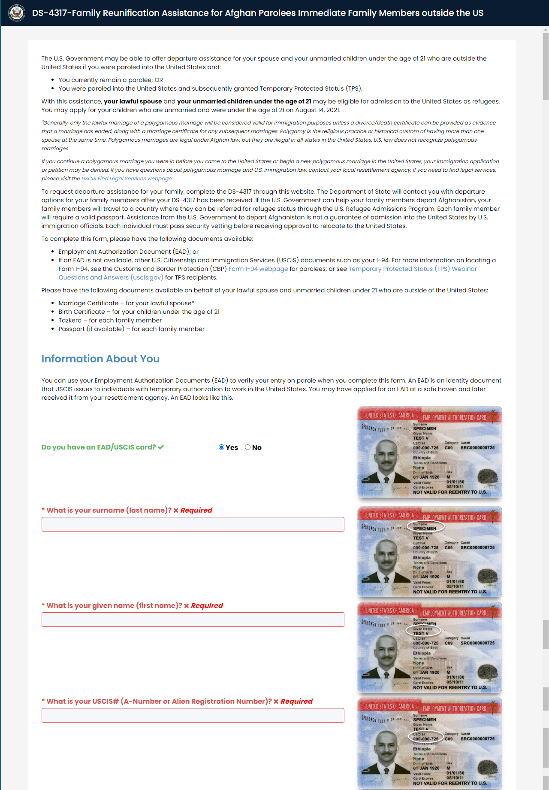
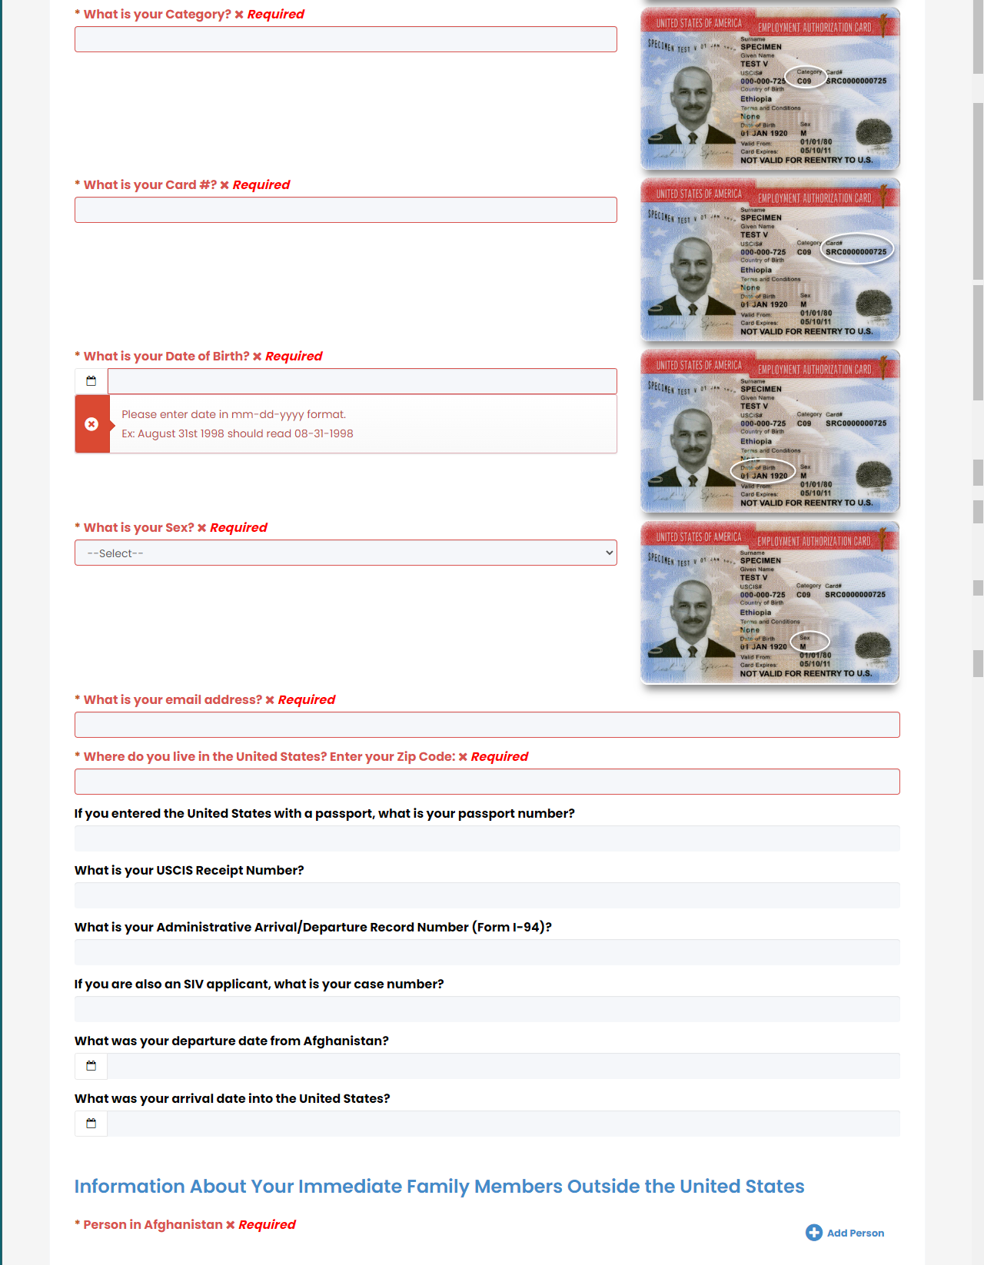
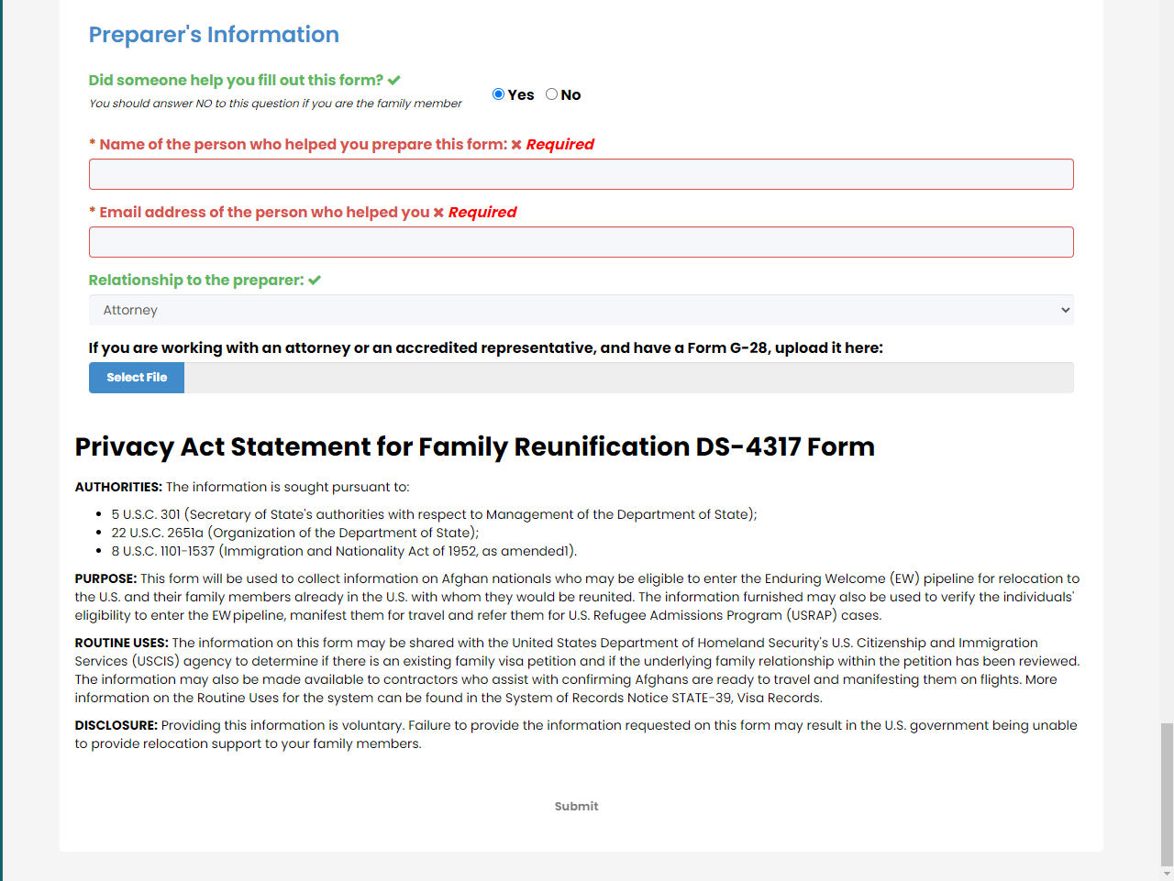

Screen: when person does NOT have an EAD USCIS card and ‘NGO, including resettlement agencies’ is selected
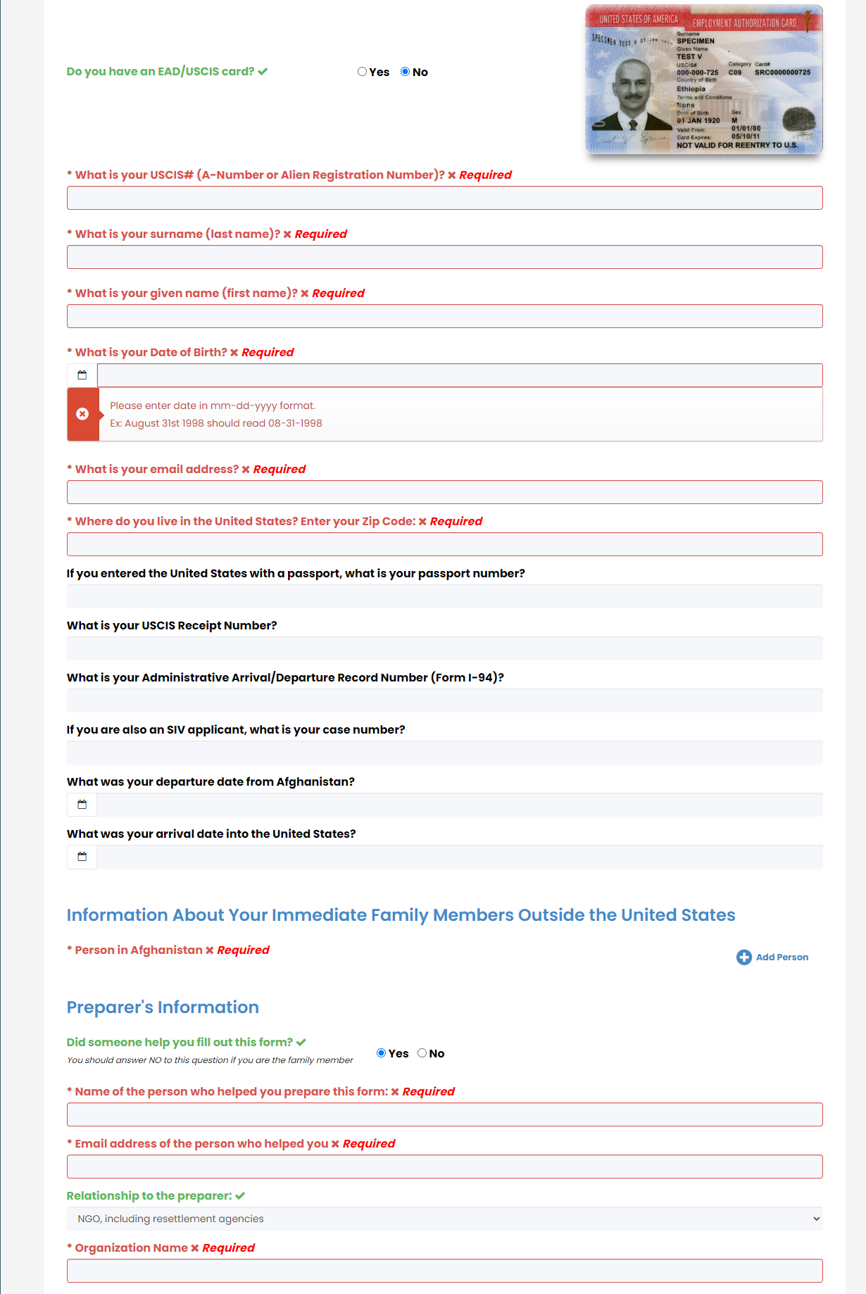
Screen: person pop up for spouse, with language = other and nationality = other
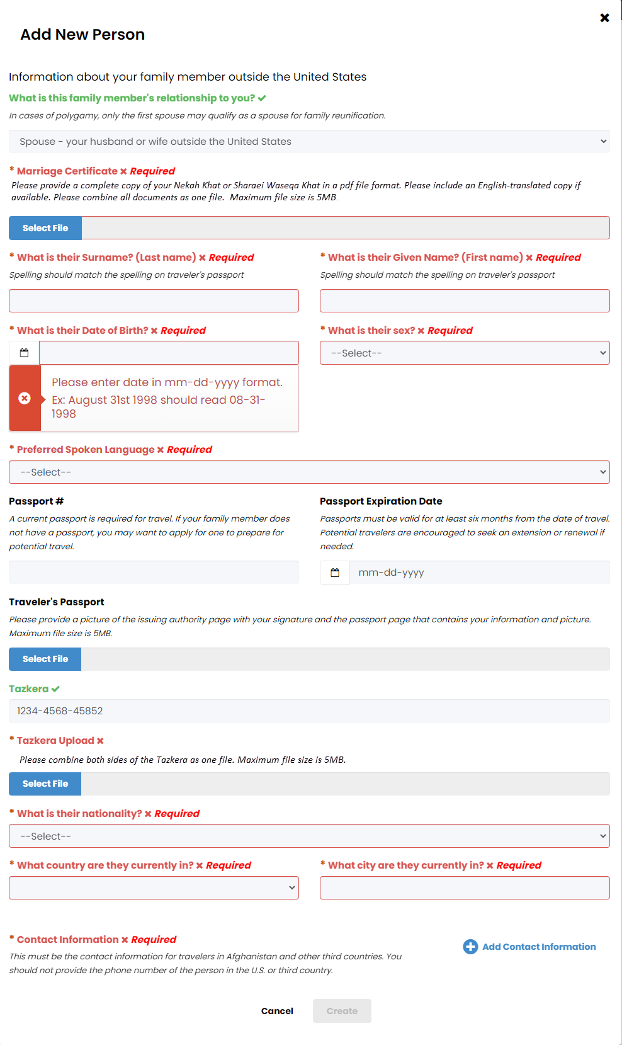

Screen: person pop up – child - birth certificate upload
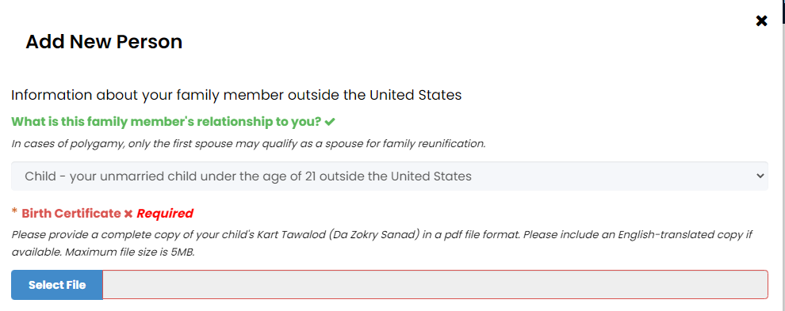

Wording at the bottom of the page

Privacy Act Statement for Family Reunification DS-4317 Form
AUTHORITIES: The information is sought pursuant to:
- 5 U.S.C. 301 (Secretary of State's authorities with respect to Management of the Department of State);
- 22 U.S.C. 2651a (Organization of the Department of State);
- 8 U.S.C. 1101-1537 (Immigration and Nationality Act of 1952, as amended1).

PURPOSE: This form will be used to collect information on Afghan nationals who may be eligible to enter the Enduring Welcome (EW) pipeline for relocation to the U.S. and their family members already in the U.S. with whom they would be reunited. The information furnished may also be used to verify the individuals' eligibility to enter the EW pipeline, manifest them for travel and refer them for U.S. Refugee Admissions Program (USRAP) cases.
ROUTINE USES: The information on this form may be shared with the United States Department of Homeland Security's U.S. Citizenship and Immigration Services (USCIS) agency to determine if there is an existing family visa petition and if the underlying family relationship within the petition has been reviewed. The information may also be made available to contractors who assist with confirming Afghans are ready to travel and manifesting them on flights. More information on the Routine Uses for the system can be found in the System of Records Notice STATE-39, Visa Records.
DISCLOSURE: Providing this information is voluntary. Failure to provide the information requested on this form may result in the U.S. government being unable to provide relocation support to your family members.

Screen: thank you page
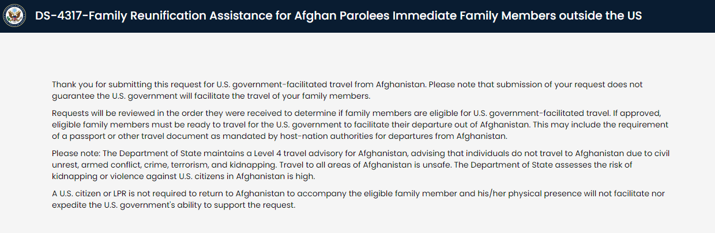
Wording after reunification request was submitted
Thank you for submitting this request for U.S. government-facilitated travel from Afghanistan. Please note that submission of your request does not guarantee the U.S. government will facilitate the travel of your family members.
Requests will be reviewed in the order they were received to determine if family members are eligible for U.S. government-facilitated travel. If approved, eligible family members must be ready to travel for the U.S. government to facilitate their departure out of Afghanistan. This may include the requirement of a passport or other travel document as mandated by host-nation authorities for departures from Afghanistan.
Please note: The Department of State maintains a Level 4 travel advisory for Afghanistan, advising that individuals do not travel to Afghanistan due to civil unrest, armed conflict, crime, terrorism, and kidnapping. Travel to all areas of Afghanistan is unsafe. The Department of State assesses the risk of kidnapping or violence against U.S. citizens in Afghanistan is high.
A U.S. citizen or LPR is not required to return to Afghanistan to accompany the eligible family member and his/her physical presence will not facilitate nor expedite the U.S. government's ability to support the request.

