Appendix D – SAP Portal Privacy Portal Webpage and Application Form
(Note: Webpage wording and application form questions included below are submitted in draft form and are subject to change prior to the SAP Portal public release in late 2022.)

SAP Portal Privacy Portal Webpage

Privacy Policy
Thank you for visiting the ReseachDataGov.org website. Please note that we collect no personal information about you when you visit our website unless you choose to provide that information to us as described in the Personally Provided Information section below.

Information Automatically Collected and Stored
When you browse through any website, certain personal information about you can be collected. We automatically collect and store the following information about your visit:
- The IP address of the computer you used to access our website (for example, 141.211.92.1). This IP address is often translated into a domain name, such as stanford.edu, if you are connecting from Stanford University's domain.
- Geographic coordinates based upon your IP address. These coordinates usually describe the location of your provider (such as Stanford University) rather than the actual location of your computer.
- The date and time of your visit
- The pages you visited
- The address of the website you came from when you visited our site
- The operating system of your computer
- The version and type of Web browser you use when you visit our website

We use this information to create summary information about our users and to help us make our site more valuable to users. Unless it is specifically stated otherwise, no additional information will be collected about you.

Personally Provided Information
If you choose to begin an application to request access to confidential data through ResearchDataGov.org, you will be asked to provide us with additional identifying information as part of the application process.

When you begin an application to request access to confidential data, you will be asked to provide identifying information at two points in the process.

MyData Account
ResearchDataGov.org was built leveraging the infrastructure of ICPSR and therefore uses their login system. If you do not already have one, you will be asked to create an ICPSR MyData account by entering the following information:
- Email address
- User-provided MyData password
- Name
- Organizational affiliation (college/university faculty, research organization, etc.)
- Department or field with which you identify

If you are at an ICPSR member institution, you will also be asked whether name and email address can be shared with your campus’ official ICPSR representative. You will be asked to log in with this account whenever you wish to begin, edit, or review an application and associated reviewer comments. On ResearchDataGov.org, your MyData account is used only to associate you with any project proposals you have started and/or submitted. If you represent one of the participating federal agencies in an official capacity on ResearchDataGov.org, such as a reviewer or a metadata editor, the account will be used to associate you with the permissions afforded those roles.

Application Form
If you wish to use data described on ResearchDataGov.org in a research project, you will be asked to complete an application in order to request access to the restricted-use microdata. The application includes the following information:
- Name, affiliation, and position of each member of the project team
- Specific information about the proposed project, such as title, description, research questions, methodology, sources of funding, and expected outputs
- Administrative information including from where you wish to access the data, special software requirements, justification for data request, and a list and description of any data you will be providing to be used with the requested data.
- A description of the benefits to the agency(ies) providing access to the data

The information collected in the application form will be used by the agencies owning the data to determine whether the project may proceed with the requested data.

Disclosure

Applicant information and research proposal information for approved applications will be made publicly available through the ResearchDataGov.org in accordance with the standards for transparency requirement of the Evidence Act (§3583(a)(6)).

Intrusion Detection
For site security purposes and to ensure that this service remains available to all users, we employ software programs to monitor traffic and to identify unauthorized attempts to upload or change information or to otherwise cause damage. In the event of authorized law enforcement investigations, and pursuant to any required legal process, information from these sources may be used to help identify an individual.
SAP Portal Application Form
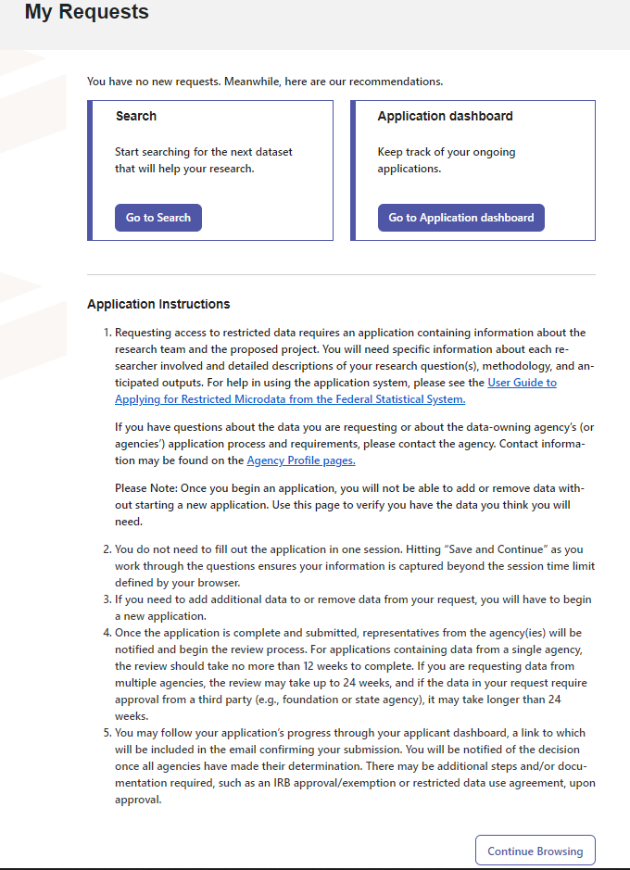

Welcome to your application workspace
Requesting access to restricted data requires an application containing information about the research team and the proposed project. You will need specific information about each researcher involved and detailed descriptions of your research question(s), methodology, and anticipated outputs.

For help in using the application system, please see the User Guide to Applying for Restricted Microdata from the Federal Statistical System.

This standard application replaces the processes and forms previously used by the participating federal agencies. Your answers will be reviewed by agency staff responsible for granting access to restricted data and you may be asked to revise and resubmit to provide additional information. Finally, this is the beginning of the process of requesting access, there may be additional steps or documentation required, such as an IRB approval or signed restricted data use agreement, upon approval.

In order to ensure transparency in the process, information about the number of applications received, the data requested, and application determinations will be made available on ResearchDataGov.org. Additionally, project title, abstract, and researcher names will be made public for approved projects in accordance with the standards for transparency requirement of the Evidence Act (§3583(a)(6)).

The information requested within the application is solicited under the authority of the Foundations for Evidence-Based Policymaking Act of 2018, 44 U.S.C. 3583, and the National Science Foundation Act of 1950, as amended. The information collected from applicants will primarily be used by federal statistical agencies to make determinations regarding access to federal statistical data. The information requested may be disclosed to other government agencies or other entities needing information in order to coordinate programs or policy. See Systems of Records, NSF-50, "Principal Investigator/Proposal File and Associated Records,” 79 Federal Register 76398 (December 22, 2014) for a complete list of applicable routine uses. Submission of the information is voluntary. Failure to provide full and complete information, however, may prevent an applicant from being approved for access to confidential data.

Pursuant to 5 CFR 1320.5(b), an agency may not conduct or sponsor, and a person is not required to respond to, an information collection unless it displays a valid Office of Management and Budget (OMB) control number. The OMB control number for this collection is 3145-XXXX. Public reporting burden for this collection of information is estimated as 60 minutes per response, including the time for reviewing instructions.

Send comments regarding this burden estimate and any other aspect of this collection of information, including suggestions for reducing this burden, to: Suzanne H. Plimpton, Reports Clearance Officer, National Science Foundation, 2415 Eisenhower Ave., Suite E7400, Alexandria, VA 22314; telephone (703) 292-7556; or send email to splimpto@nsf.gov

Helpful Hints
- You do not need to fill out the application in one session. Hitting “Save and Continue” as you work through the sections ensures your information is captured beyond the session time limit defined by your browser.
- If you find you need to add additional data to or remove data from your request, you will have to begin a new application.
- The email address you use for the principal investigator/lead researcher will be the one to receive notifications about the progress of your request. You will also use the MyData account associated with this email address to edit, submit, or withdraw this application.
- Some questions will be answered in text boxes within the application, others -- especially those most likely to require formulas or special characters -- will require you to upload a document to answer. Accepted file formats for uploads are .pdf and .docx and you will need to upload individual documents for each of the questions requiring them.
- You will be asked to refer back to the information about the data you are requesting for answers to questions such as where they data will be accessed.
- Data are offered in different physical locations or via other access modalities depending on which agency provides them. You may request data from multiple locations in a single application, but approval does not imply the ability to access all files from a common location. Similarly, some data assets may be offered via the same modality but may not be used together because of the policies governing one or more of the assets.

Next Steps
- Once the application is complete and submitted, representatives from the agency(ies) will be notified to begin the review process. For applications containing data from a single agency, the review should take no more than 12 weeks to complete. If you are requesting data from multiple agencies or an asset requires approval from two or more agencies, the review may take up to 24 weeks; and if the data in your request require approval from a third party (e.g., foundation or state agency), a decision may take longer than 24 weeks.
- You may follow your application’s progress through your applicant dashboard, a link to which will be included in the email confirming your submission. You will be notified of the decision once all agencies have made their determination. There may be additional steps and/or documentation required upon approval.

