Foreign Purchaser Acknowledgement Statement (FPAS)
Quick Guide

The United States Environmental Protection Agency (EPA) Office of Pesticide Programs (OPP) developed the Foreign Purchaser Acknowledgment Statement (PFAS) application to provide registrants an electronic option to create and submit ‘EPA Form 9600-026 – FPAS via the Pesticide Submission Portal (PSP) in the Central Data Exchange (CDX).
This quick reference guide explains how to electronically submit a FPAS using the PSP. This guide assumes a user has a CDX account and is registered for the PSP program service. Please refer to the PSP Registration Guide for information on how to obtain a CDX account and register for PSP.

Exhibit 1-1 shows a screen capture of the ‘My CDX’ screen:
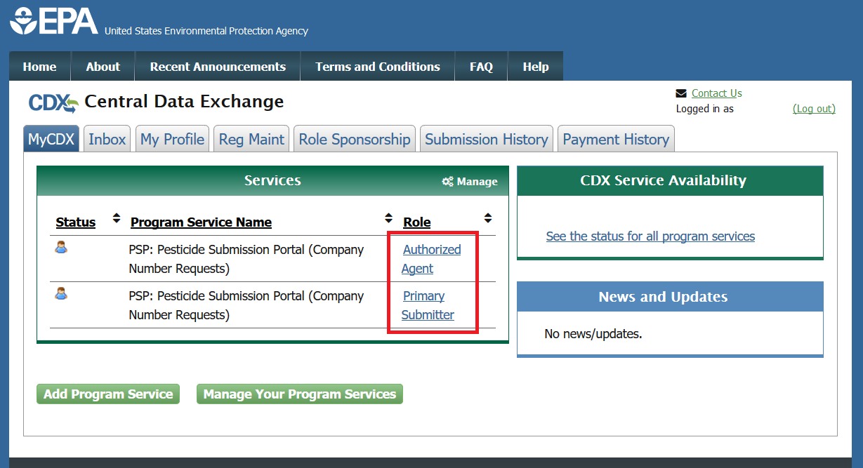
Exhibit 1-1: ‘MyCDX’ Screen – PSP Program Services
Navigation: Upon logging into the Central Data Exchange (CDX), users are navigated to the ‘MyCDX’ screen. Select either the ‘Primary Submitter’ or ‘Authorized Agent’ role for the ‘PSP: Pesticide Submission Portal (Company Number Requests)’ Program Service to access the Pesticide Submission Portal (PSP).
Note: If the selected role is associated with multiple organizations, chose the correct organization and select the ‘Proceed’ button. Otherwise, navigation directly into PSP will occur.

Exhibit 1-2 shows a screen capture of how to navigate the PSP ‘Home’ screen to access the FPAS application:
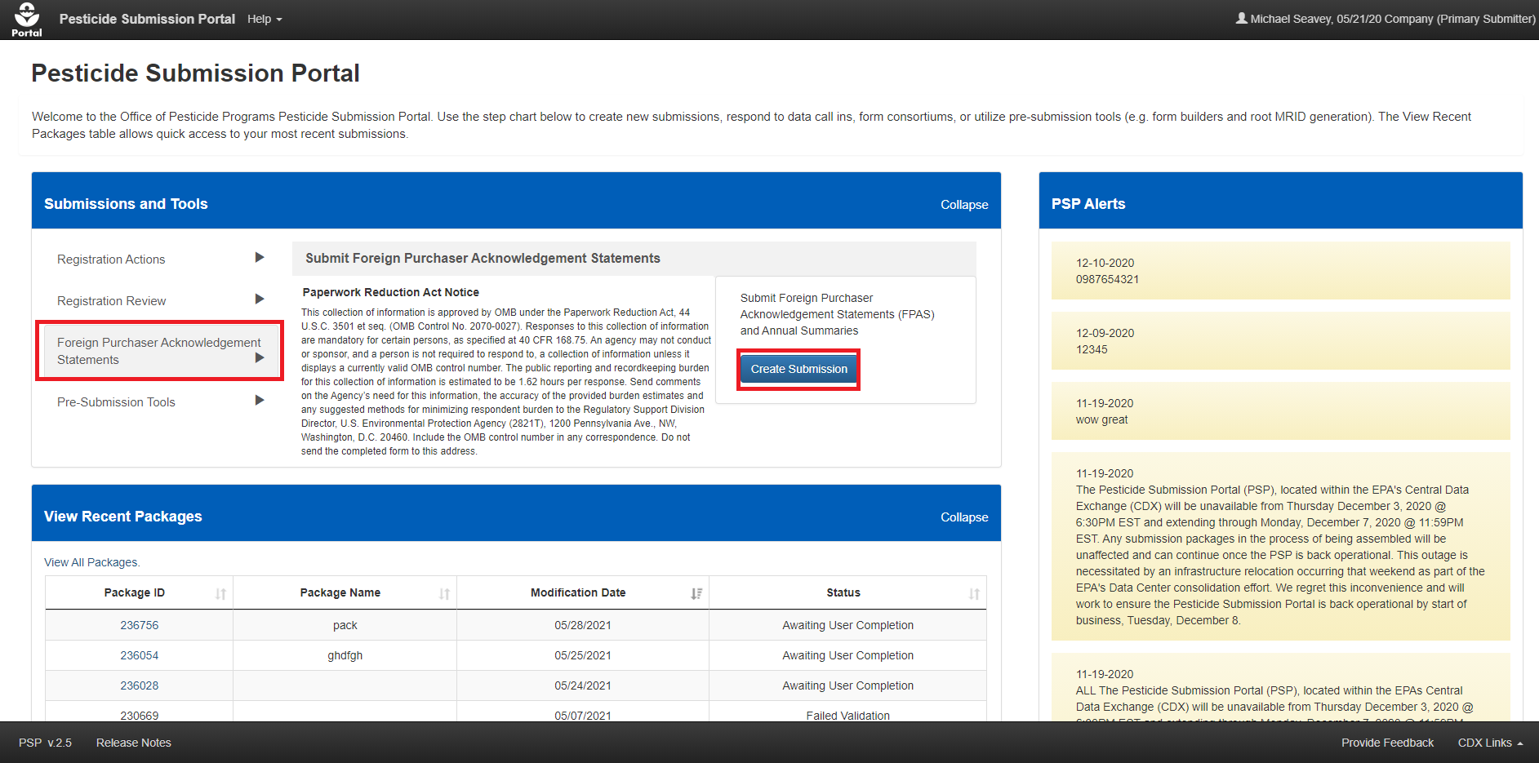
Exhibit 1-2: Pesticide Submission Portal ‘Home’ Screen – Create FPAS Submission Option
Navigation: In the ‘Submissions and Tools’ panel, select the ‘Foreign Purchaser Acknowledgment Statement’ option in the first column, review the Paperwork Reduction Act Notice in the second column, and finally select the ‘Create Submission’ button to navigate to the ‘Create Passphrase’ screen and create a package.

Exhibit 1-3 shows a screen capture of the ‘Create Passphrase’ screen:
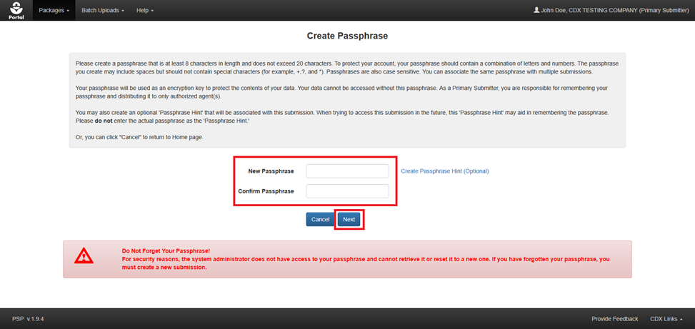
Exhibit 1-3: ‘Create Passphrase’ Screen
Navigation: Enter a passphrase in the ‘New Passphrase’ field that is at least eight (8) characters long and does not contain special characters. Next, enter the same passphrase in the ‘Confirm Passphrase’ field. Finally, select the ‘Next’ button to navigate to the ‘Package Information’ screen.
Important: The user who creates a submission is responsible for remembering the passphrase and only distributing it to authorized persons. OPP is unable to retrieve a passphrase or unlock a package if the passphrase is lost or forgotten. A new submission will need to be created when a passphrase is lost or forgotten. OPP suggests that each organization use the same passphrase for all submissions. A shared passphrase ensures that someone from the same organization can retrieve and/or complete the submission when the package creator is unavailable. A ‘Passphrase Hint’ may be created to assist with passphrase recall.

Exhibit 1-4 shows a screen capture of the ‘Package Information’ screen:
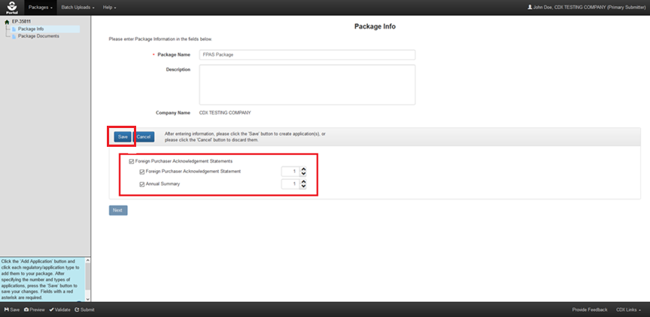
Exhibit 1-4: ‘Package Information’ Screen
Navigation: Perform the following steps on the ‘Package Information’ screen:
- First, enter a value in the ‘Package Name’ field.
- Select the ‘Add Application’ button (not pictured) to enable the applications panel.
- Select the ‘Foreign Purchaser Acknowledgment Statement’ checkbox to display the available applications.
- Select the ‘Foreign Purchaser Acknowledgment Statement’ and/or ‘Annual Summary’ checkbox(es) to display a number box for the application type(s).
- Select the number of each ‘Foreign Purchaser Acknowledgment Statement’ and/or ‘Annual Summary’ to be included in the submission.
- Select the ‘Save’ button.

Exhibit 1-5 shows a screen capture of the ‘Package Information’ screen with one FPAS application added:
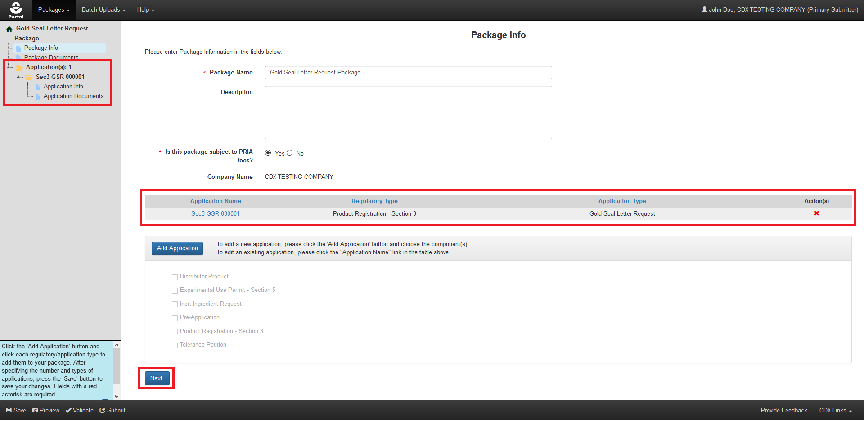
Exhibit 1-5: ‘Package Information’ Screen Displaying FPAS Application
Navigation: Confirm that the correct number of ‘Foreign Purchaser Acknowledgment Statement’ applications were added to the package and then select the ‘Next’ button to navigate to the ‘Package Documents’ screen.

Exhibit 1-6 shows a screen capture of the ‘Package Documents’ screen:
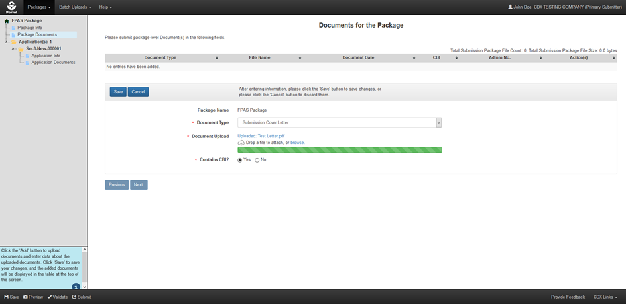
Exhibit 1-6: ‘Package Documents’ Screen
Navigation: Perform the following steps on the ‘Package Documents’ screen to include an optional cover letter that applies to all ‘Foreign Purchaser Acknowledgment Statement’ applications included in the submission:
- Select the ‘Add’ button (not pictured).
- Upload a file by searching local drives or dragging and dropping the file into the upload area.
- Indicate whether the file contains Confidential Business Information (CBI).
- Select the ‘Save’ button to attach the uploaded file to the package. A file is attached when it is displayed in the table at the top of the screen.
- Finally, select the ‘Next’ button to navigate to the ‘Application Info’ screen for the first application in the package.

Exhibit 1-7 shows a screen capture of the ‘Application Information’ screen:
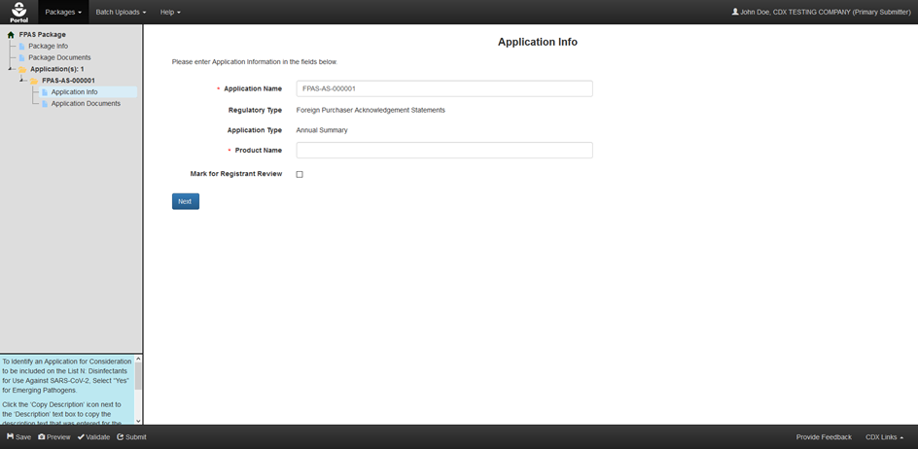
Exhibit 1-7: ‘Application Information’ Screen
Navigation: Perform the following steps on the ‘Application Information’ screen:
- Update the ‘Application Name,’ if necessary.
- Enter the ‘Product Name’ of the exported product.
- Finally, select the ‘Next’ button to navigate to the ‘Application Documents’ screen.

Exhibit 1-8 shows a screen capture of the ‘Application Documents’ screen:
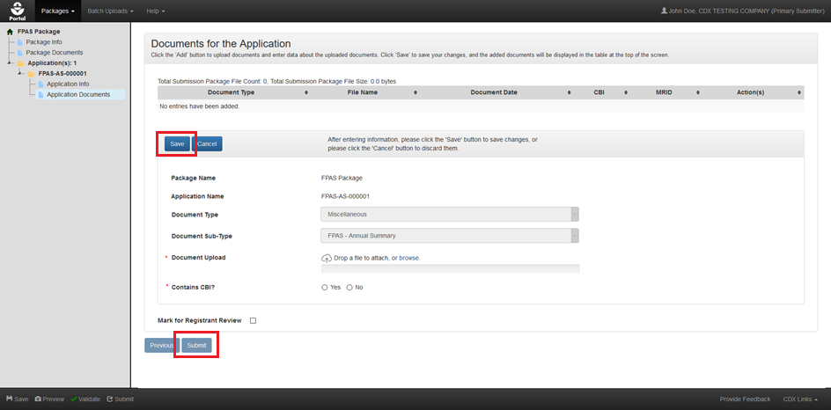
Exhibit 1-8: ‘Application Documents’ Screen
Navigation: Perform the following steps on the ‘Application Documents’ screen:
- Select the ‘Add’ button (not pictured).
- Confirm that the values in the ‘Document Type’ and ‘Document Sub-Type’ fields are accurate. Note: The ‘Document Sub-Type’ value should always match the application type.
- Upload a file by searching local drives or dragging and dropping the file into the upload area.
- Indicate whether the file contains CBI.
- Select the ‘Save’ button to attach the uploaded file to the application. A file is attached when it is displayed in the table at the top of the screen.
- Finally, select the ‘Submit’ button to begin the submission process.
Note: If there are additional applications in the package a ‘Next’ button will display to navigate to the ‘Application Info’ screen for the next application in the package in lieu of the ‘Submit’ button.

Exhibit 1-9 shows a screen capture of the screens that comprise the PSP submission process:
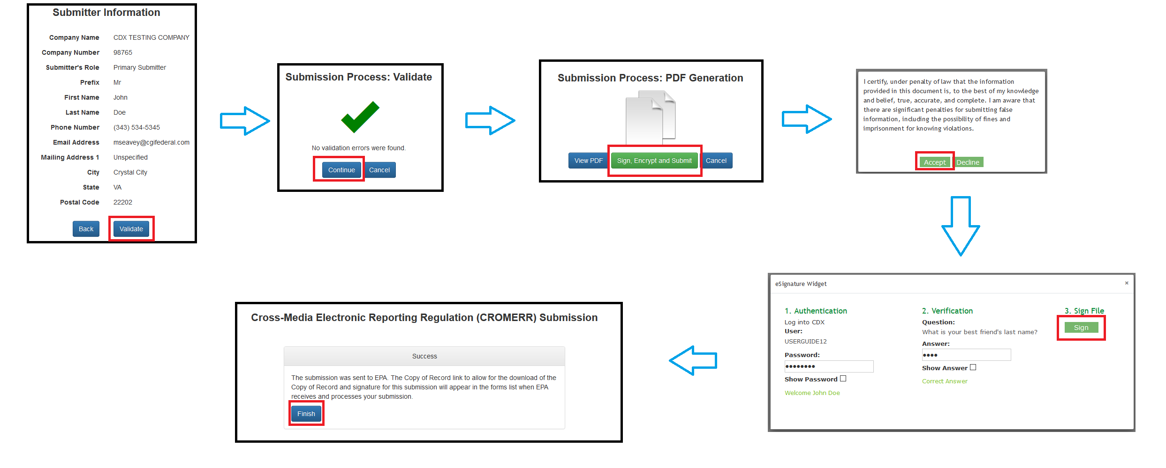
Exhibit 1-9: PSP Submission Process Screen
Navigation: The PSP submission process includes steps to validate that a submission is complete, generate a PDF rendering of submitted data, and electronically sign the package submission. Follow these steps to complete the submission process:
- Review the information on the ‘Submitter Information’ screen for accuracy and select the ‘Validate’ button.
- If the package submission passes validation, select the ‘Continue’ button on the ‘Validation’ screen.
- Next, review the generated PDF rendering and select the ‘Sign, Encrypt, and Submit’ button.
- Enter the required account credentials into the ‘eSignature Widget’ and select the ‘Sign’ button.
- Finally, a message indicating submission success will display. Select the ‘Finish’ button to return to the PSP ‘Home’ screen.

