Operational Plan

IBM Skillsbuild

Table of Contents
Implementation 2
Solution 3
Solution Statement 3
Stakeholder Analysis 4
Table 1 – Preliminary Stakeholder Analysis 5
Risks and Mitigation Strategies 6
Table 2 on the next page provides an example of a potential risk register and content. 6
Table 2 – Sample Project Risk Table 6
Mitigation Strategy 6
Timeline 7
Communications 8
Operations and Training 9

Document Version History
Date | Version | Description | Author
Aug 22, 2022 | 0.1 | Initial draft | Jeffrey Brown
Aug 26, 2022 | 0.2 | IBM edits | Sherry Wynn
Sep 8, 2022 | 0.3 | Revised draft | Steven Wagner
*The document version history will be used to track document changes throughout the cycle of the product planning process. Please provide the version number (major or minor) when changes are made.

Purpose
The Operational Plan (Ops Plan) aims to provide context and insight into the IBM SkillsBuild Program and its implementation as a training platform supporting VA Education programs. This operational plan provides a framework that outlines the purpose of IBM SkillsBuild, scope, solution, stakeholder analysis, risks, mitigation, etc. This operational plan and the project charter; defines IBM’s continued gold standard of good tech through the application of innovative technology, industry expertise, and responsible stewardship. The information has been separated by the workstreams involved in implementation, including Communications, Information Technology, Operations, and Policy.

Purpose
This operations plan will focus on how IBM and VA will work together to pilot and scale IBM SkillsBuild. This free online learning platform allows adult learners to access IT skills and forge bridges to the current technology demands. By offering access to 1,000+ courses on workplace skills, like collaboration and presentation, data analytics, cybersecurity, Artificial Intelligence (AI), and cloud computing, IBM SkillsBuild helps create pathways for career success. According to VA qualifications and requirements, IBM will provide diagnostics, online coursework, resume-building credentials, and 1:1 mentoring to military members, veterans, and dependents. These participants can earn IBM-branded digital credentials to certify their relevant skills in emerging technologies and related proficiencies to prepare them for successful careers.

To date, the U.S. Department of Veteran Affairs (VA), in collaboration with IBM, created a custom learning plan to upskill veterans eligible for VA’s Veteran Employment Through Technology Education Courses (VET-TEC) training. VET-TEC program similarly pairs eligible Veterans with technology training to earn certification in the high-tech career field and boosts technical skills like coding, cloud computing, and data processing. After finalizing a SkillsBuild partnership agreement, VA and IBM will curate additional learning pathways and advanced training to support further VET TEC participants in their skilling and career journeys. VA and IBM will also develop and implement customized pathways for additional VA programs and strategize to activate and engage learners and track employment metrics.

Implementation
Date of Enactment: May 25, 2022
Date of Skillsbuild Partnership Agreement: In Progress
Date of Enactment: May 10, 2022
On May 10, 2022, IBM announced education initiatives with the U.S. Department of Veterans Affairs (VA) to provide no-cost Science, Technology, Engineering, and Mathematics (STEM) job training to U.S. Military Veterans, neurodivergent learners worldwide, and university students from underrepresented communities in the U.S.
These collaborations underscore IBM’s focus on providing STEM jobs training traditionally underrepresented communities as part of its commitment to skill 30 million people worldwide by 2030 to create equitable, inclusive economic opportunities while addressing a longstanding technology skill shortage.
IBM will provide:
- Access to Industry-leading tech content, badges, and certifications administered by IBM and online learning experts
- Additional six weeks of a train-the-trainer model to drive technology adoption and implementation within VA
- Ongoing technical support and platform updates
- Access to granular reporting on learner progress and badges earned, with the ability to customize learning paths most relevant to learners
- Access to mentors who will guide learners’ career trajectory
- Partnership and co-creation of project-based learning opportunities and Advanced career events
VA will provide:
- Identification, recruitment, and registration of Veterans and beneficiaries into IBM Skillsbuild through marketing and communication efforts
- A designee(s) to serve as VA’s primary point of contact with IBM, responsible for learning the administrative components of SkillsBuild and for driving beneficiary use of the Platform (anticipated time commitment - 30% of full-time work tasks)
- Regular monthly feedback to IBM on the use of SkillsBuild and opportunities for Program Improvement
- Personnel to Co-design and develop implementation and activation plans and collaborate on exploration of new pathways, including content, credentials, and Project-based learning (“PBL”) experiences.
- Continuous monitoring of Beneficiary progress and engagement against agreed-upon KPIs leading to quarterly progress updates on the number of SkillsBuild learners receiving interviews and employment opportunities

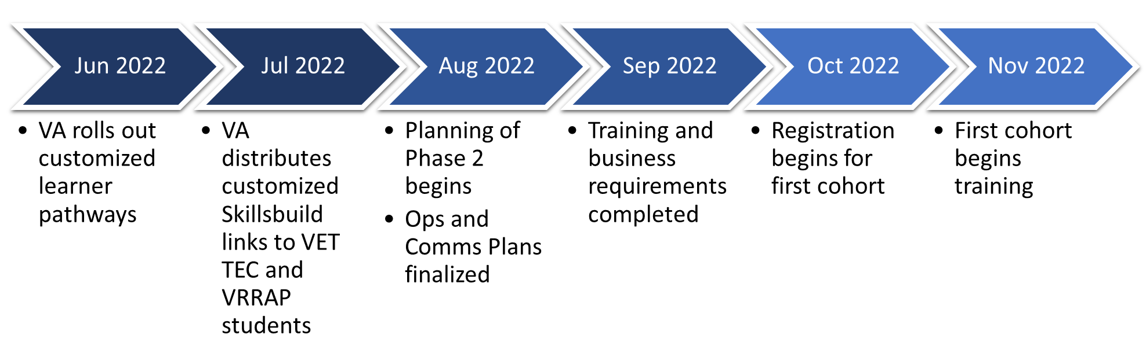
High-Level Timeline of Implementation

INTAKE PROCESS

Eligible Participants:
- Veterans and Servicemembers with current or previous GI Bill entitlement, spouses, and children with current or previous GI Bill entitlement.
Registration:
- Registration will be on a first-come, first-served basis; registration will ten days before the cohort begins.
- To register, individuals will complete an Intake Form (In Progress).
- Individuals will be added to the training cohort based on their preferred dates and desired training.

Solution

Solution Statement
IBM Skillsbuild will be an enhanced resource for transitioning Service members and veterans seeking job training and credentials through the VA to pursue a career after military service. In collaboration with the VA’s Veteran Employment Through Technology Education Courses (VET-TEC) Employer Consortium, IBM will help military veterans and their beneficiaries pursue customized learning paths and work roles for high-demand technology careers. The strategic goals of IBM and VA collaboration:
- To upskill/reskill Veterans, transitioning service members, and their beneficiaries through Industry-leading tech training badge, and certifications free of charge.
- To provide cost-effective and customized learning pathways to obtain meaningful employment in the high-demand tech industry.
- To cultivate a STEM talent pipeline from underrepresented communities and veterans throughout the country that employers can turn to to fill their tech employment gaps, especially in cyber and data analytics.

Stakeholder Analysis
The VA and IBM will conduct a stakeholder analysis to identify all stakeholders who have a vested interest in IBM Skillsbuild. By identifying the impact each stakeholder has on the project, VA and IBM can be better prepared for potential disruptive issues and reduce corresponding negative impacts. The VA Work Stream has conducted a preliminary stakeholder analysis per the Project Charter. Based on this preliminary analysis:
Internal Stakeholders include, but are not limited to:
- VA and Veterans Benefits Administration (VBA) Senior Leadership: direct strategic policy guidance for implementation of IBM Skillsbuild as it relates to statutory requirements, management priorities, and the VA and VBA Strategic Plan.
- EDU Service: IBM Skillsbuild project sponsor and operational/oversight owner; provide instruction and guidance to IBM.
- IBM: Project development, oversight, and implementation.
- VR&E: Mentors veteran students during IBM Skillsbuild program participants
- VA OIT: Employer and Cybersecurity SMEs
External Stakeholders include:
- Eligible Veterans and other GI Bill beneficiaries: enroll in IBM Skillsbuild; attend high technology courses
- Veterans Service Organizations (VSO): Market IBM Skillsbuild to the eligible Veterans that they serve.
- Employers: primary benefactor of IBM Skillsbuild. Industry partners can hire newly qualified veterans in relevant high technology fields.
- School Certifying Officers (SCO): Primary point of contact with veterans and their beneficiaries
- USO-Skillsbuild Administrators: Employees transition specialist who specialize in IBM Skillsbuild
- VetJobs/CASY: IBM Skillsbuild dedicated staff, with 1600 veteran learners
- Workforce Solutions Capital Area: Administrative leads for data analytics and Cybersecurity
- Veterans and Beneficiaries: Recipients of IBM Skillsbuild training
The table below identifies stakeholders who will be impacted by or required during the implementation of IBM Skillsbuild. Table 1 categorizes potential Stakeholders as “internal” (within the Department) versus “external” (outside of the Department) and identifies the impact type(s) associated with each Stakeholder.

Table 1 – Preliminary Stakeholder Analysis
Stakeholder Group | Impacts
Internal | Pilot Implementation | Approval Criteria | Program Management | Monitoring | Report Generation | Marketing | Benefits Disbursement | Increased Opportunities
VA Leadership | x | x | x | x | x | x |  | x
EDU Service |  |  |  | x |  |  |  | x
IBM | x | x | x | x | x | x | x | x
VR&E |  |  |  | x |  | x | x | x
VA OIT | x | x |  | x |  |  | x | x
External | Pilot Implementation | Approval Criteria | Program Management | Monitoring | Report Generation | Marketing | Benefits Disbursement | Increased Opportunities
SCO |  |  |  |  |  |  |  | x
Veterans |  |  |  |  |  | x | x | x
USO |  |  |  |  |  | x |  | x
VetsJobs/CASY |  |  |  |  |  | x |  | x
VSOs |  |  | x |  |  | x | x | x
Employers |  |  |  |  |  | x |  | x
Workforce Solutions  Capital Area |  |  |  |  |  | x | x | x

Risks and Mitigation Strategies
The Veteran Benefits Administration Education service (EDU) will utilize risk management processes to assist in identifying and mitigating potential project uncertainties that would jeopardize IBM Skillsbuild readiness and success. EDU will identify and manage a register of project risks which will identify barriers or surprises and mitigation strategies.
The SI&I Project Manager, working with the Project Team and Sponsors, will ensure that risks are actively identified, analyzed, and managed throughout the life of the project. Once a risk is identified it will be included in a risk register to keep track of project risks and strategies to mitigate them. The register will also track the risk level, current risk status, risk ownership, and potential impact. All identified risks will be assessed to identify the range of possible outcomes for the project using either a qualitative risk analysis or quantitative risk analysis. Risks that are of high or medium priority will have a risk response plan that may include a risk response strategy and a risk contingency plan. Those risks will also be assigned to a Risk Owner who will be responsible for monitoring and controlling to ensure that the risk will have attention paid to it. Following this risk management process will help minimize the likelihood that delays occur due to unconsidered risks and makes it more likely that the project will be completed on time.
The Project Team will identify ways to prevent a risk from occurring, reduce its impact, or reduce the probability of it occurring. Secondary risks that result from the risk mitigation response will be documented and follow the same risk management protocol as the primary risks. Risk Owners will report the status of their risks to the Project Manager on a weekly basis. The Project Manager will maintain a list of the highest priority risks which will be reported weekly as part of the project status reporting process. As risk events occur and are addressed, the list will be re-prioritized during the weekly meetings. Risk will be considered closed when it meets preset criteria or at the Project Manager’s discretion. Afterward, lessons learned will be captured and recorded for future process improvement opportunities.

Table 2 on the next page provides an example of a potential risk register and content.

Table 2 – Sample Project Risk Table

Mitigation Strategy
Risk Description | Risk Level | Risk Owner | Impact | Mitigation Strategy
Overwhelming interest in the program can lead to added ECC delays and confusion | High | IBM & VA | Announce program with large interest during 1st co-hort, and response is overwhelming | Ensure all resources are available during the launch
Program Management (Intake resources) | Medium | VA | Staff not properly trained to handle new program influx | Properly train all stakeholders via IBM Skillsbuild training
Lack of Employer-partners to fulfill employment resources | Medium | VA | Reduced number of employer partners to assist with 1st cohort | Engage with employer-partners during every phase
Internal Controls | Low | IBM | Proper program controls to mitigate risk | Develop Ops and Communication listing mitigation factors
Announcing the program to soon and not communicating its intentions clearly | High | VA | Generate the attention of leadership without a clearly executed framework | Ensure the IPT Project Management team remains involved in all aspects of the program, to answer questions fully and accurately.

Timeline
Category | Phase | Milestone | Anticipated Date
Outcomes | All | Go Live | 10/15/2022
Key Deliverables | Initiation | Project Initiation Documentation Complete | TBD
 |  | High–Level Ops Plan Complete | 08/25/2022
 | Planning | Target Operations and Design Model Complete | 08/30/2022
 |  | Requirements Complete | 09/05/2022
 |  | Comms Plan Complete | 08/30/2022
 | Execution | Build Complete | 09/15/2022
 |  | Administrator Training Complete | 10/01/2022
 |  | Business Readiness Complete | 09/15/2022
 | Evaluation | Post Implementation Review | 1/15/2023

Communications-Appendix A
The Stakeholder Engagement Team will develop a Strategic Communications Plan, whose purpose will be to communicate the project goal and desired outcomes, identify internal and external stakeholders who will receive communications, analyze methodologies that will be used to reach out to those stakeholders, pinpoint key messages that will be carried through all products, and display a communications timeline that shows when each of the tactics will be deployed. The plan will allow the project team to be more proactive, assist with deploying resources more effectively and strategically by highlighting shared opportunities in work areas and serve as a guide for any media or publication relations activities.
Utilizing the Strategic Communications Plan, the Communications Workstream will release a series of pushes, in synchronization with the business process flow and in recognition of major timeline events where communications with different audiences are necessary. These pushes will include varying combinations of artifacts targeted to specific internal (e.g., VA Offices) and external (e.g., Veterans and Training Providers) audiences. The pushes will utilize marketing tactics such as briefings, direct messaging communications, social media communications, digital media communications, website updates, and others to successfully distribute IBM Skillsbuild informational updates to relevant stakeholders. For external audiences, the Communications Workstream will provide updates to affected individuals via the integrated strategic communications plan featuring website information, blog posts, Facebook, and Twitter to leverage the power and reach of social media. The Communications Workstream has already developed a one-page IBM Skillsbuild infographic to provide internal stakeholders that share the partnership pathways for veterans to receive upskilling/reskilling through this initiative. All of these will be posted on a website, blog page, via social media, or handed out at in-person events. If needed, the Communications Workstream will support graphics for products such as presentations and other related products.
IBM will support VA’s communications strategy and co-create messaging and events to support the SkillsBuild partnership. IBM Communications team includes Estefania Sanchez, Deirdre Leahy, and Sherry Wynn. Plans will include an internal communications strategy to engage and activate learners, and inform VA and IBM Leadership, and stakeholders for both organizations. External comms to promote the partnership to the public and amplify the opportunity provided to qualifying veterans served by VA. Additionally, external comms will communicate the opportunity for hiring trained veterans following completion of IBM SkillsBuild and VET-TEC programs.

Operations-IBM

Communications: Stakeholder Engagement and Digital Engagement Teams will partner with IBM to create a strategic Communications Plan. The Communications content is incorporated in the Operations and Training description below.

Training: IBM will provide train-the-trainer sessions to (2-3) VA-identified Skillsbuild Administrators. The training will prepare the SB Admins to effectively operate and distribute IBM-related functions and to lead the operations of Skillsbuild at VA.

Operations: VA will manage Operations of the Skillsbuild platform. SI&I will create documents and processes to maximize the efficiency and success of this rollout. In collaboration with IBM personnel, SI&I will develop the following comprehensive requirements and implementation plans for Skillsbuild.

IBM will lead VA’s adoption of SkillsBuild in the following three phases:

Phase 1: Strategy and Onboarding
- Define program goals and draft implementation strategy
- Set up Admin permissions
- Select pilot group of learners and content
- Administrative training in tandem with on-boarding pilot group of learners
Phase 2: Execution
- Hit Key milestones/metrics defined in Implementation strategy
- Marketing and press
- Mentoring and projects
Phase 3: Independence and growth
- Expand program to have impact at scale
- Incorporate SkillsBuild to existing programs as much as possible

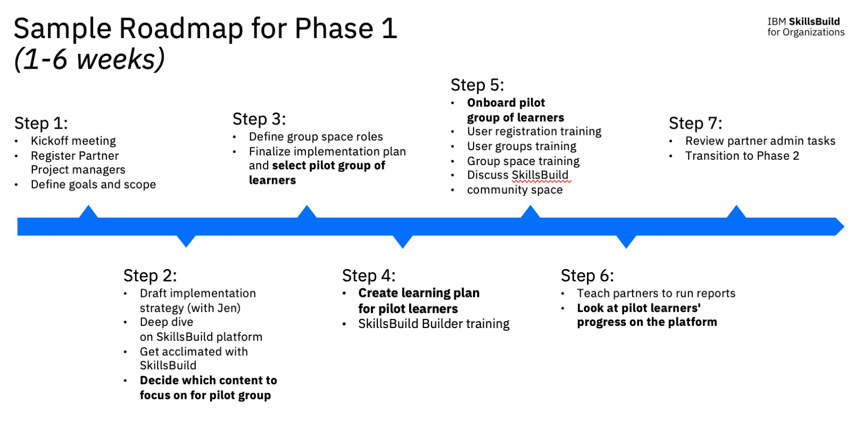

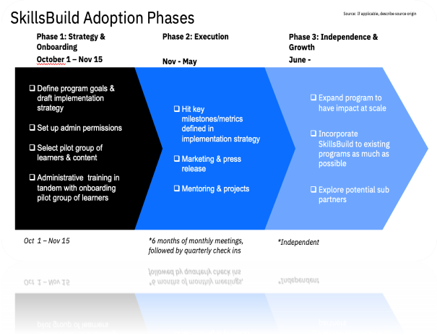

Training -TBD in conjunction with IBM (pending)
TRAINING REQUIREMENTS
- Enrollment: Individuals can choice to enroll in basic or advanced training.
- Individuals will be required to provide details of completion of basic skills to qualify for enrollment in advanced training pathway otherwise training pathway will default to basic level course offerings.
- Training consists of 10 modules (20-30 minutes each).
- Prior to registering a new ….
- Registered individuals will be required to complete initial orientation. Orientation will cover training requirements and a detailed explanation of the syllabus and expected outcomes.

TRAINING CONTENT -IBM (being developed)
- Topics for Phase 1 Modules
- TBD

- Topics for Phase 2 Modules (Provide Summary of Training Modules)
- TBD

REPORTING REQUIREMENTS
THIS SECTION DESCRIBES THE RELEVANT CONTINUED REPORTING REQUIREMENTS (SHORT-TERM AND LONG-TERM) AFTER IMPLEMENTATION
Short Term Implementation Reports
- N/A

Long Term Reporting Activity

- Quarterly Leadership Report
- Reporting on this provision could be included as part of…. It would contain the following data elements:
- Number of Registered
- Number of Individuals that completed training
- Number of Individuals that found employment
- Number of Mentors
- Number of Orientation Sessions
- Number of Employment Activities Held
- Average/Median Salaries
- Number of Individuals with Prior Experience
- VA will have the ability to generate ad-hoc reports, upon request.

Appendix A- Communications Plan

Appendix B- IBM Skillsbuild Intake Form

