Dear RIC 2023 attendees:

Thank you for attending the U.S Nuclear Regulatory Commission’s (NRC’s) 35th Annual Regulatory Information Conference (RIC). Please find live polling questions for this session below. The estimated burden to respond to this voluntary information collection is less than 1 minute. The information provided will be used to inform the discussion during the session and improve future interactions with industry. Send comments regarding the burden estimate by e-mail to infocollects.resource@nrc.gov. If a means used to impose an information collection does not display a currently valid OMB control number, the NRC may not conduct or sponsor, and a person not required to respond to, the information collection.

Please note, your responses are anonymous, and data will be presented in aggregate form. Again, thank you for your support of the RIC!

Session T5: Building on a Strong Foundation: A Voyage through Risk Informed Decision-Making

- With regards to implementing RIDM, Industry ___
- Needs to do more/has not done enough
- Has performed just the right amount
- Has done too much, too soon, beyond comfort level

Desktop View | Mobile View
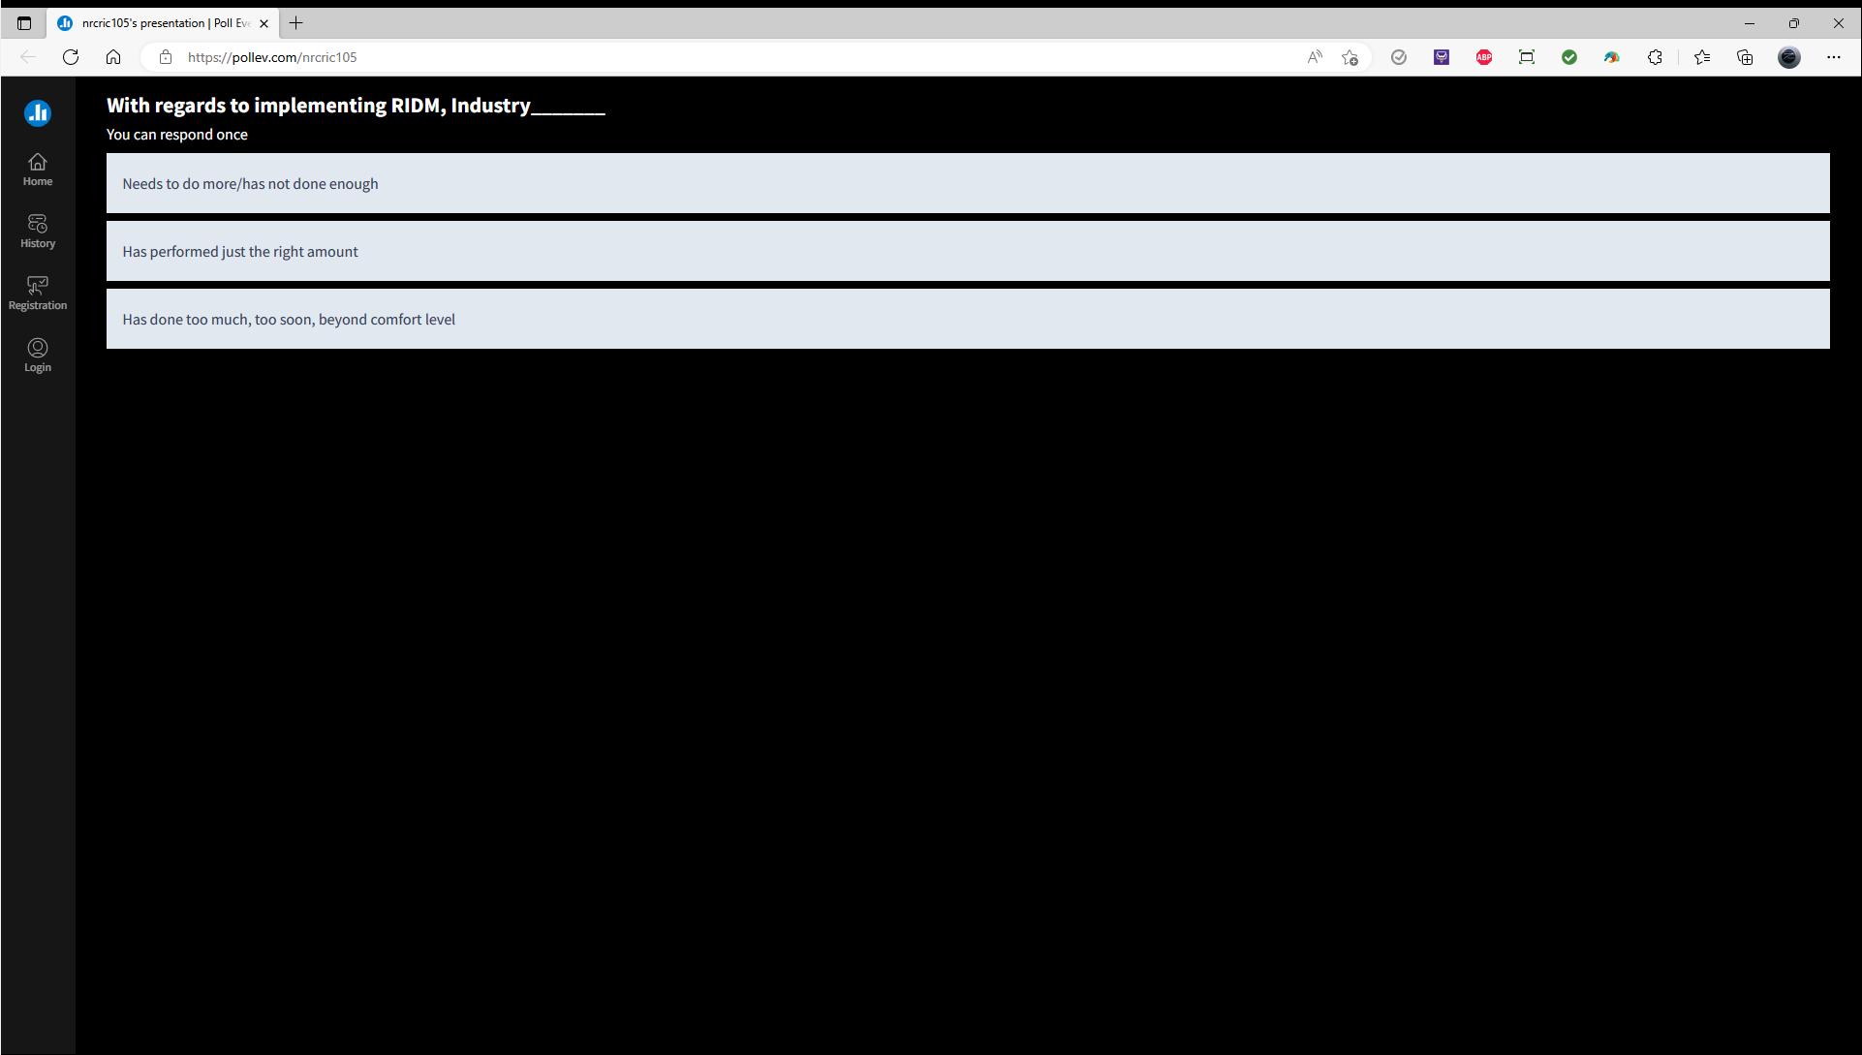 | 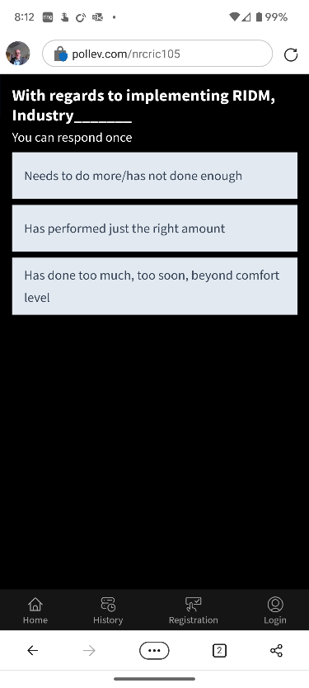

With regards to implementing RIDM, NRC and other Regulatory Agencies __
- Needs to do more/has not done enough
- Has performed just the right amount
- Has done too much, too soon, beyond comfort level

Desktop View | Mobile View
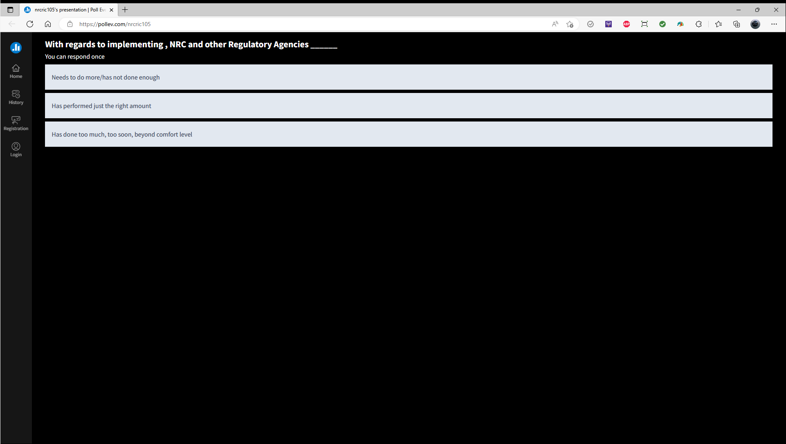 | 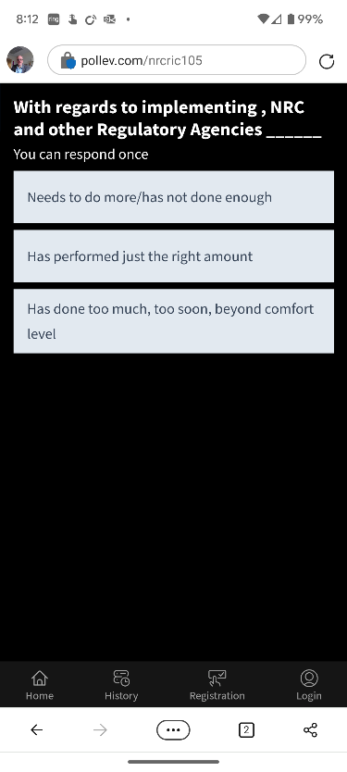

- What is your affiliation?
- NRC staff or contractor
- U.S. industry – operating reactors
- U.S. industry - new/advanced reactors
- International regulator / industry representative
- Other

Desktop View | Mobile View
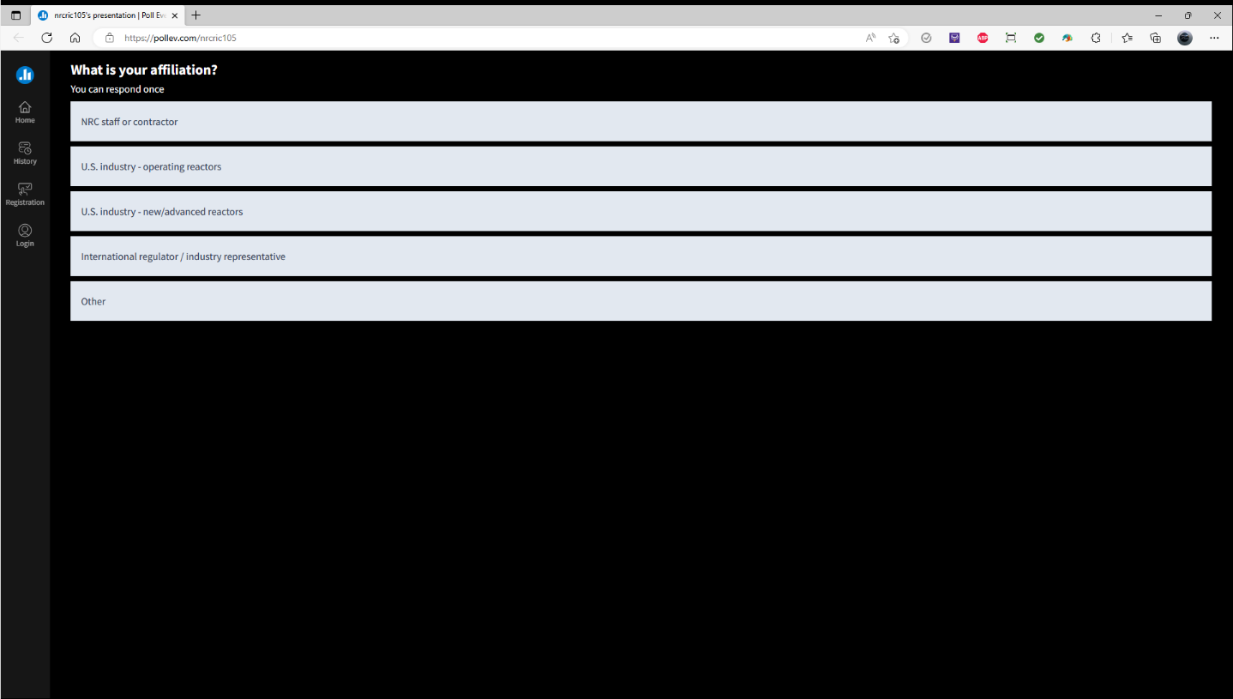 | 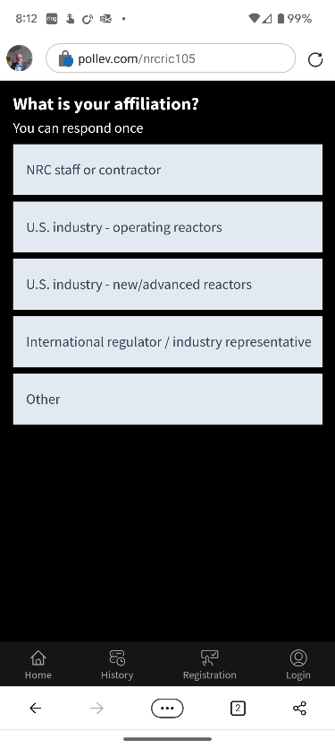

- Part 1: For a future risk-informed workshop, which of these topics would you most like to discuss (choose one or more)?
- LIC-206, "Integrated Risk-Informed Decision Making for Licensing Reviews"
- Progress on risk-informed licensing applications including lessons learned
- Risk informing 10 CFR 50.59
- Risk informing aging management

Desktop View | Mobile View
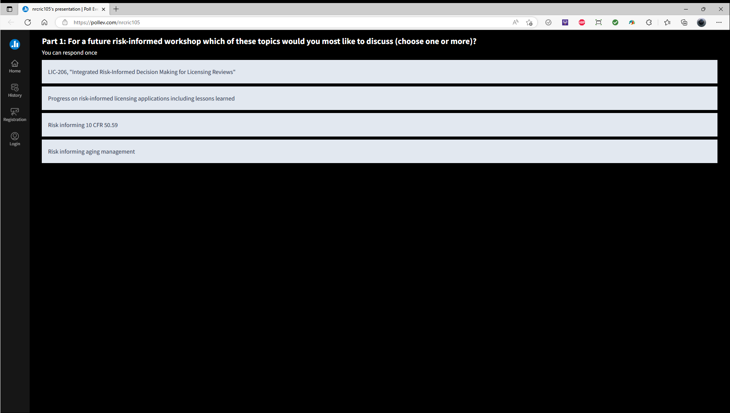 | 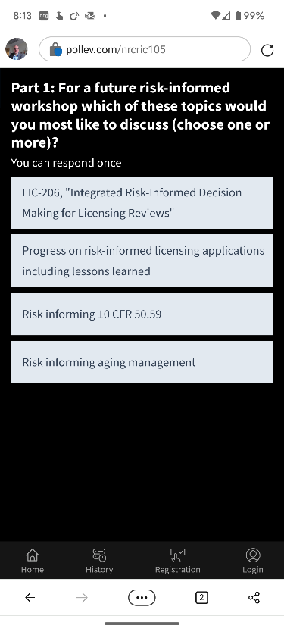

- Part 2: For a future risk-informed workshop which of these additional topics would you most like to discuss (choose one or more)?
- Risk informing new and advanced reactors
- Risk informing emergency preparedness for new reactors
- Risk informing security
- Other (Send suggestions through the question app)

Desktop View | Mobile View
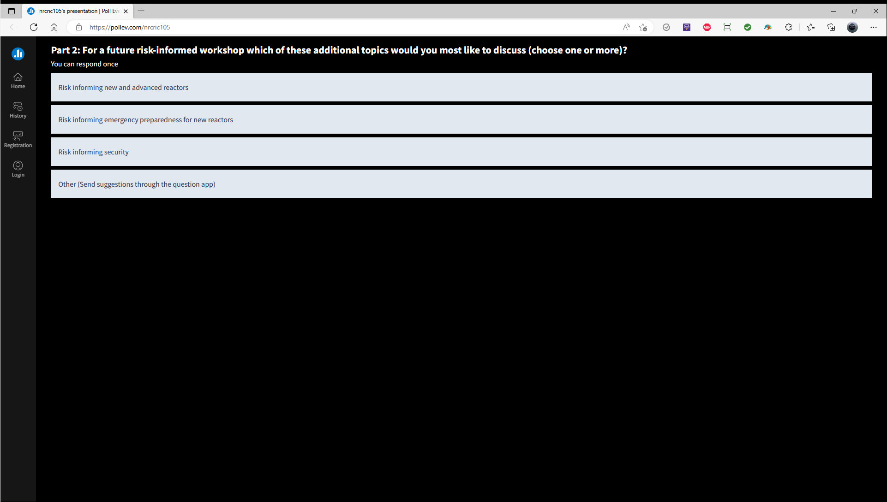 | 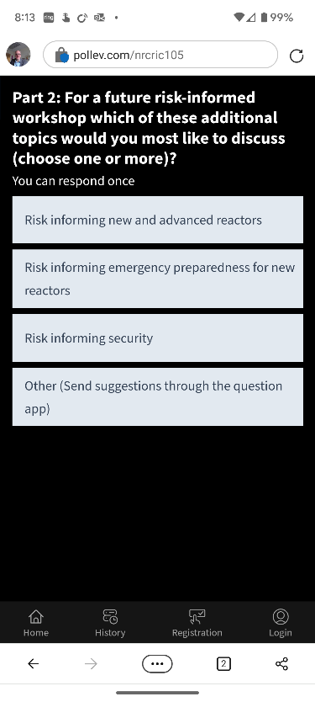

Session T6: How AI and I Became Friends: The Next Steps on the AI Journey

- What nuclear technology areas could potentially benefit most from using AI applications? (choose one or more)
- Non-destructive evaluation, predictive maintenance or condition monitoring
- Inspection automation
- Corrective action, work order, or other natural language processing tasks
- Plant autonomous operation or robotics
- Other (e.g., design optimization, alternative empirical models, etc.)

Desktop View | Mobile View
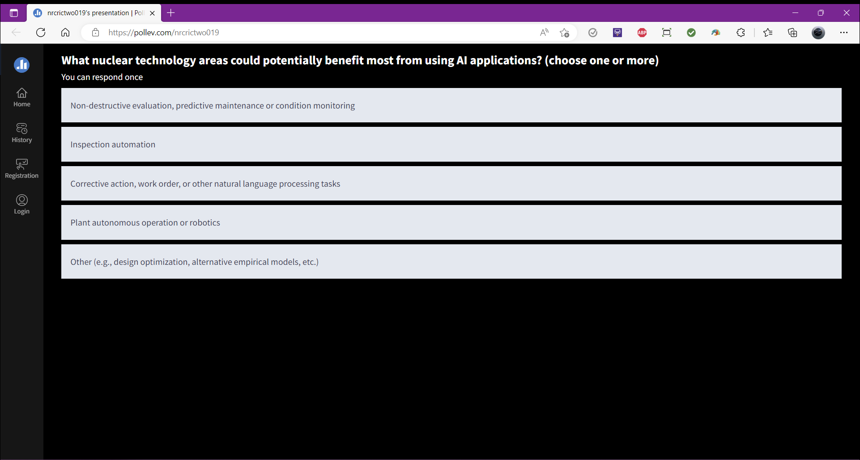 | 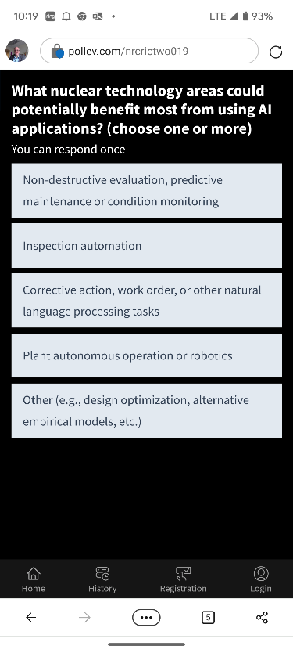

- How likely do you believe it is that new nuclear energy technologies will include aspects of AI in their design and operations? (choose one)
- Very likely
- Somewhat likely
- Unlikely
- Highly unlikely
- Never

Desktop View | Mobile View
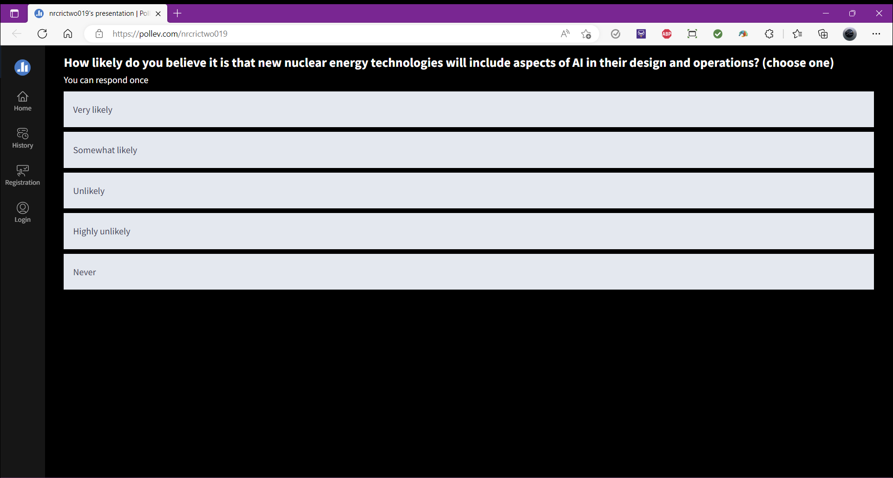 | 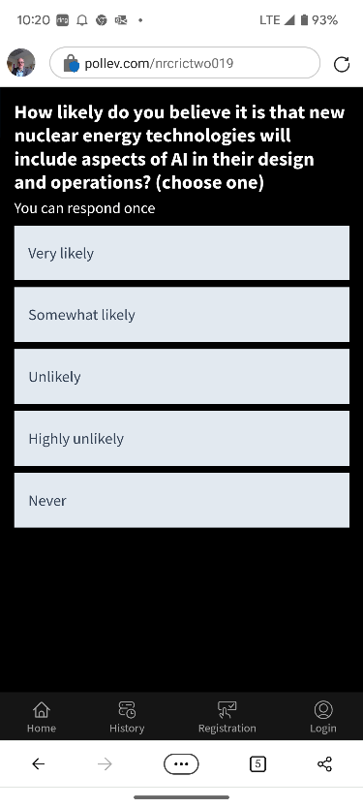

- How soon do you think commercial nuclear will be using AI applications in an NRC-regulated activity? (choose one)
- Already using it
- 1-5 years
- 6-10 years
- More than 10 years
- Never
Desktop View | Mobile View
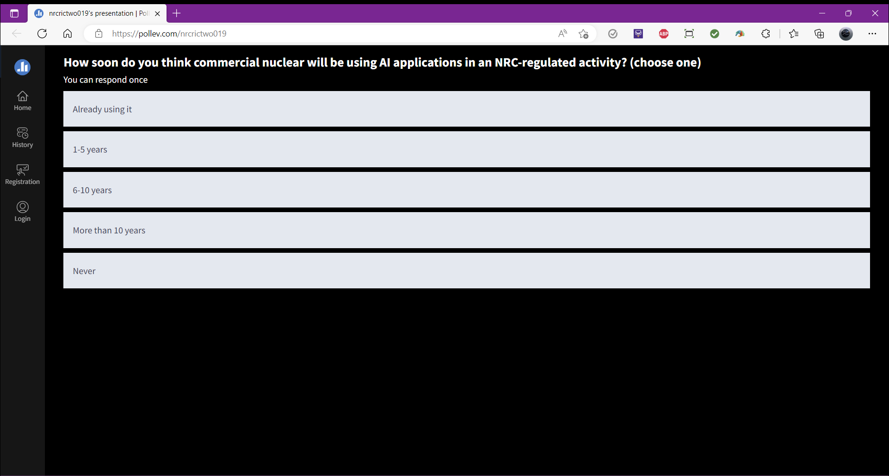 | 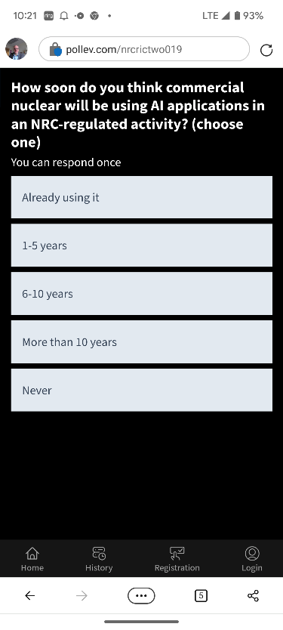

- What industry do you view as leading AI safety/security assessments? (choose one)
- Automotive
- Defense
- Energy Generation and Distribution
- Finance
- Healthcare

Desktop View | Mobile View
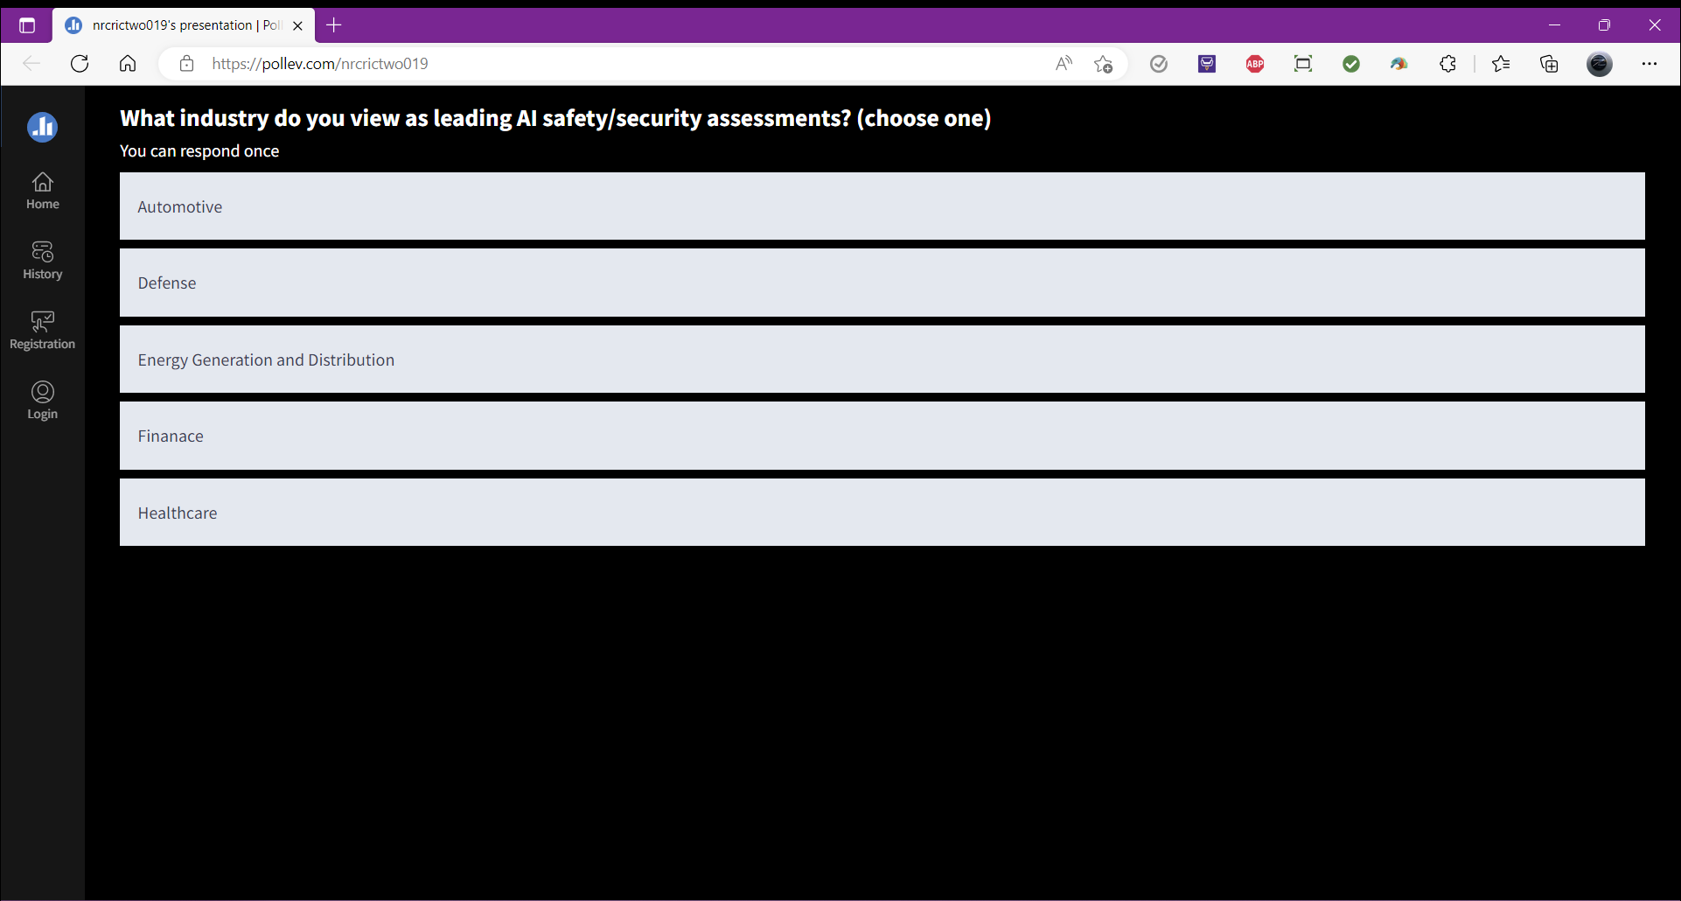 | 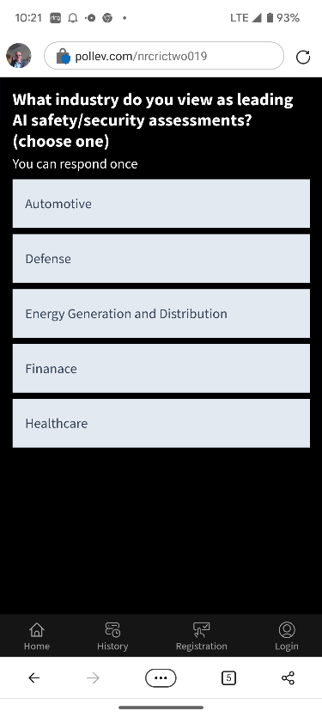

Session W11 Polling Questions

- How satisfied are you with the NRC response to stakeholder suggestions on Part 53?
  - Answer (0-5, with 5 being the most satisfied)
Desktop View | Mobile View
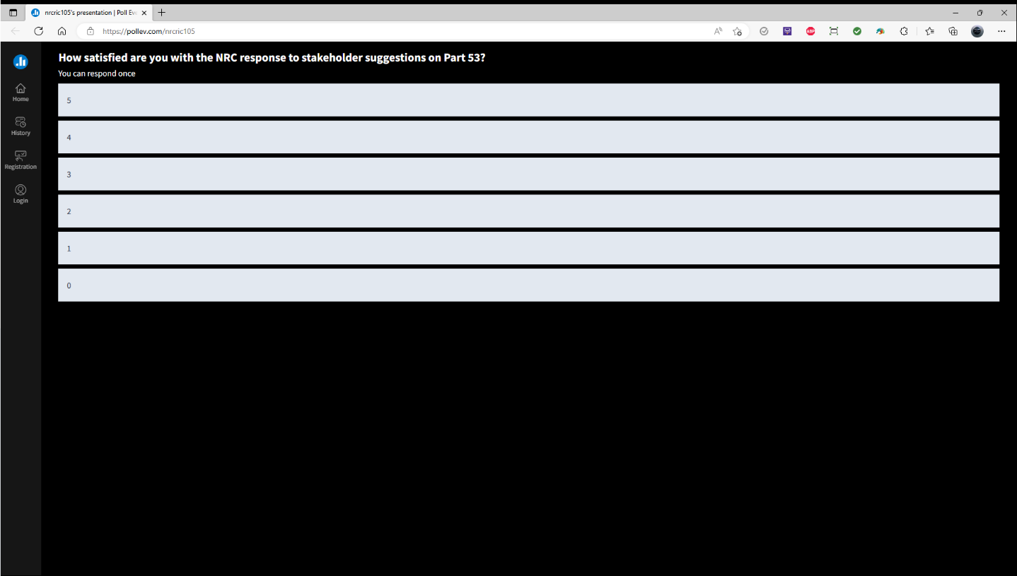 | 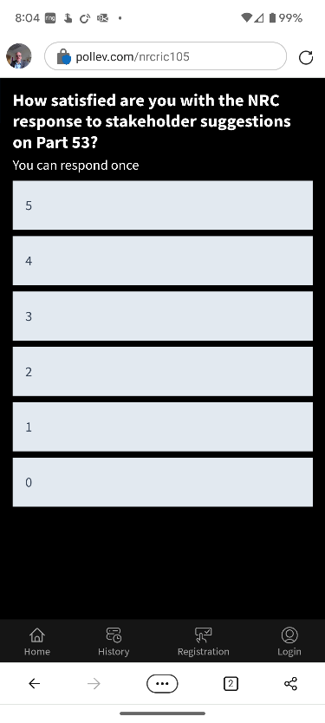

- For applications in 2025 and beyond, how likely are you to use the NRC Part 53 Framework A?
  - Framework A of Part 53 is the likely first choice
  - Will likely use Framework A of Part 53, but not for the first application
  - May use Framework A of Part 53 after someone else does
  - Not likely to use Framework A of Part 53
  - Will not use Framework A of Part 53 —substantial increases in regulatory burden
Desktop View | Mobile View
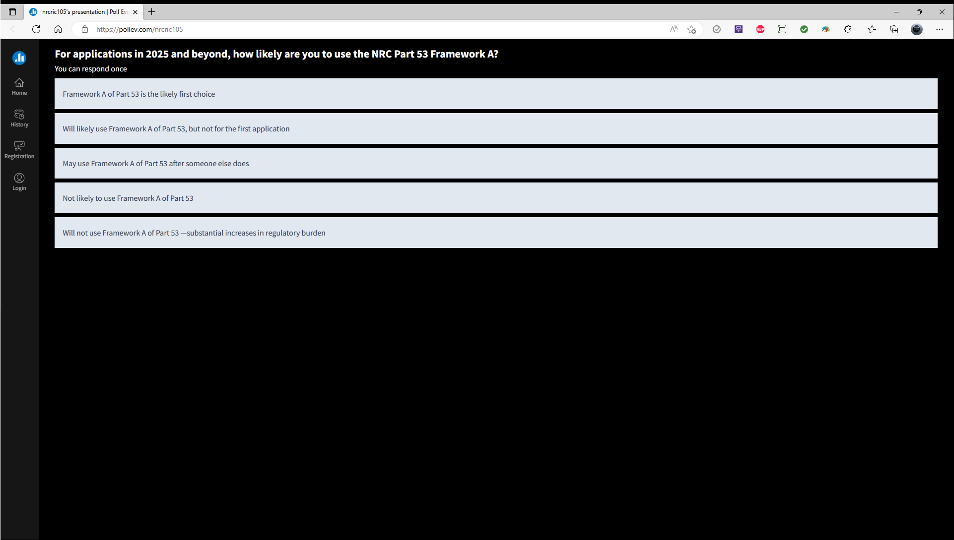

- In developing Part 53, has the NRC set the right level for what will be in the licensing basis vs what would be under licensee control (i.e., in a TRM or similar document)?
  - Yes
  - No, the boundary should match the LMP design-basis/beyond-design-basis cutoff
  - No, the licensing basis should only include safety-related items
  - No, the boundaries should be proposed by applicants (e.g., the use of the QHOs should not be mandated, but could be proposed in application technical specifications)
Desktop View | Mobile View
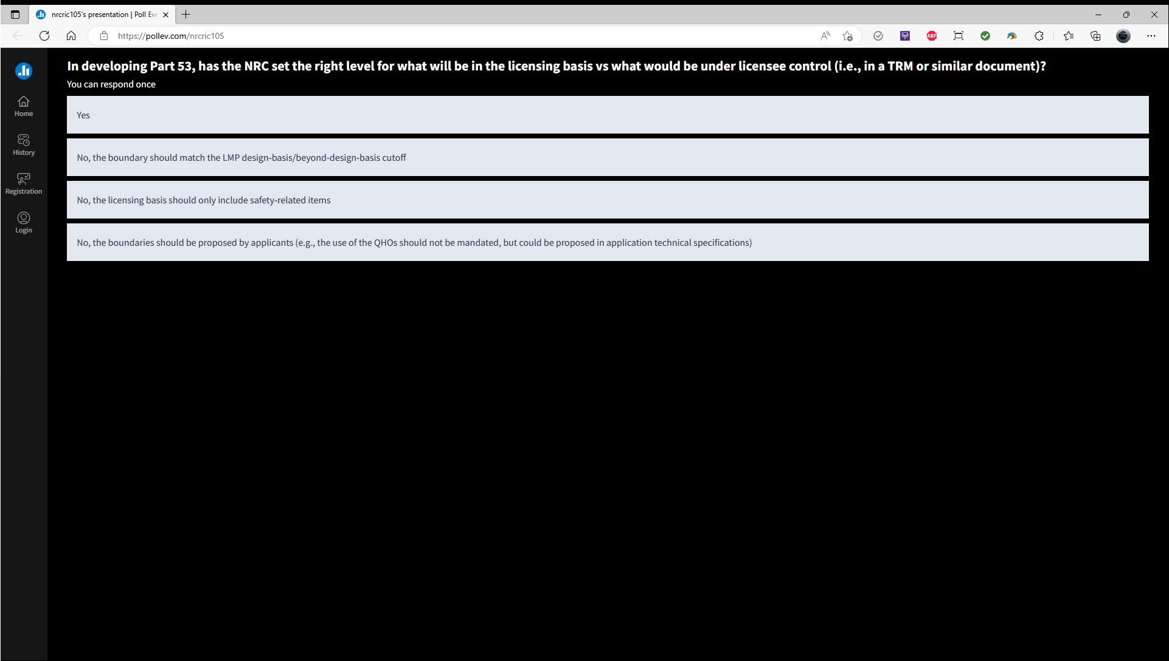

Session W12: TayTalks Live!

- How are you today?
  - Fantastic! Loving the RIC!
  - I'm on my 5th cup of coffee, but ready for this session
  - I just had lunch. A little sleepy.
  - Fine. I'm just here out of curiosity.

Desktop View | Mobile View
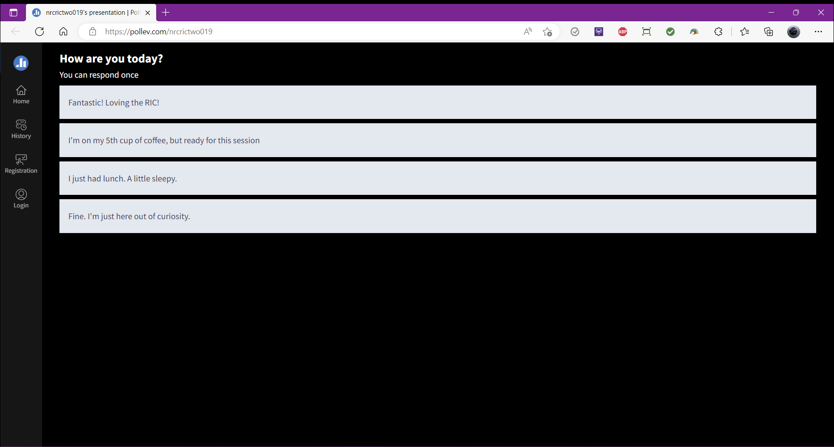 | 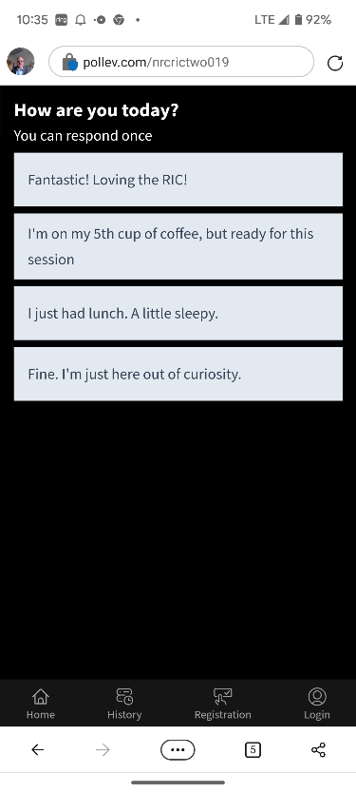

- How do you think the NRC is doing with innovation?
  - Great!
  - On the way, but could be better
  - Not as well as I anticipated
  - The NRC has been innovating?

Desktop View | Mobile View
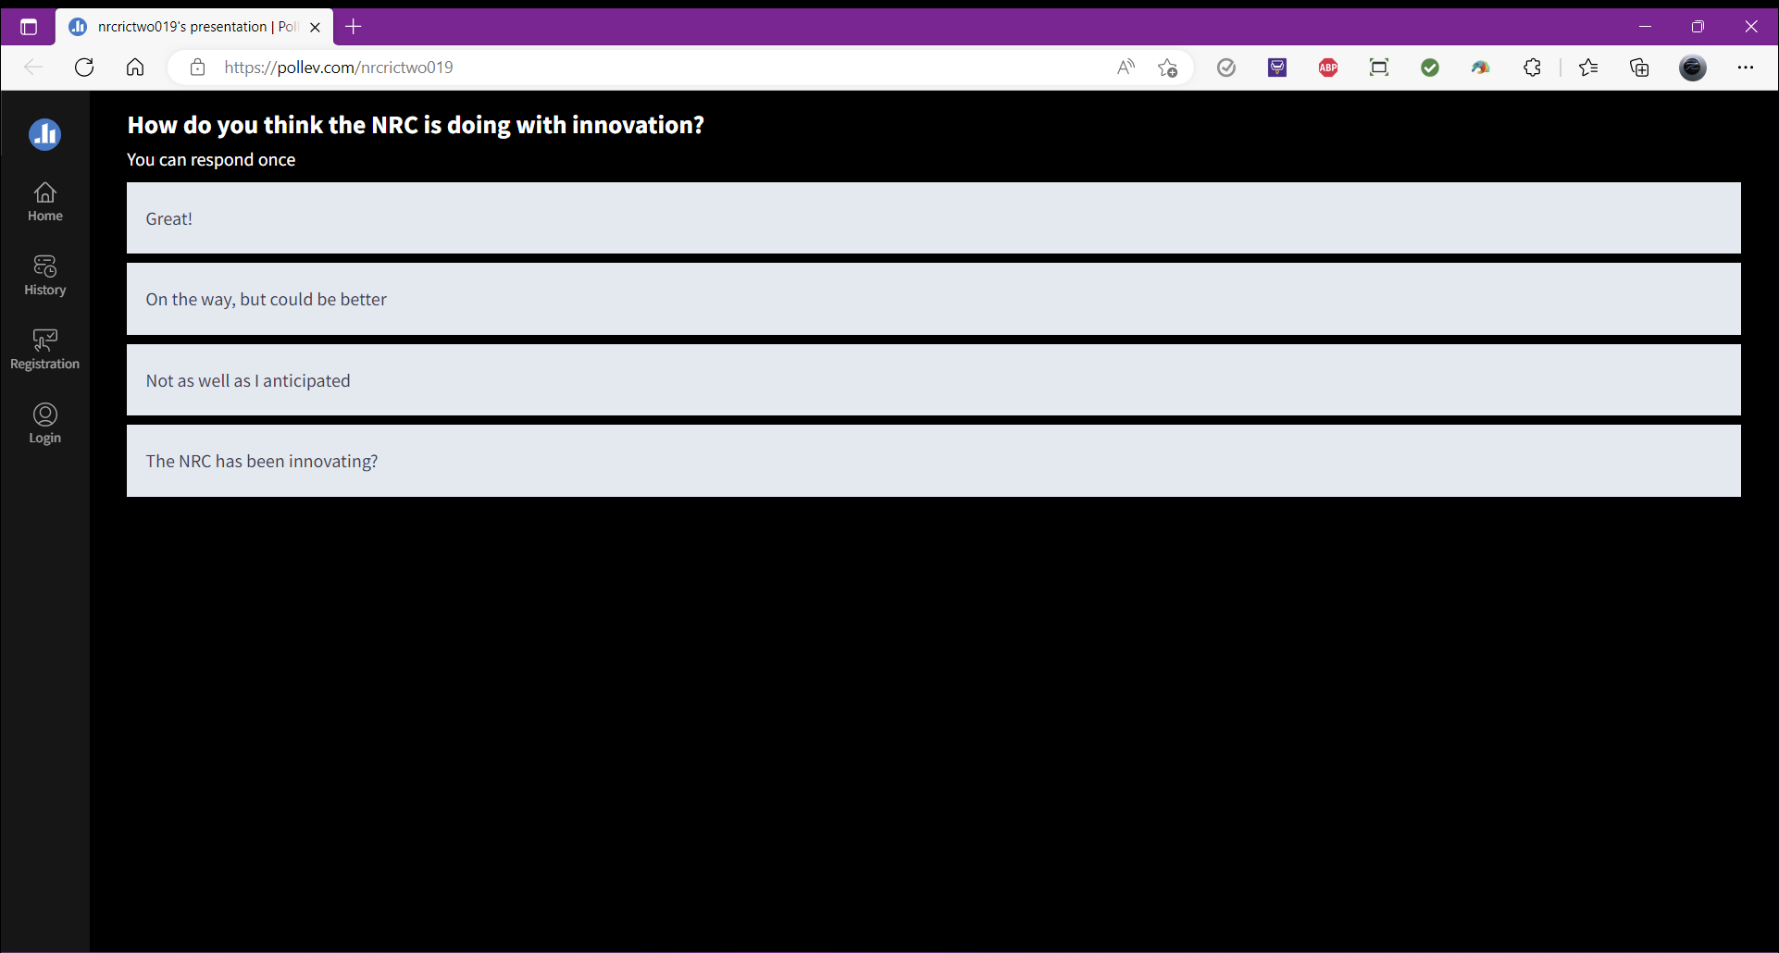 | 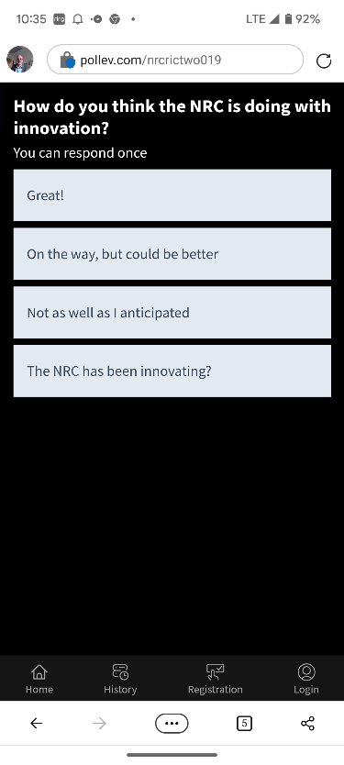

- How would you like to get involved in innovation at the NRC?
  - Via crowdsourcing
  - Posting suggestions via the NRC public webpage
  - Participating in public meetings related to innovation
  - All of these sound great!

Desktop View | Mobile View
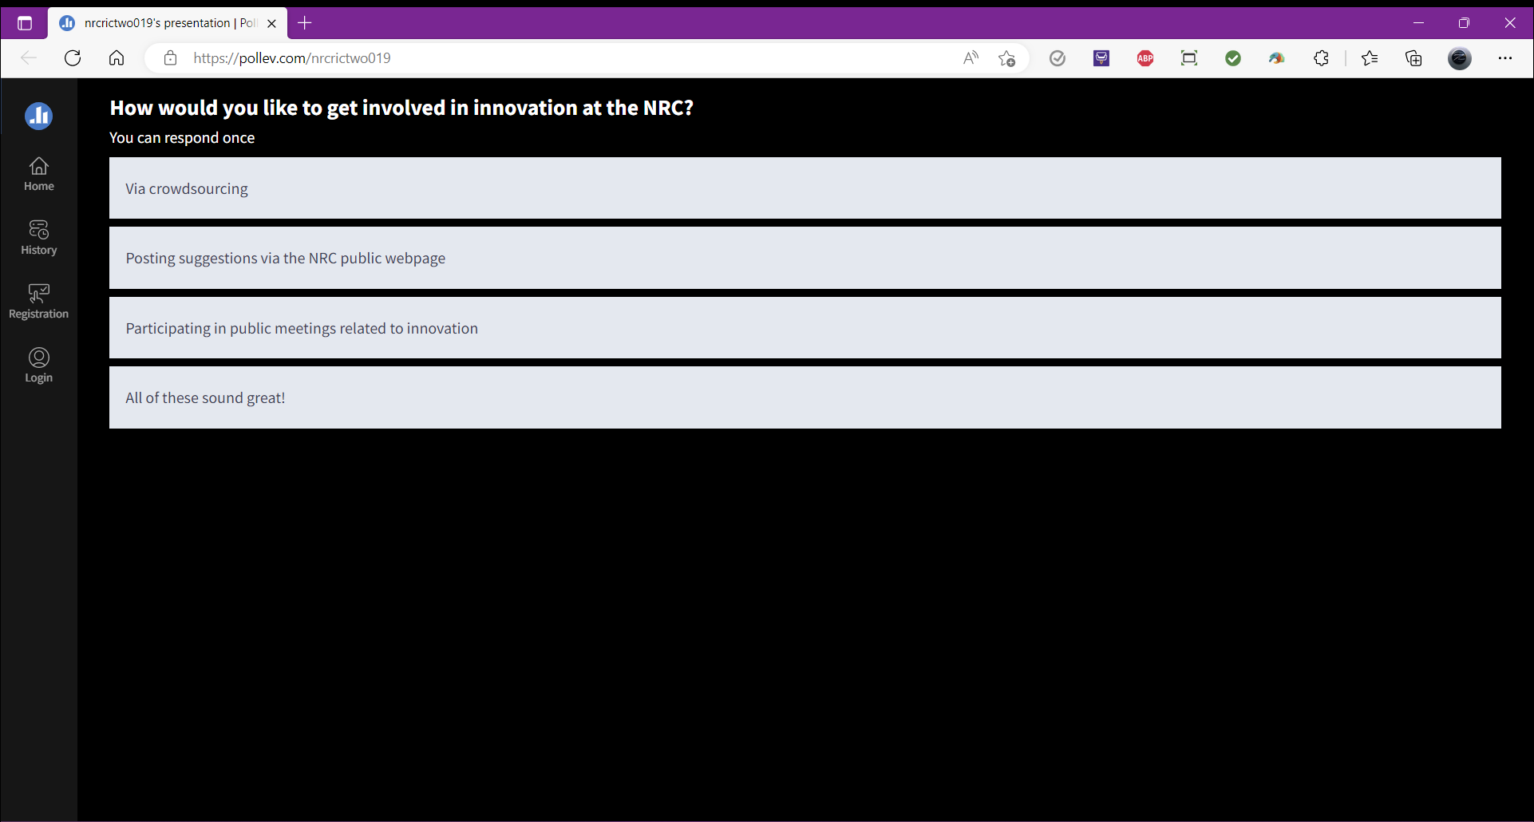 | 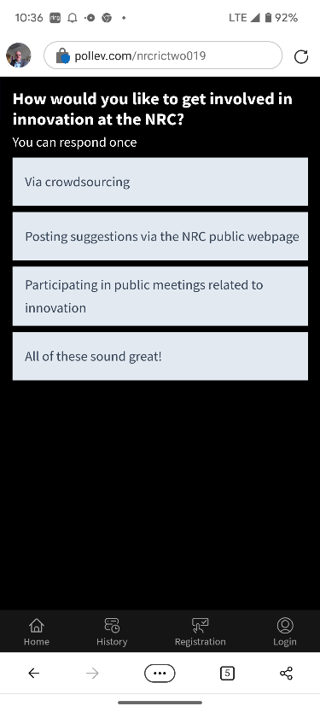

Session TH18: How Ex-Siting it is for New Reactors

- Do you know what siting is?
  - Yup! I'm intimately familiar.
  - A little, but curious to learn more.
  - No clue. That's why I'm here.

Desktop View | Mobile View
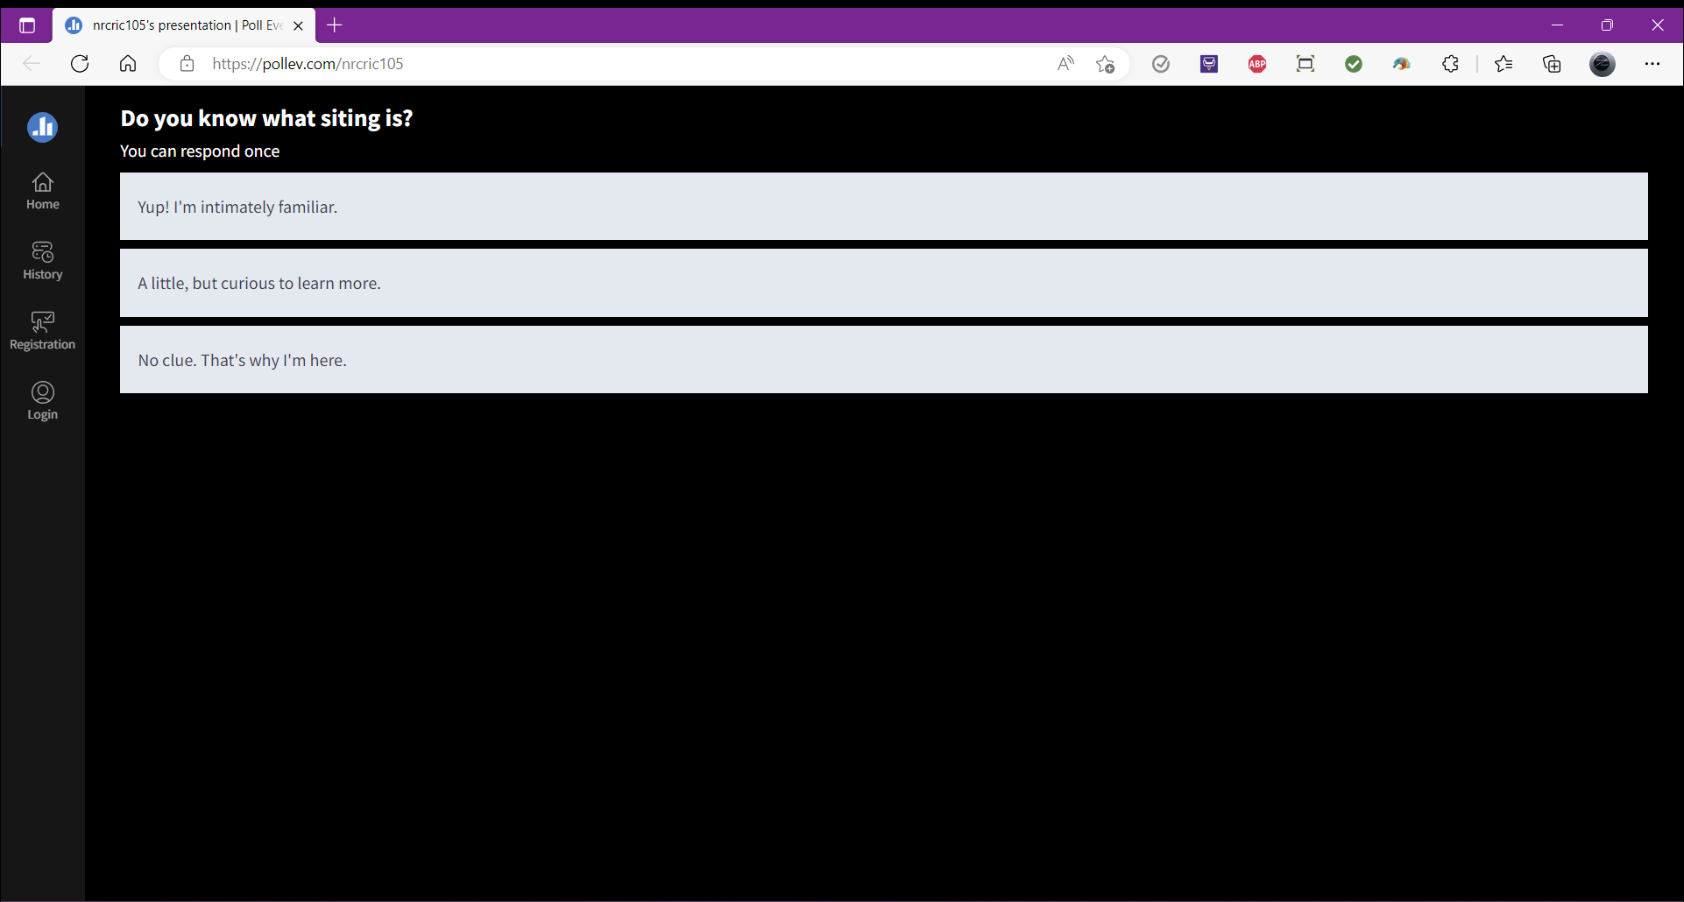 | 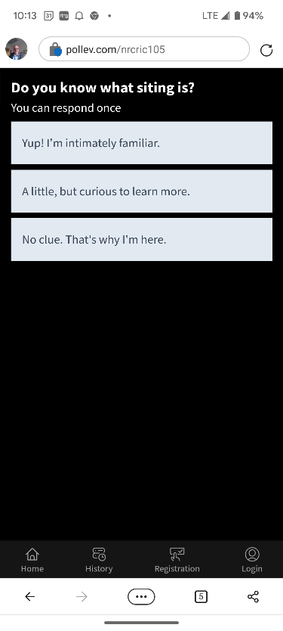

- Do you plan on going through the siting process?
  - Yes
  - No
  - Considering it

Desktop View | Mobile View
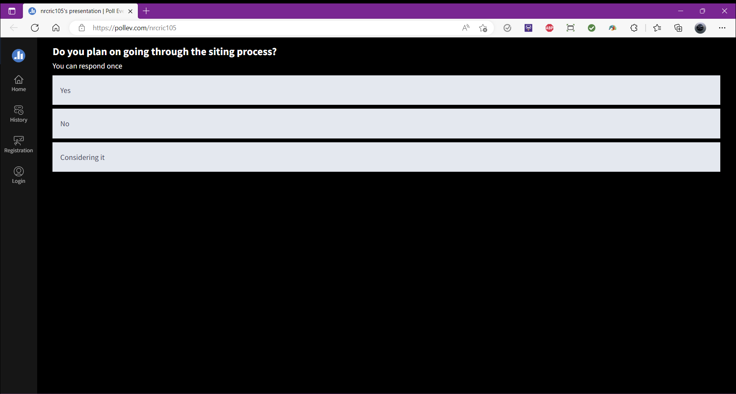 | 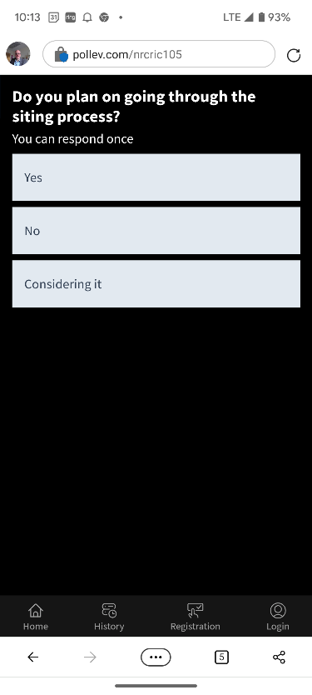

- Whose perspective would you like to learn more about?
  - NRC
  - DOE
  - Industry
  - The State

Desktop View | Mobile View
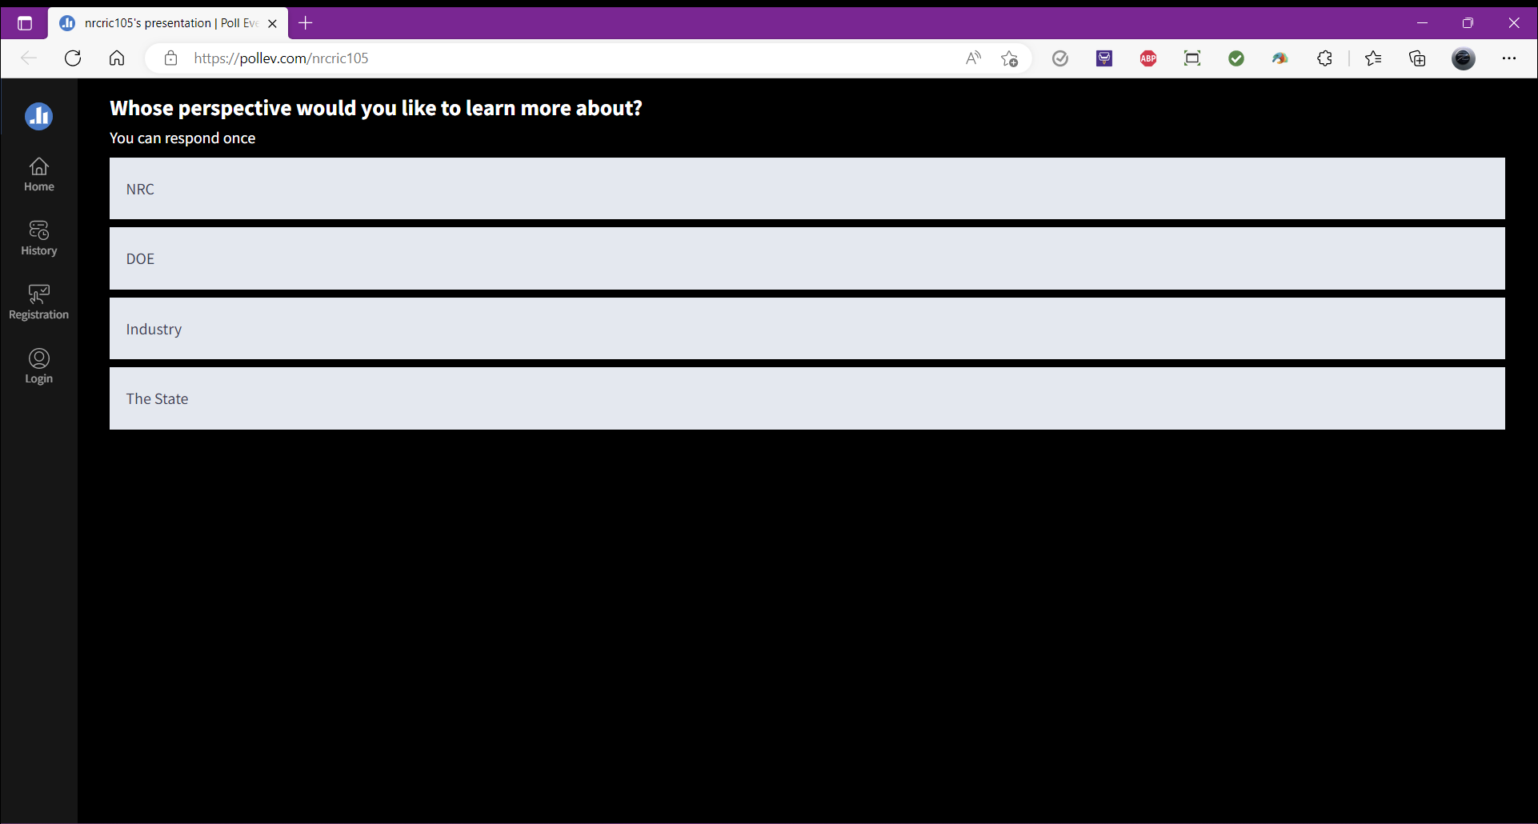 | 