Live Polling Questions for TH19
Dear RIC 2023 attendees:

Thank you for attending the U.S Nuclear Regulatory Commission’s (NRC’s) 35th Annual Regulatory Information Conference (RIC). Please find live polling questions for this session below. The estimated burden to respond to this voluntary information collection is less than 1 minute. The information provided will be used to inform the discussion during the session and improve future interactions with industry. Send comments regarding the burden estimate by e-mail to infocollects.resource@nrc.gov. If a means used to impose an information collection does not display a currently valid OMB control number, the NRC may not conduct or sponsor, and a person not required to respond to, the information collection.

Please note, your responses are anonymous, and data will be presented in aggregate form. Again, thank you for your support of the RIC!

- Who is joining us today for this session? What is your background or affiliation?
  - Nuclear Regulator
  - Operating Reactor Licensee
  - New or advanced reactor Vendor/Applicant
  - Non-governmental organization
  - Public

Desktop View | Mobile View
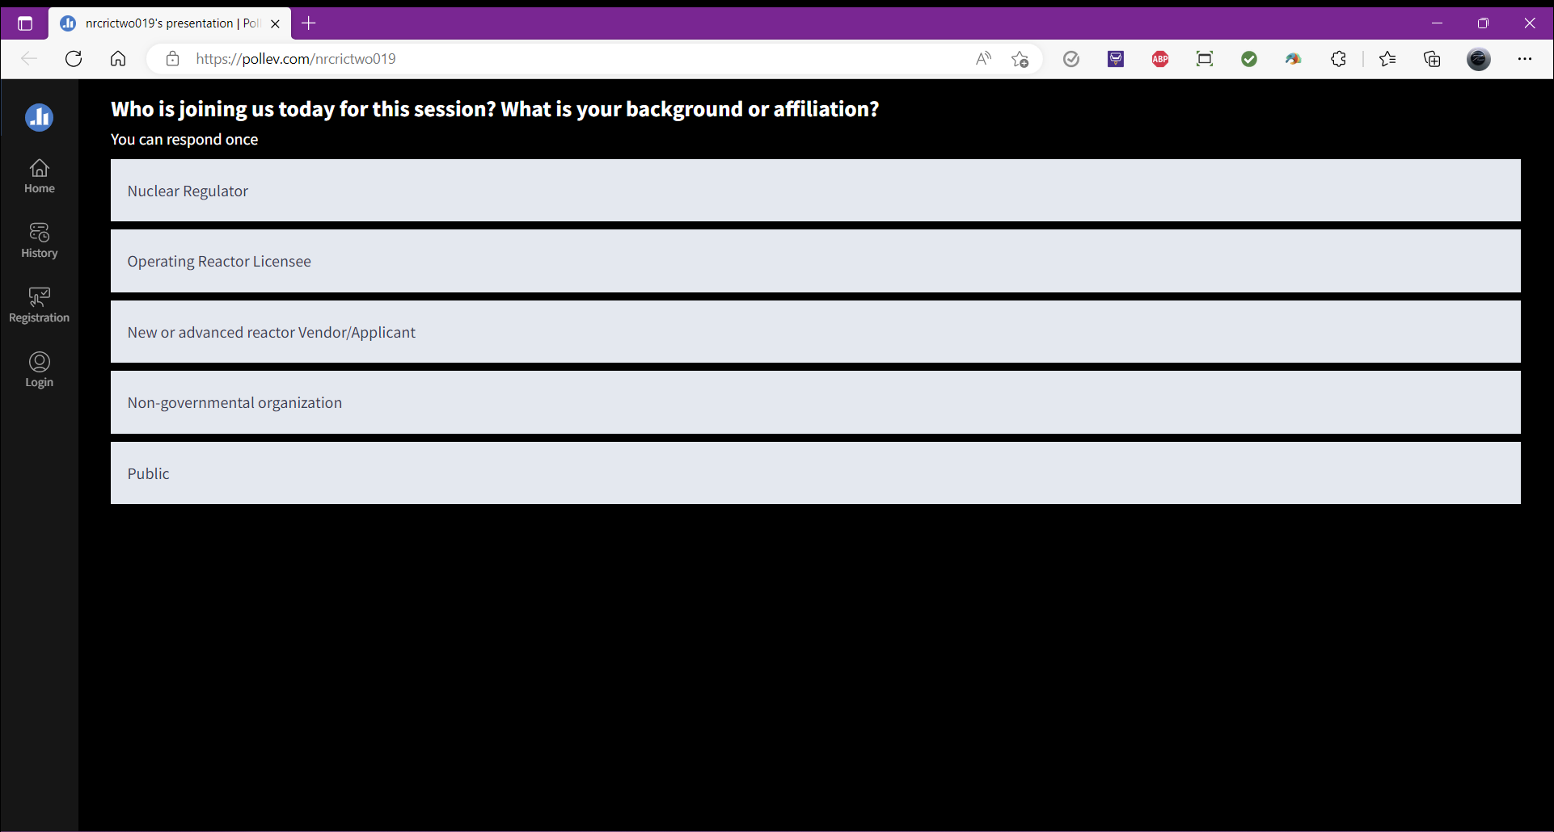 | 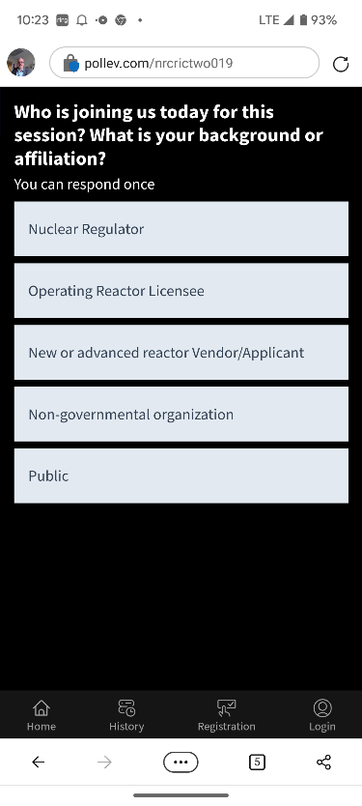

- What active projects are underway in your organization to expand the capability and sustainability of nuclear power (choose one or more)?:
  - License Renewal
  - Power Uprates
  - Behind-the-Meter customer co-location
  - Small Modular Reactor construction
  - Alternative energy storage (Batteries, Hydrogen, eFuels production, etc . . .)

Desktop View | Mobile View
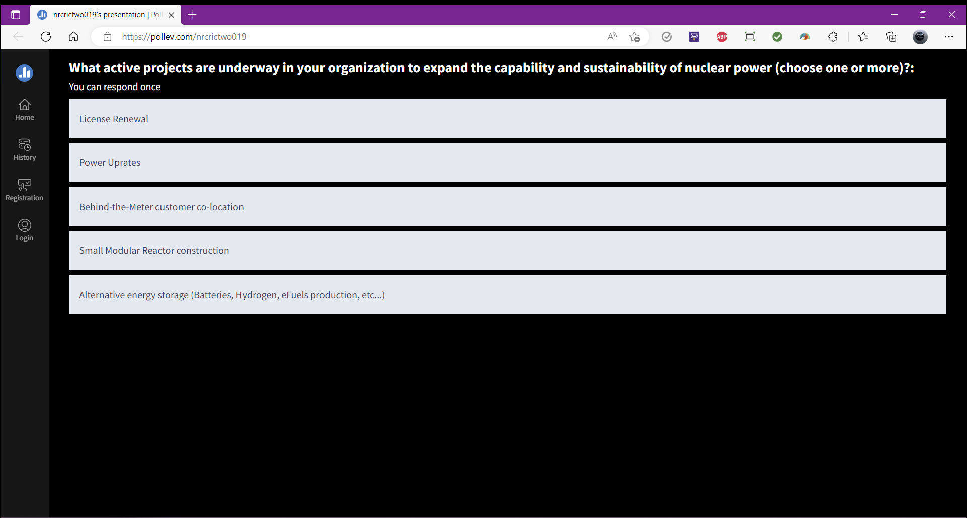 | 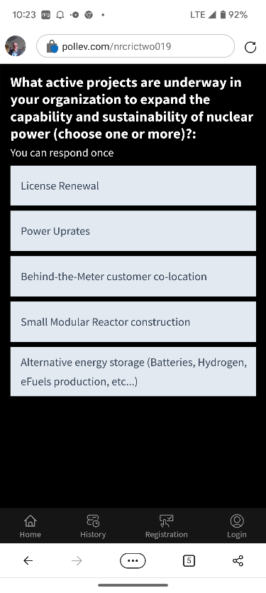

- There is a lot of excitement about Small Modular Reactors (SMRs) and Advanced Reactors (ARs). When do you believe the first SMR/ARs will be commercially deployed in North America and/or Europe?
  - Within 2 years (2023-2025)
  - Within 7 years (2026-2030)
  - Within 10 years (2031-2033)
  - After 10 years (2034+)
  - Never
Desktop View | Mobile View
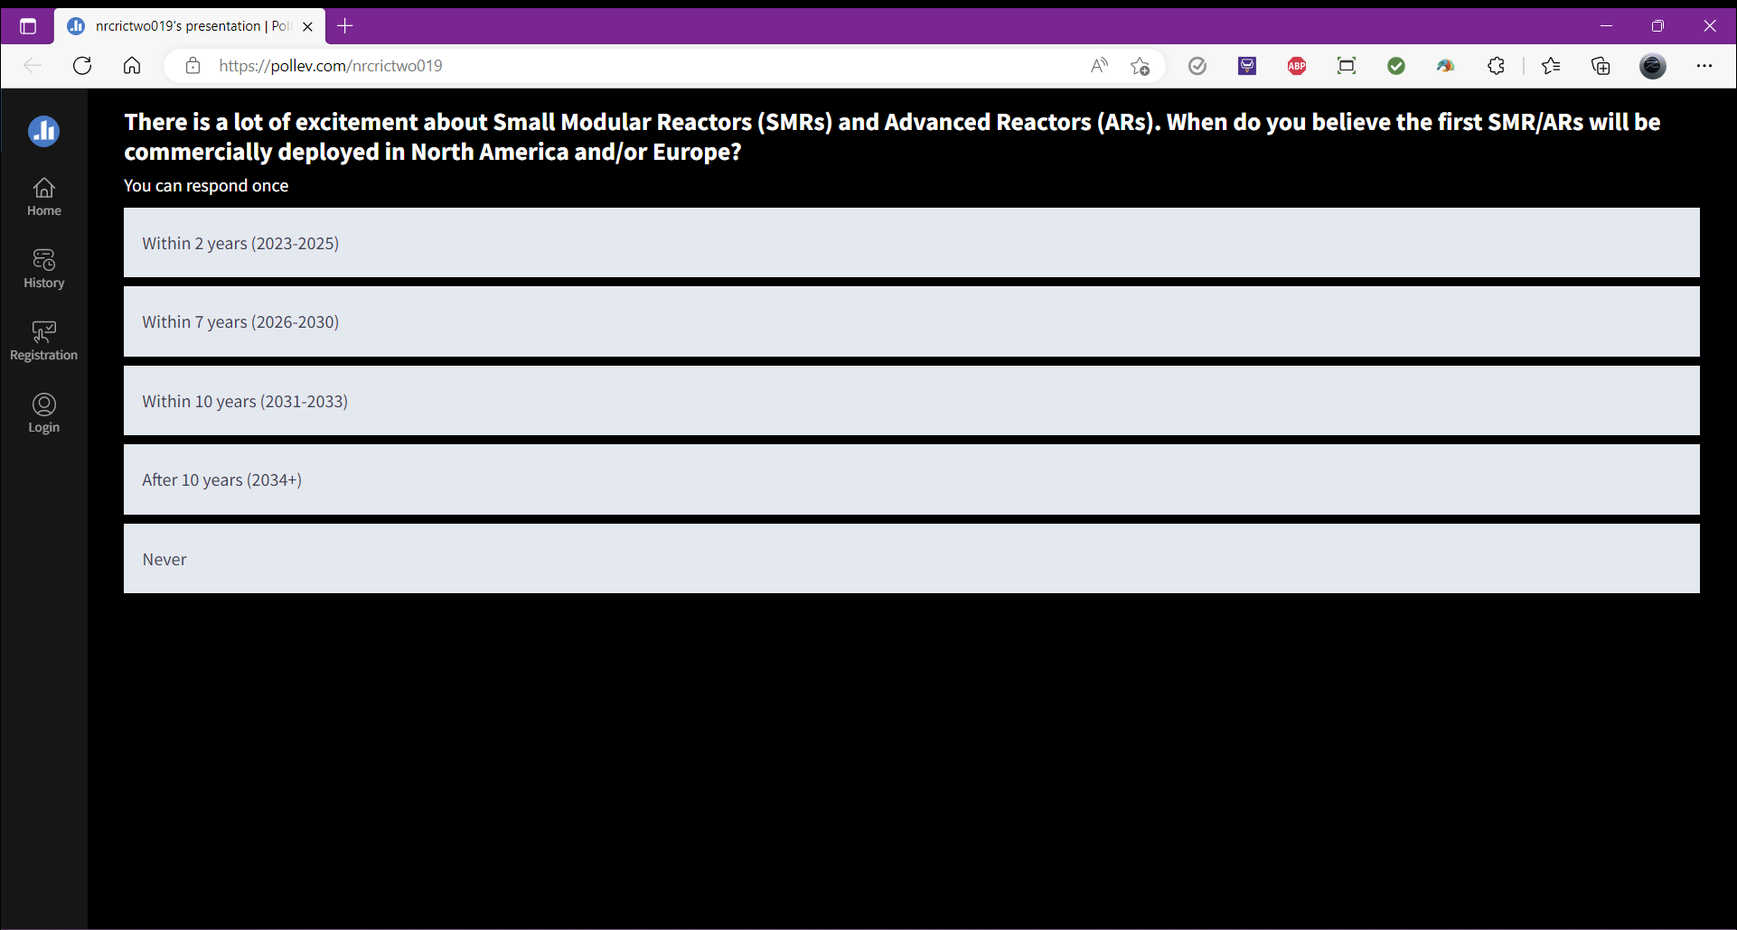 | 