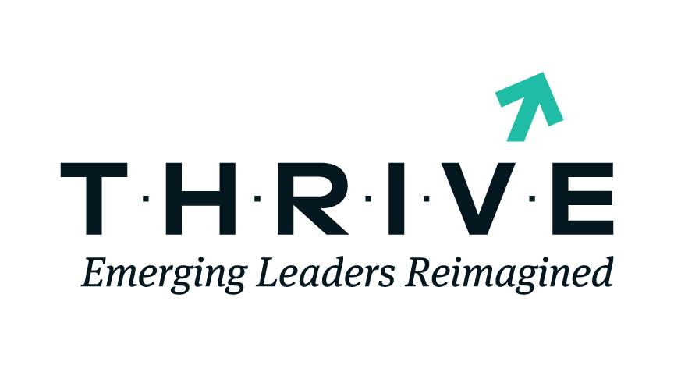
Get the knowledge, know-how, and networks to advance your business. Enroll in the T.H.R.I.V.E. Emerging Leaders Reimagined Program to unlock your growth potential. Seize the time to work on your business, not just in it! Apply today!
Fill out the application form below if you are interested in learning more about the T.H.R.I.V.E. Initiative. An SBA representative will contact you.

How did you find out about this opportunity?
- SBA District Offices
- Other SBA-funded Organization (SCORE, SBDC, WBC, PTAC, etc.)
- Past Participant or Instructor
- Financial Institution or Lender
- Chamber of Commerce or other Business Organization
- Local or National Media (Newspaper, Television, Magazine, or Radio)
- Social Media
- Other
Please Select Program Location
Select a site in close proximity to your location
- AL, Birmingham
- AL, Mobile
- AR, Little Rock
- AZ, Phoenix
- CA, Fresno
- CA, Irvine
- CA, Los Angeles
- CO, Denver
- DC, Washington
- FL, Miami
- FL, Orlando*
- GA, Atlanta
- HI, Honolulu
- ID, Boise
- IL, Chicago
- IN, Indianapolis
- KS, Wichita
- MA, Springfield*
- MD, Baltimore
- ME (Portland), Brunswick
- MI, Detroit
- MN, Minneapolis
- MO, St. Louis
- NC, Charlotte
- ND, Fargo
- NJ, Newark
- NV, Las Vegas
- NY, New York City
- NY, Syracuse
- OH, Columbus
- OH, Dayton*
- OH, Youngstown
- OK, Oklahoma City
- PA, Philadelphia
- PA, Pittsburgh
- PR, Ponce
- PR, San Juan
- SC, Charleston
- SD, Sioux Falls
- TN, Memphis
- TN, Nashville
- TX, Austin/San Antonio
- TX, Dallas
- TX, El Paso*
- TX, Greater Houston
- TX, Houston
- TX, Weslaco
- UT, Salt Lake City
- VT, Williston
- WA, Spokane
- WI, Milwaukee
- WV, Fairmont*
Full Name
First Name
Last Name
Preferred Email
Mobile Phone Number
This information is for internal purposes only and is never shared or distributed. Please type your phone number in the format XXX-XXX-XXXX or XXXXXXXXXX.
Office Phone Number
This information is for internal purposes only and is never shared or distributed. Please type your phone number in the format XXX-XXX-XXXX or XXXXXXXXXX.
Do you currently describe yourself as male, female, or transgender?
- Male
- Female
- Transgender
What is your race (select all that apply)?
- American Indian or Alaska Native
- Asian
- Black or African American
- Native Hawaiian or Other Pacific Islander
- White
- Other
Are you Hispanic, Latino, or Spanish origin?
- No, not of Hispanic, Latino, or Spanish origin
- Yes, Mexican, Mexican Am, Chicano
- Yes, Puerto Rican
- Yes, Cuban
- Yes, another Hispanic, Latino, or Spanish origin
Job Title(s)
- Owner
- Partner
- Chief Executive Officer (CEO)
- Chief Operating Officer (COO)
- Chief Financial Officer (CFO)
- President
- Vice President
- Board Director/Member
- Manager
- Founder
- Other
Company Name
SAM.GOV Unique Entity Identifier (UEI)
Business Website URL
Business Address (the physical location of your business)
Street Address
Street Address 2
City
Postal Code
State
Is Mailing address same as Business address?
- Yes
- No
What is the age of the business?
- 1 year
- 2 years
- 3 years
- 4 years
- 5+ years
Number of Full-Time Employees besides the owner
- I’m the only employee
- 1-5 employees
- 6-10 employees
- 11-20 employees
- More than 20 employees
Number of Part-Time Employees
- 0 employees
- 1-10 part-time employees
- 11-20 part-time employees
- More than 20 part-time employees
Total revenue for your Business in 2020
- $0-$100,000
- $100,000-$250,000
- $250,000-$400,000
- $400,000-$800,000
- $800,000-$1,500,00
- $1,500,000-$5,000,000
- $5,000,000-$10,000,000
- More than $10,000,000

Total revenue for your Business in 2021
- $0-$100,000
- $100,000-$250,000
- $250,000-$400,000
- $400,000-$800,000
- $800,000-$1,500,00
- $1,500,000-$5,000,000
- $5,000,000-$10,000,000
- More than $10,000,000
What goals have you set for your business to achieve in 3 to 5 years?
- Increase revenue and profit
- Create new jobs
- Contribute to the local communities
- Develop and implement the business plan
- Increase capital expenditures
- Access new markets
- Open new business locations
- Increase innovation
- Growth Strategies Plans
- Other
How may we help you achieve these goals?
- A three-year strategic growth action plan with benchmarks and performance targets
- Government and non-government contracting
- Mentoring
- Human resource management
- A network of government resources, peers, local business leaders, and the financial community
- Financing and access to capital
- Other
What social media platforms do your business use? (select all that apply)
- None
- Facebook. Enter your business handle _______________
- Instagram. Enter your business handle _______________
- Twitter. Enter your business handle _______________
- LinkedIn. Enter your business handle _______________
- YouTube. Enter your business handle _______________
- Others

