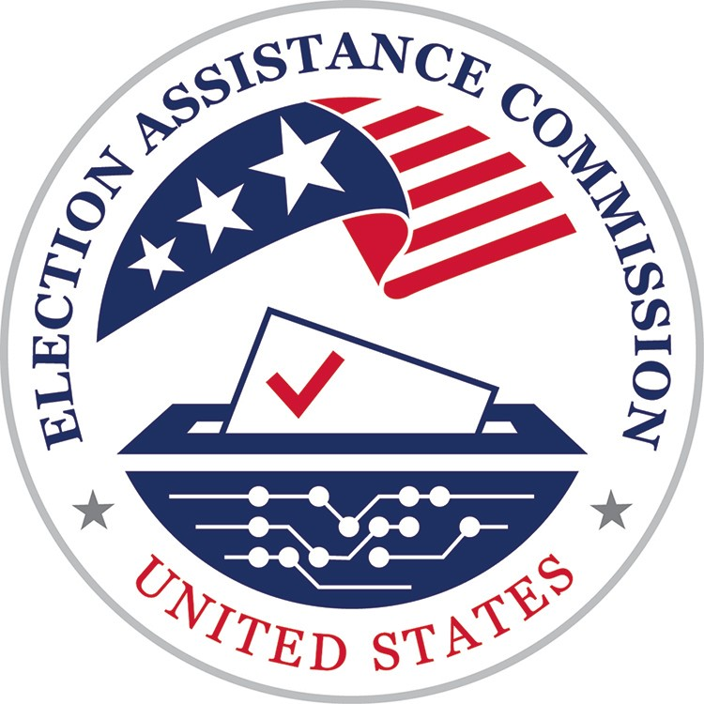
U.S. Election Assistance Commission
Manufacturer Registration Application OMB Control # 3265-0024 Expires 9/30/2025

Manufacturer Information

Legal Name of Business: Address of Business:

City:
State:
ZIP Code:

Organization Type:
Corporation
Partnership
Sole Proprietorship
Other

Names of Officers, Board of Directors, and all Partners:

Name of Individual or Entity with Controlling Ownership in the Manufacturer:

Management Representative

First Name: Title:

Last Name: Middle Initial:

Address:

City: State: ZIP Code:

Email: Phone Number:

Technical Representative

First Name: Title:

Last Name: Middle Initial:

Address:

City: State: ZIP Code:

Email: Phone Number:

- Briefly describe your quality system (e.g. ISO 9001). Provide your written policies supporting this description as a part of this application:

- Briefly describe your internal requirements for managing change control/version control for both hardware/firmware and software. Provide your written policies supporting this description as part of this application:

- Briefly describe your document retention requirements. Provide your written policies supporting this description as part of this application:

- List the name, address, city, state/province, country, postal code, and phone number for all facilities used by your company to manufacture your voting system product, and the name, title, address, email address, and phone number for a person at each facility:

Manufacturer Certification Agreement:

To maintain a voting system certification under the Election Assistance Commission (EAC) program, the manufacturer must agree to all provisions as stated in the Manufacturer Agreements section in the currently effective Testing and Certification Program Manual.

Signature (handwritten or digital)

Title:

Date:

EAC Use Only

Manufacturer's Designation:

Notes:

Instructions:

This form provides for the registration of voting system manufacturers. Registration is the initial required step in the EAC Voting System Certification Program. This form is prescribed by Section 2.4 of the Manual. For more information on registration requirements please see Section 2.2 of the Manual.

This form is generally self-explanatory however the numbers and the instructions below correspond to the numbered sections of the form.

- Manufacturer Information.

Names of Officers and/or Board of Directors and/or all Partners: Ensure that all individuals are identified by name, and title.

Name of Individual or Entity with Controlling Ownership in the Manufacturer: Ensure that the controlling individual is properly named, and an address is provided.

- Management Representative.

Please provide the name and information requested for the designated Manufacturer Representative pursuant to Section 2.2 of the Manual.

- Technical Representative.
Please provide the name and information requested for the designated Technical Representative pursuant to Section 2.2 of the Manual.

4 - 7
Provide the information listed and attach to your submission the written documentation required by Section 2.2 of the Manual.

8. Manufacturer Certification Agreement
Manufacturers are required to take or abstain from certain actions consistent with the certification program. Your concurrence to these requirements is signified by affixing the signature of the manufacturer representative.

This information is required for the EAC to provide for the certification of voting systems as required by 42 U.S.C. Section 15371. This information will be used solely to administer the EAC Testing and Certification Program. This program is voluntary, however, individuals who wish to participate must meet the requirements of the Program. This information will be made public consistent with the requirements of the Freedom of Information Act, the Trade Secrets Act, and any other applicable Federal law or regulation. Public reporting burden for this collection of information is estimated to average about 9.75 hours for completion of this form. This estimate includes the time for reviewing the instructions, gathering information, and completing the form. Send comments regarding this burden estimate to the Testing and Certification Program Director, Election Assistance Commission, 633 3rd Street NW Suite 200, Washington DC 20001. Notwithstanding any other provision of law, no person is required to respond to, nor shall any person be subject to a penalty for failure to respond to, or comply with, a collection of information subject to the requirements of the Paperwork Reduction Act, unless that collection of information displays a currently valid OMB Control Number.

