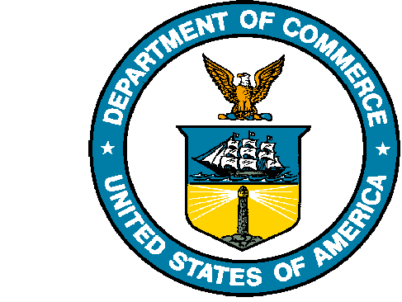
UNITED STATES DEPARTMENT OF COMMERCE

National Oceanic and Atmospheric Administration
NATIONAL MARINE FISHERIES SERVICE
Northwest Fisheries Science Center
2725 Montlake Boulevard East
Seattle, WA 98112-2097

Enter Name Here:

We would like to inform you of a continuing study focused on individuals whom participate in any aspect of the West Coast Groundfish Fishery. This study aims to gain social information about the individuals and communities in the fishery related to the catch shares program. As social scientists, we study the human dimensions of ecosystems, working to better understand people and their relationship to marine resources. In this study, we are interested in learning more about the people connected to the West Coast Groundfish Fishery.

Our initial data collection effort was conducted in the fall of 2010. A supplemental effort was conducted in 2012, and a third effort was completed in 2015/2016. These three efforts provided excellent information about the individuals and communities that participate in the fishery. Data we collected contributed to the 2017 5-year review. We are now moving to collect data on 5-year rotation to understand continued changes and contribute to the next review of the catch shares program. Our new and current data collection effort will be conducted during 20XX.

The main tool to collect data for this research is a survey. Over the next several months, NOAA Fisheries will be surveying individuals whom are part of the West Coast Groundfish Fishery. The survey will be conducted by the Northwest Fisheries Science Center’s (NWFSC) Human Dimensions Program. We invite you, your industry colleagues, employees, crew, family members, suppliers, service providers, and others connected to the fishery to participate in the study.

The best method for administering the survey is by conducting them in-person. This will be done by scheduling an appointment ahead of time; we can conduct the survey at a time and location that is convenient for each person. We can also provide any additional information or answer any questions that may arise. The survey may be given to multiple people at once or to individuals. Depending on the person being surveyed, we expect the survey to take about one hour to complete. If it is not possible to meet in person, the survey will be available electronically, on our website, and through the mail. In addition to the survey, the researchers would greatly appreciate an opportunity to conduct a short interview to obtain any other information that is important to you.

We understand that your time and the time of your employees and colleagues is very valuable. We are trying to respect that time by scheduling appointments. We encourage your participation in this survey as you and other industry members are the only people that can provide the necessary information. By collecting this information we can better understand the industry itself. Your participation is critical to the success of the study and the accurate description of the fishing industry and your local communities.

All results, reports, and information generated from this study will be publicly available and provided to each study participant.

Please expect a follow up call within two weeks after receipt of this letter to discuss any questions and schedule appointments.

Thank you very much for your consideration and we look forward to talking to you further. If you have any questions about our program, the study, or would like to schedule your appointment please contact us at the number provided below or email at nwfsc.study@noaa.gov or see our web page at www.nwfsc.noaa.gov/research/divisions/cbd/groundfish-study.cfm.
Thank you again for your time and consideration.

Sincerely,
Suzanne Russell
Social Scientist
Principal Investigator
National Marine Fisheries Service
Northwest Fisheries Science Center
Human Dimensions Program
2725 Montlake Blvd. East
Seattle, WA 98112
Suzanne.Russell@noaa.gov
(206) 860-3274 - Office
(206) 437-2755 - Cell
(206) 860-3475 - Fax

