OMB No.: 0915-0285. Expiration Date: XX/XX/20XX
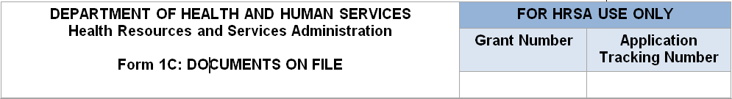
Note: Example date formats for use on this form are 01/15/2016, First Monday of every April, and bi-monthly (last rev 01/16). This listing does not include all policy/procedure documents required to be maintained on file. Records demonstrating implementation of required policies and procedures must also be available for review.

Management and Finance | Date of La Review/Revision st  (maximum 100 characters) | Not Applicable  (N/A)
Personnel policies, including selection and dismissal procedures, salary and benefit scales, employee grievance procedures, and equal opportunity practices.
Procurement procedures.
Standards of Conduct/Conflict of Interest policies/procedures.
Financial Management/Accounting and Internal Control policies and/or procedures to ensure awarded Health Center Program federal funds are not expended for restricted activities.
- Financial Management/Accounting and Internal Control policies/procedures related to restrictions on the use of federal funds for the purchase of sterile needles or syringes for the hypodermic injection of any illegal drug. (Only applicable if your organization provides syringe exchange services or is otherwise engaged in syringe service programs; otherwise, indicate as N/A).
- Financial Management/Accounting and Internal Control policies/procedures related to restrictions on the use of federal funds to provide abortion services, except in cases of rape or incest or where there is a threat to the life of the mother.your organization provides abortion services; otherwise, indicate as N/A). (Only applicable if
Billing and Collections policies/procedures, including those regarding waivers or fee reductions and refusal to pay.

Services | Date of La Review/Revision st  (maximum 100 characters) |  | Not Applicable  (N/A)
Credentialing/Privileging operating procedures.
Coverage for Medical Emergencies During and After Hours operating procedures.
Continuity of Care/Hospital Admitting procedures. operating
Sliding Fee Discount Program policies, operating procedures, and sliding fee schedule.
Quality Improvement/Assurance Program policies and .operating procedures that address clinical services and management, patient safety, and confidentiality of patient records

Governance |  | Date of Latest Review/Revision (maximum 100 characters)
Governing Board laws. By
Co-Applicant Agreement ; otherwise, indicate as N/A.) nly applicable to public entity health centers(O

Public Burden Statement: Health centers (section 330 grant funded and Federally Qualified Health Center look-alikes) deliver comprehensive, high quality, cost-effective primary health care to patients regardless of their ability to pay. to average 3is estimated). Public reporting burden for this collection of information 42 U.S.C. 254bThe OMB control number for this information collection is 0915-0285 and it is valid until XX/XX/XXXX. This information collection is mandatory under the Health Center Program authorized by section 330 of the Public Health Service (PHS) Act ( for application evaluation; funding recommendation and approval; designation; and monitoring. objective review committee panelsThe Health Center Program application forms provide essential information to HRSA staff and 0 minutes per response, including the time for reviewing instructions, searching existing data sources, and completing and reviewing the collection of information. Send comments regarding this burden estimate or any other . paperwork@hrsa.govaspect of this collection of information, including suggestions for reducing this burden, to HRSA Reports Clearance Officer, 5600 Fishers Lane, Room 14N136B, Rockville, Maryland, 20857 or

Pub. L. 115-141, Consolidated Appropriations Act, 2018, Division H, Title V, Section 520
Pub. L. 115-141, Consolidated Appropriations Act, 2018, Division H, Title V, Sections 506 and 507

