U.S. DEPARTMENT OF HEALTH AND HUMAN  SERVICES  PUBLIC HEALTH SERVICE  Centers for Disease Control and Prevention  Division of Global Migration and Quarantine, MS V18-2  Atlanta, Georgia 30329  E-mail: cdcanimalimports@cdc.gov |  | 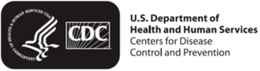
Permit to Conditionally Import a Dog into the United States - Multi-Entry
In accordance with 42 CFR Section 71.51 of the Public Health Service Foreign Quarantine Regulations, permission is granted to import the dog below into the United States.
PHS Permit Number | 5309-21-329-1001 If QR code not visible, see email attachment.
Permit valid: | 11/25/2021 to 05/24/2022
 | Name of pet: Wily  Date of Birth:01/01/2019  Sex: Female Neutered  Color: White and Brown  Rabies Vaccination: 06/29/2021  Titer date: 08/01/2021  Microchip Number:123456789  Country of Origin: El Salvador

