Webpages and Webforms for the Expert Directory

# Join the Expert Directory (webform)­

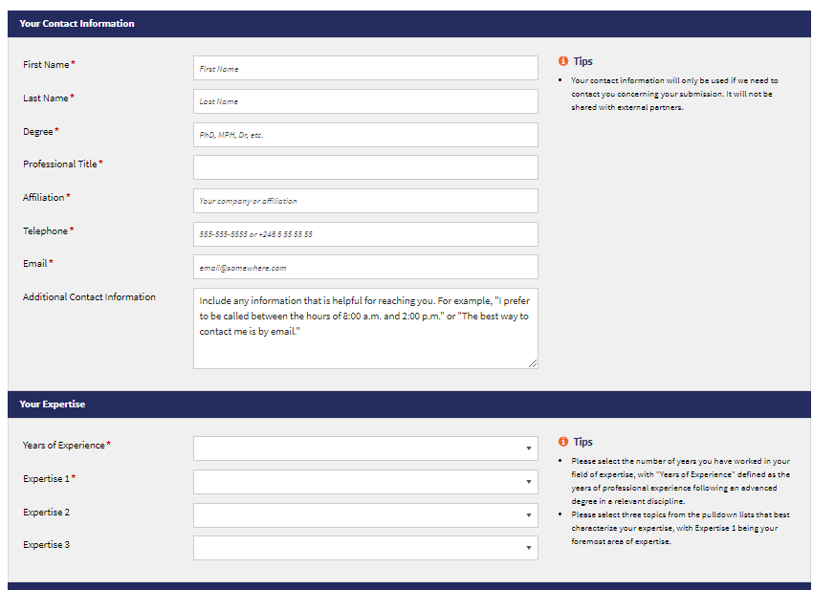

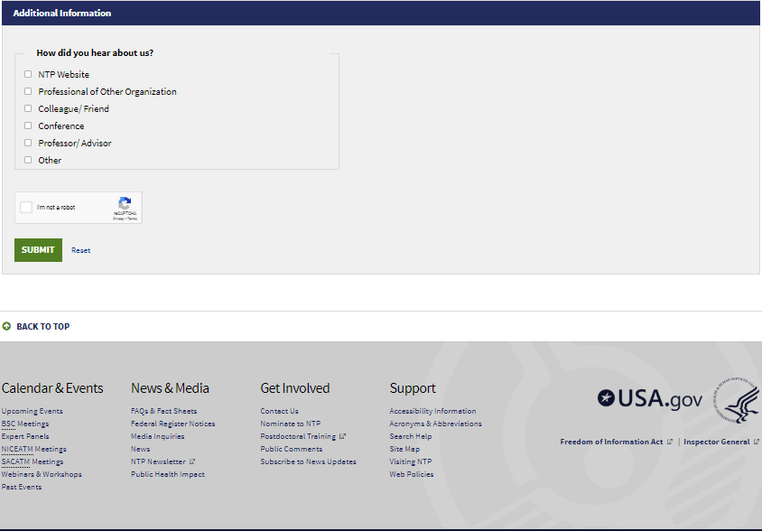

# Get Involved page



# 

# Join the Expert Directory page (before sub links are opened)

# Join the Expert Directory page (with links opened)

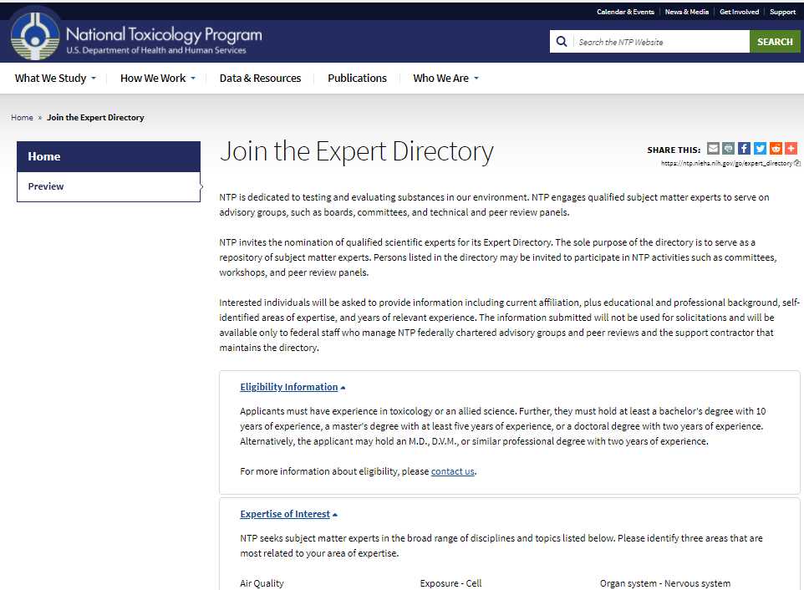

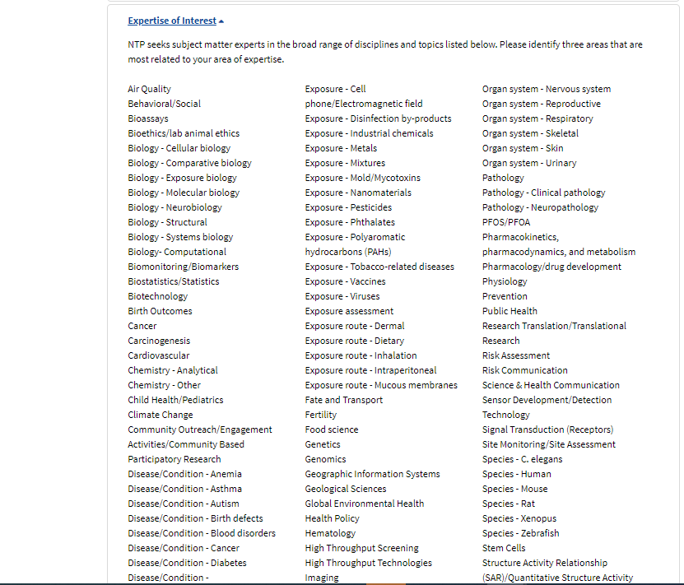

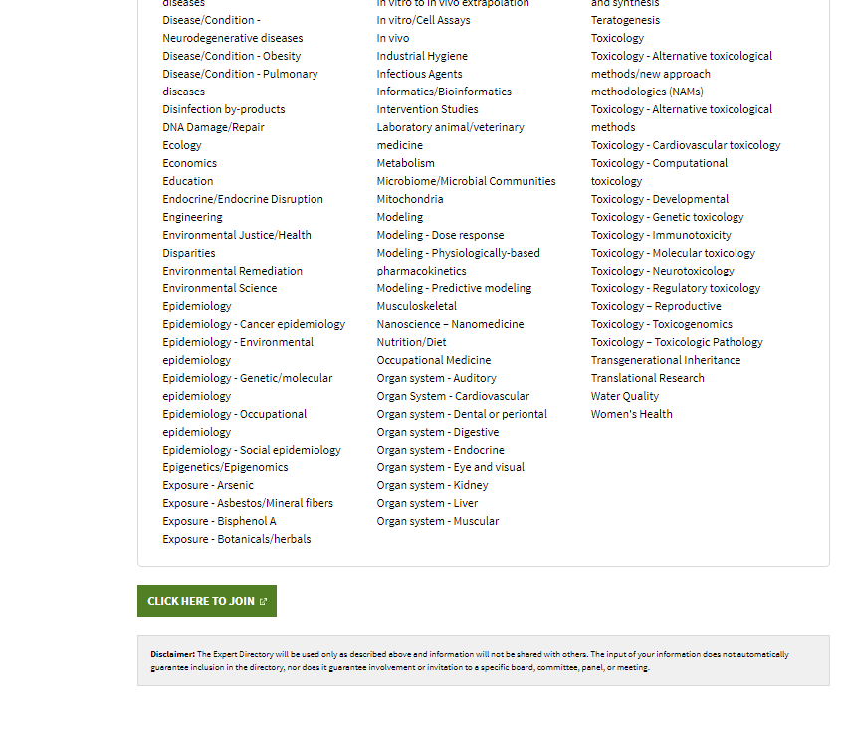

# Contact Us page

