Recruitment Messaging Kit

Social

Slack/MS Teams
Image: None

Content:
Hello @NIHDataScience followers. Do you find yourself looking for cancer data and analytics tools? Or do you want to learn more about sharing your data? Perhaps you build tools and algorithms? The National Cancer Institute’s Center for Biomedical Informatics and Information Technology is looking for cancer researchers and data scientists to share their information needs and preferences. Whether you are just beginning your career in cancer research or have decades of experience, we want to learn from you! To volunteer, please sign-up through this short survey:
###

Hello @NCIDataScience followers. Our division, NCI’s Center for Biomedical Informatics and Information Technology, is looking for cancer researchers and data scientists to share their information needs and preferences. We are interested in hearing from cancer researchers and data scientists at any stage in their career paths. We’d be very grateful if you would be willing to participate or share this opportunity with others in your network who want to help shape how we provide content about NCI cancer data science and informatics. To volunteer, please sign-up through this short survey:
###

@NCIDataSci
1. We aim to please! But to hit the mark, we need to hear from #DataScientists & #CancerResearchers like you. Sign up to share your thoughts with @theNCI #NCICBIIT. Your perspective is important!
[Char 193+]

2. What do you want? #NCICBIIT wants to know! We can’t provide you with tailored resources and information without your input, so please share your thoughts and preferences with us. #CancerResearchers and #DataScientists


3. Who doesn’t love a mystery? Well, we don’t when it comes to knowing your preferences for how we can provide #DataScience resources and info for your #CancerResearch. We’d love to get your thoughts:
[Char 218]
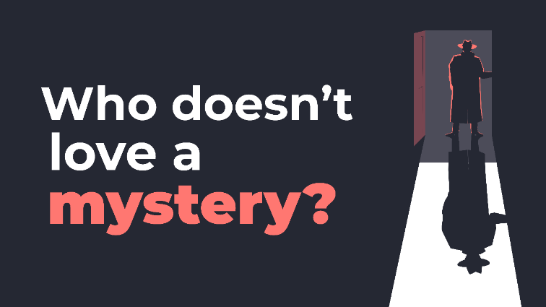

4. We want to get to know you better! Share a little bit with us so we can provide you with the resources and information that #CancerResearchers and #DataScientists need. Complete this survey by FILL IN DATE #NCICBIIT

5. Hey #DataScientists and #CancerResearchers, we want to know more about you! Spend a few minutes sharing your thoughts and preferences, we’ll return the favor by giving you more of the resources and content you need!

6. We’re still looking to learn from #DataScientists/CancerResearchers at any stage of your career. You have valuable insight and preferences. Please complete this survey.
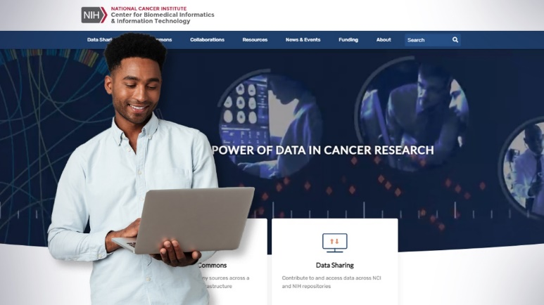

NCIJBSloan
The best part of my job is getting to know amazing #CancerResearchers and #DataScientists! Share a little bit about yourself with my @theNCI colleagues who want to get to know you better too. #NCICBIIT
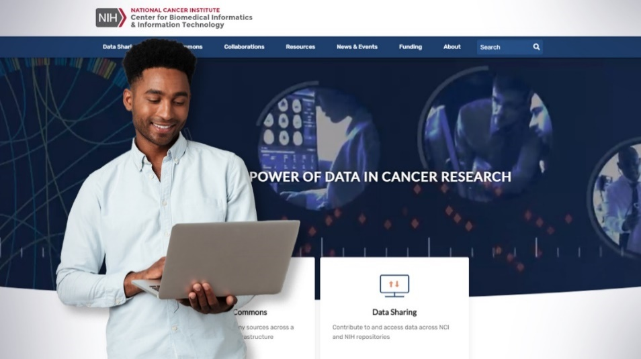

NCIKerlavage
The #NCICBIIT is looking for #DataScientists and #CancerResearchers to share their preferences. Taking this survey will help us provide you high quality info that you want. An honorarium will be provided for your time (if eligible). More at:

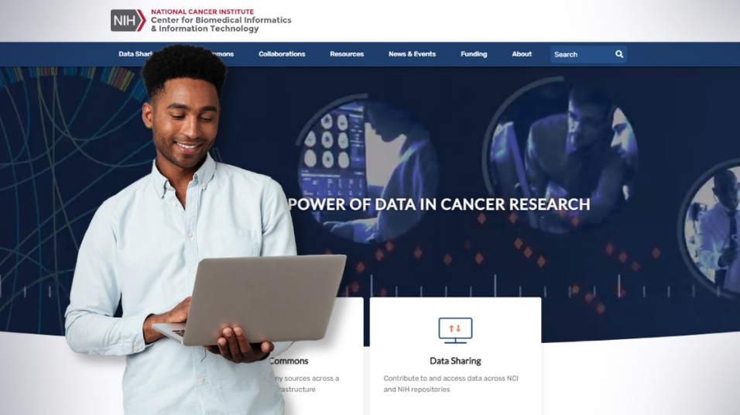

Email

Data Science List Servs
Posting Date: [TBD]
Image:
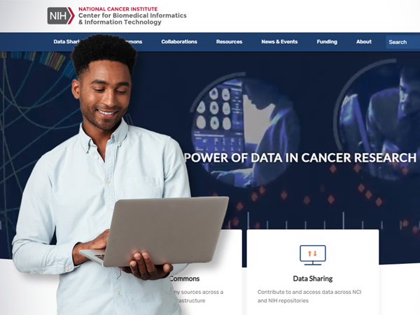
Subject: Help us solve a cancer data science mystery!
Subline: Tell us what you want! Data scientists and cancer researchers needed!
Content:
Dear NCI Cancer Researchers and Data Science Colleagues,
We strive for certainty, so help us solve a cancer data science mystery. We don’t know what you want when it comes to your resource and information preferences. We can take a guess, but it would be better if you would share your thoughts and preferences about the information and resources you need for your job. We are interested in hearing and learning from you, no matter where you are in your career. We want to provide you with content that helps you in this stage and beyond. Please participate if you are a:
- Cancer biologist
- Clinician
- Cancer bioinformatician
- Data scientist
First complete this short survey. For those interested and eligible, we will schedule follow up interviews.
We look forward to meeting with you and learning more about your needs.
Thank you,
NCI Center for Biomedical Informatics and Information Technology
###

Web

NCI Data Science News
Posting Date: TBD
Image:
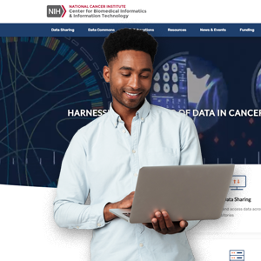
Title: Help Us Help You: Take Survey on Your Cancer Data Sci Information Needs
Summary: We want to learn more about the resource and information you need to work in cancer data science.
News Tags: N/A
Content:
We want to hear from cancer researchers and data scientists to learn more your information needs and preferences so that we can better serve you.
To kick off the conversation, please fill out this 13-minute screener survey so that we can follow up with you. Then, we will schedule remote listening sessions with researchers and data scientists across the cancer research community between [Date] and [date]. We’d love to hear from people who have different levels of career experience, so we can learn from those who are just starting out and those who are late career professionals.
Your feedback will help us plan new content and features to help you as you drive cancer research forward with data science.

Volunteer to share feedback

Web Banner
Banner Text:
Share Your Thoughts
Are you a cancer researcher or data scientist? We want to learn from you! Complete a short survey to help us create content that meets your needs.
