Attachment B

Revisions to the

SAMHSA SOAR Web-Based Data Form

Part II: Annual State Reporting

(2 Revisions)

Screenshots of the Current Quantitative Questionnaire
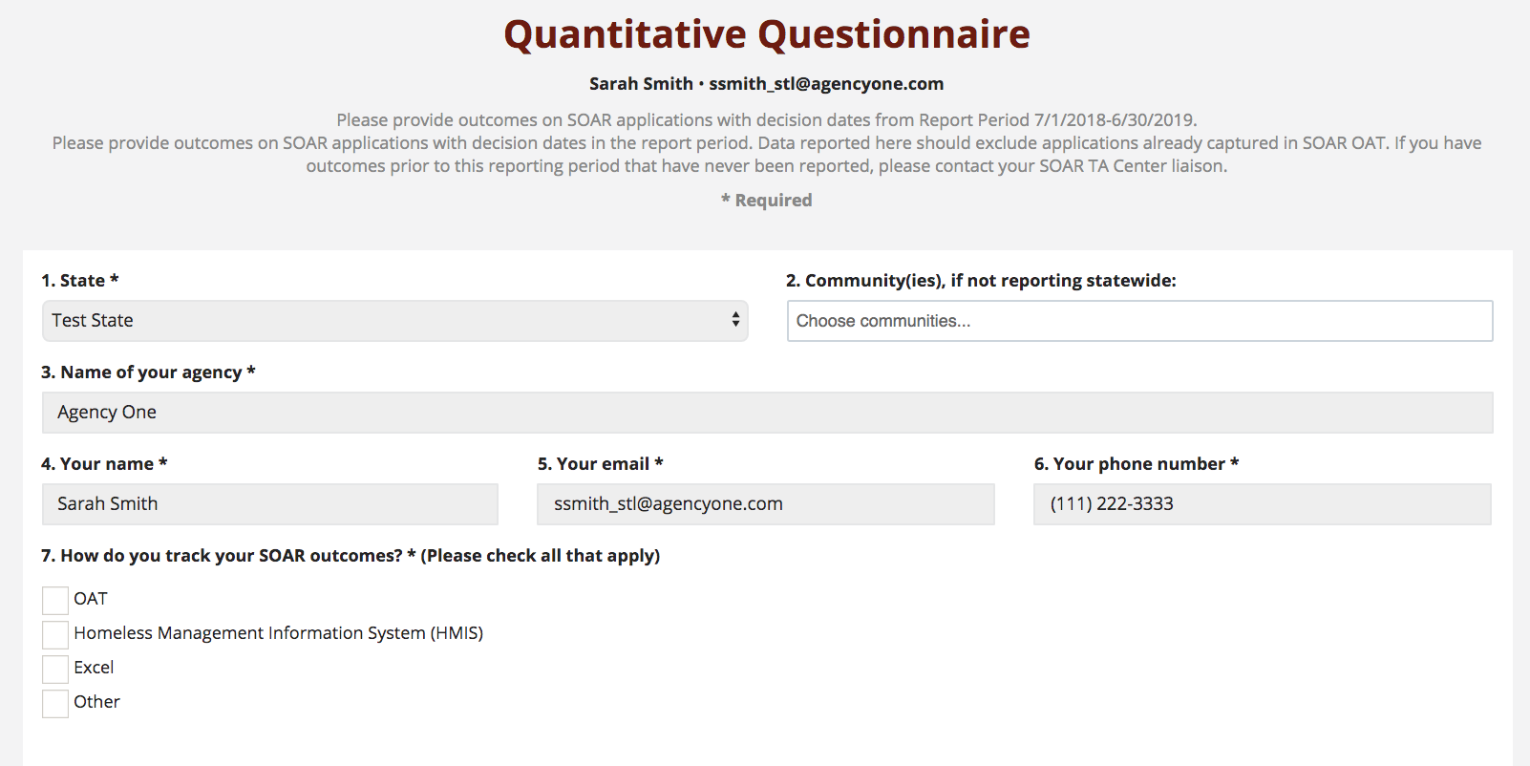

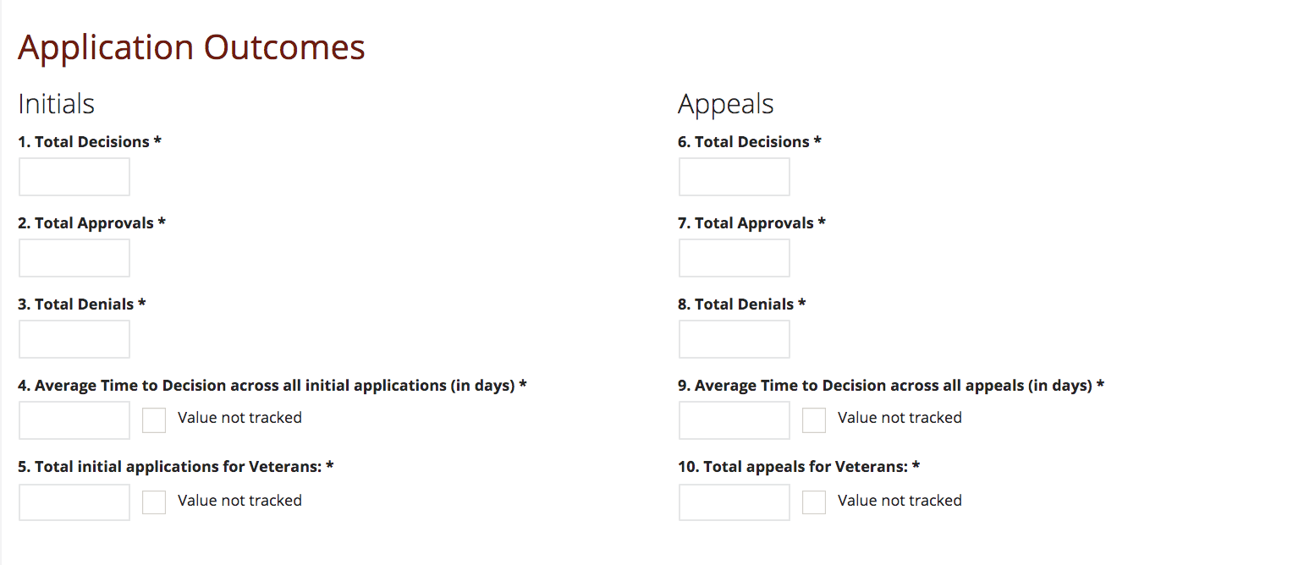

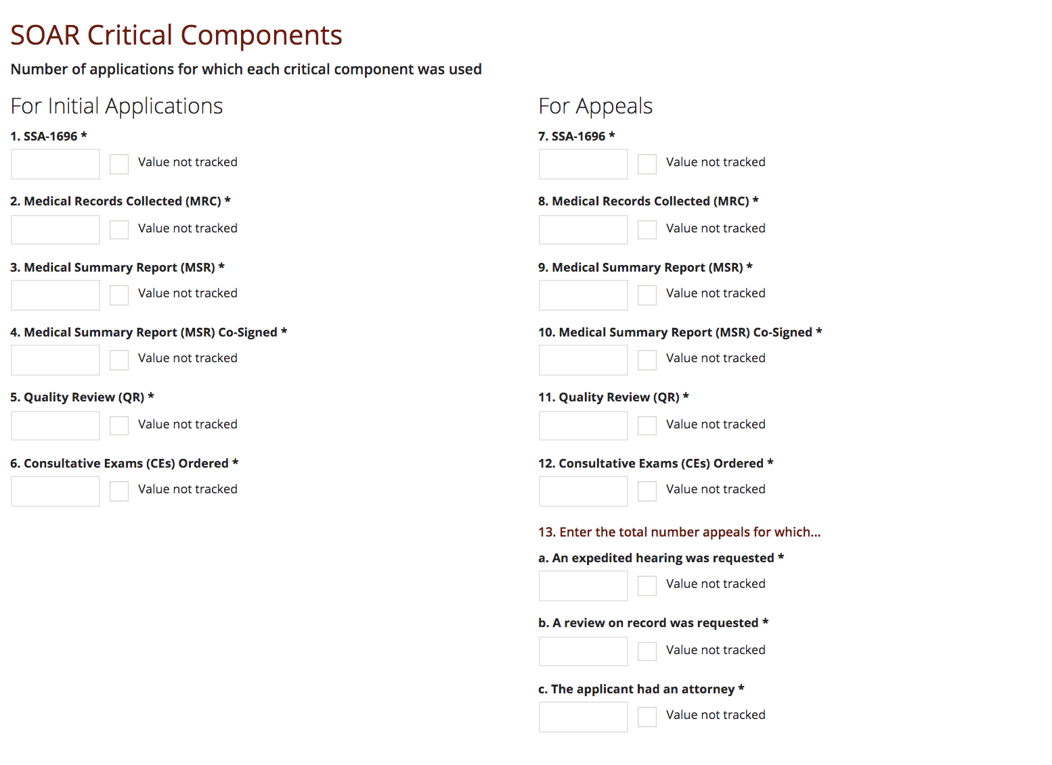

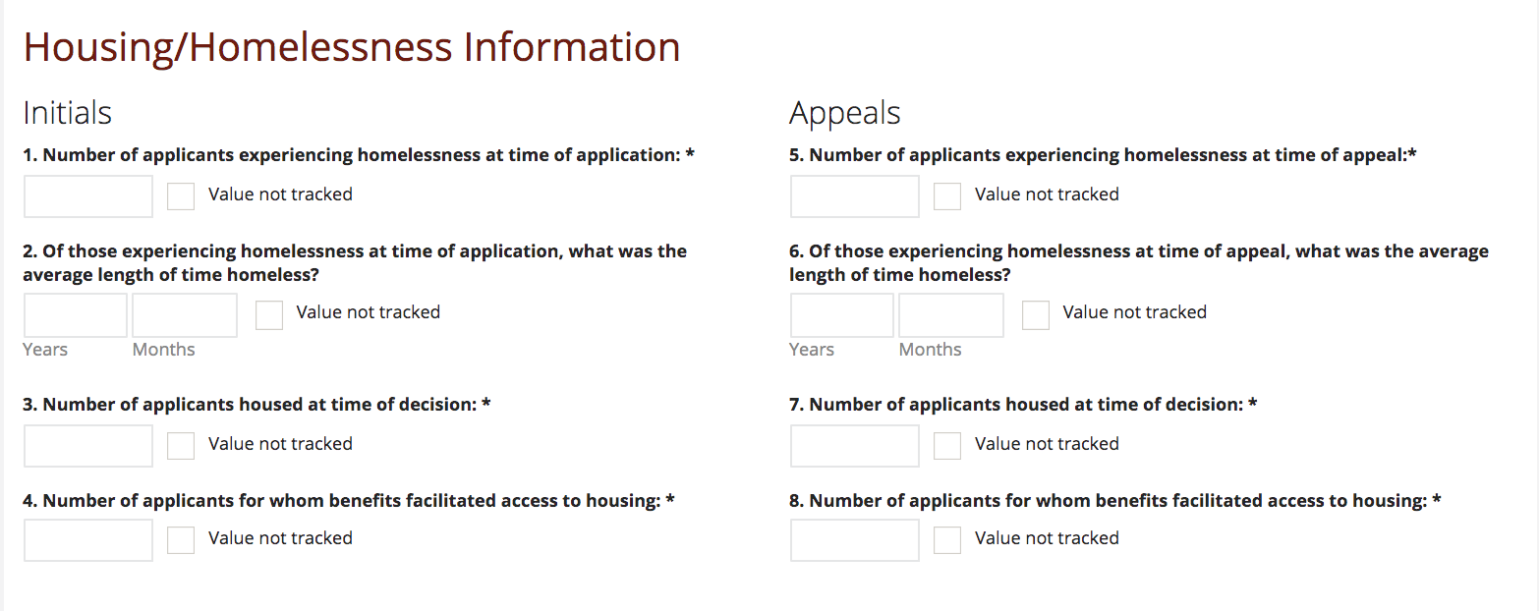
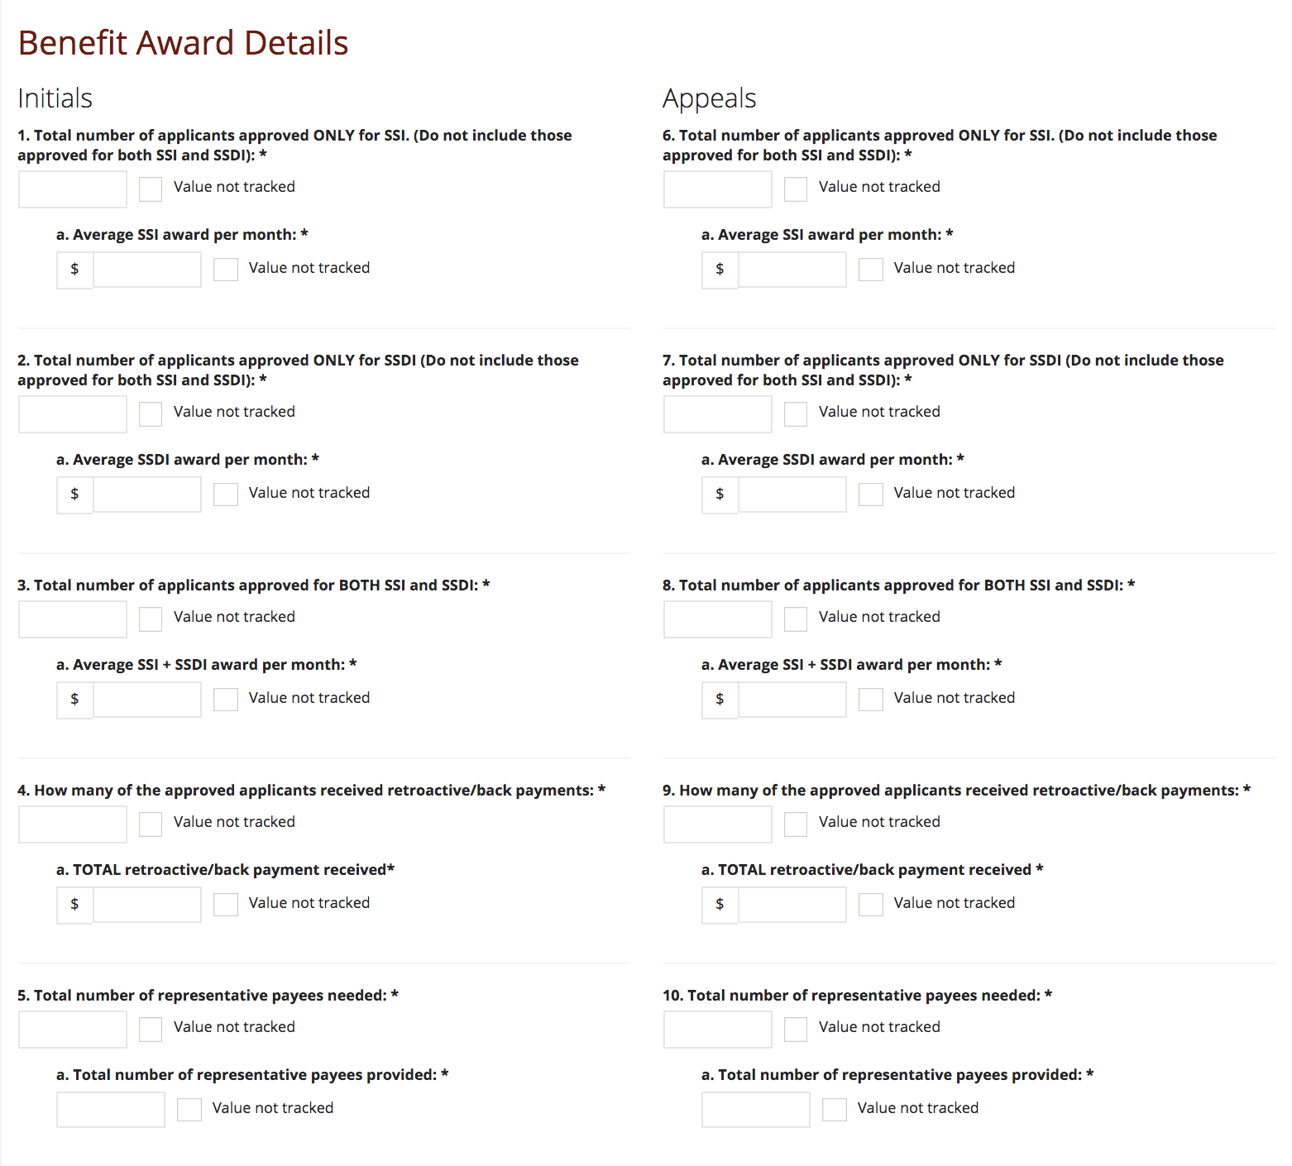
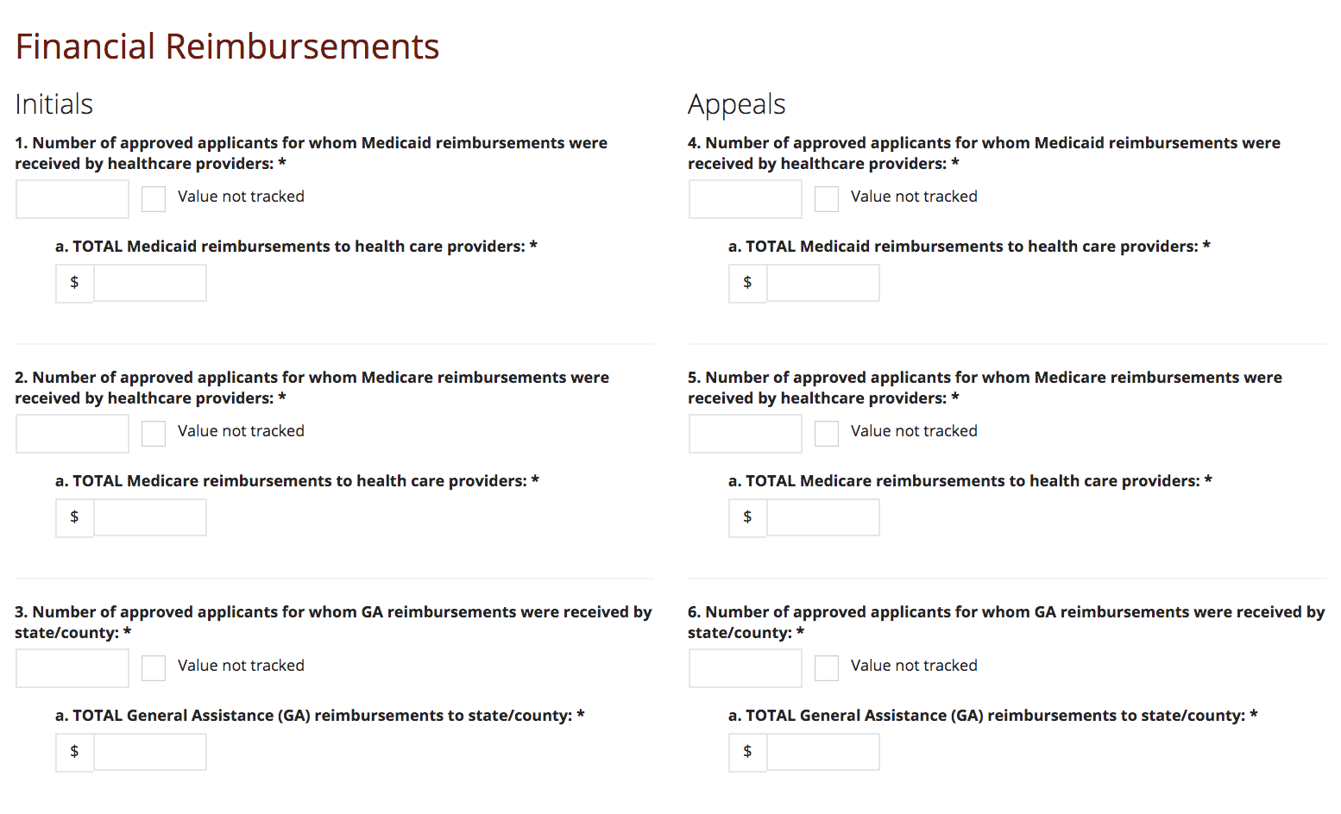
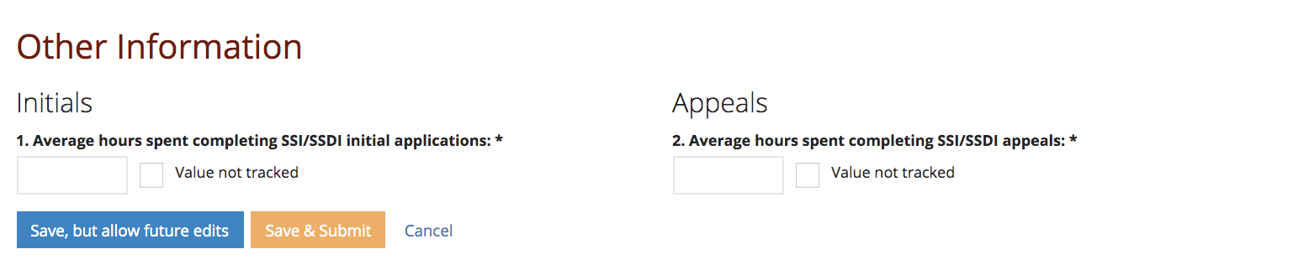
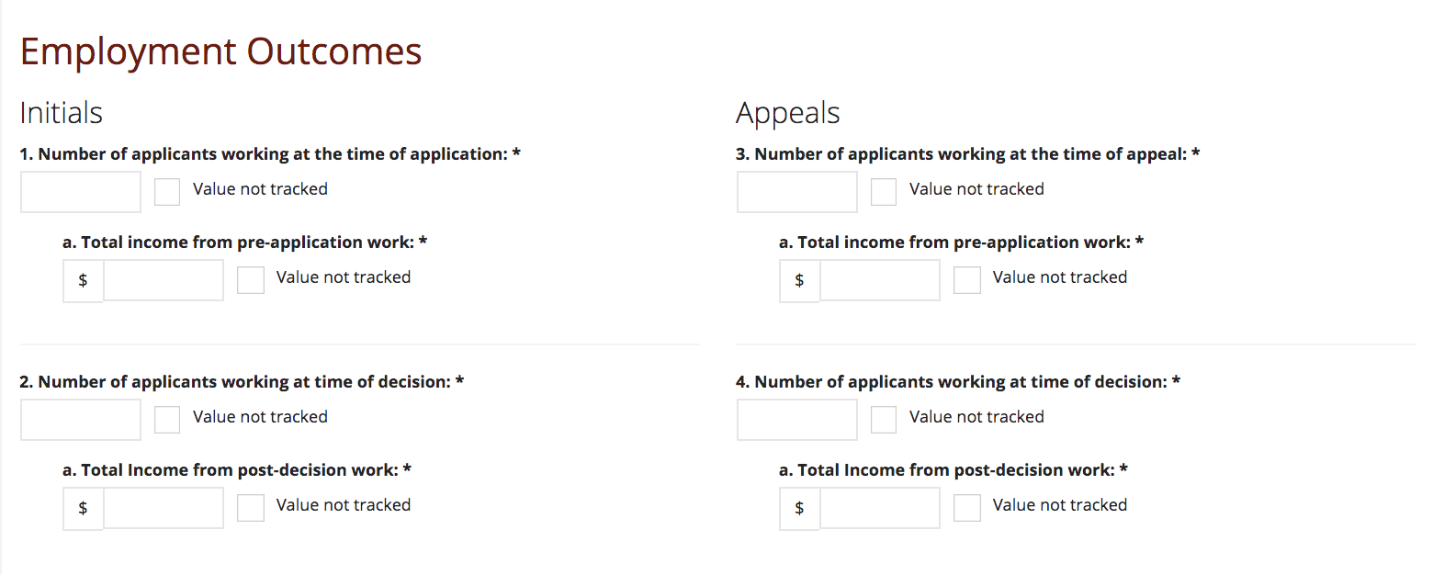

Additional Questions for the Qualitative Questionnaire

Additional Questions to be added to the Collaborations section of the Qualitative Questionnaire include the opportunity to describe collaborations with child-serving organizations and whether meetings and trainings were for SOAR for Adults or SOAR for Children.
- Please select/describe the collaborations that your SOAR program has with the following:
- Child Welfare
- Education System
- Juvenile Justice
- Children’s Behavioral Health
- Peer Supports (including youth, adults, and family supports)
2. For Steering Committees and Trainings questions, the answer options will be expanded to allow for State Team Leads to indicate whether the training or meeting was for SOAR for Adults or SOAR for Children.

Screenshots of the Current Qualitative Questionnaire
