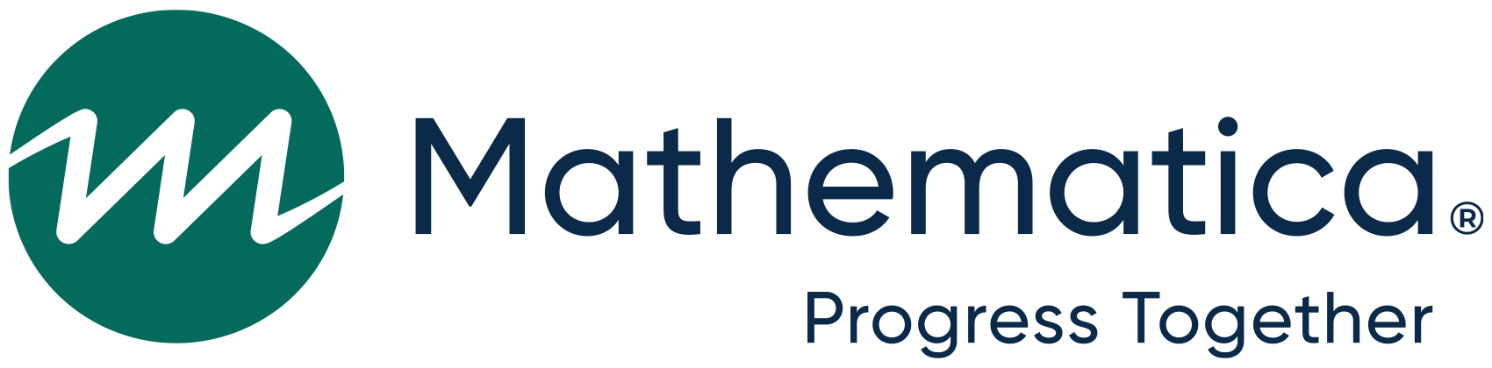
d
Project Impact rapid-cycle learning reflection and technical assistance feedback survey
January 2023
OMB #: 0970-0401
Expiration Date: June 30, 2024

We would like to collect some feedback about your experiences using rapid-cycle learning (RCL) and the supports available to you as a grant recipient of Project Impact, including individual coaching, the monthly group convenings, and the resources on the project website. Your feedback will help us understand your successes and challenges with the RCL process and inform similar projects that work with grant recipients similar to your organization.
Your responses to this survey will remain anonymous, meaning we will not attribute your responses to your name or organization. The survey should take no longer than 20 minutes to complete. We appreciate your honest feedback!

PAPERWORK REDUCTION ACT OF 1995 (Pub. L. 104-13) STATEMENT OF PUBLIC BURDEN: Public reporting burden for this collection of information is estimated to average 20 minutes per respondent, including the time for reviewing instructions, gathering and maintaining the data needed, and reviewing the collection of information. This is a voluntary collection of information. agency may not conduct or sponsor, and a person is not required to respond to, a collection of information subject to the requirements of the Paperwork Reduction Act of 1995, unless it displays a currently valid OMB control number. The OMB # is 0970-0401 and the expiration date is 06/30/2024. If you have any comments on this collection of information, please contact Roneika Carr at Roneika.Carr@acf.hhs.gov

Overall feedback on RCL
1. PITAS supported grant recipients in completing key steps in the RCL process. Rate the steps from easiest (1) to hardest (7) for your team to complete.
Rating
1-7
a. Identify a challenge to address through RCL
b. Propose a strategy and identify learning questions
c. Design a rapid-cycle learning test
d. Conduct a test and collect relevant, easily accessible information
e. Analyze information and learn from the results
f. Make evidence-informed decisions about next steps for the tested strategy
g. Develop a plan to share findings from the project with stakeholders or other communities
2. Throughout the grant, PITAS supported grant recipients in completing and updating an RCL Plan, which included developing a road map for change, completing a self-assessment, and developing learning questions.
What was the most useful part of the RCL Plan for your team?
Select one only
Developing a strategy- or project-level road map for change 1
Reflecting on the RCL self-assessment 2
Developing high-level learning questions 3
We did not find the RCL Plan to be a useful tool 4
NO RESPONSE M
3. In the final phase of the grant, PITAS supported grant recipients in assessing project success, planning for project sustainability and scaling, and documenting lessons learned and disseminating findings.
What was the most useful part of the final phase of the grant for your team?
Select one only
Assessing overall project success 1
Assessing project sustainability and creating a sustainability plan 2
Assessing potential for scaling and creating a scaling plan 3
Documenting lessons learned and disseminating findings 4
We did not find the final project phase to be useful 5
NO RESPONSE M

4. What were your team’s biggest successes related to RCL? (Such as learning new skills or getting staff to buy into the process)

NO RESPONSE M
5. What were your team’s biggest challenges related to RCL? (Such as staff time, lack of buy-in, or not understanding the RCL approach)

NO RESPONSE M

Individual coaching
Through PITAS, you worked closely with a coach from Mathematica or Public Strategies. This section asks you for feedback on that coaching.
6. I was satisfied with the quality of individual coaching through PITAS.
Select one only
Strongly agree 1
Agree 2
Disagree 3
Strongly disagree 4
NO RESPONSE M
7. The guidance provided by my PITAS coach helped our team to carry out rapid-cycle learning activities.
Select one only
Strongly agree 1
Agree 2
Disagree 3
Strongly disagree 4
NO RESPONSE M
8. How would you rate the frequency of meetings with your coach?
Select one only
We met too much 1
We met the right amount 2
We didn’t meet enough 3
NO RESPONSE M
9. What suggestions do you have for improving the individual coaching you received?

NO RESPONSE M

Group convenings
PITAS held group convenings via Webex on the third Wednesday of every month during the Project Impact grant period. In total, we hosted 10 group convenings this year on different topics related to rapid-cycle learning (e.g., road maps, methods, data collection, analysis). This section asks for your feedback on the monthly group convenings.
10. About how many group convenings did you attend?
Select one only
0 1 GO TO Q14
1-3 2
4-7 3
8-10 4
NO RESPONSE M
11. I was satisfied with the quality of the monthly group convenings.
Select one only
Strongly agree 1
Agree 2
Disagree 3
Strongly disagree 4
NO RESPONSE M
12. The guidance provided though monthly group convenings helped our team to carry out RCL.
Select one only
Strongly agree 1
Agree 2
Disagree 3
Strongly disagree 4
NO RESPONSE M
13. How would you rate the frequency of group convenings?
Select one only
I didn’t see value in meeting as a group 1
I would have preferred meeting less frequently 2
Monthly meetings were the right amount 3
I would have preferred meeting more frequently 4
NO RESPONSE M

14. What suggestions do you have for improving the group convenings for similar projects in the future?

NO RESPONSE M

Website
The PITAS website contained a library of resources to support your team in engaging with RCL. This section asks for your feedback on the PITAS website and resources.
15. How often did you seek out resources on the PITAS website?
Select one only
Frequently 1 GO TO Q16
Occasionally 2 GO TO Q16
Once or twice 3 GO TO Q16
Never 4
NO RESPONSE M
16. (If Q14 = Never) Why didn’t you use the website? Check all that apply.
Select all that apply
I didn’t know we had a project website 1
I didn’t need to use the website 2
My coach shared resources directly in our individual coaching calls 3
Other (SPECIFY) 99
Specify
NO RESPONSE M
17. I was satisfied with the quality of the PITAS website and resources housed there.
Select one only
Strongly agree 1
Agree 2
Disagree 3
Strongly disagree 4
NO RESPONSE M

18. The guidance provided in written materials on the PITAS website helped our team to carry out rapid-cycle learning.
Select one only
Strongly agree 1
Agree 2
Disagree 3
Strongly disagree 4
NO RESPONSE M
19. Please share any other thoughts on our website or quality of the resources offered (e.g., any resources that you used frequently or found useful).

NO RESPONSE M

Sustaining RCL beyond Project Impact
20. How likely is it that your team will continue to use RCL beyond Project Impact?
Select one only
Very likely 1
Likely 2
Somewhat likely 3
Not very likely 4
NO RESPONSE M
21. How likely is your organization as a whole to use RCL beyond the scope of your work for Project Impact?
Select one only
Very likely 1
Likely 2
Somewhat likely 3
Not very likely 4
NO RESPONSE M

Wrap up
22. Which form of technical assistance was most useful to support your organization’s use of RCL?
Select one only
Individual coaching 1
Group convenings 2
PITAS website and resources 3
NO RESPONSE M
23. What other supports, if any, would have been helpful?

NO RESPONSE M
24. Overall, how would you rate your experience being a grant recipient of Project Impact?
Select one only
Excellent 1
Good 2
Fair 3
Poor 4
NO RESPONSE M
25. Is there any other feedback related to Project Impact that you would like to provide?

NO RESPONSE M

