DATA COLLECTION SHEET (please print, fill out, and submit with your samples)
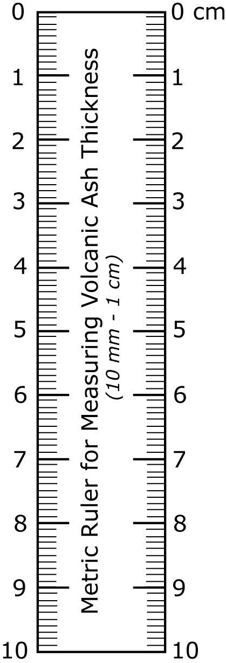
Please send samples and sample datasheet to:
A | B | C | D | E | F | G
Sample Number | Date & time of Collection (or duration if applicable) | Location of collection | Dimensions of container | Thickness of ash layer (nearest ½ millimeter) | Describe surface upon which ash has fallen | Describe weather conditions during ash fall, if known

USGS/Alaska Volcano Observatory, 4230 University Drive, Suite 201, Anchorage, AK 99508, 907-786-7497

Collector Contact Information: Name_______________________, Phone ________________, Email_____________________

H. Photos

Please indicate if you give permission to the Alaska Volcano Observatory to use your photographs on their
Webpage __________________________ all photos ____ select photos only____ (please indicate which images).
signature

Please only send copies or digital images as they will not be returned. All photos will be credited to photographer.

