Form: 5-5529 |  | OMB No. 1076-0157
 | UNITED STATES | Expires: ##/##/####
 | DEPARTMENT OF THE INTERIOR
 | BUREAU OF INDIAN AFFAIRS
REMOVABLE RANGE IMPROVEMENTS RECORDS

Reservation ________________________________ |  | Range Unit ________________________________

It is hereby certified that the following removable improvements have been constructed on Indian trust land or government-owned land on the above range unit during previous grazing permit periods and that I (we) claim ownership of said improvements (Show location on plat on page 2 or acceptable map):

Table 1. Existing removable range improvements claimed.
Improvement | Description | Dimensions (Length, capacity, …) | Estimated $ Value

The following removable improvements will be constructed (or purchased) on Indian trust land or government lands in the unit during the current permit period ___/___/______ to ___/___/______ (Show location on plat on page 2 or acceptable map):

Table 2. Removable range improvements planned.
Improvement | Description | Dimensions (Length, capacity, …) | Estimated $ Value

Authority is hereby requested to remove all the above improvements upon expiration of the grazing permit, provided my occupancy has been satisfactory, and it is understood that any improvements not shown in the above list will remain on the ground and become property of the landowner. It is further understood and agreed that all wells and casings on the range unit from which pumping equipment will be removed will be capped upon expiration of the permit contract in such manner that the succeeding permittee will be able to use the well. All the above improvements will be removed within thirty days of the expiration of the permit unless the time is extended by the Superintendent. Improvements not removed within the time limit become the property of the landowner.

Request | Approval
Permittee ____________________________ ___/___/______ | Superintendent _______________________ ___/___/______

Paperwork Reduction Act Statement: This form is covered by the Paperwork Reduction Act. It is used to establish the respective rights and responsibilities of the respondent and the Federal government. The information is provided by respondents to obtain or retain a benefit. In compliance with the Paperwork Reduction Act of 1995, as amended, the collection has been reviewed by the Office of Management and Budget and assigned a number and an expiration date. The number and expiration date are at the top right corner of the form. An agency may not sponsor or conduct, and a person is not required to respond to, a request for information collection unless it displays a currently valid OMB Control Number. The public reporting burden is estimated to average 20 minutes per respondent. This includes the time needed to understand the requirements, gather the information, complete the form, and submit it to the Department. Comments regarding the burden or other aspects of the form may be directed to the Indian Affairs Information Collection Clearance Officer, Office of Regulatory Affairs – Indian Affairs, 1849 C Street, NW, MS-4141, Washington, DC 202

Improvement | Symbol
Improvement | Existing | Planned
Fence | ---x---x--- | ---/---/---
Corral | 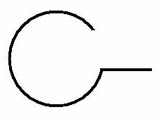 | 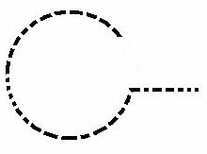
Well |  | 
Well and Windmill | 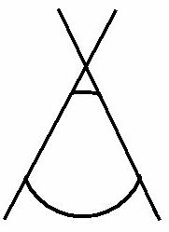 | 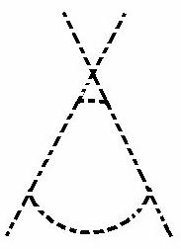
Tank |  | 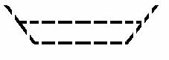
Building

