Application or Renewal of Self-Insurance Authority
Print

U.S. Department of Labor
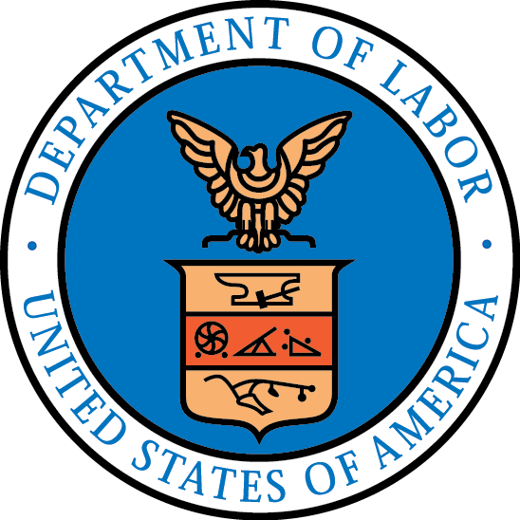
Office of Workers' Compensation Programs
Reset
www.dol.gov/owcp/dcmwc/index.htm

OMB No. 1240-0057
Expires: 11/30/2025
Use this form to request that the Office of Workers' Compensation Programs (OWCP) authorize your company (or continue to authorize you) to self-insure your obligations under the Black Lung Benefits Act (BLBA), 30 USC 901-944. 30 USC 933(a)(1). OWCP will not consider any self- insurance authorization request without a completed application. 30 USC 933(a)(1); 20 CFR 726.102, 726.112.
OWCP will use the information in this application to determine whether you possess sufficient ability to pay benefits, furnish medical services and supplies, and meet all other obligations under the BLBA. 20 CFR 726.104. OWCP will also use this information to fix the amount of security you must deposit to guarantee payment of benefits and all other obligations under the BLBA. 20 CFR 726.104-726.105.
INSTRUCTIONS: You must complete all items; please see the attached instructions for guidance. If you need more space than provided, attach additional pages. Please specify the item you are answering on any additional sheet. OWCP will also use this information to fix the amount of security you must deposit to guarantee payment of benefits and all other obligations under the BLBA.
New applicants: The application must be accompanied by: (1) Form CM-2017b, “Report of Claims Information.” (2) A statement from your insurance carrier(s) showing all BLBA benefits paid for the past three years. (3) A current, certified actuarial report on your existing and future BLBA liabilities.
Renewal applicants: The application must be accompanied by: (1) Form CM-2017b, “Report of Claims Information. (2) A current, certified actuarial report on your existing and future BLBA liabilities unless you have provided one to OWCP within the past three years.

1. Name, address, and FEIN of parent company Name
Addr1
FEIN:
City

Addr2
- Name, address, and FEIN of each subsidiary company Name
Addr1
Addr2
- NATURE OF BUSINESS - Check all that apply:
State Zip Country United States FEIN:

City
State Zip Country United States

Bituminous coal
Anthracite coal
Lignite coal
Sub-bituminous coal

Underground mining
Surface mining
Preparation plants Coal transportation/coal mine construction

- Information appearing in the columns below should relate to employees covered by the BLBA and for which self-insurance authorization is requested.
a. Mine site names and locations | b. Subsidiary name mine site operates under | c. MSHA ID # | d. Mining type | e. Number of covered employees | f. Total payroll for covered employees for past three years 20**/20**/20**
Form CM-2017

- If this application is granted, which form of security would you prefer to deposit? Commercial Insurance
Indemnity Bond Federal Deposit
Letter of Credit, in conjunction with one of the above securities

- How do you intend to administer claims? (If you have checked "a", give name and address of persons responsible for claims handling, with

  - Deal directly with employees
  - Use a Third Party Administrator
brief resume of their experience. If you have checked "b", give name and address of the Third Party Administrator, and describe the arrangements, including what, if any, experience the organization has in administering claims under the BLBA.) You must provide the name, telephone number, and email of the primary point of contact for BLBA claims.

- Total Claims Data for Previous Three Years
 | 20 |  |  | 20 | 20
a. # Claims awarded and accepted,
excluding Medical Benefits Only claims
b. # Medical Benefits Only claims being paid
c. # Claims awarded but challenged at hearing or appellate
level
d. # New claims filed
e. Indemnity benefits paid | $ |  |  | $ | $
f. Medical benefits paid | $ |  |  | $ | $
8. Date of incorporation (mm/dd/yyyy) |  | 9. State of incorporation | 10. Date applicant was established (if not a corporation) (mm/dd/yyyy)
11. Did you succeed anyone? (If "Yes," state whom and explain the transaction)  Yes No |  |  |  | 12. Has your corporate/business structure changed in the past three years? (If “Yes,” explain the change)  Yes No
13. Name of President |  |  |  | 14. Name of Vice President
15. Name of Treasurer |  |  |  | 16. Name of Secretary
- Name, telephone number, and email address of Risk Manager Telephone Email

- I certify that I am an official of the Applicant, duly authorized to file this application, that I have carefully examined the foregoing statements, and the facts in this application and required attachments are true.

I also certify that the Applicant will, if authorized to self-insure:
  - Comply with all statutory and regulatory obligations under the BLBA;
  - Make timely payments of benefits, including medical treatment benefits, required under effective orders;
  - Monitor claims administration by any insurance service organization or other claims handlers to be sure benefits are paid promptly;
  - Promptly comply with all OWCP requests for information necessary to determine self-insurance authorization and the amount of a security deposit;
  - Make and maintain a security deposit, in a form and in an amount determined by OWCP, subject to OWCP's order; and
  - Advise OWCP immediately of any change in corporate or business structure, or sale of significant coal mining assets

Signature
(SEAL)

Telephone

- Name and Title 20. Date of this application (mm/dd/yyyy)

DO NOT WRITE IN THE ITEMS BELOW
21. Date application received (mm/dd/yyyy) 22.OWCP Certification

Public Burden Statement

According to the Paperwork Reduction Act of 1995, no persons are required to respond to an information collection unless such collection displays a valid OMB control number. We estimate that it will take an average of 2 hours per response to complete this collection of information, including time for reviewing instructions, searching existing data sources, gathering and maintaining the data needed, and completing and reviewing the collection of information. Use of this form is optional; however, furnishing the information is required to obtain or retain authorization to self-insure under the BLBA. Send comments regarding this burden estimate or any aspect of this information collection process, including suggestions for reducing this burden, to the U.S. Department of Labor, 200 Constitution Avenue, NW, Room N-3464, Washington, D.C. 20210 and reference the OMB Control Number.

