Supporting Statement
( Application for Employment with the Federal Aviation Administration)
OMB 2120-0597

1. Explain the circumstances that make the collection of information necessary. Identify any legal or administrative requirements that necessitate the collection.

Under the provisions of Public Law 104-50, the Federal Aviation Administration (FAA) was given the authority and the responsibility for developing and implementing its own personnel system without regard to most of the provisions of Title 5, United States Code, except those that apply to veteran’s preference and various benefits. This collection of information is pertinent for gathering data concerning potential new hires for the Federal Aviation Administration (FAA). The information collected is essential to establish basic eligibility for employment and potential eligibility for Veteran’s Preference, Veteran’s Readjustment Act, and People with Disability appointments. In addition, there are specific occupation questions that assist FAA’s Office of Human Resource Management (AHR) in concluding candidates' qualifications to ascertain the best-qualified candidates are hired for the many FAA occupations. Without this collection of information, reliable means to accurately evaluate applicants' skills, knowledge, and abilities to perform the duties of these positions are limited.

2. Indicate how, by whom, and for what purpose the information is to be used. Except for a new collection, indicate the actual use the agency has made of the information received from the current collection.

Applicants interested in applying for jobs with the FAA voluntarily complete the online Web based application (USAJOBS/AVIATOR) process. The FAA Automated Vacancy Information Access Tool for Online Referral (AVIATOR) facilitates the FAA hiring process with instant certification of qualified candidates for employment. It allows simultaneous online application submittal; screening and testing; scoring and notification; eligibility list placement; and referral for interview. Once an applicant’s electronic application form is complete and the job announcement date expires, FAA Office of Human Resource Management, Human Resources (AHR) performs qualification reviews.

Qualification Reviews:

- AHR specialists perform qualification reviews on submitted applications for a job vacancy announcement on which they have access to witnin AVIATOR. The AHR specialist will select the job vacancy and navigate to the list of applicants’ names and profiles. The AHR specialist can select a particular applicant, review the submitted questionnaire, review the attached documents, and perform any adjudications or exclusions.
- The adjudication and exclusions process entails a review of the the application and supplementary documentation by staff within AHR; thereafter, making a determination based on AHR best practices, AHR standards, and federal law. This is an initial AHR vetting process to ensure applications are complete and that individuals meet basic qualifications before an application is submitted to hiring officials.
- There are no system outputs or reports generated during this review process. Following are applicant’s profile information that is reviewed by the AHR specialist:
Full Name
Full Address
Phone number
Citizenship status
Selective Service status
Military Service status (for military preference)
Employment history (i.e. resume)
Applicable Documents required to be submitted

Creation of a referral list follows the qualification reviews.

Referral List Creation:
- The AHR specialist can create a referral list of qualified applicants for a job vacancy announcement on which they have access.
- The AHR specialist will then select the particular case vacancy announcement, navigate to create referral list module and enter the criteria required to create the list of referred applicants.

In summary, the data gathered from the Federal Aviation Administration (FAA) Application for Employment is analyzed and evaluated by AHR specialists to identify applicants with required qualifications for a variety of positions within the FAA. While the FAA is exempt from provisions relating to normal competitive examination processing within Title 5, USC, Sections 3302-3305, this process enables the FAA to establish a selection pool of best-qualified candidates to fulfill its many critical safety-related jobs.

3. Describe whether, and to what extent, the collection of information involves the use of automated, electronic, mechanical, or other technological collection techniques or other forms of information technology.

In accordance with the Government Paperwork Elimination Act, the collection of information is fully automated with Web enabled transmission: employment application forms are automated and completed by applicants online via a Web based system. They are collected and processed within a database that utilizes innovative Web tools and enhanced code scripting with efficient database (DB) process flow. This systematic framework enhances user input/output DB processing time. In conjunction with unique job announcements tailored to specific job requirements, the applicants’ reporting burden is minimized: FAA is able to maximize the reliability and validity of the rating process.

4. Describe efforts to identify duplication. Show specifically why any similar information already available cannot be used or modified for use for the purposes described in Item 2 above.

This information is not gathered by any other collection entity. The FAA AVIATOR system is integrated with the Office of Personnel Management’s USAJOBS system, which has its own data collection processes and authority. Applicants must complete a profile containing their contact information, resumes, work history, supporting documents, etc. via USAJOBS. The profile information is automatically collected from USAJOBS by AVIATOR data services when an applicant applies on an FAA announcement. The profile data as well as resume and other documentation are stored in AVIATOR as part of the job application. Subsequent changes or updates by the applicant to their profile or documentation in USAJOBS are not collected by AVIATOR unless the applicant re-applies. This profile can be used repeatedly to apply for numerous jobs of interest. This relieves the burden for the applicant to duplicate this information each time they apply for job.

5. If the collection of information involves small businesses or other small entities, describe the methods used to minimize burden.

The collection of information does not impact small business or other small entities.

6. Describe the consequence to Federal program or policy activities if the collection is not conducted or is conducted less frequently, as well as any technical or legal obstacles to reducing burden.

The information collection is utilized in the evaluation and qualification hiring process of job applicants for various critical aviation safety positions, including other aviation regulations, certifications, as well as other essential positions. Void of the collection, the FAA would have limited reliable methods to analyze and evaluate accurately applicant’s skills to ensure attainment of best-qualified candidates for FAA positions.

The frequency of the collection is not determined by the FAA. It is determined by the desire of the individual to apply for a job with the FAA. If the frequency of the collection was otherwise limited, the FAA would not be able to fill FAA positions.

7. Explain any special circumstances that would cause an information collection to be conducted in a manner:
- requiring respondents to report information to the agency more often than quarterly;
- requiring respondents to prepare a written response to a collection of information in fewer than 30 days after receipt of it;
- requiring respondents to submit more than an original and two copies of any document; requiring respondents to retain records, other than health, medical, government contract, grant-in-aid, or tax records, for more than three years;
- in connection with a statistical survey, that is not designed to produce valid and reliable results that can be generalized to the universe of study;
- requiring the use of a statistical data classification that has not been reviewed and approved by OMB;
- that includes a pledge of confidentiality that is not supported by authority established in statute or regulation, that is not supported by disclosure and data security policies that are consistent with the pledge, or which unnecessarily impedes sharing of data with other agencies for compatible confidential use; or
- requiring respondents to submit proprietary trade secrets, or other confidential information unless the agency can demonstrate that it has instituted procedures to protect the information's confidentiality to the extent permitted by law.
There are no special circumstances.

8. Provide information on the PRA Federal Register Notice that solicited public comments on the information collection prior to this submission. Summarize the public comments received in response to that notice and describe the actions taken by the agency in response to those comments. Describe the efforts to consult with persons outside the agency to obtain their views on the availability of data, frequency of collection, the clarity of instructions and recordkeeping, disclosure, or reporting format (if any), and on the data elements to be recorded, disclosed, or reported.

A Federal Register Notice published on 24 January 2023 (88 FR 4280) solicited public comment. No comments were received.
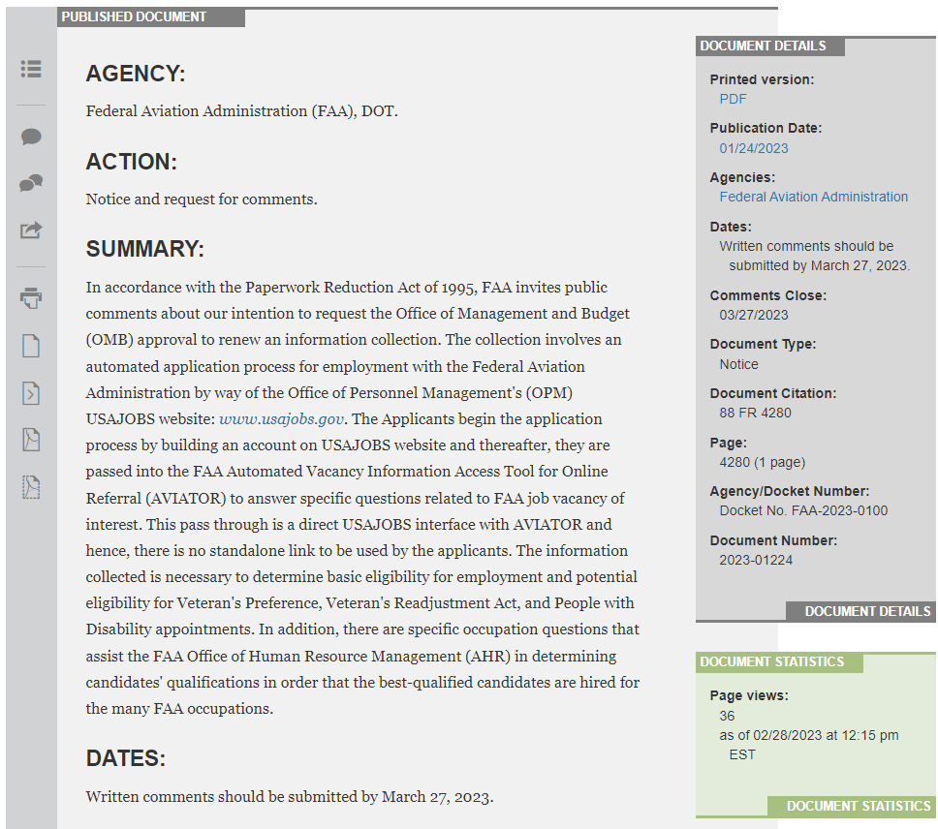

9. Explain any decision to provide any payment or gift to respondents, other than remuneration of contractors or grantees.

No payment or gifts will be provided to respondents.

10. Describe any assurance of confidentiality provided to respondents and the basis for the assurance in statute, regulation, or agency policy.

Assurance of confidentiality is that applicable to the Privacy Act notice: Privacy Act of 1974, as amended. Information becomes part of the Privacy Act System of Records OPM/GOVT-5, Recruiting, Examining, and Placement Records.

11. Provide additional justification for any questions of a sensitive nature, such as sexual behavior and attitudes, religious beliefs, and other matters that are commonly considered private.

No questions of a sensitive or private nature are asked.

12. Provide estimates of the hour burden of the collection of information. The statement should:

- Indicate the number of respondents, frequency of response, annual hour burden, and an explanation of how the burden was estimated. Unless directed to do so, agencies should not conduct special surveys to obtain information on which to base hour burden estimates. Consultation with a sample (fewer than 10) of potential respondents is desirable. If the hour burden on respondents is expected to vary widely because of differences in activity, size, or complexity, show the range of estimated hour burden, and explain the reasons for the variance. Generally, estimates should not include burden hours for customary and usual business practices. * If this request for approval covers more than one form, provide separate hour burden estimates for each form and aggregate the hour burdens.
- Provide estimates of annualized cost to respondents for the hour burdens for collections of information, identifying and using appropriate wage rate categories. The cost of contracting out or paying outside parties for information collection activities should not be included here. Instead, this cost should be included under item 13.
It is estimated that approximately 180,000 respondents will complete an application form on an annual basis. Based on this sample of potential applicants, it is estimated that the average respondent requires approximately 1 hour to read the instructions and complete the application form, although the range could be as little as .25 hours to as much as 2 hours per respondent. The total burden is estimated to be 180,000 hours annually.
The estimated total annualized labor cost to respondents for the hour burdens for collecting the information is approximately 4 million. This figure is determined by multiplying the total hourly burden (180,000) by the average hourly starting pay ($22.57 / hour) of the positions for which individuals are applying (FG-9 level, equivalent of the GS-9 grade level in the Civil Service).

Summary (Annual numbers) | Reporting | Recordkeeping | Disclosure
# of Respondents | 180,000
# of Responses per respondent | 1
Time per Response | 1 Hr.
Total # of responses | 180,000
Total burden (hours) | 180,000 Hrs

Copy of FY 2022 Salary Chart from Office Of Personnel Management (OPM) is as follows (reference: https://www.opm.gov/policy-data-oversight/pay-leave/salaries-wages/salary-tables/22Tables/html/GS_h.aspx):

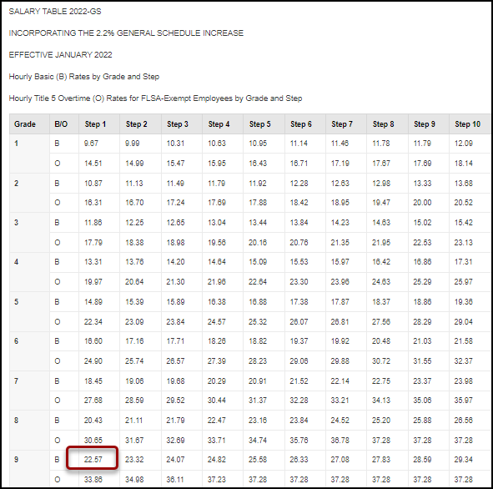

13. Provide an estimate for the total annual cost burden to respondents or record keepers resulting from the collection of information.

There are no annual related cost buden to repsondents or record keepers resulting from the collection of information.

14. Provide estimates of annualized costs to the Federal government. Also, provide a description of the method used to estimate cost, which should include quantification of hours, operational expenses (such as equipment, overhead, printing, and support staff), and any other expense that would not have been incurred without this collection of information.

Annualized costs associated with the collection of this information are binding via a best interest determination Interagency Agreement (IAA) between Federal Aviation Administration (FAA) and the US Office of Personnel Management (OPM). The purpose of the IAA is to provide necessary funds to support services furnished by the US Office of Personnel Management. OPM coordinates efforts concerning implementation and maintenance of the AVIATOR System, which the FAA uses to interface with the USAJOBS application. The annualized cost of the IAA for Fiscal Year 2023 is $452,468.00; estimate of the annualized cost is established by OPM.

Respondent involvement is limited to technical and functional system support services; i.e., advising applicants on the application process and/or status of their applications where automation does not suffice, correcting/updating applicant records, etc. 1 FTE of a staffing assistant, FV-E, at a cost of $56,536 per annum will be dedicated to providing functional support to applicants.

The FAA Office of Human Resource Management’s staff (HR staff) are tasked with reviewing and evaluating the applications that were not screened out by the automation in the AVIATOR system. Statistics show that approximately 80% of applications pass the automated screening process and require further review by HR staff. It is estimated that this equates to 144,000 applications needing a review. A HR staff member takes approximately 10 minutes to review an application; hence, it is estimated that HR staff spend approximately 23,040 hours per year reviewing applications. The average hourly salary (midpoint) of a HR staff at the FV-H level is $42.56, including Locality Pay. Given such, the estimated cost to review 80% of the applications would be $980,582 (23,040 hours X $42.56 hourly rate).

The total cost to the government is $452,468.00+ $56,536 + $980,582 = 1,489,586.00
Any other expenses are considered customary and usual.

15. Explain the reasons for any program changes or adjustments.

The adjustment is based OPM’s program service fees, cost of living/inflation, system operation and maintenance requirements. The reduction in man-hours for the review process is attributed to HR user training on performing qualifications reviews.

16. For collections of information whose results will be published, outline plans for tabulation and publication. Address any complex analytical techniques that will be used. Provide the time schedule for the entire project, including beginning and ending dates of the collection of information, completion of report, publication dates, and other actions.

The information collected will not be published.

17. If seeking approval to not display the expiration date for OMB approval of the information collection, explain the reasons that display would be inappropriate.

Such approval is not being pursued.

18. Explain each exception to the topics of the certification statement identified in “Certification for Paperwork Reduction Act Submissions.”

There are no exceptions to the certification statement.

