Table of Contents
SECTION I. LEARNER EXPERIENCE (e.g. STUDENT / EDUCATOR)NAVIGATING THE COMMUNITY AS A LEARNER (I.E. STUDENT OR EDUCATOR) 3
1. Public Home Page View 4
2. NASA Privacy Statement 4
3. Paperwork Reduction Act Statement 5
1.2 CREATE PROFILE 7
1. Age Verification 7
2. Minors 15 Years or Under 8
3. Minors 16 - 17 Years | Enter Parent / Legal Guardian Contact Info 9
4. Parent / Legal Guardian Consent Response = No 9
5. Parent / Legal Guardian Consent Response = Yes 11
6. Create Profile – NASA Media Release 12
7. Create Profile – Personal Information 13
8. Create Profile – Demographic Information 14
9. Create Profile - Demographic Information Help Text 15
10. Create Profile – Citizenship 16
11. Create Profile – Education or Affiliate Organization for Student 17
12. Create Profile – Education or Affiliate Organization for Educator 18
1.3 APPLY TO OPENINGS 19
1. Internships & Pathways Applications – Personal Information 19
2. Internships & Pathways Applications – Education or Affiliate Organization 20
3. Internships & Pathways Applications – Employment 21
4. Internships & Pathways Applications – Other Experience 22
5. Internships & Pathways Applications – Documents 23
6. Internships & Pathways Applications – Skills 24
7. Internships & Pathways Applications – Languages 25
8. Internships & Pathways Applications – Letter of Recommendation Invitation 26
9. Internships & Pathways Applications – Submit Letter of Recommendation 27
10. Internships & Pathways Applications – Submit Letter of Recommendation Continued 28
11. Internships & Pathways Applications – Availability 29
12. Challenges Application – Institutions 30
13. Challenges Application – Team Information 31
14. Challenges Application – Documents 32
15. Fellowships & Research Opportunities Application – Identification Numbers 33
16. Fellowships & Research Opportunities Application – Points of Contact 34
17. Fellowships & Research Opportunities Application – Documents 35
18. Educator Professional Development Application – Basic Information 36
19. Educator Professional Development Application – Planned Implementation 37
20. Educator Professional Development Application – Estimated Numbers 38
21. College / Pre-College STEM Experience Group Registration – Primary & Secondary Point of Contact 39
22. College / Pre-College STEM Experience Group Registration – Primary & Secondary Point of Contact 40
23. College / Pre-College STEM Experience Group Registration – Planned Implementation 41
24. College / Pre-College STEM Experience Group Registration – Number of Educators 42
25. College / Pre-College STEM Experience Group Registration – Number of Students 43
26. College / Pre-College STEM Experience Group Registration – Supporting Documentation 44
27. College / Pre-College STEM Experience Application – Personal Information 45
28. College / Pre-College STEM Experience Application – Education or Affiliate Organization 46
29. College / Pre-College STEM Experience Application – Documents 47
30. College / Pre-College STEM Experience Application – Letter of Recommendation Invitation 48
31. College / Pre-College STEM Experience Application – Submit Letter of Recommendation 49
32. College / Pre-College STEM Experience Application – Submit Letter of Recommendation Continued 50
1.4 ACCEPT/DECLINE OFFER 51
1. Offer Letter - Respond to Offer (Accept / Decline) 51

SECTION I. LEARNER EXPERIENCE (e.g. STUDENT / EDUCATOR)NAVIGATING THE COMMUNITY AS A LEARNER (I.E. STUDENT OR EDUCATOR)
- Public Home Page View
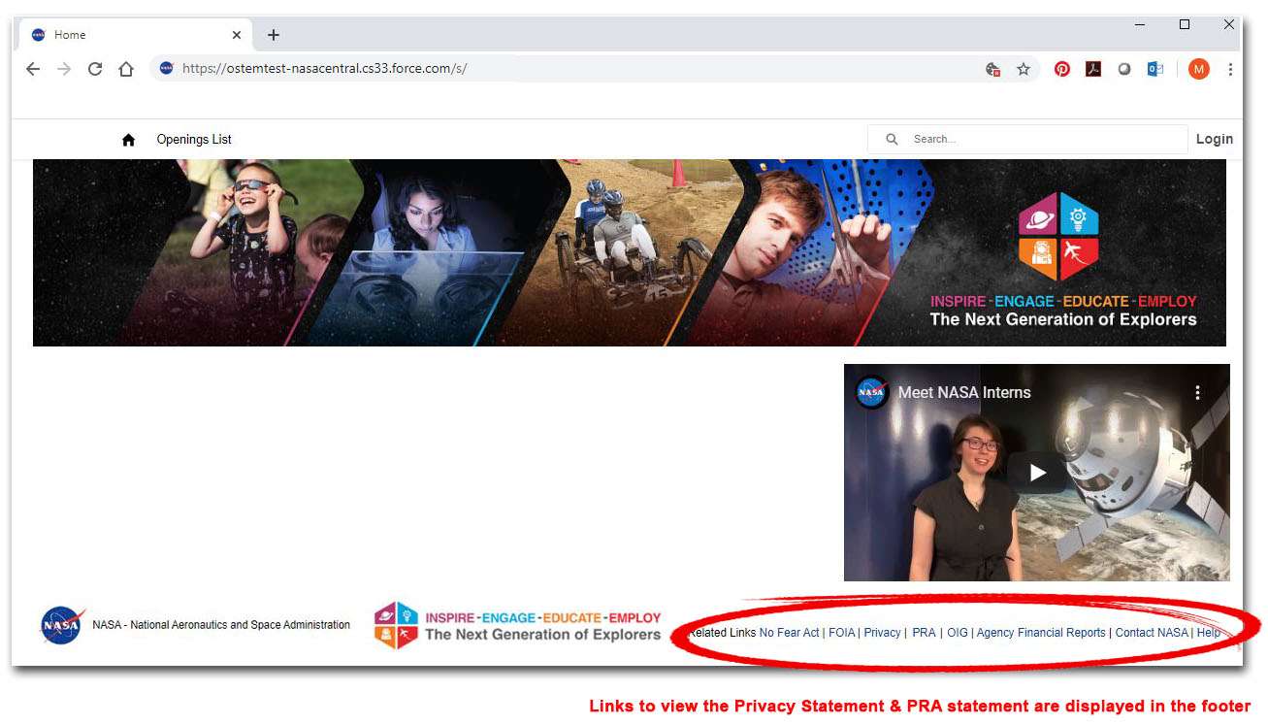
- NASA Privacy Statement
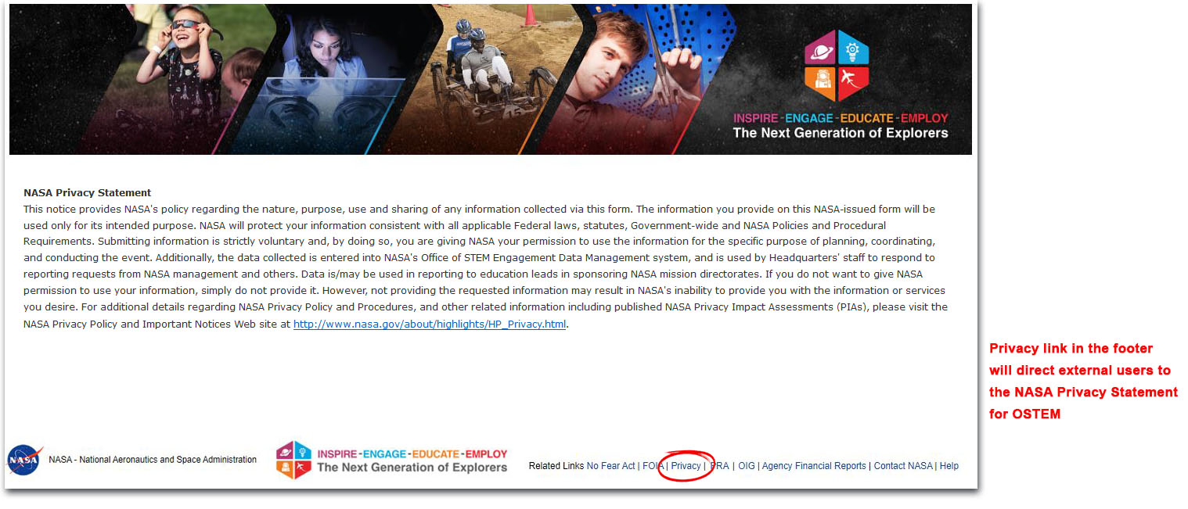
- Paperwork Reduction Act Statement
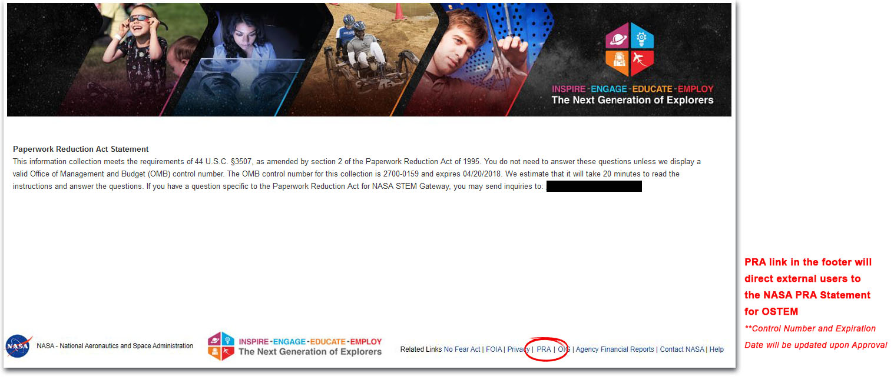

1.2 CREATE PROFILE

- Age Verification
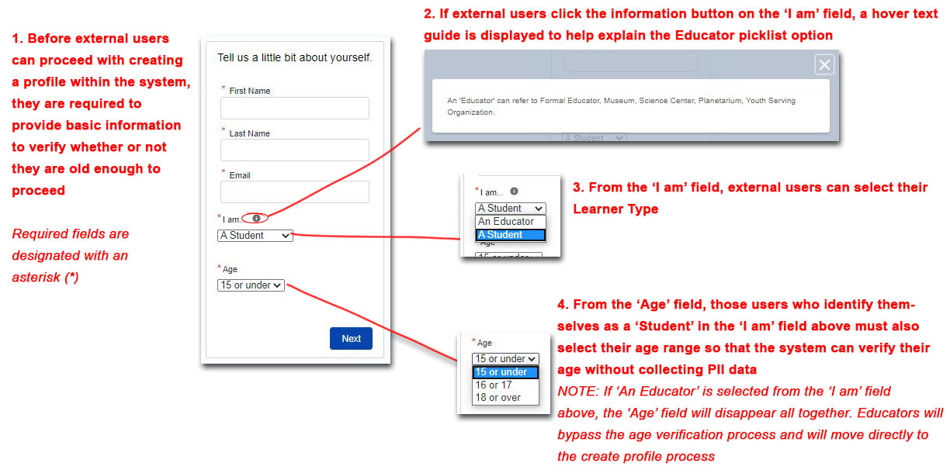
- Minors 15 Years or Under
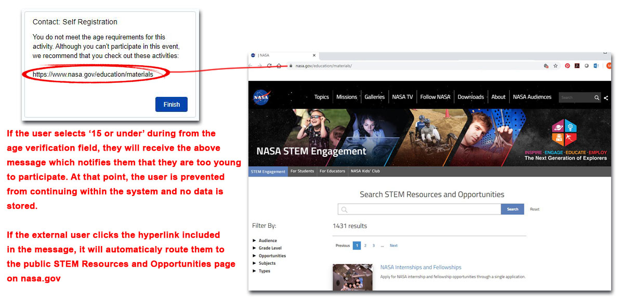
- Minors 16 - 17 Years | Enter Parent / Legal Guardian Contact Info
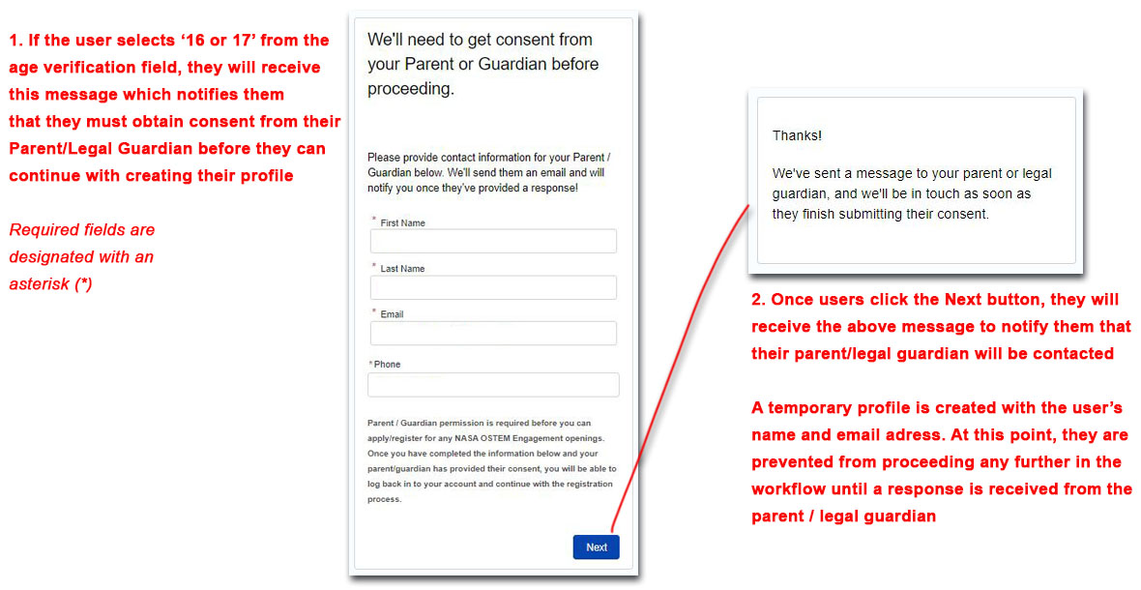
- Parent / Legal Guardian Consent Response = No
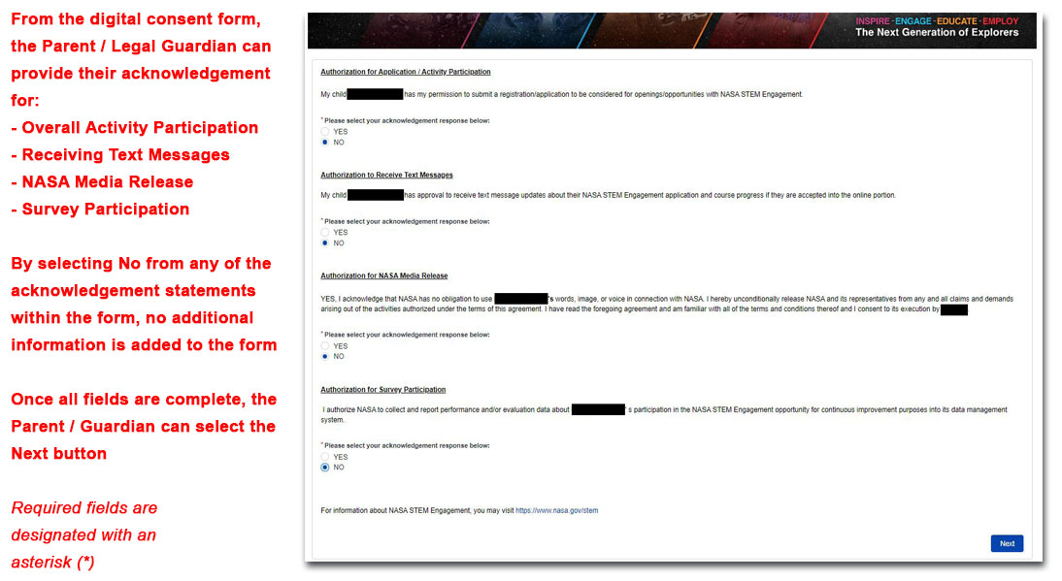
- Parent / Legal Guardian Consent Response = Yes
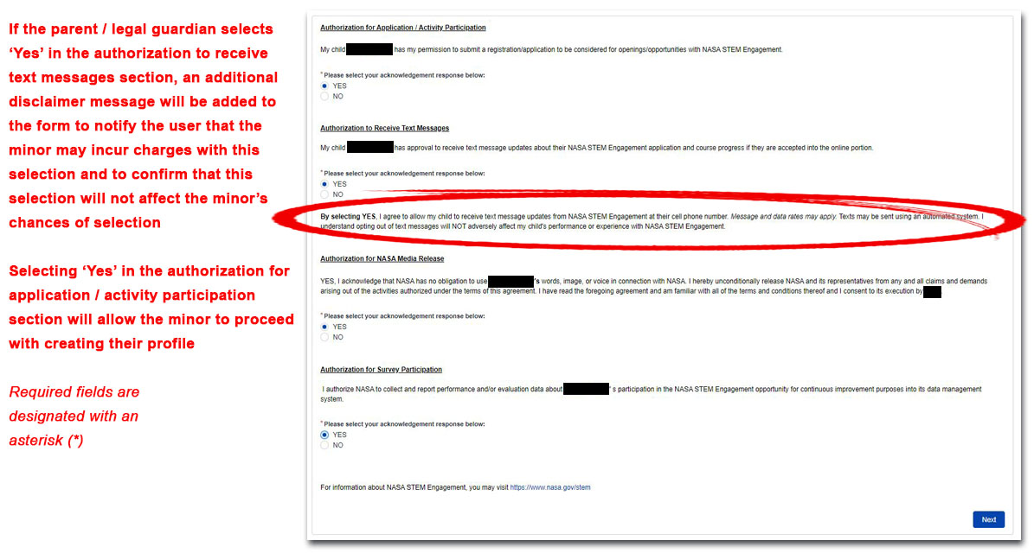
- Create Profile – NASA Media Release
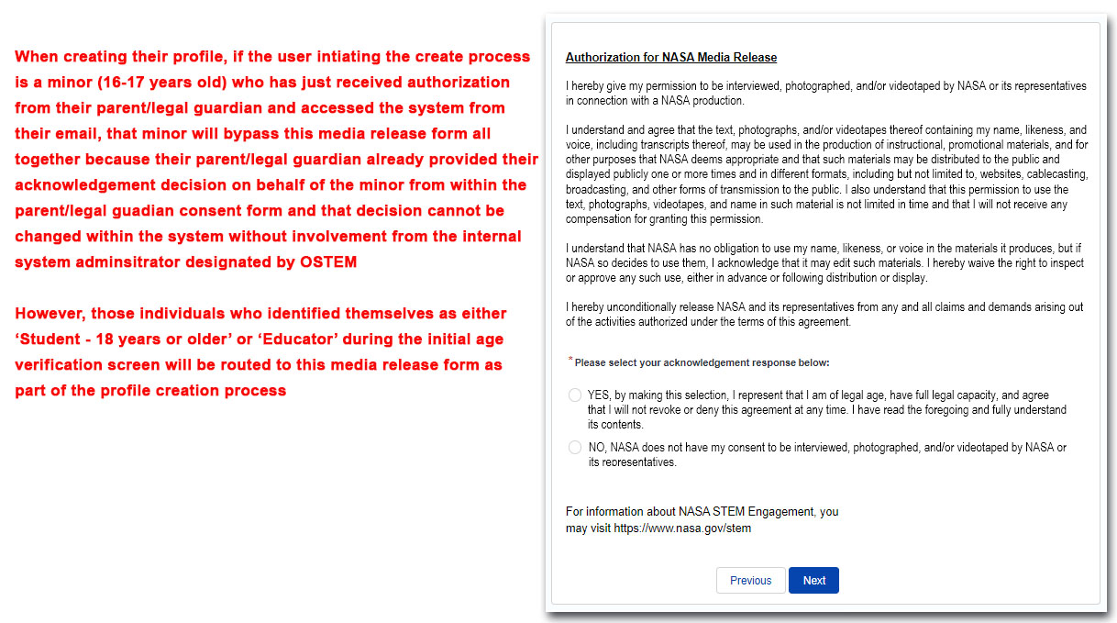
- Create Profile – Personal Information
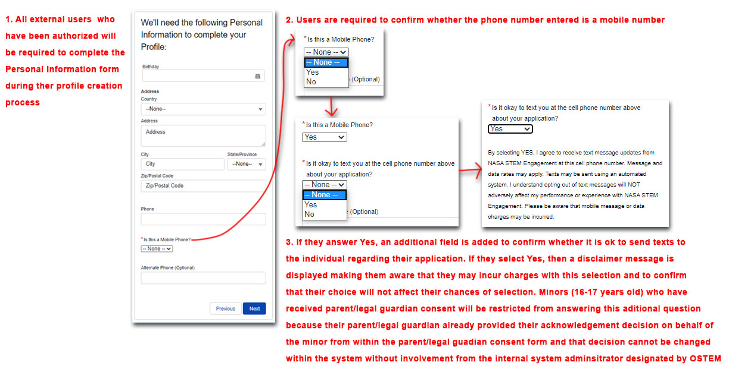
- Create Profile – Demographic Information
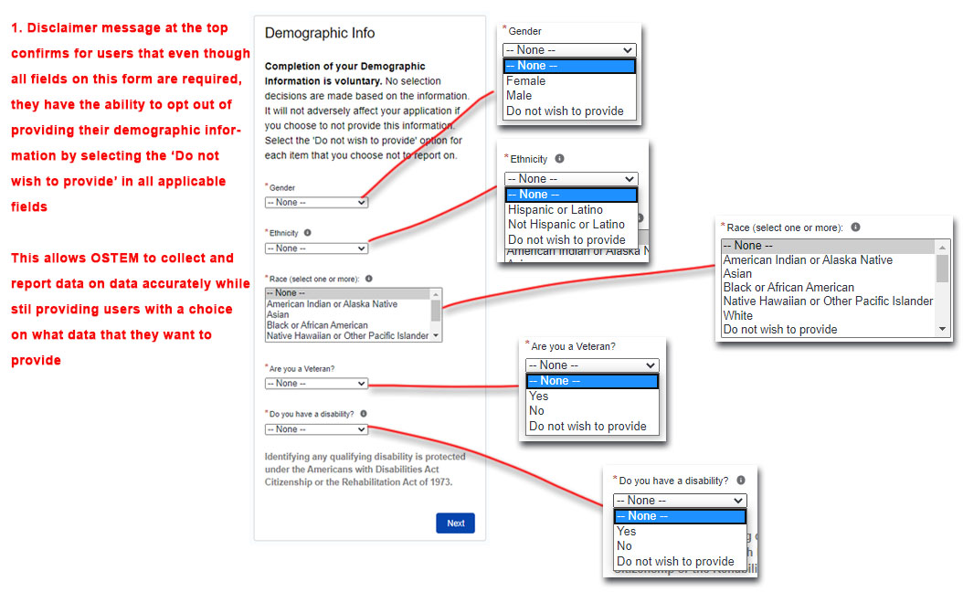
- Create Profile - Demographic Information Help Text
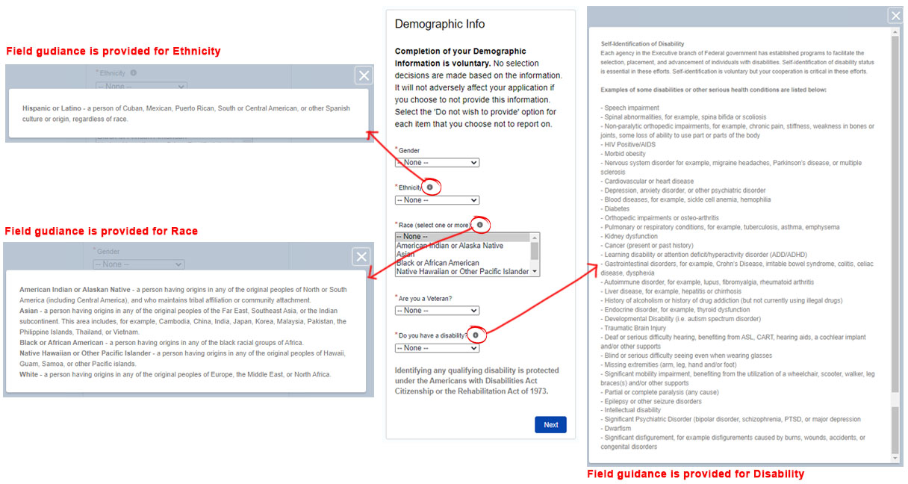
- Create Profile – Citizenship
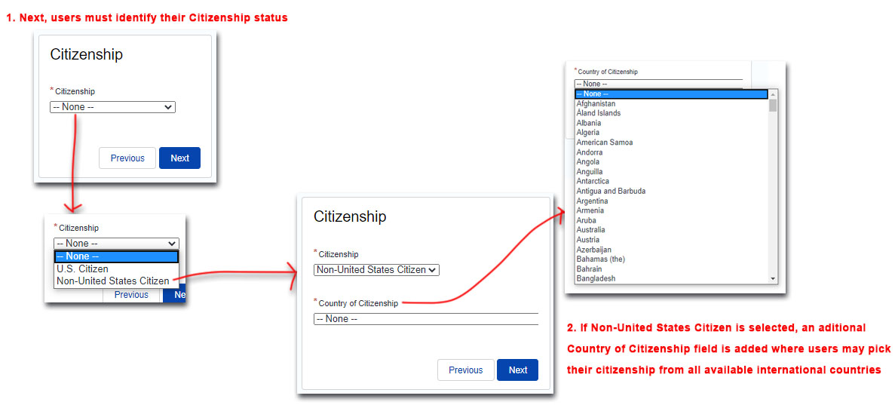
- Create Profile – Education or Affiliate Organization for Student
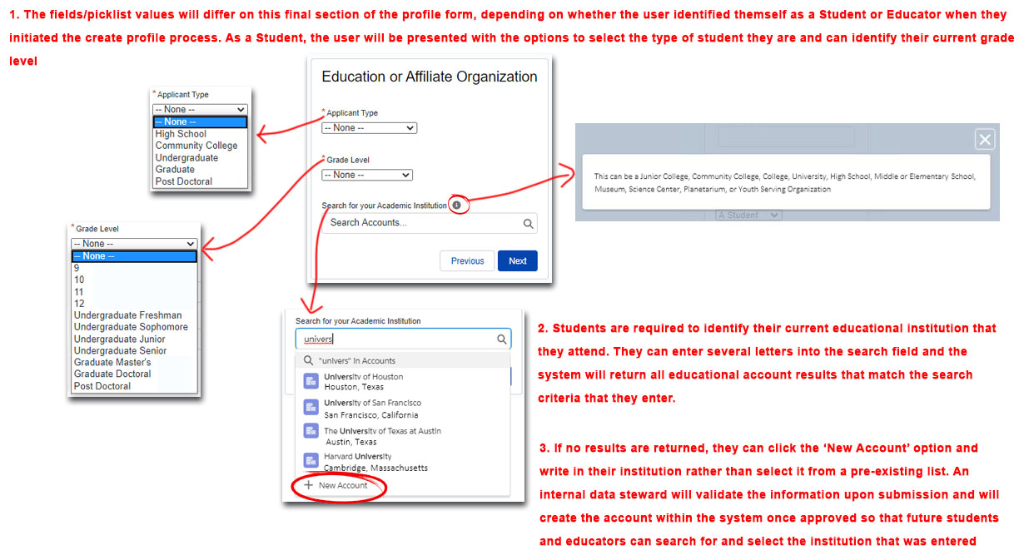
- Create Profile – Education or Affiliate Organization for Educator
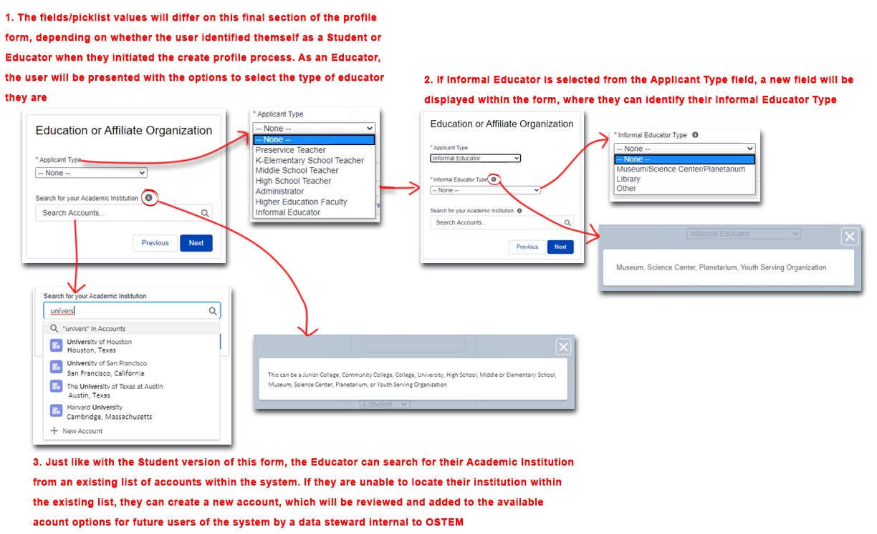

1.3 APPLY TO OPENINGS
- Internships & Pathways Applications – Personal Information
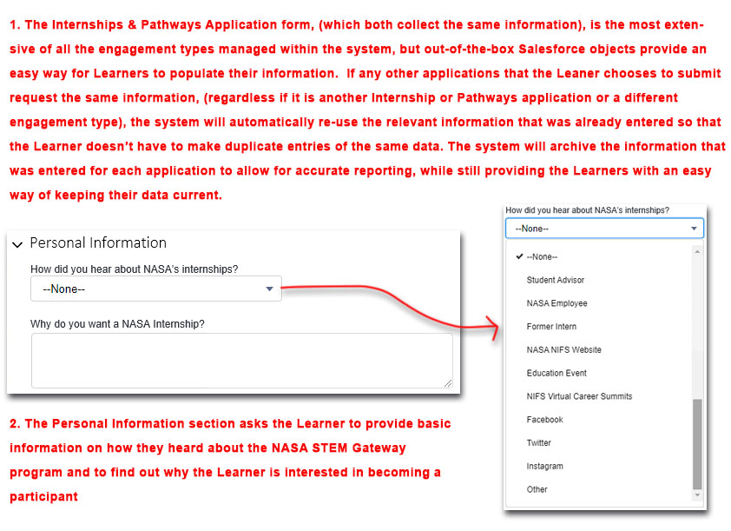
- Internships & Pathways Applications – Education or Affiliate Organization
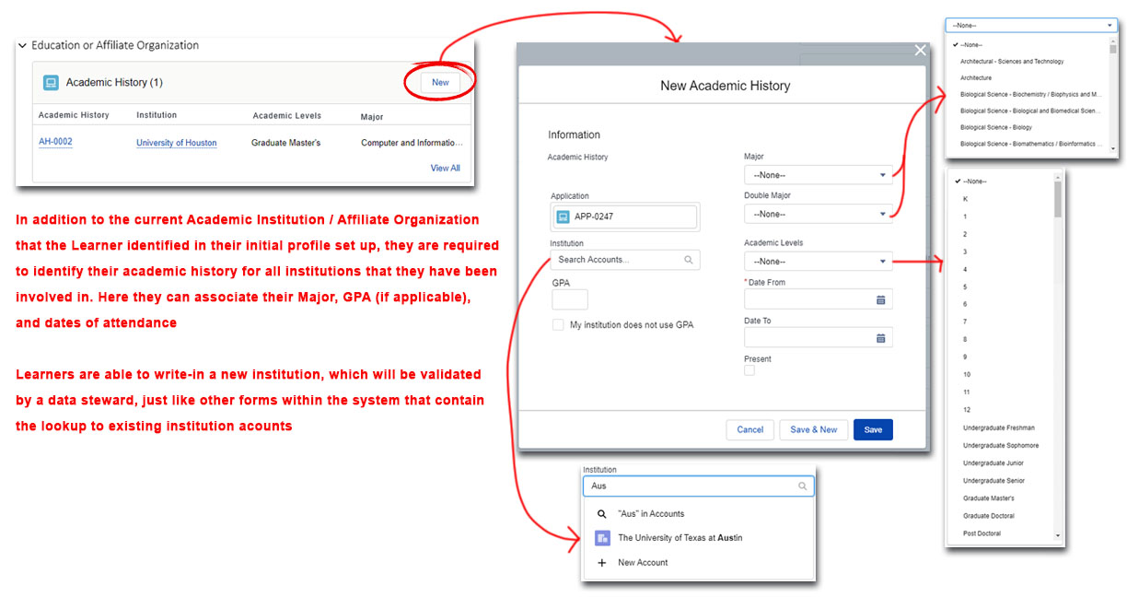
- Internships & Pathways Applications – Employment
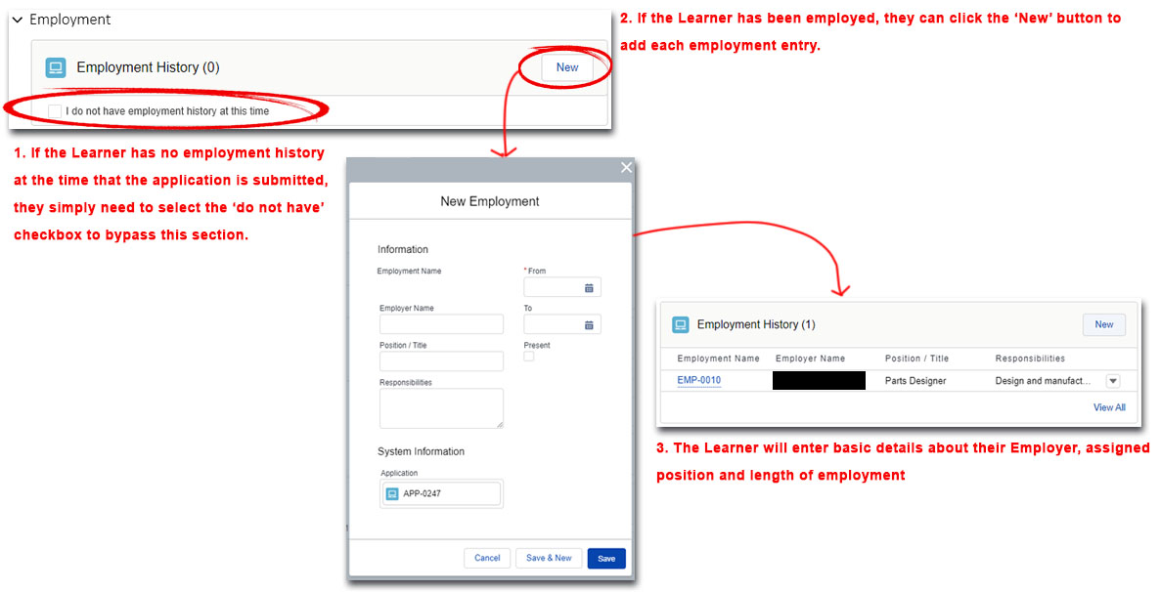
- Internships & Pathways Applications – Other Experience
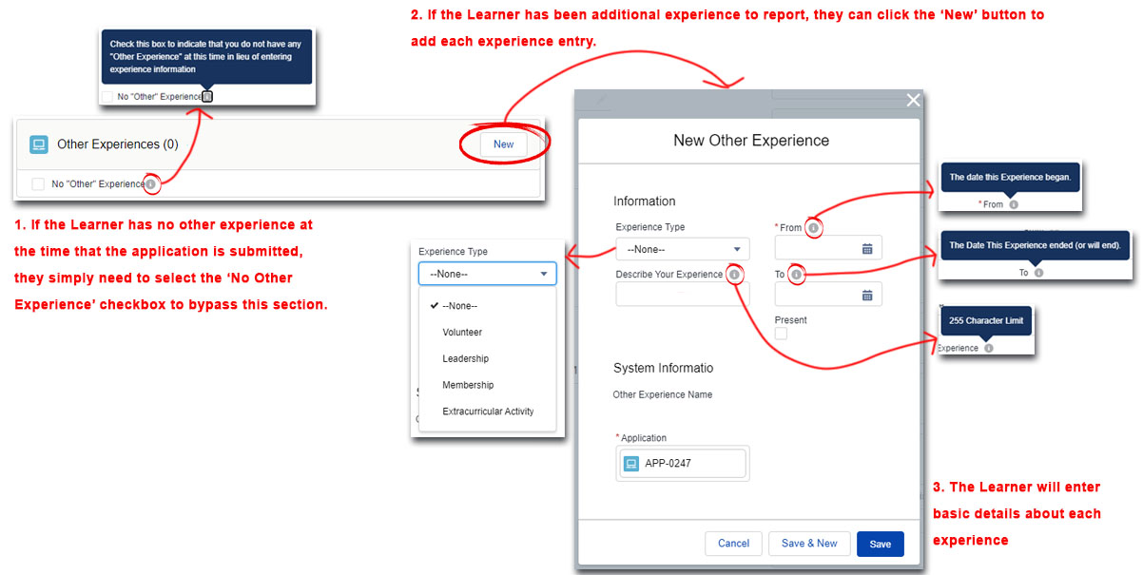
- Internships & Pathways Applications – Documents
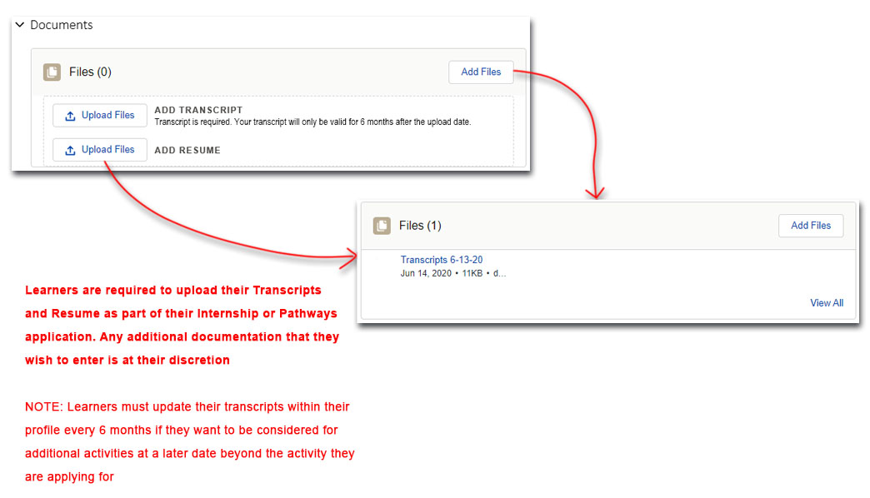
- Internships & Pathways Applications – Skills
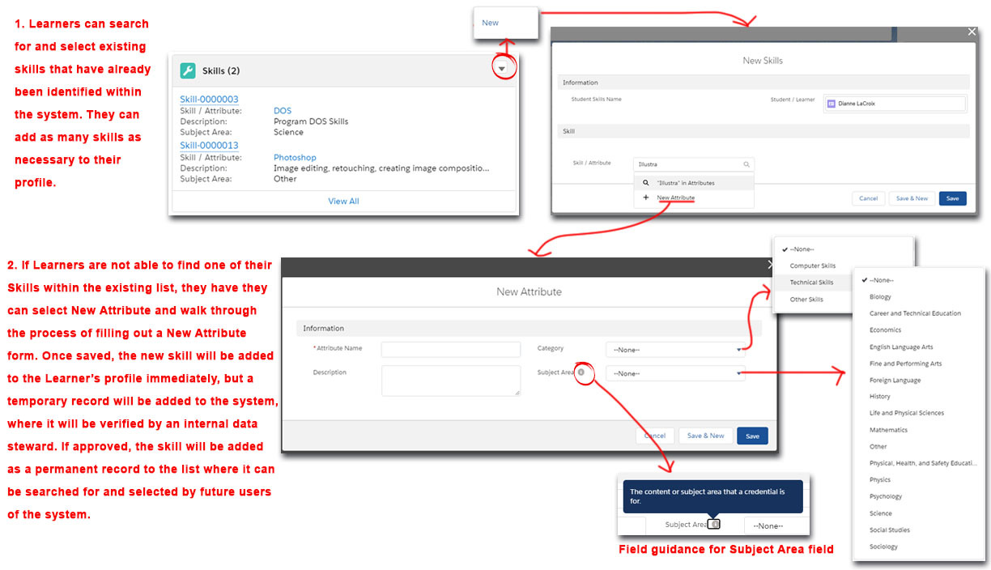
- Internships & Pathways Applications – Languages
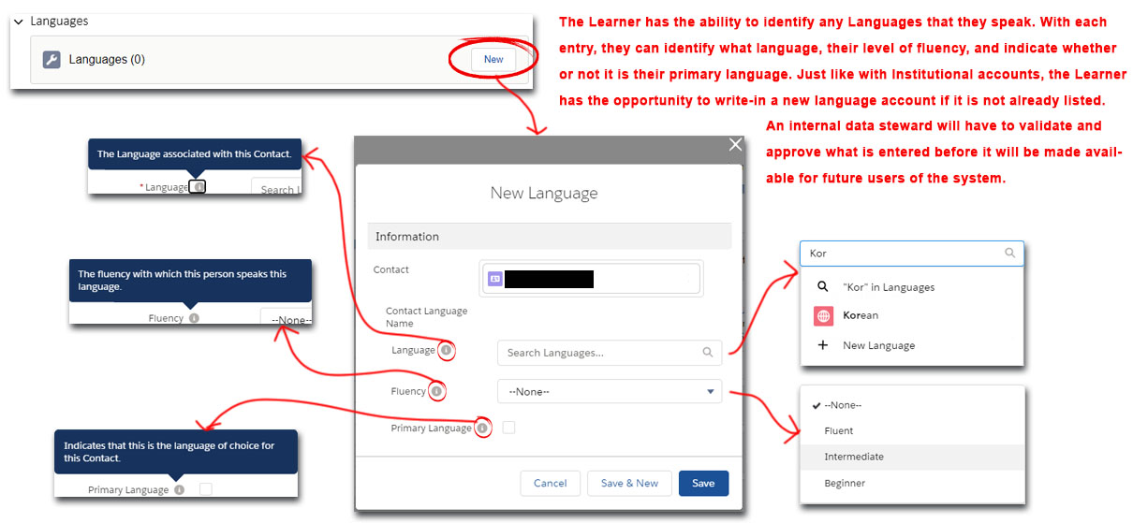
- Internships & Pathways Applications – Letter of Recommendation Invitation
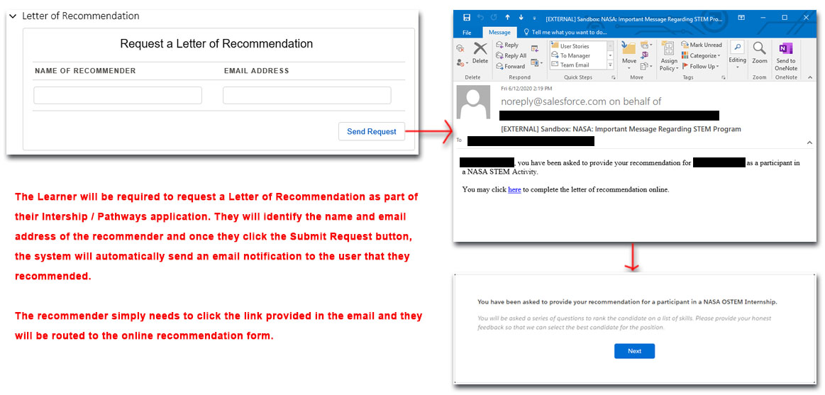
- Internships & Pathways Applications – Submit Letter of Recommendation
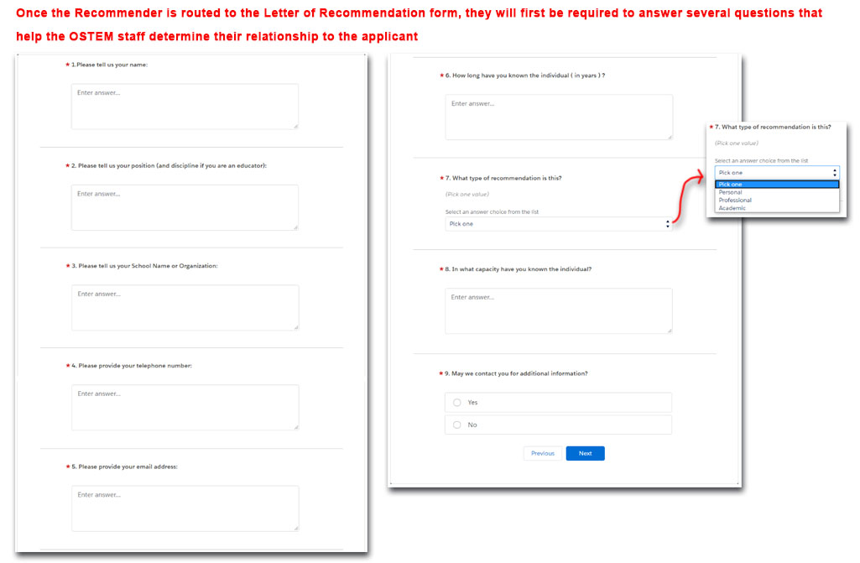
- Internships & Pathways Applications – Submit Letter of Recommendation Continued
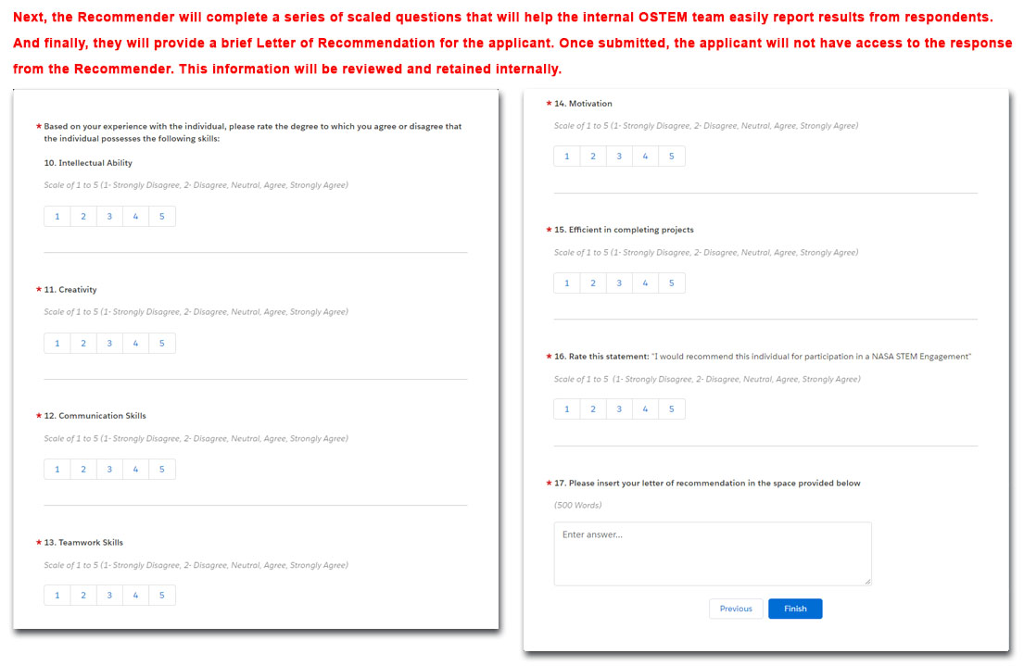
- Internships & Pathways Applications – Availability
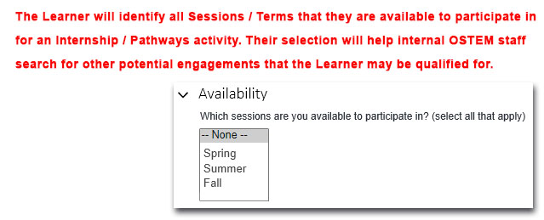
- Challenges Application – Institutions
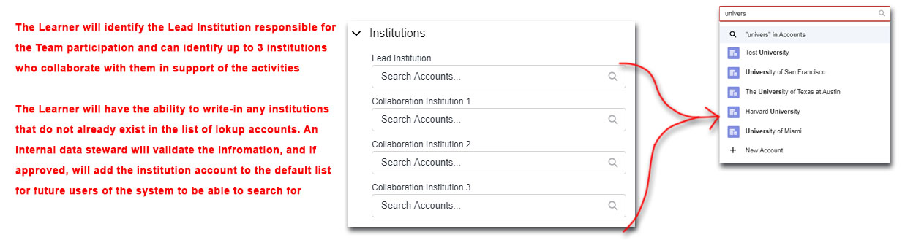
- Challenges Application – Team Information
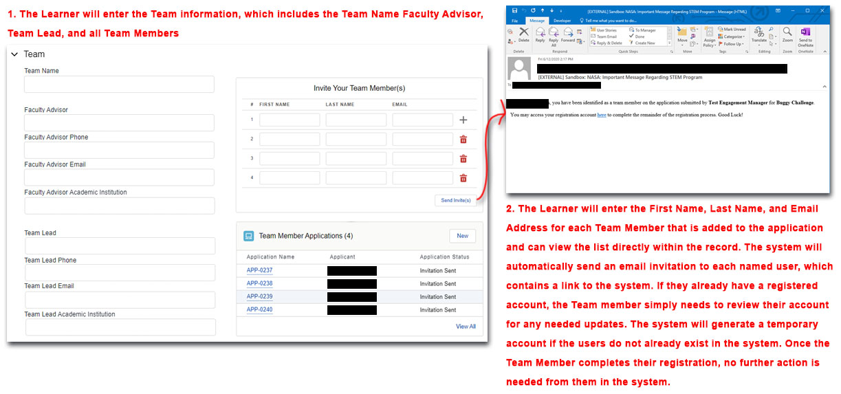
- Challenges Application – Documents
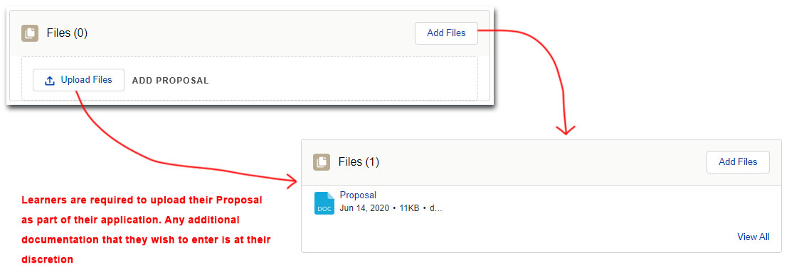
- Fellowships & Research Opportunities Application – Identification Numbers
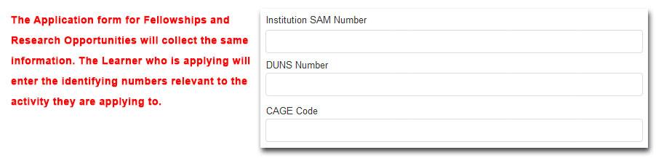
- Fellowships & Research Opportunities Application – Points of Contact
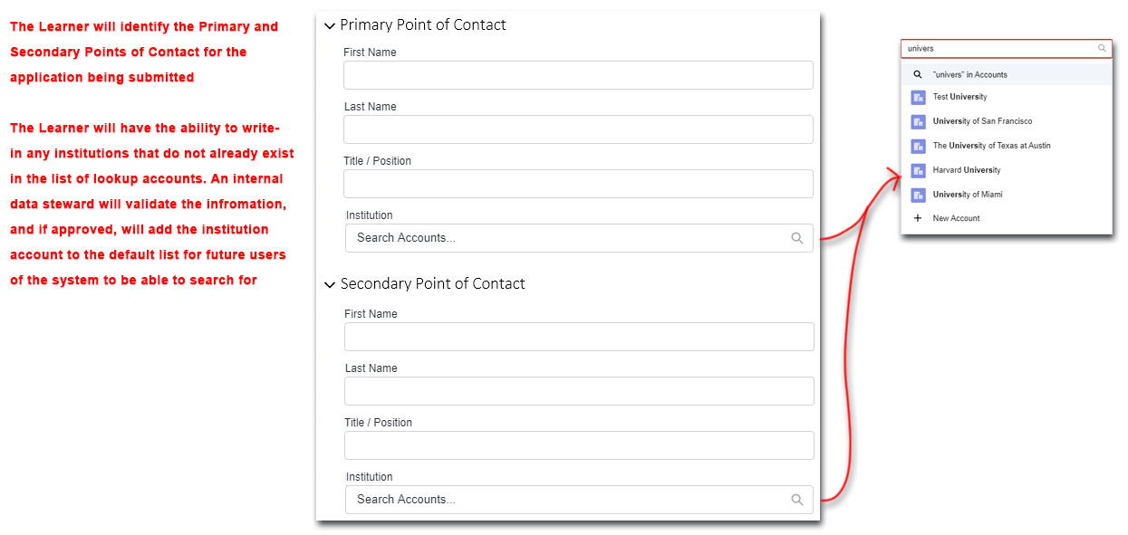
- Fellowships & Research Opportunities Application – Documents
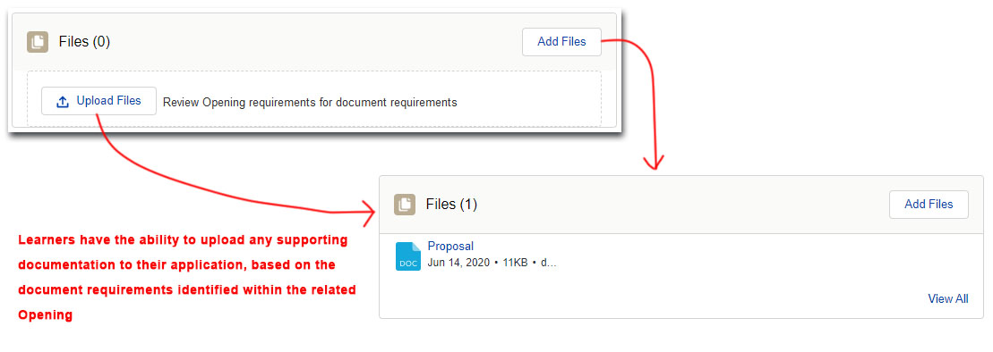
- Educator Professional Development Application – Basic Information
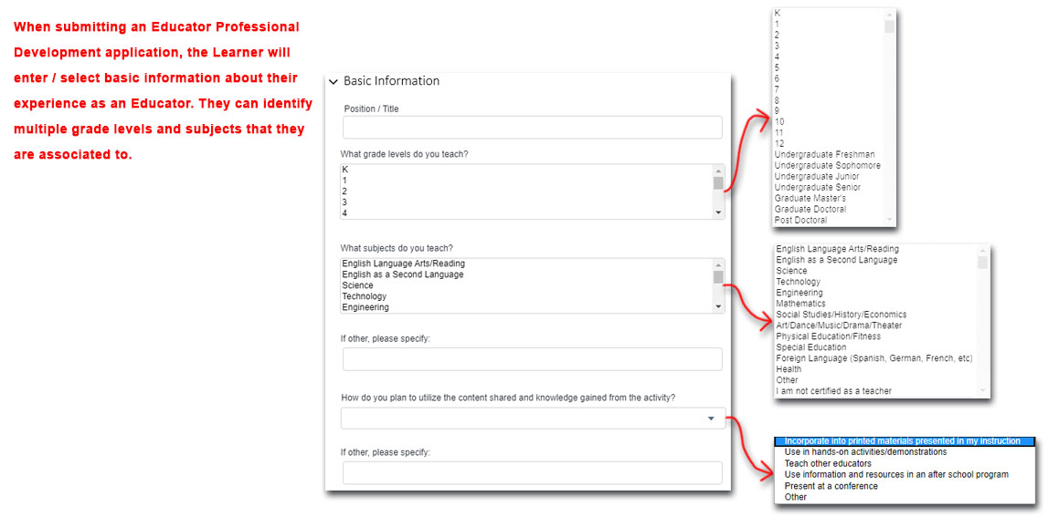
- Educator Professional Development Application – Planned Implementation
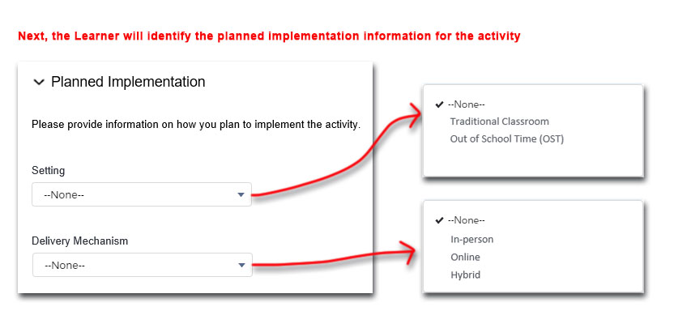
In-person
Incorporate into printed materials presented in my instruction
Use in hands-on activities/demonstrations
Teach other educators
Use information and resources in an after school program
Present at a conference
Other
Utilization
- Educator Professional Development Application – Estimated Numbers
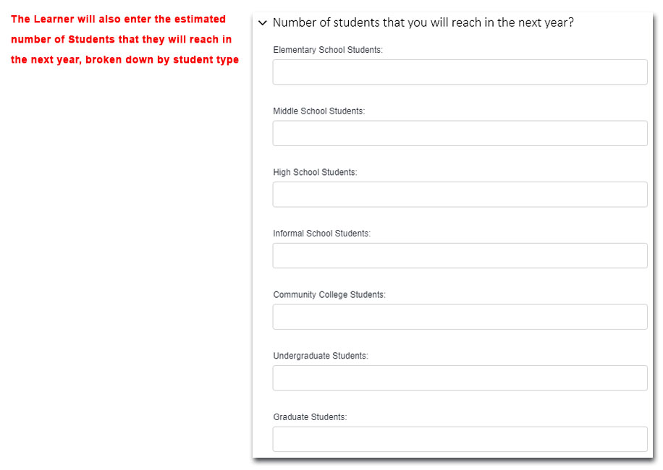
- College / Pre-College STEM Experience Group Registration – Primary & Secondary Point of Contact
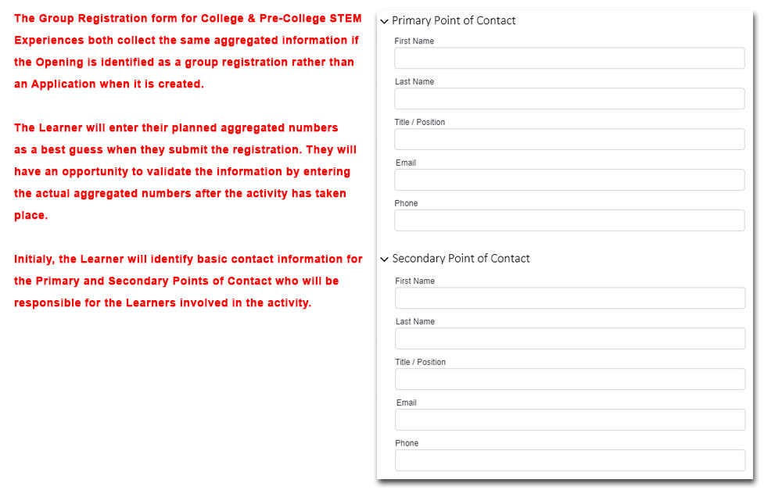
- College / Pre-College STEM Experience Group Registration – Primary & Secondary Point of Contact
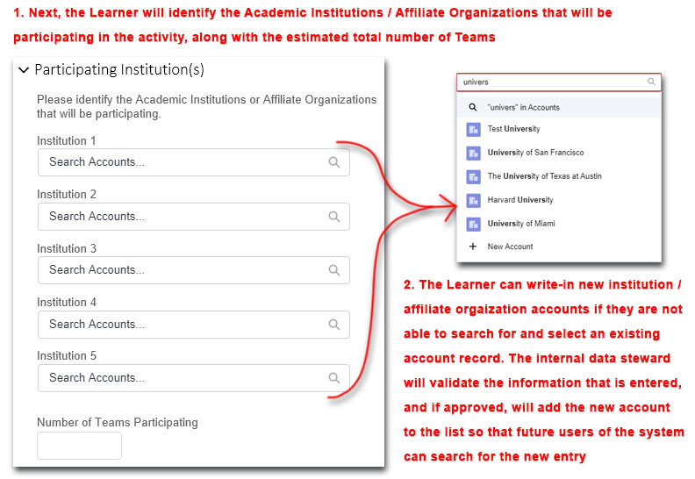
- College / Pre-College STEM Experience Group Registration – Planned Implementation
In-person
Incorporate into printed materials presented in my instruction
Use in hands-on activities/demonstrations
Teach other educators
Use information and resources in an after school program
Present at a conference
Other
Utilization
- College / Pre-College STEM Experience Group Registration – Number of Educators
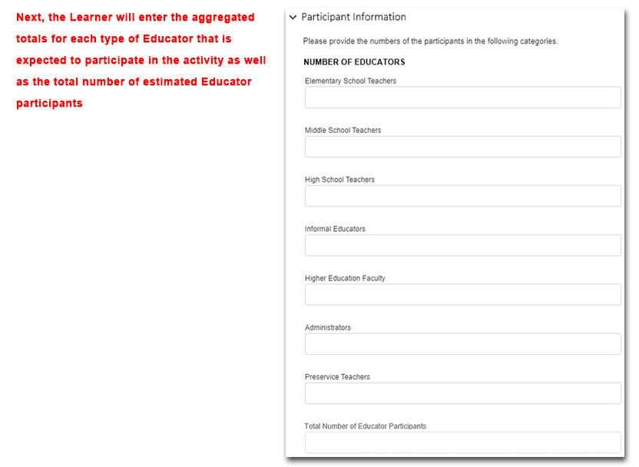

- College / Pre-College STEM Experience Group Registration – Number of Students
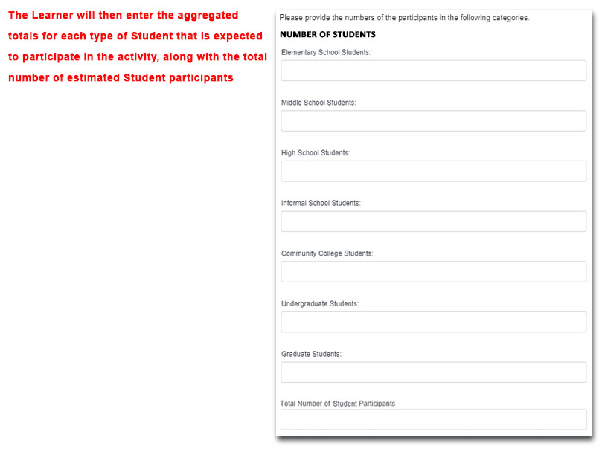
- College / Pre-College STEM Experience Group Registration – Supporting Documentation
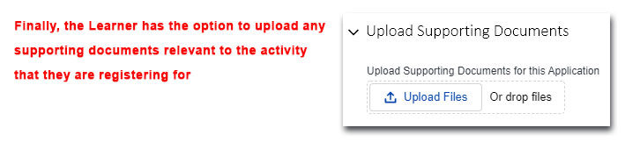
- College / Pre-College STEM Experience Application – Personal Information
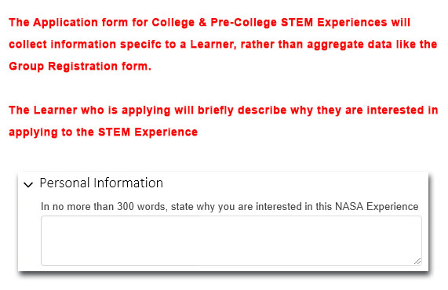
- College / Pre-College STEM Experience Application – Education or Affiliate Organization
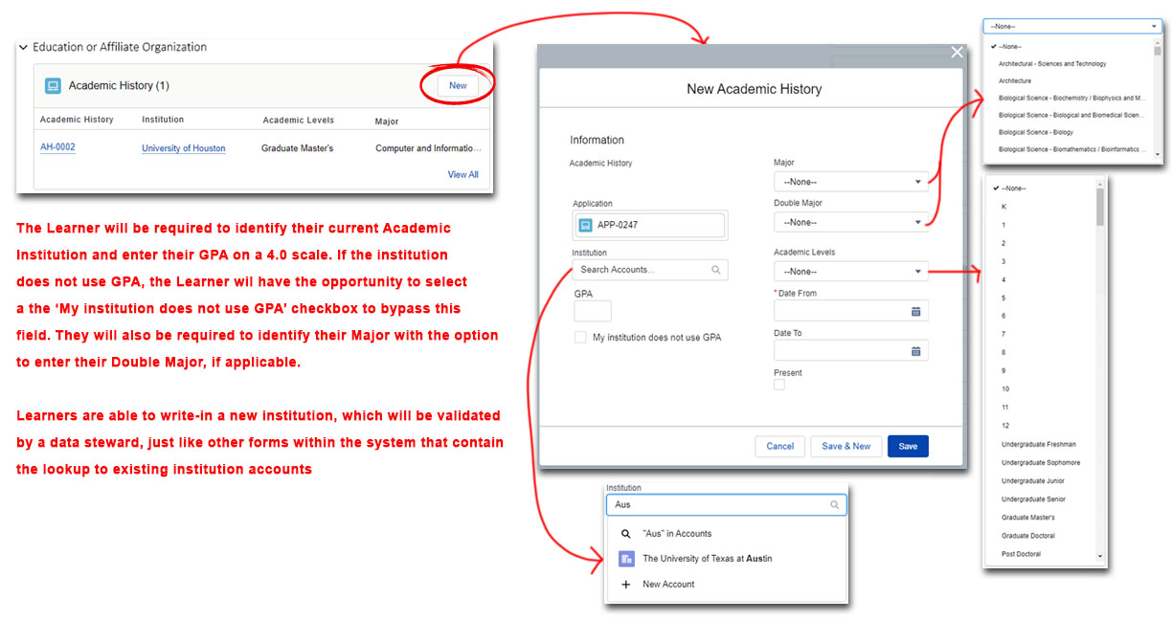
- College / Pre-College STEM Experience Application – Documents
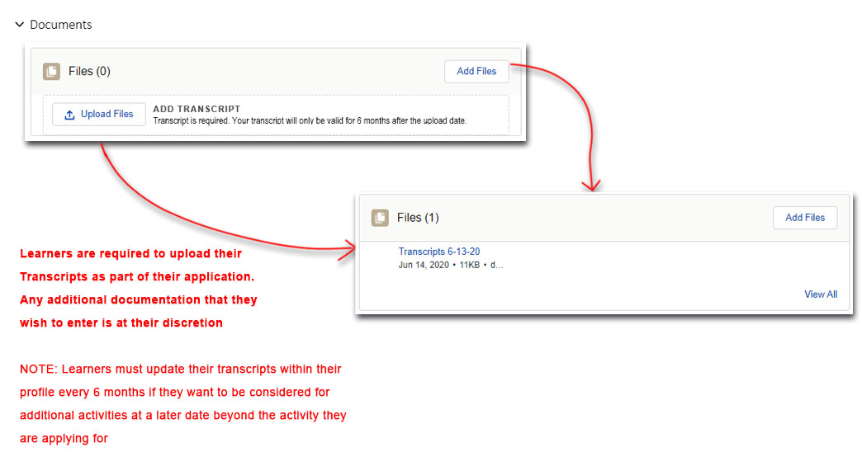
- College / Pre-College STEM Experience Application – Letter of Recommendation Invitation
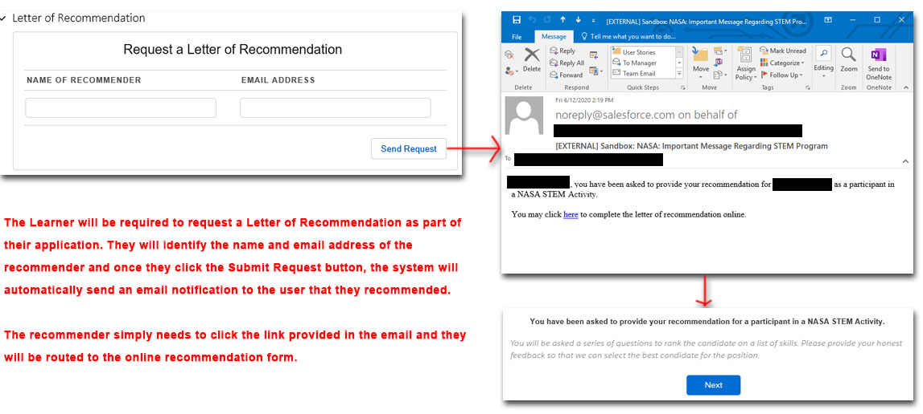
- College / Pre-College STEM Experience Application – Submit Letter of Recommendation
- College / Pre-College STEM Experience Application – Submit Letter of Recommendation Continued

1.4 ACCEPT/DECLINE OFFER
- Offer Letter - Respond to Offer (Accept / Decline)
