Thank you for your valuable service as a Peace Corps Campus Ambassador (CA). We have developed this survey to provide you an opportunity to anonymously share feedback on your experience with the CA program and make positive suggestions for improvement. It takes about five minutes to complete. Please complete the survey at your earliest convenience, and **no later than 30 days within completion of your current assignment as Campus Ambassador.**   
  
The results of this effort will help us to better understand student views about the Campus Ambassador program and the Peace Corps as a whole. Your ideas and impressions will be very important to us in identifying practices, programs, and values that affect our success and our ability to reach our goals together.

* = required responses to the question

* 1. What region is your school in? Please select the appropriate option. (see below for map)

* West
* Central
* East

Campus Ambassador Geographic Region Map

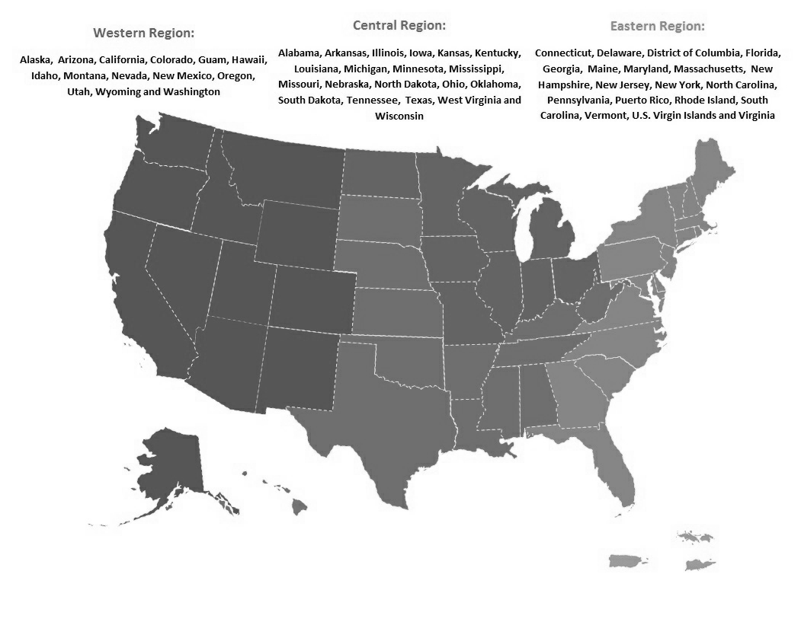

We are looking for ways to improve our training program and get insight on how we did with managing the training program and supporting you.

* 2. I completed the Campus Ambassadors program online orientation at the beginning of the program. Please select the appropriate option.

* Yes
* No
* I don't remember
* Other: ______________

3. If you completed the online orientation, how was it valuable and what could be improved? Please provide a short answer below.

|  |
| --- |
|  |

* 4. How comfortable were you with conducting the following activities on your campus. Please rate each of the following items on a rating scale of very comfortable, comfortable, no opinion, slightly uncomfortable, not comfortable at all.

* Social media
  + Very comfortable
  + Comfortable
  + No option
  + Slightly uncomfortable
  + Not comfortable at all
* Supporting recruiter at campus events
  + Very comfortable
  + Comfortable
  + No option
  + Slightly uncomfortable
  + Not comfortable at all
* Identifying campus contacts
  + Very comfortable
  + Comfortable
  + No option
  + Slightly uncomfortable
  + Not comfortable at all
* General promotion (using swag and Peace Corps materials)
  + Very comfortable
  + Comfortable
  + No option
  + Slightly uncomfortable
  + Not comfortable at all

5. Please provide additional comments here regarding question #4:

|  |
| --- |
|  |

* 6. What skills, knowledge and/or abilities have you gained from your experience as a Campus Ambassador? How will these help you in your future career? Please provide a short answer below.

|  |
| --- |
|  |

* 7. What were some of your challenges as a Campus Ambassador? How did you overcome these? Please provide a short answer below.

|  |
| --- |
|  |

* 8. What was the most valuable part of your Campus Ambassador experience? Please provide a short answer below.

|  |
| --- |
|  |

* 9. How supported did you feel in your role? Please select the appropriate option.

* Not Supported
* Slightly Supported
* No Opinion
* Moderately Supported
* Extremely Supported

* 10. Please describe how you felt or didn't feel supported in your role. Please provide a short answer below.

|  |
| --- |
|  |

* 11. Would you recommend the Campus Ambassadors program to a friend? Please select the appropriate option.

* Yes
* No

Why or why not? Please provide a short answer below.

|  |
| --- |
|  |

12. Please share any general comments, ideas, and/or suggestions for improving the Campus

Ambassador program in the future. Please provide a short answer below.

|  |
| --- |
|  |

* 13. Are you planning to apply as a Peace Corps Volunteer? Please select the appropriate option.

* Yes
* No
* Already Applied
* Not Sure
* Other (please specify)

14. If you selected "no" or "not sure" please explain why. Please provide a short answer below.

|  |
| --- |
|  |

Thank you very much for providing your feedback!