OMB Control No. 0551-0015
Expiration Date: 09/30/2025

Instructions for Applying for a License under the Sugar Re-Export Program

Part I: FAS Website with instructions on required documents for submission
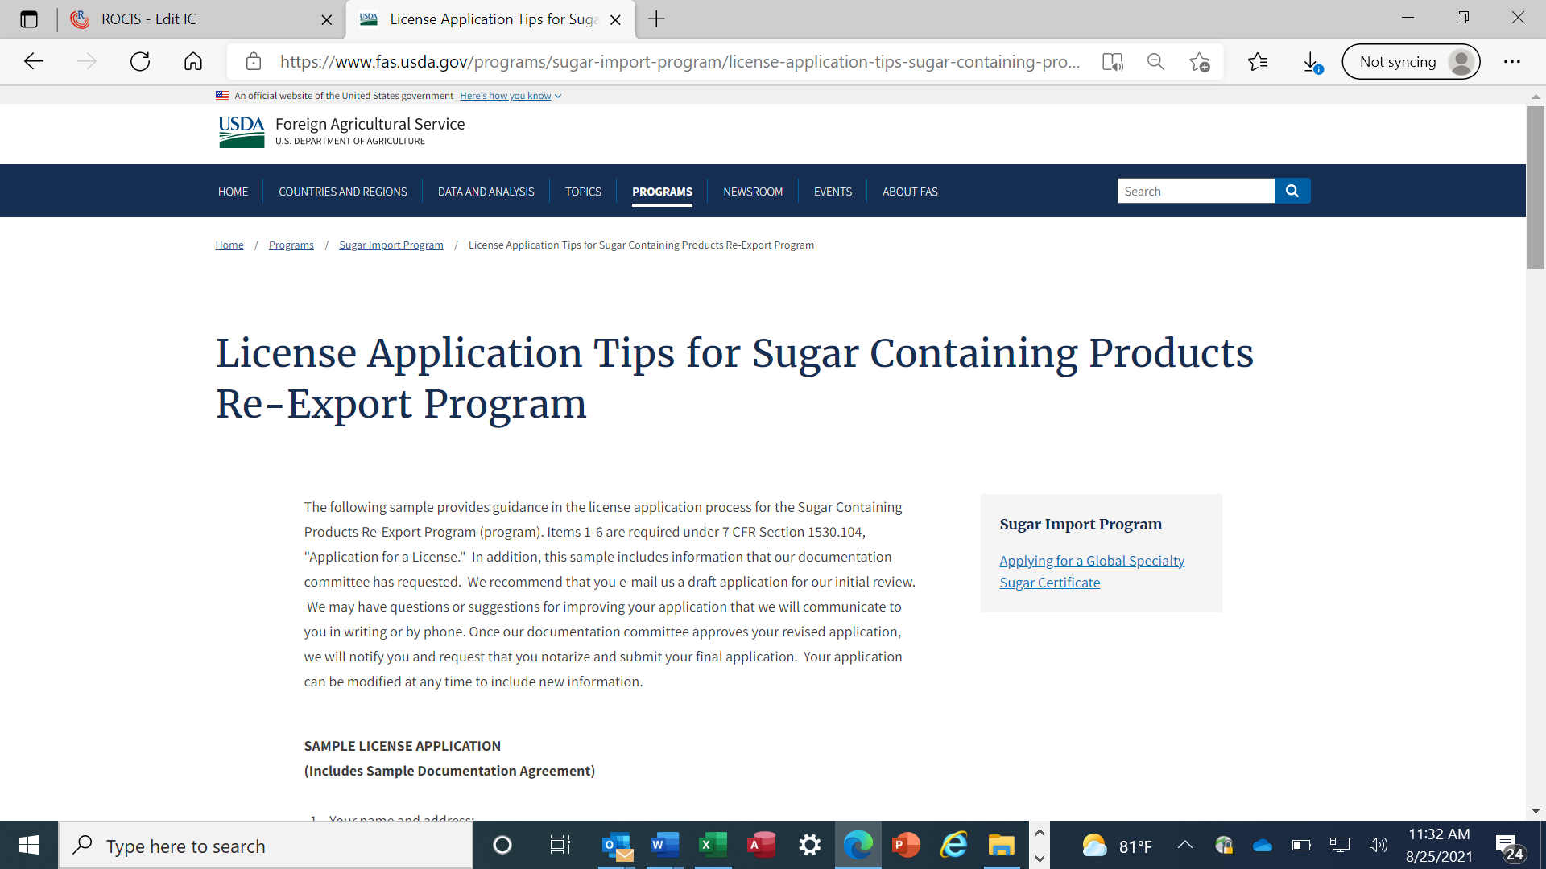
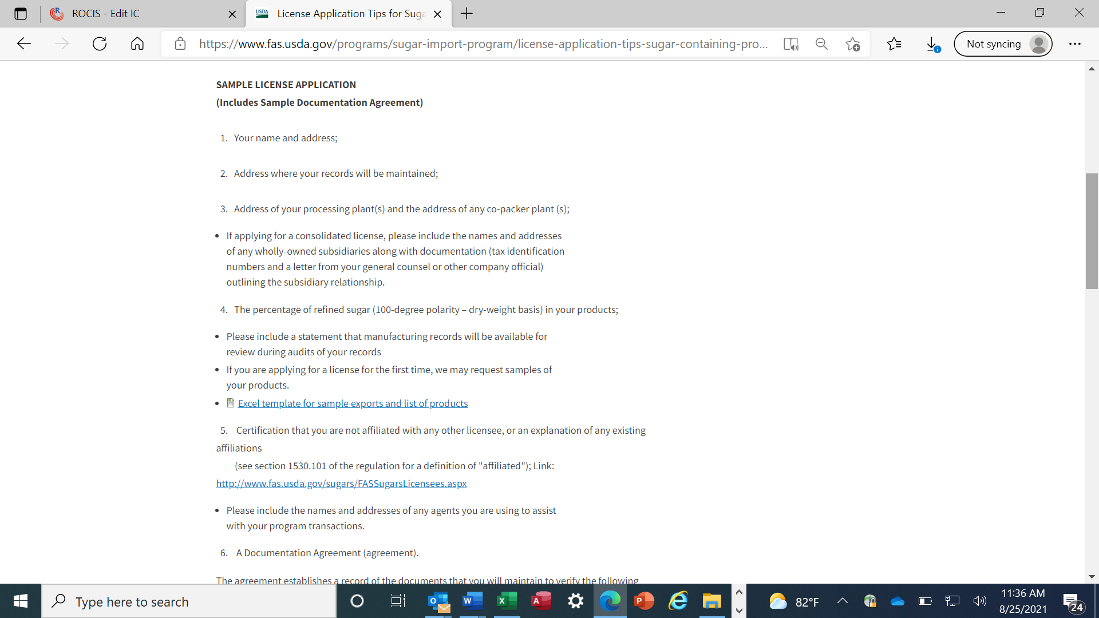

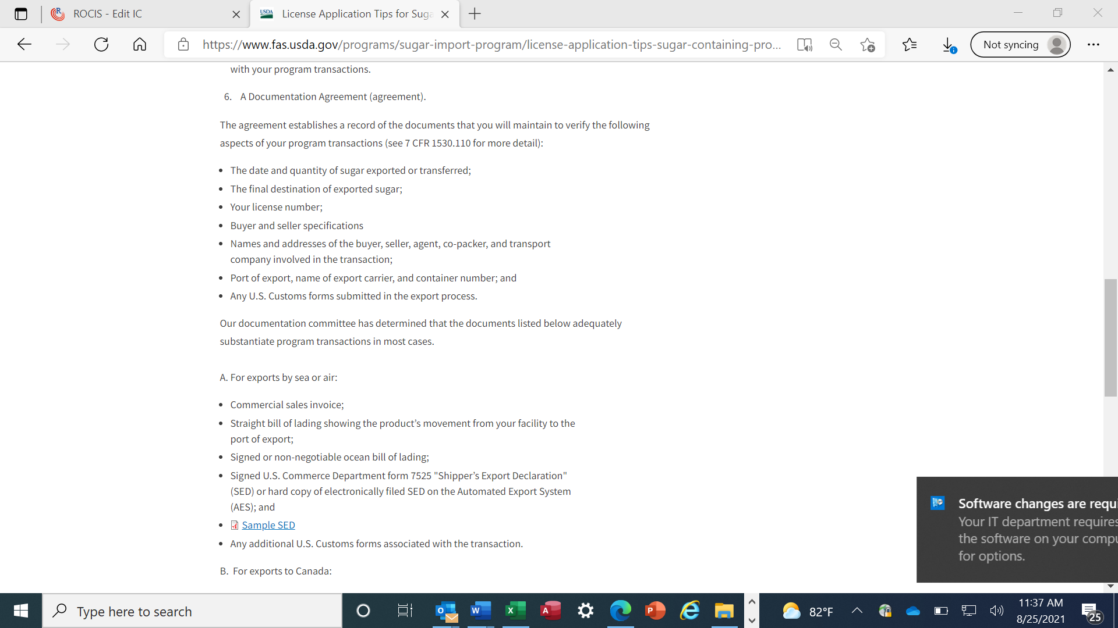
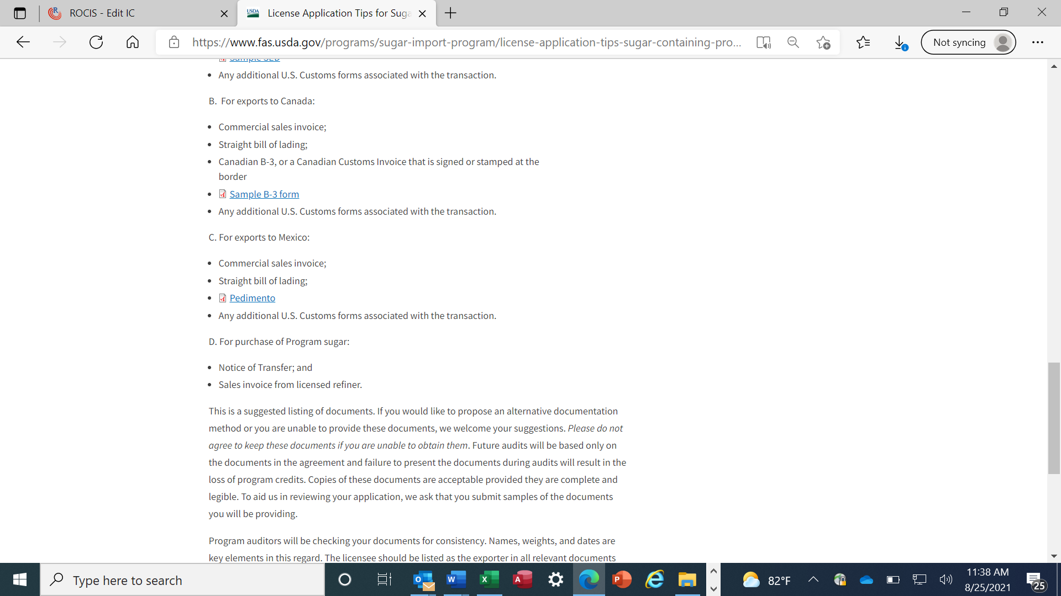
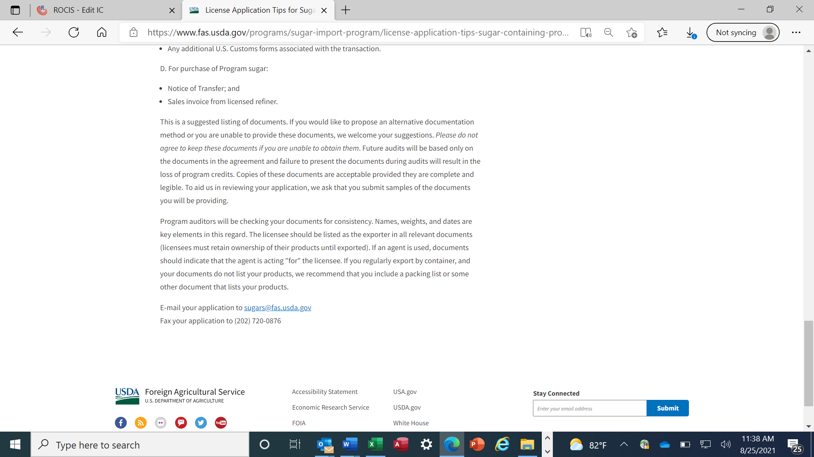

Part II: Application submission forms and instructions through the SUCROSE system
Note: The refiner applicant view is portrayed in the screenshots below, but slight variations in required information exist for sugar-containing product manufacturer and polyhydric alcohol producer applicants.
