Attachment 3b

Household Screener and Family Relationship Modules
2021-22
Form Approved
OMB No. 0920-0950
Exp. Date XX/XX/20XX

Notice – CDC estimates the average public reporting burden for this collection of information as 10 minutes per response, including the time for reviewing instructions, searching existing data/information sources, gathering and maintaining the data/information needed, and completing and reviewing the collection of information. An agency may not conduct or sponsor, and a person is not required to respond to a collection of information unless it displays a currently valid OMB control number. Send comments regarding this burden estimate or any other aspect of this collection of information, including suggestions for reducing this burden to CDC/ATSDR Information Collection Review Office, 1600 Clifton Road, MS D-74, Atlanta, GA 30333; ATTN: PRA (0920-0950).

Assurance of Confidentiality – We take your privacy very seriously. All information that relates to or describes identifiable characteristics of individuals, a practice, or an establishment will be used only for statistical purposes. NCHS staff, contractors, and agents will not disclose or release responses in identifiable form without the consent of the individual or establishment in accordance with section 308(d) of the Public Health Service Act (42U.S.C. 242m(d)) and the Confidential Information Protection and Statistical Efficiency Act of 2018 (CIPSEA Pub. L. No. 115-435, 132 Stat. 5529 § 302). In accordance with CIPSEA, every NCHS employee, contractor, and agent has taken an oath and is subject to a jail term of up to five years, a fine of up to $250,000, or both if he or she willfully discloses ANY identifiable information about you. In addition to the above cited laws, NCHS complies with the Federal Cybersecurity Enhancement Act of 2015 (6 U.S.C. §§ 151 and 151 note) which protects Federal information systems from cybersecurity risks by screening their networks.

HOUSEHOLD SCREENER AND FAMILY RELATIONSHIP MODULES

TABLE OF CONTENTS

In-Person/Telephone Interview Instrument 3
Web Instrument 32
Web Instrument Example Screen Shots 60
Paper Instrument 66

In-Person/Telephone Interview Instrument

SCREENER MODULE #1 (SCQ)

SCQ.003 INTERVIEWER INSTRUCTION: SELECT INTERVIEW MODE. SELECT ‘PAPER’ ONLY IF RECEIVING INFORMATION FROM FIELD SUPPPORT STAFF.

IN-PERSON......................................................... 1 (SCQ_INTR)
PHONE................................................................ 2 (SCQ_INTR)
PAPER 3

SCQ.004 INTERVIEWER INSTRUCTION: PAPER SCREENER COMPLETED BY:

HH RESPONDENT.............................................. 1
FIELD SUPPORT OVER PHONE................................................................ 2

SCQ_INTR Hello, I’m {INTERVIEWER’S NAME} and we are conducting a survey for the National Center for Health Statistics, part of the Centers for Disease Control and Prevention (CDC).

IF IN PERSON, SHOW ID CARD.

A letter was sent to you recently explaining a survey which is called the National Health and Nutrition Examination Survey and is about your family’s health.

IF RESIDENT DOES NOT REMEMBER LETTER, HAND NEW COPY OR REFER RESPONDENT TO WEBSITE FOR A COPY.

FOR IN PERSON, IF NEEDED: REASSURE RESPONDENT THAT YOU ARE WELL AND THAT YOU CHECK YOURSELF DAILY FOR CORONAVIRUS SYMPTOMS FOLLOWING CDC GUIDELINES.

IF RESPONDENT SAYS S/HE COMPLETED THE WEB OR MAIL SCREENER AND ASKS WHY YOU ARE ASKING THESE QUESTIONS AGAIN, LET HIM/HER KNOW WE NEED TO VERIFY INFORMATION PROVIDED IN THE SCREENER TO DETERMINE WHO IN THE HOUSEHOLD IS ELIGIBLE TO PARTICIPATE.

All the information that you give us is voluntary and will be kept confidential. Your name will not be attached to any of your answers without your specific permission.

HELP SCREEN:
Assurance of Confidentiality – We take your privacy very seriously. All information that relates to or describes identifiable characteristics of individuals, a practice, or an establishment will be used only for statistical purposes. NCHS staff, contractors, and agents will not disclose or release responses in identifiable form without the consent of the individual or establishment in accordance with section 308(d) of the Public Health Service Act (42 U.S.C. 242m(d)) and the Confidential Information Protection and Statistical Efficiency Act of 2018 (CIPSEA Pub. L. No. 115-435, 132 Stat. 5529 § 302). In accordance with CIPSEA, every NCHS employee, contractor, and agent has taken an oath and is subject to a jail term of up to five years, a fine of up to $250,000, or both if he or she willfully discloses ANY identifiable information about you. In addition to the above cited laws, NCHS complies with the Federal Cybersecurity Enhancement Act of 2015 (6 U.S.C. §§ 151 and 151 note) which protects Federal information systems from cybersecurity risks by screening their networks.

Public reporting burden for this collection of information is estimated to average 10 minutes per response, including the time for reviewing instructions, searching existing data sources, gathering and maintaining the data needed, and completing and reviewing the collection of information.

An agency may not conduct or sponsor, and a person is not required to respond to a collection of information unless it displays a currently valid OMB control number.

Send comments regarding this burden estimate or any other aspect of this collection of information, including suggestions for reducing this burden to CDC/ATSDR Reports Clearance Officer; 1600 Clifton Road, MS D-74, Atlanta, GA 30333, ATTN: PRA (0920-0950).

SCQ.011 Before we begin, I would like to verify a few things.

ASK ALL PERSONS WHO APPEAR UNDER 30 YEARS OF AGE:

Are you 18 years or older?

YES 1
NO 2 (SCQ_END6)
NO, EMANCIPATED MINOR 3

BOX 0

CHECK ITEM SCQ.005:
IF SCQ.003a = 1, CONTINUE.
OTHERWISE, GO TO SCQ.070a.

SCQ.016 Do you live here?

YES 1
NO 2 (SCQ_END6)

SCQ.070a Please tell me your complete physical street address.

{#} {DIRECTION} {STREET NAME} {STREET/ROAD/AVENUE} {DIRECTION} {#}
{PO BOX} {RURAL ROUTE #} {RURAL ROUTE BOX} {CITY} {STATE} { ZIP}

YES 1 (SCQ.600)
NO (WRONG ADDRESS) 2 (SCQ_END5)
YES (CORRECTIONS) 3 (SCQ.070b)

SCQ.070b Please tell me your complete physical street address.

{ADDITIONAL ADDRESS LINE}
{STREET #} {DIRECTION PRE} {STREET NAME} {STREET/ROAD/AVENUE} {DIRECTION POST}
{UNIT/APT/BLDG} {UNIT #}
{CITY} {STATE} { ZIP}

CAPI INSTRUCTIONS: DISPLAY THE ADDRESS COLUMNS LISTED ABOVE AND ALLOW THE INTERVIEWER TO MAKE CORRECTIONS AS NEEDED. ONCE THE INTERVIEWER IS DONE, SHE WILL PRESS THE NEXT KEY TO CONTINUE.

THE FIELD FOR STATE MAY NOT BE UPDATED.

IF SCQ.070A = 2 AND NONE OF THE ADDRESS FIELDS ARE MODIFIED, AUTO-BACKCODE THE RESPONSE TO SCQ.070A = 3 (YES) AND GO TO SCQ.600.

HARD EDIT: IF UNIT/APT/BLDG = PO BOX OR IF “PO BOX” OR “P.O. BOX” IS ENTERED IN THE ADDITIONAL ADDRESS LINE, STREET #, OR STREET NAME FIELDS, DISPLAY MESSAGE, “PLEASE ENTER THE PHYSICAL STREET ADDRESS. DO NOT ENTER P.O. BOX ON THIS SCREEN.”

SCQ.600 First, I have some general questions about your health.

Would you say your health in general is . . .

excellent, 1
very good, 2
good, 3
fair, or 4
poor? 5
REFUSED 7
DON'T KNOW 9

SCQ.610 Are you now taking any medications prescribed by a health professional such as a doctor or dentist?

YES 1
NO 2 (SCQ.630)
REFUSED 7 (SCQ.630)
DON'T KNOW 9 (SCQ.630)

SCQ.620 How many prescription medications do you currently use or take? Would you say…

1 to 2, 1
3 to 5, or 2
6 or more? 3
REFUSED 7
DON'T KNOW 9

SCQ.630 Has a doctor or other health professional ever told you that you had diabetes?

INTERVIEWER INSTRUCTION:
IF DIABETES ONLY DURING PREGNANCY, CODE NO.

YES 1
NO 2
BORDERLINE OR PREDIABETES 3
REFUSED 7
DON'T KNOW 9

SCQ.640 Has a doctor or other health professional ever told you that you had hypertension (hy-per-ten-shun), also called high blood pressure?

INTERVIEWER INSTRUCTION:
IF HIGH BLOOD PRESSURE ONLY DURING PREGNANCY, CODE NO.
IF RESPONDENT SAYS “HIGH NORMAL BLOOD PRESSURE”, “BORDERLINE HYPERTENSION” OR “PREHYPERTENSION” CODE NO.

YES 1
NO 2
REFUSED 7
DON'T KNOW 9

SCQ.090 To continue, I need to know more about this household. How many people live here? Please do not include anyone who usually lives somewhere else.

________
SELECT NUMBER OF HOUSEHOLD MEMBERS

DK 99
RF 77

CAPI INSTRUCTION:
DISPLAY RESPONSES 1-15 AS A DROP DOWN.

SCQ.130/131 What are the names of all of the persons living here? Start with the name of the person, or one of the persons, who owns or rents this home. (Please remember not to include anyone who usually lives somewhere else.)

PROBE: Any others?

______ _______
FIRST MIDDLE LAST SUFFIX GENDER

DK 9
RF 7

CAPI INSTRUCTIONS: WHEN THE FOCUS IS ON THE “GENDER” FIELD (SCQ.131), DISPLAY:

IF OBVIOUS, VERIFY ONLY:
Is {NAME} male or female?

MALE 1
FEMALE 2
DK 9
RF 7

CAPI INSTRUCTIONS:

ENSURE THAT EACH NAME (COMBINATION OF FIRST, MIDDLE, LAST, SUFFIX) IS UNIQUE WITHIN THE HOUSEHOLD. IF A DUPLICATE NAME IS ENTERED, DISPLAY THE FOLLOWING HARD EDIT, “NAMES MUST BE UNIQUE. PERSONS # AND # HAVE IDENTICAL NAMES RECORDED. CORRECT THE ERROR TO CONTINUE.”

HARD EDIT: TRIGGER EACH TIME GENDER IS COMPLETED FOR THE FIRST ROW.
“IS THIS PERSON AT LEAST 18 YEARS OLD OR AN EMANCIPATED MINOR?"

YES 1
NO 2

IF YES, CONTINUE.
IF NO, DISPLAY, ”THE HEAD OF HOUSEHOLD CANNOT BE UNDER 18 YEARS OF AGE UNLESS HE OR SHE IS AN EMANCIPATED MINOR.” INCLUDE OPTIONS TO GO BACK TO EITHER EDIT CHECK RESPONSE FIELD OR TO FIRST NAME FIELD.

SCQ.145 I have {TOTAL # OF PERSONS ENUMERATED} {person/people} living here --

REVIEW NAMES LISTED BELOW. REFER TO THE LIST AS NEEDED.

______ _______
FIRST MIDDLE LAST SUFFIX GENDER

SCQ.150 Have I missed . . .
SCQ.150 . . . any babies or small children?
SCQ.160 . . . any lodgers, boarders, or persons in your employ who live here?
SCQ.170 . . . anyone who usually lives here but is now away from home?
SCQ.180 . . . anyone else living or staying here?

YES 1 (SCQ.150N, 160N, 170N, 180N)
NO 2 (SCQ.190)
DK 9 (SCQ.190)
RF 7 (SCQ.190)

CAPI INSTRUCTIONS: THE SWEEP QUESTIONS (SCQ.150, 160, 170 AND 180) SHOULD BE DISPLAYED ON A SINGLE SCREEN. A "YES" RESPONSE TO A SWEEP QUESTION BRINGS UP THE HOUSEHOLD COMPOSITION MATRIX. BY CLICKING ON THE “INSERT ROW” BUTTON ON THIS SCREEN, A NEW ROW APPEARS FOR ENTRY OF NAME AND GENDER.

UPON EXITING THE NAME/GENDER SCREEN, THE CURSOR SHOULD RETURN TO THE SCREEN OF SWEEP QUESTIONS WITH THE CURSOR RESIDING ON THE NEXT LINE (QUESTION) THAT REQUIRES AN ANSWER.

IF ALL THE QUESTIONS HAVE BEEN ANSWERED, GO TO SCQ.190.

SCQ.150N [Have I missed any babies or small children?] (What are their names?)
PROBE (IF MALE): Is he a “Junior”, “Senior”, “the 3rd” or something like that? (What is that?)
PROBE: Any others?

______ _______
FIRST MIDDLE LAST SUFFIX GENDER

DK 9
RF 7

CAPI INSTRUCTIONS: IF THE FOCUS IS ON THE GENDER FIELD, DISPLAY:

IF OBVIOUS, VERIFY ONLY:
Is {NAME} male or female?
MALE 1
FEMALE 2
DK 9
RF 7

SCQ.160N [Have I missed any lodgers, boarders, or persons in your employ who live here?] (What are their names?)
PROBE: Any others?

______ _______
FIRST MIDDLE LAST SUFFIX GENDER

DK 9
RF 7

CAPI INSTRUCTIONS: IF THE FOCUS IS ON THE GENDER FIELD, DISPLAY:

IF OBVIOUS, VERIFY ONLY:
Is {NAME} male or female?
MALE 1
FEMALE 2
DK 9
RF 7

SCQ.170N [Have I missed anyone who usually lives here but is now away from home?] (What are their names?)
PROBE: Any others?

______ _______
FIRST MIDDLE LAST SUFFIX GENDER

DK 9
RF 7

CAPI INSTRUCTIONS: IF THE FOCUS IS ON THE GENDER FIELD, DISPLAY:

IF OBVIOUS, VERIFY ONLY:
Is {NAME} male or female?
MALE 1
FEMALE 2
DK 9
RF 7

SCQ.180N [Have I missed anyone else living or staying here?] (What are their names?)
PROBE: Any others?

______ _______
FIRST MIDDLE LAST SUFFIX GENDER

DK 9
RF 7

CAPI INSTRUCTIONS: IF THE FOCUS IS ON THE GENDER FIELD, DISPLAY:

IF OBVIOUS, VERIFY ONLY:
Is {NAME} male or female?
MALE 1
FEMALE 2
DK 9
RF 7

SCQ.190 [VERIFY HOUSEHOLD MEMBERS BY READING NAMES LISTED BELOW.]

INTERVIEWER INSTRUCTIONS: FOR STATUS COLUMN, SELECT ‘OK’ TO KEEP ROW OR ADD A NEW ROW. SELECT ‘DEL’ TO DELETE ROW.

______ _______
FIRST MIDDLE LAST SUFFIX GENDER

CAPI INSTRUCTIONS: INCLUDE A STATUS COLUMN AT BEGINNING OF EACH ROW WITH DROPDOWN OPTIONS ‘OK’ AND ‘DEL. A SELECTION OF ‘OK’ RETAINS AN EXISTING ROW OR ADDS A NEW ROW. ‘DEL’ DELETES ROW. DEFAULT EXISTING ROWS TO ‘OK.’

SCQ.195 Do {you/any of the persons in this household} have a home anywhere else?

INTERVIEWER INSTRUCTION: STUDENTS AWAY AT SCHOOL WHO STILL LIVE SOMEWHERE ELSE FOR PART OF THE YEAR ARE CONSIDERED TO HAVE A HOME SOMEWHERE ELSE.

YES 1 (SCQ.200)
NO 2 (SCQ.220)

CAPI INSTRUCTIONS: FILL ‘you’ IF ONLY ONE PERSON ENTERED IN HH ROSTER.

SCQ.200 (Who is that?)

SELECT MEMBERS WITH HOME ELSEWHERE.

Name Other Home

CAPI INSTRUCTIONS: DISPLAY FIRST AND LAST NAMES OF ALL PERSONS LISTED ON THE HOUSEHOLD COMPOSITION MATRIX.

PROBE: Anyone else?

CAPI INSTRUCTIONS:
SOFT EDIT CHECK:
IF NONE OF THE “OTHER HOME” CELLS HAVE BEEN SET TO “YES”, DISPLAY: “YOU DID NOT SELECT ANY HH MEMBER LIVING IN ANOTHER PLACE. GO BACK AND SELECT A PERSON OR PRESS SUPPRESS IF NO ONE LIVES SOMEWHERE ELSE.” IF SUPPRESSED, AUTO-BACKCODE THE RESPONSE TO SCQ.195 TO “NO” AND PROCEED TO SCQ.220.

SCQ.210 Where {do you/does {NAME}} usually live and sleep; here or somewhere else?

Name Live Here

INTERVIEWER INSTRUCTION: STUDENTS SHOULD SELECT WHERE THEY LIVE FOR THE MAJORITY OF THE CALENDAR YEAR.

CAPI INSTRUCTIONS: DISPLAY “NAME” AND “LIVE HERE” COLUMNS. THE ANSWER CATEGORIES FOR THE LIVE HERE COLUMN ARE “HERE” (1), “SOMEWHERE ELSE” (2), “DK” (9), AND “RF” (7)

HERE 1
SOMEWHERE ELSE 2
DK 9
RF 7

CAPI INSTRUCTIONS: IF “1”, “9”, OR “7” IS SELECTED, LEAVE THE PERSON ON THE HH COMPOSITION MATRIX; ELSE

IF “2” IS SELECTED AND THIS IS A SINGLE PERSON HOUSEHOLD, OR IF “2” HAS BEEN SELECTED FOR ALL HOUSEHOLD MEMBERS, THE HOUSEHOLD IS “INELIGIBLE” AND THE SCREENER IS TERMINATED AFTER THE COLLECTION OF THE TELEPHONE NUMBER (SCQ.430/SFQ.230-SCQ.490) = SKIP TO SCQ.430; ELSE

IF “2” IS SELECTED FOR AT LEAST ONE PERSON AND THE HOUSEHOLD IS MORE THAN A SINGLE PERSON HOUSEHOLD AND “2” HAS NOT BEEN SELECTED FOR ALL MEMBERS OF THE HH, SET A FLAG TO INDICATE THIS PERSON’S PERMANENT RESIDENCE WAS SOMEWHERE ELSE.
THE FLAG IS AN INDICATION THAT ON ALL FUTURE DISPLAYS OF THE HH COMPOSITION MATRIX, THIS PERSON (AND ALL PERSON-LEVEL DATA) WILL NOT BE DISPLAYED.

ASK SCQ.210 ONLY FOR THOSE HH MEMBERS SELECTED IN SCQ.200.

SCQ.220 Are {you/any of the persons in this household} now on full-time active duty with the Armed Forces of the United States?

YES 1 (SCQ.230)
NO 2 (SCQ.250)
DK 9 (SCQ.250)
RF 7 (SCQ.250)

CAPI INSTRUCTIONS: IF CODED “1” AND THIS IS A SINGLE PERSON HOUSEHOLD, OR IF ALL HOUSEHOLD MEMBERS ARE "1", THE HOUSEHOLD IS “INELIGIBLE” AND THE SCREENER IS TERMINATED AFTER THE COLLECTION OF THE TELEPHONE NUMBER (SCQ.430/SFQ.230- SCQ.490); ELSE

IF THE HOUSEHOLD IS MORE THAN A SINGLE PERSON HOUSEHOLD, THE SKIPS SHOULD BE FOLLOWED AS SPECIFIED ABOVE.
FILL ‘you’ IF ONLY ONE PERSON ENTERED ON HH ROSTER. OTHERWISE DISPLAY “any of the persons in this household.”

SCQ.230 (Who is that?)

Name Military

SELECT ACTIVE MILITARY MEMBERS.

CAPI INSTRUCTIONS: DISPLAY FIRST, MIDDLE AND LAST NAMES OF ALL PERSONS LISTED ON THE HOUSEHOLD COMPOSITION MATRIX.

PROBE: Anyone else?

CAPI INSTRUCTIONS: THE CURSOR SHOULD RESIDE IN THE COLUMN “Military”.

SOFT EDIT CHECK:
WHEN LEAVING THIS SCREEN, IF NONE OF THE “Military” CELLS HAVE BEEN SET TO “YES”, DISPLAY,
“YOU DID NOT SELECT ANY HH MEMBER ON ACTIVE DUTY. GO BACK AND SELECT A PERSON OR PRESS SUPPRESS IF NO ONE ON ACTIVE DUTY.” IF SUPPRESSED, AUTO-BACKCODE THE RESPONSE TO SCQ.220 TO “NO” AND PROCEED TO SCQ.250.

SCQ.240 Where {do you/does {NAME}} usually live and sleep; here or somewhere else?

HERE 1
SOMEWHERE ELSE 2
DK 9
RF 7

CAPI INSTRUCTIONS: IF “1”, “9”, OR “7” IS ENTERED, LEAVE PERSON ON HH COMPOSITION MATRIX; DO NOT FLAG FOR SAMPLING.

IF “2” IS ENTERED, SET A FLAG TO INDICATE PERSON’S PERMANENT RESIDENCE WAS SOMEWHERE ELSE. THE FLAG IS AN INDICATION THAT ON ALL FUTURE DISPLAYS OF THE HH COMPOSITION MATRIX, THIS PERSON (AND ALL PERSON-LEVEL DATA) WILL NOT BE DISPLAYED.

ASK SCQ.240 ONLY FOR THOSE HH MEMBERS SELECTED IN SCQ.230.

SCQ.250 THESE ARE THE MEMBERS OF THE DU WHO HAVE BEEN LISTED AS HH MEMBERS.

{NAME GENDER}

SCQ.235 How old {are you/is {NAME}}?
Q/U
INTERVIEWER INSTRUCTION: COLLECT AGE IN MONTHS IF AGE IS LESS THAN 12 MONTHS. IF INFANT IS LESS THAN ONE MONTH OLD, ENTER ‘0.’

|___|___|___|
ENTER NUMBER OF YEARS OR MONTHS

DK 999 (SCQ.310)
RF 777 (SCQ.310)

|___|
ENTER UNIT

MONTHS 1 (BOX 4)
YEARS 2 (BOX 4)

CAPI INSTRUCTIONS:
HARD EDIT: IF AGE IN YEARS NOT 1-120 DISPLAY, “AGE IN YEARS MUST BE BETWEEN 1-120.”
HARD EDIT: IF AGE IN MONTHS NOT 0-11 DISPLAY, “AGE IN MONTHS MUST BE BETWEEN 0-11.”

SCQ.310 About how old {are you/is {NAME}}? {Are you/Is {NAME}}…

less than 6 years, 1
6-11 years, 2
12-19 years, 3
20-39 years, 4
40-59 years, 5
60-79 years, or 6
80 years or older?, 7
DK 9999
RF 7777

CAPI INSTRUCTIONS: DISPLAY QUESTION TEXT ABOVE THE HH COMPOSITION MATRIX WITH THE CURSOR RESIDING IN THE “AGE RANGE” CELL ON THE MATRIX.

DISPLAY THE FOLLOWING SOFT EDIT THE FIRST TIME A DK OR RF IS ENTERED.

“A missing value here may result in inconclusive sampling. Please re-enter the value to confirm.”

ACCEPT THE SECOND ENTRY.

BOX 4

CHECK ITEM SCQ.305:
ASK SCQ.235 - SCQ.310 FOR NEXT PERSON ON ROSTER. IF NO NEXT PERSON, CONTINUE.

SCQ.301 WARNING: REVIEW AGE FOR EACH PERSON! SAMPLING ALGORITHM WILL BE APPLIED.

{NAME AGE RANGE}

CAPI INSTRUCTIONS: DISPLAY NAME AND AGE AS DETERMINED AT SCQ.235 OR SCQ.300 FOR EACH EMUNERATED PERSON. INTERVIEWER MAY BACK-UP TO CORRECT.

IF THE REFERENCE PERSON IS NOT ELIGIBLE TO BE THE REFERENCE PERSON BASED ON WHERE S/HE USUALLY LIVES, IDENTIFICATION OF A NEW REFERENCE PERSON IS REQUIRED. RE-APPLY THE REFERENCE PERSON EDIT LOGIC TO IDENTIFY THE REFERENCE PERSON AS THE FIRST PERSON ON THE ENUMEARATION TABLE WHO IS > 18 YEARS OLD; ELSE

IF NO ONE ON THE EMUNERATION TABLE IS AGE 18 OR OLDER, IDENTIFY THE REFERENCE PERSON AS THE OLDEST PERSON IN THE HOUSEHOLD FOR WHOM THIS IS THE PRIMARY RESIDENCE.

BOX 5

CHECK ITEM SCQ.303:
APPLY THE SAMPLING ALGORITHM. SEE JIRA IM-166 FOR DETAILS.

CONTINUE.

BOX 3A

CHECK ITEM SCQ.256:
ASK SCQ.260 FOR EACH PERSON ON HH ROSTER.

SCQ.260 {Do you/ Does NAME} consider {yourself/himself/herself} to be Hispanic, Latino, or of Spanish origin?

READ IF NECESSARY: Where do {your/his/her} ancestors come from?
Puerto Rico
Cuba
Dominican Republic
Mexico
Central/South America
Other Latin America Countries
Other Hispanic or Latino Countries

YES 1
NO 2
DK 9
RF 7

HELP SCREEN:
SPANISH, HISPANIC OR LATINO PEOPLE MAY BE OF ANY RACE. LISTED BELOW ARE HISPANIC OR LATINO CATEGORIES/COUNTRIES.

MEXICAN
PUERTO RICAN
CUBAN
DOMINICAN REPUBLIC
CENTRAL AMERICAN:
COSTA RICAN
GUATEMALAN
HONDURAN
NICARAGUAN
PANAMANIAN
SALVADORAN
OTHER CENTRAL AMERICAN
SOUTH AMERICAN:
ARGENTINEAN
BOLIVIAN
CHILEAN
COLOMBIAN
ECUADORIAN
PARAGUAYAN
PERUVIAN
URUGUAYAN
VENEZUELAN
OTHER SOUTH AMERICAN
OTHER HISPANIC OR LATINO:
SPANIARD
SPANISH
SPANISH AMERICAN

BOX 3B

CHECK ITEM SCQ.265:
CYCLE THROUGH SCQ.270 FOR EACH PERSON LISTED ON HH ROSTER THEN GO TO SCQ.420/SFQ.220.

SCQ.270 What race or races do you consider {yourself/NAME} to be? Please select one or more.

CHECK ALL THAT APPLY.

American Indian or Alaska Native 1
Asian 2
Black or African American 3
Native Hawaiian or Pacific Islander 4
White 5
Other 6
DK 99
RF 77

SCQ.420 Is {REFERENCE PERSON}’s mailing address the same as {his/her} street address?
SFQ.220
YES 1 (SCQ.430/SFQ.230)
NO 2 (SCQ.425)
DK 9 (SCQ.430/SFQ.230)
RF 7 (SCQ.430/SFQ.230)

SCQ.425 Please tell me {REFERENCE PERSON}'s complete mailing address.
SFQ.225

HARD EDIT: IF “PO BOX” OR “P.O. BOX” IS ENTERED IN THE ADDITIONAL ADDRESS LINE, STREET #, OR STREET NAME FIELDS, DISPLAY “DO NOT ENTER P.O. BOX INFORMATION IN THIS FIELD. DELETE P.O. BOX FROM FIELD AND SELECT “PO BOX” FROM THE UNIT/APT/BLDG DROP DOWN MENU. ENTER THE P.O. BOX NUMBER IN THE UNIT # FIELD.”

HARD EDIT: IF “PO BOX” IS SELECTED FROM THE UNIT/APT/BLDG DROP DOWN MENU AND TEXT IS ENTERED IN THE ADDITIONAL ADDRESS LINE, STREET #, OR STREET NAME FIELDS, OR AN ITEM IS SELECTED FROM DIR PRE, ST/RD/AVE OR DIR POST DROP DOWN MENUS, DISPLAY, “DO NOT INCLUDE STREET ADDRESS INFORMATION WHEN SELECTING PO BOX AS THE MAILING ADDRESS. DELETE ALL STREET ADDRESS INFORMATION OR REMOVE P.O. BOX INFORMATION TO CONTINUE. IF THE ADDRESS IS A BOX OTHER THAN A P.O. BOX, SELECT “BOX” FROM THE DROP DOWN MENU.”

{STREET #} {DIRECTION PRE} {STREET NAME} {STREET/ROAD/AVENUE} {DIRECTION POST} {UNIT/APT/BLDG} {UNIT #} {CITY} {STATE} { ZIP}

CAPI INSTRUCTIONS: DISPLAY THE COMPLETE ADDRESS OF THE HOUSEHOLD AS COLLECTED IN SCQ070 AND ALLOW UPDATES IN ALL FIELDS. IF UPDATES ARE MADE, STORE THIS ADDRESS AS THE MAILING ADDRESS. IF NO UPDATES ARE MADE, RESET SCQ.420 TO “NO” AND CONTINUE TO SCQ.430/SFQ.230.

SCQ.431/G/a/b
SFQ.231G/a/b What is the best telephone number to reach you in case my office wants to check my work?

ENTER PHONE NUMBER 1
NO OTHER TELEPHONE 2 (BOX 13)
DK 9 (BOX 13)
RF 7 (BOX 13)

(|__|__|__|) |__|__|__|- |__|__|__|__|
ENTER 10 DIGIT PHONE NUMBER

|__|__|__|__|
ENTER EXTENSION

HARD EDIT:
IF SCQ.431G=1, ONLY ALLOW 10 DIGIT PHONE NUMBER FOR SCQ.431A. DISPLAY HARD RANGE CHECK MESSAGE IF NOT 10 DIGITS.
IF SFQ.231G=1, ONLY ALLOW 10 DIGIT PHONE NUMBER FOR SFQ.231A. DISPLAY HARD RANGE CHECK MESSAGE IF NOT 10 DIGITS.
CAPI INSTRUCTIONS: THE FIELD FOR "EXTENSION" IS ALLOWED TO BE BLANK.

SCQ.450
/SFQ.450 Is this number a cell phone or landline?

CELL PHONE 1
LANDLINE 2 (SCQ.460/SFQ.460)
DK 9 (SCQ.460/SFQ.460)
RF 7 (SCQ.460/SFQ.460)

SCQ.470/
SFQ.470 May we send a text message to this number? We may need to follow up with you regarding your household’s participation in this study.

YES 1
NO 2
DK 9
RF 7

SCQ.461/G/a/b
SFQ.461G/a/b Is there another number where you can be reached?

ENTER PHONE NUMBER 1
NO OTHER TELEPHONE 2 (BOX 13)
DK 9 (BOX 13)
RF 7 (BOX 13)

(|__|__|__|) |__|__|__|- |__|__|__|__|
ENTER 10 DIGIT PHONE NUMBER

|__|__|__|__|
ENTER EXTENSION

HARD EDIT:
IF SCQ.461G=1, ONLY ALLOW 10 DIGIT PHONE NUMBER FOR SCQ.461A. DISPLAY HARD RANGE CHECK MESSAGE IF NOT 10 DIGITS.
IF SFQ.461G=1, ONLY ALLOW 10 DIGIT PHONE NUMBER FOR SFQ.461A. DISPLAY HARD RANGE CHECK MESSAGE IF NOT 10 DIGITS.
CAPI INSTRUCTIONS: THE FIELD FOR "EXTENSION" IS ALLOWED TO BE BLANK.

SCQ.480/
SFQ.480 Is this number a cell phone or landline?

CELL PHONE 1
LANDLINE 2 (BOX 13)
DK 9 (BOX 13)
RF 7 (BOX 13)

SCQ.490/
SFQ.490 May we send a text message about your participation in this study to this number as well?

YES 1
NO 2
DK 9
RF 7

BOX 13

CHECK ITEM SCQ.465:
IF THIS IS AN INELIGIBLE HOUSEHOLD, GO TO SCQ_END1; ELSE
IF THIS IS AN ELIGIBLE HOUSEHOLD, GO TO SCQ_END2; ELSE
IF THIS IS A BREAK-OFF, GO TO SCQ_END3 AND REQUIRE ENTRY OF DISPOSITION; ELSE
IF MISSING CRITICAL SAMPLING DATA, GO TO SCQ_END4; ELSE
IF SCQ.070 (ADDRESS VERIFICATION) IS “NO (WRONG ADDRESS)”; GO TO SCQ_END 5.

SCQ_END1 Thank you for your responses today. No members of this household were selected for further participation in the survey.

SCQ_END2 Thank you for your responses today. This household has eligible survey participants.

[READ NAMES LISTED BELOW.]

{UNIQUE NAMES, GENDERS, AGES OF SAMPLE PERSONS}

[IF APPROPRIATE, EXPLAIN PARTICIPATION IN STUDY TO RESPONDENT.]

SCQCONT PERFORM THE RELATIONSHIP INTERVIEW AT THIS TIME?

YES 1 (SCQ_MODULE 2)
NO 2 (RIQ.010)

CAPI INSTRUCTIONS: IF CODED “YES” (1), UPON LEAVING THIS SCREEN, LAUNCH MODULE 2 OF THE SCREENER, COLLECTING RELATIONSHIP INFORMATION.

RIQ.010 SELECT RESPONDENT FOR THE SCREENER MODULE 1 – HOUSEHOLD COMPOSITION.

Respondent
{FIRST NAME} {LAST NAME}

CAPI INSTRUCTIONS: WHEN THE FOCUS OF THE CURSOR IS ON THE “RESPONDENT” FIELD, THE ANSWER CHOICES SHOULD BE A LIST THAT DISPLAYS FIRST AND LAST NAMES OF ALL HH MEMBERS ON THE HH COMPOSITION MATRIX.

BOX 15

CHECK ITEM SCQ.585:
GO TO INTERPRETER MODULE – INT.001.

SCQ_END3 Thank you.

SCQEND3 PROGRAMMER SPEC: AFTER EXITING FROM THIS SCREEN, PRESENT THE LIST OF DISPOSITIONS AND DO NOT ALLOW EXIT FROM THE APPLICATION WITHOUT ENTRY OF A DISPOSITION.

SCQ_END4 Thank you.

[EXPLAIN TO RESPONDENT THAT YOU WILL NEED TO RETURN TO THE HOUSEHOLD TO COLLECT CRITICAL INFORMATION THAT WAS NOT PROVIDED THIS TIME.]

SCQ_END5 Thank you.

LOCATE CORRECT ADDRESS AND RESTART SCREENER.

SCQ_END6 Thank you.

IDENTIFY HOUSEHOLD RESIDENT WHO IS 18 YEARS OR OLDER.

CAPI INSTRUCTION: KEEP SCREENER DISPOSITION AS ‘NOT WORKED’.

SCREENER MODULE #2 (SFQ)

TO BE ADMINISTERED TO ALL ELIGIBLE HOUSEHOLDS

BOX 1

CHECK ITEM SFQ.001:
IF ONLY 1 PERSON HOUSEHOLD, CODE PERSON AS "REFERENCE PERSON", CODE RELATIONSHIP AS "SELF", ASSIGN FAMILY #1 TO PERSON AND GO TO END OF SECTION.
OTHERWISE, CONTINUE.

BOX 2

CHECK ITEM SFQ.004:
CODE FIRST PERSON LISTED ON H.H. MATRIX WHOSE AGE IS > 18 AND IS NOT FLAGGED AS LIVING "SOMEWHERE ELSE" AS "REFERENCE PERSON", HEAD OF FAMILY #1 AND RELATIONSHIP AS "SELF".

BOX 2A

CHECK ITEM SFQ.002:
IF SCQCONT = 1, GO TO SFQ.000
IF SCQCONT = 2, CONTINUE.

SFQ.003 INTERVIEWER INSTRUCTION: SELECT INTERVIEW MODE.

IN-PERSON 1 (SFQ.000)
PHONE 2 (SFQ.000)
PAPER 3

SFQ.008 INTERVIEWER INSTRUCTION: PAPER SCREENER COMPLETED BY:

HH RESPONDENT 1
FIELD SUPPORT OVER PHONE 2

SFQ.000 {The next questions are about family relationships.}

INTERVIEWER INSTRUCTION:
IF RESPONDENT SAYS S/HE COMPLETED THE WEB OR MAIL SCREENER AND ASKS WHY YOU ARE ASKING THESE QUESTIONS AGAIN, LET HIM/HER KNOW WE NEED TO COLLECT A LITTLE MORE INFORMATION ABOUT FAMILY RELATIONSHIPS TO DETERMINE WHO IN THE HOUSEHOLD MIGHT BE ELIGIBLE TO PARTICIPATE.

BOX 3

LOOP 1:
ASK BOX 3A – SFQ.100 AS APPROPRIATE FOR EACH PERSON {P} LISTED BELOW REFERENCE PERSON ON THE HOUSEHOLD MATRIX.

BOX 3A

CHECK ITEM SFQ.005:
CHECK GENDER OF {PERSON} FROM SCREENER. IF {PERSON} IS MALE, DISPLAY SFQ.006. IF FEMALE, DISPLAY SFQ.007.

BOX 3B

IF EXIT BEFORE SFQEND, GO TO SFQ.210.

SFQ.006 What is {PERSON'S} relationship to {REFERENCE PERSON}?

INTERVIEW INSTRUCTION: READ RESPONSE CATEGORIES IF NEEDED.

RELATED  HUSBAND 01  PARTNER 02  SON (BIOLOGICAL, SON-IN-LAW,  ADOPTIVE, FOSTER, STEP) 03  SON OF PARTNER 04  GRANDSON 05  FATHER 06  BROTHER 07  GRANDFATHER 08  UNCLE 09  NEPHEW 10  OTHER RELATIVE 11 | NOT RELATED  HOUSEMATE/ROOMMATE 12  ROOMER/BOARDER 13  OTHER/NON RELATED 14  LEGAL GUARDIAN 15  WARD 16  REFUSED 77  DON’T KNOW 99

CAPI INSTRUCTIONS:

SOFT EDIT:
- IF CODE 1 AND {PERSON} IS <16 YEARS OLD, DISPLAY: To confirm, I have {PERSON} listed as {REFERENCE PERSON’S} husband. Is this correct?
- IF CODE 6 OR 15 AND {PERSON} <16, DISPLAY: To confirm, I have {PERSON} listed as {REFERENCE PERSON’S} {father/legal guardian}. Is this correct?
- IF CODE 8 AND {PERSON} <32, DISPLAY: To confirm, I have {PERSON} listed as {REFERENCE PERSON’S} grandfather. Is this correct?
- IF CODE 6 OR 15 AND {PERSON} IS >16 BUT YOUNGER THAN {REFERENCE PERSON}, DISPLAY: To confirm, I have {PERSON} listed as {REFERENCE PERSON’S} {father/legal guardian}. Is this correct?
- IF CODE 8 AND {PERSON} IS >32 BUT YOUNGER THAN {REFERENCE PERSON}, DISPLAY: To confirm, I have {PERSON} listed as {REFERENCE PERSON’S} grandfather. Is this correct?
- IF CODE 3 OR 5 OR 16 AND {PERSON} IS OLDER THAN {REFERENCE PERSON}, DISPLAY: To confirm, I have {PERSON} listed as {REFERENCE PERSON’S} {son/grandson/ward}. Is this correct?

PRESS GOTO AND SELECT ANOTHER RELATIONSHIP OR PRESS SUPPRESS TO CONTINUE.” IF SUPPRESSED, CONTINUE WITH BOX 5.

SFQ.007 {The next questions are about family relationships.}

What is {PERSON'S} relationship to {REFERENCE PERSON}?

INTERVIEW INSTRUCTION: READ RESPONSE CATEGORIES IF NEEDED.

RELATED  WIFE 01  PARTNER 02  DAUGHTER (BIOLOGICAL,  DAUGHTER-IN-LAW, ADOPTIVE,  FOSTER, STEP) 03  DAUGHTER OF PARTNER 04  GRANDDAUGHTER 05  MOTHER 06  SISTER 07  GRANDMOTHER 08  AUNT 09  NIECE 10  OTHER RELATIVE 11 | NOT RELATED  HOUSEMATE/ROOMMATE 12  ROOMER/BOARDER 13  OTHER/NON RELATED 14  LEGAL GUARDIAN 15  WARD 16  REFUSED 77  DON’T KNOW 99

CAPI INSTRUCTIONS:
SOFT EDIT:
- IF CODE 1 AND {PERSON} IS <16 YEARS OLD, DISPLAY: To confirm, I have {PERSON} listed as {REFERENCE PERSON’S} wife. Is this correct?
- IF CODE 6 OR 15 AND {PERSON} <16, DISPLAY: To confirm, I have {PERSON} listed as {REFERENCE PERSON’S} {mother/legal guardian}. Is this correct?
- IF CODE 8 AND {PERSON} <32, DISPLAY: To confirm, I have {PERSON} listed as {REFERENCE PERSON’S} grandmother. Is this correct?
- IF CODE 6 OR 15 AND {PERSON} IS >16 BUT YOUNGER THAN {REFERENCE PERSON}, DISPLAY: To confirm, I have {PERSON} listed as {REFERENCE PERSON’S} {mother/legal guardian}. Is this correct?
- IF CODE 8 AND {PERSON} IS >32 BUT YOUNGER THAN {REFERENCE PERSON}, DISPLAY: To confirm, I have {PERSON} listed as {REFERENCE PERSON’S} grandmother. Is this correct?
- IF CODE 3 OR 5 OR 16 AND {PERSON} IS OLDER THAN {REFERENCE PERSON}, DISPLAY: To confirm, I have {PERSON} listed as {REFERENCE PERSON’S} {daughter/granddaughter/ward}. Is this correct?

PRESS GOTO AND SELECT ANOTHER RELATIONSHIP OR PRESS SUPPRESS TO CONTINUE.”
IF SUPPRESSED, CONTINUE WITH BOX 5.

BOX 5

CHECK ITEM SFQ.017:
IF {P} RELATIONSHIP IN SFQ.006 or SFQ.007 = SON OR DAUGHTER (CODE 3), CONTINUE.
OTHERWISE, SKIP TO BOX 6.

SFQ.020 Is {PERSON}, {REFERENCE PERSON'S} biological (natural), adoptive, step, foster {son/daughter} or {son/daughter}-in-law?

BIOLOGICAL (NATURAL) {SON/
DAUGHTER} 1
ADOPTIVE {SON/DAUGHTER} 2
STEP {SON/DAUGHTER} 3
FOSTER {SON/DAUGHTER} 4
{SON/DAUGHTER}-IN-LAW 5
REFUSED 7
DON'T KNOW 9

BOX 6

CHECK ITEM SFQ.025:
IF {P} RELATIONSHIP IN SFQ.006 or SFQ.007 = FATHER OR MOTHER (CODE 6), CONTINUE.
OTHERWISE, GO TO BOX 7.

SFQ.030 Is {PERSON}, {REFERENCE PERSON'S} biological (natural), adoptive, step, or foster parent or {mother/father}-in-law?

BIOLOGICAL (NATURAL) PARENT 1
ADOPTIVE PARENT 2
STEP PARENT 3
FOSTER PARENT 4
{MOTHER/FATHER}-IN-LAW 5
REFUSED 7
DON'T KNOW 9

BOX 7

CHECK ITEM SFQ.035:
IF {P} RELATIONSHIP IN SFQ. 006 or SFQ.007 = BROTHER OR SISTER (CODE 7), CONTINUE.
OTHERWISE, GO TO BOX 8.

SFQ.100 Is {PERSON}, {REFERENCE PERSON'S} full, half, adoptive, step, or foster {brother/sister} or {brother/sister}-in-law?

FULL {BROTHER/SISTER} 1
HALF {BROTHER/SISTER} 2
ADOPTED {BROTHER/SISTER} 3
STEP {BROTHER/SISTER} 4
FOSTER {BROTHER/SISTER} 5
{BROTHER/SISTER}-IN-LAW 6
REFUSED 7
DON'T KNOW 9

BOX 8

END LOOP 1:
ASK BOX 3A – SFQ.100 AS APPROPRIATE FOR NEXT PERSON {P} LISTED BELOW REFERENCE PERSON OR NEXT PERSON RELATED TO HEAD OF FAMILY ON THE HOUSEHOLD MATRIX.
IF NO NEXT PERSON, GO TO BOX 9.

BOX 9

CHECK ITEM SFQ.043:
IF ALL PERSONS IN HOUSEHOLD ARE RELATED (HAVE RELATIONSHIP CODES ASSOCIATED WITH CODES 1, 2, 3, 4, 5, 6, 7, 8, 9, 10, 11, 15, 16, 77 OR 99 IN SFQ.006 OR SFQ.007), GO TO BOX 20.
OTHERWISE, CONTINUE WITH BOX 10.

BOX 10

CHECK ITEM SFQ.045:
CODE FIRST PERSON REMAINING UNRELATED TO REFERENCE PERSON AND HEADS OF ADDITIONAL FAMILIES AND WHOSE AGE IS >18 AS HEAD OF NEXT FAMILY {H OF F} AS APPROPRIATE (#2, 3, 4, ETC.), AND GO TO BOX 11.
IF NO PERSONS AGE > 18, CODE OLDEST PERSON FROM THIS GROUP AS HEAD OF FAMILY.

BOX 11

CHECK ITEM SFQ.047:
IF MORE THAN ONE PERSON CODED AS UNRELATED, CONTINUE WITH SFQ.050.
OTHERWISE, GO TO BOX 20.

SFQ.050 Now I would like to talk about those persons in the household who are not related to {REFERENCE PERSON/REFERENCE PERSON OR HEADS OF FAMILY}. That is {LIST ALL PERSONS IN HOUSEHOLD NOT RELATED TO {REFERENCE PERSON/REFERENCE PERSON OR HEADS OF FAMILY}.

DISPLAY NAME OF REFERENCE PERSON IF THIS IS THE FIRST TIME THIS QUESTION IS ASKED. DISPLAY NAMES OF REFERENCE PERSON AND ALL HEADS OF ADDITIONAL FAMILIES IF THIS IS NOT THE FIRST TIME QUESTION IS ASKED.

Is {HEAD OF FAMILY #2, 3, 4, ETC} related to anyone in the household?

YES 1
NO 2 (BOX 19)
REFUSED 7
DON'T KNOW 9

SFQ.060 Who is {HEAD OF FAMILY #2, 3, 4, ETC. FROM BOX 10} related to?

INTERVIEWER INSTRUCTION:
SELECT NAMES OF PERSONS RELATED TO {REFERENCE PERSON OR HEAD(S) OF FAMILY}.

CAPI INSTRUCTION:
DISPLAY RESPONSE OPTIONS AS CHECK ALL THAT APPLY. POSSIBLE RESPONSES ARE NAMES OF ALL PERSONS WHO ARE NOT REFERENCE PERSON, OR HEAD OF FAMILY AND WHO ARE NOT RELATED TO ANYONE ELSE IN HOUSEHOLD (DO NOT HAVE RELATIONSHIP CODE = CODE 1, 2, 3, 4, 5, 6, 7, 8, 9, 10, 11, 15 OR 16)

BOX 13

EMBEDDED LOOP 2A:
ASK BOX 3A THROUGH SFQ.100 FOR EACH PERSON SELECTED IN SFQ.060.

BOX 18

END EMBEDDED LOOP 2A:
ASK BOX 3A THROUGH SFQ.100 AS APPROPRIATE FOR NEXT PERSON SELECTED AS RELATED TO HEAD OF FAMILY IN SFQ.060.
IF NO NEXT PERSON, GO TO BOX 19.

BOX 19

END LOOP 2:
IF MORE THAN 1 PERSON REMAINS UNRELATED TO THE REFERENCE PERSON OR THE HEAD OF ADDITION FAMILY:

DESIGNATE NEXT HEAD OF FAMILY AS INSTRUCTED IN BOX 10.
ASK BOX 3A THROUGH SFQ.100 FOR NEXT HEAD OF FAMILY AND PERSONS WHO REMAIN AS UNRELATED.

IF NO NEXT PERSONS GO TO BOX 20.

BOX 20

CHECK ITEM SFQ.105:
IF REFERENCE PERSON OR HEAD OF FAMILY IS MARRIED (CODED AS 01 IN SFQ.006 OR SFQ.007) OR
LIVING WITH A PARTNER (CODED AS UNMARRIED PARTNER IN SFQ.006 OR SFQ.007).

AND

REFERENCE PERSON OR HEAD OF FAMILY HAS A CHILD OR THE PARTNER HAS A CHILD (CODED AS 03 OR 04 IN SFQ.006 OR SFQ.007), CONTINUE.

OTHERWISE GO TO BOX 23.

BOX 21

LOOP 3:
ASK SFQ.110 FOR EACH PERSON (CHILD OF REFERENCE PERSON AND CHILD OF PARTNER – RELATIONSHIP CODE 3 OR 4).

SFQ.110 I recorded that {NAME OF MOTHER/FATHER OF CHILD – THIS IS SPOUSE OR PARTNER OF REFERENCE PERSON} is the {father/mother} of {NAME OF CHILD – THIS IS CHILD OF REFERENCE PERSON AND SPOUSE OR REFERENCE PERSON AND PARTNER OR CHILD OF PARTNER}. Is {NAME OF CHILD} {his/her} biological, adoptive, step, foster child, (son or daughter)-in-law or a non relative of {NAME OF MOTHER/FATHER}?

BIOLOGICAL CHILD 1
ADOPTIVE CHILD 2
STEP CHILD 3
FOSTER CHILD 4
(SON/DAUGHTER)-IN-LAW 5
NON RELATIVE 6
REFUSED 7
DON'T KNOW 9

BOX 22

END LOOP 3:
ASK SFQ.110 FOR NEXT PERSON (CHILD OR CHILD OF PARTNER).
IF NO NEXT PERSON, CONTINUE WITH BOX 23.

BOX 23

CHECK ITEM 115:
CHECK RELATIONSHIPS. IF ALL HOUSEHOLD MEMBERS HAVE MOTHER, FATHER, AND SPOUSE OR PARTNER IDENTIFIED, GO TO BOX 31.
OTHERWISE, IF ANY OF THESE RELATIONSHIPS FOR EACH PERSON IS NOT ALREADY IDENTIFIED, CONTINUE.

BOX 24

LOOP 4:
ASK SFQ.120 – SFQ.200 AS APPROPRIATE FOR EACH PERSON WHO DOES NOT HAVE A MOTHER AND FATHER AND SPOUSE OR PARTNER IDENTIFIED IN HOUSEHOLD.

BOX 25

CHECK ITEM SFQ.117:
IF PERSON'S MOTHER HAS NOT BEEN IDENTIFIED, AND THERE ARE FEMALES IN THE HOUSEHOLD WHO ARE > 13 YEARS OLDER THAN PERSON, CONTINUE OTHERWISE, GO TO BOX 27.

SFQ.120 Is {PERSON'S} mother a household member? [Include mother-in-law].

IF OBVIOUS, VERIFY ONLY.

CHOOSE MOTHER OVER MOTHER-IN-LAW IF BOTH PRESENT.

YES – MOTHER IN HOUSEHOLD 1
NO – MOTHER NOT IN HOUSEHOLD 2 (BOX 27)
LEGAL GUARDIAN IN HOUSEHOLD 3
REFUSED 7 (BOX 27)
DON'T KNOW 9 (BOX 27)

SFQ.130 Who is that?
[SELECT PERSON FROM HOUSEHOLD MATRIX.

BOX 26

CHECK ITEM SFQ.135:
IF LEGAL GUARDIAN CODED IN SFQ.120, GO TO BOX 27.
OTHERWISE, CONTINUE.

SFQ.140 Is {NAME OF MOTHER IN SFQ.130}, {PERSON'S} biological [natural], adoptive, step, or foster mother or mother-in-law?

BIOLOGICAL MOTHER 1
ADOPTIVE MOTHER 2
STEP MOTHER 3
FOSTER MOTHER 4
MOTHER-IN-LAW 5
REFUSED 7
DON'T KNOW 9

BOX 27

CHECK ITEM SFQ.145:
IF PERSON'S FATHER HAS NOT BEEN IDENTIFIED, AND THERE ARE MALES IN THE HOUSEHOLD WHO ARE > 13 YEARS OLDER THAN PERSON, CONTINUE.
OTHERWISE, GO TO BOX 29A.

SFQ.150 Is {PERSON'S} father a household member? [Include father-in-law].

IF OBVIOUS, VERIFY ONLY.

CHOOSE FATHER OVER FATHER-IN-LAW IF BOTH PRESENT.

YES – FATHER IN HOUSEHOLD 1
NO – FATHER NOT IN HOUSEHOLD 2 (BOX 29)
LEGAL GUARDIAN IN HOUSEHOLD 3
REFUSED 7 (BOX 29)
DON'T KNOW 9 (BOX 29)

SFQ.160 Who is that?
[SELECT PERSON FROM HOUSEHOLD MATRIX.

BOX 28

CHECK ITEM SFQ.165:
IF LEGAL GUARDIAN CODED IN SFQ.150, GO TO BOX 29A.
OTHERWISE, CONTINUE.

SFQ.170 Is {NAME OF FATHER IN SFQ.160}, {PERSON'S} biological (natural), adoptive, step, or foster father or father-in-law?

BIOLOGICAL FATHER 1
ADOPTIVE FATHER 2
STEP FATHER 3
FOSTER FATHER 4
FATHER-IN-LAW 5
REFUSED 7
DON'T KNOW 9

BOX 29A

CHECK ITEM SFQ.175:
IF PERSON'S AGE >= 14 AND SPOUSE OR UNMARRIED PARTNER HAS NOT BEEN IDENTIFIED, CONTINUE.
OTHERWISE, GO TO BOX 30.

SFQ.180 Is {PERSON'S NAME} now married, widowed, divorced, separated, never married or living with a partner?

MARRIED 1
WIDOWED 2 (BOX 30)
DIVORCED 3 (BOX 30)
SEPARATED 4 (BOX 30)
NEVER MARRIED 5 (BOX 30)
LIVING WITH PARTNER 6
REFUSED 7 (BOX 30)
DON'T KNOW 9 (BOX 30)

BOX 29B

CHECK ITEM SFQ.185:
IF THERE ARE PERSONS IN THE HOUSEHOLD WHO ARE > = 14 YEARS OLD, CONTINUE.
OTHERWISE, GO TO BOX 30.

SFQ.190 Is {PERSON'S} {spouse/partner} living in the household?

YES 1
NO 2 (BOX 30)
REFUSED 7 (BOX 30)
DON'T KNOW 9 (BOX 30)

SFQ.200 Who is that?

DISPLAY LIST OF ALL NONDELETED HOUSEHOLD MEMBERS WHO ARE 14 YEARS OLD OR OLDER.

BOX 30

END LOOP 4:
ASK SFQ.120 – SFQ.200 FOR NEXT PERSON.
IF NO NEXT PERSON, GO TO BOX 31.

BOX 31

CHECK ITEM SFQ.205:
APPLY NHANES AND CPS FAMILY DEFINITIONS. IF A MINOR WARD IS
NOT RELATED TO A HOUSEHOLD MEMBER AGE 18+, PLACE WARD IN
THE SAME NHANES FAMILY AS HIS/HER GUARDIAN, BUT IN A
SEPARATE CPS FAMILY.
IF MORE THAN 1 NHANES FAMILY, CONTINUE.
IF ONLY 1 NHANES FAMILY, GO TO SFQ.END. DO NOT REASK SCQ.430/SFQ.230– SCQ.490.

OTHERWISE, GO TO SFQ.210.

BOX 32

LOOP 5:
ASK MODULE 1 – SCQ.420 – SCQ.425 FOR EACH ADDITIONAL NHANES FAMILY.
NOTE: THE SUBJECT OF QUESTIONS SHOULD BE EACH ADDITIONAL HEAD OF NHANES FAMILY AND NUMBERED SFQ.220, SFQ.225.

SFQEND Thank you. That completes the questions about family relationships.

RIQ.010 SELECT RESPONDENT FOR THE SCREENER MODULE II – HOUSEHOLD RELATIONSHIPS.

Respondent
{FIRST NAME} {LAST NAME}

CAPI INSTRUCTIONS: WHEN THE FOCUS OF THE CURSOR IS ON THE “RESPONDENT” FIELD, THE ANSWER CHOICES SHOULD BE A LIST THAT DISPLAYS FIRST AND LAST NAMES OF ALL HH MEMBERS ON THE HH COMPOSITION MATRIX.

INT.001 WAS AN INTERPRETER USED FOR INTERVIEW?

YES 1
NO 2 (GO TO THE END
OF THE SECTION)

BOX #1

CHECK ITEM INT.001A:
IF THIS IS SCREENER, SKIP TO INT.003.
OTHERWISE, IF THIS IS RELATIONSHIP MODULE, CONTINUE WITH BOX 2.

BOX #2

CHECK ITEM INT.001B:
IF SCREENER AND RELATIONSHIP MODULES COMPLETED DURING SAME SESSION (SCQ_END 2a = YES), SKIP TO INT.003.
OTHERWISE, CONTINUE.

INT.002 IS THIS THE SAME INTERPRETER THAT WAS USED FOR THE SCREENER?

YES 1 (CODE INTERPRETER
SCREENER INFORMATION
AND SKIP TO END OF SECTION)
NO 2 (CONTINUE)

INT.003 LANGUAGE USED FOR INTERVIEW

AMERICAN SIGN LANGUAGE 1 (SKIP TO INT.005)
CHINESE (CANTONESE) 2 (SKIP TO INT.005)
CHINESE (MANDARIN) 3 (SKIP TO INT.005)
FRENCH 4 (SKIP TO INT.005)
GERMAN 5 (SKIP TO INT.005)
ITALIAN 6 (SKIP TO INT.005)
JAPANESE 7 (SKIP TO INT.005)
KOREAN 8 (SKIP TO INT.005)
RUSSIAN 9 (SKIP TO INT.005)
SPANISH (READER) 10 (SKIP TO INT.005)
VIETNAMESE 11 (SKIP TO INT.005)
OTHER SPECIFY 99

INT.004 ENTER LANGUAGE USED FOR INTERVIEW

_________________________________

INT.005 HOW WAS INTERPRETER OBTAINED?

ARRANGED BY THE OFFICE 1
RECRUITED DURING VISIT/APPOINTMENT 2 (INT.007)

INT.006 SELECT INTERPRETER NAME OR SELECT “OTHER” AND ENTER INTERPRETER NAME

{ LIST SHOULD HAVE ALL NAMES FROM EVM AND AN “OTHER SPECIFY” TO ALLOW FOR THOSE NAMES THAT HAVE NOT BEEN TRANSFERRED TO INTERVIEWER PENTOP}

BOX #3

CHECK ITEM INT.006A:
IF OTHER (SELECTED IN INT.006) GO TO INT.009.
OTHERWISE, GO TO BOX 5.

INT.007 SELECT INTERPRETER SOURCE

RELATIVE LIVING IN HOUSEHOLD 1
NON-RELATIVE LIVING IN HOUSEHOLD 2
NEIGHBOR, RELATIVE OR FRIEND –
NOT IN HOUSEHOLD 3 (SKIP TO INT.009)

INT.008 SELECT NAME OF INTERPRETER FROM HOUSEHOLD ROSTER.

{DISPLAY LIST FROM HH ROSTER}

BOX #4

CHECK ITEM INT.008A:
GO TO END OF SECTION.

INT.009 ENTER NAME OF INTERPRETER

______________________________________

INT.010 ENTER PHONE # OF INTERPRETER

ENTER '00' IN AREA CODE IF NO PHONE.

___ -___ -____

HARD EDIT: "ONLY ALLOW "00" or 10 DIGIT PHONE NUMBER. DISPLAY HARD RANGE CHECK MESSAGE IF NOT "00" or 10 DIGITS".

BOX 5

GO TO END OF SECTION.

SFQ.210 Thank you.

BOX 6

GO TO SFQ.NEW4.

SFQ.250 TAP NEXT TO EXIT THE MODULE AS ‘PARTIALLY WORKED.” CONTACT YOUR SUPERVISOR IF THE QUESTIONNAIRE SHOULD BE FINALIZED AS A REFUSAL.

END OF SECTION

Web Instrument

WEB SCREENER

OVERALL PROGRAMMING NOTES

- Display all question stems in bold. Do not bold response options.
- Display “Previous” and “Next” buttons at the bottom of the screen to navigate between questions.
- Do not display response option values.
- Do not display question numbers.
- If respondent tries to proceed without answering an item marked “DO NOT ADVANCE WITHOUT A RESPONSE,” display the following message:
  - Click ‘Go back’ to provide a response. You may not continue the form without providing a response.
- If respondent proceeds without answering an item not marked as “DO NOT ADVANCE WITHOUT A RESPONSE” and there is no other specific edit check language provided, display the following message:
  - This question was not answered. If you want to continue to the next question, please click ‘Next.’ Otherwise, click ‘Go back’ to answer the question.
  - If respondent proceeds to skip the item, assign value -9 to question.
- If respondent leaves the form and returns later, send returning respondent to the last answered question after login.
- Display “Save and Exit” button at the bottom of the screen to save and exit form. If respondent clicks “Save and Exit” button before SCQ.800, go to SCQ.800-SCQ.850 before saving and exiting form. If respondent clicks “Save and Exit” on SCQ.800-850, save and exit form.
- If respondent exits form and sampling has not occurred, save form as Partially Worked.
- Display OMB No. 0920-0950 at top right corner of each page.
- Display a language drop down with “English” and “Spanish” options. Default each page to English selection with English text. Respondent may change selection to Spanish at any point in the form and all text will translate to Spanish. All future screens will remain in Spanish until respondent returns dropdown selection to English.

LOG IN PAGE

- Main Page (SCQ.700)
WELCOME TO NHANES

The National Health and Nutrition Examination Survey (NHANES) is designed to assess the health and nutritional status of adults and children in the United States. This short online form will help us learn more about the people that live at this address. Doing this will help us know who in your household can take part in the next step of NHANES.

To begin, please enter the passcode that was included in your invitation letter.

Enter your passcode.

|__|__|__|__|- |__|__|__|__|- |__|__|__|__|- |__|__|
Passcode

{DISPLAY STUDY/GOVERNMENT LOGOS}
WEBSITE INSTRUCTIONS:
DISPLAY “WELCOME…” TEXT IN BOLD AND BLUE IN HEADER ABOVE TEXT.
INSERT PASSCODE ENTRY BOX.

HARD EDIT CHECK 1: IF PASSCODE IS INVALID, DISPLAY THE FOLLOWING MESSAGE:

“The passcode you entered is incorrect. If you lost your passcode or need assistance, please contact us at 855-958-0631. For general questions about the survey, visit www.cdc.gov/nhanes.”

ALLOW RESPONDENT TO REENTER PASSCODE.
DISPLAY ERROR MESSAGE IN RED FONT.

HARD EDIT CHECK 2: IF A COMPLETED FORM HAS ALREADY BEEN SUBMITTED FROM EITHER WEB OR PAPER, AND A RESPONDENT TRIED TO ENTER THE WEB FORM AGAIN, DISPLAY THE FOLLOWING MESSAGE,

“Thank you! A completed form has already been submitted for this household.

If you have questions or concerns, please contact us at 855-958-0631. For general questions about the survey, visit www.cdc.gov/nhanes.

DISPLAY “Thank you! A completed…” Text IN BOLD AND BLUE.

- Survey Guide button
1. Log in using the unique passcode that was included in your invitation letter.
2. Answer the questions to the best of your ability. There are no right or wrong answers.
3. Use the Next or Back buttons to navigate between questions.
4. When you have completed this online form, select “Submit Form.”

WEBSITE INSTRUCTIONS: DISPLAY TEXT ON SURVEY GUIDE BUTTON ON LANDING PAGE.

- FAQ button

Why did you pick my household?
We want everyone to have an equal chance of being in the survey. We can’t go to every household in the U.S., so we randomly choose homes to visit. We want our information to reflect the many different types of people and homes in the U.S. You have the chance to represent thousands of other people in the U.S. like you!

How will my information be used?
We will use the information from this short form to see if anyone in your household is able to take part in the next step of the NHANES.

How long will this take?
This online form takes about 10 minutes to complete.

How is NHANES useful?
For more than 60 years, thousands of people like you have been part of NHANES. The information NHANES gathers has helped improve our country’s health. It showed us:
    - What chemicals in food and gasoline were harming people’s health.
    - What a healthy growth rate is for babies and children.
    - How many people in the U.S. have high blood pressure, high cholesterol, and diabetes.
NHANES data also help determine which health programs get funding and in which communities.

Who runs this study?
NHANES is run by the National Center for Health Statistics at the Centers for Disease Control and Prevention.

WEBSITE INSTRUCTIONS: DISPLAY TEXT ON FAQ BUTTON ON LANDING PAGE.

- Privacy button

About the Study- This survey is conducted by the National Center for Health Statistics - part of the Centers for Disease Control and Prevention (CDC). A letter was sent to you recently explaining a survey called the National Health and Nutrition Examination Survey and is about your family’s health. Thank you for agreeing to answer a few questions online. Your answers will help us conduct the survey more efficiently. This will take about 10 minutes of your time.

This is a secure website. All information that you give us is voluntary and will be kept confidential. Your name will not be attached to any of your answers without your specific permission.

Assurance of Confidentiality- We take your privacy very seriously. All information that relates to or describes identifiable characteristics of individuals, a practice, or an establishment will be used only for statistical purposes. NCHS staff, contractors, and agents will not disclose or release responses in identifiable form without the consent of the individual or establishment in accordance with section 308(d) of the Public Health Service Act (42 U.S.C. 242m(d)) and the Confidential Information Protection and Statistical Efficiency Act of 2018 (CIPSEA Pub. L. No. 115-435, 132 Stat. 5529 § 302). In accordance with CIPSEA, every NCHS employee, contractor, and agent has taken an oath and is subject to a jail term of up to five years, a fine of up to $250,000, or both if he or she willfully discloses ANY identifiable information about you. In addition to the above cited laws, NCHS complies with the Federal Cybersecurity Enhancement Act of 2015 (6 U.S.C. §§ 151 and 151 note) which protects Federal information systems from cybersecurity risks by screening their networks.

Public reporting burden for this collection of information is estimated to average 10 minutes per response, including the time for reviewing instructions, searching existing data sources, gathering and maintaining the data needed, and completing and reviewing the collection of information. An agency may not conduct or sponsor, and a person is not required to respond to a collection of information unless it displays a currently valid OMB control number. Send comments regarding this burden estimate or any other aspect of this collection of information, including suggestions for reducing this burden to CDC/ATSDR Reports Clearance Officer; 1600 Clifton Road, MS D-74, Atlanta, GA 30333, ATTN: PRA (0920-0950).

WEBSITE INSTRUCTIONS: DISPLAY TEXT ON PRIVACY BUTTON ON LANDING PAGE.

- Contact Button

Contact us with any questions or comments about NHANES!
If you need assistance, please contact 855-958-0631. For general questions about the survey, please visit www.cdc.gov/nhanes.

WEBSITE INSTRUCTIONS: DISPLAY TEXT ON CONTACT BUTTON ON LANDING PAGE.

SURVEY TIMEOUT MESSAGE

Your session has timed out.

Please sign-in again.

If you have questions or concerns, please contact us at 855-958-0631. For general questions about the survey, please visit www.cdc.gov/nhanes.

WEBSITE INSTRUCTIONS: TRIGGER MESSAGE IF SESSION TIMES OUT. SESSION SHOULD TIME OUT AFTER 20 MINUTES OF INACTIVITY.

BOX 1

CHECK ITEM SCQ.705 IF LOG IN CREDENTIALS ARE FOR FIELD SUPPORT STAFF, CONTINUE.
OTHERWISE, GO TO SCQ.730.

SCQ.710 FIELD SUPPORT INSTRUCTION: SELECT INTERVIEW MODE. SELECT PHONE IF DATA COLLECTED FROM RESPONDENT OVER PHONE. SELECT PAPER IF RESPONDENT RETURNED PAPER SCREENER IN MAIL.

PHONE 2
PAPER 3

SCQ.720 FIELD SUPPORT INSTRUCTION: ENTER RESPONDENT PASSCODE

|__|__|__|__|- |__|__|__|__|- |__|__|__|__|- |__|__|
Passcode

WEBSITE INSTRUCTIONS:
HARD EDIT CHECK: IF A COMPLETED FORM HAS ALREADY BEEN SUBMITTED FROM EITHER WEB OR PAPER, DISPLAY, “A form has already been completed for this passcode. Please verify passcode number.”

HARD EDIT CHECK: IF ENTERED PASSCODE NOT FOUND IN DATABASE DISPLAY, “Invalid passcode. Please confirm passcode with respondent and reenter or contact IT support.”

SCQ.730 INSTRUCTIONS FOR COMPLETING THE FORM
- Please do NOT use your browser's forward and back buttons to navigate through the form. If you do, the answers you have entered may be lost. Instead, please use the ‘Previous’ and ‘Next’ buttons on the bottom of each page.
- If you would like to leave the form before you are finished, please click on the ‘Save and Exit’ button. Exiting out of your browser window will cause your data to be lost.
- Once you complete the form, you will be asked to submit it. Once you click the ‘Submit’ button, you will not be able to re-enter your form.
To begin, please click ‘Next’

WEBSITE INSTRUCTIONS:
DISPLAY “Instructions for Completing the Form” AND “To begin, please click ‘Next’ IN BLUE AND BOLD.

SCQ.010 This form should be completed by an adult age 18 or older. Are you 18 years or older?

YES 3
NO 1 (SCQ_END5)

WEBSITE INSTRUCTIONS:
DISPLAY ANSWERS AS RADIO BUTTONS. DO NOT ADVANCE WITHOUT A RESPONSE.
DISPLAY “ABOUT YOUR HOUSEHOLD” IN BOLD AND BLUE IN HEADER ABOVE QUESTION TEXT.

SCQ.015 Do you live at the address shown below? This is the address where the invitation letter was mailed to.

{ADDITIONAL ADDRESS LINE}
{#} {DIRECTION} {STREET NAME} {STREET/ROAD/AVENUE} {DIRECTION}
{UNIT/APT/BLDG} {UNIT #} {PO BOX} {RURAL ROUTE #} {RURAL ROUTE BOX}
{CITY} {STATE} { ZIP}-{ZIP-4}

Yes 1 (SCQ.070a)
No 2

WEBSITE INSTRUCTIONS:
DISPLAY THE ADDRESS ASSOCIATED WITH THE RESPONDENT PASSCODE FROM ISIS DATABASE.
DISPLAY ANSWERS AS RADIO BUTTONS. DO NOT ADVANCE WITHOUT A RESPONSE.
DISPLAY “ABOUT YOUR HOUSEHOLD” IN BOLD AND BLUE IN HEADER ABOVE QUESTION TEXT.

SCQ_END5 Thank you for your time!

Please have an adult 18 years or older who lives at this address come back to complete this form. If you have any questions, please call 855-958-0631. For general questions about the survey, please visit www.cdc.gov/NHANES.

Click the ‘Exit’ button to exit the form.

EXIT (LOG IN PAGE)

WEBSITE INSTRUCTIONS:
EXIT FORM ONCE EXIT BUTTON IS CLICKED. RETURN TO LOG IN PAGE. KEEP SCREENER DISPOSITION AS NOT WORKED.

SCQ.070a Please review your physical address shown below. If it is correct, click ‘Next’ to continue. If it is incorrect, please update the information.

{ADDITIONAL ADDRESS LINE}
{#} {DIRECTION} {STREET NAME} {STREET/ROAD/AVENUE} {DIRECTION}
{UNIT/APT/BLDG} {UNIT #} {PO BOX} {RURAL ROUTE #} {RURAL ROUTE BOX}
{CITY} {STATE} {ZIP}-{ZIP-4}

WEBSITE INSTRUCTIONS:
DISPLAY THE ADDRESS ASSOCIATED WITH RESPONDENT PASSCODE FROM ISIS DATABASE.
RESPONDENT SHOULD BE ABLE TO EDIT OR ENTER THROUGH EACH FIELD. DO NOT ALLOW THE FIELD FOR STATE TO BE UPDATED..
DISPLAY “ABOUT YOUR HOUSEHOLD” IN BOLD AND BLUE IN HEADER ABOVE QUESTION TEXT.

SCQ.600 First, please answer some general questions about your health.

Would you say your health in general is . . .

excellent, 1
very good, 2
good, 3
fair, or 4
poor? 5

WEBSITE INSTRUCTIONS:
DISPLAY ANSWERS AS RADIO BUTTONS.
DISPLAY “ABOUT YOUR HOUSEHOLD” IN BOLD AND BLUE IN HEADER ABOVE QUESTION TEXT.

SCQ.610 Are you now taking any medications prescribed by a health professional such as a doctor or dentist?

Yes 1
No 2 (SCQ.630)

WEBSITE INSTRUCTIONS:
DISPLAY ANSWERS AS RADIO BUTTONS.
DISPLAY “ABOUT YOUR HOUSEHOLD” IN BOLD AND BLUE IN HEADER ABOVE QUESTION TEXT.

SCQ.620 How many prescription medications do you currently use or take? Would you say…

1 to 2, 1
3 to 5, or 2
6 or more? 3

WEBSITE INSTRUCTIONS:
DISPLAY ANSWERS AS RADIO BUTTONS.
DISPLAY “ABOUT YOUR HOUSEHOLD” IN BOLD AND BLUE IN HEADER ABOVE QUESTION TEXT.

SCQ.630 Has a doctor or other health professional ever told you that you had diabetes?

If you had diabetes only during pregnancy, select ‘No.’

Yes 1
No 2
Borderline or prediabetes 3

WEBSITE INSTRUCTIONS:
DISPLAY ANSWERS AS RADIO BUTTONS.
DISPLAY “ABOUT YOUR HOUSEHOLD” IN BOLD AND BLUE IN HEADER ABOVE QUESTION TEXT.

SCQ.640 Has a doctor or other health professional ever told you that you had hypertension, also called high blood pressure?

If you were told you had high blood pressure only during pregnancy, select ‘No.’

If you were told you had high normal blood pressure, borderline hypertension, or prehypertension, select ‘No.’

Yes 1
No 2

WEBSITE INSTRUCTIONS:
DISPLAY ANSWERS AS RADIO BUTTONS.
DISPLAY “ABOUT YOUR HOUSEHOLD” IN BOLD AND BLUE IN HEADER ABOVE QUESTION TEXT.

SCQ.090 These next questions are about the people that live at this address. How many people live here? Please do not include anyone who usually lives somewhere else. Remember to include yourself.

I___I___I

WEBSITE INSTRUCTION:
DISPLAY NUMBER FIELD AS TEXT ENTRY BOX. DO NOT ALLOW MORE THAN 2 DIGITS TO BE ENTERED.
DO NOT ADVANCE WITHOUT A RESPONSE.
DISPLAY “ABOUT YOUR HOUSEHOLD” IN BOLD AND BLUE IN HEADER ABOVE QUESTION TEXT.

BOX 2

CHECK ITEM SCQ.735:
CREATE HH ROSTER WITH NUMBER OF PEOPLE INDICATED IN SCQ.090. EACH PERSON WILL INITIALLY BE IDENTIFIED AS ‘PERSON {#}’ FOR SCQ.130.
ASK SCQ.130 -SCQ.270 FOR EACH PERSON ON HH ROSTER.

SCQ.130 Complete the next questions about each person that lives at this address. Start with the name of the person, or one of the persons, who is 18 years or older who owns or rents the home. Please do not include anyone who usually lives somewhere else. Remember to include yourself.

What is {your/PERSON {#}’s} name?

FIRST _______________________
MIDDLE _______________________
LAST _______________________
SUFFIX _______________________

WEBSITE INSTRUCTION:
DISPLAY EACH NAME FIELD AS A TEXT ENTRY BOX. ALLOW BLANK ENTRIES, EXCEPT IN FIRST NAME FIELD. IF NOTHING IS ENTERED IN THE FIRST NAME FIELD, DO NOT ADVANCE WITHOUT A RESPONSE.
DISPLAY “ABOUT YOUR HOUSEHOLD” IN BOLD AND BLUE IN HEADER ABOVE QUESTION TEXT.
DISPLAY {#} WITH NUMBER OF PERSON IN ROSTER, STARTING WITH ‘1’.
DISPLAY “PERSON {#}” AS A SUBHEADER.
DISPLAY “your” IF ONLY ONE PERSON IN HOUSEHOLD.

ENSURE THAT EACH NAME (COMBINATION OF FIRST, MIDDLE, LAST, SUFFIX) IS UNIQUE WITHIN THE HOUSEHOLD. IF A DUPLICATE NAME IS ENTERED, DISPLAY THE FOLLOWING HARD EDIT, “Names must be unique. Persons {#} and {#} have identical names recorded. Click ‘Go back’ to correct the error to continue.”

SCQ.131 {Are you/Is {PERSON}} male or female?

Male 1
Female 2

WEBSITE INSTRUCTIONS:
DISPLAY ANSWERS AS RADIO BUTTONS. DO NOT ADVANCE WITHOUT A RESPONSE.
DISPLAY “ABOUT YOUR HOUSEHOLD” IN BOLD AND BLUE IN HEADER ABOVE QUESTION TEXT.
DISPLAY “Are you” IF ONLY ONE PERSON IN HOUSEHOLD. OTHERWISE, DISPLAY “Is {FIRST NAME} {LAST NAME}” FOR PERSON.
DISPLAY “PERSON {#}” AS A SUBHEADER.

SCQ.740 How old {are you/is {PERSON}}?

Enter ‘0’ if less than 1 year old.

|___|___|___| year(s) old

WEBSITE INSTRUCTIONS:
DISPLAY “ABOUT YOUR HOUSEHOLD” IN BOLD AND BLUE IN HEADER ABOVE QUESTION TEXT.
DISPLAY “are you” IF ONLY ONE PERSON IN HOUSEHOLD. OTHERWISE, DISPLAY “is {FIRST NAME} {LAST NAME}– {SEX}” FOR PERSON.
DISPLAY “PERSON {#}” AS A SUBHEADER.
HARD EDIT: IF PERSON # = 1 AND AGE IN YEARS <18 DISPLAY, “You have reported that the owner/renter of this home is less than 18 years old. Click ‘Go back’ to enter an age equal to or greater than 18 or to go back and change the name of the person that owns or rents the home.”
HARD EDIT: IF AGE IN YEARS >120 DISPLAY, “Age in years must be between 0-120. Click ‘Go back’ to enter a valid age.”

BOX 3

CHECK ITEM SCQ.745:
IF SCQ.740 > 0, GO TO SCQ.260.
IF SCQ.740 IS BLANK, GO TO SCQ.310.
IF SCQ.740 = 0, CONTINUE.

SCQ.750 How old is {PERSON} in months?

Enter ‘0’ if less than 1 month old.

|___|___| month(s) old

WEBSITE INSTRUCTIONS:
DISPLAY “ABOUT YOUR HOUSEHOLD” IN BOLD AND BLUE IN HEADER ABOVE QUESTION TEXT.
DISPLAY “{FIRST NAME} {LAST NAME}– {SEX}” FOR PERSON.
DISPLAY “PERSON {#}” AS A SUBHEADER.
HARD EDIT: IF AGE IN MONTHS > 11 DISPLAY, “Age in months must be between 0-11. Click ‘Go back’ to enter a valid age.”

BOX 4

CHECK ITEM SCQ.755:
IF SCQ.750 IS NOT BLANK, GO TO SCQ.260.
OTHERWISE, CONTINUE.

SCQ.310 About how old {are you/is {PERSON}}?

Less than 6 years, 1
6-11 years, 2
12-19 years, 3
20-39 years, 4
40-59 years, 5
60-79 years, or 6
80 years or older? 7

WEBSITE INSTRUCTIONS:
DISPLAY AGE RANGES AS RADIO BUTTONS. DO NOT ADVANCE WITHOUT A RESPONSE.
DISPLAY “ABOUT YOUR HOUSEHOLD” IN BOLD AND BLUE IN HEADER ABOVE QUESTION TEXT.
DISPLAY “are you” IF ONLY ONE PERSON IN HOUSEHOLD. OTHERWISE, DISPLAY “is {FIRST NAME} {LAST NAME} – {SEX}” FOR PERSON.
DISPLAY “PERSON {#}” AS A SUBHEADER.
HARD EDIT: IF PERSON # = 1 AND RESPONSE OPTION IS 1 OR 2 DISPLAY, “You have reported that the owner/renter of this home is less than 18 years old. Click ‘Go back’ to enter an age range for someone 18 years or older or change the name of the person that owns or rents the home to someone that is 18 years or older.” RESPONDENT CANNOT MOVE TO THE NEXT QUESTION WITHOUT ENTERING A RESPONSE OPTION THAT IS NOT 1 OR 2.

SCQ.260 {Do you/Does {PERSON}} consider {yourself/himself/herself} to be Hispanic, Latino, or of Spanish origin?

Yes 1
No 2

WEBSITE INSTRUCTIONS:
DISPLAY ANSWER CHOICES AS RADIO BUTTONS.
DISPLAY “ABOUT YOUR HOUSEHOLD” IN BOLD AND BLUE IN HEADER ABOVE QUESTION TEXT.
DISPLAY “Do you/yourself” IF ONLY ONE PERSON IN HOUSEHOLD. OTHERWISE, DISPLAY “ Does {FIRST NAME} {LAST NAME} – {SEX}” FOR PERSON.
DISPLAY “himself” IF PERSON IS MALE AND “herself” IF PERSON IS FEMALE. IF NO GENDER SELECTED, DISPLAY ‘himself or herself.’
DISPLAY “PERSON {#}” AS A SUBHEADER.

SCQ.270 What race or races do you consider {yourself/{PERSON}} to be? Please select one or more.

American Indian or Alaska Native 1
Asian 2
Black or African American 3
Native Hawaiian or Pacific Islander 4
White 5
Other 6

WEBSITE INSTRUCTIONS:
DISPLAY ANSWER CHOICES AS CHECKBOXES.
DISPLAY “ABOUT YOUR HOUSEHOLD” IN BOLD AND BLUE IN HEADER ABOVE QUESTION TEXT.
DISPLAY “do you/yourself” IF ONLY ONE PERSON IN HOUSEHOLD. OTHERWISE ,DISPLAY “{FIRST NAME} {LAST NAME} – {SEX}” FOR PERSON.
DISPLAY “himself” IF PERSON IS MALE AND “herself” IF PERSON IS FEMALE.
DISPLAY “PERSON {#}” AS A SUBHEADER.

BOX 5

CHECK ITEM SCQ.760:
LOOP THROUGH SCQ.130 – SCQ.270 FOR NEXT PERSON ON HH ROSTER. IF NO NEXT PERSON, CONTINUE.

SCQ.770 You have told us about the following {TOTAL # OF PERSONS ENUMERATED} {person/people} living at this address. Is this correct?

{#} {FIRST NAME} {LAST NAME} / {SEX} / {AGE}

Yes 1
No 2 (SCQ.780)

WEBSITE INSTRUCTIONS:
DISPLAY “ABOUT YOUR HOUSEHOLD” IN BOLD AND BLUE IN HEADER ABOVE QUESTION TEXT.
DISPLAY {#} WITH THE SEQUENTIAL LOOP NUMBER FOR THE PERSON LISTED. DISPLAY {FIRST NAME}, {LAST NAME}, {SEX}, and {AGE} WITH CORRESPONDING PERSON #, FIRST NAME, LAST NAME, SEX, AND AGE.
DISPLAY “person” IF ONE PERSON ENUMERATED. DISPLAY “people” IF MORE THAN ONE PERSON ENUMERATED.

SCQ.150 Are there any babies or small children living at this address that you did not include?

Yes 1
No 2

WEBSITE INSTRUCTIONS:
DISPLAY ANSWERS AS RADIO BUTTONS. DO NOT ADVANCE WITHOUT A RESPONSE.
DISPLAY “ABOUT YOUR HOUSEHOLD” IN BOLD AND BLUE IN HEADER ABOVE QUESTION TEXT.

SCQ.160 Are there any lodgers, boarders, or persons in your employ who live at this address that you did not include?

Yes 1
No 2

WEBSITE INSTRUCTIONS:
DISPLAY ANSWERS AS RADIO BUTTONS. DO NOT ADVANCE WITHOUT A RESPONSE.
DISPLAY “ABOUT YOUR HOUSEHOLD” IN BOLD AND BLUE IN HEADER ABOVE QUESTION TEXT.

SCQ.170 Is there anyone who usually lives at this address but is now away from home that you did not include?

Yes 1
No 2

WEBSITE INSTRUCTIONS:
DISPLAY ANSWERS AS RADIO BUTTONS. DO NOT ADVANCE WITHOUT A RESPONSE.
DISPLAY “ABOUT YOUR HOUSEHOLD” IN BOLD AND BLUE IN HEADER ABOVE QUESTION TEXT.

SCQ.180 Is there anyone else living or staying at this address that you did not include?

Yes 1
No 2

WEBSITE INSTRUCTIONS:
DISPLAY ANSWERS AS RADIO BUTTONS. DO NOT ADVANCE WITHOUT A RESPONSE.
DISPLAY “ABOUT YOUR HOUSEHOLD” IN BOLD AND BLUE IN HEADER ABOVE QUESTION TEXT.

BOX 6

CHECK ITEM SCQ.775:
IF SCQ.150, 160, 170, OR 180 = 1, CONTINUE.

ELSE, GO TO SCQ.190.

SCQ.780 How many additional people that usually live at this address need to be added? {If you do not need to add a person, but do need to update the information for a household member already on the roster, enter ‘0’ to continue.}

|___|___| additional household members

WEBSITE INSTRUCTIONS:
DO NOT ADVANCE WITHOUT A RESPONSE.
DISPLAY “ABOUT YOUR HOUSEHOLD” IN BOLD AND BLUE IN HEADER ABOVE QUESTION TEXT.
DISPLAY “If you do not need to add a person…” ONLY IF SCQ.770 = 2.

BOX 7

CHECK ITEMS SCQ.150, SCQ.160, SCQ.170, SCQ.180:
IF SCQ.150, 160, 170, OR 180 = 1, LOOP THROUGH SCQ.130-SCQ.270 THE NUMBER OF TIMES INDICATED IN SCQ.780, THEN GO TO SCQ.190.
IF SCQ.770 = 2, LOOP THROUGH SCQ.130-760 FOR EACH PERSON ON HH ROSTER.

ELSE, GO TO SCQ.190.

SCQ.190 You have listed {TOTAL # OF PERSONS ENUMERATED} {person/people} living at this address.

{#} {FIRST NAME} {LAST NAME} / {SEX} / {AGE}

WEBSITE INSTRUCTIONS:
DISPLAY “ABOUT YOUR HOUSEHOLD” IN BOLD AND BLUE IN HEADER ABOVE QUESTION TEXT.
DISPLAY {#} WITH THE SEQUENTIAL LOOP NUMBER FOR THE PERSON LISTED. DISPLAY {FIRST NAME}, {LAST NAME}, {SEX}, and {AGE} WITH CORRESPONDING PERSON #, FIRST NAME, LAST NAME, SEX, AND AGE.

RIQ.010 Select your name from the list of persons living at this address.

{#} {FIRST NAME} {LAST NAME} / {SEX} / {AGE}

WEBSITE INSTRUCTIONS:
DO NOT ADVANCE WITHOUT A RESPONSE.
DISPLAY “ABOUT YOUR HOUSEHOLD” IN BOLD AND BLUE IN HEADER ABOVE QUESTION TEXT.
DISPLAY IN RESPONSE DROP DOWN THE LIST OF HH MEMBERS ON ROSTER WHO LIVE AT THE ADDRESS.

SCQ.195 Do any of the persons at this address have a home anywhere else?

Students living away at school for a majority of the year are considered to have a home somewhere else.

Yes 1
No 2

WEBSITE INSTRUCTIONS:
DISPLAY “ABOUT YOUR HOUSEHOLD” IN BOLD AND BLUE IN HEADER ABOVE QUESTION TEXT.
DISPLAY ANSWERS AS RADIO BUTTONS. DO NOT ADVANCE WITHOUT A RESPONSE.

BOX 8

CHECK ITEM SCQ.785:
IF SCQ.195 = 1 (YES), ASK SCQ.210 FOR EACH PERSON IN THE HOUSEHOLD.
IF SCQ.195 = 2 (NO), GO TO SCQ.220.

SCQ.210 {Do you/Does {PERSON}} usually live at this address or somewhere else?

Students should select where they live for the majority of the calendar year.

This address 1
Somewhere else 2

WEBSITE INSTRUCTIONS:
DISPLAY ANSWER CHOICES AS RADIO BUTTONS. DO NOT ADVANCE WITHOUT A RESPONSE.
DISPLAY “ABOUT YOUR HOUSEHOLD” IN BOLD AND BLUE IN HEADER ABOVE QUESTION TEXT.
DISPLAY “Do you” FOR RESPONDENT SELECTED IN SCQ.RIQ010. DISPLAY “Does {FIRST NAME} {LAST NAME}– {SEX}” FOR ALL OTHER PERSONS.

IF “2” IS SELECTED AND THIS IS A SINGLE PERSON HOUSEHOLD, OR IF “2” HAS BEEN SELECTED FOR ALL HOUSEHOLD MEMBERS, THE HOUSEHOLD IS “INELIGIBLE.” SET A FLAG TO INDICATE THE ADDRESS IS NOT USED AS PERMANENT RESIDENCE. THE SCREENER IS TERMINATED (SCQ_END3) AFTER THE COLLECTION OF THE TELEPHONE NUMBERS (SCQ.800-SCQ.850). ELSE;

IF “2” IS SELECTED FOR AT LEAST ONE PERSON AND THE HOUSEHOLD IS MORE THAN A SINGLE PERSON HOUSEHOLD AND “2” HAS NOT BEEN SELECTED FOR ALL MEMBERS OF THE HH, SET A FLAG TO INDICATE THIS PERSON’S PERMANENT RESIDENCE WAS SOMEWHERE ELSE.
THE FLAG IS AN INDICATION THAT ON ALL FUTURE DISPLAYS OF THE HH COMPOSITION MATRIX, THIS PERSON (AND ALL PERSON-LEVEL DATA) WILL NOT BE DISPLAYED.

IF THE REFERENCE PERSON IS NOT ELIGIBLE TO BE THE REFERENCE PERSON BASED ON WHERE S/HE USUALLY LIVES, IDENTIFICATION OF A NEW REFERENCE PERSON IS REQUIRED. RE-APPLY THE REFERENCE PERSON EDIT LOGIC TO IDENTIFY THE REFERENCE PERSON AS THE FIRST PERSON ON THE ENUMEARATION TABLE WHO IS > 18 YEARS OLD; ELSE

IF NO ONE ON THE ENUMERATION TABLE IS AGE 18 OR OLDER, IDENTIFY THE REFERENCE PERSON AS THE OLDEST PERSON IN THE HOUSEHOLD FOR WHOM THIS IS THE PRIMARY RESIDENCE.

BOX 9

CHECK ITEM SCQ.790:
ASK SCQ.210 FOR NEXT PERSON. IF NO NEXT PERSON, CONTINUE.

SCQ.220 Are you or any of the persons in the household now on full-time active duty with the Armed Forces of the United States?

Yes 1
No 2

WEBSITE INSTRUCTIONS:
DISPLAY ANSWER CHOICES AS RADIO BUTTONS. DO NOT ADVANCE WITHOUT A RESPONSE.
DISPLAY “ABOUT YOUR HOUSEHOLD” IN BOLD AND BLUE IN HEADER ABOVE QUESTION TEXT.
IF CODED “1” AND THIS IS A SINGLE PERSON HOUSEHOLD, THE HOUSEHOLD IS “INELIGIBLE.” THE SCREENER IS TERMINATED (SCQ_END3) AFTER THE COLLECTION OF THE TELEPHONE NUMBERS (SCQ.800-SCQ.850).

BOX 10

CHECK ITEM SCQ.225:
IF SCQ.220 = 1 (YES), ASK SCQ.230-SCQ.240 FOR EACH PERSON IN THE HOUSEHOLD.
IF SCQ.220 = 2 (NO), GO TO SCQ.250.

SCQ.230 {Are you/Is {PERSON}} on full-time active duty with the Armed Forces of the United States?

Yes 1
No 2 (BOX 10A)

WEB INSTRUCTIONS:
DISPLAY ANSWER CHOICES AS RADIO BUTTONS. DO NOT ADVANCE WITHOUT A RESPONSE.
DISPLAY “ABOUT YOUR HOUSEHOLD” IN BOLD AND BLUE IN HEADER ABOVE QUESTION TEXT.
DISPLAY “Are you” FOR RESPONDENT SELECTED IN RIQ.010. DISPLAY “ Is {FIRST NAME} {LAST NAME}– {SEX}” FOR ALL OTHER PERSONS.

IF “1” SELECTED AND THIS IS A SINGLE PERSON HOUSEHOLD, OR IF “1” HAS BEEEN SELECTED FOR ALL HOUSEHOLD MEMBERS, THE HOUSEHOLD IS “INELIGIBLE.” SET A FLAG TO INDICATE THE ADDRESS IS NOT USED AS PERMANENT RESIDENCE. THE SCREENER IS TERMINATED (SCQ_END3) AFTER THE COLLECTION OF THE TELEPHONE NUMBERS (SCQ.800-SCQ.850). ELSE;

PERSONS IDENTIFIED AS BEING IN THE MILITARY ARE NOT ELIGIBLE FOR SAMPLING BUT REMAIN ON THE HH ROSTER AS LONG AS THEY LIVE AT THE HOUSEHOLD.

SCQ.240 Where {do you/does {PERSON}} usually live and sleep; at this address or somewhere else?

At this address 1
Somewhere else 2

WEBSITE INSTRUCTIONS:
DISPLAY ANSWER CHOICES AS RADIO BUTTONS. DO NOT ADVANCE WITHOUT A RESPONSE.
DISPLAY “ABOUT YOUR HOUSEHOLD” IN BOLD AND BLUE IN HEADER ABOVE QUESTION TEXT.
DISPLAY “Do you” FOR RESPONDENT SELECTED IN SCQ.RIQ.010. DISPLAY “does {FIRST NAME} {LAST NAME}– {SEX}” FOR ALL OTHER PERSONS.

IF “2” IS SELECTED AND THIS IS A SINGLE PERSON HOUSEHOLD, OR IF “2” HAS BEEN SELECTED FOR ALL HOUSEHOLD MEMBERS, THE HOUSEHOLD IS “INELIGIBLE.” SET A FLAG TO INDICATE THE ADDRESS IS NOT USED AS PERMANENT RESIDENCE. THE SCREENER IS TERMINATED (SCQ_END3) AFTER THE COLLECTION OF THE TELEPHONE NUMBERS (SCQ.800-SCQ.850). ELSE;

IF “2” IS FOR AT LEAST ONE PERSON AND THE HOUSEHOLD IS MORE THAN A SINGLE PERSON HOUSEHOLD AND “2” HAS NOT BEEN SELECTED FOR ALL MEMBERS OF THE HH, SET A FLAG TO INDICATE PERSON’S PERMANENT RESIDENCE WAS SOMEWHERE ELSE. THE FLAG IS AN INDICATION THAT ON ALL FUTURE DISPLAYS OF THE HH COMPOSITION MATRIX, THIS PERSON (AND ALL PERSON-LEVEL DATA) WILL NOT BE DISPLAYED.

IN THE EVENT THAT THE PERSON BEING FLAGGED AS LIVING “SOMEWHERE ELSE” IS THE REFERENCE PERSON, IDENTIFICATION OF A NEW REFERENCE PERSON IS REQUIRED. RE-APPLY THE REFERENCE PERSON EDIT LOGIC TO IDENTIFY THE REFERENCE PERSON AS THE FIRST PERSON ON THE ENUMERATION TABLE WHO IS >= 18 YEARS OLD; ELSE

IF NO ONE ON THE ENUMERATION TABLE IS AGE 18 OR OLDER, IDENTIFY THE REFERENCE PERSON AS THE OLDEST PERSON IN THE HOUSEHOLD FOR WHOM THIS IS THE PRIMARY RESIDENCE.

BOX 10A

CHECK ITEM SCQ.245:
ASK SCQ.230-240 FOR NEXT PERSON. IF NO NEXT PERSON, CONTINUE.

SCQ.250 You have {TOTAL # OF PERSONS ENUMERATED} {person/people} living at this address.

{#} {FIRST NAME} {LAST NAME} / {SEX} / {AGE}

WEBSITE INSTRUCTIONS:
DISPLAY “ABOUT YOUR HOUSEHOLD” IN BOLD AND BLUE IN HEADER ABOVE QUESTION TEXT.
DISPLAY {#} WITH THE SEQUENTIAL LOOP NUMBER FOR THE PERSON LISTED. DISPLAY {FIRST NAME}, {LAST NAME}, {SEX}, and {AGE} WITH CORRESPONDING PERSON #, FIRST NAME, LAST NAME, SEX, AND AGE.

BOX 11

CHECK ITEM SCQ.795:
APPLY THE SAMPLING ALGORITHM. SEE JIRA IM-166 FOR DETAILS. FLAG SAMPLED PERSONS.

CONTINUE.

SCQ.420 Is {REFERENCE PERSON}’s mailing address the same as his/her street address?
SFQ.220

YES 1 (SCQ.800)
NO 2

WEBSITE INSTRUCTIONS:
DISPLAY “CONTACT INFORMATION” IN BOLD AND BLUE IN HEADER ABOVE QUESTION TEXT
DISPLAY “{FIRST NAME} {LAST NAME}– {SEX}” FOR REFERENCE PERSON.
.

SCQ.425 Please update the address below to {REFERENCE PERSON}'s complete mailing address.
SFQ.225

{#} {DIRECTION} {STREET NAME} {STREET/ROAD/AVENUE} {DIRECTION} {#}
{PO BOX} {RURAL ROUTE #} {RURAL ROUTE BOX} {CITY} {STATE} {ZIP}

WEBSITE INSTRUCTIONS:
DISPLAY “CONTACT INFORMATION” IN BOLD AND BLUE IN HEADER ABOVE QUESTION TEXT.
DISPLAY “{FIRST NAME} {LAST NAME} – {SEX }” FOR REFERENCE PERSON.

DISPLAY THE COMPLETE ADDRESS OF THE HOUSEHOLD AS COLLECTED IN SCQ070 AND ALLOW UPDATES IN ALL FIELDS. IF UPDATES ARE MADE, STORE THIS ADDRESS AS THE MAILING ADDRESS. IF NO UPDATES ARE MADE, RESET SCQ.420 TO “NO” AND CONTINUE TO SCQ.800.

HARD EDIT: IF “PO BOX” OR “P.O. BOX” IS ENTERED IN THE ADDITIONAL ADDRESS LINE, STREET #, OR STREET NAME FIELDS, DISPLAY “Do not enter P.O. Box information in this field. Delete P.O. Box from field and select “PO Box” from the Unit/Apt/Bldg drop down menu. Enter the P.O. Box number in the Unit # field.” Click ‘Go back’ to correct address.”

HARD EDIT: IF “PO BOX” IS SELECTED FROM THE UNIT/APT/BLDG DROP DOWN MENU AND TEXT IS ENTERED IN THE ADDITIONAL ADDRESS LINE, STREET #, OR STREET NAME FIELDS, OR AN ITEM IS SELECTED FROM DIR PRE, ST/RD/AVE OR DIR POST DROP DOWN MENUS, DISPLAY, “Do not include street address information when selecting PO box as the mailing address. Delete all street address information or remove P.O. Box information to continue. If the address is a box other than a P.O. box, select “Box” from the drop down menu.” Click ‘Go back’ to correct address.”

SCQ.800 What is the best telephone number to reach you in case we have any questions about your responses to this survey?

This number will be used only if we need to contact you for the NHANES study. It will not be used or shared for any other purpose.

Telephone: (|__|__|__|) |__|__|__| - |__|__|__|__|

Extension: |__|__|__|__|

WEBSITE INSTRUCTIONS:
DISPLAY TELEPHONE FIELDS AS OPEN TEXT ENTRY. ONLY ACCEPT NUMBERS AND FULL 10 DIGIT PHONE NUMBERS. ALLOW BLANK ENTRIES. ONLY ACCEPT NUMBERS AND ALLOW BLANK ENTRIES IN EXTENSION FIELD AS WELL.
DISPLAY “CONTACT INFORMATION” IN BOLD AND BLUE IN HEADER ABOVE QUESTION TEXT.

BOX 12

CHECK ITEM SCQ.805:
IF SCQ.800 BLANK, GO TO BOX1.
OTHERWISE, CONTINUE

SCQ.810 Is this number a cell phone or landline?

Cell phone 1
Landline 2 (SCQ.830)

WEBSITE INSTRUCTIONS:
DISPLAY ANSWERS AS RADIO BUTTONS..
DISPLAY “CONTACT INFORMATION” IN BOLD AND BLUE IN HEADER ABOVE QUESTION TEXT.

SCQ.820 May we send a text message to this number? We may need to follow up with you regarding your household’s participation in this study.

Yes 1
No 2

WEBSITE INSTRUCTIONS:
DISPLAY ANSWERS AS RADIO BUTTONS.
DISPLAY “CONTACT INFORMATION” IN BOLD AND BLUE IN HEADER ABOVE QUESTION TEXT.

SCQ.830 Is there another number where you can be reached in case we have any questions about your responses to this survey?

If there is no other number, leave blank and click ‘Next.’

Telephone: (|__|__|__|) |__|__|__| - |__|__|__|__|

Extension: |__|__|__|__|

WEBSITE INSTRUCTIONS:
DISPLAY TELEPHONE FIELDS AS OPEN TEXT ENTRY. ONLY ACCEPT NUMBERS AND FULL10 DIGIT PHONE NUMBERS. ALLOW BLANK ENTRIES. ONLY ACCEPT NUMBERS AND ALLOW BLANK ENTRIES IN EXTENSION FIELD AS WELL.
DISPLAY “CONTACT INFORMATION” IN BOLD AND BLUE IN HEADER ABOVE QUESTION TEXT.

BOX 13

CHECK ITEM SCQ.835:
IF SCQ.830 BLANK, GO TO BOX1.
OTHERWISE, CONTINUE

SCQ.840 Is this number a cell phone or landline?

Cell phone 1
Landline 2 (BOX 1)

WEBSITE INSTRUCTIONS:
DISPLAY ANSWERS AS RADIO BUTTONS..
DISPLAY “CONTACT INFORMATION” IN BOLD AND BLUE IN HEADER ABOVE QUESTION TEXT.

SCQ.850 May we send a text message about your participation in this study to this number as well?

Yes 1
No 2

WEBSITE INSTRUCTIONS:
DISPLAY ANSWERS AS RADIO BUTTONS.
DISPLAY “CONTACT INFORMATION” IN BOLD AND BLUE IN HEADER ABOVE QUESTION TEXT.

BOX 14

CHECK ITEM SCQ.855:
IF THIS IS AN INELIGIBLE HOUSEHOLD, GO TO SCQ_END3.
OTHERWISE, CONTINUE.

BOX 1

CHECK ITEM SFQ.001:
IF ONLY 1 PERSON HOUSEHOLD, CODE PERSON AS "REFERENCE PERSON", CODE RELATIONSHIP AS "SELF", ASSIGN FAMILY #1 TO PERSON AND GO TO END OF SECTION.
OTHERWISE, CONTINUE.

BOX 2

CHECK ITEM SFQ.004:
CODE FIRST PERSON LISTED ON HH ROSTER WHOSE AGE IS > 18 AND IS NOT FLAGGED AS LIVING "SOMEWHERE ELSE" AS "REFERENCE PERSON", HEAD OF FAMILY #1 AND RELATIONSHIP AS "SELF".

BOX 3

LOOP 1:
ASK BOX 3A – SFQ.100 AS APPROPRIATE FOR EACH PERSON {PERSON} LISTED BELOW REFERENCE PERSON ON THE HOUSEHOLD MATRIX.

BOX 3A

CHECK ITEM SFQ.005:
CHECK SEX OF {PERSON} FROM SCREENER. IF {PERSON} IS MALE, DISPLAY SFQ.006. IF FEMALE, DISPLAY SFQ.007.

SFQ.006 The next questions are about family relationships.

How is {PERSON} related to {REFERENCE PERSON}?

Related  Husband 01  Partner 02  Son (biological, son-in-law,  adoptive, foster, step) 03  Son of partner 04  Grandson 05  Father 06  Brother 07  Grandfather 08  Uncle 09  Nephew 10  Other relative 11 | Not Related  Housemate/roommate 12  Roomer/boarder 13  Other/non related 14  Legal guardian 15  Ward 16

WEBSITE INSTRUCTIONS:
DISPLAY “HOUSEHOLD RELATIONSHIPS” IN BOLD AND BLUE IN HEADER ABOVE QUESTION TEXT.
DISPLAY ANSWERS AS RADIO BUTTONS. DO NOT ADVANCE WITHOUT A RESPONSE.
DISPLAY ({FIRST NAME} {LAST NAME} – {SEX}) FOR PERSON AND REFERENCE PERSON.

SOFT EDIT CHECK:
- IF CODE 1 AND PERSON IS <16 YEARS OLD, DISPLAY: “To confirm, you have PERSON listed as {REFERENCE PERSON’S} husband. If this is correct, click ‘Next’ to continue. If this is incorrect, click ‘Go back’ to correct the relationship.”
- IF CODE 6 OR 15 AND {PERSON} <16, DISPLAY: “To confirm, you have {PERSON} listed as {REFERENCE PERSON’S} {father/legal guardian}. If this is correct, click ‘Next’ to continue. If this is incorrect, click “Go back” to correct the relationship.”
- IF CODE 8 AND {PERSON} <32, DISPLAY: “To confirm, you have {PERSON} listed as {REFERENCE PERSON’S} grandfather. If this is correct, click ‘Next’ to continue. If this is incorrect, click “Go back” to correct the relationship.”
- IF CODE 6 OR 15 AND {PERSON} IS >16 BUT YOUNGER THAN {REFERENCE PERSON}, DISPLAY: “To confirm, you have {PERSON} listed as {REFERENCE PERSON’S} {father/legal guardian}. If this is correct, click ‘Next’ to continue. If this is incorrect, click ‘Go back’ to correct the relationship.”
- IF CODE 8 AND {PERSON} IS >32 BUT YOUNGER THAN {REFERENCE PERSON}, DISPLAY: “To confirm, you have {PERSON} listed as {REFERENCE PERSON’S} grandfather. If this is correct, click ‘Next’ to continue. If this is incorrect, click ‘Go back’ to correct the relationship.”
- IF CODE 3 OR 5 OR 16 AND {PERSON} IS OLDER THAN {REFERENCE PERSON}, DISPLAY: “To confirm, you have {PERSON} listed as {REFERENCE PERSON’S} {son/grandson/ward}. If this is correct, click ‘Next’ to continue. If this is incorrect, click ‘Go back’ to correct the relationship.”

SFQ.007 The next questions are about family relationships.

How is {PERSON} related to {REFERENCE PERSON}?

Related  Wife 01  Partner 02  Daughter (biological,  daughter-in-law, adoptive,  foster, step) 03  Daughter of partner 04  Granddaughter 05  Mother 06  Sister 07  Grandmother 08  Aunt 09  Niece 10  Other relative 11 | Not Related  Housemate/roommate 12  Roomer/boarder 13  Other/non related 14  Legal guardian 15  Ward 16

WEBSITE INSTRUCTIONS:
DISPLAY “HOUSEHOLD RELATIONSHIPS” IN BOLD AND BLUE IN HEADER ABOVE QUESTION TEXT.
DISPLAY ANSWERS AS RADIO BUTTONS. DO NOT ADVANCE WITHOUT A RESPONSE.
DISPLAY ({FIRST NAME} {LAST NAME} – {SEX} ) FOR PERSON AND REFERENCE PERSON.

SOFT EDIT CHECK:
- IF CODE 1 AND {PERSON} IS <16 YEARS OLD, DISPLAY: “To confirm, you have {PERSON} listed as {REFERENCE PERSON’S} wife. If this is correct, click ‘Next’ to continue. If this is incorrect, click “Go back” to correct the relationship.”
- IF CODE 6 OR 15 AND {PERSON} <16, DISPLAY: “To confirm, you have {PERSON} listed as {REFERENCE PERSON’S} {mother/legal guardian}. If this is correct, click “Next” to continue. If this is incorrect, click ‘Go back’ to correct the relationship.”
- IF CODE 8 AND {PERSON} <32, DISPLAY: “To confirm, you have {PERSON} listed as {REFERENCE PERSON’S} grandmother. If this is correct, click ’Next’ to continue. If this is incorrect, click ‘Go back’ to correct the relationship.”
- IF CODE 6 OR 15 AND {PERSON} IS >16 BUT YOUNGER THAN {REFERENCE PERSON}, DISPLAY: “To confirm, you have {PERSON} listed as {REFERENCE PERSON’S} {mother/legal guardian}. If this is correct, click ‘Next’ to continue. If this is incorrect, click ‘Go back’ to correct the relationship.”
- IF CODE 8 AND {PERSON} IS >32 BUT YOUNGER THAN {REFERENCE PERSON}, DISPLAY: “To confirm, you have {PERSON} listed as {REFERENCE PERSON’S} grandmother. If this is correct, click ‘Next’ to continue. If this is incorrect, click ‘Go back to correct the relationship.”
- IF CODE 3 OR 5 OR 16 AND {PERSON} IS OLDER THAN {REFERENCE PERSON}, DISPLAY: “To confirm, you have {PERSON} listed as {REFERENCE PERSON’S} {daughter/granddaughter/ward}. If this is correct, click ‘Next’ to continue. If this is incorrect, click ‘Go back’ to correct the relationship.”

BOX 5

CHECK ITEM SFQ.017:
IF {PERSON} RELATIONSHIP IN SFQ.006 or SFQ.007 = SON OR DAUGHTER (CODE 3), CONTINUE.
OTHERWISE, SKIP TO BOX 6.

SFQ.020 Is {PERSON}, {REFERENCE PERSON'S}…

biological (natural) {son/
daughter}, 1
adoptive {son/daughter}, 2
step {son/daughter}, 3
foster {son/daughter}, or 4
{son/daughter}-in-law? 5

WEBSITE INSTRUCTIONS:
DISPLAY “HOUSEHOLD RELATIONSHIPS” IN BOLD AND BLUE IN HEADER ABOVE QUESTION TEXT.
DISPLAY ANSWERS AS RADIO BUTTONS. DO NOT ADVANCE WITHOUT A RESPONSE.
DISPLAY ({FIRST NAME} {LAST NAME} – {SEX}) FOR PERSON AND REFERENCE PERSON.
DISPLAY ‘son’ IF PERSON IS MALE, ‘daughter’ IF PERSON IS FEMALE.

BOX 6

CHECK ITEM SFQ.025:
IF {PERSON} RELATIONSHIP IN SFQ.006 or SFQ.007 = FATHER OR MOTHER (CODE 6), CONTINUE.
OTHERWISE, GO TO BOX 7.

SFQ.030 Is {PERSON}, {REFERENCE PERSON'S}…

biological (natural) parent, 1
adoptive parent, 2
step parent, 3
foster parent, or 4
{mother/father}-in-law? 5

WEBSITE INSTRUCTIONS:
DISPLAY “HOUSEHOLD RELATIONSHIPS” IN BOLD AND BLUE IN HEADER ABOVE QUESTION TEXT.
DISPLAY ANSWERS AS RADIO BUTTONS. DO NOT ADVANCE WITHOUT A RESPONSE.
DISPLAY “{FIRST NAME} {LAST NAME} – {SEX})” FOR PERSON AND REFERENCE PERSON.
DISPLAY ‘mother’ IF PERSON IS FEMALE, ‘father’ IF PERSON IS MALE.

BOX 7

CHECK ITEM SFQ.035:
IF {PERSON} RELATIONSHIP IN SFQ. 006 or SFQ.007 = BROTHER OR SISTER (CODE 7), CONTINUE.
OTHERWISE, GO TO BOX 8.

SFQ.100 Is {PERSON}, {REFERENCE PERSON'S}…

full {brother/sister,} 1
half {brother/sister}, 2
adopted {brother/sister}, 3
step {brother/sister}, 4
foster {brother/sister}, or 5
{brother/sister}-in-law? 6

WEBSITE INSTRUCTIONS:
DISPLAY “HOUSEHOLD RELATIONSHIPS” IN BOLD AND BLUE IN HEADER ABOVE QUESTION TEXT.
DISPLAY ANSWERS AS RADIO BUTTONS. DO NOT ADVANCE WITHOUT A RESPONSE.
DISPLAY “{FIRST NAME} {LAST NAME} – {SEX}” FOR PERSON AND REFERENCE PERSON.
DISPLAY ‘brother’ IF PERSON IS MALE, ‘sister’ IF PERSON IS FEMALE.

BOX 8

END LOOP 1:
ASK BOX 3A – SFQ.100 AS APPROPRIATE FOR NEXT PERSON {PERSON} LISTED BELOW REFERENCE PERSON OR NEXT PERSON RELATED TO HEAD OF FAMILY ON THE HOUSEHOLD MATRIX.
IF NO NEXT PERSON, GO TO BOX 9.

BOX 9

CHECK ITEM SFQ.043:
IF ALL PERSONS IN HOUSEHOLD ARE RELATED (HAVE RELATIONSHIP CODES ASSOCIATED WITH CODES 1, 2, 3, 4, 5, 6, 7, 8, 9, 10, 11, 15, 16, -1 OR -2 IN SFQ.006 OR SFQ.007), GO TO BOX 20.
OTHERWISE, CONTINUE WITH BOX 10.

BOX 10

CHECK ITEM SFQ.045:
CODE FIRST PERSON REMAINING UNRELATED TO REFERENCE PERSON AND HEADS OF ADDITIONAL FAMILIES AND WHOSE AGE IS >18 AS HEAD OF NEXT FAMILY {H OF F} AS APPROPRIATE (#2, 3, 4, ETC.), AND GO TO BOX 11.
IF NO PERSONS AGE > 18, CODE OLDEST PERSON FROM THIS GROUP AS HEAD OF FAMILY.

BOX 11

CHECK ITEM SFQ.047:
IF MORE THAN ONE PERSON CODED AS UNRELATED, CONTINUE WITH SFQ.050.
OTHERWISE, GO TO BOX 20.

SFQ.050 The next questions are about those persons in the household who are not related to {REFERENCE PERSON/REFERENCE PERSON OR HEADS OF FAMILY}. That is {LIST ALL PERSONS IN HOUSEHOLD NOT RELATED TO {REFERENCE PERSON/REFERENCE PERSON OR HEADS OF FAMILY}.

Is {HEAD OF FAMILY #2, 3, 4, ETC} related to anyone in the household?

Yes 1
No 2 (BOX 19)

WEBSITE INSTRUCTIONS:
DISPLAY “HOUSEHOLD RELATIONSHIPS” IN BOLD AND BLUE IN HEADER ABOVE QUESTION TEXT.
DISPLAY ANSWERS AS RADIO BUTTONS. DO NOT ADVANCE WITHOUT A RESPONSE.
DISPLAY (“{FIRST NAME} {LAST NAME} – {SEX}” OF REFERENCE PERSON IF THIS IS THE FIRST TIME THIS QUESTION IS ASKED.
DISPLAY (“{FIRST NAME} {LAST NAME} – {SEX}” OF REFERENCE PERSON AND ALL HEADS OF ADDITIONAL FAMILIES IF THIS IS NOT THE FIRST TIME QUESTION IS ASKED.

SFQ.060 Who is {HEAD OF FAMILY #2, 3, 4, ETC. FROM BOX 10} related to? Check all that apply.

{FIRST NAME} {LAST NAME} -- {SEX} ({AGE})

WEBSITE INSTRUCTIONS:
DO NOT ADVANCE WITHOUT A RESPONSE.
DISPLAY “HOUSEHOLD RELATIONSHIPS” IN BOLD AND BLUE IN HEADER ABOVE QUESTION TEXT.
DISPLAY LIST OF “{FIRST NAME} {LAST NAME} -- {SEX} ({AGE})” OF ALL PERSONS WHO ARE NOT REFERENCE PERSON, OR HEAD OF FAMILY AND WHO ARE NOT RELATED TO ANYONE ELSE IN HOUSEHOLD (DO NOT HAVE RELATIONSHIP CODE = CODE 1, 2, 3, 4, 5, 6, 7, 8, 9, 10, 11, 15 OR 16).
DISPLAY LIST AS CHECKBOX RESPONSE OPTIONS.

BOX 13

EMBEDDED LOOP 2A:
ASK BOX 3A THROUGH SFQ.100 FOR EACH PERSON SELECTED IN SFQ.060.

BOX 18

END EMBEDDED LOOP 2A:
ASK BOX 3A THROUGH SFQ.100 AS APPROPRIATE FOR NEXT PERSON SELECTED AS RELATED TO HEAD OF FAMILY IN SFQ.060.

IF NO NEXT PERSON, GO TO BOX 19.

BOX 19

END LOOP 2:
IF MORE THAN 1 PERSON REMAINS UNRELATED TO THE REFERENCE PERSON OR THE HEAD OF ADDITION FAMILY:

DESIGNATE NEXT HEAD OF FAMILY AS INSTRUCTED IN BOX 10.
ASK BOX 3A THROUGH SFQ.100 FOR NEXT HEAD OF FAMILY AND PERSONS WHO REMAIN AS UNRELATED.

IF NO NEXT PERSONS GO TO BOX 20.

BOX 20

CHECK ITEM SFQ.105:
IF REFERENCE PERSON OR HEAD OF FAMILY IS MARRIED (CODED AS 01 IN SFQ.006 OR SFQ.007) OR
LIVING WITH A PARTNER (CODED AS UNMARRIED PARTNER IN SFQ.006 OR SFQ.007).

AND

REFERENCE PERSON OR HEAD OF FAMILY HAS A CHILD OR THE PARTNER HAS A CHILD (CODED AS 03 OR 04 IN SFQ.006 OR SFQ.007), CONTINUE.

OTHERWISE GO TO BOX 23.

BOX 21

LOOP 3:
ASK SFQ.110 FOR EACH PERSON (CHILD OF REFERENCE PERSON AND CHILD OF PARTNER – RELATIONSHIP CODE 3 OR 4).

SFQ.110 You reported that {NAME OF MOTHER/FATHER OF CHILD – THIS IS SPOUSE OR PARTNER OF REFERENCE PERSON} is the {father/mother} of {NAME OF CHILD – THIS IS CHILD OF REFERENCE PERSON AND SPOUSE OR REFERENCE PERSON AND PARTNER OR CHILD OF PARTNER}. Is {NAME OF CHILD}, {NAME OF MOTHER/FATHER}’s…

biological child, 1
adoptive child, 2
step child, 3
foster child, 4
{son/daughter}-in-law, or 5
non relative? 6

WEBSITE INSTRUCTIONS:
DISPLAY “HOUSEHOLD RELATIONSHIPS” IN BOLD AND BLUE IN HEADER ABOVE QUESTION TEXT.
DISPLAY ANSWERS AS RADIO BUTTONS. DO NOT ADVANCE WITHOUT A RESPONSE.
DISPLAY “{FIRST NAME} {LAST NAME} – {SEX}” THE FIRST TIME NAME IS MENTIONED IN QUESTION. OTHERWISE, DISPLAY “{FIRST NAME}.”

BOX 22

END LOOP 3:
ASK SFQ.110 FOR NEXT PERSON (CHILD OR CHILD OF PARTNER).
IF NO NEXT PERSON, CONTINUE WITH BOX 23.

BOX 23

CHECK ITEM 115:
CHECK RELATIONSHIPS. IF ALL HOUSEHOLD MEMBERS HAVE MOTHER, FATHER, AND SPOUSE OR PARTNER IDENTIFIED, GO TO BOX 31.
OTHERWISE, IF ANY OF THESE RELATIONSHIPS FOR EACH PERSON IS NOT ALREADY IDENTIFIED, CONTINUE.

BOX 24

LOOP 4:
ASK SFQ.120 – SFQ.200 AS APPROPRIATE FOR EACH PERSON WHO DOES NOT HAVE A MOTHER AND FATHER AND SPOUSE OR PARTNER IDENTIFIED IN HOUSEHOLD.

BOX 25

CHECK ITEM SFQ.117:
IF PERSON'S MOTHER HAS NOT BEEN IDENTIFIED, AND THERE ARE FEMALES IN THE HOUSEHOLD WHO ARE > 13 YEARS OLDER THAN PERSON, CONTINUE OTHERWISE, GO TO BOX 27.

SFQ.120 Is {PERSON'S} mother or mother-in-law a household member?

Yes – mother in household 1
No – mother not in household 2 (BOX 27)
Legal guardian in household 3 (BOX 26)

WEBSITE INSTRUCTIONS:
DISPLAY “HOUSEHOLD RELATIONSHIPS” IN BOLD AND BLUE IN HEADER ABOVE QUESTION TEXT.
DISPLAY ANSWERS AS RADIO BUTTONS. DO NOT ADVANCE WITHOUT A RESPONSE.
DISPLAY ”{FIRST NAME} {LAST NAME} – {SEX}” FOR PERSON.

SFQ.130 Who is that? If mother and mother-in-law both live in the household, select the mother.

{FIRST NAME} {LAST NAME} – {SEX}

WEBSITE INSTRUCTIONS:
DO NOT ADVANCE WITHOUT A RESPONSE.
DISPLAY DROP DOWN LIST “{FIRST NAME} {LAST NAME} – {SEX}” OF ALL NONDELETED HOUSEHOLD MEMBERS WHO ARE 14 YEARS OLD OR OLDER.
DISPLAY “HOUSEHOLD RELATIONSHIPS” IN BOLD AND BLUE IN HEADER ABOVE QUESTION TEXT.

BOX 26

CHECK ITEM SFQ.135:
IF LEGAL GUARDIAN CODED IN SFQ.120, GO TO BOX 27.
OTHERWISE, CONTINUE.

SFQ.140 Is {NAME OF MOTHER IN SFQ.130}, {PERSON'S}…

biological mother, 1
adoptive mother, 2
step mother, 3
foster mother, or 4
mother-in-law? 5

WEBSITE INSTRUCTIONS:
DISPLAY “HOUSEHOLD RELATIONSHIPS” IN BOLD AND BLUE IN HEADER ABOVE QUESTION TEXT.
DISPLAY ANSWERS AS RADIO BUTTONS. DO NOT ADVANCE WITHOUT A RESPONSE.
DISPLAY “{FIRST NAME} {LAST NAME} – {SEX}" FOR PERSON.

BOX 27

CHECK ITEM SFQ.145:
IF PERSON'S FATHER HAS NOT BEEN IDENTIFIED, AND THERE ARE MALES IN THE HOUSEHOLD WHO ARE > 13 YEARS OLDER THAN PERSON, CONTINUE.
OTHERWISE, GO TO BOX 29A.

SFQ.150 Is {PERSON'S} father or father-in-law a household member?

Yes – father in household 1
No – father not in household 2 (BOX 29)
Legal guardian in household 3 (BOX 28)

WEBSITE INSTRUCTIONS:
DISPLAY “HOUSEHOLD RELATIONSHIPS” IN BOLD AND BLUE IN HEADER ABOVE QUESTION TEXT.
DISPLAY ANSWERS AS RADIO BUTTONS. DO NOT ADVANCE WITHOUT A RESPONSE.
DISPLAY “{FIRST NAME} {LAST NAME} – {SEX}”) FOR PERSON.

SFQ.160 Who is that? If father and father-in-law both live in the household, select the father.

{FIRST NAME} {LAST NAME} – {SEX}

WEBSITE INSTRUCTIONS:
DO NOT ADVANCE WITHOUT A RESPONSE.
DISPLAY DROP DOWN LIST “{FIRST NAME} {LAST NAME} – {SEX}” OF ALL NONDELETED HOUSEHOLD MEMBERS WHO ARE 14 YEARS OLD OR OLDER.
DISPLAY “HOUSEHOLD RELATIONSHIPS” IN BOLD AND BLUE IN HEADER ABOVE QUESTION TEXT.

BOX 28

CHECK ITEM SFQ.165:
IF LEGAL GUARDIAN CODED IN SFQ.150, GO TO BOX 29A.
OTHERWISE, CONTINUE.

SFQ.170 Is {NAME OF FATHER IN SFQ.160}, {PERSON'S}…

biological father, 1
adoptive father, 2
step father, 3
foster father, or 4
father-in-law? 5

WEBSITE INSTRUCTIONS:
DISPLAY “HOUSEHOLD RELATIONSHIPS” IN BOLD AND BLUE IN HEADER ABOVE QUESTION TEXT.
DISPLAY ANSWERS AS RADIO BUTTONS. DO NOT ADVANCE WITHOUT A RESPONSE.
DISPLAY “{FIRST NAME} {LAST NAME} – {SEX}” FOR PERSON AND NAME OF FATHER.

BOX 29A

CHECK ITEM SFQ.175:
IF PERSON'S AGE >= 14 AND SPOUSE OR UNMARRIED PARTNER HAS NOT BEEN IDENTIFIED, CONTINUE.
OTHERWISE, GO TO BOX 30.

SFQ.180 Is {PERSON} now…

married, 1
widowed, 2 (BOX 30)
divorced, 3 (BOX 30)
separated, 4 (BOX 30)
never married, or 5 (BOX 30)
living with partner? 6

WEBSITE INSTRUCTIONS:
DISPLAY “HOUSEHOLD RELATIONSHIPS” IN BOLD AND BLUE IN HEADER ABOVE QUESTION TEXT.
DISPLAY ANSWERS AS RADIO BUTTONS. DO NOT ADVANCE WITHOUT A RESPONSE.
DISPLAY “{FIRST NAME} {LAST NAME} – {SEX}” FOR PERSON.

BOX 29B

CHECK ITEM SFQ.185:
IF THERE ARE PERSONS IN THE HOUSEHOLD WHO ARE > = 14 YEARS OLD, CONTINUE.
OTHERWISE, GO TO BOX 30.

SFQ.190 Is {PERSON'S} {spouse/partner} living in the household?

Yes 1
No 2 (BOX 30)

WEBSITE INSTRUCTIONS:
DISPLAY “HOUSEHOLD RELATIONSHIPS” IN BOLD AND BLUE IN HEADER ABOVE QUESTION TEXT.
DISPLAY ANSWERS AS RADIO BUTTONS. DO NOT ADVANCE WITHOUT A RESPONSE.
DISPLAY “{FIRST NAME} {LAST NAME} – {SEX}” FOR PERSON.

SFQ.200 Who is that?

{FIRST NAME} {LAST NAME} – {SEX}

WEBSITE INSTRUCTIONS:
DO NOT ADVANCE WITHOUT A RESPONSE.
DISPLAY “HOUSEHOLD RELATIONSHIPS” IN BOLD AND BLUE IN HEADER ABOVE QUESTION TEXT.
DISPLAY DROPDOWN LIST “{FIRST NAME} {LAST NAME} – {SEX}” OF ALL NONDELETED HOUSEHOLD MEMBERS WHO ARE 14 YEARS OLD OR OLDER.

BOX 30

END LOOP 4:
ASK SFQ.120 – SFQ.200 FOR NEXT PERSON.
IF NO NEXT PERSON, GO TO BOX 31.

BOX 31

CHECK ITEM SFQ.205:
APPLY NHANES AND CPS FAMILY DEFINITIONS. IF A MINOR WARD IS
NOT RELATED TO A HOUSEHOLD MEMBER AGE 18+, PLACE WARD IN
THE SAME NHANES FAMILY AS HIS/HER GUARDIAN, BUT IN A
SEPARATE CPS FAMILY.
IF MORE THAN 1 NHANES FAMILY, CONTINUE.
IF ONLY 1 NHANES FAMILY, GO TO SFQ.END. DO NOT REASK SCQ.710 – SCQ.735.

OTHERWISE, GO SQQ_END3.

BOX 32

LOOP 5:
ASK SCQ.420 AND SCQ.425 FOR EACH ADDITIONAL NHANES FAMILY.
NOTE: THE SUBJECT OF QUESTIONS SHOULD BE EACH ADDITIONAL HEAD OF NHANES FAMILY AND NUMBERED SFQ.220 AND SFQ.225.

SCQ_END3 Thank you for completing this form!

Thank you for taking the time to answer these questions. By telling us about your household, you are helping to protect the health of Americans.

Please click the ‘Submit Form’ button below.

WEBSITE INSTRUCTIONS:

DISPLAY “Thank you for completing this form!” IN BLUE AND BOLD.

SCQ_END4 Your responses have been submitted.

A health study representative will contact your household soon to tell you more about the study.

If you have questions or concerns, please contact us at 855-958-0631. For general questions about the survey, please visit www.cdc.gov/nhanes.

WEBSITE INSTRUCTIONS:

DISPLAY “Your form has been submitted.” IN BLUE AND BOLD.

Web Instrument Example Screen Shots

Screen shots provided below display general layout of the screens designed for the web screener instrument. The web instrument displayed below may not reflect the most updated questionnaire specifications in pages 32-59.

A. Log-in Page

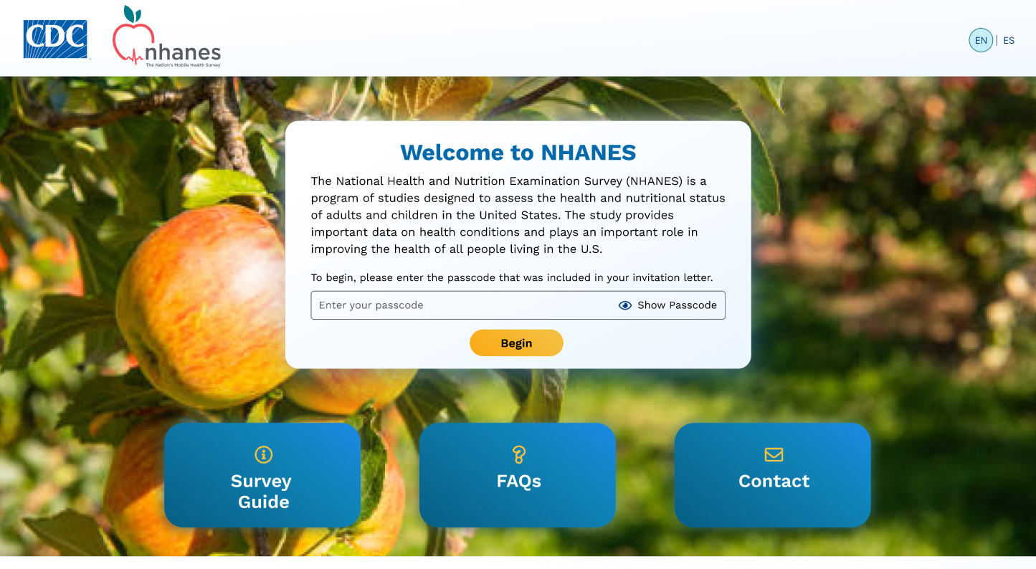

B. Survey Guide Page

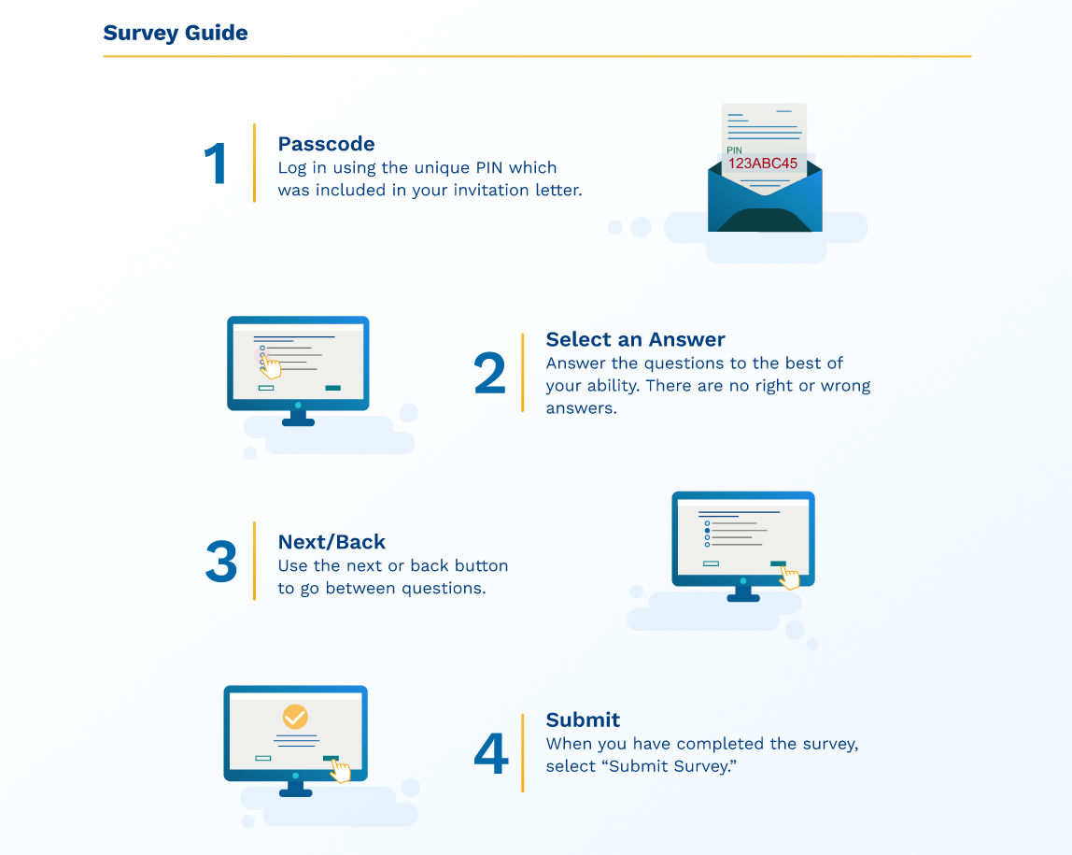

C. FAQ Page

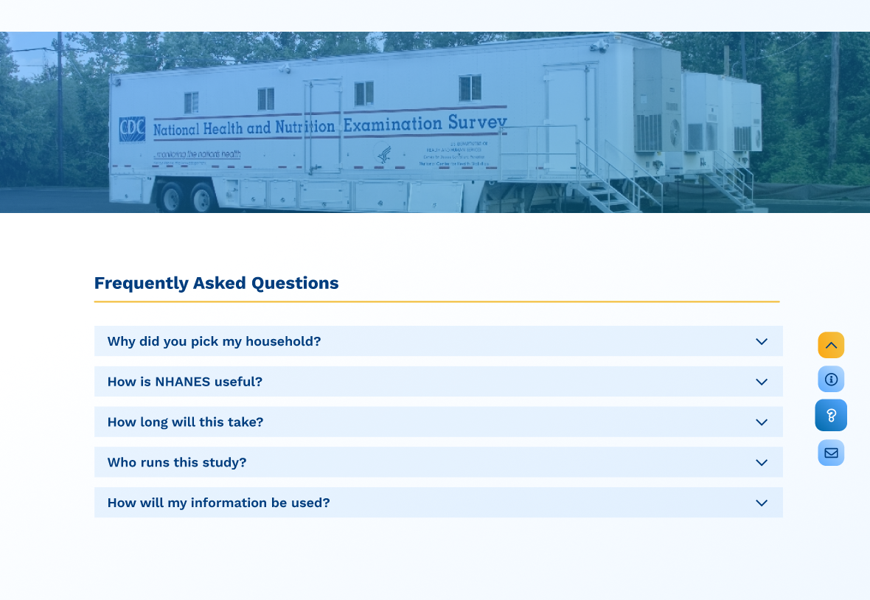

D. Contact Page

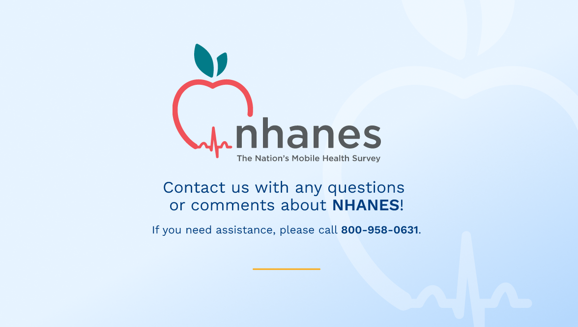

E. Example Questionnaire Pages

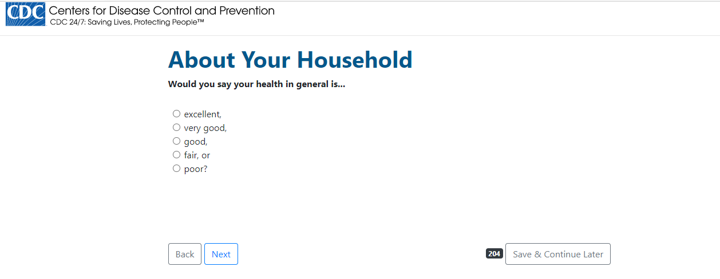

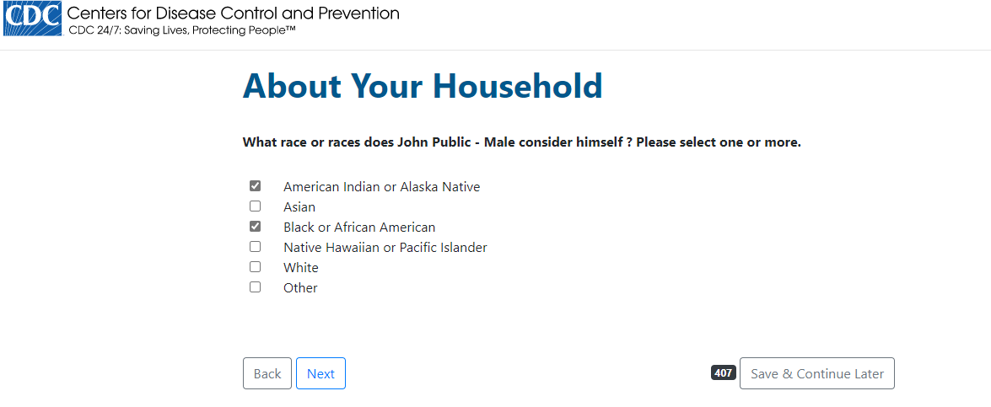

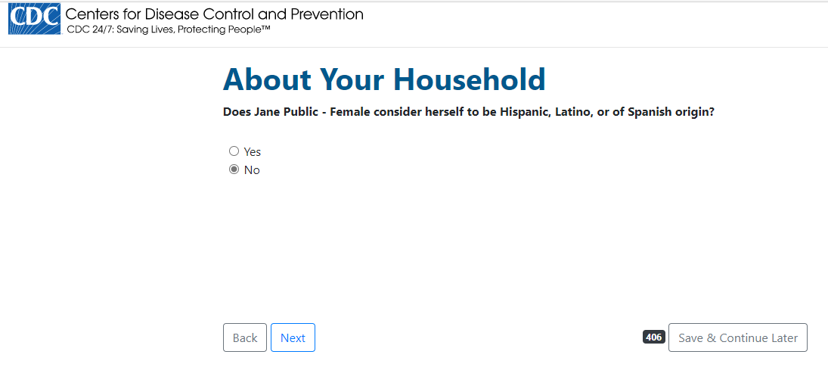

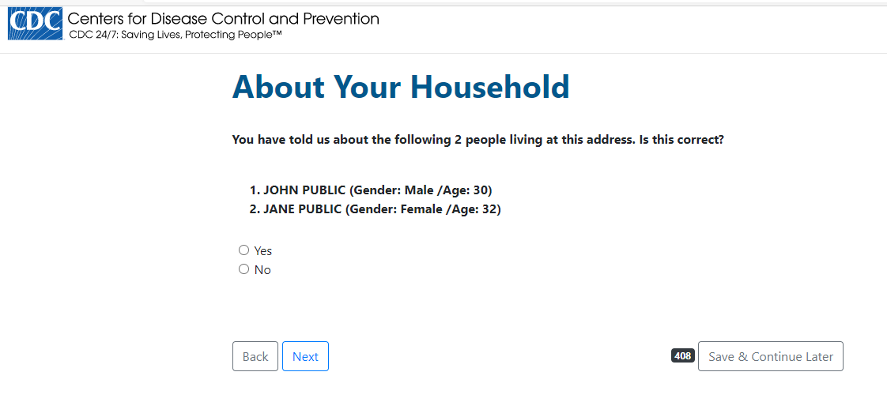

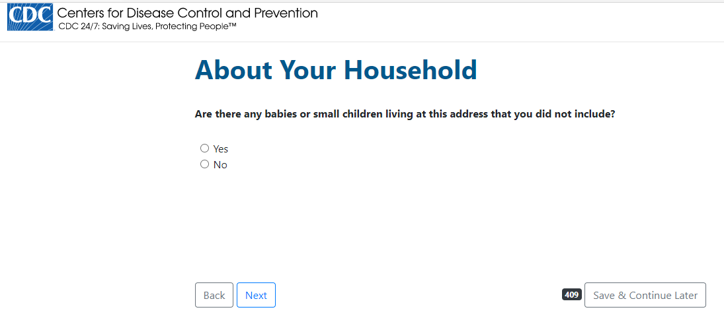

Paper Instrument
Images provided below display the general layout of the paper instrument and may be revised.

