***Attachment 3j***

***Flexible Consumer Behavior Survey (FCBS) Phone Follow-Up Module Hand Cards***

***2021-22***

**Hand Card Booklet Title Page**

**Hand Card**

**Booklet**



2021

Hand Card 1

Fast-food or pizza places

Restaurants with waiter or waitress service

All-you-can-eat buffets

Places that sell mostly beverages such as a coffee shop or juice bar

Movie theaters, sports arenas, or other places of recreation

Grocery stores

Convenience stores

Hand Card 2

1. Less than 500 Calories
2. 500-1000 Calories
3. 1001-1500 Calories
4. 1501-2000 Calories
5. 2001-2500 Calories
6. 2501-3000 Calories

G. More than 3000 Calories

Hand Card 3

Always

Most of the time

Sometimes

Rarely

Never

Hand Card 4

**Sample health claim in food labels**

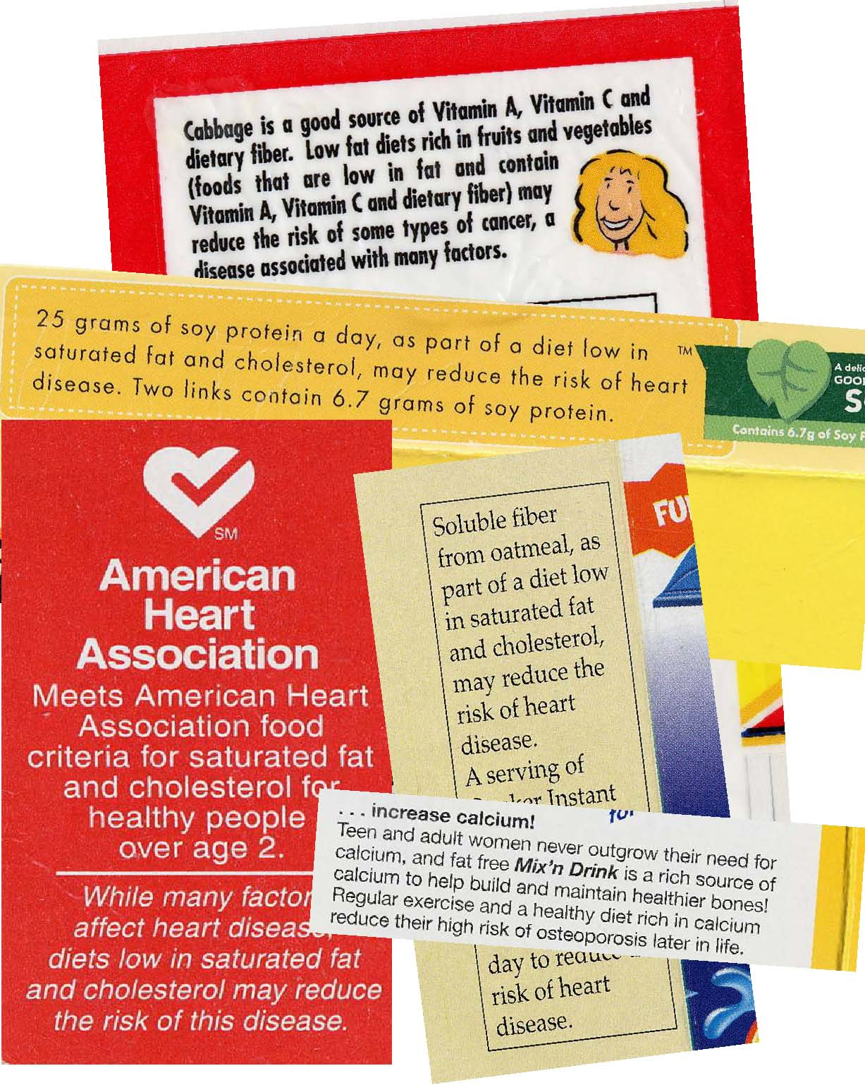

**Low fat diets rich in fruits and vegetables (foods that are low in fat and contain Vitamin A, Vitamin C**

**and dietary fiber) may reduce the risk of some types of cancer, a disease associated with many factors.**

Hand Card 5

Always

Most of the time

Sometimes

Rarely

Never

**Sample Food Label**

Hand Card 6

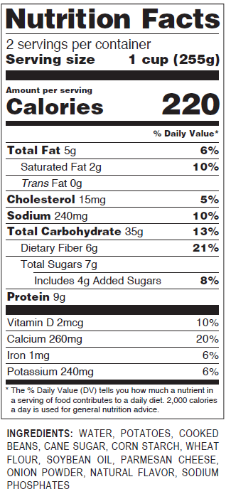

**Nutrition Facts Panel**



Hand Card 6

Always

Most of the time

Sometimes

Rarely

Never

Hand Card 7

Hand Card 8

**Sample Food Label**



**List of Ingredients**

Hand Card 9

Always

Most of the time

Sometimes

Rarely

Never

Hand Card 10

**Sample Food Label**



**Serving Size**

Hand Card 11

Always

Most of the time

Sometimes

Rarely

Never

Hand Card 12

**Sample Food Label**



**Number of servings per package**

Hand Card 13

Always

Most of the time

Sometimes

Rarely

Never

Hand Card 14

**Sample Food Label**



**Footnote**

Hand Card 15

Always

Most of the time

Sometimes

Rarely

Never

Hand Card 16

**Sample Food Label**



**Percent**

**Daily Value**

Hand Card 17

Always

Most of the time

Sometimes

Rarely

Never

Hand Card 18

**Sample Food Label**



**Percent**

**Daily Value**

**Amount of the nutrient**

Hand Card 19

When deciding to buy a food product, between the **percent daily value** and the **amount of nutrients** on a food label

I use….

* Only percent daily value
* Percent daily value more often
* Both percent daily value and the amount of nutrients about the same
* The amount of nutrients more often
* Only the amount of nutrients

Hand Card 20

**Sample Food Label**



**Percent**

**Daily Value**

**Amount of the nutrient**

Hand Card 21

When deciding to buy a food product, between the **percent daily value** and the **amount of nutrients** on a food label

I use….

* Only the amount of nutrients
* The amount of nutrients more often
* Both the amount of nutrients and percent daily value about the same
* Percent daily value more often
* Only percent daily value

Hand Card 22

**Sample Food Label**



Hand Card 23

## 10 percent of the calories in one serving of the product come from Vitamin D

## One serving of the product contains 10 percent Vitamin D by weight

## One serving of the product supplies 10 percent of the Vitamin D you should have in a day

Hand Card 24

**Sample Food Label**



Hand Card 25

## One serving of the product supplies 10 percent of the Vitamin D you should have in a day

## One serving of the product contains 10 percent Vitamin D by weight

## 10 percent of the calories in one serving of the product come from Vitamin D

Hand Card 26

**Sample Food Label**



Hand Card 27

Always

Most of the time

Sometimes

Rarely

Never

Hand Card 28

**Sample Food Label**



Hand Card 29

Always

Most of the time

Sometimes

Rarely

Never

Hand Card 30

**Sample Food Label**



Hand Card 31

Always

Most of the time

Sometimes

Rarely

Never

Hand Card 32

**Sample Food Label**



Hand Card 33

Always

Most of the time

Sometimes

Rarely

Never

Hand Card 34

**Sample food label with two columns**

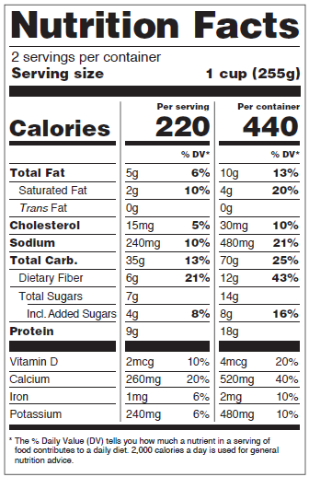

Hand Card 35

Always

Most of the time

Sometimes

Rarely

Never

Never seen

Hand Card 36

**The reason(s) that I check the food label when deciding to buy a food product is/are…**

* To watch my weight/lose weight
* A family member is trying to watch weight/lose weight
* To watch for diabetes, high triglycerides, high cholesterol, high blood pressure or other health conditions
* A family member has a health condition (for example, diabetes, high triglycerides, high cholesterol, high blood pressure, etc)
* I am allergic to certain food(s)
* A family member has food allergies
* To avoid certain ingredients (such as MSG, high fructose corn syrup, color dyes, artificial preservatives, or hydrogenated oils, etc)
* To increase certain nutrients in my/family’s diet (such as fiber, calcium, etc)
* To compare which brand/food is better/healthier
* To make better/healthier choices for me/my family
* To watch for calorie content or certain nutrients (such as sodium, trans fat, sugar, carbohydrates, or protein, etc.)
* Other (please specify)

Hand Card 37

**The reason(s) that I check the food label when deciding to buy a food product is/are…**

* To compare which brand/food is better/healthier
* To make better/healthier choices for me/my family
* To avoid certain ingredients (such as MSG, high fructose corn syrup, color dyes, artificial preservatives, or hydrogenated oils, etc)
* A family member has a health condition (for example, diabetes, high triglycerides, high cholesterol, high blood pressure, etc)
* I am allergic to certain food(s)
* A family member has food allergies
* To watch for diabetes, high triglycerides, high cholesterol, high blood pressure or other health conditions
* To increase certain nutrients in my/family’s diet (such as fiber, calcium, etc)
* To watch my weight/lose weight
* A family member is trying to watch weight/lose weight
* To watch for calorie content or certain nutrients (such as sodium, trans fat, sugar, carbohydrates, or protein, etc.)
* Other (please specify)

Hand Card 38

**The reason(s) that I rarely or never check the food label when deciding to buy a food product is/are…**

* I don't have the time
* The print is too small for me to read
* I’m satisfied with my health so there is no need for me to check
* I have a good diet so there is no need to check labels
* I usually buy foods that I'm used to, so I don’t feel that I need to check labels
* I buy what I/my family like, I don’t care about the labels
* I don’t think the food labels are important to me
* I won’t know what to look for even if I read the labels
* I can’t read English that well
* Other (please specify)

Hand Card 39

**The reason(s) that I rarely or never check the food label when deciding to buy a food product is/are…**

* I don't have the time
* I won’t know what to look for even if I read the labels
* I’m satisfied with my health so there is no need for me to check
* I can’t read English that well
* I have a good diet so there is no need to check labels
* I buy what I/my family like, I don’t care about the labels
* I don’t think the food labels are important to me
* The print is too small for me to read
* I usually buy foods that I'm used to, so I don’t feel that I need to check labels
* Other (please specify)

Hand Card 40

**Sample Food Label**



**Serving Size**

Hand Card 41

Serving size is...

The amount of this food that people should eat

The amount of this food that people usually eat

Something that makes it easier to compare foods

Hand Card 42

**Sample Food Label**



**Serving Size**

Hand Card 43

Hand Card 43

Serving size is...

The amount of this food that people usually eat

The amount of this food that people should eat

Something that makes it easier to compare foods

Hand Card 44

Label 1 Label 2

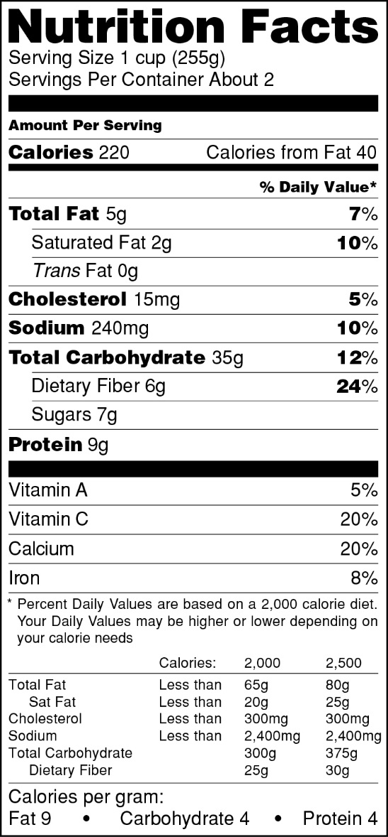

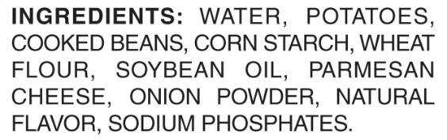

Hand Card 45

Label 1 only

Label 2 only

Both Label 1 and Label 2

Neither Label 1 or Label 2