Cross walk - 2023 form changes

FoodNet

- FoodNet Active Surveillance Data Elements List – Attachment #3
Refer to Attachment #3 - Changes are highlighted in Yellow
- FoodNet Hemolytic Uremic Syndrome Data Elements List – Attachment #4
Refer to Attachment #4 - Changes are highlighted in Yellow
- Diagnostic Laboratory Practices and Volume Elements List – Attachment #5
Refer to Attachment #5 – Changes are highlighted in Yellow

FluSurv-Net

- FluSurv-NET Influenza Surveillance Project Case Report Form– Attachment #6

Question on 2021-22 Form | Question on 2022-23 Form
C9. Race:  - White  - Black or African American  - Asian/Pacific Islander  - American Indian or Alaska Native  - Multiracial  - Not specified | C8. Race (select all that apply):  - White  - Black or African American  - Asian  - Native Hawaiian or Other Pacific Islander  - American Indian or Alaska Native  - Multiracial, not otherwise specified  - Not specified
C2. Admission Type  - Hospitalization  - Observation only | Deleted question C2 regarding Admission Type
HIj. Pregnant  - Yes  - No/Unknown | C12. Pregnant (15-49 years of age only):  - Yes  - No/Unknown  - Not applicable (Male)
This question was not present | H 10. Mental Health Conditions [] Yes [] No/Unknown  - Anxiety disorder  - Bipolar disorder  - Depression  - Schizophrenia spectrum disorder
I1. Were any culture tests performed within 7 days of admission? (for patients that died in the hospital, include culture tests performed either 1) within 7 days of admission, 2) within 3 days prior to death, or 3) within 24 hours after death?  - Yes  - No  - Unknown | I1 Were any culture tests performed within 3 days prior to or 3 days following admission  - Yes  - No  - Unknown
J1. Was the patient tested for any viral pathogen within 14 days prior to or within 7 days of admission?  - Yes  - No  - Unknown | J1. Was the patient tested for any viral pathogen within 14 days prior to or within <= 3 days after admission?  - Yes  - No  Unknown
I2. If yes, was there a positive culture for aspergillus, mucormycosis, or a bacterial pathogen?  - Yes  - No  - Unknown | I2c. Result of culture  - Positive  - Negative  - Unknown
I2a. If yes, specify pathogen  - Aspergillus (fungus)  - Mucormycosis (fungus)  - Bacteria, specify | I2d. If positive, what pathogen was identified?  - Bacteria, specify  - Aspergillus (fungus)  - Mucormycosis (fungus)
K2C. Treatment End Date  - Date or Unknown | This question was deleted
M1. Did the patient have any of the following new diagnoses at discharge (select all that apply) | M1. Did the patient have any of the following new diagnoses at discharge (select all that apply)  - All diagnoses that were previously collected are also collected this season  - Mucormycosis was added as a new diagnosis

- FluSurv-NET/RSV Laboratory Survey– Attachment #7

Question on 2021-22 form | Question on 2022-23 form
4a. Select the kit names for the rapid influenza diagnostic tests performed or planned to be used at the laboratory (check all that apply)  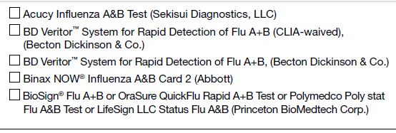  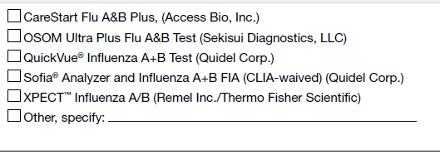 | 4a. Select the kit names for the rapid influenza diagnostic tests performed or planned to be used at the laboratory (check all that apply)  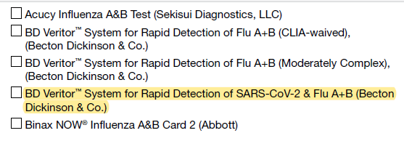  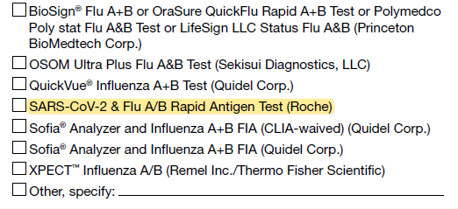
5A. Select Kit names for all molecular assays performed or planned to be used at the laboratory (check all that apply)  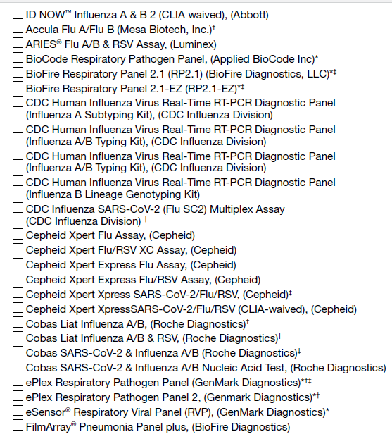  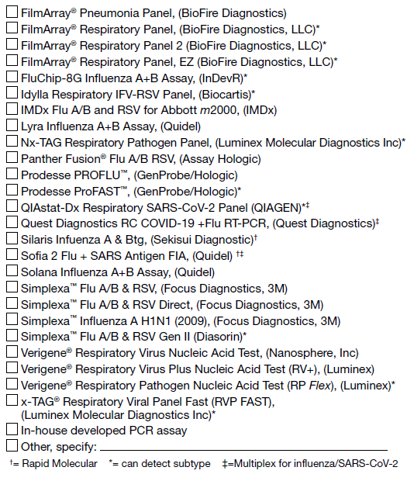 | 5A. Select Kit names for all molecular assays performed or planned to be used at the laboratory (check all that apply)  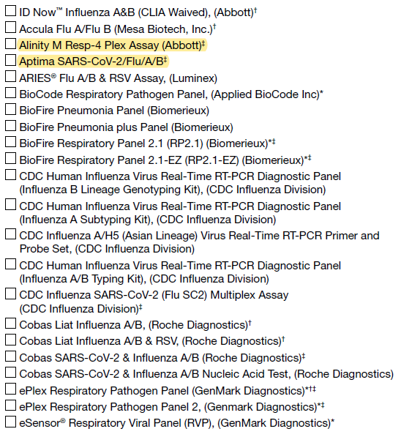  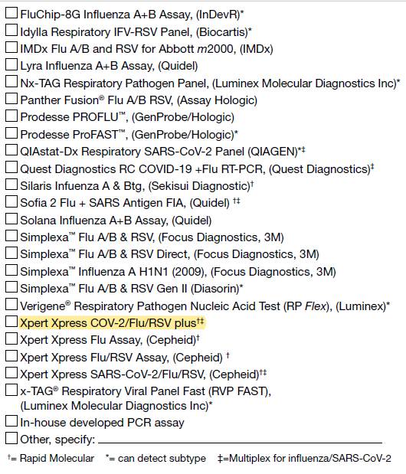
5B If more than one kit is selected above, please select the one kit name that is (or will be) used most frequently for molecular assay at the laboratory during the current influenza season:  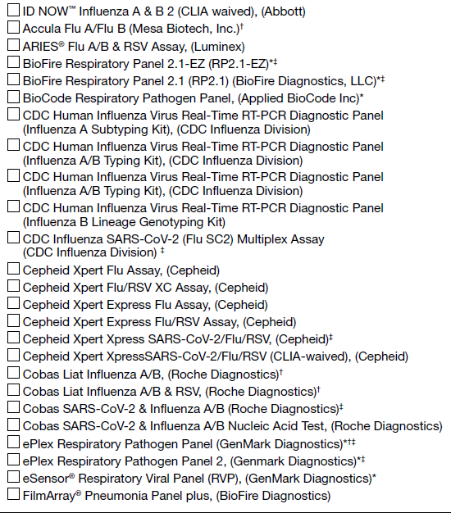  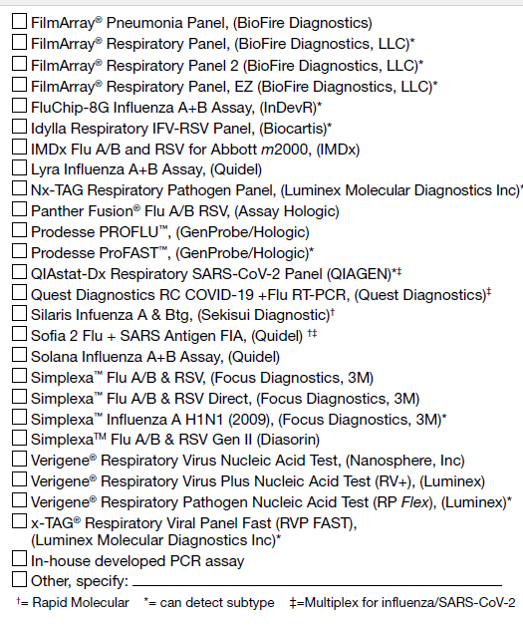 | 5B If more than one kit is selected above, please select the one kit name that is (or will be) used most frequently for molecular assay at the laboratory during the current influenza season:  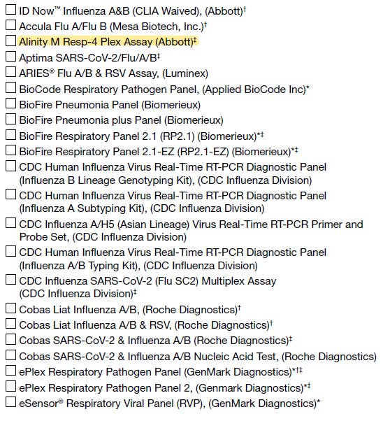  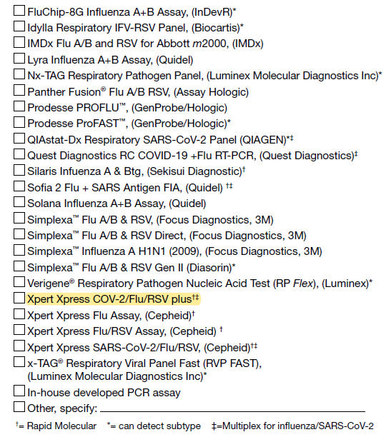
6A. Which influenza test method does the laboratory perform most frequently for pediatric patients (0-17 years)?  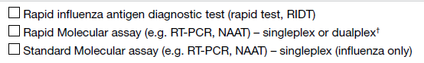  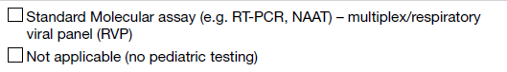 | 6A. Which influenza test method does the laboratory perform most frequently for pediatric patients (0-17 years)?  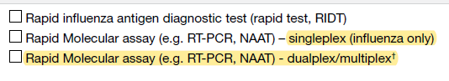  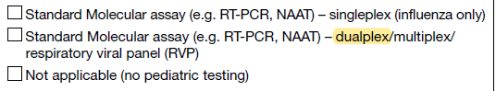
6B. Which influenza test method does the laboratory perform most frequently for adult patients (aged >= 18 years)?  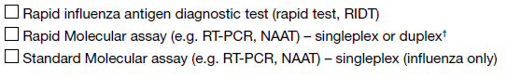  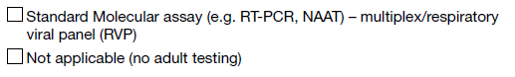 | 6B. Which influenza test method does the laboratory perform most frequently for adult patients (aged >= 18 years)?  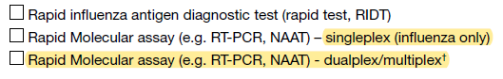  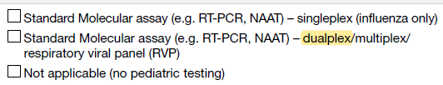
7. Based on tests that were performed during the 2021-2022 influenza season, approximately what percent of the time are each of these test types used to test for flu overall  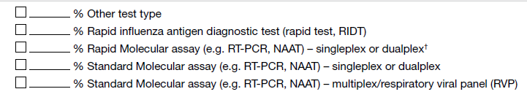 | 7. Based on tests that were performed during the 2021-2022 influenza season, approximately what percent of the time are each of these test types used to test for flu overall  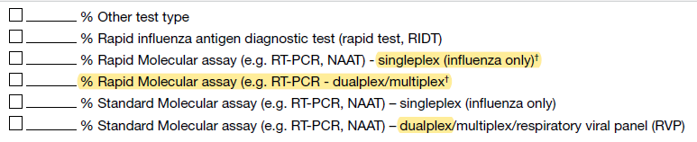

HAIC

- HAIC: Invasive Methicillin-resistant Staphylococcus aureus (MRSA) Infection Case Report Form (Attachment #9)

2022 CRF Question | Changes to the 2023 CRF Question
 | 2a. Planning region
34a. Did the patient have a positive test(s) for SARS-CoV-2 (molecular assay, serology, or other confirmatory test) on or in the year before the DISC?  □ Yes □ No □ Unknown | 34a. Did the patient have a positive test(s) for SARS-CoV-2 (molecular assay, serology, or other confirmatory test) on or in the 90 days before the DISC?  □ Yes □ No □ Unknown
34a.  IF YES, complete below for MOST RECENT positive test for SARS-CoV-2 on or in the year before the DISC:  Specimen collection date:  __-__-____ □ Unknown  Test type:  □ Antigen  □ Molecular assay  □ Serology  □ Method unknown  □ Other (specify): ________ | 34a.  Specimen collection dates for positive tests in the 90 days before or day of DISC:  First positive test: __-__-____ □ Unknown  Most recent positive test: __-__-____ □ Unknown
34a. COVIDNET Case ID: _____________  NNDSS IDs (please provide at least one of the following when applicable):  CDC 2019 NCOV ID: _____________  Local case ID: _____________  Local record ID: _____________  State case identifier: _____________  Legacy case identifier: _____________ | 34a. COVIDNET Case ID: _____________

- HAIC: Invasive Methicillin-sensitive Staphylococcus aureus (MSSA) Infection Case Report Form (Attachment #10)

2022 CRF Question | Changes to the 2023 CRF Question
 | 2a. Planning Region
34a. Did the patient have a positive test(s) for SARS-CoV-2 (molecular assay, serology, or other confirmatory test) on or in the year before the DISC?  □ Yes □ No □ Unknown | 34a. Did the patient have a positive test(s) for SARS-CoV-2 (molecular assay, serology, or other confirmatory test) on or in the 90 days before the DISC?  □ Yes □ No □ Unknown
34a.  IF YES, complete below for MOST RECENT positive test for SARS-CoV-2 on or in the year before the DISC:  Specimen collection date:  __-__-____ □ Unknown  Test type:  □ Antigen  □ Molecular assay  □ Serology  □ Method unknown  □ Other (specify): ________ | 34a.  Specimen collection dates for positive tests in the 90 days before or day of DISC:  First positive test: __-__-____ □ Unknown  Most recent positive test: __-__-____ □ Unknown
34a. COVIDNET Case ID: _____________  NNDSS IDs (please provide at least one of the following when applicable):  CDC 2019 NCOV ID: _____________  Local case ID: _____________  Local record ID: _____________  State case identifier: _____________  Legacy case identifier: _____________ | 34a. COVIDNET Case ID: _____________

- HAIC: Extended-Spectrum Beta-Lactamase (ESBL)-Producing Enterobacterales / Invasive Escherichia coli (iEC) Multi-site Gram-Negative Surveillance Initiative (MuGSI) Case Report Form (CRF) (Attachment #11)

Question on original 2022 form | Question on 2023 form | Description of change
24a. Did the patient have a positive test(s) for SARS-CoV-2 (molecular assay, serology, or other confirmatory test) in the year before or day of the DISC?  Yes  No  Unknown | 24a. Did the patient have a positive test(s) for SARS-CoV-2 (molecular assay, antigen, or other viral test, excluding serology) in the 90 days before or day of the DISC?  Yes  No  Unknown | i. Updated the text for the question
24b. If yes, complete the table below for the most recent positive SARS-CoV-2 test in the year before or day of the DISC:  Specimen collection date Test type  __/__/____ □ Unknown □ Molecular assay □ Antigen □ Serology □ Unknown □ Other (specify):___________ | 24b. Specimen collection dates for positive tests in the 90 days before or day of DISC:  First positive test: __/__/____ or □ Date unknown  Most recent positive test: __/__/____ or □ Date unknown | i. Updated the text for the question  ii. Removed the test type  iii. Added specimen collection date for first and most recent positive test

- HAIC: Carbapenem-Resistant Enterobacterales (CRE) and Carbapenem-Resistant Acinetobacter baumannii (CRAB) Multi-site Gram-Negative Surveillance Initiative (MuGSI) Case Report Form (CRF) (Attachment #12)
Question on original 2022 form | Question on 2023 form | Description of change
2022 Carbapenem Resistant Enterobacteriaceae (CRE)/ Carbapenem Resistant A. baumannii  (CRAB) Multi-site Gram-Negative Surveillance Initiative (MuGSI)  Healthcare-Associated Infections Community Interface (HAIC) Case Report | 2023 Carbapenem Resistant Enterobacterales (CRE)/ Carbapenem Resistant A. baumannii  (CRAB) Multi-site Gram-Negative Surveillance Initiative (MuGSI)  Healthcare-Associated Infections Community Interface (HAIC) Case Report | I. Updated the year to 2023  II. Updated Enterobacteriaceae to Enterobacterales
Q2. County | Q2a. County | I. Updated the question number
 | Q2b. Planning region | I. Added question
23b. Risk factors in the 7 days before the DISC:  Non-invasive positive pressure ventilation (CPAP or BiPAP) at any time in the  7 calendar days before the DISC  Nebulizer treatment at any time in the 7 calendar days before the DISC  Mechanical ventilation at any time in the 7 calendar days before the DISC | 23b. Risk factors in the 7 days before the DISC:  Non-invasive positive pressure ventilation (CPAP or BiPAP) at any time in the  7 calendar days before the DISC  Nebulizer treatment at any time in the 7 calendar days before the DISC  Mechanical ventilation at any time in the 7 calendar days before the DISC  None | I. Added a checkbox for “none”
24a. Did the patient have a positive test(s) for SARS-CoV-2 (molecular assay, serology, or other confirmatory test) in the year before or day of the DISC?  Yes  No  Unknown | 24a. Did the patient have a positive test(s) for SARS-CoV-2 (molecular assay, antigen, or other viral test, excluding serology) in the 90 days before or day of the DISC?  Yes  No  Unknown | i. Updated the text for the question
24b. If yes, complete the table below for the most recent positive SARS-CoV-2 test in the year before or day of the DISC:  Specimen collection date Test type  __/__/____ □ Unknown □ Molecular assay □ Antigen □ Serology □ Unknown □ Other (specify):___________ | 24b. Specimen collection dates for positive tests in the 90 days before or day of DISC:  First positive test: __/__/____ or □ Date unknown  Most recent positive test: __/__/____ or □ Date unknown | i. Updated the text for the question  ii. Removed the test type  iii. Added specimen collection date for first and most recent positive test

- HAIC: CDI Case Report and Treatment Form (Attachment #13)

2022 CRF | 2023 CRF | Changes
6. County | 6a. County | changed question number
[question not on CRF] | 6b. Planning region | new question
36. Previous unique CDI episode | 38. Previous unique CDI episode | changed question number
37. Any recurrent C. diff+ episodes following this incident C. diff+ episode? | 39. Any recurrent C. diff+ episodes following this incident C. diff+ episode? | changed question number
37a. If YES, Date of first  recurrent specimen | 39a. If YES, Date of first  recurrent specimen | changed question number
38. CRF status | 40. CRF status | changed question number
39. Initials of SO | 41. Initials of SO | changed question number
40. Date of abstraction | 42. Date of abstraction | changed question number
41. Did the patient have a positive test(s) for SARS-CoV-2 (molecular assay, serology, or other confirmatory test) in the year before or day of the DISC? | 36. Did the patient have a positive test(s) for SARS-CoV-2 (molecular assay, antigen, or other viral test; excluding serology) in the 90 days before or day of the DISC? | changed question number, changed time period, changed tests under consideration
[question not on CRF] | 36a. [Specimen collection dates for positive tests in the 90 days before or day of DISC]  First positive test: __ __ / __ __ / __ __ __ __ or □ Date unknown | new question
41a.1 [If YES, complete below for most recent positive test for SARS CoV-2 in the year before or date of the DISC] - Specimen collection date | 36b. [Specimen collection dates for positive tests in the 90 days before or day of DISC]  Most recent positive test: __ __ / __ __ / __ __ __ __ or □ Date unknown | Reworded, changed time period
41a.2 [If YES, complete below for most recent positive test for SARS CoV-2 in the year before or date of the DISC] - Test type | [question not on CRF] | Removed question
42a. COVID-NET Case ID | 37. COVID-NET Case ID | changed question number
42b. NNDSS IDs | [question not on CRF] | Removed question

- HAIC: CDI Annual Surveillance Officers Survey (Attachment #14)

Existing question | Modified question
2. In 2021, did any laboratories drop out of participation? | 2. In 2022, did any laboratories drop out of participation?  (changed year to 2022 to reflect change in survey year)
3. In 2021, did you identify any additional laboratories inside or outside of your catchment area which identify C.diff assays from persons who are residents of your catchment area? | 3. In 2022, did you identify any additional laboratories inside or outside of your catchment area which identify C.diff assays from persons who are residents of your catchment area?  (changed year to 2022 to reflect change in survey year)
10. Did your site complete a physician/outpatient provider survey in 2021? | 10. Did your site complete a physician/outpatient provider survey in 2022?  (changed year to 2022 to reflect change in survey year)
13. For each facility that treated a case in 2021, please provide the following | 13. For each facility that treated a case in 2022, please provide the following  (changed year to 2022 to reflect change in survey year)

- HAIC: Annual Survey of Laboratory Testing Practices for C. difficile Infections (Attachment #15)

2022 | 2023 | Changes
Was this a new laboratory in 2021? | Was this a new laboratory in 2022? | Changed year to 2022 to reflect change in survey year
Did this lab participate in surveillance in 2021? | Did this lab participate in surveillance in 2022? | Changed year to 2022 to reflect change in survey year
How often did you receive line lists from this lab in 2021? | How often did you receive line lists from this lab in 2022? | Changed year to 2022 to reflect change in survey year
How did you receive line lists from this lab in 2021? | How did you receive line lists from this lab in 2022? | Changed year to 2022 to reflect change in survey year
Did you receive specimens from this lab in 2021? | Did you receive specimens from this lab in 2022? | Changed year to 2022 to reflect change in survey year
Was this lab audited in 2021? | Was this lab audited in 2022? | Changed year to 2022 to reflect change in survey year
Types of facilities in your catchment area served by this lab in 2021 | Types of facilities in your catchment area served by this lab in 2022 | Changed year to 2022 to reflect change in survey year
1. Did your laboratory ever send specimens off-site for Clostridioides difficile testing in 2021? | 1. Did your laboratory ever send specimens off-site for Clostridioides difficile testing in 2022? | Changed year to 2022 to reflect change in survey year
2. What type and order of testing was routinely used by your laboratory in standard testing for C. difficile on December 31, 2021?  1st line of testing: ________ 2nd line of testing: ________ 3rd line of testing: ________ | [question not on survey] | Removed question
2a. Which specimens were used during your 2nd line of testing? | [question not on survey] | Removed question
2b. Which specimens were used during your 3rd line of testing? | [question not on survey] | Removed question
2c. Did your laboratory perform any onsite testing for C. difficile outside of your normal testing algorithm in 2021? | [question not on survey] | Removed question
[question not on survey] | [Question 2a is a table with this heading] Which testing method(s) for Clostridioides difficile (C. difficile) did your laboratory perform in 2022? (Choose all that apply. Include testing methods used for only part of the year or for only a specific subset of specimens, if applicable) | Added table of questions
[question not on survey] | Did your laboratory use this testing method for Clostridioides difficile (C. difficile) in 2022? | Added table of questions
[question not on survey] | [For each testing method selected] Specify when you used this test (e.g. at provider request, for outpatients, for inpatients with a length of stay > 3 days, for every specimen received) | Added table of questions
[question not on survey] | [For each testing method selected] Did you use this testing method in this way for all of 2022? | Added table of questions
[question not on survey] | [For each testing method selected] What date did you change? | Added table of questions
[question not on survey] | [For each testing method selected] What test did you use in this situation before this date? | Added table of questions
3a. Which EIA test kit was used by your laboratory in 2021? | 3a. Which EIA test kit was used by your laboratory in 2022? | Changed year to 2022 to reflect change in survey year
3b. Which Nucleic Acid Amplification test was used by your laboratory in 2021? | 3b. Which Nucleic Acid Amplification test was used by your laboratory in 2022? | Changed year to 2022 to reflect change in survey year
4a. If your laboratory used a multiplexed molecular diagnostic (e.g., Biofire Filmarray GI Panel, Luminex xTAG GPP) to test for several GI pathogens in 2021, did your laboratory suppress the C. difficile result so that clinicians could not see it? | 4a. If your laboratory used a multiplexed molecular diagnostic (e.g., Biofire Filmarray GI Panel, Luminex xTAG GPP) to test for several GI pathogens in 2022, did your laboratory suppress the C. difficile result so that clinicians could not see it? | Changed year to 2022 to reflect change in survey year
4b. If your laboratory used a multiplexed diagnostic in 2022 and the result was suppressed, where does the suppression occur? | 4b. If your laboratory used a multiplexed diagnostic in 2022 and the result was suppressed, where does the suppression occur? | Changed year to 2022 to reflect change in survey year
5a. If your laboratory used a nucleic acid amplification test (NAAT) (e.g., Cepheid Xpert C. difficile) as first line testing followed by a toxin EIA test (whenever NAAT result is positive) in 2022, did your laboratory suppress the positive NAAT result so that clinicians could not see it? | 5a. If your laboratory used a nucleic acid amplification test (NAAT) (e.g., Cepheid Xpert C. difficile) as first line testing followed by a toxin EIA test (whenever NAAT result is positive) in 2022, did your laboratory suppress the positive NAAT result so that clinicians could not see it? | Changed year to 2022 to reflect change in survey year
5b. If your laboratory used NAAT as first line testing followed by confirmatory toxin EIA testing in 2022, and both the NAAT and toxin EIA results were released to the clinician, did your laboratory provide any comments to help the clinician interpret the test results (e.g., NAAT-positive only result might represent colonization, etc.)? | 5b. If your laboratory used NAAT as first line testing followed by confirmatory toxin EIA testing in 2022, and both the NAAT and toxin EIA results were released to the clinician, did your laboratory provide any comments to help the clinician interpret the test results (e.g., NAAT-positive only result might represent colonization, etc.)? | Changed year to 2022 to reflect change in survey year
6. What are the LOINC or internal testing codes associated with the tests your lab used in 2022 (e.g. LOINC codes 13957-6, 34713-8, or 54067-4)? | 6. What are the LOINC or internal testing codes associated with the tests your lab used in 2022 (e.g. LOINC codes 13957-6, 34713-8, or 54067-4)? | Changed year to 2022 to reflect change in survey year
7a. In 2021, did your laboratory experience any shortages in supplies, reagents, and/or test kits for performing C. difficile testing (e.g., NAAT or EIA reagents, swabs)? | [question not on survey] | Removed question
7b. If your laboratory experienced a supply shortage for C. difficile testing in 2021, how did the shortage affect your laboratory’s ability to perform C. difficile testing? | [question not on survey] | Removed question
7c. In 2021, did your laboratory experience a high demand for COVID-19 testing that limited the availability of staff (e.g., reduced staffing or work time) or the use of equipment to perform C. difficile testing? | [question not on survey] | Removed question
8. Did your lab testing algorithm for C. difficile change between January 1, 2021 and December 31, 2021? | [question not on survey] | Removed question
What date did this change occur? ______ / ______ / _____ | [question not on survey] | Removed question
8a. What was the previous type and order of testing performed by your lab in 2021 before it changed its testing algorithm?  1st line of testing: ________ 2nd line of testing: ________ 3rd line of testing: ________ | [question not on survey] | Removed question
8b. Which specimens were used during your 2nd line of testing? | [question not on survey] | Removed question
8c. Which specimens were used during your 3rd line of testing? | [question not on survey] | Removed question
9. Did your lab have a policy to reject stool specimens for C. difficile testing in 2021? (Read all options. Check all that apply)  □ Yes, when stools are formed (formed stools are defined as stools that do NOT take the shape of the container)  □ Yes, if there is a stool specimen already positive within 24 hrs of a new stool specimen  □ Yes, if there is a stool specimen already positive within 48 hrs of a new stool specimen  □ Yes, if there is a stool specimen that tested negative for C. difficile within 48 hours of a new stool specimen  □ Yes, will not accept more than one stool specimen in a 24 hr period  □ No rejection policy  □ Other rejection policies  Specify other rejection policy: __________________________ | 7. Did your lab have a policy to reject stool specimens for C. difficile testing in 2022? (Read all options. Check all that apply, even if it only applies sometimes)  □ Yes, when stools are formed (formed stools are defined as stools that do NOT take the shape of the container)  □ Yes, if there was a positive stool specimen recently (e.g. within 24 hours, within 7 days)  □ Yes, if there was a negative stool specimen recently (e.g. within 24 hours, within 7 days)  □ Yes, will not accept more than one stool specimen in a 24 hr period  □ Yes, if patient is on a specific medication (e.g. laxatives)  □ No rejection policy  □ Other rejection policies  Specify other rejection policy: __________________________ | Changed year to 2022 to reflect change in survey year, simplified response options, renumbered question
9a. Did your rejection policy for stool specimens change between January 1, 2021 and December 31, 2021? | 7a. Did your rejection policy for stool specimens change between January 1, 2022 and December 31, 2022? | Changed year to 2022 to reflect change in survey year, renumbered question
10. How many stool samples did you test for C. difficile each month in 2021? | 8. How many stool samples did you test for C. difficile each month in 2022? | Changed year to 2022 to reflect change in survey year, renumbered question

- HAIC: Candidemia Case Report (Attachment #16)

2022 CRF Question | 2023 CRF Question
CANDIDEMIA 2022 CASE REPORT FORM (header) | CANDIDEMIA 2023 CASE REPORT FORM (header)  (changed year)
Version: Short Form 2022, Last Updated: 07/17/2021 (footnotes) | Version: Short Form 2023, Last Updated: 07/29/2022 (footnotes)  (changed year and date)
23. Incident Specimen Collection Site (check all that apply):  Blood, Central line  Blood, Peripheral stick  Blood, not specified  Other (specify):____________  Unknown | (removed question)
Question 24-25 | (changed number by 1)
New Question | 25. Did the patient have a culture-independent diagnostic test (CIDT) for Candida, (eg: T2), on the day of or in the 6 days before the DISC?  1 Yes 0 No 9 Unknown  25a. If yes, test type: ______________________  25b. Result: ______________________________  (new question)
30. Infection with Clostridioides difficile on the day of or in the 89 days before or 29 days after the DISC:  1 Yes 0 No 9 Unknown  30a. If yes, date of first C. diff diagnosis: ___ ___ - ___ ___ - ___ ___ ___ ___ Unknown | (removed question)
31. Did the patient have any of the following types of infection/colonization related to their Candida infection? (check all that apply):  None Unknown  Abdominal  Hepatobiliary or pancreatic  GI tract  Abscess (specify): _________  Peritonitis/peritoneal fluid  Splenic  Candiduria  Esophagitis  Oral/thrush  Osteomyelitis  Skin lesions/wounds  Pulmonary  Abscess  Respiratory specimen with Candida  CNS involvement (meningitis, brain abscess)  Eyes (endophthalmitis or chorioretinitis)  Endocarditis  Septic emboli (specify location): _________  Other (specify): __________ | 30. Did the patient have any of the following types of infection related to their Candida infection? (check all that apply):  None Unknown  Abdominal infection  Hepatobiliary or pancreatic  Abscess (specify): _________  Peritonitis/peritoneal fluid  Splenic  Urinary tract infection  Esophagitis  Oral/thrush  Osteomyelitis  Skin/wound infection  Pulmonary infection  Abscess  CNS infection (meningitis, brain abscess)  Eyes  Endophthalmitis  Chorioretinitis  Endocarditis  Septic emboli (specify location): _________  Other (specify): __________  (changed question number, question wording, response options)
Question 32-34 | (changed number by 1)
35. Did the patient receive invasive mechanical ventilation in the 30 days before the DISC, not including the DISC?  1 Yes 0 No 9 Unknown | (removed question)
Question 36-37a | (changed number by 2)
38. Did the patient have any of the following classes or specific ICD-10 codes, including any sub-codes for this hospitalization?  (Check all that apply):  None  Unknown  B37 (candidiasis)  Specify sub-code: ___________________  Specify sub-code: ___________________  P37.5 (neonatal candidiasis)  B48 (other mycoses, not classified elsewhere)  B49 (unspecified mycoses)  T80.211 (BSI due to central venous catheter)  A41.9 (sepsis, unspecified organism)  R65.2 (severe sepsis)  Other Candida-related code  Specify code: ___________________ | 36. Did the patient have any of the following classes or specific ICD-10 codes, including any sub-codes for this hospitalization?  (Check all that apply):  None  Unknown  Not applicable (i.e., patient not hospitalized)  B37 (candidiasis)  Specify sub-code: ___________________  Specify sub-code: ___________________  P37.5 (neonatal candidiasis)  B48 (other mycoses, not classified elsewhere)  B49 (unspecified mycoses)  T80.211 (BSI due to central venous catheter)  A41.9 (sepsis, unspecified organism)  R65.2 (severe sepsis)  Other Candida-related code  Specify code: ___________________  (changed question number, added check box option for not applicable)
Question 39-44 | (changed number by 2)
45. Other Substances (Check all that apply):  Mode of Delivery (Check all that apply):  IDU Skin popping Non-IDU Unknown  IDU Skin popping Non-IDU Unknown  IDU Skin popping Non-IDU Unknown  IDU Skin popping Non-IDU Unknown  IDU Skin popping Non-IDU Unknown  IDU Skin popping Non-IDU Unknown  IDU Skin popping Non-IDU Unknown  IDU Skin popping Non-IDU Unknown | 43. Other Substances (Check all that apply):  Mode of Delivery (Check all that apply):  IDU Non-IDU Unknown  IDU Non-IDU Unknown  IDU Non-IDU Unknown  IDU Non-IDU Unknown  IDU Non-IDU Unknown  IDU Non-IDU Unknown  IDU Non-IDU Unknown  IDU Non-IDU Unknown  (changed question number, removed “Skin popping” as an option)
Question 46-50 | (changed number by 2)
New Question | 49. Did the patient have any ostomies of the gastrointestinal tract including ileostomy, colostomy, etc. in the 30 calendar days before, not including the DISC?  1 Yes 0 No 9 Unknown
Question 51-53a | (changed number by 2)
53b. Were all CVCs removed or changed on the day of or in the 6 days after the DISC?  1 Yes  2 No  3 CVC removed, but can’t find dates  5 Died or discharged before indwelling catheter replaced  9 Unknown | 52b. Were all CVCs removed or changed in the 2 days before or in the 6 days after the DISC?  1 Yes  2 No  3 CVC removed, but can’t find dates  5 Died or discharged before indwelling catheter replaced  9 Unknown  (changed question number and question wording)
Question 54-55 | (changed number by 1)
56. Did the patient have a positive SARS-CoV-2 test result (molecular assay, serology, or other confirmatory test) from a specimen collected in the 90 days before the DISC or on the DISC?  1 Yes  0 No  9 Unknown | 55. Did the patient have a positive SARS-CoV-2 test result (molecular assay, antigen, or other confirmatory test, excluding serology) from a specimen collected in the 90 days before the DISC or on the DISC?  1 Yes  0 No  9 Unknown  (changed question number and question wording)
Question 56a-58 | (changed number by 1)
58a. If yes, what was the reason steroids were administered? (check all that apply)  Steroid(s) given as an outpatient medication  Steroid(s) given during hospitalization associated with candidemia episode prior to Candida DISC  Steroid(s) given as part of treatment/management for COVID-19 | 57a. If yes, what was the reason steroids were administered? (check all that apply)  Steroid(s) given as an outpatient medication  Steroid(s) given, prior to Candida DISC, during hospitalization associated with candidemia episode  Steroid(s) given as part of treatment/management for COVID-19  None of the above  (changed question number and response wording, added check box for additional response option)
Question 59 | (changed number by 1)
60. Did the patient receive any of the following immunomodulatory drugs in the 30 days before the DISC, not including the DISC? (check all that apply)  None Tocilizumab Sarilumab Baricitinib Unknown  60a. If yes were any of the immunomodulatory drugs given as part of treatment/management for COVID-19?  1 Yes 0 No 9 Unknown | (removed questions)
Question 61-65 | (changed number by 2)
New Question | 64. Did the patient have an echocardiogram (ECHO), including transthoracic (TTE) or transesophogeal (TEE), on the day of or 13 days after the DISC?  1 Yes 0 No 9 Unknown
New Question | 65. Did the patient have a dilated fundoscopic eye exam on the day of or 13 days after the DISC?  1 Yes 0 No 9 Unknown

- HAIC: Laboratory Testing Practices for Candidemia Questionnaire (Attachment #17)

2022 Lab Survey Question | 2023 Lab Survey Question
2022 LABORATORY TESTING PRACTICES FOR CANDIDEMIA QUESTIONNAIRE (header) | 2023 LABORATORY TESTING PRACTICES FOR CANDIDEMIA QUESTIONNAIRE (header)  (changed year)
- What kind of laboratory is this facility? (select one)  Hospital laboratory  Commercial laboratory (Quest, etc.)  Other (specify) ______________________  Unknown | - What kind of laboratory is this? (select one)  Hospital laboratory  Commercial laboratory (Quest, etc.)  Other (specify) ______________________  Unknown  (changed question wording to remove “facility”)
- Does this facility ever receive blood cultures from nursing homes or other long term care facilities?  Yes  No  Unknown | - Does this laboratory ever receive blood cultures from nursing homes or other long term care facilities?  Yes  No  Unknown  (changed question wording to replace “facility” with “laboratory”)
- What is the approximate volume of any type of fungal cultures performed annually in your laboratory?  Specify number: ______________ Unknown | - What is the approximate volume of fungal cultures ordered and performed annually in your laboratory for any specimen type?  Specify number: ______________ Unknown  (changed question wording)
- What is the approximate volume of fungal cultures from blood performed annually in your laboratory?  Specify number: ______________ Unknown | - What is the approximate volume of fungal blood cultures ordered and performed annually in your laboratory?  Specify number: ______________ Unknown  (changed question wording)
- Does this laboratory offer yeast identification either onsite or sent to another laboratory?  Yes  No (-------- If No, SKIP TO QUESTION 15 --------)  Unknown (is there another laboratory staff member who can assist with the questionnaire?) | - Does this laboratory offer yeast identification (either onsite or sent to another laboratory)?  Yes  No (-------- If No, SKIP TO QUESTION 18 --------)  Unknown (is there another laboratory staff member who can assist with the questionnaire?)  (added paratheses to question wording, updated skip logic in response options)
- Does this laboratory routinely use Chromagar for the identification or differentiation of Candida isolates?  Yes  No  Unknown | - Does this laboratory routinely use chromogenic agar for the identification or differentiation of Candida isolates?  Yes  No  Unknown  (changed question wording to replace “Chromagar” with “chromogenic agar”)
- Species-level identification is performed for Candida spp. isolated from which of the following?  - Blood isolates  Yes, reflexively  Yes, with clinician order  No  Unknown | - Species-level identification is performed for Candida spp. isolated from which of the following?  - Blood isolates  Yes, always  Yes, with clinician order  No  Unknown  (changed first response option wording)
- Species-level identification is performed for Candida spp. isolated from which of the following?  - Other normally sterile body site isolates  Yes, reflexively  Yes, with clinician order  No  Unknown | - Species-level identification is performed for Candida spp. isolated from which of the following?  - Other normally sterile body site isolates  Yes, always  Yes, with clinician order  No  Unknown  (changed first response option wording)
- Species-level identification is performed for Candida spp. isolated from which of the following?  - Abdominal isolates  Yes, reflexively  Yes, with clinician order  No  Unknown | - Species-level identification is performed for Candida spp. isolated from which of the following?  - Abdominal isolates  Yes, always  Yes, with clinician order  No  Unknown  (changed first response option wording)
- Species-level identification is performed for Candida spp. isolated from which of the following?  - Respiratory isolates  Yes, reflexively  Yes, with clinician order  No  Unknown | - Species-level identification is performed for Candida spp. isolated from which of the following?  - Respiratory isolates  Yes, always  Yes, with clinician order  No  Unknown  (changed first response option wording)
- Species-level identification is performed for Candida spp. isolated from which of the following?  - Urine isolates  Yes, reflexively  Yes, with clinician order  No  Unknown | - Species-level identification is performed for Candida spp. isolated from which of the following?  - Urine isolates  Yes, always  Yes, with clinician order  No  Unknown  (changed first response option wording)
- Species-level identification is performed for Candida spp. isolated from which of the following?  - Other (specify) _________________  Yes, reflexively  Yes, with clinician order  No  Unknown | - Species-level identification is performed for Candida spp. isolated from which of the following?  - Other (specify) _________________  Yes, always  Yes, with clinician order  No  Unknown  (changed first response option wording)
- Does this laboratory employ culture-independent diagnostic tests (CIDT) to identify Candida from blood specimens?  Yes (got to q14)  No (got to q17)  Unknown | - Does this laboratory employ culture-independent diagnostic tests (CIDTs) to identify Candida from blood specimens?  Yes (go to Q14)  No (go to Q17)  Unknown  (changed question wording to update CIDT abbreviation, changed formatting of skip logic in the response wording)
14) Does this laboratory employ the T2Candida Panel to identify Candida from blood specimens?  Yes (got to 12a)  No (go to 13)  Unknown | 14) Does this laboratory employ the T2Candida Panel to identify Candida from blood specimens?  Yes (go to Q14a)  No (go to Q15)  Unknown  (changed formatting of skip logic in the response wording)
14) Does this laboratory employ the T2Candida Panel to identify Candida from blood specimens?  - If Yes, does this lab culture blood if you get a positive result on T2Candida Panel?  Yes, reflexively  Yes, with a clinical order  No  Unknown | 14) Does this laboratory employ the T2Candida Panel to identify Candida from blood specimens?  - If Yes and you get a positive result on T2Candida Panel, does this lab culture the blood to obtain an isolate?  Yes, always  Yes, with a clinical order  No  Unknown  (changed question wording, changed first response option wording)
15) Does this laboratory employ the BioFire (FilmArray) to identify Candida from blood specimens?  Yes (go to 15a)  No (go to 16)  Unknown | 15) Does this laboratory employ the BioFire (FilmArray) to identify Candida from blood specimens?  Yes (go to Q15a)  No (go to Q16)  Unknown  (changed formatting of skip logic in the response wording)
15) Does this laboratory employ the BioFire (FilmArray) to identify Candida from blood specimens?  - If Yes, does this lab reflexively culture blood if you get a positive result on BioFire?  Yes, reflexively  Yes, with a clinical order  No  Unknown | 15) Does this laboratory employ the BioFire (FilmArray) to identify Candida from blood specimens?  - If Yes and you get a positive result on BioFire, does this lab culture the blood to obtain an isolate?  Yes, always  Yes, with a clinical order  No  Unknown  (changed question wording, changed first response option wording)
- Where is antifungal susceptibility testing (AFST) done? (check the most applicable)  On-site, in the laboratory  Sent to commercial lab  Sent to affiliated hospital lab  Sent to other local/regional, non-affiliated reference or public health laboratory  Other ______________________________  Unknown | - Where is antifungal susceptibility testing (AFST) done? (check the most applicable)  On-site, in the laboratory (go to Q20)  Sent to commercial lab (-------- If not an on-site laboratory, QUESTIONNAIRE COMPLETE --------)  Sent to affiliated hospital lab  Sent to other local/regional, non-affiliated reference or public health laboratory  Other ______________________________  Unknown  (changed skip logic in the response wording)
21) What methods are used for AFST? (check all that apply)  Non-commercial broth microdilution  YeastOne  E test  Vitek  Other ______________________________  Unknown | 21) What methods are used for AFST, excluding Amphotericin B? (check all that apply)  Broth microdilution with laboratory developed plates  YeastOne (Thermo Scientific™ Sensititre™  Gradient diffusion (E test)  Vitek (bioMerieux)  Other ______________________________  Unknown  (changed question wording to specify all antifungals except Amp B, changed response option wording)
- If you use Vitek for AFST, what Candida species do you test with it? (check all that apply)  C. albicans  C. glabrata  C. parapsilosis  Other Candida spp. | (removed question)
New question | 22) What methods are used for AFST of Amphotericin B? (check all that apply)  Broth microdilution with laboratory developed plates  YeastOne (Thermo Scientific™ Sensititre™  Gradient diffusion (E test)  Vitek (bioMerieux)  Other ______________________________  Unknown  (new question)
- How does this laboratory meet proficiency testing requirements for antifungal susceptibility testing, if performed?  Commercial provider (specify) _________________  Internal alternate assessments (specify) __________________ | - How does this laboratory meet proficiency testing requirements for antifungal susceptibility testing, if performed?  Commercial provider (specify) _________________  Internal alternate assessments (specify) __________________  (changed question number)
- How are results of AFST reported? (select one)  Categorical interpretation only (susceptible, resistant, etc.)  MIC only  Both--categorical interpretation PLUS MIC  Unknown | - How are results of AFST reported when breakpoints are available? (select one)  Categorical interpretation only (susceptible, resistant, etc.)  MIC only  Both--categorical interpretation PLUS MIC  Unknown  (changed question wording to specify when breakpoints are available, changed question number)
- If categorical interpretation only, how do you determine the categorical interpretation? (check all that apply)  CLSI M27 S4  CLSI M27 S3  From manufacturer of MIC test  Apply epidemiologic breakpoints  Other ______________________________ | (removed question)
New question | - How are results of AFST reported when breakpoints aren’t available? (select one)  MIC only  Both--categorical interpretation PLUS MIC  Unknown  (new question)
- For what type of Candida isolates is antifungal susceptibility testing (AFST) performed automatically/reflexively? (check all that apply)  Blood isolates  Other normally sterile body site isolates  Other (specify) ______________________ No AFST performed automatically (requires  order from a clinician)  Unknown | - For what type of Candida isolates is antifungal susceptibility testing (AFST) performed automatically? (check all that apply)  Blood isolates  Other normally sterile body site isolates  Other (specify) ______________________ No AFST performed automatically (requires  order from a clinician)  Unknown  (changed question wording to remove reflexively, changed question number)
- How is AFST performed for the following Candida spp.?  - C. albicans  Performed automatically/reflexively (Go to 21ai)  Performed with a clinician’s order (Go to 21ai)  Not performed | - When is AFST performed for the following Candida spp.?  - C. albicans  Performed automatically (Go to 27ai)  Performed with a clinician’s order (Go to 27ai)  Not performed  (changed question and response wording, updated skip logic, changed question number)
- Drugs for which AFST is performed automatically/reflexively on C. abicans (check all that apply):  Micafungin  Anidulafungin  Caspofungin  Fluconazole  Voriconazole  Amphotericin B  Other  Unknown | - Drugs for which AFST is performed on C. ablicans (check all that apply):  Micafungin  Anidulafungin  Caspofungin  Fluconazole  Voriconazole  Amphotericin B  Other  Unknown  (fixed species misspelling)
- How is AFST performed for the following Candida spp.?  - C. glabrata  Performed automatically/reflexively (Go to 21bi)  Performed with a clinician’s order (Go to 21bi)  Not performed | - When is AFST performed for the following Candida spp.?  - C. glabrata  Performed automatically (Go to 27bi)  Performed with a clinician’s order (Go to 27bi)  Not performed  (changed response wording to remove reflexively, updated skip logic)
- How is AFST performed for the following Candida spp.?  - C. parapsilosis  Performed automatically/reflexively (Go to 21ci)  Performed with a clinician’s order (Go to 21ci)  Not performed | - When is AFST performed for the following Candida spp.?  - C. parapsilosis  Performed automatically (Go to 27ci)  Performed with a clinician’s order (Go to 27ci)  Not performed  (changed response wording to remove reflexively, updated skip logic)
- How is AFST performed for the following Candida spp.?  - Other Candida spp.  Performed automatically/reflexively (Go to 21di)  Performed with a clinician’s order (Go to 21di)  Not performed | - When is AFST performed for the following Candida spp.?  - Other Candida spp.  Performed automatically (Go to 27di)  Performed with a clinician’s order (Go to 27di)  Not performed  (changed response wording to remove reflexively, updated skip logic)
New question | - Is this laboratory tracking susceptibility trends for Candida spp. isolates tested in your lab?  Yes  No  Unknown  (new question)

- Invasive Staphylococcus aureus Supplemental Surveillance Officer (Attachment #18)
2021 Survey Question | Changes to the 2021 Survey Question
COVID-19 Impact section  - Did COVID-19 response activities delay 2021 iSA surveillance work (e.g., unable to meet iSA deadlines during 2021)?  ___ yes ___no | COVID-19 Impact section  - Did COVID-19 response activities affect or delay 2022 iSA surveillance work (e.g., unable to meet iSA deadlines during 2022)?  ___ yes ___no
CDC Responsibilities section  1. CDC staff are responsive to questions/concerns/emails (e.g., Davina Campbell, Runa Gokhale, Kelly Jackson, Isaac See, and Shirley Zhang).  _______ Strongly agree  _______ Agree  _______ Neutral  _______ Disagree  _______ Strongly disagree | CDC Responsibilities section  1. CDC staff are responsive to questions/concerns/emails (e.g., Holly Biggs, Davina Campbell, Kelly Jackson, Isaac See, and Shirley Zhang).  _______ Strongly agree  _______ Agree  _______ Neutral  _______ Disagree  _______ Strongly disagree

- HAIC: Invasive Staphylococcus aureus Laboratory Survey: Use of Nucleic Acid Amplification Testing (NAAT) (Attachment #19)

2022 Survey Question | 2023 Survey Question
2b. If yes when did the change occur?  MRSA (i.e., not for MSSA) (Month/year of change) _______/_________  Staphylococcus aureus (i.e., both MRSA and MSSA) (Month/year of change) _______/____________ | 2a. If yes when did the change occur?  MRSA (i.e., not for MSSA) (Month/year of change) _______/_________  Staphylococcus aureus (i.e., both MRSA and MSSA) (Month/year of change) _______/____________  [Updated question number]
1. Do you routinely set up culture for sterile sites (blood, CSF, bone, etc.) on site (in-house) at your laboratory?  □ Yes - GO TO Q2 □ No – GO TO Q3 | 3. Do you routinely set up culture for sterile sites (blood, CSF, bone, etc.) on site (in-house) at your laboratory?  □ Yes - GO TO Q4 □ No – GO TO Q3a  [Updated question number]
1a. [If no] To which laboratory do you send sterile specimens for culture/identification? | 3a. [If no] To which laboratory do you send sterile specimens for culture/identification?  [Updated question number]
Question 4 asks about methods for identifying S. aureus or MRSA from a positive sterile site (blood, CSF, bone, etc.) culture.
[Added section header]
3c. [If using any of the above tests on sterile site specimens] Do you still obtain an isolate for S. aureus or MRSA? □ Yes □ No - GO to Q4  [question split into two– one for identifying S. aureus via positive sterile site culture and one for identifying S. aureus directly from a sterile site specimen] | 4. If a sterile site culture is positive, is sub-culturing to obtain an isolate always performed?  □ Yes – GO TO Q4b □ No  5d. Do you still obtain an isolate for S. aureus or MRSA if these tests are used?  □ Yes – END SURVEY □ No – END SURVEY  [Question split into two]
4a. [If no] explain/specify reason: ______________________________
[New question]
2. Is S. aureus or MRSA routinely identified via culture-based methods on site (in-house) at your laboratory?  □ Yes - GO TO Q3 □ No  [Updated question to document type of culture-based methods used rather than yes/no] | 4b. If a sterile site culture is positive, how do you identify it as S. aureus? This includes identifying both on-site (in-house) or at another lab. (Check all that apply)  □ MALDI-TOF – GO TO 4f  □ Biochemical tests (e.g., catalase, coagulase) – GO TO 4f  □ Molecular test – GO TO 4c  □ Other, specify: _____________________ – GO TO 4f  □ Do not identify as S. aureus– GO TO Q5
2a. [If no] To which laboratory do you send cultures for S. aureus identification?  ____________________________ | 4c. [If molecular test(s) used] Where is molecular testing from a positive sterile site culture completed?  □ On-site □ Send out, please specify lab __________________ - GO TO Q4e  [Updated wording]
3b. Which CIDTs do you use (sterile site sources only, i.e. blood, CSF, pleural fluid, bone, etc.)? Please check all that apply.  □ FilmArray® Blood Culture Identification Panel..Date started__________  □ Verigene® Gram-Positive Blood Culture Test…Date started__________  □ Verigene® Staphylococcus Blood Culture Test…Date started__________  □ Cepheid Xpert® MRSA/SA BC…Date started__________  □ BD Geneohm® StaphSR…Date started__________  □ AdvanDx Staphylococcus QuickFISH blood culture kit…Date started__________  □ AdvanDx S. aureus/CNS PNA FISH…Date started__________  □ Alere BinaxNOW® Staphylococcus aureus test…Date started__________  □ Great Basin Staph ID/R blood culture panel…Date started__________  □ T2Bacteria® Panel…Date started__________  □ Accelerate PhenoTest™ BC kit…Date started ________________  □ iCubate iC-GPC Assay™…Date started ________________  □ mecA XpressFISH® …Date started ________________  □ Micacom hemoFISH Masterpanel … Date started ________________  □ ePlex BCID-GP Panel … Date started ________________  □ Other, Lab Developed Test (detects MRSA or SA)… Date started ____________________  □ Other commercial test, Specify_______...Date started__________  [broke into two questions to separate tests that start with a positive culture from those that start with a sterile site specimen. One new response option in 4d] | 4d. Which molecular tests do you use (cultures from sterile site sources only, i.e. blood, CSF, pleural fluid, bone, etc.)? Please check all that apply.  □ FilmArray® Blood Culture Identification Panel..Date started__________  □ Verigene® Gram-Positive Blood Culture Test…Date started__________  □ Verigene® Staphylococcus Blood Culture Test…Date started__________  □ Cepheid Xpert® MRSA/SA BC…Date started__________  □ BD Geneohm® StaphSR…Date started__________  □ AdvanDx Staphylococcus QuickFISH blood culture kit…Date started__________  □ AdvanDx S. aureus/CNS PNA FISH…Date started__________  □ Alere BinaxNOW® Staphylococcus aureus test…Date started__________  □ Great Basin Staph ID/R blood culture panel…Date started__________  □ Accelerate PhenoTest™ BC kit…Date started ________________  □ iCubate iC-GPC Assay™…Date started ________________  □ mecA XpressFISH® …Date started ________________  □ Micacom hemoFISH Masterpanel … Date started ________________  □ ePlex BCID-GP Panel … Date started ________________  □ BioFire Blood Culture Identification 2 (BCID2) Panel… Date started ________________  □ Other, Lab Developed molecular Test (detects MRSA or SA)… Date started ____________________  □ Other commercial molecular test, Specify_______...Date started__________  5b. Which tests do you use to detect S. aureus directly from a sterile site source without culture? (sterile site sources only, i.e. blood, CSF, pleural fluid, bone, etc.)? Please check all that apply.  □ T2Bacteria® Panel…Date started__________  □ Karius TestTM…Date started__________  □ Other, Lab Developed Test (detects MRSA or SA)… Date started ____________________  □ Other commercial test, Specify_______...Date started__________
4e. Are positive molecular tests from sterile site cultures appearing in the S. aureus surveillance laboratory line lists? □ Yes – GO TO Q5
□ No – GO TO Q5 □ Unknown – GO TO Q5
[New question]
3d. [If no] Do you plan to start offering any CIDTs for S. aureus or MRSA within the next year?  □ Yes □ No – END SURVEY  [Broke into two questions to separate tests that start with a positive culture from those that start with a sterile site specimen] | 4f. [If not using molecular tests from sterile site cultures on-site] Do you plan to start offering any molecular tests for detection of S. aureus or MRSA from a positive sterile source culture within the next year? □ Yes □ No – GO TO Q3  5e. [If no] Do you plan to start offering any tests for detection of S. aureus or MRSA directly from a sterile source within the next year?  □ Yes □ No – END SURVEY
3e. When do you plan to start offering CIDTs?  Month/Year: ____/____  [Broke into two questions to separate tests that start with a positive culture from those that start with a sterile site specimen] | 4g. When do you plan to start offering molecular tests?  Month/Year: ____/____  5f. When do you plan to start offering these tests?  Month/Year: ____/____
3f. Where do you plan to have CIDT tested?  □ On-site □ Send out, please specify lab __________________ - END SURVEY  [Broke into two questions to separate tests that start with a positive culture from those that start with a sterile site specimen] | 4h. Where do you plan to have molecular tests performed?  □ On-site □ Send out, please specify lab __________________ - GO TO Q3  5g. Where do you plan to have these tests performed?  □ On-site □ Send out, please specify lab __________________ - END SURVEY
Question 5 asks about testing performed directly on sterile site specimens (a positive blood culture is not required to perform these tests).
[Added section header]
3. Do you routinely run any culture independent diagnostic tests (CIDT) on site or at another lab for detection of S. aureus or MRSA either directly from a sterile source (CSF, Blood, etc.) or from a positive blood culture?  □ Yes □ No - GO TO Q3d | 5. Do you routinely run any tests on site (in-house) or at another lab that detect of S. aureus directly from a sterile source (e.g., blood, CSF) without a culture?  □ Yes □ No - GO TO Q5e  [Updated question number. Edited question so it only refers to tests performed directly from a sterile source]
3a. [If yes] Where is CIDT testing completed?  □ On-site □ Send out, please specify lab __________________ - GO TO Q3c | 5a. [If yes] Where is this testing completed?  □ On-site □ Send out, please specify lab __________________ - GO TO Q5e  [Updated question number. Edited question so it only refers to tests performed directly from a sterile source]
5c. Are all positive tests directly from sterile sources appearing in the S. aureus surveillance laboratory line lists?
□ Yes □ No □ Unknown
[New question]
4. How does your lab use the CIDT for detection of S. aureus or MRSA? (select one)
□ Test concurrently with culture
□ Reflex to culture after positive by CIDT panel
□ Only run CIDT panel, no additional testing is done
□ Other, specify _____________
[Deleted question]

