**Guidance to Parties Submitting Round-Robin Data to Support**

**Requests for Approval of Alternate Non-VCSB Test Methods**

**Fuels Compliance Center**

**Compliance Division**

**Office of Transportation and Air Quality**

**U.S. Environmental Protection Agency**

**May 2022**

|  |
| --- |
| This collection of information is approved by OMB under the Paperwork Reduction Act, 44 U.S.C. 3501 et seq. OMB Control No 2060-0731. Responses to this collection of information are voluntary 1090 CFR 1360 through 1090 1365. An agency may not conduct or sponsor, and a person is not required to respond to, a collection of information unless it displays a currently valid OMB control number. The public reporting and recordkeeping burden for this collection of information is estimated to average 180 hours per response. Send comments on the Agency’s need for this information, the accuracy of the provided burden estimates and any suggested methods for minimizing respondent burden to the Regulatory Support Division Director, U.S. Environmental Protection Agency (2821T), 1200 Pennsylvania Ave., NW, Washington, D.C. 20460. Include the OMB control number in any correspondence. Do not send the completed form to this address. |

5900-364

**Disclaimer**

The discussion in this document is intended solely as guidance. The statutory provisions and EPA regulations described in this document contain legally binding requirements. This document is not a regulation itself, nor does it change or substitute for those provisions and regulations. Thus, it does not impose legally binding requirements on EPA, States, or the regulated community. This guidance does not confer legal rights or impose legal obligations upon any member of the public.

While EPA has made every effort to ensure the accuracy of the discussion in this guidance, the obligations of the regulated community are determined by statutes, regulations, or other legally binding requirements. In the event of a conflict between the discussion in this document and any statute or regulation, this document would not be controlling.

The general description of the application process provided here may not apply to a particular situation. Interested parties are free to raise questions about the substance of this guidance and its applicability to a particular situation. EPA may adopt approaches on a case-by-case basis that differ from those described in this guidance.

Mention of trade names or commercial products does not constitute endorsement or recommendation for their use.

This is a living document and may be revised periodically without public notice. EPA welcomes public input on this document at any time.

**Introduction:** EPA published requirements on the “Performance-Based Analytical Test Method Approach” on April 28, 2014 and May 14, 2020.

**Applicable Dates:** These requirements for reporting under § 80.47(m)(4) are effective on 1-1- 2016.

40 CFR 1090.1360-1375 requires that instrumentation used to measure various physical properties in motor vehicle fuel comply with certain minimum accuracy and precision limits. These limits are expressed in terms of standard deviation and arithmetic average.

Limits are specified for the following items:

1. Sulfur in gasoline

2. Sulfur in butane

3. Sulfur in ULSD

4. Sulfur in ECA marine fuel

5. Sulfur in LM fuel (500 ppm)

6. Oxygen and oxygenate content in gasoline

7. RVP in gasoline

8. Benzene in gasoline

9. Reference installations

The following example shows the CFR requirement for Sulfur in ULSD:

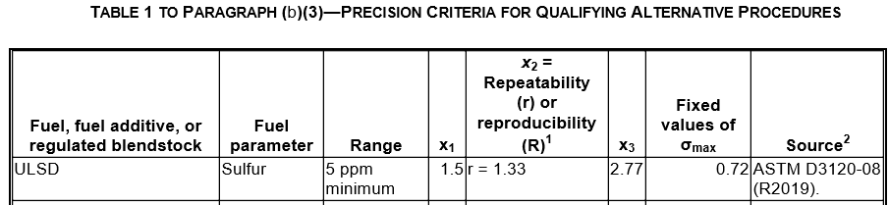

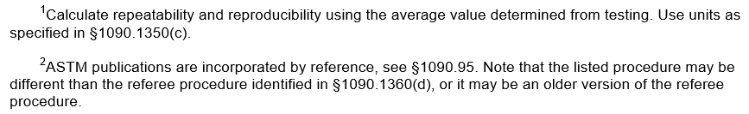

**Instructions for completing reporting form**

The reporting form has a tab for general information, a tab for laboratory identification data, a tab for Round-Robin data, and a tab for Precision data. Lab Name is entered automatically on the “Test data – Round Robin” tab once it is entered on the “Lab data” tab, and Method Name is entered automatically on the “Test data – Round Robin” tab once it is entered on the “General Info” tab. The form is intended to be

used for one fuel parameter, so if you are applying for permission to use a method(s) which is applicable to more than one parameter, complete a form for each method.

All tabs have a field for indicating whether confidentiality is claimed for the information on the tab.

General information

Enter the fuel parameter type by selecting a standard type from the pulldown list.

Review the attestations and “Attest” using the pulldown lists.

Enter the data in columns J, W, and X. These fields have no pulldown lists, and accept whatever the user types.

Laboratory identification information

Enter location and contact information on this tab.

Test data

Enter test results for all labs that participated in the round robin. Enter sample identification numbers in the rows where “1”, “2”, “3”, etc. appear in column D. Sample ID numbers do not need to be entered again for re-tests of samples. As a reminder, a yellow popup message appears when a cell in column D, below the “1”, “2”, or “3”, is selected, indicating that data should not be manually entered here. Enter the date and time for each test result.

Contact information:

FuelsProgramSupport@epa.gov